Attendance Certification
End of Year

Report Details

Reporting Timeframe: Open Date: 06/15 Due Date: 07/15

Who should report: Charter Schools, CSDs, Maine Indian Education, MSUs, RSUs, State Operated, UT, Private Special Purpose, Regional Programs, Privates that except Publicly Funded Students.

Description: End of Year attendance will show attendance per school in your district, along with the percent of student body chronically absent.

Accessing the reports:

To access this report, you will log into NEO. (Student Data permission are required)
Then go to Student Data, then Student Reports, you will see these four reports (Certification and Summary are the focus of these instructions):
-Certification Report will load the district aggregate totals per school, you can also see the modality totals per school, and allow the Superintendent to certify the data.
-Summary Report will load all district students that have been entered into Synergy to show their attendance for the entire year. This data can be all schools or individual schools within the district.
-Detail’s Report will load district/school level attendance totals.
-The Lookup Report will allow you to lookup individual students and see their attendance entered by each day for the entire year.

Daily Attendance Certification Report
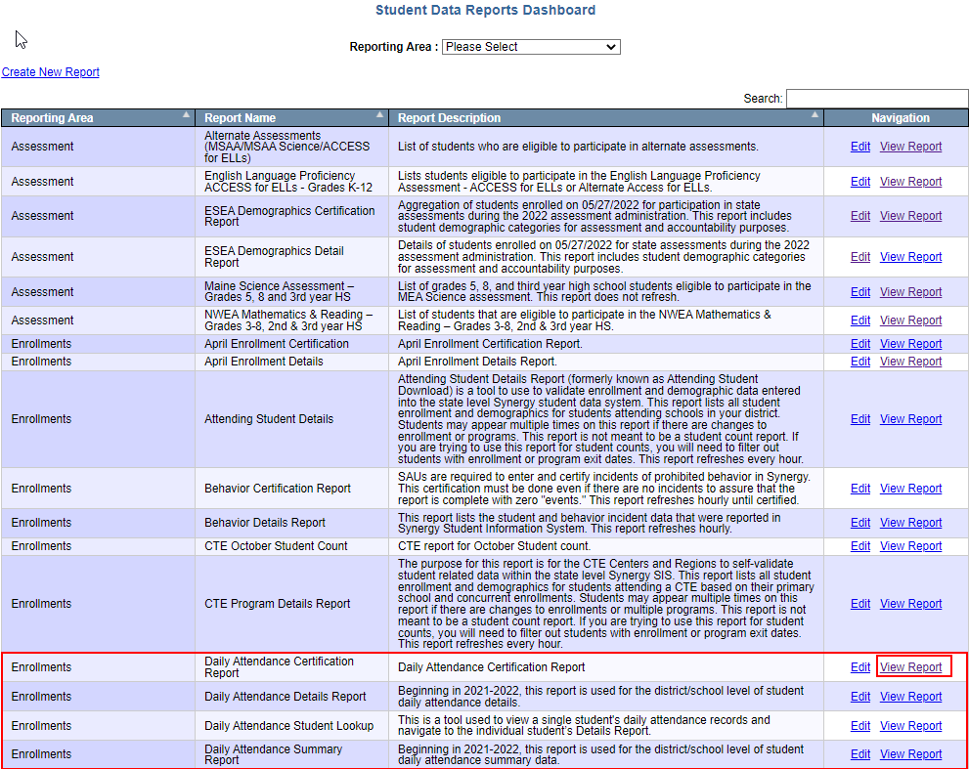

Click on ‘View Report’ for ‘Daily Attendance Certification Report’. Then select your district under the Reporting Organization dropdown, along with ‘End of Year’ under quarter, which will load your district data. Please note that if you only have access to one district it will be auto loaded by default but those with access to multiple districts will need to pick one to view.

Each school in your district will be listed along with totals:
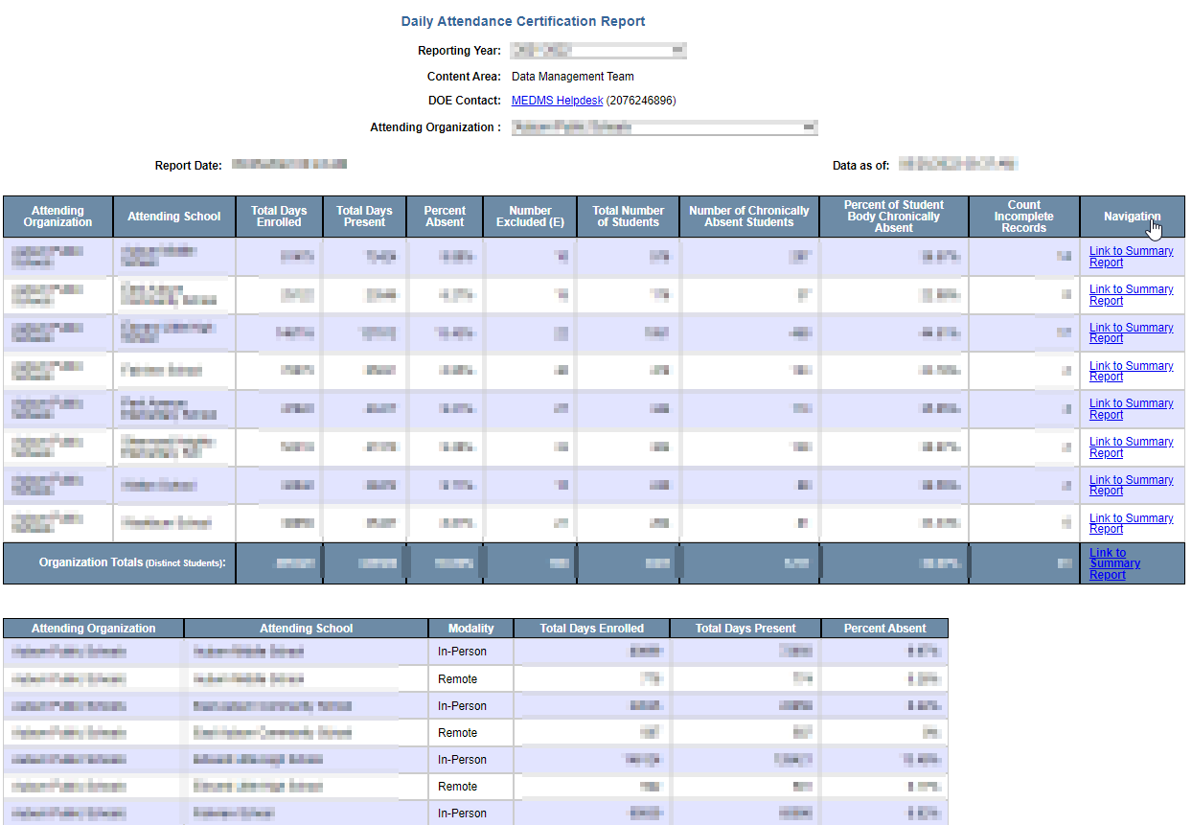

The report has 11 columns:
Attending Organization: District where data is pulled from.
Attending School: Specific school data is pulled from.
Total Days Enrolled: This is the number of active instructional days that all students have been in enrolled in the specific quarter.
Total Days Present: The total number of days all students were in attendance in the specific quarter for at least 50% or more of the student’s scheduled school day.
Percent Absent: Percentage of the quarter that all students were absent.
Number Excluded: This column reports the total amount of the student body that are excluded from the chronic absenteeism count.
Total Number of Students: The total amount of students for the quarter that should have attendance.
Number of Chronically Absent Students: The total amount of the student body for the quarter that were chronically absent.
Percent of Student Body Chronically Absent: The percentage of the student body that was chronically absent.
Count Incomplete Records: The number of students that are missing attendance. Clicking into ‘Live Student Data’ will allow you to filter on Incomplete Data and see who these students are.
Navigation: Links to the ‘Attendance Details Report – Quarterly’ report
The bottom section displays attendance per school based on modality.

Important things to note:
- The report cannot be certified until all ‘Counts Incomplete Records’ have been resolved.
- Only the Superintendent will be able to click the ‘Certify and Submit to DOE’ button. If a certification submission needs to be removed please contact the helpdesk. (Contact info is at the bottom of instructions)

Daily Attendance Summary Report
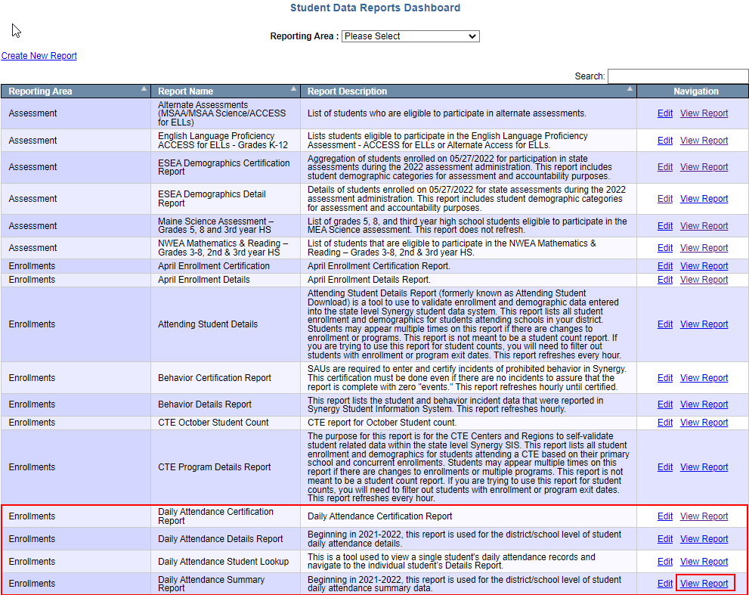

Click on ‘View Report’ for ‘Daily Attendance Summary Report’. Then select your district under the Reporting Organization dropdown, along with ‘Attending School under quarter, which will load your district data.

A school will be listed based on the dropdown selection for attending school along with end of year totals (By default, the Attending Schools will be set to All. Please note that if you only have access to one district it will be auto loaded by default but those with access to multiple districts will need to pick one to view via Attending Organization):
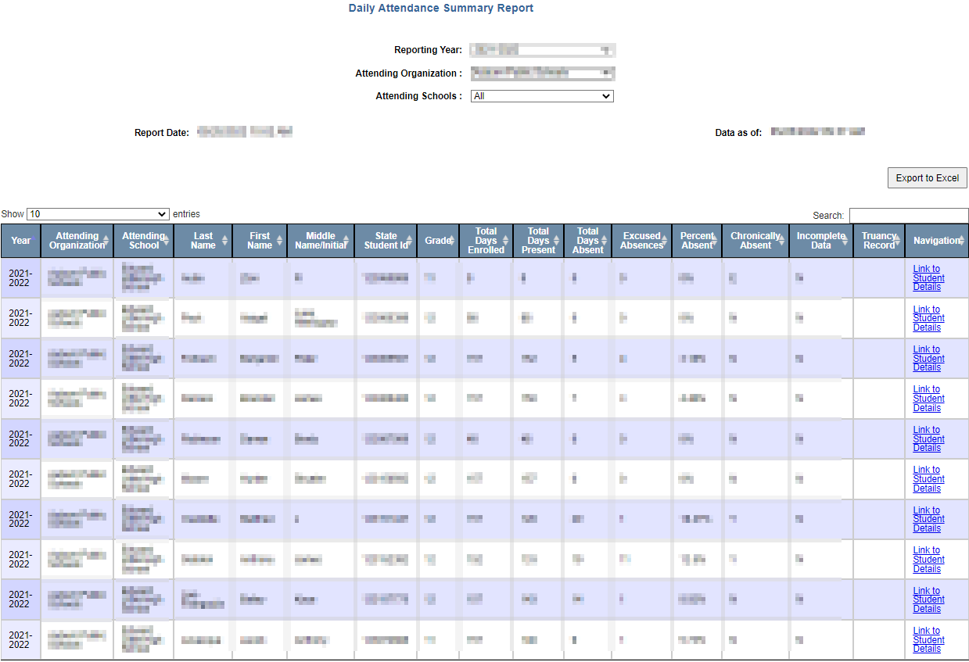

The report has 17 columns:
Year: School year for data details.
Attending Organization: District where data is pulled from. Attending School: Specific school data is pulled from.
Last Name: Students last name.
First Name: Students first name.
Middle Name/Initial: Students middle name or initial.
State Student ID: Students SSID.
Grade: Students Grade.
Total Days Enrolled: This is the number of active instructional days that the student has been in enrolled in the specific quarter.
Total Days Present: The total number of days the student was in attendance in the specific quarter for at least 50% or more of the student’s scheduled school day.
Total Days Absent: Number of days the student was absent in the quarter.
Excused Absences: Number of excused absences the student has for the quarter.
Percent Absent: Percentage of the quarter that the student was absent.
Chronically Absent: Indicates if the student was chronically absent for the quarter.
- Please note that the ‘E’ means they are excluded from CA counts.
Incomplete Data: Allows you to see if the student needs attendance data entered into Synergy.
Truancy Record: Indicates if the student has a truancy record in Synergy.
Navigation: Links to the details report which will show the district level attendance information.

Important things to note:
- The data in the details report is “live” and updates every hour and a half. (once the report is certified this will no longer update)
- If you do not see a change you made in Synergy please wait an additional hour, if you still do not see the change please contact the helpdesk.
We have two more reports for daily attendance:
Daily Attendance Details Report Instructions: Beginning in 2021-2022, this report is used for the district/school level of student daily attendance details.
Daily Attendance Student Lookup Instructions: This is a tool used to view a single student's daily attendance records and navigate to the individual student’s Details Report.

Once everything looks correct, the Superintendent can click on ‘Certify and Submit to DOE’ via the Daily Attendance Certification Report.

Contact Information

If you have any questions or comments please contact the MEDMS Helpdesk:
Email: medms.helpdesk@maine.gov
Phone: (207) 624-6896

