Special Education FTE Staff Certification EF-S-05 Part II Instructions
Reporting Begins: September 1, 2021
Reporting Ends: November 15, 2021

All changes to data within the EF-S 05 PT 2 Special Education FTE Staff Certification Report must be done within NEO staff assignments directly.
The EF-S-05 Part 2 is used to verify the full-time equivalency (FTE) and qualification status of special education teachers, paraprofessionals (educational technicians), and related services personnel who are employed or contracted or anticipated to be employed or contracted by Dec 1, 2021 to provide special education services to students with disabilities ages 3 through 21. It is based on staff data for the current year staff reporting. For educational technicians and related services personnel, the FTE should reflect only the portion of time the staff provide the services listed in the section below under the heading “Related Services Personnel Categories” for children with disabilities ages 3 through 21 receiving special education and related services.

Special Education Teachers

Which teachers are included in the report?
Teachers who are employed by public or private agencies, regardless of funding source, and have responsibility for educating children with disabilities ages 3 through 21. This includes classroom teachers, preschool teachers, itinerant/consulting teachers, and home/hospital teachers.

Which teachers should not be included?
The data collection does not include FTEs of special education teachers who:
- Provide special education services to children with disabilities from birth through age 2,
- Are regular education teachers (school-age or preschool) even when their classroom instruction includes children with disabilities,
- Work exclusively with students without disabilities.

How to determine whether a teacher is qualified or not qualified:
Maine’s definition of a qualified teacher:
1) The teacher has obtained full Maine certification as a special education teacher (including certification obtained through alternative routes to certification and including conditional certification), or passed the Maine special education teacher licensing examination, and holds a Maine license as a special education teacher, and
2) The teacher has not had special education certification or licensure requirements waived on an emergency, temporary, or provisional basis, and
3) The teacher holds at least a bachelor's degree.

Paraprofessionals (Educational Technicians) and Related Services Personnel

Educational Technicians I, II, III (Paraprofessionals) - Employees who provide instructional support, including those who:
- Provide one-on-one tutoring if such tutoring is scheduled at a time when a student would not otherwise receive instruction from a teacher
- Assist with classroom management, such as organizing instructional and other materials
- Provide instructional assistance in a computer laboratory
- Conduct parental involvement activities
- Provide support in a library or media center
- Act as a translator
- Provide instructional support services under the direct supervision of a teacher - definition adapted from P.L 108-446, Section 612(14)(B), 34 C.F.R. Part 300.156(b)
How to count paraprofessionals and related services personnel who work with both students with disabilities and their non-disabled peers:

If paraprofessionals and related services personnel work part of their time with children without disabilities, and other times with children with disabilities, report only the proportion of their FTE that is related to their services to children with disabilities.
How to determine the qualification status of Paraprofessionals and Related Services Personnel:
Paraprofessionals and Related Services Personnel are “certified” if they
- Hold the appropriate State certification or licensure for the position held, or
- Are in positions for which no State requirements exist (i.e., no certification or licensure requirements).
Paraprofessionals and Related Services Personnel are “not certified” if they
- Are employed on an emergency, provisional, or other basis, and do not hold the State certification or licensure for the position to which they are assigned, or
- They do not meet other existing State requirements for the position.

Does the EFS-05 Part 2 include ALL special education staff?

No, the data are not a comprehensive count of all types of personnel who provide services to children with disabilities. In addition to Teachers and Paraprofessionals (Educational Technicians), the report includes only the related services personnel types specified below.
Related Services Personnel Categories - The following are the types of related services personnel categories reported (Adapted from P.L. 108-446, Sections 618(a)(1)(A)(i) and 618(a)(3), 34 C.F.R. Part 300.34(c)):

  - Audiologists - provide the following services to children with disabilities:
- Identification of children with hearing loss;
- Determination of the range, nature, and degree of hearing loss, including referral for medical or other professional attention for the habilitation of hearing;
- Provision of habilitative activities, such as language habilitation, auditory training, speech reading (lip-reading), hearing evaluation, and speech conservation;
- Creation and administration of programs for prevention of hearing loss;
- Counseling and guidance of children, parents, and teachers regarding hearing loss; and
- Determination of the children’s needs for group and individual amplification, selecting and fitting an appropriate aid, and evaluating the effectiveness of amplification.

  - Speech-language pathologists - provide the following services to children with disabilities:
- Identification of children with speech or language impairments
- Diagnosis and appraisal of specific speech or language impairments;
- Referral for medical or other professional attention necessary for the habilitation of speech or language impairments;
- Provision of speech and language services for the habilitation or prevention of communicative impairments; and
- Counseling and guidance of parents, children, and teachers regarding speech and language impairments.

  - Interpreters - provide services to children who are deaf or hard of hearing:
- Oral transliteration services
- Cued language transliteration services
- Sign language interpreting services.

  - Psychologists - provide the following services to children with disabilities:
- Administering psychological and educational tests, and other assessment procedures;
- Interpreting assessment results
- Obtaining, integrating, and interpreting information about child behavior and conditions relating to learning;
- Consulting with other staff members in planning school programs to meet the special needs of children as indicated by psychological tests, interviews, and behavioral evaluations;
- Planning and managing a program of psychological services, including psychological counseling for children and parents; and
- Assisting in developing positive behavioral intervention strategies.

  - Occupational therapists - provide the following services to children with disabilities:
- Improving, developing or restoring functions impaired or lost through illness, injury, or deprivation;
- Improving ability to perform tasks for independent functioning if functions are impaired or lost; and
- Preventing, through early intervention, initial or further impairment or loss of function.

  - Physical therapists - provide the following services to children with disabilities:
- Screening, evaluation, and assessment of children ". . . to identify movement dysfunction
- Obtaining, interpreting, and integrating information appropriate to program planning to prevent, alleviate, or compensate for movement dysfunction and related functional problems
- Providing individual and group services or treatment to prevent, alleviate, or compensate for movement dysfunction and related functional problems

  - Physical education teachers and recreation and therapeutic recreation specialists - provide the following services to children with disabilities:
- Provide special physical education, adaptive physical education, movement education, or motor development to children and youth with disabilities
- Assessment of leisure function;
- Therapeutic recreation services
- Recreation programs in schools and community agencies
- Leisure education.

  - Social workers - provide the following services to children with disabilities:
- Preparing a social or developmental history on a child with a disability
- Group and individual counseling with the child and family
- Working in partnership with parents and others on those problems in a child’s living situation (home, school, and community) that affect the child’s adjustment in school
- Mobilizing school and community resources to enable the child to learn as effectively as possible in his or her educational program
- Assisting in developing positive behavioral intervention strategies

- Medical/Nursing service staff - provide the following services to children with disabilities:
- Medical services (adapted from 34 C.F.R. Part 300.34(5)) for diagnostic and evaluation purposes provided to determine whether a child has a disability and the nature and extent of the special education and related services that the child needs.
- Nursing services designed to enable a child with a disability to receive FAPE as described in the child’s IEP, with the exception of services related to medical devices that are surgically implanted (e.g., cochlear implants).

- Counselors and rehabilitation specialists - provide the following services to children with disabilities:
- Guide individuals, families, groups, and communities by assisting them in problem solving, decision-making, discovering meaning, and articulating goals related to personal, educational and career development.
- Provide services in individual or group sessions that focus specifically on career development, employment preparation, achieving independence, and integration in the workplace and community of a student with a disability.
- Vocational rehabilitation services provided to a student with disabilities by vocational rehabilitation programs funded under the Rehabilitation Act of 1973, as amended.

- Orientation and mobility specialists - provide the following services to children with disabilities:
- Services provided to blind or visually impaired students to enable those students to attain systematic orientation to and safe movement within their environments in school, home, and community
- Teaching students the following, as appropriate:
  - Spatial and environmental concepts and use of information received by the senses (such as sound, temperature and vibrations) to establish, maintain, or regain orientation and line of travel (e.g., using sound at a traffic light to cross the street)
  - To use the long cane to supplement visual travel skills or as a tool for safely negotiating the environment for students with no available travel vision
  - To understand and use remaining vision and distance low vision aids
  - Other concepts, techniques, and tools.

The table below indicates how the special education NEO staff positions are categorized into the Related Services Personnel Categories listed above:

NEO STAFF POSITION | RELATED SERVICES PERSONNEL CATEGORY
Athletic Trainer | Physical Education Teachers and Recreation and Therapeutic Recreation Specialists
Audiologist | Audiologists
Board Certified Behavior  Analyst | Psychologist
Certified Employment Specialist | Counselors and Rehabilitation Specialists
Counselor or Rehabilitation  Counselor | Counselors and Rehabilitation Specialists
Director of Guidance | Counselors and Rehabilitation Specialists
Employment Coordinator | Counselors and Rehabilitation Specialists
Guidance Counselor | Counselors and Rehabilitation Specialists
Health Assistant | Medical/Nursing Service Staff
Interpreter | Interpreters
Interpreter or Transliterator for the Deaf | Interpreters
Licensed Clinical Professional  Counselors | Counselors and Rehabilitation Specialists
Nurse | Medical/Nursing Service Staff
Occupational Therapist | Occupational Therapists
Occupational Therapy Aides | Occupational Therapists
Orientation and Mobility  Specialists | Orientation and Mobility Specialists
Other Special Education  Services Provider | Counselors and Rehabilitation Specialists
Physical Therapist | Physical Therapists
Physical Therapists Assistant | Physical Therapists
Physician/Doctor | Medical/Nursing Service Staff
Psychometrics/Psychological  Examiner | Psychologist
Recreation/Therapeutic  Recreation Specialist | Physical Education Teachers and Recreation and  Therapeutic Recreation Specialists
School Psychologist | Psychologist
School Social Worker | Social Workers
Sign Language Interpreter | Interpreters
Special Education Consultant | Counselors and Rehabilitation Specialists
Speech - Language Pathologist | Speech - Language Pathologist
Speech - Language Pathology  Aides and Assistants | Speech - Language Pathologist
Speech & Hearing Clinician | Speech - Language Pathologist

Accessing the report
- Log into NEO (note clicking this link requires you to enter your username and password).
- Once logged in click on Special Education in the body of NEO or at the top of the screen
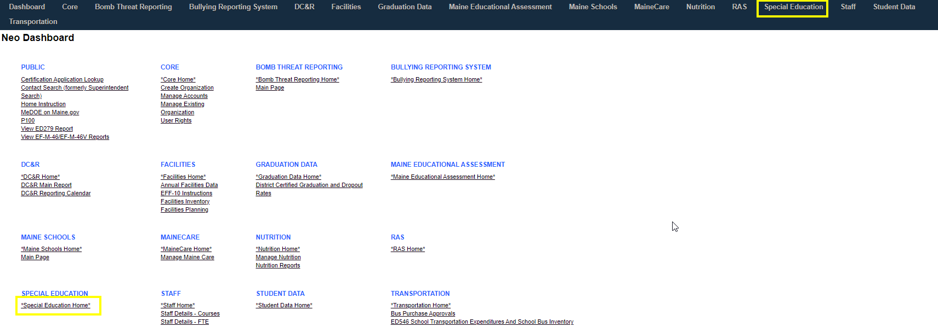

Once you are in Special Education hover over forms then select ‘Special Education FTE Staff Certification (EF-S 05 PT2)’
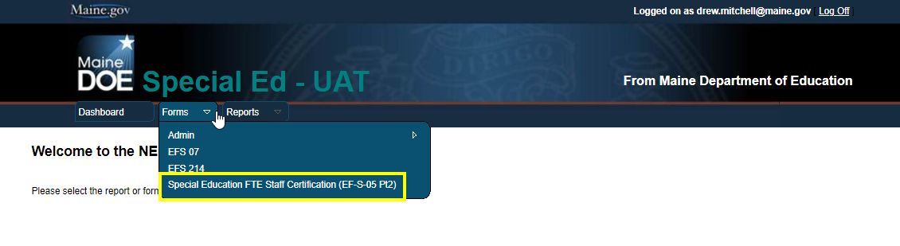

Reviewing the report
Once the report loads ensure you’re looking at the current year and submission date then select your district
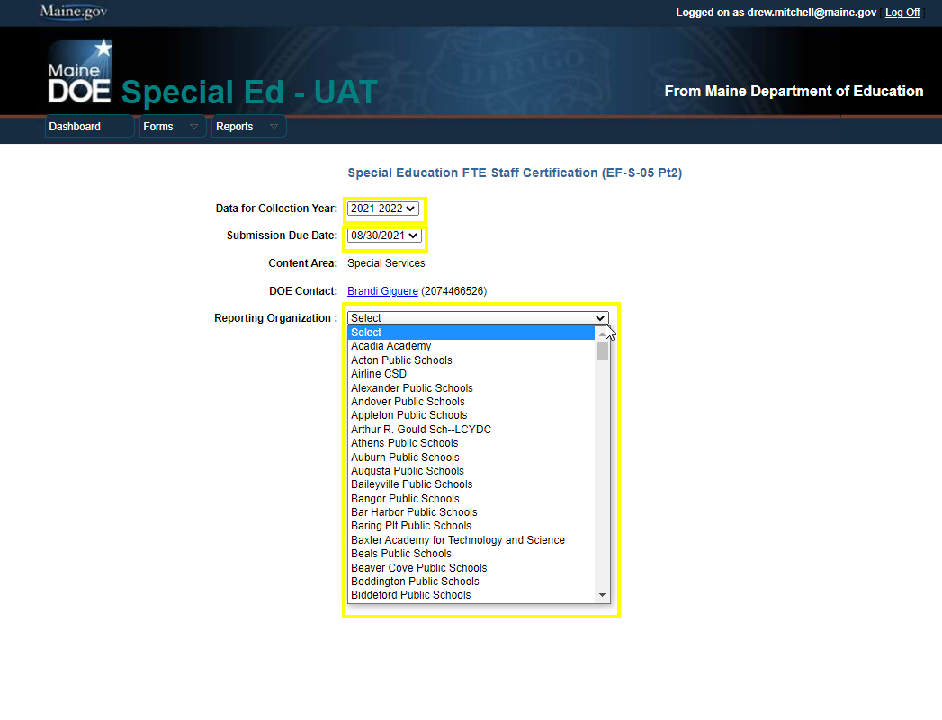
Once the district is selected you will see your FTE counts for your staff that serve special education students, broken into Fully Certified and Not Fully Certified.
Note that the report will only show staff within NEO that are marked as active (no pending or in-progress positions) .
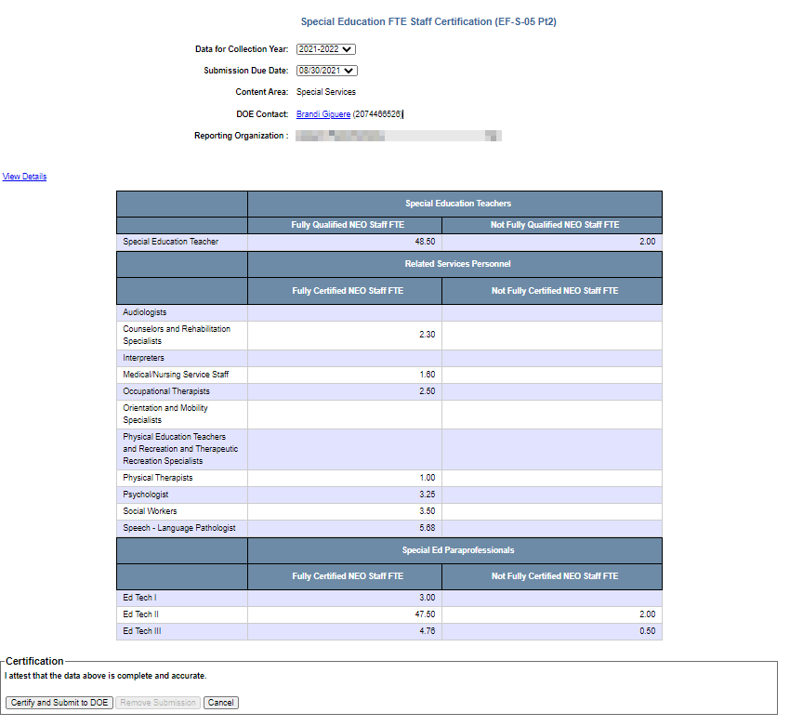

Details

Staff that appear on this report may include personnel who work part of their time with children without disabilities, and other times with children with disabilities (IDEA). The FTE is based on the proportion of time the personnel work specifically with children with disabilities (IDEA) receiving special education and provide the services listed in the instructions section above under the heading “Related Services Personnel Categories”. The FTEs are derived from the special education question in staff assignments in NEO:
Example:
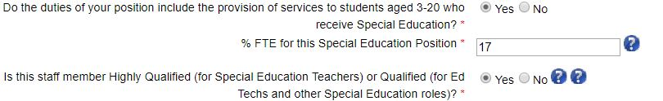

The ‘View details’ link will break down the totals into each related staff assignment (IE: SPED Teachers would show each of the teachers that are counting towards the 48.50 total seen above). If these numbers are not accurate then the person at the district handles NEO Staff data entries will need to modify the related staff assignments within NEO Staff. Note that once a staff assignment is updated and submitted in NEO Staff this report updates instantly.

Information on NEO Staff can be found on the Helpdesk Webpage.

Certifying the report

Once all the data is accurate and all NEO Staff and in an active status the report can be submitted by clicking on the ‘Certify and submit to DOE’ button. Note that if changes need to be made the submission will need to be removed for the updates of staff to reflect in this report.

Contact Information

- If you have questions about accessing the report please contact the MEDMS Helpdesk via Email or call 207-624-6896
  - If you need access to NEO to view this report please have your superintendent’s office submit an access request on your behalf.
- If you have questions regarding EF-S-05 Part 2 please contact Brandi Giguere at brandi.a.giguere@maine.gov or call 207- 446-6526

