Dropout Certification Report Instructions
2020-2021 Federal Reporting Year: 10/1/2020 – 9/30/2021
The dropout certification report will no longer have functionality to change exit codes of students. Instead we are only asking you to verify that the report is correct and accurate. These instructions will be a guide for locating the dropout report, as well as a guide on how to validate that the report is correct and accurate.
Report Location: NEO -> Student Data -> Student Reports -> Dropout Certification Report
- First log into NEO and find the module labeled ‘Student Data’
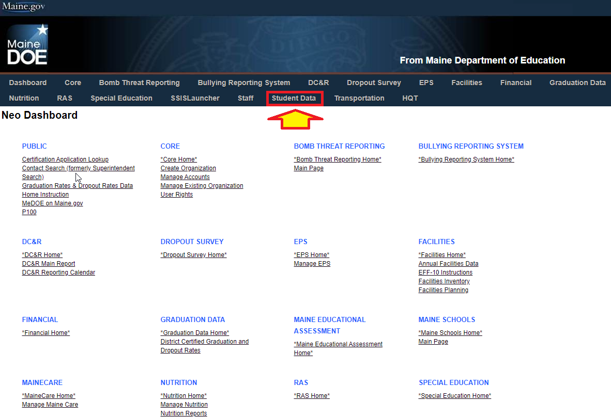
- Once in Student Data, find the section labeled ‘Student Reports’
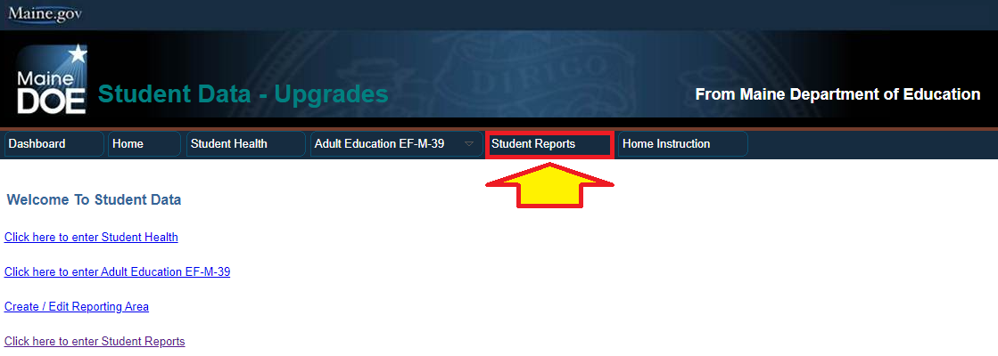
- Here you’ll see a listing of reports, find the report labeled ‘Dropout Certification Report’
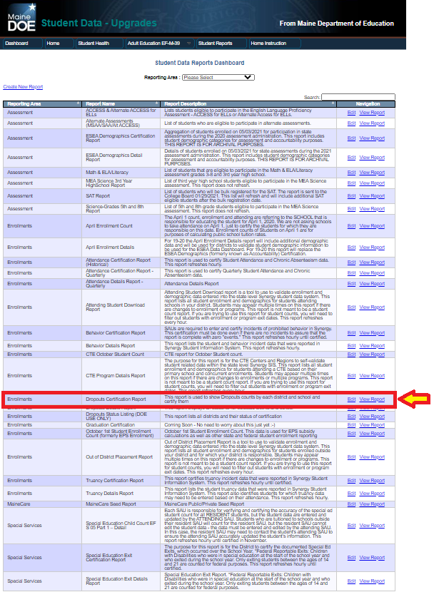
- This will bring up your certification report for your district. In order to see which students are your dropouts, you can click the ‘View Details’ link next to the school you wish to view. You may also view your district level dropouts with the View Details link next to ‘District totals’.
- If the information in the report is correct, you can complete the report by clicking the ‘Certify and submit to DOE’ button under the report.
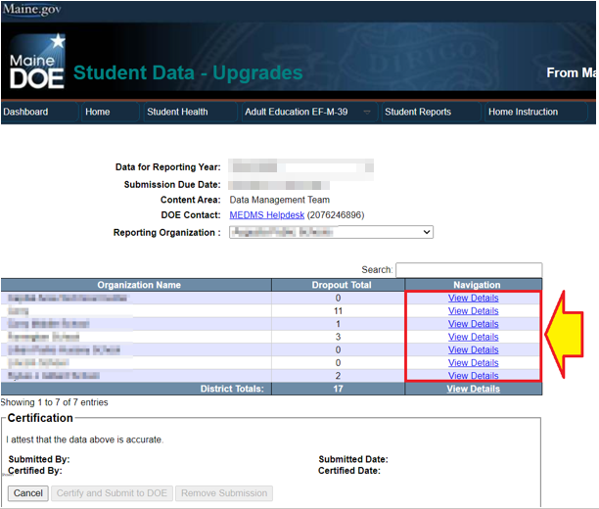

Dropout reporting is for all grades of compulsory age students. USDOE has requested grades less than 7 for many years now, state statute does not specifically define a grade range, data governance team decision from December 10, 2019 was to collect this data from all grades for compulsory age students for 2019-2020 forward.

Definition: A student meets the criteria for federal dropout reporting when the student was enrolled at some point during the federal reporting year (10/1/2020 – 9/30/2021) and was expected to return to school by October 1st, 2021 and does NOT have a 10/1/2021 enrollment. Students will be counted as a dropout for each year they meet the federal reporting dropout definition.
Who can be removed from the report: The only students who are eligible to be removed from the dropout report are those who transferred to homeschooling, transferred to a private school, or transferred out of state/country, but in the report have a different exit status. If any of these changes are needed, please contact the helpdesk along with evidence/documentation explaining why the change is being requested.
Students who are exited with the following Exit Codes are excluded from Dropout reporting:
- Transferred to a school in a different state (01909)
- Transferred to a school outside of the country (01916)
- Transferred to Home Instruction (01918)
- Graduated (01921)
- Died (01923)
- Enrolled in a postsecondary early admission program, eligible to return (01930)
- Transfer to a Maine private school (00027)
- Enrolled in a Foreign Exchange Program, eligible to return (03503)
- Completed with a State recognized equivalency certificate (Adult Ed & HiSET). (03509)

Removing students from the report: If a student was not exited from your school with one of the above codes, and should have been, you may enter a 1-day enrollment for 7/1 of the current school year to re-enter and exit them the same day with the correct status. After the next report refresh period the student should be removed from the dropout report.
- Students that were not enrolled by a receiving school: Students that exited your district and were not subsequently enrolled by their new district will need to have the records request emailed to MEDMS.Helpdesk@Maine.Gov with the explanation of the situation and we can assist.

How Reporting Grade is determined:

- Students who were last exited with a code that indicating they were NOT expected to return the following year and who did not return by 10/1/2021, will be counted as a dropout with their last enrollment grade as their Reported Grade.
  - Exit codes NOT expected to return the following year:
    - Aged out (01926)
    - Discontinued Schooling (01927)
    - Not enrolled unknown status (01931)
    - Withdrew to Adult Ed (73060)
    - Withdrew to workforce program (73061)

- Students last exited with a code that expected them to return but who did not return by 10/1/2021 will be reported as a dropout with the following grade information.
  - Students last exited between 10/1/20 – 6/30/21, will have their last enrollment grade plus one as their Reported Grade.
  - Students last exited between 7/1/21 – 9/30/21 will have their last enrollment grade as their Reported Grade.
  - Exit codes expected to return:
    - Transfer to a Maine public School in same LEA (01907)
    - Transferred to a Maine public school in a different LEA (01908)
    - Transfer to an Institution (01917)
    - Transfer to a Charter School (01919)
    - Expelled (01927)
    - Not enrolled eligible to return (03502)
    - Withdrawn from school, under the age for compulsory attendance, eligible to return (03504)

NOTE: Students last exited as Expelled (01927)
  - These students will be reviewed by MDOE prior to the dropout reports being provided to the districts to validate the duration of the expulsion period in relation to the dropout determination criteria.
  - MDOE will identify the appropriate status of the students exit and populate the district reports accordingly. Districts will be contacted by the MDOE as needed to review any questions regarding the enrollment or expulsion information for those students.

How Reporting SAU and Reporting School are determined:
PUBLIC SCHOOLS:
- Students that were exited “NOT expected to return” will be reported at the last Attending SAU and Attending School.

- Students that were exited “expected to return” between 10/1/20 and 6/30/21 will be reported at the last Attending SAU and Attending School IF the Attending SAU and Attending School both offer the Reported Grade.

- If the last Attending SAU and Attending School do not offer the Reported Grade then the Reported SAU will be the last Attending SAU and the Reported School will be NULL. Student will be counted at the district level only.

- If the last Attending School, doesn't offer the Reported Grade, but the last Attending SAU does at only one (other) school, then the student will be reported at the school that offers that grade.

- If the Attending School, in the Attending SAU, doesn't offer the Reported Grade, but the Attending SAU does at MORE than one (other) school, then the Reporting School will be NULL. Student will be counted at the district level only.

- Students that were exited “expected to return” between 7/1/21 and 9/30/21 will be reported at the last Attending SAU and Attending School.
- PUBLICLY FUNDED Students at PRIVATE SAU’s: Publicly funded students attending Private SAU’s will be reported at the Responsible SAU IF the Responsible SAU offers the Reported Grade. The Reported School will be NULL. Student will be counted at the district level only.
If you have questions regarding a student on your dropout report, please contact The MEDMS Helpdesk.
Email: Medms.helpdesk@maine.gov Phone: (207) 624-6896

