**Graduation Certification**

**Report Instructions**

**Description/Purpose:**

The purpose of this reporting is to allow districts/schools to validate the graduate counts.

**What is this data used for?**

Adjusted Cohort Graduation Rates (ACGR) are reported annually by the Maine DOE to the USDOE for all public high schools and all publicly funded students attending private schools. In addition, the ACGR is used for ESSA school accountability determinations. The State calculates 4-year, 5-year and 6-year Adjusted Cohort Graduation Rates.

**Due Date:**

• Due Date: 8/30

**Completion Instructions:**

This requires access to the Student Data Module. If you need access, please have your superintendent submit a NEO access request form on your behalf.

[NEO Access Request Form](https://mainedoe.co1.qualtrics.com/jfe/form/SV_0Hg1z6QgRAuoKPk)

* Log into NEO
* On the NEO dashboard; find the ribbon header labeled “Student Data”.

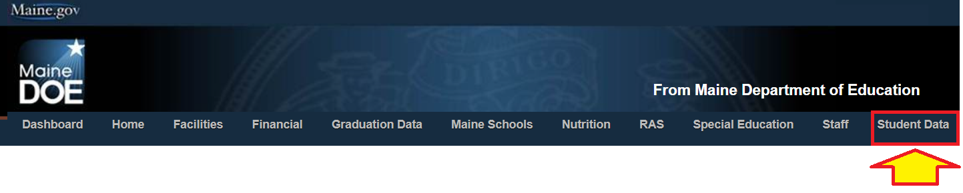

* After selecting the Student Data module select “Student Reports” which will provide you with a list of reports.



* On the Reporting Area dropdown listing select “Enrollments”.

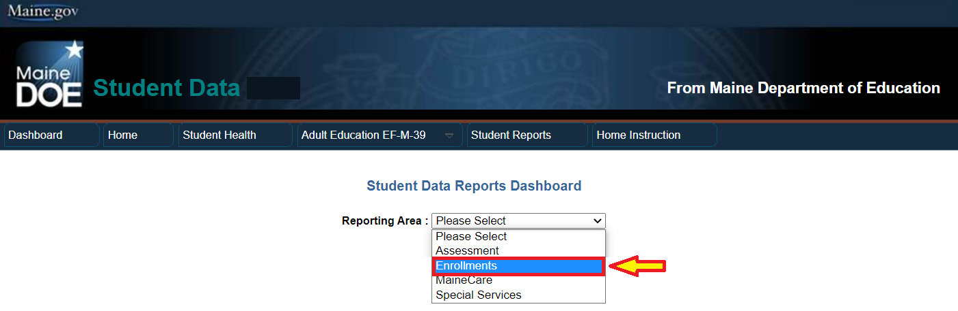

* From the list of reports find “Graduation Certification Report” and select “View Details”.

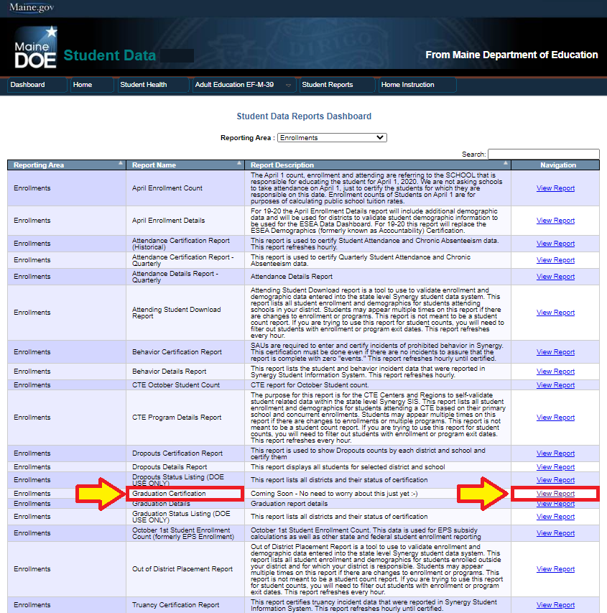

* Once you’re inside the Graduation report, you will be presented with your district’s count of 4, 5, 6-year graduates as well as the number of completers for the current year. Each of these counts have an associated ‘Student Details’ report alongside of them. Inside this link is where you will verify which of your students make up your numbers for the completers, 4, 5- and 6-year counts.

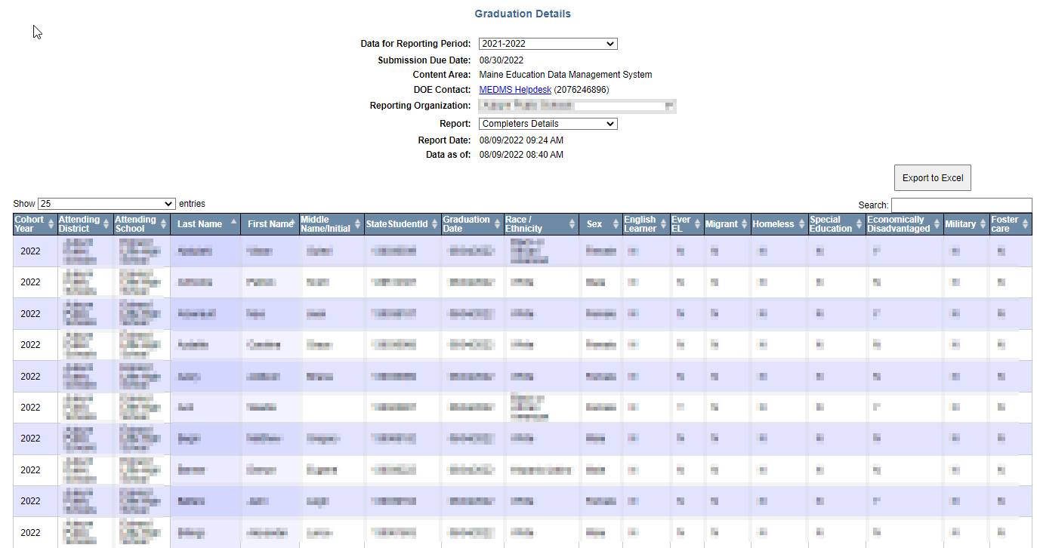

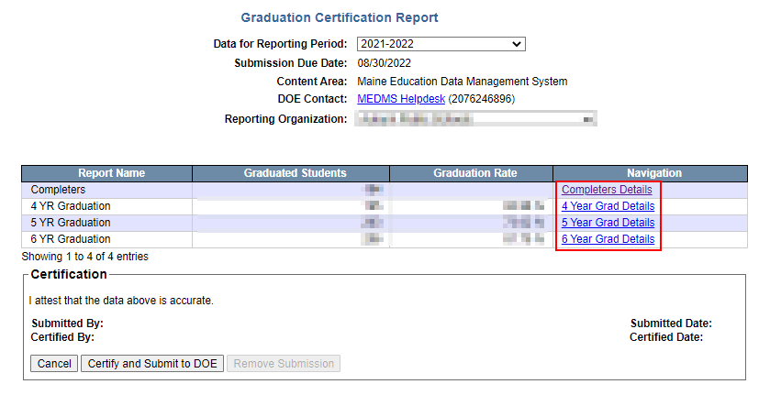

***\*Please note that only superintendents will have access to the “Certify and Submit to DOE” button.***

* If the counts and all the information within the detail reports are correct, your superintendent can click the ‘Certify and Submit’ button.
* Updates to the report can be done in Synergy until 8/15. This means you can update the exit state for the previous year live. If you need assistance with this, please call or email.
* **DO NOT make enrollments in the next year to graduate a student as it will move them out of the correct cohort.**

**Cohort Adjustment Updates:**

Cohort is determined by a student’s first high school (9-12) enrollment in the State Synergy Student Data System. The purpose is to track graduates and facilitate assessment testing of a student. For example: a student moves to Maine from another State or Country for the first time in the 2019-2020 school year. The school assesses that, based on the student records or other available information, the student will be considered 10th grade. This sets the student’s cohort to 2022, meaning they will be expected to graduate in the 2021-2022 school year (after 3 school years since enrollment).

Situations which ***will*** allow for manual adjustment a Cohort by MEDMS Support:

1. Schools alter the initial high school entry grade in Synergy after a grade level is entered in error. For example, student enrollment is entered into Synergy as grade 10, but the student is in grade 9.
2. A school entered a 1-day enrollment in Synergy, expecting the student to attend for a certain grade, but then the student ends up attending a different SAU at a different assessed grade.
3. Simple user error uploading or manually entering to Synergy.

Situations which ***will not*** allow for manual adjustment a cohort by MEDMS Support:

1. Student was held back a grade.
2. Student Synergy enrollment history clearly shows multiple years of certified reporting through high school grade progression.
3. A student is graduating early. (They remain with their original cohort and will be captured in graduation reporting as such)

Graduation Cohort has been added to the Attending Student Details report to allow for regular review.

[MEDMS.Support@Maine.gov](mailto:MEDMS.Support@Maine.gov)

or

(207) 624-6896

* It is no longer necessary to validate the start and exit codes of students during this report. The report will also no longer be required to be ‘Accepted’ by the MDOE. Please make sure that all the data is accurate, as these are the students upon which the graduation rate statistics will be generated.

# **FAQ:**

1. **What is a “four-year adjusted cohort graduation rate”?**
   1. The four-year adjusted cohort graduation rate is the number of students who graduate in four years with a regular high school diploma divided by the number of students who form the adjusted cohort for the graduating class. From the beginning of 9th grade, students who are entering that grade for the first time form a cohort that is subsequently “adjusted” by adding any students who transfer into the cohort later during the 9th grade and the next three years and subtracting any students who transfer out, emigrate to another country, or die during that same period.
2. **How is the four-year graduation rate calculated?**
3. **How is a student who graduates in more than four years counted in the four-year graduation rate?**
   1. A student who graduates in more than four years is counted as a non-graduate in the four-year graduation rate. Such a student must be included in the denominator of the four-year graduation rate and may not be included in the numerator because the student did not graduate in four years or less with a regular high school diploma. The student may not be removed from the cohort or assigned to a different cohort when calculating the four-year graduation rate. However, such a student may be counted as a graduate in an extended-year graduation rate.
4. **What is an extended-year adjusted cohort graduation rate?**
   1. An extended-year adjusted cohort graduation rate is defined as the number of students who graduate in four years or more with a regular high school diploma divided by the number of students who form the adjusted cohort for the four-year graduation rate, provided that the adjustments add to the cohort all students who transfer into the cohort by the end of the year of graduation being considered and subtract students who transfer out, emigrate to another country, or are deceased by the end of that year. An extended-year graduation rate follows the same rules as the four-year graduation rate.
5. **May the four-year graduation rate include students who graduate in the summer after their fourth year of high school?** 
   1. Students have until August 15th to meet all graduation requirements. Any students who finish after this time will be considered graduates for the following school year.
6. **Does the four-year graduation rate include a student who graduates from high school in less than four years?** 
   1. Yes. The four-year graduation rate counts a student who graduates with a regular high school diploma in four years or less as a high school graduate in his or her original cohort—that is, the cohort with which he or she started 9th grade. For example, a student who enters the 9th grade for the first time in the 2011-2012 school year and graduates in three years would be included in the cohort of students expected to graduate in the 2014-2015 school year, even though that student would receive his or her diploma in the 2013-2014 school year; effectively, the student’s graduation information is “banked” for a year until his or her cohort graduates in 2014-2015.
7. **What documentation is required to confirm that a student has transferred out--i.e., transferred to another school or to an educational program that culminates in the award of a regular high school diploma?**
   1. To confirm that a student transferred out, a school or LEA must have “official written documentation” that a student has transferred to another school or to an educational program that culminates in the award of a regular high school diploma. A request for student records from a receiving public or private high school or an educational program (that culminates in a regular high school diploma); or a written record of a response from an official in the receiving school or program acknowledging the student’s enrollment. It is not always possible to obtain a request for records from out-of-state or out of country schools therefore, a school may replace this requirement with written documentation from the parent/guardian that they are moving out of state/country.
8. **Is a student who leaves school because the student is incarcerated considered a transfer?**
   1. An incarcerated student may be considered a transfer only if the prison or juvenile facility to which the student is confined has a school (as defined under State law) or provides an educational program that culminates in the award of a regular high school diploma. If the facility does not have a school or educational program, or provides an educational program that does not culminate in the award of a regular high school diploma, the student may not be considered a transfer, may not be removed from the cohort, and must remain in the denominator of the graduation rate calculation for the school, LEA, and State in which the student last attended high school. In addition, the student can only be considered a transfer to the juvenile detention facility if the student has been adjudicated to the facility. While the student is being detained and is awaiting a court hearing, the student is still the responsibility of the school district and cannot be transferred to the juvenile detention facility.
9. **If, after multiple attempts, an LEA cannot successfully obtain official written documentation that a student has transferred out, may the LEA remove the student from the cohort?**
   1. No. Although in some cases it may be difficult for an LEA to obtain official written documentation of a student’s transfer, the student may not be removed from the cohort simply because the student’s status cannot be documented. Removing a student from the cohort whose status cannot be documented could produce an inaccurate graduation rate if that student dropped out of school rather than transferred.
10. **May a GED/HiSET, alternative diploma, or certificate of attendance be counted as a regular high school diploma?**
    1. No. Alternative graduation credentials that are not fully aligned with a State’s academic content standards may not be counted as a regular high school diploma for the purpose of calculating the four-year or extended-year graduation rate. Thus, students who graduate with a credential other than a regular high school diploma, such as a GED/HiSET, modified diploma, or certificate of attendance, may not be included in the numerator, but must be included in the denominator of the four-year and extended-year graduation rate.
11. **Do you have a document that describes which exit statuses count as Transfer-Outs and which start statuses count as Transfer-Ins?**
    1. Yes, this file can be located on our Helpdesk’s Synergy instruction webpage under the Synergy uploads section. Here is the link to the page: <https://www.maine.gov/doe/data-reporting/collection/helpdesk/resources/synergy_instructions>. Find the section labeled “Student Enrollment” and click on the link for “Data Dictionary”. This excel spreadsheet will have tab for Start and Exit codes.
12. **Is a student counted as a dropout if they do not graduate in 4 years?**
    1. No. A student is considered a dropout if they are exited during the school year and do not return to enrollment on October 1st, of the following school year.
13. **Can a student be enrolled after they graduate?**
    1. Yes, a student may be enrolled after graduating, but once a student has graduated, they will no longer be eligible to receive subsidy in the years after they’ve graduated.
14. **How is the expected year of graduation (cohort year) determined?**
    1. The cohort year of a student is based off their first 9th grade enrollment. The cohort year of a student is the expected graduation year of that student, so a student entering 9th grade in the 2018-2019 school year will receive a cohort year of 2021-2022.
15. **Who should I contact in order to request a change on student’s record that I’m unable to edit?**
    1. If the record you wish to change is associated with your school and you are unable to edit it due to a bug or a missed deadline, contact the MEDMS Support Team at either [MEDMS.Support@maine.gov](mailto:MEDMS.Support@maine.gov) or (207) 624-6896