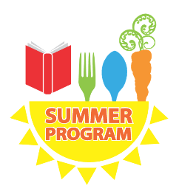

# Join us for FREE [ Breakfast, Lunch,Dinner]

# This Summer!

# [enter dates here ]

Kids ages 18 and under can get free meals at schools, parks, community centers and more across Maine!

[Enter Location]

[enter days of the week]

[ enter time of service ]

This institution is an equal opportunity provider.