Cooking at Home!
These project activities are meant to build upon each other and be completed over the course of a week or so. They incorporate learning opportunities from multiple content areas such as: Science, Math, Language and Literacy, Physical Activity, Social Studies, Health, World Languages, Career Exploration and Visual and Performing Arts. Some activities are also focused on spending time outdoors. Parents and caregivers need to make appropriate decisions for each child, based on their location and availability of materials. The most important thing you can do for your child is to talk with them during each aspect of their day. Explain what you’re doing, let them be involved and assure them that they are loved and safe every day.
Introduction
These activities are meant to provide hands-on learning experiences for young children. Parents and/or caregivers can follow these simple activities using the provided recipes or use their own. Young children learn many important skills by mixing ingredients, following recipes, and talking about what they are doing. This plan can be followed in order to enhance learning through each activity or each activity can be done alone.
As you work through the activities, take time to talk about the meaning of bolded words. A glossary is provided after the activity section.
Materials (read each activity and gather any materials needed)
- Various ingredients to make playdoh
- Writing tool (Pencil, Marker, Pen)
- Mixing bowls
- Measuring cups & spoons
- Various cooking tools (rolling pin, spoons, butter knives, toothpicks)
- Empty cereal boxes, milk jugs, laundry soap jug, etc…
Activities
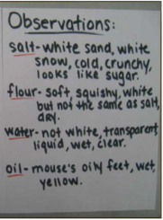
Activity 1: Let’s Talk About Ingredients!
Get a piece of paper and a marker or other writing tool. Gather the four ingredients (salt, flour, water, oil) and place each in separate bowls in front of your child for exploration. Write down each ingredient’s name on the piece of paper and write down what your child says after asking the following prompts:
- What color do you think it is? Why is it that color?
- What does it feel like when you touch it?
- What does it look like to you?
- What does it taste like?
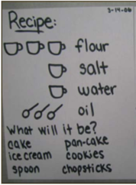
Activity 2: Let’s Make Playdoh!
Gather the four ingredients, a mixing bowl, measuring cups, measuring spoons and a large spoon for mixing. Let your child scoop the ingredients into the measuring cup and show them how to level each scoop. As your child pours each measuring cup into the mixing bowl encourage them to count how many. Tell them you are following a recipe! Ask them… what do you think we are making? Let your child stir the ingredients together (you may need to help). Ask them… how does it feel? What can you create with the playdoh?
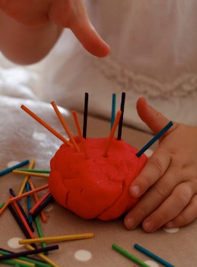
Activity 3: Creating Playdoh Food!
Gather different cooking tools (rolling pins, butter knives, forks, spoons, toothpicks, etc…) and place everything on a table or other flat surface. Show your child how to use each one. For example, begin to roll out the playdoh with the rolling pin. You might need to explain that sometimes you might need to sprinkle extra flour on the table, so your playdoh won’t stick. Let them try!
Tell your child that you are hungry and are going to make something to eat! Begin to create a pizza, cheeseburger, or something else! Maybe you’re going to celebrate a birthday and need to make a cake with candles!
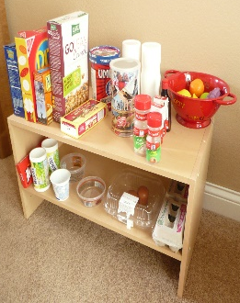
Activity 4: Grocery Shopping!
Look around your home for empty cereal boxes, cracker boxes, juice bottles, laundry soap jugs, play food, etc… to create a pretend play grocery store. You can ask your child to think about what they see at the grocery store. Talk about the signs they have seen and make some of your own. For example, create a “Produce” sign and explain which foods are in this area of the grocery store. Maybe there’s a “Pharmacy” or “Dairy” section. You can also add a cash register and pretend money to practice simple addition and subtraction skills.
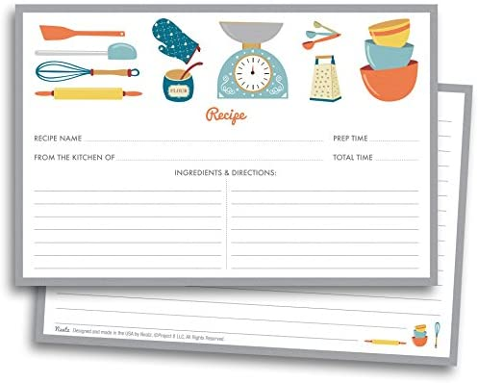
Activity 5: Procedural Writing: Recipes
Gather ingredients for your favorite kid-friendly simple ingredient recipes. Give your child index cards or paper squares and a pencil/crayon/marker etc. Look at the recipe together and talk about the measurements (1 cup. What does that look like?). Ask your child to write the recipe (using basic words or drawing pictures), one ingredient per card, with measurement directions. When your child is finished with their recipe writing, go back to the original recipe, have your child organize their recipe cards in the order that you are reading for the original recipe. Use words like… First, Then, After. You can glue or tape them to a sheet of paper. Now, you can use your child’s recipe to make your treat.
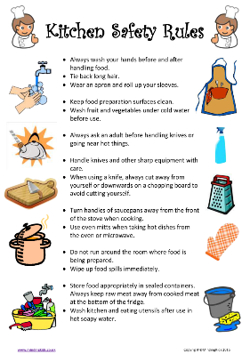
Activity 6: Ingredients for a Safe Kitchen
Help your child to learn kitchen safety. Talk about ways to be safe in the kitchen such as when they can cut foods (with adult supervision), which tools they can use (such as a butter knife), what to do when the stove is on and hot, cleaning foods before cooking and of course the importance of washing hands prior to starting a kitchen project. Have your child write or draw an “Expectation List” of the kitchen rules to hang on the fridge. Review them whenever you begin a cooking or kitchen project.

Glossary
- Ingredients – one of the parts of a mixture
- Measurement - the act or process of measuring
- Measuring Cups – small cups used for measurement
- Measuring Spoons – small spoons used for measurement
- Organize – to set in order, arrange in an orderly way
- Safety – the condition of being safe from danger
- Large – of a size, or amount bigger than normal or average, not small
- Level – having a flat even surface
- Pours – to cause to flow in a steady stream
- Count – to list or name one by one in order to find the total
- Recipe – a list of ingredients and instructions for making a food dish
- Extra – more than is expected or usual
- Sprinkle – to drop or scatter in small bits
- Sticky – tending to stick to or hold on to something when touched
- First – before all others in time, importance, or quality
- Then – soon after, next
- After – later in time
Additional Readings/Links
Book Ideas:

Chef Roy Choi – By: Jacqueline Briggs Martin

Or watch it here https://www.youtube.com/watch?v=LZ5uHHEB-Og

Rainbow Stew – By: Cathryn Falwell
Or watch it here https://www.youtube.com/watch?v=NxMvfgcuWV8

Plant a Little Seed – By: Bonnie Christensen
Or watch it here https://www.youtube.com/watch?v=EHZsD7Ea-iw
Blueberries for Sal – By: Robert McCloskey
Or watch it here https://www.youtube.com/watch?v=Mx1eL1reOEU
The Very Hungry Caterpillar – By: Eric Carle
Or watch it here https://www.youtube.com/watch?v=75NQK-Sm1YY
Eating the Alphabet – By: Lois Ehlert
Or watch it here https://www.youtube.com/watch?v=D7BdF3F8f-o
The Giant Jam Sandwich – By: Janet Burroway and John Vernon Lord
Or watch it here https://www.youtube.com/watch?v=rnr65z4AN_I
Cloudy with a Chance of Meatballs – By: Judi Barrett
Or watch it here https://www.youtube.com/watch?v=q5uXp4694sE
Growing Vegetable Soup – By: Lois Ehlert
Or watch it here https://www.youtube.com/watch?v=vTCSbPgZZgM
Sun Bread - By: Elisa Kleven
Or watch it here https://www.youtube.com/watch?v=n6k_yqPyiME

