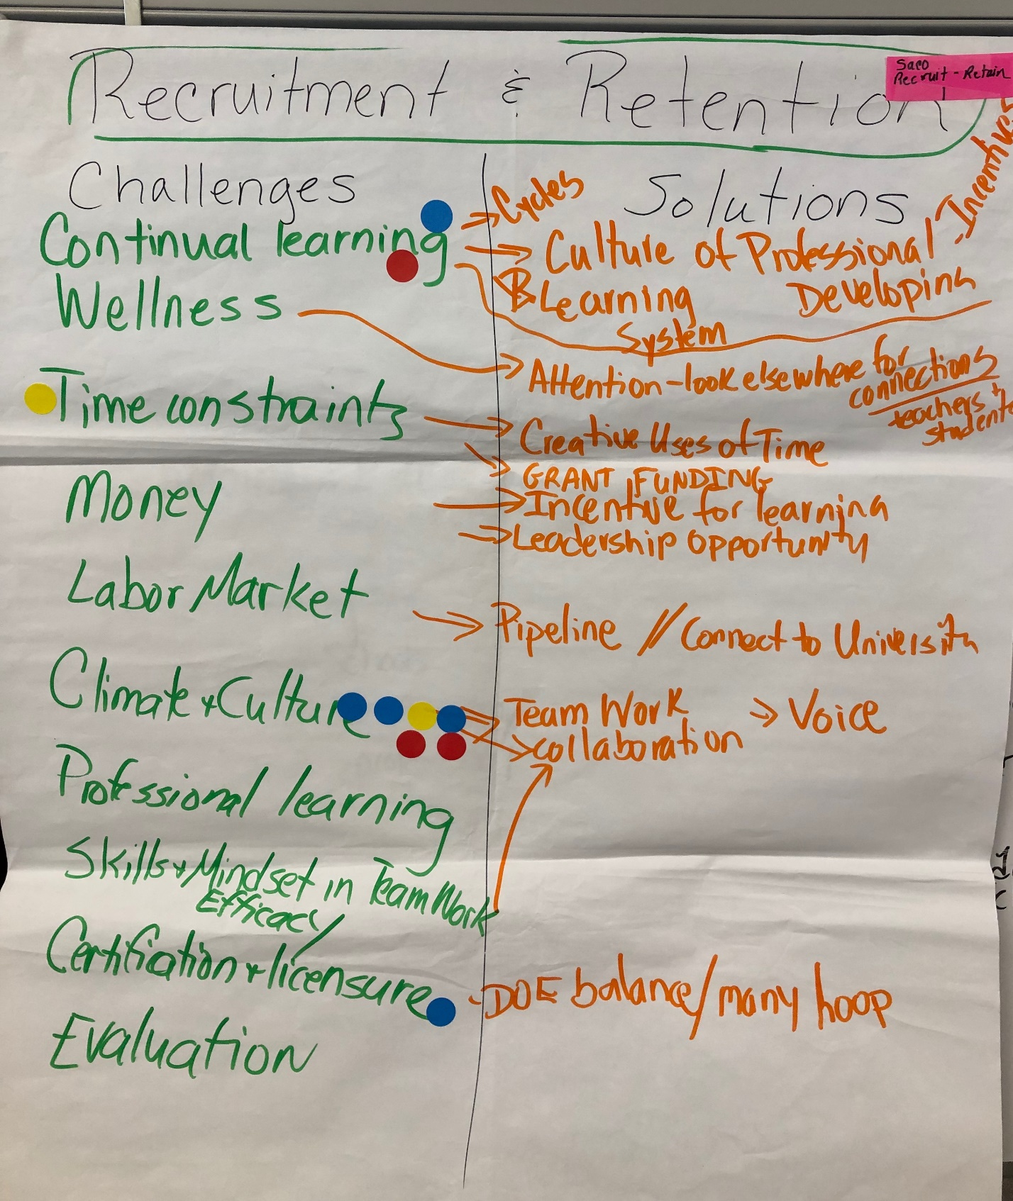

Saco Recruit and Retain 1

Challenges  Continual learning → →→→→→→→→→→→→  Wellness →→→→→→→→→→→→→→→→→  Time Constraints →→→→→→→→→→→→→→  Money  Labor Market →→→→→→→→→→→→→→→→  Climate and Culture****** →→→→→→→→→  Professional Learning  Skills → Mindset in Teamwork – Efficacy  Certification + licensure*→→→→→→→→→→→  Evaluation | Solutions  Cycles  Culture of Professional Development – Incentives  Learning System  Attention – look elsewhere for connections: teachers and students  Creative uses of time  Grant funding  Incentive for learning  Leadership Opportunity  Pipeline//Connect to University  Teamwork → Voice  Collaboration  DOE balance/many hoops

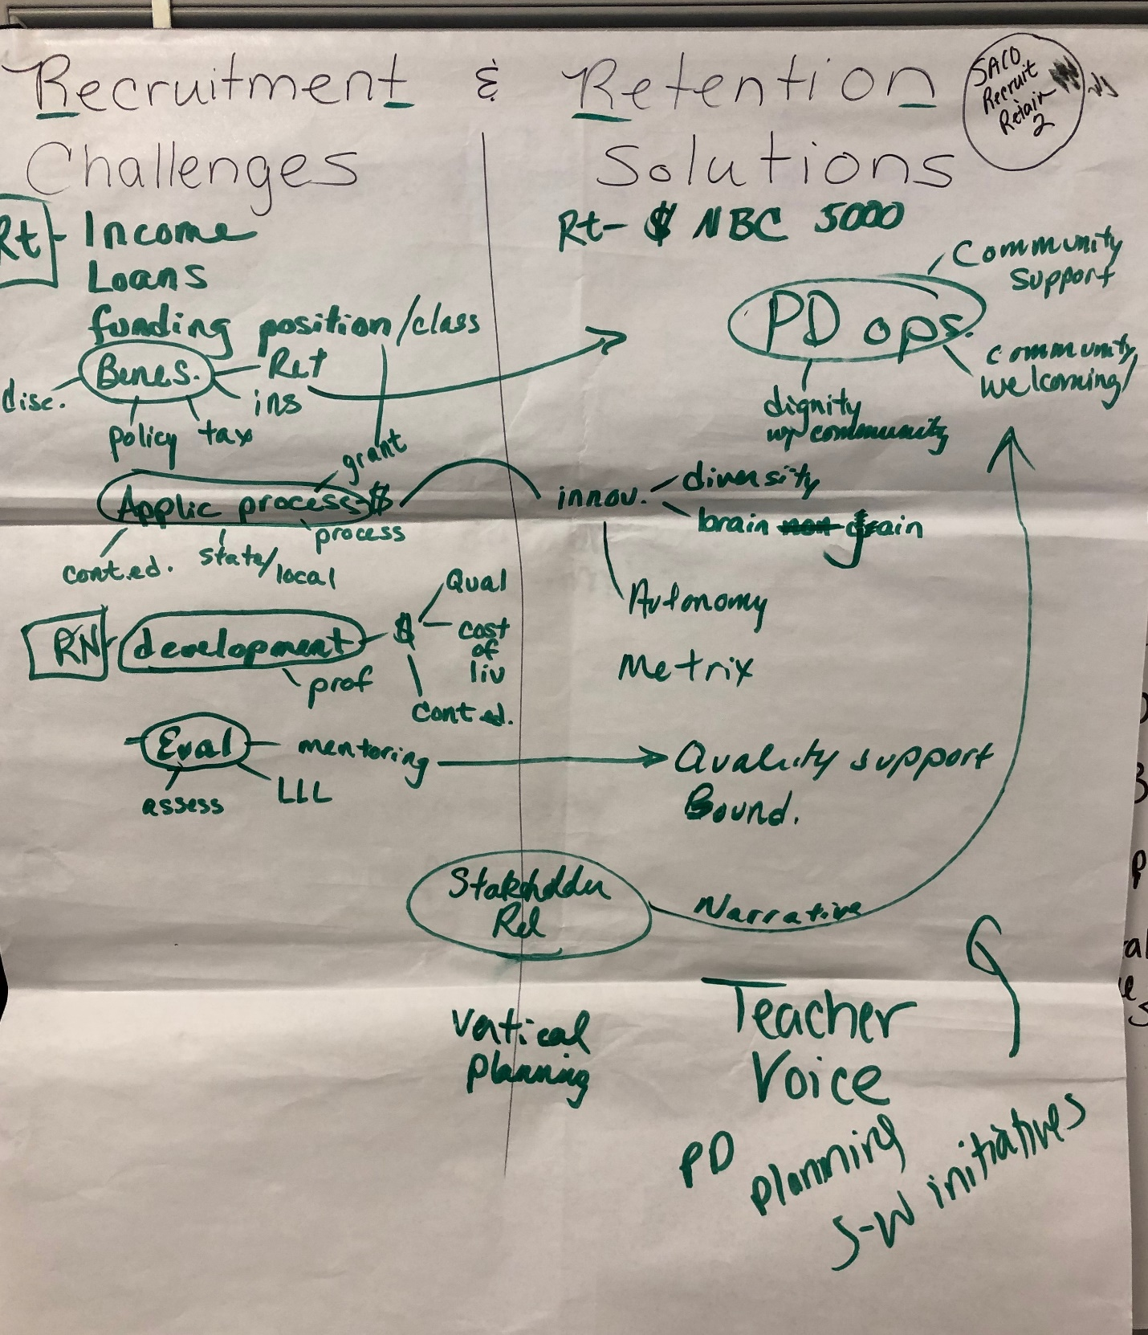

Saco: Recruit and Retain 2

Challenges  RT – Income  Loans  Funding positin/class  Benes:  - Disc  - Policy  - Tax  - Ins  - Ret  Applic Process:  - Grant  - Cont.ed  - State/local  - $  Development→ Prof  $ →Qual  → Cost of Liv  → Cont Ed  Eval :  - Mentoring  - LLL  - Assess | Solutions  RT: $ NBC 5000  PD ops:  - Community support  - Community/welcoming  - Dignity w/community  Innov  Diversity  Brain gain  Autonomy  Metrix  Quality support Bound  Stakeholder Rel  Vertical planning  Teacher Voice  PD – Planning – S-W Initiatives

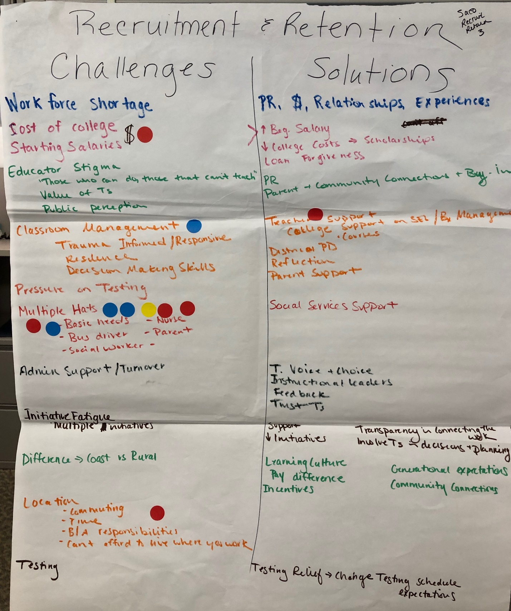
Saco Recruit and Retain 3
Challenges  Workforce shortage  Cost of College  Starting Salaries $ *  Educator Stigma  - “Those who can do, those that can’t, teach”  - Value of Teachers  - Public perception  Classroom Management*  Trauma Informed/Responsive  Resilience  Decision Making Skills  Pressure on Testing  Multiple Hats*******  - Basic needs  - Nurse  - Parent  - Bus driver  - Social Worker  Admin support/Turnover  Initiative Fatigue  Multiple Initiatives  Difference → Coast vs Rural  Location  - Commuting  - Time  - B/A Responsibilities  - Can’t afford to live where you work  Testing | Solutions  PR,, $, Relationships, Experiences  ↑ Beg. Salary  ↓College Costs → Scholarships  Loan Forgiveness  PR  Parent and Community Connections + Buy-In  Teacher Support  College Support on SEL + Courses  B× Management  District PD  Reflection  Parent Support  Social Services Support  T. Voice + Choice  Instructional Leaders  Feedback  Trust T’s  Support Initiatives  Transparency in Connecting the work: Involve Ts in decisions and planning  Learning Culture  Pay Difference  Incentives  Generational Expectations  Community Connections  Testing Relief →Change Testing Schedule and Expectations

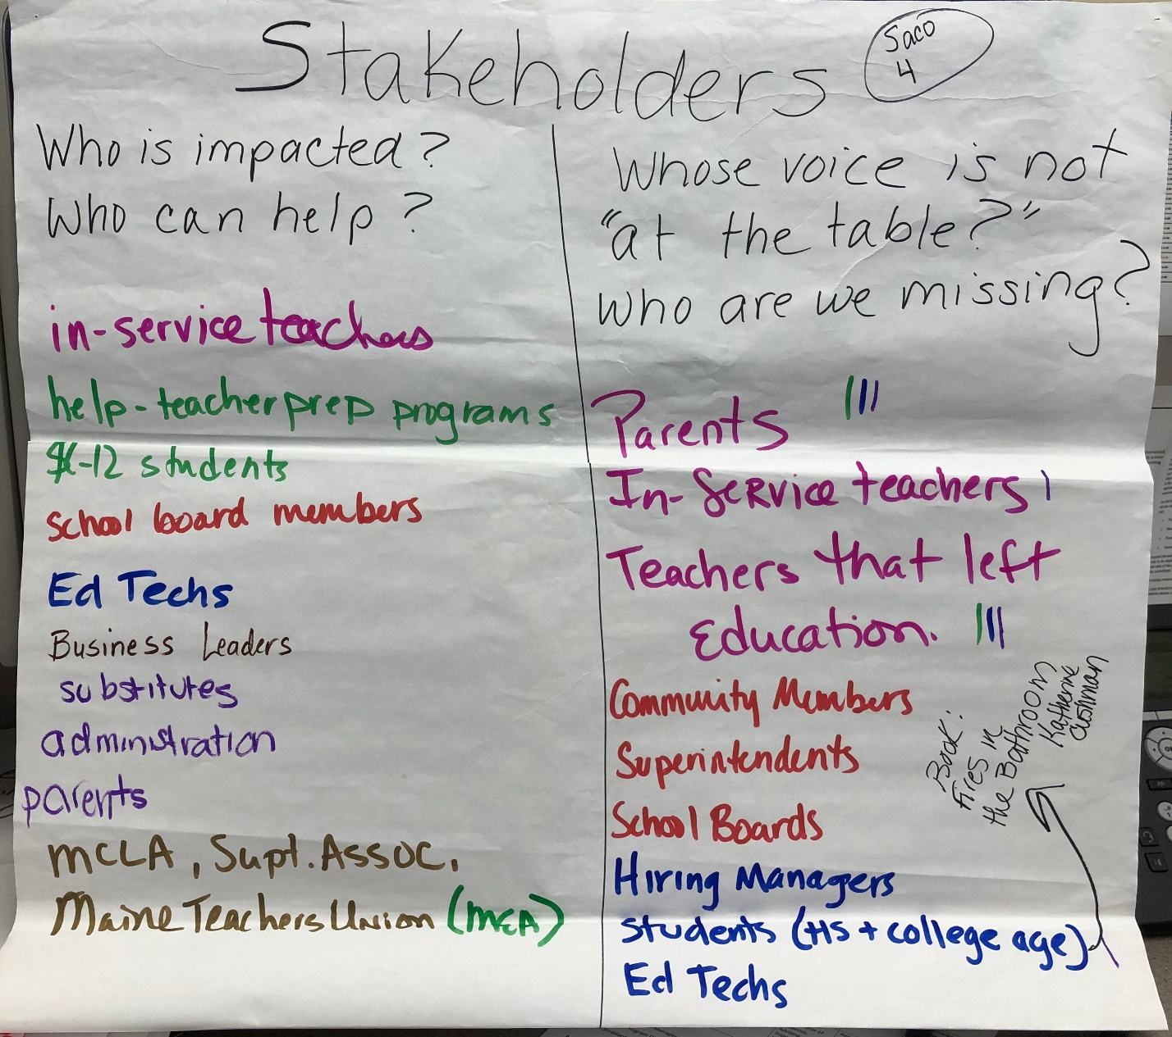
Saco Stakeholders 4
Who is impacted?  Who can help?  In-service teachers  Help- teacher prep programs  K-12 Students  School board members  Ed Techs  Business Leaders  Substitutes  Administration  Parents  MCLA, Supt. Assoc., Maine Teachers Union (MEA) | Whose voice is not “at the table?” Who are we missing?  Parents ***  In-service teachers  Teachers that left education  Community members  Superintendents  School boards  Hiring Managers  Students (HS and College age) → Book: Fires in the Bathroom by Katherine Cushman  Ed techs

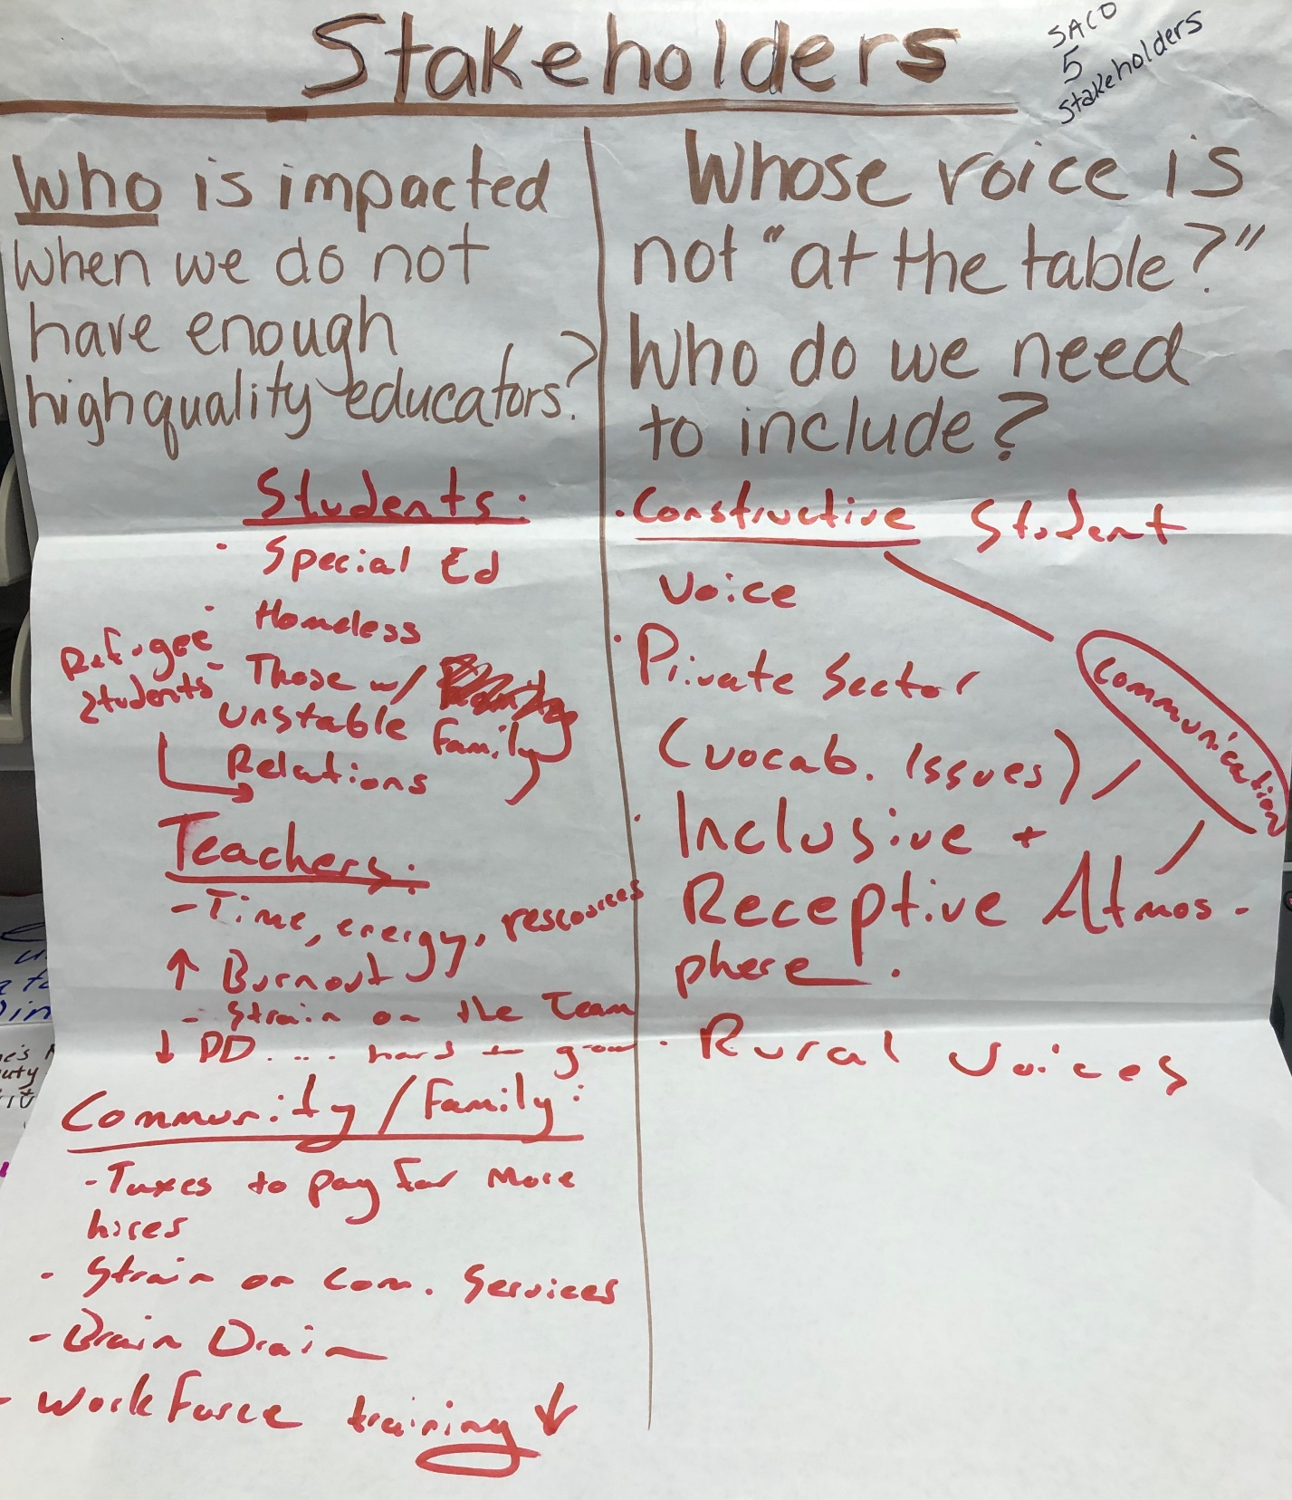
Saco Stakeholders 5

Who is impacted when we do not have enough high-quality educators?  Students:  - Special Ed  - Homeless  - Refugee students  - Homeless  - Those w/unstable family relations  Teachers:  - Time, energy, resources  - ↑ Burnout: strain on the team  - ↓ PD . . . hard to grow  Community/Family:  - Taxes to pay for more hires  - Strain on Comm Services  - Brain Drain  - Workforce Training ↓ | Whose voice is not “at the table?” Who do we need to include?  - Constructive Student Voice – communication (vocab issues)  - Private sector  - Inclusive and Receptive atmosphere  - Rural voices

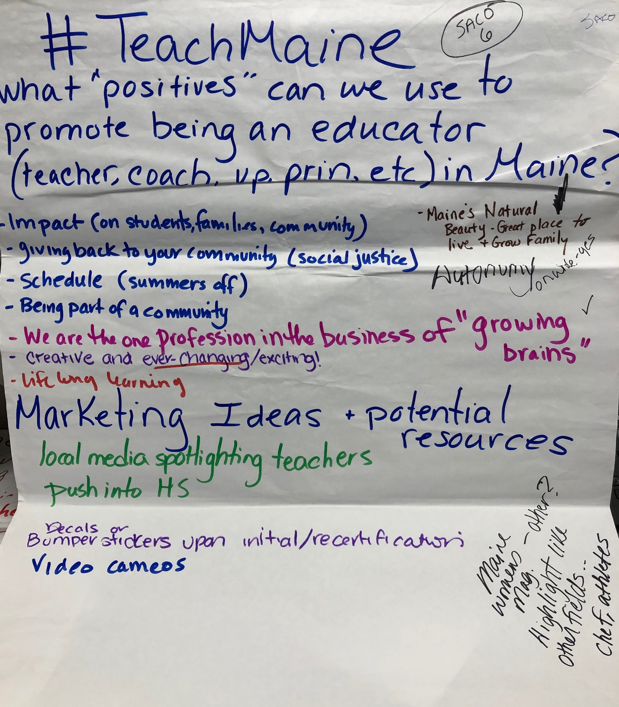
Saco #TeachMaine 6

What “positives” can we use to promote being an educator (teacher, coach, VP, Prin, etc.) in Maine?

- Impact (on students families, community)
- Giving back to your community (social justice)
- Schedule (summers off)
- Being part of a community
- We are the one profession in the business of “growing brains” *
- Creative and ever-changing/exciting!
- Lifelong learning
- Maine’s natural beauty – great place to live and grow family

Marketing Ideas and potential resources:

- Local media spotlighting teachers
- Push into HS
- Decals or bumper stickers upon initial/recertification
- Video cameras
- Maine’s women’s magazine other? Highlight like other fields: chefs, athletes

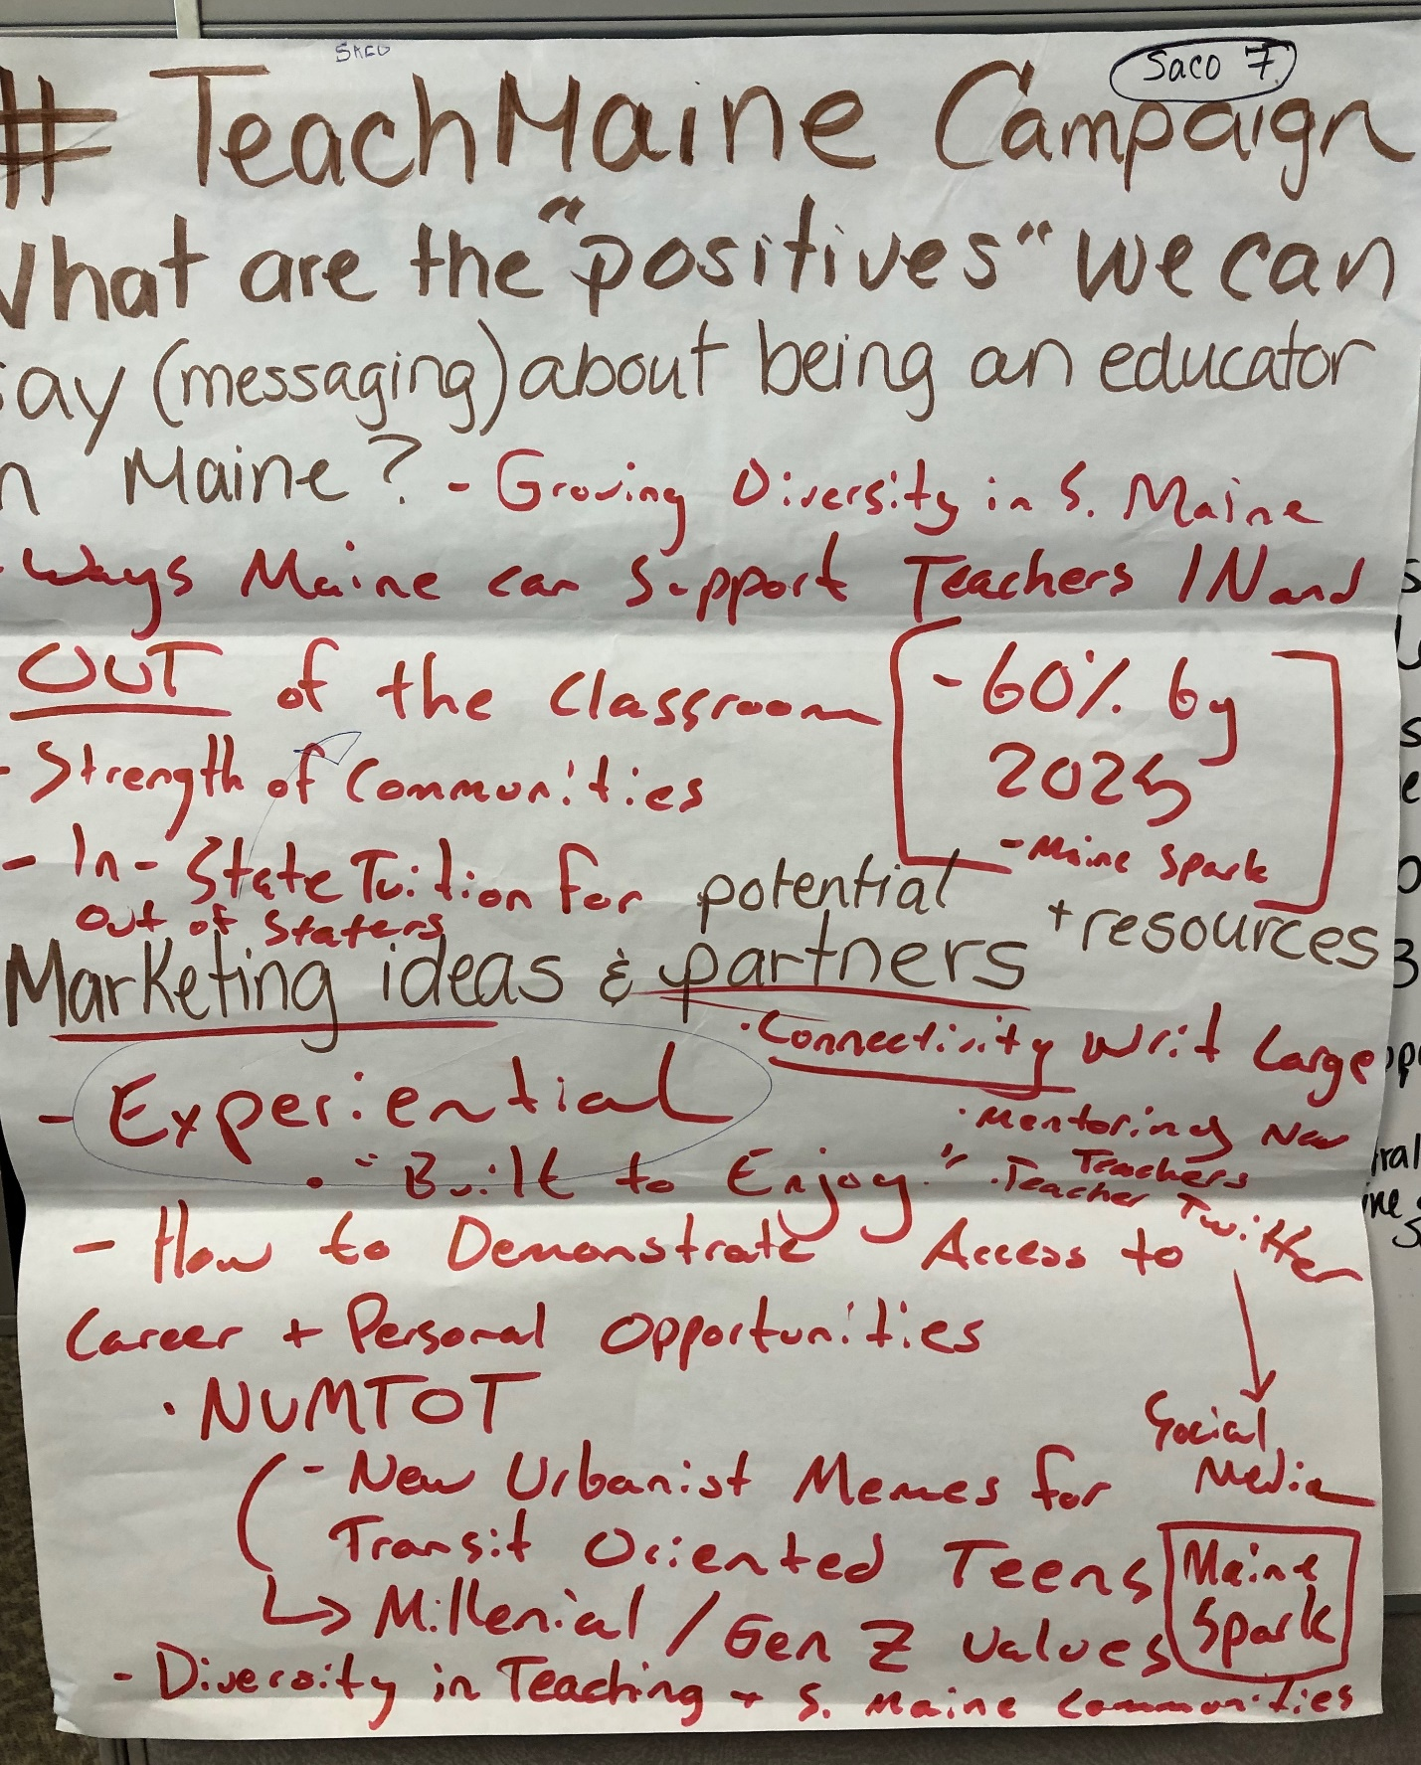
Saco Teach Maine 7

#TeachMaine Campaign

What are he “positives” we can say (messaging) about being an educator in Maine?

- Growing diversity in S. Maine
- Ways Maine can support teachers IN and Out of the classroom
- Strength of communities
- In-state tuition for out of staters
- 60% by 2025: Maine Spark

Marketing ideas and potential partners + resources:

- Connectivity
- Mentoring new teachers
- Teacher twitter/Social media
- Experiential “Built to Enjoy”
- How to demonstrate access to career and personal opportunities
- NUMTOT: New Urbanist Memes for Transit Oriented Teens → Millenial/Gen Z values
- Diversity in Teaching and S. Maine communities

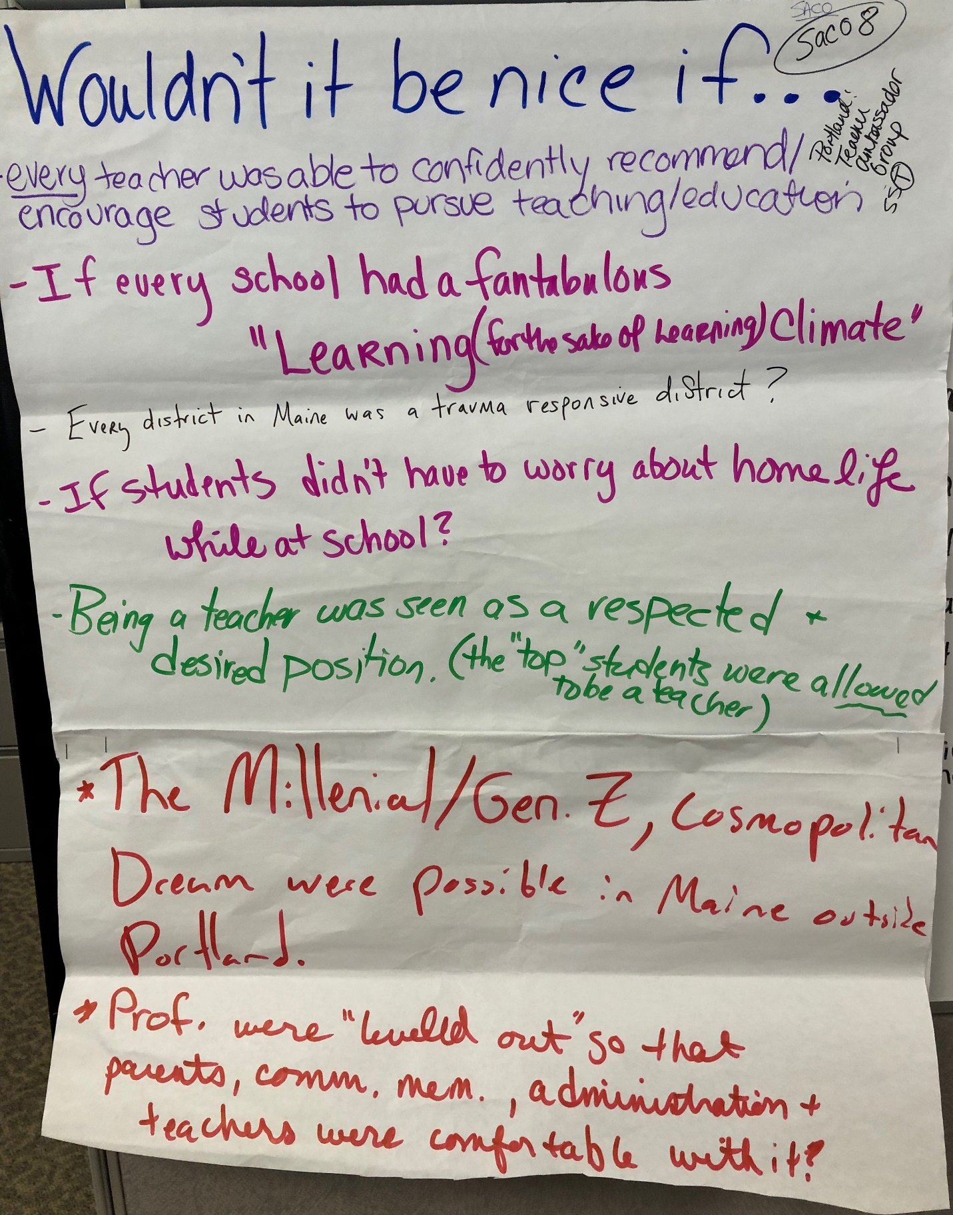
Saco “Nice if” 8

Wouldn’t it be nice if . . .

Every teacher was able to confidently recommend/encourage students to pursue teaching/education? Portland: Teacher Ambassador Group

If every school had a fantabulous “Learning (for the sake of learning) climate”

Every district in Maine was a trauma responsive district?

If students didn’t have to worry about homelife while at school?

Being a teacher was seen as a respected and desired position (the “top” students were allowed to be a teacher)

The Millennial/Gen Z, cosmopolitan dream were possible in Maine outside Portland

Prof were “leveled out” so that parents, comm mem, administration and teachers were comfortable with it?

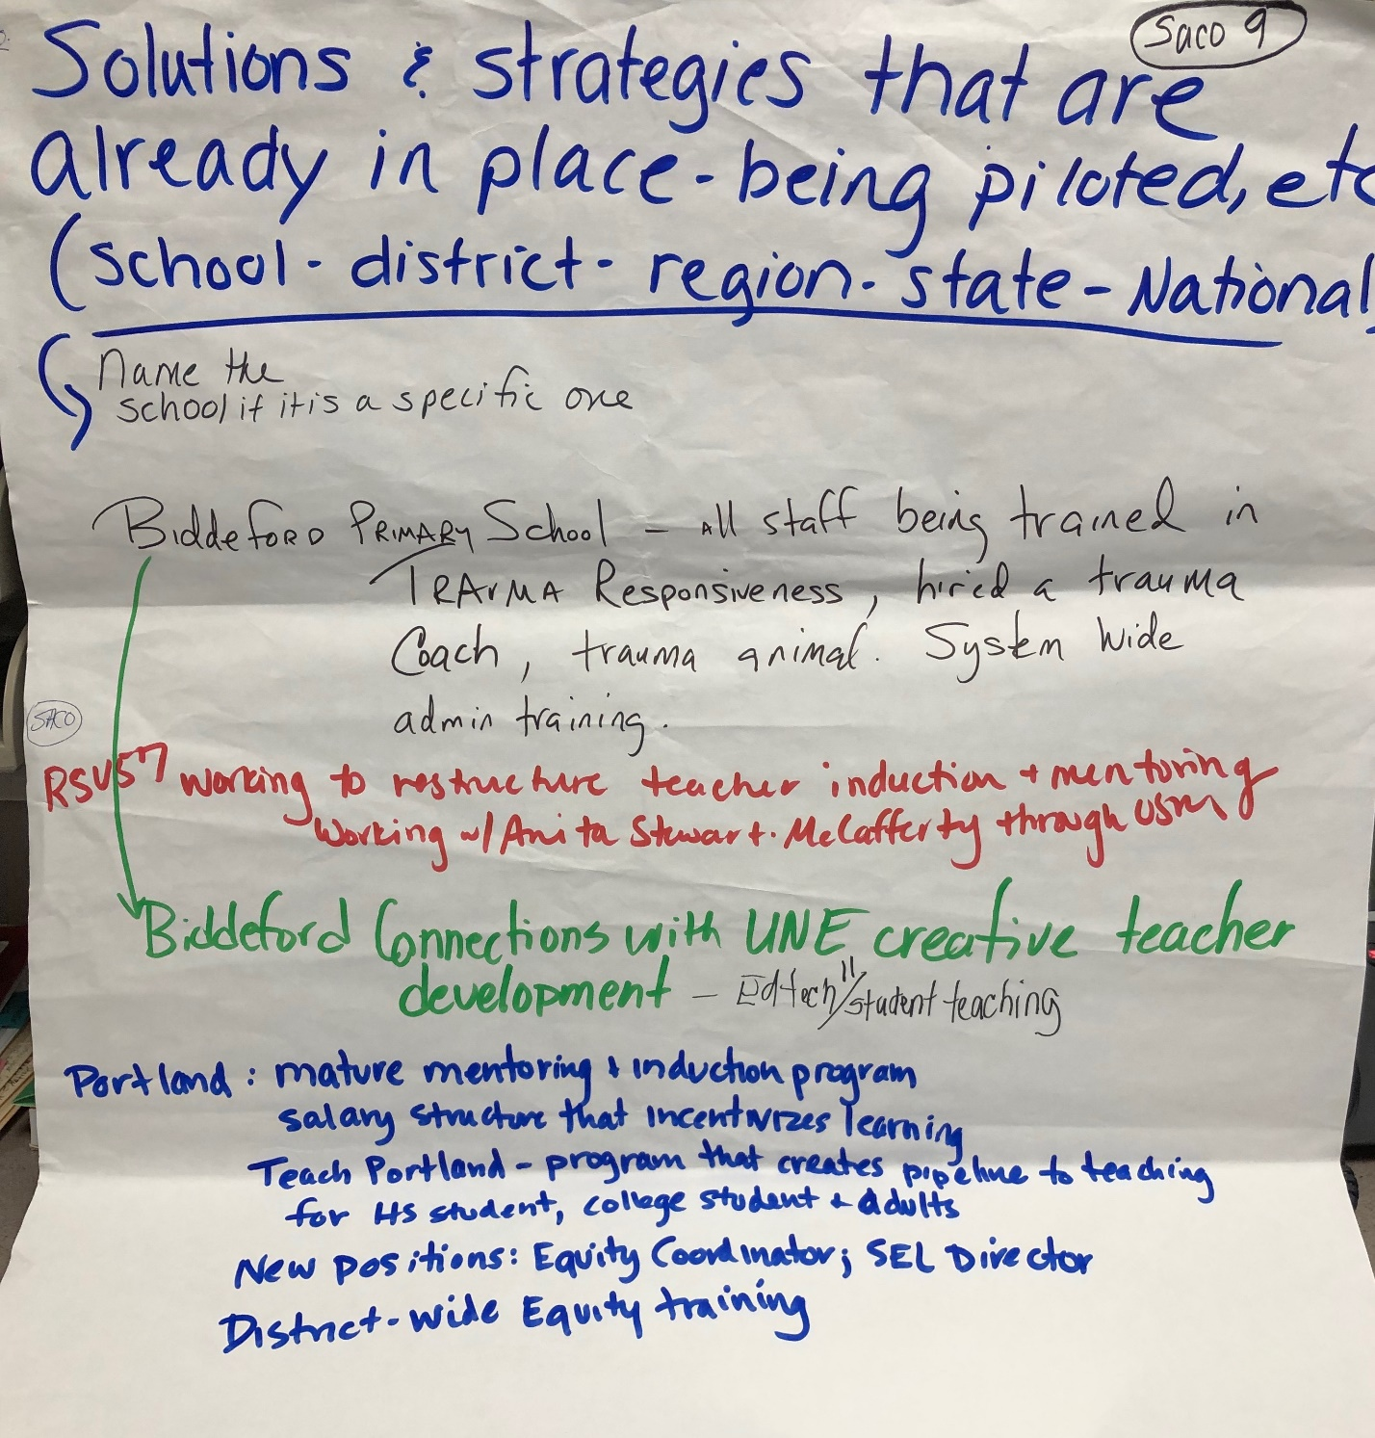

Saco Solutions 9

Solutions and Strategies that are already in place- being piloted, etc.
(school – district – state – national)

Biddeford Primary School – all staff being trained in Trauma Responsiveness, hired a trauma coach, trauma animal. System-wide admin training.

RSU 57: Working to restructure teacher induction and mentoring – working with Anita Steward-McCafferty through USM

Biddeford connections with UNE creating teacher development – Ed tech/student teaching

Portland:
- Mature mentoring + induction program
- Salary structure that incentivizes learning
- Teach Portland – program that creates pipeline to teaching for HS student, college student + adults
- New position: Equity coordinator, SEL Director
- District-wide Equity Training

