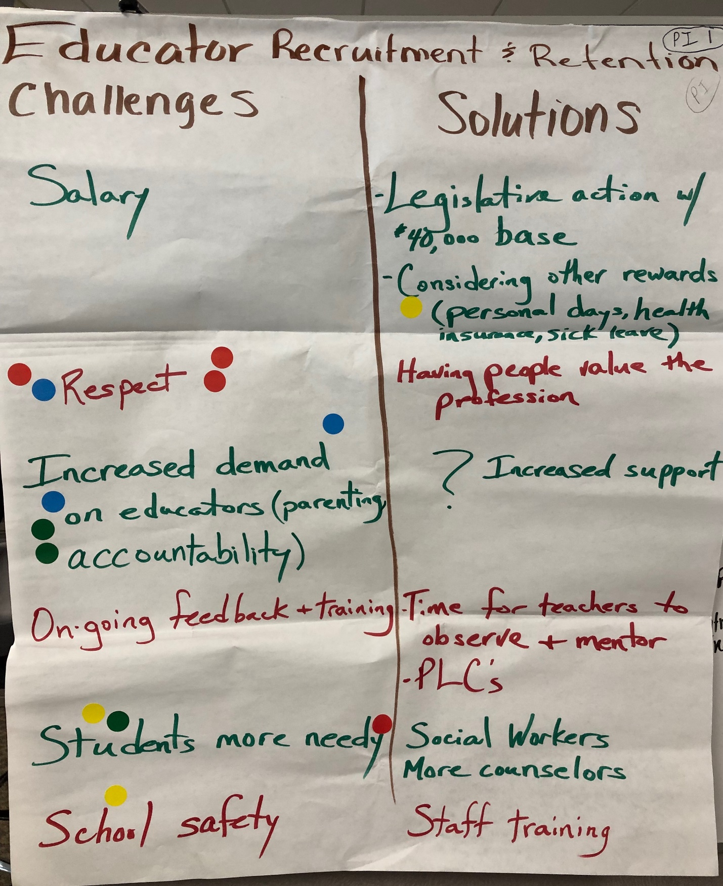
Presque Isle Recruit – Retain – 1 June 20, 2019

Educator Recruitment and Retention  Challenges  - Salary  - Respect ****  - Increased demand on educators (parenting)**  - Accountability*  - Ongoing feedback and training  - Students more needy ***  - School safety * | Solutions  - Legislative action w/$40,000 base  - Considering other rewards (personal days, health insurance, sick leave)  - Having people value the profession  - Increased support  - Time for teachers to teach ad observe and mentor  - PLC’s  - Social workers and more counselors  - Staff training

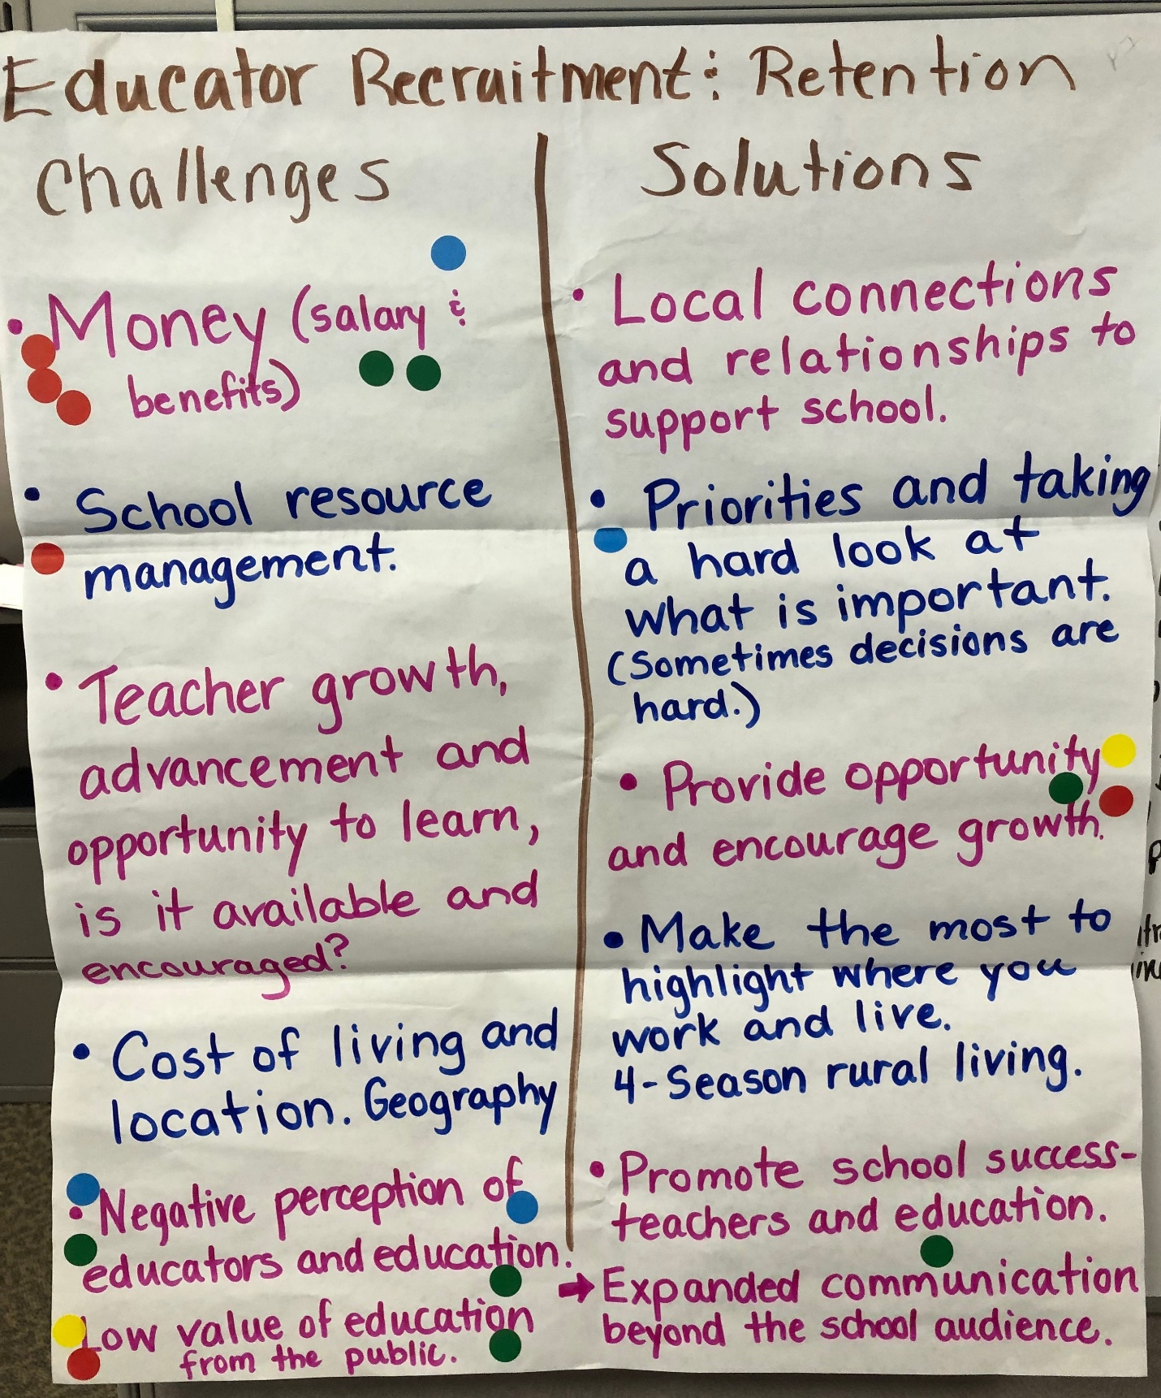
Presque Isle Recruit & Retain 2 June 20, 2019

Educator Recruitment and Retention  Challenges  - Money (salary and benefits) ******  - School resource management  - Teacher growth, advancement and opportunity to learn: is it available and encouraged?  - Cost of living and location. Geography.  - Negative perception of educators and education. ****  - Low value of education from the public. *** | Solutions  - Local connections and relationships to support school.  - Priorities and taking a hard look at what is important. (Sometimes decisions are hard.)  - Provide opportunity and encourage growth. ***  - Make the most to highlight where you work and live. 4-season rural living.  - Promote school success – teachers and education.  - Expanded communication beyond the school audience.

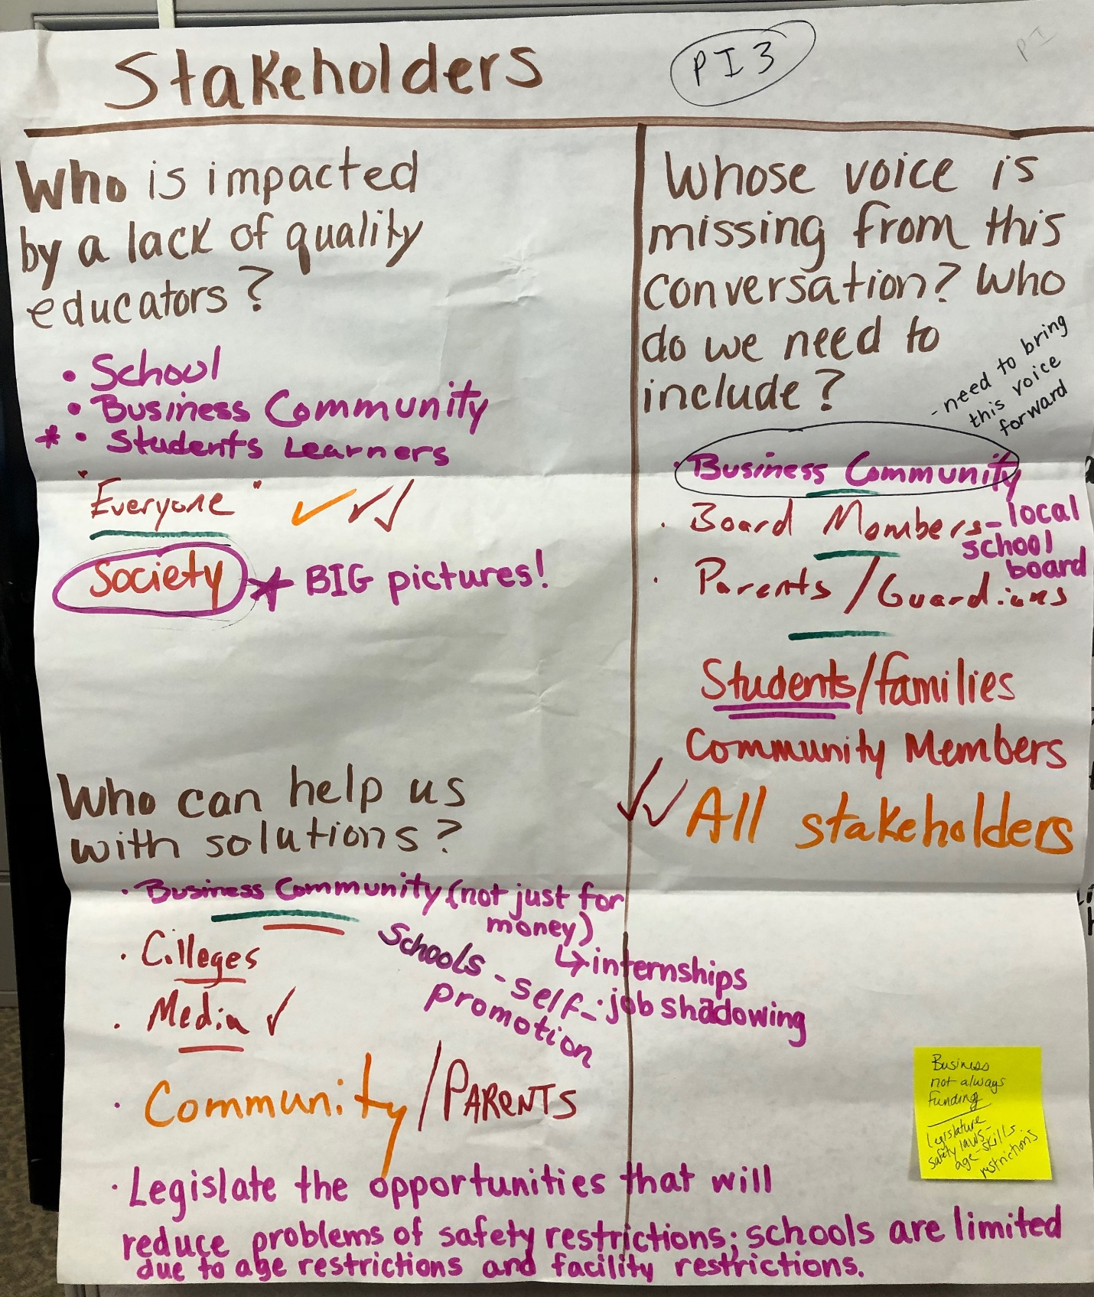
Presque Isle Stakeholders 3 June 20, 2019

Stakeholders:

Who is impacted by a lack of quality educators?

- School
- Business Community
- Students/learners*
- Everyone ***
- Society – BIG pictures!

Who can help us with solutions?

- Business Community (not just for money- internships, job-shadowing (businesses not always being asked to fund)
- Colleges
- Media
- Community/parents
- Schools – self promotion
- Legislate the opportunities that will reduce problems of safety restrictions; schools are limited due to age restrictions and facility restrictions (legislative safety laws – age- skill restrictions)

Whose voice is missing from this conversation? Who do we need to include?

- Business community – need to bring this voice forward
- Board members – local school board
- Parents/guardians
- Students/families
- Community members
- All stakeholders **

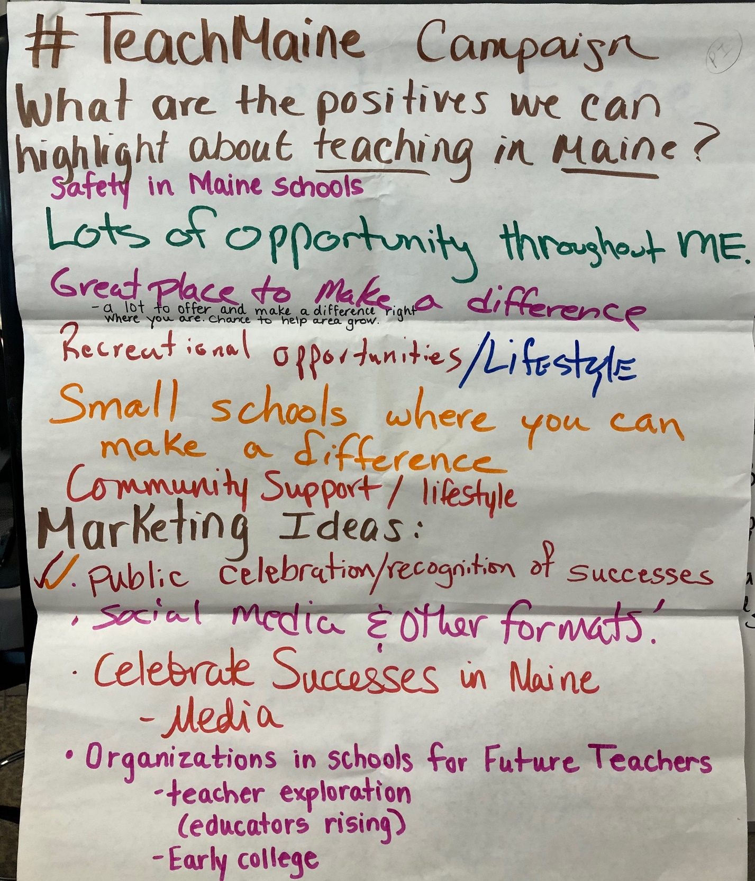

Presque Isle #TeachMaine 4 June 20, 2019

#TeachMaine Campaign

What are the positives we can highlight about teaching in Maine?

- Safety in Maine Schools
- Lots of opportunity throughout Maine
- Great place to make a difference
- A lot to offer and make a difference right where you are. Chance to help area grow.
- Recreational opportunities/lifestyle
- Small schools where you can make a difference
- Community support/lifestyle

Marketing Ideas

- Public celebration and recognition of successes
- Social media and other formats!
- Celebrate successes in Maine
- Media
- Organizations in schools for future teachers
- Teacher exploration – Educators Rising
- Early college

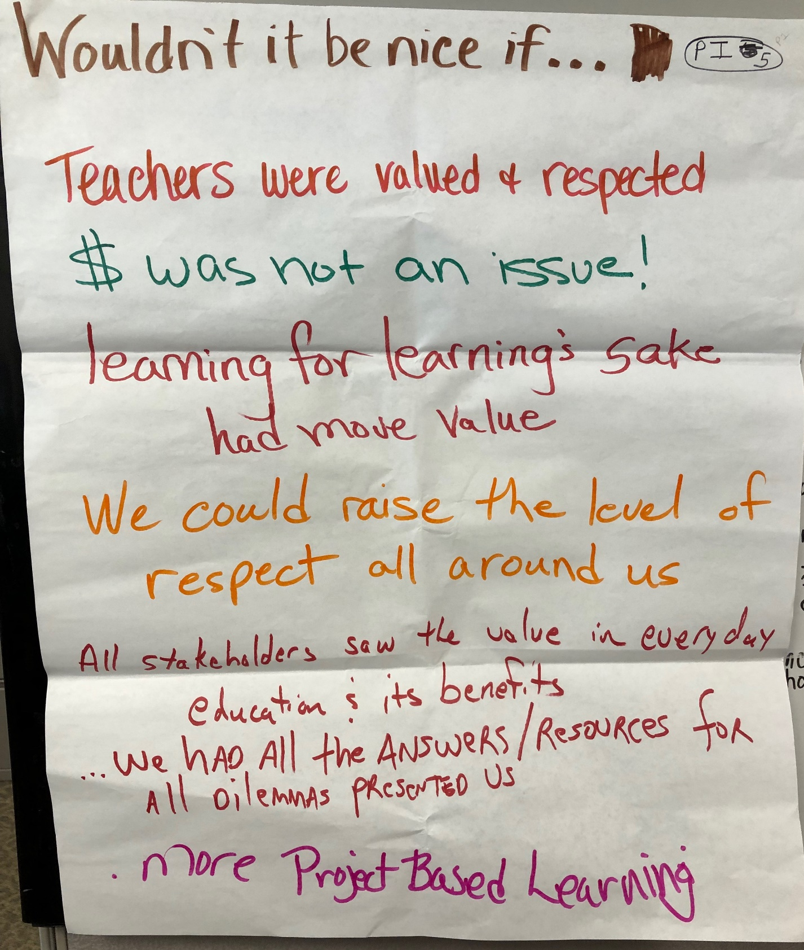

Presque Isle Wouldn’t it be nice if . . . 5 June 20, 2019

Wouldn’t it be nice if . . .

- Teachers were valued and respected
- $ was not an issue
- Learning for learning’s sake had more value
- We could raise the level of respect all around us
- All stakeholders saw the value in everyday education and its benefits
- We had all the ANSWERS/RESOURCES for all dilemmas presented us
- More project-based learning

Presque Isle Wouldn’t it be nice if . . . 5 June 20, 2019

Wouldn’t it be nice if . . .

- Teachers were valued and respected
- $ was not an issue
- Learning for learning’s sake had more value
- We could raise the level of respect all around us
- All stakeholders saw the value in everyday education and its benefits
- We had all the ANSWERS/RESOURCES for all dilemmas presented us
- More project-based learning

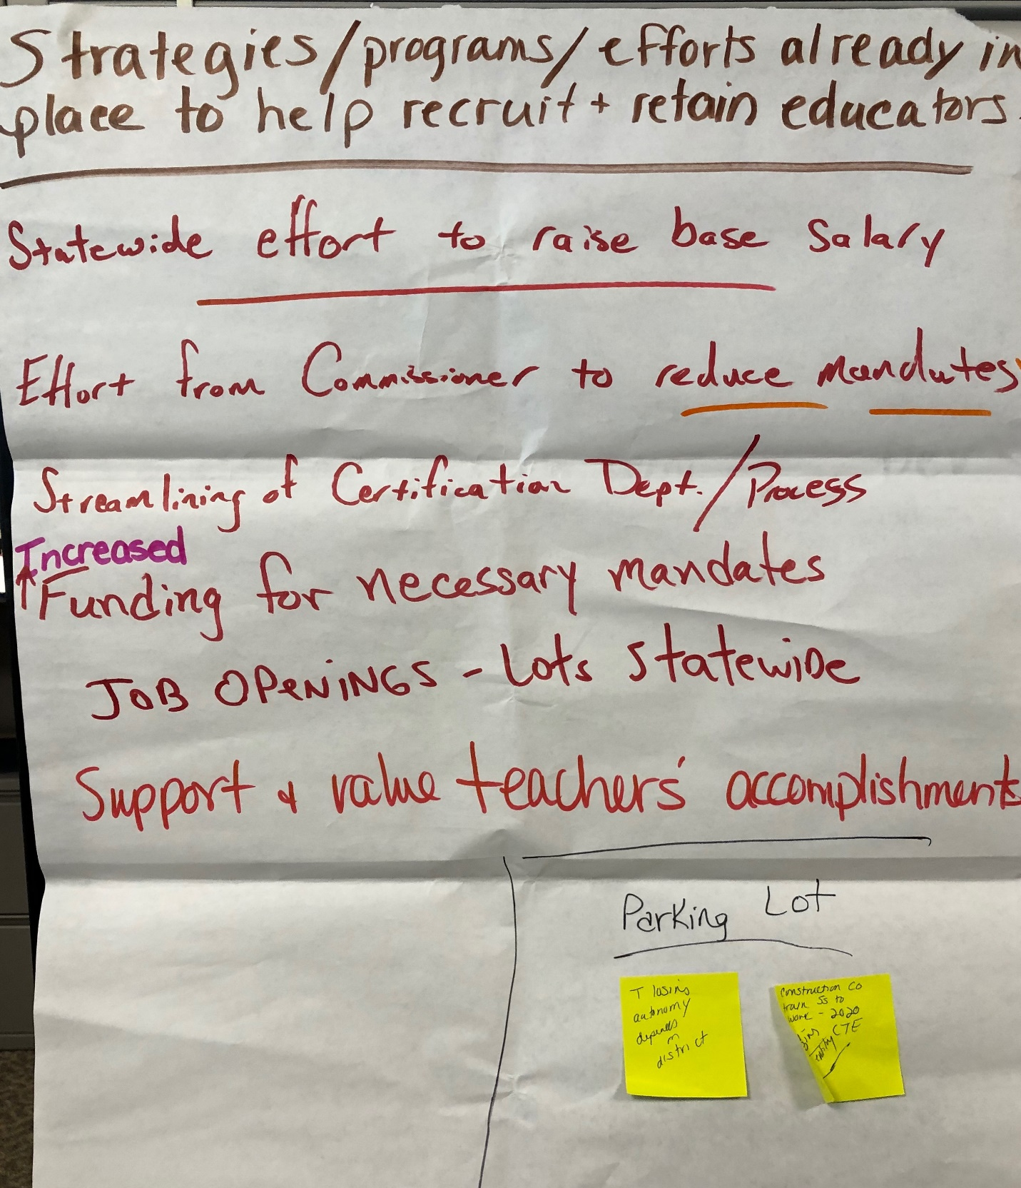
Presque Isle Wouldn’t it be nice if . . . 5 June 20, 2019

Wouldn’t it be nice if . . .

- Teachers were valued and respected
- $ was not an issue
- Learning for learning’s sake had more value
- We could raise the level of respect all around us
- All stakeholders saw the value in everyday education and its benefits
- We had all the ANSWERS/RESOURCES for all dilemmas presented us
- More project-based learning

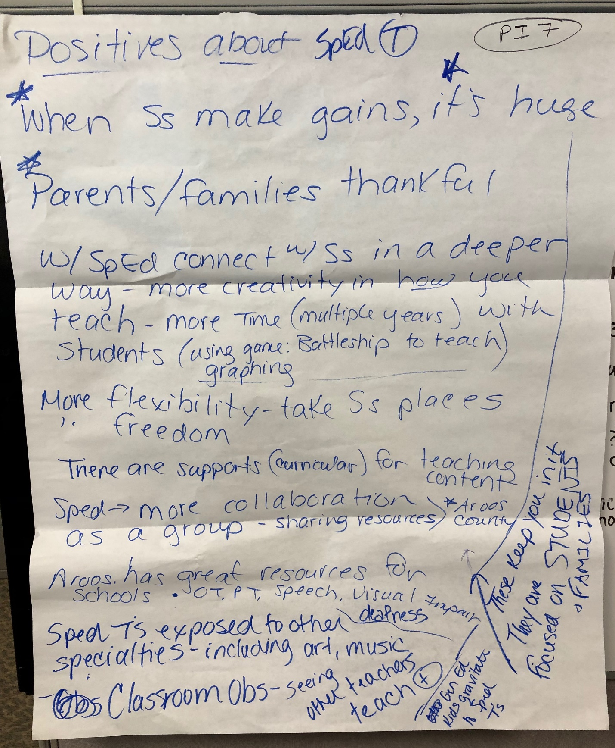

Presque Isle SpEd Positives 7 June 20, 2019

Positives about being a Special Education teacher:

- When students make gains, it’s huge**
- Parents/families thankful
- With special education you connect with students in a deeper way- more creativity in how you teach -more time (multiple years) with students (for example: using game – Battleship to teach graphing
- More flexibility – take students places- freedom
- There are supports (curricular) for teaching content
- Special education – more collaboration as a group sharing resources – Aroostook County (these keep you in it—they are focused on students and families)
- Aroostook has great resources for schools: OT, PT, Speech, visual impairment, deafness
- Special education teachers exposed to other specialties, including art, music, through classroom observations—seeing other teachers teach
- General education kids gravitate to special education teachers

