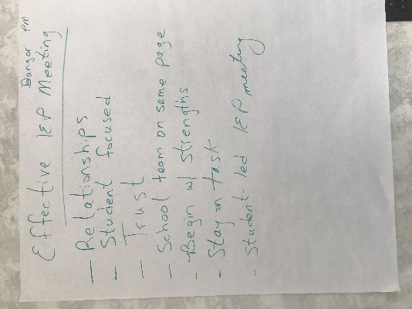
Characteristics of Effective IEP MeetingsBangor PM

- Relationships
- Student focused
- Trust
- School team on same page
- Begin with strengths
- Stay on task
- Student-led IEP meeting

Most Challenging Aspect of IEP Process

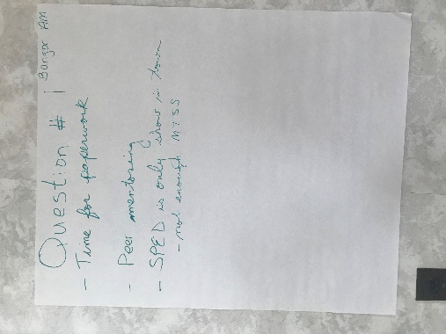
Bangor AM

- Time for paperwork
- Peer mentoring
- SPED IS only show in town, not enough MTSS

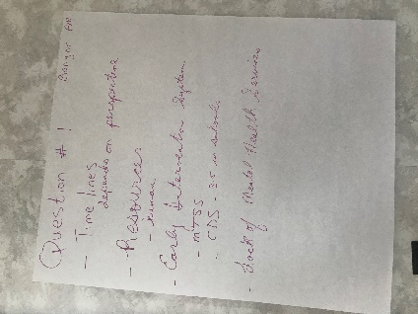
Bangor PM
- Time Lines – depends on perspective
- Resources, humor
- Early intervention system (MTSS, CDS 3-5 in schools)
- Lack of mental health services

Are MUSER user friendly? Why or why not?

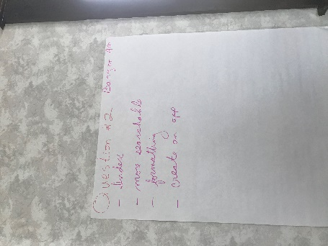
Bangor AM
- Index
- More searchable
- Formatting
- Create an app

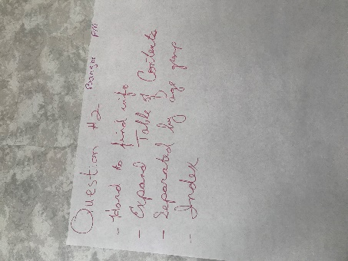
Bangor PM
- Hard to find info
- Expand table of contents
- Separated by age group
- Index

How Can the DOE support SAUs?
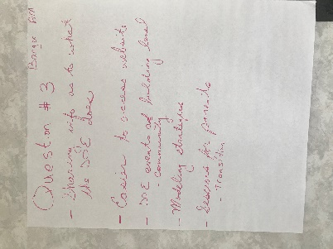
Bangor AM
- Sharing info as to what the DOE does
- Easier to access website
- DOE events and building level – community
- Modeling strategies
- Sessions for parents – transition

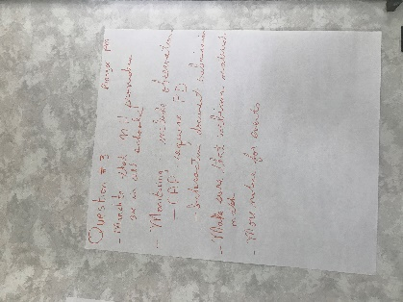
Bangor PM
- Mandate that Mental Health providers are in all schools
- Monitoring – include observations
      - CAP – require PD
      - Interactive document submission
- Make sure that webinar materials match
- More notice for events

Technical Assistance/Training Topics

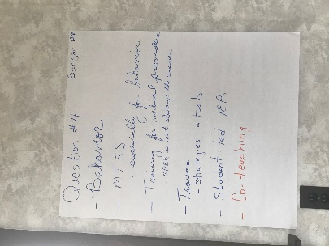
Bangor AM
- Behavior
- MTSS – especially for behavior
- Training for medical providers – SPED is not always the answer
- Student-led IEPs
- Co-teaching

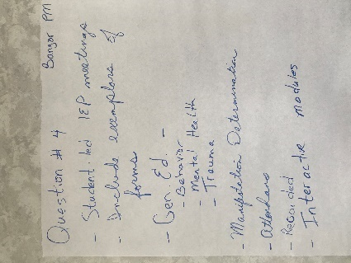
Bangor PM
- Student-led IEP meetings
- Include examples of forms
- Gen ed
      - Behavior
      - Mental health
      - Trauma
- Manifestation determination
- Attendance
- Recorded
      - Interactive modules

Are there practices/policies that create barriers for students with disabilities?
Bangor AM
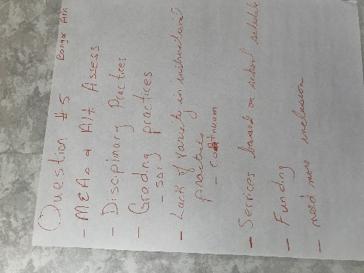
MEAs & Alt Assess.
- Disciplinary practices
- Grading practices – SDI
- Lack of variety in instructional practices – continuum
- Services based on school schedules
- Funding
- Need more inclusion

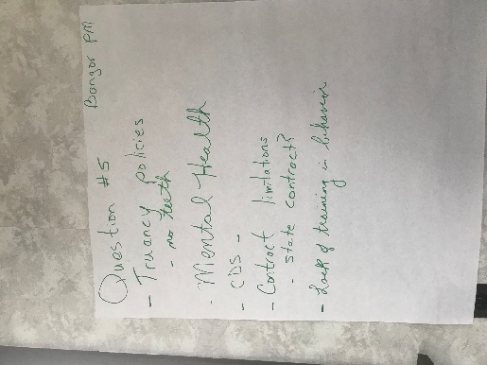
Bangor PM
- Truancy policies – no teeth
- Mental health
- CDS
- Contract limitations – state contract?
- Lack of training in behavior

