Characteristics of Effective IEP Meetings

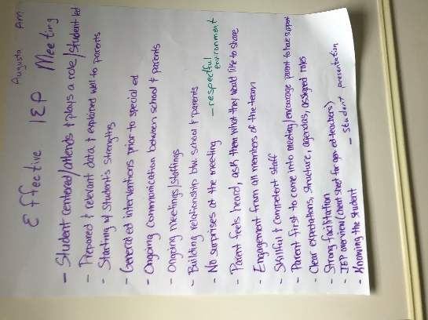
Augusta AM
- Student centered/attends & plays a role/student let
- Prepared & relevant data & explained well to parents
- Starting w/student’s strengths
- General ed interventions prior to special ed
- Ongoing communication between school & parents
- Building relationships between school & parents
- No surprises at the meeting
- Parent feels heard, ask them what they would like to share
- Engagement from all members of the team
- Skillful & competent staff
- Parent first to come into meet/encourage parent to have support
      - Clear expectations, structure, agendas, assigned roles
      - Strong facilitation
      - IEP overview (cheat sheet for gen ed teachers)
      - Knowing the student
      - Student presentation
      - Respectful environment

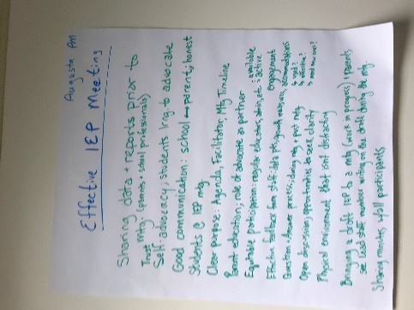
Augusta PM
- Sharing data & reports prior to meeting (parents & school professionals)
- Trust
- Self-advocacy; students learning to advocate
- Good communication: school ↔ parent; honest
- Students @ IEP meeting
- Clear purpose: Agenda, facilitator, meeting timeline
- Parent education, role of advocate as partner
- Equitable participation: regular educators, admin, etc. = available, active
- Effective feedback from staff: data pts, growth measures, engagement, accommodations (used?, effective?, need new ones?)
      - Question & answer process; during meeting & post meeting
      - Open discussion; opportunities to seek clairity
      - Physical environment that isn’t distracting
      - Bringing a draft IEP to a meeting (work in process) & parents see staff member writing on the draft during the meeting
      - Sharing minutes w/all participants

Most Challenging Aspect of IEP Process

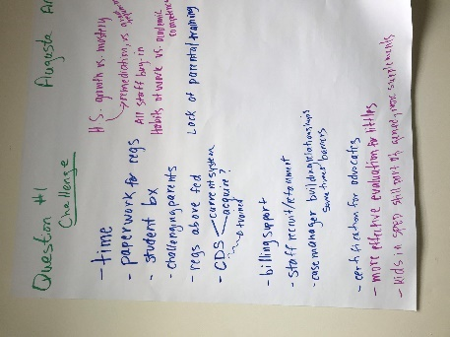
Augusta AM
- Time
- Paperwork for regs
- Student behavior
- Challenging parents
- CDS – current system, acquire?
- Billing support
- Staff recruitment/retainment
- Case manager building relationships sometimes barriers
- Certification for advocates
      - More effective evaluation for littles
      - Kids in sped still part of gen ed; more supplements
      - H.S. growth vs. mastery, remediation vs. grade requirements
      - All staff buy-in
      - Lack of parent training

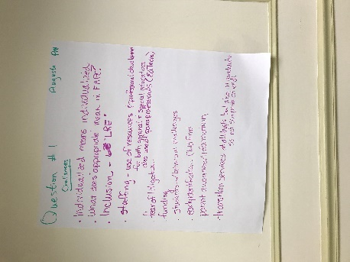
Augusta PM
- Individualized means individualized
- What does “appropriate” mean in FAPE
- Inclusion – LRE
- Staffing -use of resources & professional development for both general and special educators; also use of paraprofessionals (ed techs)
- Fear of litigation
- Funding
- Students w/behavioral challenges
- Early identification – child find
      - Parent awareness/information
      - Transition services at all levels but also at graduation so as not surprises at end

Are MUSER user friendly? Why or why not?
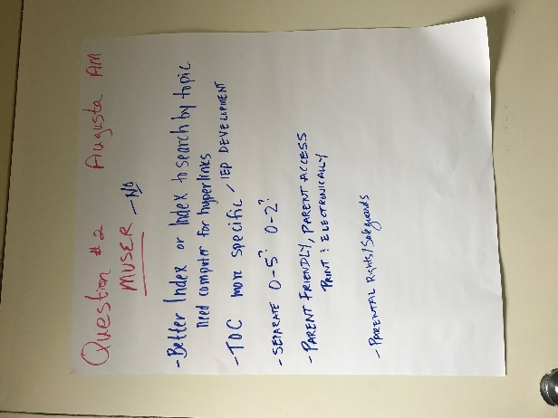
Augusta AM
- Better index or index searchable by topic
- Need computer for hyperlinks
- TOC more specific – IEP development
- Separate 0-5? 0-2?
- Parent friendly, parent access
- Print : electronically
- Parental rights/safeguards

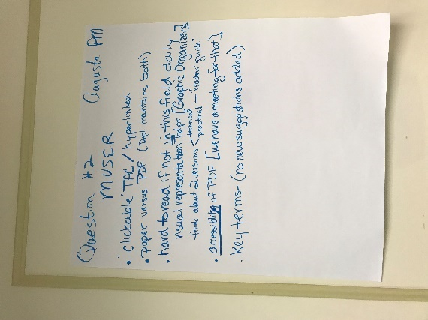
Augusta PM
- Clickable TAC/ hyperlinked
- Paper vs pdf (Dept. maintains both)
- Hard to read if not in this field daily
        - Visual representation [graphic organizers]
        - Think about 2 versions – technical, practical – “readers’ guide”
- Accessibility of PDF (we have a meeting for that)
- Key terms – no new suggestions added

How Can the DOE support SAUs?

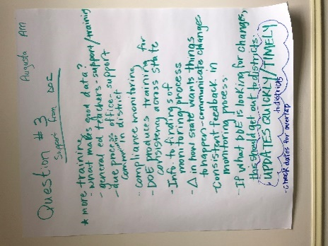
Augusta AM
- More training
        - What makes good data?
        - General ed teachers support/training
        - Due process office – support communication in district
        - Info to findings of monitoring process
        - Δ in how state wants things to happen – communicate changes
        - Consistent feedback in monitoring process
        - If what DOE is looks for changes, this should get out to districts
        - UPDATES QUICKLY/TIMELY
        - Check dates for overlap

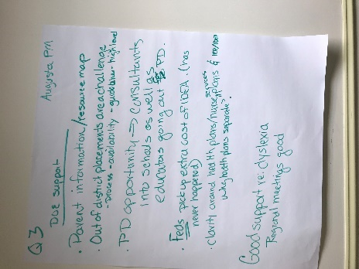
Augusta PM
- Parent information/resource map
- Out of district placements are a challenge – process – availability – guidance – high level
- PD opportunity → consultants into schools as well as educators going out for PD
- Feds pickup extra cost of IDEA (has never happened)
- Clarity around health plans/nurse services plans & IEP/IDEA – why health plans separate
- Good support re: dyslexia
- Regional meetings good

Technical Assistance/Training Topics

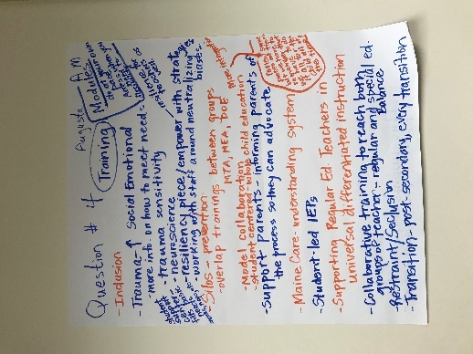
Augusta AM
- Inclusion
- Trauma – social emotional
        - More info on how to meet needs
        - Neuroscience
        - Resiliency piece/empower with strategies; resilience for teachers as well
        - Working with staff around neutralizing biases
        - Student support center – fills basic needs (snacks, naps, etc.)
      - Silos – prevention
        - Overlap trainings between groups (MTA, MEA, DOE)
        - Model collaboration
        - Student centered – whole child educator
        - More integration – review some pieces at times, but we have to remember that we have to do it all for the child all of the time
      - Support parents – informing parents of the process so they can advocate
      - MaineCare – understanding system
      - Supporting regular ed teachers in universal design/differentiated instruction
      - Collaborative training to reach both groups of teachers – regular and special ed
      - Restraint/seclusion
      - Transition – post-secondary, every transition
      - Modules – do at your own pace
        - Access when you need to
        - Flexibility

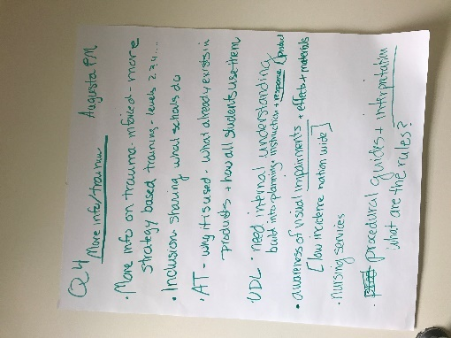
Augusta PM
- More info on trauma-informed – more strategy-based training – levels 2, 3, 4…
- Inclusion – sharing what schools do
- AT (assistive technology) – why is it used – what already exists in products & how all students use them
- UDL need internal understanding – build into planning instruction + response/product
- Awareness of visual impairments + effects + materials [low incidence nation-wide]
- Nursing services
- Procedural guides + interpretation – what are the rules?

Are there practices/policies that create barriers for students with disabilities?
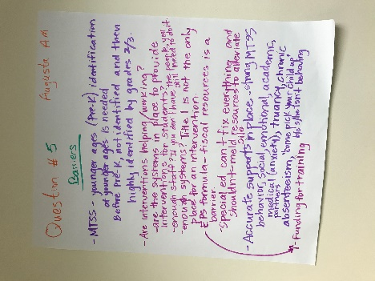
Augusta AM
- MTSS – younger ages (Pre-k) identification of younger ages is needed
        - Before pre-k, not identified and then highly identified by grades 2/3
      - Are interventions helping/working?
        - Are the systems in place to provide interventions for students?
        - Enough staff? – if you don’t have the people you still need to do it
        - Enough systems – Title one is not the only place for an intervention
        - EPS formula- fiscal resources is a barrier – funding for training
        - Special ed can’t fix everything and shouldn’t - meld resources to alleviate silos
      - Accurate supports in place – strong MTSS
        - Behavior, social/emotional, academic, medical (anxiety), truancy, chronic absenteeism, “come pick your child up” b/c she isn’t behaving

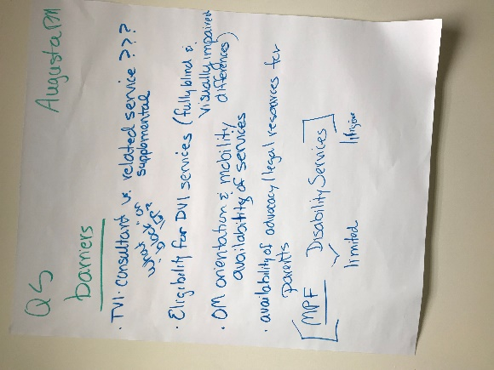
Augusta PM
- TVI consultant vs. related service
- Eligibility for DVI services (fully blind & visual impairment differences)
- OM – orientation & mobility – availability of services
- Availability of advocacy – legal resources for parents
- MPF – disability services – limited

Special Ed Dessert – High Qualify Special Education Program
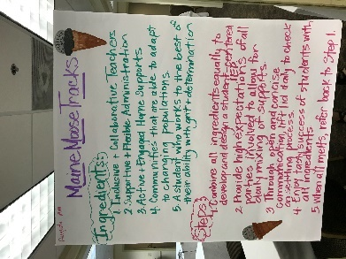
Augusta AM
Maine Moose Tracks
Ingredients:
1. Inclusive and collaborative teachers
2. Supportive and flexible administration
3. Active & engaged home supports
4. Communities that are able to adapt to changing populations
5. A student who works to the best of their ability with grit & determination

Steps:
1. Combine all ingredients equally to develop and design a student-centered IEP.
2. Provide high expectations of all parties involved to allow for daily mixing of supports.
3. Through open and concise communication, lift lid daily to check on settling process.
4. Enjoy tasty success of students with all ingredients.
5. When all melts, refer back to Step 1.

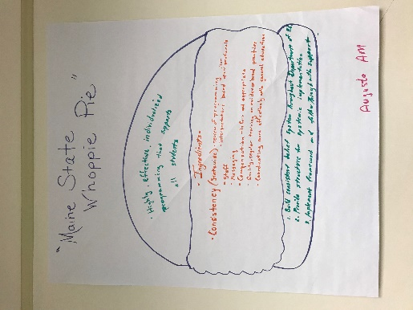
Augusta AM
“Maine State Whoopie Pie”
Top cake: Highly effective, individualized programming that supports all students.

Filling: Consistency (statewide) review of programming
Interpretations based upon clear protocols
Staff
Messaging
Compensation is fair and appropriate
Quality regular training on evidence-based practices
Coordinating more effectively with general education

Bottom cake:
1. Build consistent belief system throughout the Department of Ed.
2. Provide structure for systemic implementation
3. Implement framework and follow through with support.

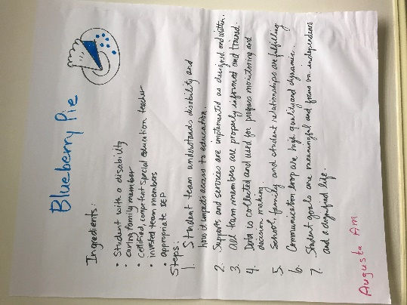
Augusta AM
Blueberry Pie
Ingredients:
- Student with a disability
- Caring family member
- Certified, competent special education teacher
- Invested team members
- Appropriate IEP

Steps:
1. Student team understands disability and how it impacts access to education.
2. Supports and services are implemented as designed and written.
3. All team members are properly informed and trained.
4. Data is collected and used for progress monitoring and decision making.
5. School, family, and student relationships are fulfilling.
6. Communication loop are high quality and dynamic.
7. Student goals are meaningful and focus on independence and a dignified life.

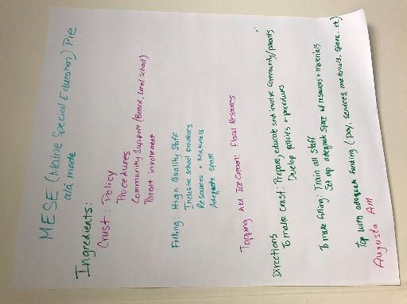
Augusta AM
MESE (Maine Special Education) Pie ala Mode
Ingredients:
Crust: Policy
Procedures
Community Support (Board, local school)
Parent involvement

Filling: High quality staff
Inclusive school practices
Resources & materials
Adequate space

Topping: AKA Ice Cream: Fiscal Resources

Directions:
To make crust: Prepare, educate and involve community/parents; develop policies & procedures

To make filling: Train all staff; Set up adequate space w/resource & materials

Top with adequate funding (pay, services, materials, space… etc.)

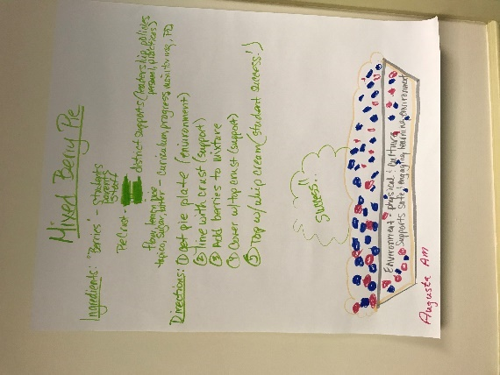
Augusta AM
Mixed Berry Pie

Ingredients:
“Berries”: Students, parents, staff
Pie crust: district supports (leadership, policies, personnel, practices)
Flour, Lemon juice, tapioca, sugar, butter: curriculum, progress monitoring, PD

Directions:
1. Get pie plate (environment)
2. Line with crust (support)
3. Add berries to mixture
4. Cover w/top crust (support)
5. Top w/whip cream (student success!)

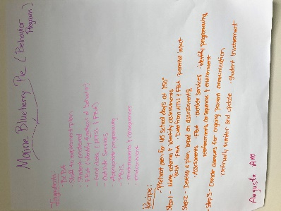
Augusta AM
Maine Blueberry Pie (Behavior Program)
Ingredients:
- BCBA - Outside services
- Staff to implement plan - Appropriate programming
- Student-centered - PBIS
- FBA (identify functions of behavior) - Reinforcements & consequences
- Good data (MTSS & FBA) - Environment

Recipe:
- Preheat oven for 45 school days at 150 degrees
Step 1 – Make referral & identify assessments – BCBA, FBA, Data from MTSS & FBA, parental input
Step 2 - Develop a plan based on assessments (assessments, FBA, outside services identify programming, reinforcements, consequences & environment
Step 3 – Create avenues for ongoing parent communication; continually monitor and update; student involvement

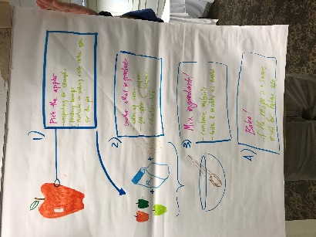
Augusta PM
1) Pick the apples
- inspect for strengths
- finding bumps
- evaluate → setting aside certain apples for the pie
2) Gather other ingredients
- warm up oven
- get spices (programs, caregivers)
- education staff

3) Mix ingredients!
- combine materials
- taste and modify as needed.
4) Bake!
- if the recipe is a success, record for future use

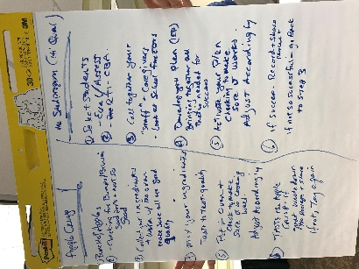
Augusta PM
Apple Crisp | Me Sped Program (Hi Qual)
1. Bunch of apples | 1. Select students – eval/assess
2. Check for bumps/bruises – good parts and not so good | 2. RTI – CBA
3. Collect your ingredients & warm the oven; make sure all are good quality | 3. Call together your “staff” & caregivers  - look at school factors
4. Mix your ingredients – taste to test quality | 4. Develop your plan (IEP) bringing together all that is needed for success
5. Put in oven & check to make sure it is cooking well. | 5. Activate your plan, checking to make sure t works; adjust accordingly
6. Taste the apple crisp – if great, write down the recipe & share; if not, try again | 6. If success – record & share result; if not so successful – go back to step 3

