April Enrollment Certification

Report Details

Reporting Timeframe: Open Date: 4/1 Due Date: 4/15

Who should report: RSUs, CSDs, MSADs, municipal school units, and Maine Indian Education units that operate schools. While charter schools, Education in Unorganized Territories, and private schools with publicly funded students will not have an attending count for tuition rates, these units do need to certify their attending enrollment count.

The April Enrollment Certification report will be available for SAUs to submit and certify beginning on April 1st. There is much interest from many entities to compare April enrollments to October enrollments and to use this data for policy and decision making. It is important for SAUs to complete this review and certification in the reported timeframe so that the data may be used as soon as possible for policy and decision making

April Enrollment Certification

Description/Purpose:

The April Enrollment Certification will be used for the dual purposes of measuring April student enrollment counts and calculating tuition rates. The April 1 count is necessary in order to calculate the tuition rate according to Title 20-A, §5805, subsection 1.B, which states: B. “The number of students shall be the average number of public secondary pupils enrolled on October 1st and April 1st of the same year.” This count will not be used for the Essential Services and Programs (EPS) School funding formula but is necessary for calculating the tuition rates. Students that are enrolled outside placements at regional programs or special purpose private schools will provide a general attending enrollment count but will not for the primary enrollment district in the calculation of attending counts for tuition rate purposes. In preparation for this report, it is vital that each school administrative unit (SAU) keeps their state level enrollment data current and complete.

Completion Instructions:
Please note this report changed drastically last year (20-21) in layout and data provided, and the report will only show data from 20-21 onwards. Previous years data can be found in the ‘Historical April Enrollment Count’.

To access this report, you will log into NEO:
https://neo.maine.gov/DOE/NEO/Accounts/Account/Login

Then go to Student Data, then Student Reports, you will see these:

Click on ‘view report’ for ‘The April Enrollment Certification’ report. Then select your district under the SAU Name dropdown which will bring to this page:

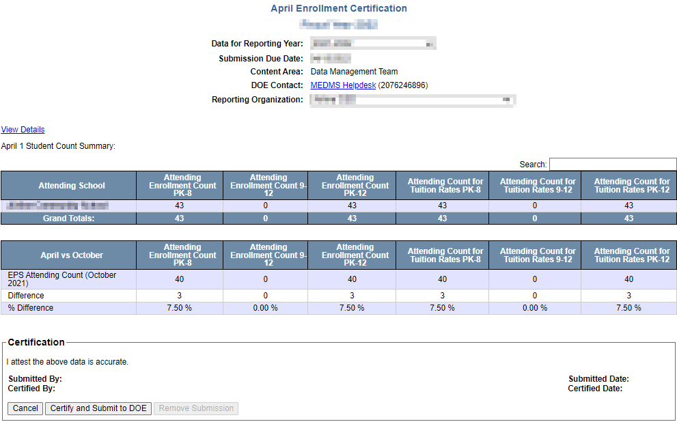
This page will show you all of your schools in the district as well as their April 1 attending counts, broken down by count type and grade range. You will also see a comparison between October counts and April counts. If you see a difference it means students have entered or left between October 1 and April 1.

Clicking ‘View Details’ in the upper left of the report will take you to the April Enrollment Details.

April Enrollment Details

The details page can be access via Student Data, Student Reports, then ‘view report’ OR from the ‘View Details’ link within the certification page (previously mentioned):

Once you click on either option you will open into the April Enrollment Details proper, from here you will see a breakdown of all enrolled students. The report header looks like this:
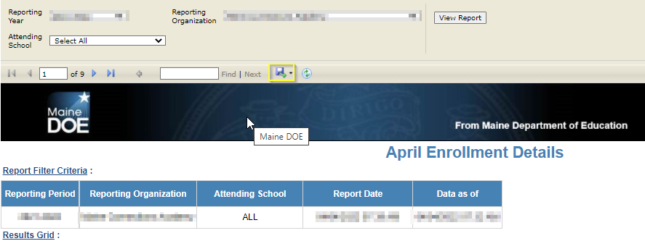

*The report can be pulled into excel for ease of sorting via the disk icon (Highlighted above).
Please keep in mind if you pull the report into excel THEN make changes to student data in Synergy you will need to redownload the report or you will not see the changes you’ve been making.

Attending Indicator:
The details now include a column that can be filtered to show you who counts towards the attending count for tuition rates (as seen below). What this means is that if a place holder enrollment for students in your district is within Synergy and they are attending a school such as a Regional Program, Special Purpose Private, etc. they will show with a zero in this column and will not count for the attending count for tuition rates.
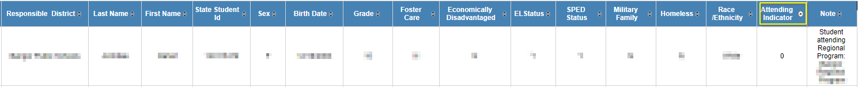

If changes are needed they can be done directly in Synergy and this report will update automatically within an hour and a half. Once everything looks correct, the Superintendent can click on ‘Submit/Certify’.

Contact Information
MEDMS Helpdesk:
Email: medms.helpdesk@maine.gov Phone: (207) 624-6896

