Preparing Invoice and Supporting Documents for ARP ESSER III grant
- GEM Systems will be utilized for the reimbursement process. Please go to - www.4pcamaine.org
- Select the link for “Federal Grant Reimbursement System”
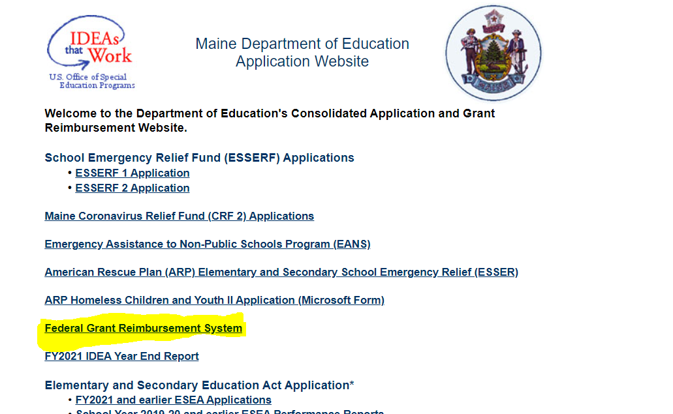
- From federal grant reimbursement menu, select the invoice for ARP ESSER III
- Fill out the Billing period. The billing period on the invoices can be monthly or up to three months but cannot overlap fiscal years.

- Select Reimbursement as the type of funds requested.

- Fill out the funds invoiced per project per budget category.

- Provide all the required documentation for the invoice. These need to be attached by uploading the .pdf files in GEM system.
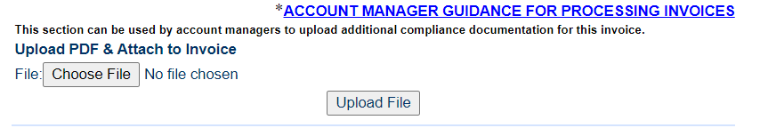

Required Documentation -
Each invoice submission should include:
- Trial Balance –
  - A detailed trial balance
  - Trial balance period must match period being invoiced
- Copies of paid receipts / POs -
Receipts / POs for each expense need to be submitted. Only POs and Invoices are needed, no checks.
- Write the Project name (in short form) and the Category on each invoice or PO; i.e. Family Support-6000 means that the item is charged to the project Family support resources and 6000 indicates that it is Supplies.
- It would be very helpful if, in addition to the Trial Balance, you provide a list of invoices by Project and Category i.e. Family Support-6000, Enrichment Program-1000-2000, etc.

Following are important information to prepare your submittal-
- ARP ESSER III is a reimbursement grant which means you can only request for reimbursement once the expenses are incurred.
- Sales tax is not an allowable expense for federal grants and should not be submitted for reimbursement.
- For each category of expenses submitted, ensure there is a budget amount in that category. Expenses cannot be submitted in categories that do not have an associated budget.

