2023 Agricultural Technology & Mechanical Systems CDE

NOTE: All student competitors must complete by time of event registration the
web-posted Welding Log, documenting their prior welding experience, as well as a proctored/corrected “Welding Safety Test” on which they achieve a perfect score of 100%

Scoring
Participants will be scored as follows: All 4 scores count for overall team score
Individual Team Points
Team Activity (Small engines) * 1/4 of team 120 points
Welding (MIG and stick) 30 points 120 points
Team Activity (Electricity) 1/4 of team 120 points
General Knowledge Exam 30 points 120 points
Total points possible 120 points 480 points
- Small engine will have parts Identification component which will require each member of the team to identify the parts during the team activity portion of this CDE. All four scores will be added and divided by four to get the 10 points or portion thereof of total 120 points available.

Tiebreaker
The team score for the event will be determined by adding all the points earned by adding individual points as listed above. The following activities will be used to break ties between individuals and/or teams:

The highest written exam scores; if still tied top welding scores

Maine FFA Agricultural Technology and Mechanical System
Skills Activity Guidelines

General Guidelines for Skills Activities
- No iPad, tablet, laptop computer or cell phone devices will be allowed in the contest area.
- Activities may involve problem solving and calculations. A calculator is highly recommended.
- Students will have 30 minutes to complete skill activities. They will be given five minutes to pass to the next skill activity.
- Students must use their own equipment for welding section, but this is not required for all other sections. Except for proper welding clothing and safety glasses, all required equipment will be provided.
Safety Glasses
- All participants must wear safety glasses during the team and skill events.
- To enter the CDE area, students must have safety glasses in their possession.
- Safety glasses must have a Z87+ rating.
- Side shields are required on safety glasses. Safety glasses must protect the eyes around the eyebrows, temples and cheeks.
- Personal prescription safety glasses are permitted only if they have a Z87+ rating, are equipped with side shields and meet the description above.
- Only in activities where students are given verbal permission to remove their safety glasses can they take off their safety glasses. Such an example would be the written exam.
Clothing
- Official FFA dress should not be worn during this event, except for taking team pictures prior to the event.
- Students’ clothing must be appropriate for the activities.
- Open-toed shoes are not permitted. Shoes with cloth tops that welding sparks can burn through are also not permitted.
- Loose clothing with long, loose or frayed ends that can get wrapped up in power tools or equipment are to be avoided.
- Equipment for welding, such as welding helmets and gauntlet gloves, will not be provided. However, students are permitted to bring their own if they choose.

Agricultural Technology & Mechanical Systems CDE Score Sheets 2023

Name and FFA Chapter | General Knowledge | Electrical Activity | Welding Section | Engine Activity | Total | Place
Combo Team
1.
2.
3.
4.
Caribou 1
1.
2.
3.
4.
Caribou 2
1.
2.
3.
4.
Mars Hill
1.
2.
3.
4.
Presque Isle 1
1.
2.
3.
4.
Presque Isle 2
1.
2.
3.
4.

Agricultural Technology and Mechanical Systems CDE 2023

With spring planting in full swing, Farmer Bradshaw came into the shop at Luke’s Small Engines with a tinge of panic in his voice. He sent his planting crew to lunch when the fertilizer auger engine failed to start at the remote planting location. “Normal” troubleshooting promptly took place, yet his crew could not get the engine to fire. Farmer Bradshaw needs your help to get them back in the planting business.
“All hands-on deck,” said Luke. “Let’s get er done! Look at workorder at your engine”.
All team members need to do the jobs to get the engine ready in 30 minutes or less. Someone on the crew needs to answer the engine questions below preferably while others on crew get engine running properly using correct troubleshooting order.
Luke glanced in fuel tank and noted that it appears to have fuel. OK team go!!!

If oil was needed, those available are before you on table. Which oil is the incorrect oil to use for this engine at any temperature? Chose correct type and correct amount of oil that needs to be added to engine.
Oil brand and SAE rating to not use (20points)
Oil amount needed ounces (10 points)
Oil level okay? (10 points)
Check fuel level. Does it need fuel? (10 points)
Check and verify to judge that there is sufficient spark (10 points)
Engine running properly? (30 points)
(Did this team use proper troubleshooting procedure?)

Did each person do parts identification? Total score/4 (transfer from test room scoring) (20 points) Safety glasses worn at all times & tools properly returned (10 points)
Total (120 possible)

Note: Briggs and Stratton 200 cc model # 130G32 0022 F1 engine is utilized. The engine is used to power a fertilizer auger in remote locations.

2023 Maine FFA Agricultural Technology & Mechanical Systems CDE

2023 _Electrical Wiring Box A
5 points per line
Box A ---Wiring (source and switched pigtailed to correct wires should be four (4) 2.5 points per connection) ______(10)
Staple wire at correct distance from box A to C (5)
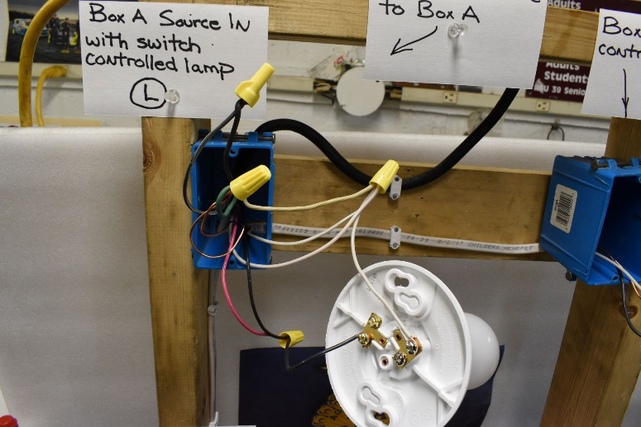

Workmanship (5 points each) Box A---Stripping

(5)
Connect ground wires _ (5) Correct wire nuts (secure?) (5)
Length of leads (5)

Overall neatness (5 points) (5)
Total Points (40) A Box

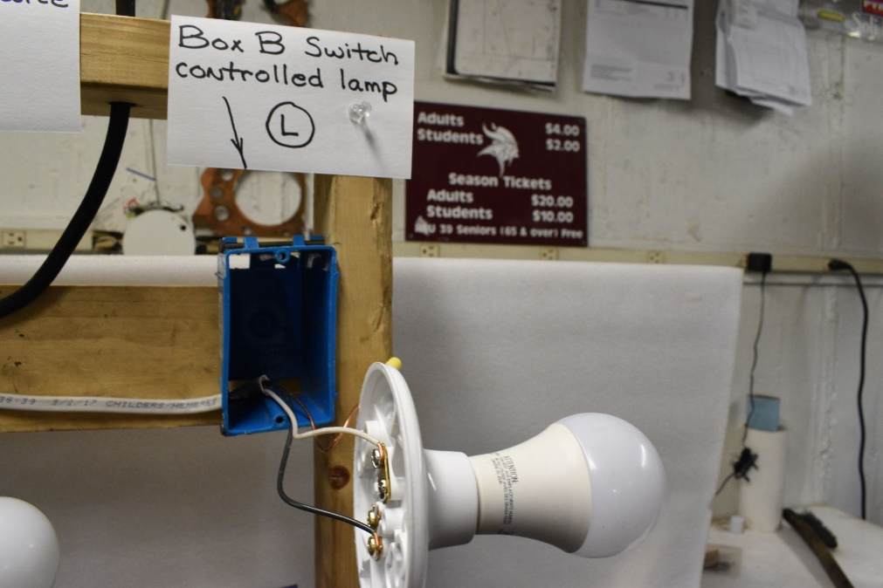
2023 Electrical Wiring Box B

Code correct (5 points per line)

Box B ---Wiring (black to black terminal) _____(5)

Properly secured bare wire
White wire to neutral terminal

(5)
(5)

Workmanship (5 points per line)

 | Box B---Stripping correct length | (5)
 | Clockwise around screws | (5)
 | Length of leads | (5)
 | Secure connectors | (5)
 | Overall neatness (5 points) | (5)
 | Total Points B Box (40)

Electrical Wiring Box C

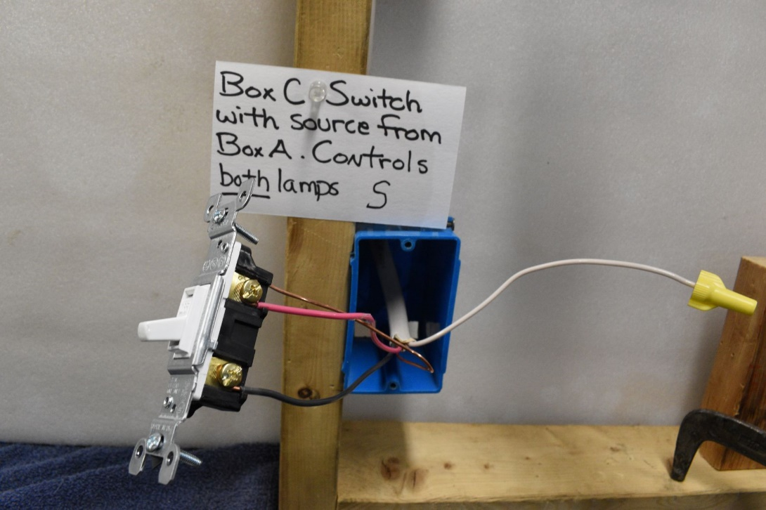

Code correct (2 points per line)

Correct down wire (14/3 type NM) _____ (2)
Box wiring (black & red to switch) ___ (2)
White wire capped with wire nut (2)
Properly grounded bare wire _____ (2)
Staple correct distance from box ______(2)

Box C---Stripping correct length | (5)
Clockwise around screws | (5)
Correct wire nut | (5)
Length of leads | (5)
Secure connectors | (5)
3. Overall neatness (5 points) | (5)
Total Points C Box (40)

Agricultural Technology & Mechanical Systems Electrical Segment Wiring Diagram
THIS IS A TEAM ACTIVITY

Wire the following devices using the tools provided. The use of safety glasses is mandatory. The source wire will begin at box A. 14/2 type NM wires from box A will run to single pole switch in box B and 14/3 type NM to single pole switch in box C.
Do not back wire switch, use hooks only. Box A requires pigtails to lamp. Boxes B and C do not require pigtails. Do not tuck the wires into the individual boxes thus allowing the judge to look at the quality of work. Plug the device extension cord into supplied portable GFCI. Carefully actuate single pole switch to turn lamps on. Pick up all tools and excess wiring materials before moving on to next segment.

Overall View of wiring exercise 2023
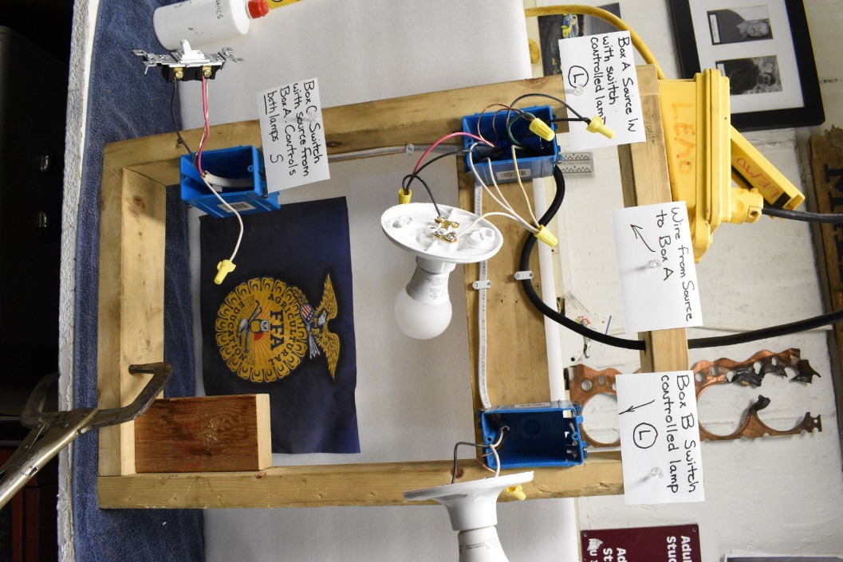

2023 Agricultural Technology and Mechanical Systems CDE

The Agricultural Technology and Mechanical Systems Career Development Event is intended for teams of four FFA members, with all individual scores counted toward the overall team score.
For this event, students must come prepared with proper safety equipment, including welding jackets, closed-toe leather shoes, safety glasses and welding gloves. Official FFA Dress is not required for this event.
The following components will be included in this event:
- Welding with stick and MIG welder. Welding assignment will include a butt, lap and tee weld for the stick welding and MIG welding. See photos provided at website and on following pages.

- General Knowledge Test plus tool identification – questions and tools for identification are based on list to be provided by Darrell Espling, Ag Mechanics instructor at Presque Isle Technical Center. Though parts ID will administered in same room as general knowledge, the score gets entered into small engines segment.

- You are working for Luke’s Small Engine Repair when Farmer Bradshaw brings in his fertilizer auger engine with complaint listed on work order at small engine station. Manual use will be part of the test. By the end of systematic trouble shooting, the engine will be running properly.

- Electrical Circuit – Teams will wire a single pole switch controlling two lamps. The source enters the first lamp and is routed to the single pole switch below it. This exercise in wiring incorporates the new electrical code requirement for a neutral in all light circuit boxes. Please note the change.
2022 Agricultural Technology & Mechanical Systems CDE Welding Section
Make sure your competitor number is clearly displayed on finished product that is turned in to the judge. Handle all hot metals with care. Safety glasses must be on during all parts of this CDE.
Student: Fill out top section (not scoring boxes) each sheet:
WELDING PRODUCT SCORING SHEET

NAME: ____________________________________
CHAPTER: ________________________________
Type of Welder (circle): SMAW (Stick) GMAW (Mig)
Weld Joint: ___________________________________________
Welding Position: _____________________________________
Type and size of rod used: ____________________________
Type and thickness of base metal: ____________________

CRITERIA | JUDGE’S SCORE (CIRCLE ONE)
General Appearance (smooth, uniform ripples, straight) | 0 2 4 6 8 10 12 14 16 18
Proper Lead and Work Angle | 0 2 4 6 8
Uniform Width & Height (Speed) | 0 2 4 6 8
Penetration (Proper Heat Setting) | 0 2 4 6 8 10 12 14 16 18
Clean Start & Stop | 0 2 4 6 8 10 12 14 16 18
Safety Procedures followed and paper filled correctly (Full Name, Date, 1.5” width steel, etc.) | 0 2 4 6 8 10 12 14 16 18 20
TOTAL POINTS:
WELDING PRODUCT SCORING SHEET

NAME: ____________________________________
CHAPTER: ________________________________
Type of Welder (circle): SMAW (Stick) GMAW (Mig)
Weld Joint: ___________________________________________
Welding Position: _____________________________________
Type and size of rod used: ____________________________
Type and thickness of base metal: ____________________

CRITERIA | JUDGE’S SCORE (CIRCLE ONE)
General Appearance (smooth, uniform ripples, straight) | 0 2 4 6 8 10 12 14 16 18
Proper Lead and Work Angle | 0 2 4 6 8
Uniform Width & Height (Speed) | 0 2 4 6 8
Penetration (Proper Heat Setting) | 0 2 4 6 8 10 12 14 16 18
Clean Start & Stop | 0 2 4 6 8 10 12 14 16 18
Safety Procedures followed and paper filled correctly (Full Name, Date, 1.5” width steel, etc.) | 0 2 4 6 8 10 12 14 16 18 20
TOTAL POINTS:
TOTAL POINTS FOR BOTH WELDER TYPES:

STUDENT NAME: | CHAPTER:

