Lodging Options for
2022 Annual Commissioner’s Conference for Superintendents
June 26-28, 2022
Atlantic Oceanside Hotel & Event Center
119 Eden Street, Bar Harbor, ME
Tel: (207) 288-5801
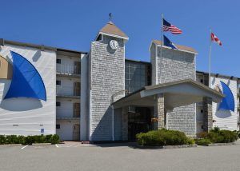

- Main Hotel - $323
  - One king bed w/ balcony
  - Two queen beds w/ balcony
  - ADA w/ two queen beds/balcony

- Atlantic View - $323
  - King bed/balcony
  - Two queen beds w/ balcony/patio
  - ADA with one kind bed

- Oceanside - $323
  - Two queen beds w/ balcony/patio
  - One king bed w/ balcony

Cut-off Date: Call by May 17th

Bar Harbor Motel  100 Eden Street  Bar Harbor, ME  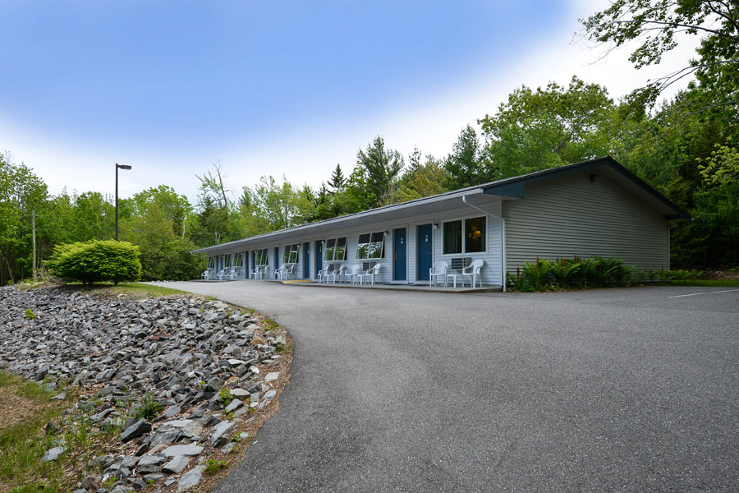  Tel: 1- (800) 388-3453  Price - $199  Room Type: One king or two queens  Mention: Superintendent Conference  Cut-off Date: Call by May 17th | Acadia Inn  98 Eden Street  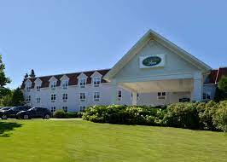  Bar Harbor, ME  Tel: (207) 288-3500  Price - $212-$226  Room Type: One king or two queens  Mention: Superintendent Conference  Cut-off Date: Call by May 17th

Please feel free to book your lodging at any hotel/motel in the area – if you wish

