Instructions for the Summer Food Service Program (SFSP)

Site Information Sheet

The following is complete guidance on how to complete a Site info sheet, highlighted in yellow are fields all sponsors are responsible to update for accuracy at this time.

Where to find the Site Info Sheet in NEO?

Log -in to NEO https://neo.maine.gov/DOE/NEO/Accounts/Account/Login?ReturnUrl=%2fDOE%2fneo%2fcore%2fHome%2fHome
Go to:
Nutrition
Summer Food
Application Listing
Click “View Summary” on the left had side of the Sponsor’s name
you will see the list of approved site info sheets at the bottom of the application summary page.
For each Site Info Sheet please make sure the following highlighted in yellow are accurate and updated for each of your site info sheets.
- Name of Meal Service Site: Enter the name of the new site.

- Site Supervisor First Name/Last Name: Enter the first and last name of the person trained by the sponsor to be responsible for the operation of the meal service at the site.

- Beginning Date of Meal Service: Indicate the first day reimbursable meals will be served at this site. Check for accuracy

- Ending Date of Meal Service: Indicate the last day reimbursable meals will be served at this site. Check for accuracy

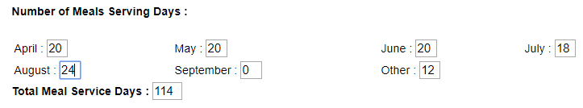
- Number Meal Service Days:

(Other (March) April/ May/June/July/August/September):
Indicate (by month) the total number of days reimbursable meals will be provided to children. DO NOT count days when meals are not provided– such as holidays or weekends, when applicable.
Serving days should represent all days you have provided meals to children, even with
the current waiver allowing multiple days’ worth of meals provided in one day. Please edit all months to reflect the number days meals have been provided to children, for both past and future months.

Example:
If you are providing 7 days’ worth of meals please but only distributing 3 times a week, please enter days representing the 7 you provided for, not the 3 you physically served.
- Total Meal Service Days: NEO will add the number of operating days you entered for each month.

- Site Type: Depending your sponsor type, you are given a drop-down box with site types applicable to you. If you need any help determining what type of site you are operating, contact adriane.ackroyd@maine.gov or kaitlin.fayle@maine.gov

- All Sponsors use the text box below to indicate if you are:
Non-Congregate, and if you are providing multiple days’ worth of meals, what days you are distributing those meals.

See example below:
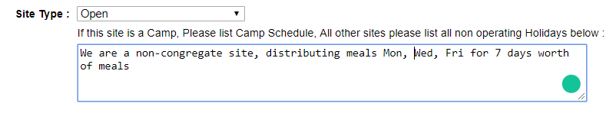
Open Sites: These are geographic areas where at least 50 percent of the local children are eligible for free or reduced price meals, based on information provided by local school officials; or in geographic areas where 50 percent of the population is shown to be below 185 percent of the poverty level based on information provided by welfare or education agencies, zoning commissions, census tract data, or other appropriate sources. At open sites, meals are served to all children 18 years old and under with no registration or enrollment procedures required. Examples include: schools, parks, playgrounds, churches, etc. Currently sites that have not met the 50% criteria are operating on an eligibility waiver that expires June 30th, all sites have listed “other” eligibility will have to be re-assessed after June 30th.
Enrolled Sites: Sites that serve only identified groups of children, as opposed to the community at large. At least 50% of the enrolled children at the site must be eligible for free or reduced-price school meals under the National School Lunch Program. Eligibility is based on income applications. Examples include: Boys and Girls Clubs, YMCAs, etc.
Closed Enrolled Area Eligible: Like Enrolled Sites, Closed Enrolled Area Eligible Sites only serve identified groups of children. The difference is that these sites are qualified to operate by using census track or school data where at least 50% of children in the area qualify and not by student application. Maine has historically had an approved USDA waiver to offer this option but that may change.
Nonresidential Day Camps: Sites that offer a regularly scheduled food service as part of a daily organized camp program for enrolled children. Camps are reimbursed only for meals served to children who meet the income eligibility criteria.
Residential Camps: Sites where enrolled children stay overnight as part of the regular program. Sponsors may claim reimbursement only for those meals served to children at the camp who meet the income eligibility criteria.
NYSP – National Youth Sports Programs: A day camp sponsored program.
For more information regarding eligibility, please refer to the SFSP Administration Guide.
Migrant Sites: Open sites where the majority of the children being served are the children of migrant workers.

The name and address of the site automatically populates to the Site Information Sheet after entering the address in the Site Listing.
- Non-Camp Site (is Monday through Friday) if your site is serving meals Monday through Friday at the same times, selecting (yes) will streamline the table below where meal service days and times can be entered.

- Fill out the meal service times table. two meals may now be recorded as the same service time. Make sure all meal times, and days you are providing meals for are accurate. Please remember that dates and meal service times for open sites will be advertised publicly, so make sure you are accurate in reporting your service times.

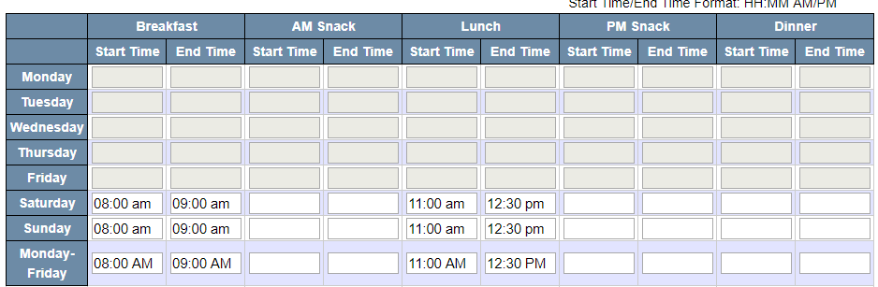

  - Method of Meal Preparation: found at the bottom of the meal service time table:
Self-preparation - meals are prepared by the sponsoring organization itself.
Vended - the sponsoring organization is under contract with an outside organization to produce the meals for the SFSP.

- Maximum Number of Meals:
Maximum Capacity, adjust for accuracy: The maximum number of participants that can be held in the facility. Or for open sites, the maximum amount the sponsor can provide meals for in one day. Attendance cannot exceed maximum capacity and you will not be able to claim participants above this number.
Expected ADA, adjust for accuracy Please edit this to reflect an average of meals you are providing a day: The average daily attendance (ADA) you expect to receive can be calculated from last year’s attendance. To estimate the ADA, first estimate the maximum number of children you expect to serve at each meal for each site. Second, adjust this number downward. For programs with open sites, the ADA is usually about 2/3 of the maximum attendance. Enrolled programs and camps can expect smaller variations in their attendance. This adjusted number is the expected ADA.
Estimated Number of Eligible: Enter the number of children eligible for both free and reduced price meals (Camp and Migrant Only).
- Was this a site last year? Enter “Yes” or “No” accordingly.

- Was this a site last year: All new operating sites should be listed as (No)

13. Name of person conducting the pre-operational site visit and date of visit: Prior to approval of the application, sponsors must visit all new sites and any sites that had operational problems last year. If you are continuing with any new sites after the unanticipated school closure has ended, please enter the date the pre-operational site visit will be conducted. These visits are to determine that the site has the facilities to provide meal service for the anticipated number of children and the capability to conduct the proposed meal service. These visits are NOT to be confused with the

14. Give dates on which the following monitoring visits will be conducted:

a. First Week’s Monitor Visit: To be conducted before the end of the first week of operation. This has been waived for all sponsors in 2020
b. Fourth Week Monitor Review: for all sites operating after June 30th a visit must conducted before the end of the fourth week of site operation (by the 28th calendar day). The monitor must be at the site during the complete meal service at which time the ethnic (beneficiary data) count is taken as required by Federal regulations.

15. Select appropriate eligibility data for this site: Check only one category to describe the data used to document site eligibility.
a). National School Lunch Data: This data is used to qualify open sites that are in an attendance area of a school whose enrollment 50% or more free and reduced.
Enter: Enrollment: Enter the total number of children enrolled at the school.
Eligible for Free and Reduced: Enter the number of children eligible for both free
and reduced price meals.
School: Enter the name of the school from which the data is collected.
.
** The percent eligibility will be automatically calculated. The percentage should be 50% or over to qualify as eligible to operate an open site.
b). Census Tract Data: Census tract data shows that the median family income in the area is equal to or less than the reduced-price school lunch criteria. Can be found here: https://www.fns.usda.gov/areaeligibility
County/City: Indicate the County and/or City for which the data pertains.
%: Indicates the number and percentage of children, ages 0-18 years, households with income below 185% of poverty.
Census Tract #/Block Group #: Indicate the Census Tract number and Block Group number for which the data pertains.

c). Enrolled Sites: All enrolled sites must establish the eligibility of the participating children using the Income Eligibility Application provided by the State Agency. Residential camps are reimbursed only for those meals served to children eligible for free and reduced price school meals.
Enrollment: Enter the total number of children enrolled at the site.
Eligible for Free and Reduced: Enter the number of children eligible for free and reduced price meals (according to the applications).
d). Closed Enrolled Area Eligible:
Enter NSLP data or Census Data

**If the information is not available at the time of application, the State Agency will designate this site as “Pending” until the actual information is received. In the meantime, choose “Other Data” and explain that eligibility will be determined before the program begins.

e). Other Data: Choose this category if you will be using other appropriate data,
document site eligibility (for example: local zoning data, housing authority information,
economic surveys), or if you are waiting for the eligibility information (as described
above in Enrolled Sites).

16. SFSP or NSLP meal pattern if you are a school sponsor you have the option of offering meals through the school lunch pattern or through the summer meal pattern. Select which one you plan to use.
17. Will the offer vs. serve option be used?: Currently all Sponsors are allowed to use Offer vs Serve please, indicate if you are doing OvS at this time. This provision allows children at school sites to refuse certain meal components based on the school’s menu planning system.

18. Is this site in a rural area? Answer is “YES” unless you are providing vended meals.

19. Will meal delivery be within one hour of meal service? If meals are delivered to a satellite site away from the point where the meals are made, the meals must be at the site within one hour of meal service.

20. Meals will be stored until the time of meal service: Check the appropriate space or describe the procedure and equipment to be used.

21. Is there shelter in case of inclement weather? Check “YES” if the site is protected from the elements and will not be affected by bad weather. Check “NO” if the opposite is the case. Meals do not have to be served if the weather prevents outdoor service.

22. Any excess meals will be: Check the appropriate space or describe the procedure and equipment to be used. Please refer to the SFSP Nutrition Guide for guidance regarding the safe handling of food.

23. Are there regularly scheduled organized activities at this site? A planned function at a
site that takes place before or after the SFSP meal service.

24. How will the site supervisor communicate with the sponsor to adjust the number of meals served? Check the appropriate space or describe how the Site Supervisor will notify the sponsoring organization or kitchen of the number of meals required.

25. How will the meal service be supervised? Provide a short description of the method of meal service and who is responsible for meal counts and ensuring each meal contains all the required components.

