2020 Agricultural Technology & Mechanical Systems CDE

Scoring
Participants will be scored as follows: All 4 scores count for overall team score
Individual Team Points
Team Activity (Small engines) * 1/3 of team 90 points
Welding (MIG and stick) 30 points 90 points
Team Activity (Electricity) 1/3 of team 90 points
General Knowledge Exam 30 points 90 points
Total points possible 120points 360 points
- Small engine will have parts Identification component which will require each member of the team to identify the parts during the team activity portion of this CDE. All four scores will be added and divided by four to get the 10 points or portion thereof of total 90 points available.

Tiebreaker
The team score for the event will be determined by adding all the points earned by adding individual points as listed above. The following activities will be used to break ties between individuals and/or teams:

The highest written exam scores; if still tied top welding scores

Maine FFA Agricultural Technology and Mechanical System
Skills Activity Guidelines

General Guidelines for Skills Activities
- No iPad, tablet, laptop computer or cell phone devices will be allowed in the contest area.
- Activities may involve problem solving and calculations. A calculator is highly recommended.
- Students will have 25 minutes to complete skill activities. They will be given five minutes to pass to the next skill activity.
- Students must use their own equipment for welding section, but this is not required for all other sections. Except for proper welding clothing and safety glasses, all required equipment will be provided.
Safety Glasses
- All participants must wear safety glasses during the team and skill events.
- To enter the CDE area, students must have safety glasses in their possession.
- Safety glasses must have a Z87+ rating.
- Side shields are required on safety glasses. Safety glasses must protect the eyes around the eyebrows, temples and cheeks.
- Personal prescription safety glasses are permitted only if they have a Z87+ rating, are equipped with side shields and meet the description above.
- Only in activities where students are given verbal permission to remove their safety glasses can they take off their safety glasses. Such an example would be the written exam.
Clothing
- Official FFA dress should not be worn during this event, except for taking team pictures prior to the event.
- Students’ clothing must be appropriate for the activities.
- Open-toed shoes are not permitted. Shoes with cloth tops that welding sparks can burn through are also not permitted.
- Loose clothing with long, loose or frayed ends that can get wrapped up in power tools or equipment are to be avoided.
- Equipment for welding, such as welding helmets and gauntlet gloves, will not be provided. However, students are permitted to bring their own if they choose.

Agricultural Technology & Mechanical Systems CDE Score Sheets 2020

Name and FFA Chapter | General Knowledge | Electrical Activity | Welding Section | Engine Activity | Total | Place
Ashland
1.
2.
3.
4.
Caribou
1.
2.
3.
4.
Easton
1.
2.
3.
4.
Mars Hill
1.
2.
3.
4.
Presque Isle
1.
2.
3.
4.
1.
2.
3.
4.

Agricultural Technology and Mechanical Systems CDE 2020

The aerator owned by your turf care company is powered by a small gas engine. The person running your aerator called stating that the engine would not start. If they could not get the engine running, they would be unable to use the machine after lunch break.
Your crew noted the engine seems to pull over fairly easy and will not fire. The operator accidentally bumped into the trailer when they loaded up after the last lawn. They had to winch the aerator onto the trailer.
You immediately leave to get to that jobsite since rain is predicted for the next day and aerating in the pouring rain is not recommended.
Your group of technicians must work together to get the engine running in less than 25 minutes. You give the aerator crew a ½ hour lunchbreak and expect to be ready after lunch.
One of the technicians on the crew said they would change oil while you were troubleshooting the engine, your crew has determined that you have time to change oil in this limited time segment. (Do not actually change the oil) The oils available are before you on table. Which oil is the incorrect oil to use for this engine at any temperature? Chose correct type and correct amount of oil that needs to be added to engine.
Oil brand and SAE rating to not use (5points)
Oil amount needed ounces (5 points)
Oil level okay? (5 points)
Check fuel level. Does it need fuel? (10 points)
Check and verify to judge that there is sufficient spark (10 points)
Adjustment correct? ? (15 points)
Engine running properly? (20 points)
(Did this team use proper troubleshooting procedure?)

Did each person do parts identification? Total score/4 (10 points) Safety glasses worn at all times & tools properly returned (10 points)
Total (90 possible)

Note: Briggs and Stratton 200 cc model # 130G32 0022 F1 engine is utilized. The engine is used to power an aerator in remote locations. The engine replaced the worn engine which formerly powered the aerator

2020 Maine FFA Agricultural Technology & Mechanical Systems CDE

2020 _Electrical Wiring Box A
5 points per line
Box A ---Wiring (black, ground and white to GFCI correct ___(10)
Followed wiring diagram (5)
Staple wire at correct distance from box A to C (5)
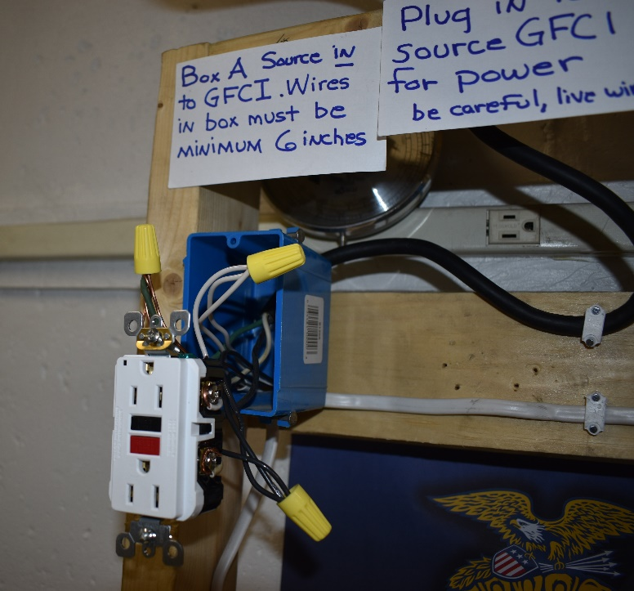

Workmanship (5 points each) Box A---Stripping

(5)
Correct ground wire nut _ (5) Correct wire nuts (hot & neutral) (5)
Length of leads (5)
Secure connectors (5)

Overall neatness (5 points) (5)
Total Points A Box

Maine FFA Agriculture & Technical Systems
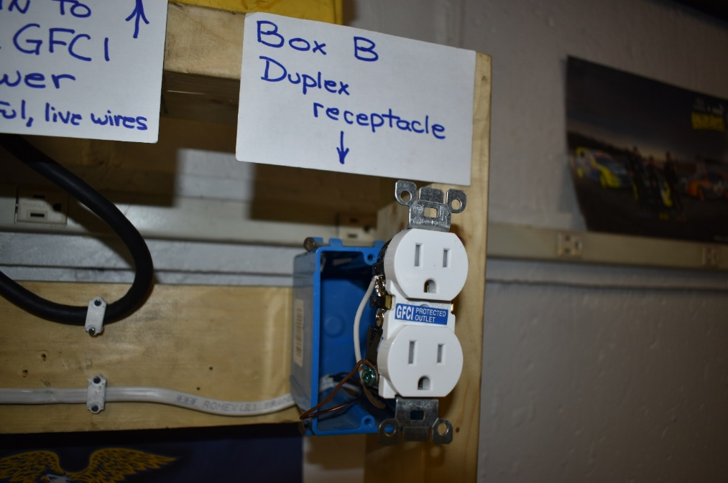
2020 Electrical Wiring Box B

Code correct (5 per line)

Box B ---Wiring (black to black terminal _____(5)

Properly grounded bare wire
White wire to neutral terminal

(5)
(5)

Staple entrance wire at correct distance from box (5)

Workmanship (5 points)

 | Box B---Stripping correct length | (5)
 | Clockwise around screws | (5)
 | Correct wire nuts | (5)
 | Length of leads | (5)
 | Secure connectors | (5)
 | Overall neatness (5 points) | (5)
 | Total Points B Box

Electrical Wiring Box C

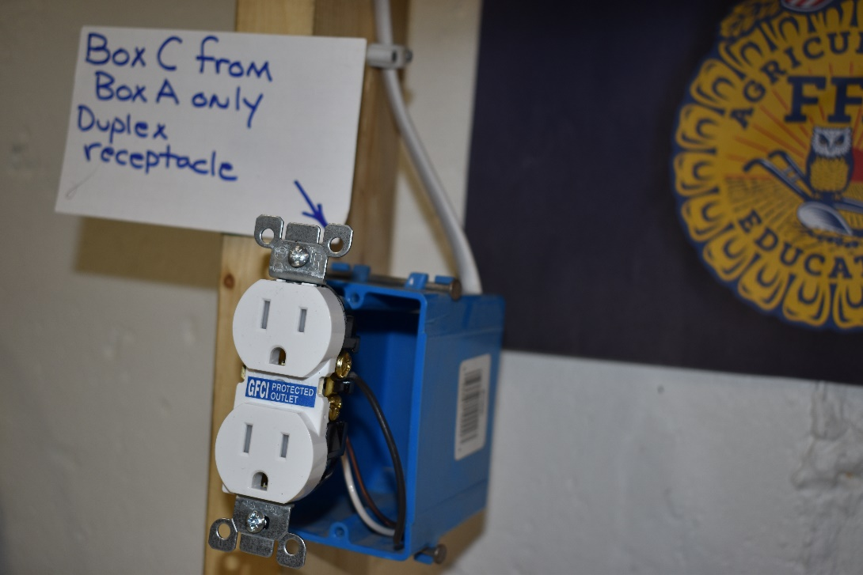

Code correct (5 points per line)

Box wiring (black to black terminal, etc ___ (5)
White wire to neutral terminal (5)
Properly grounded bare wire _____ (5)
Staple correct distance from box ______(5)

Box C---Stripping correct length | (5)
Clockwise around screws | (5)
Correct wire nuts | (5)
Length of leads | (5)
Secure connectors | (5)
3. Overall neatness (5 points) | (5)
Total Points C Box

Agricultural Technology & Mechanical Systems Electrical Segment Wiring Diagram
THIS IS A TEAM ACTIVITY

Wire the following devices using the tools provided. The use of safety glasses is mandatory. The source wire will begin at the GFCI box A. 14/2 type NM wires from GFCI box will run to duplex receptacle in box B and duplex receptacle in box C.
Do not back wire receptacle, use hooks only. Do not tuck the wires into the junction box thus allowing the judge to look at the quality of work. Either duplex receptacle box may be tested by using supplied extension cord plugged in for a tool. Pick up all tools and excess wiring materials before moving on to next segment.

Overall View of wiring exercise 2020
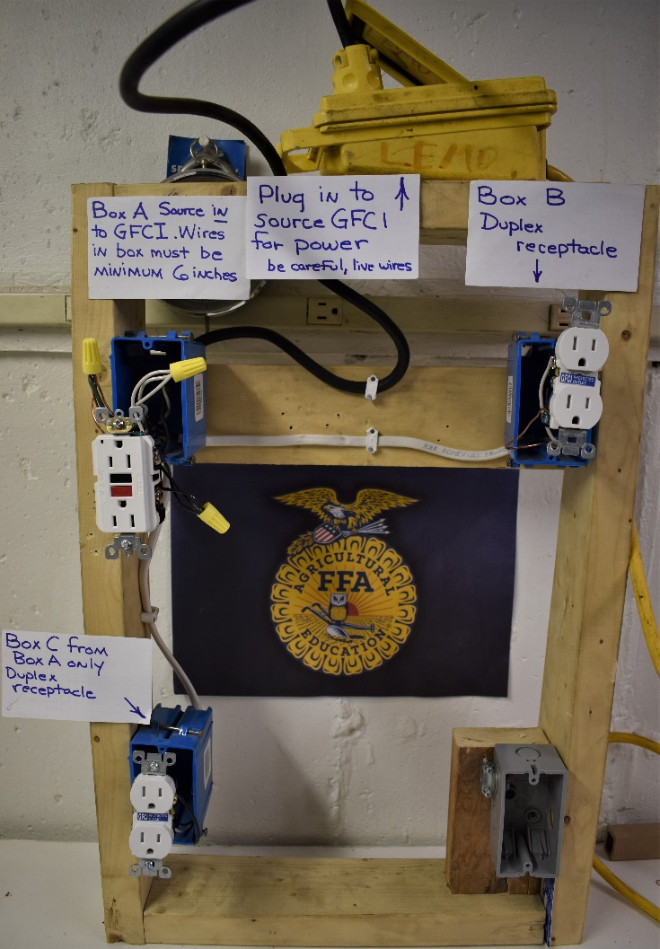

2020 Agricultural Technology and Mechanical Systems CDE

The Agricultural Technology and Mechanical Systems Career Development Event is intended for teams of four FFA members, with all individual scores counted toward the overall team score.
For this event, students must come prepared with proper safety equipment, including welding jackets, closed-toe leather shoes, safety glasses and welding gloves. Official FFA Dress is not required for this event.
The following components will be included in this event:
- Welding with stick and MIG welder. Welding assignment will include a butt, lap and tee weld for the stick welding and MIG welding. See photos provided at website and on following pages.

- General Knowledge Test plus tool identification – questions and tools for identification are based on list to be provided by Darrell Espling, Ag Mechanics instructor at Presque Isle Technical Center.

- Turf grass aerator problem- The company owned aerator has a no start condition. Turf team noted engine would not start after loading onto trailer. Each individual must take a small engine parts identification test. Manual use will be part of the test. By the end of systematic trouble shooting, the engine will be running properly.

- Electrical Circuit – Teams will wire a GFCI and branch off to separate boxes B & C which have duplex receptacles using materials and instructions provided. An example of the circuit to be assigned will be posted on the Maine FFA website and instructional video.
2020 Agricultural Technology & Mechanical Systems CDE Welding Section
Make sure your competitor number is clearly displayed on finished product that is turned in to the judge. Handle all hot metals with care. Safety glasses must be on during all parts of this CDE.
Student: Fill out top section (not scoring boxes) each sheet:
WELDING PRODUCT SCORING SHEET

NAME: ____________________________________
CHAPTER: ________________________________
Type of Welder (circle): SMAW (Stick) GMAW (Mig)
Weld Joint: ___________________________________________
Welding Position: _____________________________________
Type and size of rod used: ____________________________
Type and thickness of base metal: ____________________

CRITERIA | JUDGE’S SCORE (CIRCLE ONE)
General Appearance (smooth, uniform ripples, straight) | 0 2 4 6 8 10 12 14 16 18
Proper Lead and Work Angle | 0 2 4 6 8
Uniform Width & Height (Speed) | 0 2 4 6 8
Penetration (Proper Heat Setting) | 0 2 4 6 8 10 12 14 16 18
Clean Start & Stop | 0 2 4 6 8 10 12 14 16 18
Safety Procedures followed and paper filled correctly (Full Name, Date, 1.5” width steel, etc.) | 0 2 4 6 8 10 12 14 16 18 20
TOTAL POINTS:
WELDING PRODUCT SCORING SHEET

NAME: ____________________________________
CHAPTER: ________________________________
Type of Welder (circle): SMAW (Stick) GMAW (Mig)
Weld Joint: ___________________________________________
Welding Position: _____________________________________
Type and size of rod used: ____________________________
Type and thickness of base metal: ____________________

CRITERIA | JUDGE’S SCORE (CIRCLE ONE)
General Appearance (smooth, uniform ripples, straight) | 0 2 4 6 8 10 12 14 16 18
Proper Lead and Work Angle | 0 2 4 6 8
Uniform Width & Height (Speed) | 0 2 4 6 8
Penetration (Proper Heat Setting) | 0 2 4 6 8 10 12 14 16 18
Clean Start & Stop | 0 2 4 6 8 10 12 14 16 18
Safety Procedures followed and paper filled correctly (Full Name, Date, 1.5” width steel, etc.) | 0 2 4 6 8 10 12 14 16 18 20
TOTAL POINTS:
TOTAL POINTS FOR BOTH WELDER TYPES:

STUDENT NAME: | CHAPTER:

