Agricultural Technology & Mechanical Systems
Small Engine Parts Identification Contest Guidelines

Each contestant must be able to identify the parts of the small engine and be able to give the purpose of each part. The engine parts will be identified on a disassembled engine, not on an assembled engine. The contestant will look at each part and write its name on answer sheet*. There will be a word bank at the bottom of the test page.

Engine Parts:
A. Air Cleaner | K. Exhaust Valve
B. Armature | L. Fuel Tank
C. Camshaft | M. Flywheel
D. Carburetor | N. Flywheel Key
E. Combustion Chamber | O. Intake Valve
F. Connection Rod | P. Oil Filler Plug
G. Crankcase | Q. Piston
H. Crankshaft | R, Piston Head
I. Cylinder | S. Piston Ring
J. Cylinder Block U. Cylinder Head | T. Spark Plug

Each contestant must work on parts identification independently and without assistance*. Any outside assistance may disqualify the contestant.

* Students who require reading assistance may request to have the parts list read to them.

Photos for parts Identification

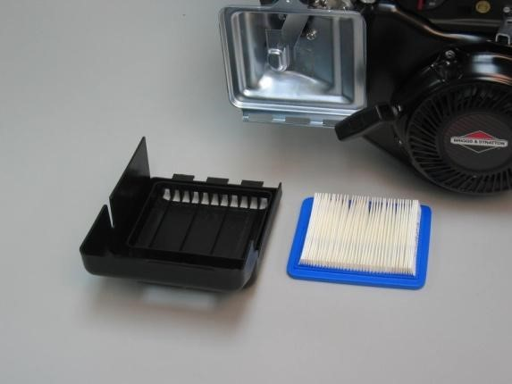

Air Cleaner: a device that filters the air that is mixed with the fuel in the engine.

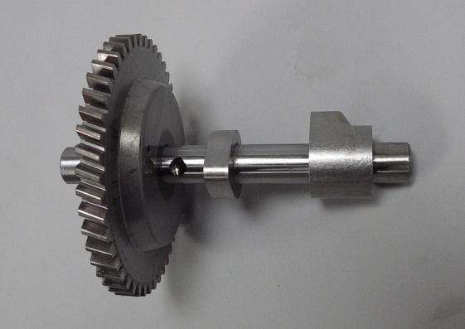
Camshaft: the shaft containing lobes or cams which rotate to raise and lower the valves.

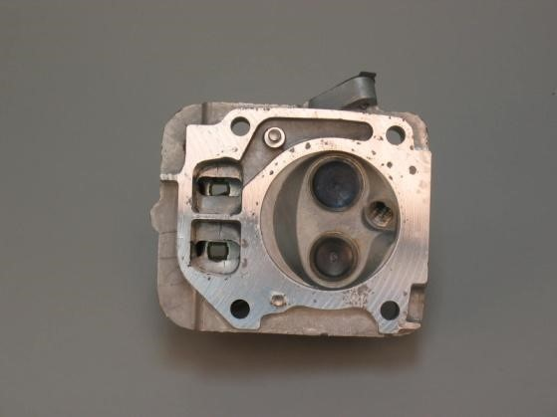

Combustion Chamber: the volume of the cylinder above the piston with the piston at top dead center.

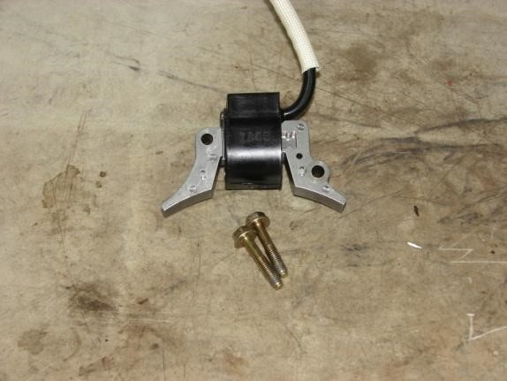
Armature: a part consisting of coils of wire around an iron core that induces an electric current when it is rotated in a magnetic field.

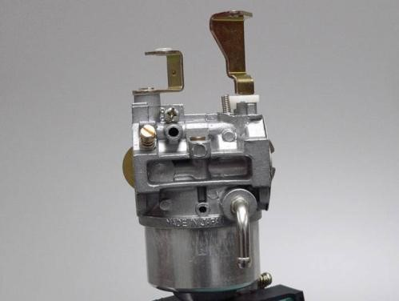
Carburetor: a device for automatically mixing fuel in the proper proportion with air to produce a combustible gas.

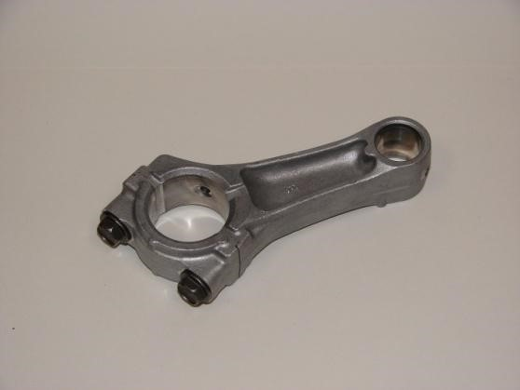
Connecting Rod: a rod that connects the piston to the crankshaft.
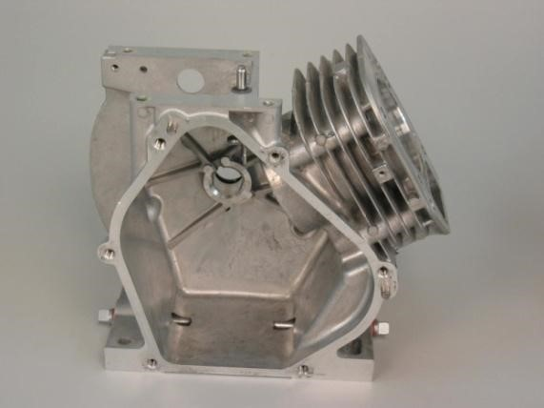

Crankcase:
the housing where the crankshaft

and many other parts of the engine operate.

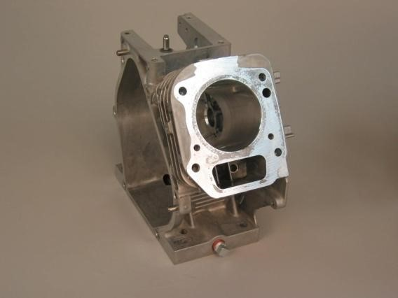

Cylinder: a round hole having some depth bored to receive a piston. Sometimes referred to as a bore or barrel.

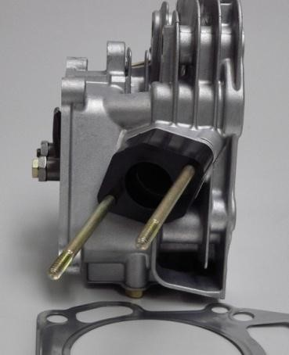
Cylinder Head: a detachable portion of an engine fastened securely to the cylinder block that contains all or part of the combustion chamber.

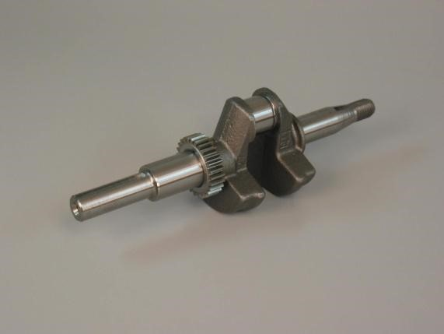
Crankshaft: the main shaft of the engine which, in conjunction with the connecting rod, changes the reciprocating motion of the piston into rotary motion.

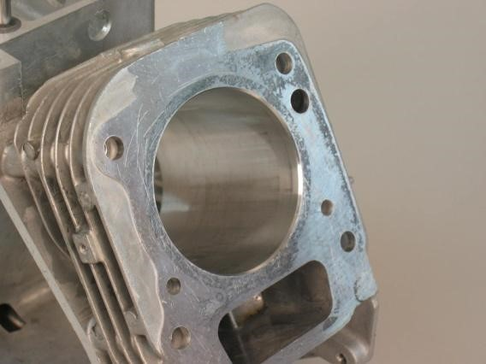
Cylinder Block: the largest single part of an engine; the main mass of metal where the cylinders are bored or placed.
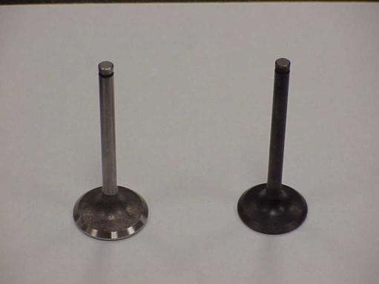

Exhaust Valve: a valve that permits the remains of the burned fuel to leave the combustion chamber.

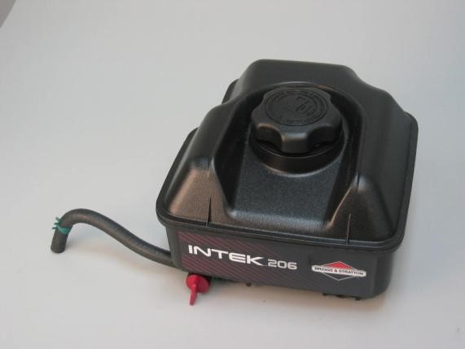
Fuel Tank: the device which contains the fuel to be burned in the engine.
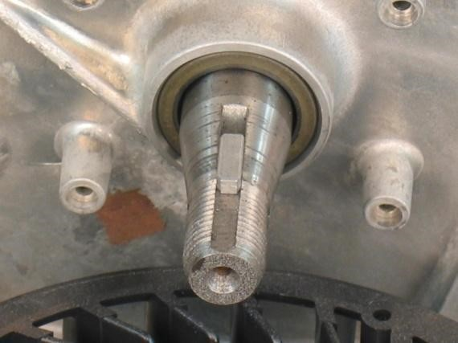

Flywheel Key: a device that holds the flywheel in place.

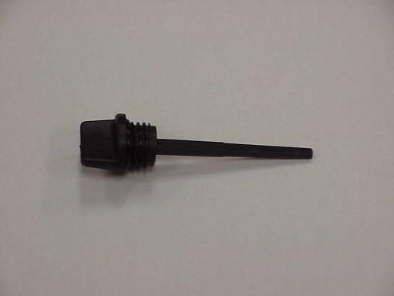
Oil Filler Plug: the device that closes the opening where the crankcase is filled with oil.

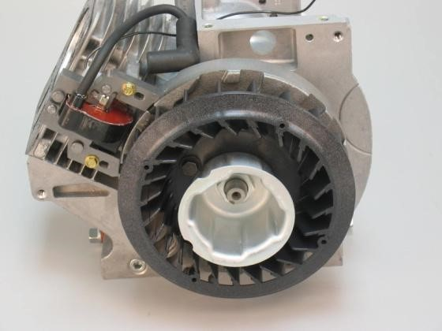

Flywheel: a heavy wheel that maintains the speed of the engine while it is running.

Intake Valve: a valve that permits the air- fuel mixture to enter the combustion chamber and seals its exit.

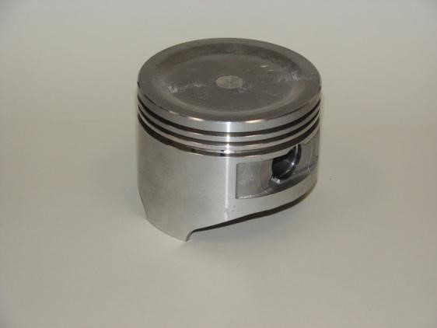
Piston: a cylindrical part closed at one end that is connected to the crankshaft by the connecting rod.

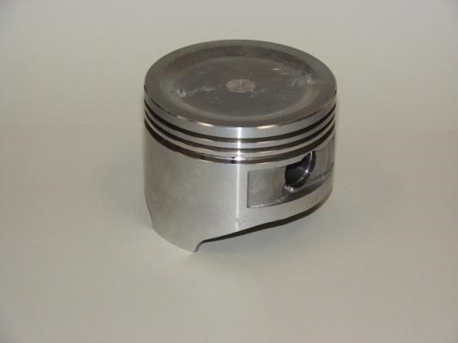

Piston Head: the part of the piston above the rings.

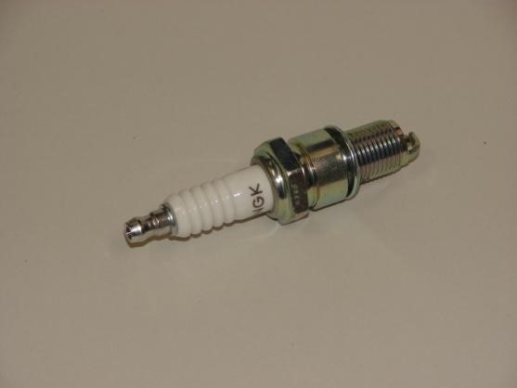
Spark Plug: a device inserted into the combustion chamber of an engine that contains an insulated control electrode for conducting current.

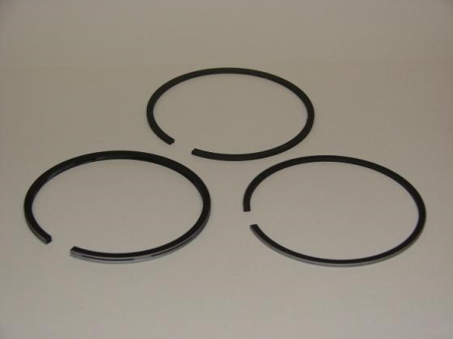
Piston Rings: expanding rings placed in the grooves of the piston to create a seal that prevents the passage of fluid or gas past the piston.

Contestant Name and Chapter __________________________

Small Engine Parts Identification

Part # | Name (letter only) | Part # | Name (letter only)
1 |  | 6
2 |  | 7
3 |  | 8
4 |  | 9
5 |  | 10
 |  | Total

A. Air Cleaner | K. Exhaust Valve
B. Armature | L. Fuel Tank
C. Camshaft | M. Flywheel
D. Carburetor | N. Flywheel Key
E. Combustion Chamber | O. Intake Valve
F. Connection Rod | P. Oil Filler Plug
G. Crankcase | Q. Piston
H. Crankshaft | R, Piston Head
I. Cylinder | S. Piston Ring
J. Cylinder Block U. Cylinder Head | T. Spark Plug

