2019 Agricultural Technology & Mechanical Systems CDE

Scoring
Participants will be scored as follows: All 4 scores count for overall team score
Individual Team Points
Team Activity (Small engines)* 1/3 of team 90 points
Welding (MIG and stick) 30 points 90 points
Team Activity (Electricity) 1/3 of team 90 points
General Knowledge Exam 30 points 90 points
Total points possible 120points 360 points
- Small engine will have parts Identification component which will require each member of the team to identify the parts during the team activity portion of this CDE. All four scores will be added and divided by four to get the 10 points or portion thereof of total 90 points available.

Tiebreaker
The team score for the event will be determined by adding all the points earned by adding individual points as listed above. The following activities will be used to break ties between individuals and/or teams:

The highest written exam scores; if still tied top welding scores

Maine FFA Agricultural Technology and Mechanical System
Skills Activity Guidelines

General Guidelines for Skills Activities
- No iPad, tablet, laptop computer or cell phone devices will be allowed in the contest area.
- Activities may involve problem solving and calculations. A calculator is highly recommended.
- Students will have 25 minutes to complete skill activities. They will be given five minutes to pass to the next skill activity.
- Students must use their own equipment for welding section, but this is not required for all other sections. Except for proper welding clothing and safety glasses, all required equipment will be provided.
Safety Glasses
- All participants must wear safety glasses during the team and skill events.
- To enter the CDE area, students must have safety glasses in their possession.
- Safety glasses must have a Z87+ rating.
- Side shields are required on safety glasses. Safety glasses must protect the eyes around the eyebrows, temples and cheeks.
- Personal prescription safety glasses are permitted only if they have a Z87+ rating, are equipped with side shields and meet the description above.
- Only in activities where students are given verbal permission to remove their safety glasses can they take off their safety glasses. Such an example would be the written exam.
Clothing
- Official FFA dress should not be worn during this event, except for taking team pictures prior to the event.
- Students’ clothing must be appropriate for the activities.
- Open-toed shoes are not permitted. Shoes with cloth tops that welding sparks can burn through are also not permitted.
- Loose clothing with long, loose or frayed ends that can get wrapped up in power tools or equipment are to be avoided.
- Equipment for welding, such as welding helmets and gauntlet gloves, will not be provided. However, students are permitted to bring their own if they choose.
Agricultural Technology & Mechanical Systems CDE

Score Sheets 2019

Name and FFA Chapter | General Knowledge | Electrical Activity | Welding Section | Engine Activity | Total | Place
Ashland
1.
2.
3.
4.
Caribou
1.
2.
3.
4.
Easton
1.
2.
3.
4.
Mars Hill
1.
2.
3.
4.
1.
2.
3.
4.
Presque Isle
1.
2.
3.
4.

Name | School | Number
Total welding points

2019 Agricultural Technology & Mechanical Systems CDE Welding Section
Make sure your competitor number is clearly displayed on finished product that is turned in to the judge. Handle all hot metals with care. Safety glasses must be on during all parts of this CDE.
MIG Section Scoring

Point Value | What judges will look for
1 2 3 | No visible imperfections or spatter damage. Pieces fit correctly.
1 2 3 4 | High quality appearance
1 2 | Proper welding apparel
1 2 | Safety glasses worn at all times
1 | Check for hazards
1 2 | Proper handling of hot materials
1 | Clean up and tool return
 | Total points earned (15 possible)
Number | Contestant Name & Chapter

Stick Welding Segment

Point value | What the judge is looking for
1 2 3 | All pieces fit properly and are correctly located.
1 2 3 | High quality appearance each bead
1 2 | Proper welding apparel
1 2 | Safety glasses worn at all times
1 | Check for hazards
1 2 | Proper chipping
1 | Safe handling of hot metal
1 | Clean up and tool return
 | Total points earned (15 possible)

Agricultural Technology and Mechanical Systems CDE 2019

The aerator located owned by your turf care company is powered by a small gas engine. The person running your aerator called stating that the engine pull cord was frayed and needed to be replaced since they were concerned that the cord may break and spin back into recoil housing and they would be unable to start the machine after lunch break.
Your crew noted the engine seems to lack power despite it being relatively new. At times it may run rough and be hard to start.
You immediately leave to get to that jobsite since rain is predicted for the next day and aerating in the pouring rain is not recommended.
Your group of technicians must work together to get the engine running in less than 25 minutes. You give their crew a ½ hour lunchbreak and expect to be ready after lunch.
Your crew has determined that you have time to change oil in this limited time segment. (Do not actually change the oil, simply check it) The oils available are before you on table. Chose correct type and correct amount of oil that needs to be added to engine.
Oil brand and SAE rating (5 points)
Oil amount needed ounces (5 points)
Oil level okay? (5 points)
Check fuel level. Does it need fuel? (10 points)
Check and verify to judge that there is sufficient spark (15 points)
Engine pull cord replaced correctly? (15 points)
Engine running properly? (15 points)

Did each person do parts identification? Total score/4 (10 points) Safety glasses worn at all times & tools properly returned (15 points)
Total (90 possible)

Note: Briggs and Stratton 200 cc model # 130G32 0022 F1 engine is utilized. The engine is used to power an aerator in remote locations. The engine replaced the worn engine which formerly powered the aerator

2019 Maine FFA Agricultural Technology & Mechanical Systems CDE

Electrical Wiring Box A
- Followed wiring diagram (6 points) (6)
- Code correct (4 per line)
Box A ---Wiring (black, ground and white to switch correct) (4) Attach wire at correct distance from box (4)
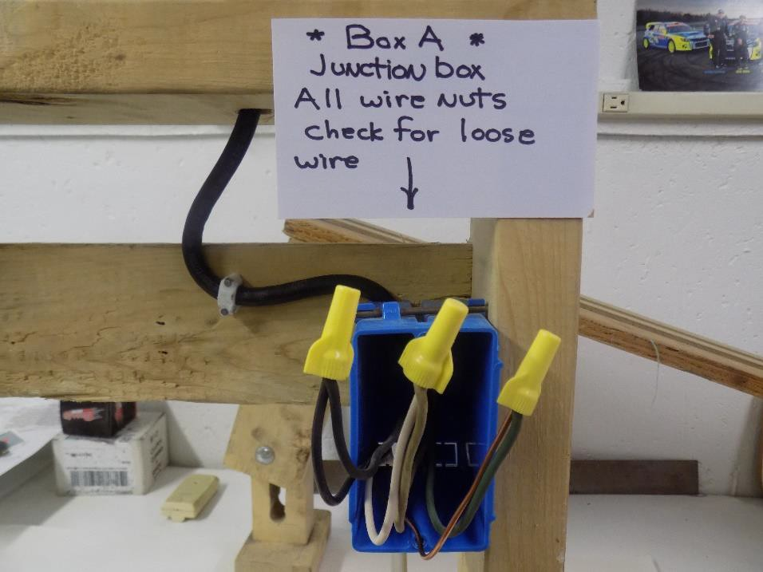

- Workmanship (4 points each) Box A---Stripping

(4)

Correct ground wire nut (4) Correct wire nuts (hot & neutral) (4) Length of leads (4)
Secure connectors (4)

- Overall neatness (6 points) (6)
Total Points A Box

2019 Maine FFA Agricultural Technology & Mechanical Systems CDE
Electrical Wiring Box B
- Code correct (5 per line)
Box B ---Wiring (blacks to black terminal, etc.) White wires to neutral terminal
Properly grounded bare wire

(5)
(5)
(5)

Staple entrance wire at correct distance from box (5)

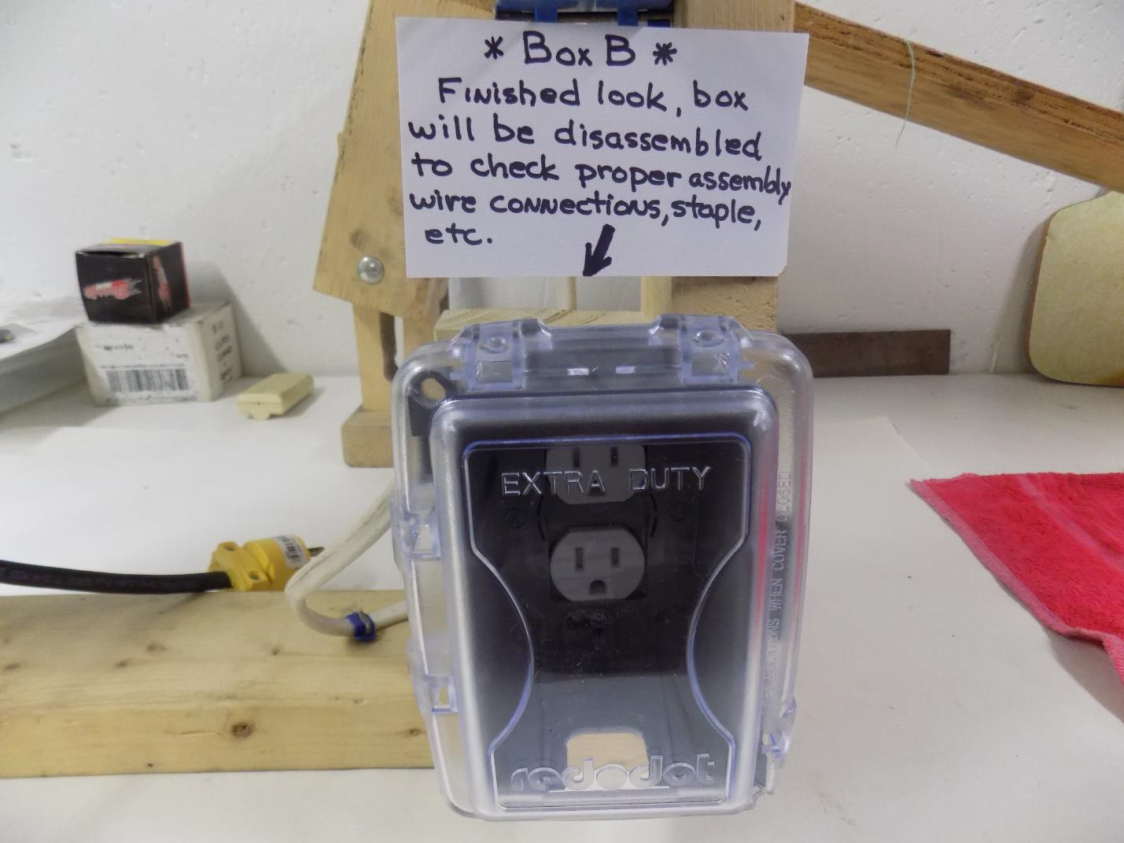

- Workmanship (5 points each)

 | Box B---Stripping correct length | (5)
 | Clockwise around screws | (5)
 | Correct wire nuts | (5)
 | Length of leads | (5)
 | Secure connectors | (5)
 | 3. Overall neatness (6 points) | (5)
 | Total Points B Box
Total | Box A + B (90 points possible)

Agricultural Technology & Mechanical Systems Electrical Segment Wiring Diagram
THIS IS A TEAM ACTIVITY

Wire the following devices using the tools provided. The use of safety glasses is mandatory. The source wire will begin at the junction box A. 14/2 type NM wires from junction box will run to box B, weatherproof outlet.
Do not backwire receptacle, use hooks only. Do not tuck the wires into the junction box thus allowing the judge to look at the quality of work. The weatherproof box must be fully assembled with supplied extension cord plugged in for a tool. Pick up all tools and excess wiring materials before moving on to next segment.

Overall View of wiring exercise 2019
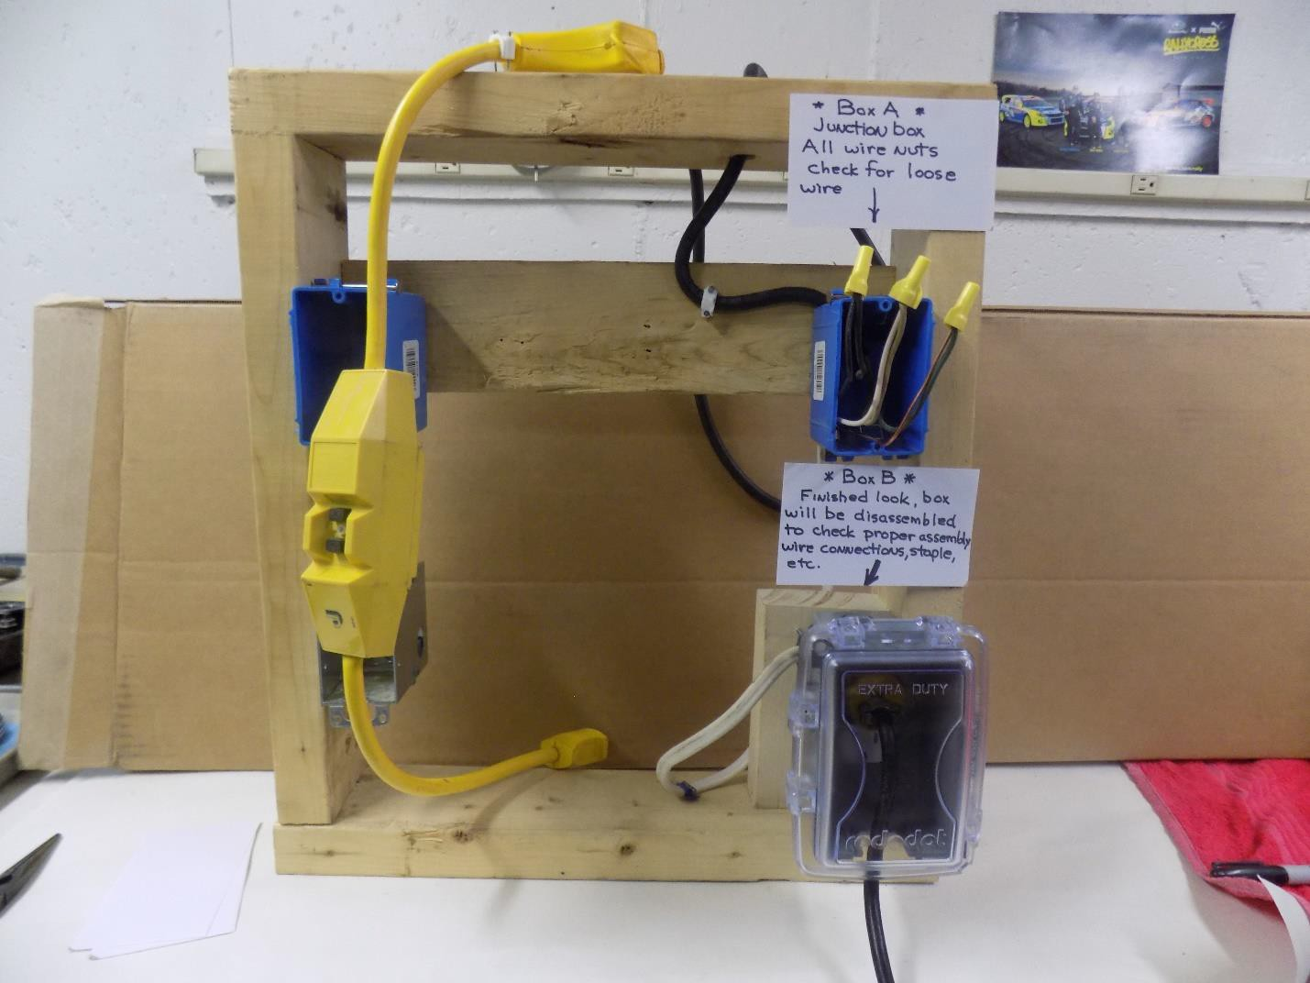

2019 Agricultural Technology and Mechanical Systems CDE

The Agricultural Technology and Mechanical Systems Career Development Event is intended for teams of four FFA members, with all individual scores counted toward the overall team score.
For this event, students must come prepared with proper safety equipment, including welding jackets, closed-toe leather shoes, safety glasses and welding gloves. Official FFA Dress is not required for this event.
The following components will be included in this event:
- Welding with stick and MIG welder. Welding assignment will include a butt, lap and tee weld for the stick welding and mig welding. See photos provided at website and on following pages.

- General Knowledge Test plus tool identification – questions and tools for identification are based on list to be provided by Darrell Espling, Ag Mechanics instructor at Presque Isle Technical Center.

- Turf grass aerator problem- The company owned aerator has a frayed starter cord which must be replaced. Turf team noted a rough running engine as well. Each individual must take a small engine parts identification test. Manual use will be part of the test. By the end of trouble shooting, the engine will be running properly.

- Electrical Circuit – Teams will wire a junction box to feed a weatherproof duplex receptacle( Thomas & Betts Red Dot Code Keeper Universal In-Use Weatherproof Cover) using materials and instructions provided. An example of the circuit to be assigned will be posted on the Maine FFA website and instructional video. During the video they recommend cutting the wire to 4 inches…do not cut to 4 inches. You need at least 8 inches. The box used may not look exactly like your setup, however, they will be similar. https://www.youtube.com/watch?v=q61A_wsghRc

