Think Tank Artifacts Lewiston and Saco
Maine Defines School Success: A Statewide Conversation led by the Maine Department of Education
Goals of Maine Defines School Success
- Identify authentic, relevant indicators of a successful school—locally and statewide
- Qualify the indicators to give them value and meaning
- Design and implement a framework for the indicators as representing the success of schools

Think Tank session debrief: Each Maine Defines School Success think tank session was attended by a group of educators whose expertise and contributions have helped tremendously in charting the way toward achieving the goals statewide. In an adaptation of the Human Centered Design approach to solutions, participants were invited to

- Explore the current challenges through analogy and discussion;
- Provide feedback on a solution prototype;
- Identify the characteristics that makes schools successful through stories and conversation; and
- Offer suggestions and insights as to how we can involve every school community in identifying the indicators of successful schools

Artifacts of discussion by location

Lewiston

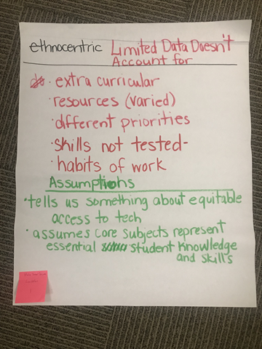
1:
Ethnocentric Limited Data Doesn’t Account for
- Extra curricular
- Resources (varied)
- Different priorities
- Skills are not tested
- Habits of work
Assumptions
- Tells us something about equitable access to technology
- Assumes core subjects represent essential student knowledge and skills
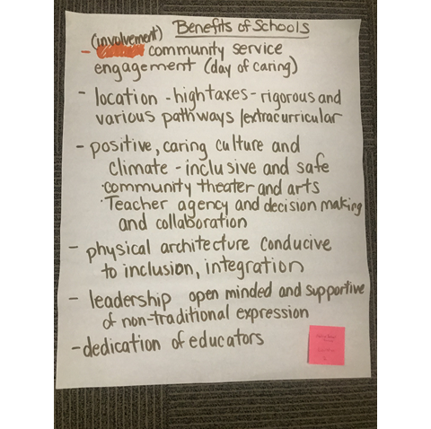
2:
Benefits of Schools
- (involvement) community service engagement (day of caring)
- Location – high taxes – rigorous and various pathways or extracurricular
- Positive, caring culture and climate – inclusive and safe
- Community theater and arts
- Teacher agency and decision making and collaboration
- Physical architecture conducive to inclusion, integration
- Leadership, open minded and supportive of non-traditional expression
- Dedication of educators
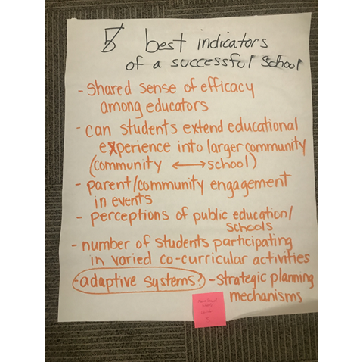
3:
Best indicators of a successful school
- Shared sense of efficacy amongst educators
- Can students extend educational experience into larger community (community <–> school)
- Parent and community engagement in events
- Perceptions of public education and schools
- Number of students participating in varied co-curricular activities
- (adaptive systems?) -- strategic planning mechanisms
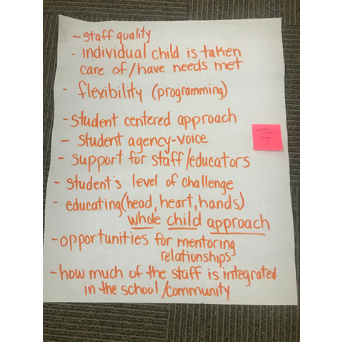
5:
- Staff quality
- Individual child is taken care of and has their needs met
- Flexibility (programming)
- Student centered approach
- Student agency-voice
- Support for staff and educators
- Student's level of challenge
- Education (head, heart, hands) -- whole child approach
- Opportunities for mentoring relationships
- How much of the staff is integrated in the school and community

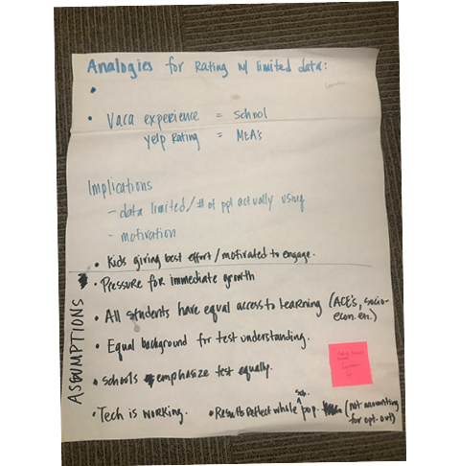
Analogies for rating with limited data:
- Vacation experience = school
- Yelp rating = MEAs
Implications
- Data limited number of people actually using
- Motivation
Assumptions
- Kids giving best effort/motivated to engage.
- Pressure for immediate growth
- All students have equal access to learning (ACEs, socio-economic, etc...)
- Equal background for test understanding
- Schools emphasize test equality
- Technology is working
- Results reflect whole school population (not accounting for opt-out)

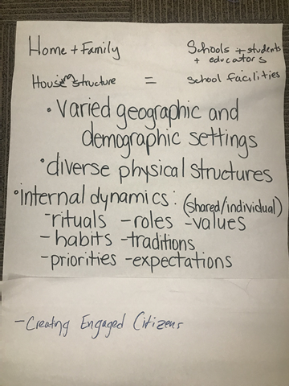
6:
Home + family = schools + students + educators
Housing structure = school facilities
- Varied geographic and demographic settings
- Diverse physical structures
- Internal dynamics: (shared and individual)
- Rituals
- Roles
- Values
- Habits
- Traditions
- Priorities
- Expectations
- Creating engaged citizens

Saco

No Chart Paper (room was not conducive); participants used handouts.

If you were considering a move to another Maine town, what are five questions you would want to ask about the school system in the town or city?
Balance/Continuity -- Jenga
-What type of assessments and how frequent?
-How do you use assessment data?
-Offer teacher P.D.
-Assessment
-Can students redo assessments until mastery
Strategic Planning
-how is student learning communicated?
-Digital Portfolio
-Conversation with teachers
1 – How question asking is embraced?
2 – How are answer seekers supported? -- empowerment
3 – Use of critical thinking in and out of the classroom?
4 – Evidence of new research and learning (in and out) of classroom?
5 – Evidence of incorporation of positive and safe school culture?
- Expectations for child learning and certain landmarks...progression
- Shared sense of confidence and success
- How is this integrated? (I.e. arts)
- How to honor and address different perspectives
- What is the continuum of learning – curriculum?
- Clarity on learning experience – experience @ district vs. Individual level vs. At all levels/stakeholders
School culture
Facilities – clean, safe
Teaches effectiveness
What social emotional training incorporated in schools
What opportunities exist for integration with service learning, apprenticeships, community?
What extracurricular opportunities exist?
Diversity experiences?
Strategic plan?
What are the 5 best indicators of a successful school?
What is the leadership make up?
-how is it used?
Multiple pathways:
- Entrepreneurship
- Trades training – supported college experiences
How to get along with (restorative practices) student voice, self-advocacy
Number of community members who attend events
Life skills, success, guiding principles

If you were talking with someone who was thinking of moving to your school community, what qualities of your school would you highlight as the most beneficial? Consider different types of prospective residents (with young children, with middle or high school aged children; single with no children; seniors, business owners; other community members).
Questions will come from different types – some who won’t know what to ask
-How do you keep my child safe?
-What is the average class size?
How big are classes?
Support of teachers
Fiscally responsible and engaged
-Safety and comfort
-Flexibility and exploring
-Social interaction and diversity
-Different styles and situations and teachers
Parents and children:
- Values arts
- Community engagement
Considering your school system as a whole, what are its most valuable qualities?
Older person learning opportunities
To what extent is the community engaged in education?
-Intentional
-Timely
-Vertical or horizontal communication
-Development of critical thinking
- At all levels we talked about and act on taking students where they are at
- Cultural sensitivity
What are the top three characteristics you personally value in your school and district?
School:
Did your student enjoy their experience there? “Positive school question”
Is your student able to move, or be served in multiple levels and classrooms? Based on what parameters?
How many social, cultural, economic, and developmental levels/groups will they interact with in a year?
School District:
What experiential learning opportunities regarding relevant settings has your child been a part of?
How hard is it to get ahold of the school leader, district leader? How long did it take to see change? Did it follow your child vertically?
What is the most valuable information for anyone to know about any school?
Best Indicators:
-Safety and comfort
- Relationship
- Attend
- Food and clothing
- Being heard
- Background hiring rigorous
- Allowed to ask questions
-flex/exploring
- Variety in schedules and classrooms
- Inclusivity
- Learning spaces
-social interaction
- Diversity
- Community involvement
- Teacher mentoring
- Time for discussion openness
-styles of learning
- Allow for questions and answers (development of critical thinking)
- Relevant settings
-communication
- Intentional
- Timely
- Horizontal or vertical

- Community involvement
- Culture and teacher longevity, new teachers, ongoing PD with active involvement
- Rigorous hiring practices
- Services for all learners
- Resources, people, and materials
- A personable and passionate strong leader
- Identified goals
- Diverse opportunities outside of school
- Evidence of new research being put into action. For example flexible grouping
- Evidence of social, emotional learning, cultural sensitivity, and trauma informed practices
- Classrooms which are not always in a traditional set up
- A well cared for building
- Building leadership responsibilities from teachers
- Student centered
- Strong relationship between admin and teachers
-Community and school interaction
-Support for the arts and student accomplishments
Personable, passionate, strong leader

Bangor

