If you are a sophomore, junior or senior in high school, join the Division of Vocational Rehabilitation (DVR) and Division of the Blind and Visually Impaired (DBVI) staff on a University of Maine System and Community College tour. Tours will include a walking tour of the campus and specific learning opportunities offered by DVR/DBVI staff, plus time to answer your questions!
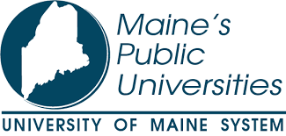 | Visit:  University of Maine  University of Maine Augusta  University of Maine Augusta- Bangor location  University of Maine at Farmington  University of Southern Maine

Visit:
Kennebec Valley Community College
Central Maine Community College
Southern Maine Community College
York Community College

JUNE 26th- JUNE 30th
Pick-up and drop-off locations to be announced soon

In addition to DVR/DBVI staff supervision, DVR post-secondary students will share their experiences in transitioning from high school to college. Participants will hear from two panels of students with disabilities on adjusting to campus and residential life and the importance of self-advocacy.

DVR/DBVI will cover all costs associated with the college tour program which includes transportation, hotel, meals, and supervision.

Students, parents, and guardians will be provided an itinerary and staff phone list once finalized. Written consent is required for participants to attend.

If accommodations are needed to participate please speak with your Vocational Rehabilitation counselor or you can contact Samantha Fenderson at (207)754-1726, samantha.j.fenderson@maine.gov

