Lodging Options for
2023 Annual Commissioner’s Conference for Superintendents
June 25-27, 2023

Atlantic Oceanside Hotel & Event Center
119 Eden Street, Bar Harbor, ME
Tel: (207) 288-5801
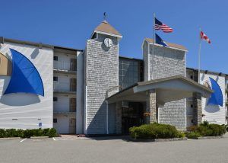

- Atlantic Oceanside – (15 Rooms available @ $259.00 & 63 Rooms available @ $359)
  - One king bed or two queen beds w balcony/patio and bay view
    - 78 Rooms – 6/26
    - 82 Rooms – 6/27

Cut-off Date: Call by May 26th

Bar Harbor Motel  100 Eden Street  Bar Harbor, ME  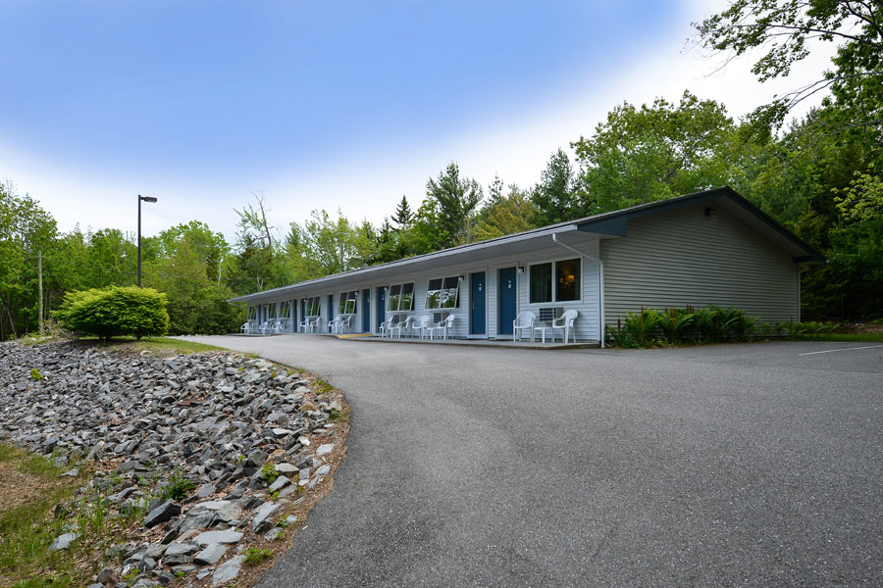  Tel: 1- (800) 388-3453 | Acadia Inn  98 Eden Street  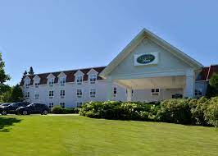  Bar Harbor, ME  Tel: (207) 288-3500  Price - $239  Room Type:  - One king bed  - 6/26 & 6/27 (5 rooms)  - Two queen beds  - 6/26 & 6/27 (10 rooms)  Mention: Superintendents Conference Room Block (6/25-6/27)  To be tax-exempt, each person reserving must email a copy of the departmental/school/organization tax-exempt certificate (after they have reserved). Payment must be made with a departmental/school/organization check or credit card to be tax exempt (can’t use personal credit card to get tax exempt status).  Cut-off Date: Call by May 17th
Bar Harbor Regency Holiday Inn
123 Eden Street
Bar Harbor, Maine 04609

The hotel is holding 15 rooms at a rate of $319.

Click here for more details and booking.

