ESEA Federal Programs: Year-at-a-Glance
Month | Key Items | Key Practices
June | - Schoolwide Plan/Comprehensive Needs Assessment  - ESEA Consolidated Application | - Begin planning for upcoming fiscal year: ESEA Consolidated Application  - Review/Update Schoolwide Plan/Comprehensive Needs Assessment  - Provide time for public comment for upcoming fiscal year ESEA Consolidated Application  - Optional: Submit application for Title I Schoolwide program (if applying for new status)  - Send MDOE ESEA staff notice of any school changes for the upcoming year
July | - ESEA Consolidated Application  - ESEA Dashboard  - Family Engagement  - Semi-Annual Certification(s)  - Planning and review of data | - July 1 (Optional): Submit new application for Title I Schoolwide program  - Review public comments and amend ESEA application where needed  - Update ESEA Dashboard information on district webpage(s)  - Receive Final ESEA allocations for current fiscal year  - Review annual district and school plans for family engagement  - ESEA Coordinator and district leadership meet and review school and district-level data and goals for new school year  FISCAL  - Semi-annual certification of Title I personnel on a single cost objective (January to June)
August | - ESEA Consolidated Application  - Parent’s Right to Know | - August 1: Submit new fiscal year’s ESEA Consolidated Application  - Send home a copy of Parent’s Right to Know notification (teacher and para-professional qualifications) and assessment policy
September | - School and district level data  - Performance Report  - Title I Family meeting | - Conduct annual Title I Family meeting (within 30 days of school start date)  - Distribute District and School Data Dashboard information  - Performance Report is available for updating  FISCAL  - September 30: Funds from any expiring fiscal year(s) must be obligated by September 30
October | - Planning and alignment  - Fiscal reimbursements | - Ensure alignment between approved application, project budgets and schoolwide plans  - Prepare to submit Performance Report and carryover reports from prior fiscal year  FISCAL  - October 31: End of invoicing period for expiring funds  - Submit reimbursement invoices for carryover-funded project expenses
November | - Performance Report  - Closeout Report | - November 1: Submit Performance Report for July 1—September 30 of prior fiscal year grant  - Submit Closeout Reports  - Save evidence of professional development and family engagement activities
December | - ED 534 | - Review ED 534 report and check for eligibility (Title I and V)
January | - Title V  - Title I Schoolwide  - Semi-Annual Certification | - Review and verify Title V data (poverty, ADA, etc.)  - New Title I Schoolwide applicants begin meeting with local planning team  FISCAL  - Semi-annual certification of Title I personnel on a single cost objective (July to December)
February | - Planning and alignment | - Review and ensure alignment between approved application, project budgets and schoolwide plans
March | - Carryover expenditures  - Non-public schools | - Meet with non-public schools to discuss needs of students and teachers, current year’s projects and upcoming year’s ESEA Consolidated application  FISCAL  - Reconcile carryover expenditures with budget and invoices
April | - ESEA Consolidated Application  - Schoolwide Plan  - Title V Funding Application | - Receive preliminary allocations for upcoming fiscal year  - Submit requests to amend budgets, applications and schoolwide plans for current fiscal year as needed  - Begin development of upcoming fiscal year ESEA Consolidated Application  - Current schoolwide schools review and update schoolwide plan  - Title V (SRSA) funding applications due to USDE
May | - Schoolwide Plan and/or Comprehensive Needs Assessment  - Non-public schools | - Review and update the Schoolwide Plan and/or Comprehensive Needs Assessment  - Non-public school consultation for current and upcoming fiscal year

Throughout the year, districts should expect to do the following:
- Collect and save evidence of parent and family engagement activities throughout the year
- Submit fiscal reimbursement invoices every 3-month interval or less (ideally, each month)
- Updates to applications and plans when relevant
- Quarterly meetings between the ESEA coordinator and business manager
- Consult with non-public regularly to ensure alignment between approved application and project budgets

Throughout the year, districts should expect the following from the ESEA team:
- Monthly office hours
- Monthly newsletters
- Ongoing communication, trainings, resources, and support related to ESEA federal programs and grants

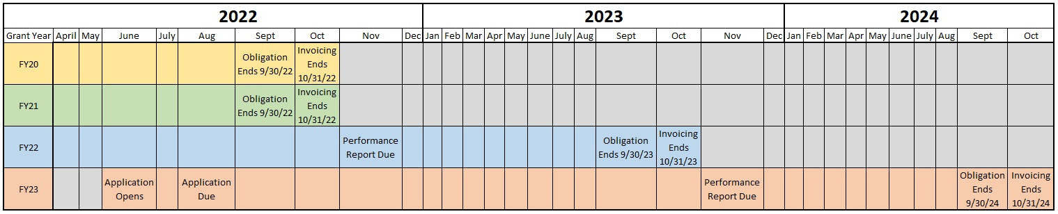
Grant Life Cycle for the ESEA Consolidated Application (Updated June 2022) *
*Please be aware that this grant life cycle will be updated often to reflect waivers, yearly changes, etc. Please use the resources page to access the most recent visual when this no longer applies.

