

LIMITED PURPOSE AQUACULTURE LICENSE (LPA) APPLICATION

This is a joint application form for a limited purpose aquaculture (“LPA”) license from the Maine Department of Marine Resources (DMR) and a permit for aquaculture gear from the U.S. Army Corps of Engineers (ACOE). You must have both an LPA license and Army Corps permit before you can place aquaculture gear in Maine coastal waters.

Incomplete Applications: Incomplete applications may be automatically denied, and application fees forfeited. Review each checklist carefully to make sure all required information is included. Do not leave questions blank. Contact the Aquaculture Division at DMRaquaculture@maine.gov or (207) 350-7815 with any questions.

Missing Signatures: You must have all required signatures before submission. Required signatures are listed in Chapter 2.90(2)(D). If an LPA is sited in five feet of water or less and the municipality has a shellfish management program in accordance with 12 M.R.S.A. §6671 then the signature of the chairperson of the committee or designated town officer is required. Some municipalities have a shellfish program, but no committee. If that is the case, then a municipal official shall sign. If you are unsure if the municipality has such a program, please contact the town. Failure to provide any required signature will result in automatic denial and loss of all application fees.

Required Signature(s) Denied: If required signature is denied (except for cases where a riparian landowner denies signature), you may request that DMR review the basis for the denial of signature (see Chapter 2.90(2)(D)(4)). However, you need to submit with the application a statement that indicates which signatures were denied and a request that DMR review the basis for their denial. Failure to provide this information and request with the initial submission will result in automatic denial and forfeiture of all application fees. Please note that if DMR determines that the signature was denied on reasonable grounds, the application will be denied, and you will forfeit associated fees.

Non-notification of Riparian Landowners: You are required to notify all shorefront and/or intertidal landowners within 300 feet of the license site (please note: many landowners have deeded ownership of intertidal flats and this must be considered for purposes of notification) by sending, via certified mail, a copy of the LPA application, including information about how riparians can submit comments to DMR regarding issuance of the license. If DMR determines that the riparian list is incomplete (i.e. you missed any parcels), the application will be denied and you will forfeit associated fees. Mapping needs to comply with DMR policy, which is hosted on our website on the tab titled “Resources for Growers and Applicants.”

Fee: The Maine Department of Marine Resources requires a non-refundable fee of $100 for each LPA license application from Maine residents and $400 from non-residents of Maine. Make check payable to “Treasurer, State of Maine.” There is no charge for the Army Corps permit. For the purposes of this license application, a resident is a person who: A. If registered to vote, is registered in Maine; B. If licensed to drive a motor vehicle, has made application for a Maine motor vehicle operator’s license; C. If the owner of one or more motor vehicles located within the State, has registered at least one of the motor vehicles in Maine; and D. If required to file a Maine income tax return on the previous April 15th, filed a Maine income tax return.

Legibility: Please use black ink or type when completing your application. In accordance with regulation, DMR sends a copy of your application to the ACOE and municipality. Other ink colors and pencil often become illegible when scanned and copied and can result in delays for the applicant.

Communication and Response: Email is the method of contact DMR will utilize to communicate with you about the application. Failure to respond to inquiries within 30 days is grounds for denial and forfeiture of fees. Please monitor your email and provide requested information in a timely manner. If you do not use email, then all correspondence will be mailed to you, and you need to reply to any requests for information within 30 days of the date listed on the letter.

To apply for an LPA license: Complete this application form, including the required attachments. Send one copy of the application with the attachments and the license fee to the address below. DMR will forward a copy of your application to the Army Corps of Engineers and municipality.

DEPARTMENT OF MARINE RESOURCES
ATTN: Aquaculture Division
21 SHS
Augusta, ME 04333-0021

APPLICATION CHECKLIST

Before submitting your application make sure you have answered all questions and included all of the following documents. Failure to do so may result in significant delays in processing time or denial of the application and forfeiture of application fees.

Required documents for all LPA applications.

☐ Payment for non-refundable application fee $100 for each LPA license application from Maine residents and $400 from non-residents of Maine. Checks must be included with the application and payable to “Treasurer State of Maine”. If paying via credit card, DMR staff will contact you with payment instructions once the application has been received. DO NOT include your credit card information with the application. Note: your application will not be reviewed until payment has been received
☐ Vicinity map with required items shown
☐ Overhead view depicting layout of the gear from overhead
☐ Cross-section view depicting gear & moorings from the side

Documents that are only required for sites that are within 300’ from shorefront property (measured from mean low water mark). Applications for LPA sites in marina slips, lobster pounds, and similar sites are exempt from this requirement.

☐ Tax map
☐ Riparian list, certified
☐ Copies of receipts for sending certified mail to riparian landowners
☐ Complete application including ALL required signatures.

REQUIREMENTS AND RESTRICTIONS FOR LPA LICENSES
See DMR Regulation 2.90 for the full regulation

- License Limit: No more than four licenses may be held by any individual at the same time.

- Density Limit: There can be no more than four LPA license sites within a 1,000-ft. radius. Riparian landowners are allowed to have one LPA site within 150 feet of their shorefront property that does not count toward this limitation. LPA sites located in marina slips, lobster pounds, or similar enclosed or partially-enclosed sites that are owned or controlled by an entity which has the legal authority to restrict access to or use of the site and which has consented in writing to the placement of the gear on the site are exempt from this density standard.

- Assistants: Up to three unlicensed assistants per license may be declared as helpers. An individual holding four licenses can be an assistant on up to eight additional licenses. If the license holder represents an educational institution, students are authorized to work under the direct supervision of the license holder or assistants.

- Intertidal Sites: For LPA sites above the extreme low water mark (XLW) in towns with a municipal shellfish management program established in accordance with 12 M.R.S.A. §6671, the chairperson (or designated town officer) of the municipal shellfish committee is required to sign the LPA application form to verify that the LPA will not unreasonably interfere with the activities of the shellfish program. If the municipality does not have a committee, then a municipal official shall sign. To ensure that all LPA applications above XLW obtain the necessary signatures, all proposed sites in 5 feet of water or less at MLW are required to obtain necessary signatures in communities that have a shellfish management program. For LPA sites above the mean low water mark (MLW), the signature of the riparian landowner of the adjacent upland is required on the application to verify that the landowner consents to the LPA activity being conducted on the owner’s intertidal land.

- Water Quality: Find the water quality classification of your LPA site on the web at https://www.maine.gov/dmr/fisheries/shellfish/shellfish-closures-and-aquaculture-leases-map. LPA license sites for shellfish may not be within 300 feet of any areas classified as prohibited and can only be located in areas that are classified as approved or conditionally approved, except for the sole culture of seed. Sites raising only shellfish seed and complying with maximum seed size limits (DMR Rule Chapter 2.95(A)(4)(a)) may be located in restricted, conditionally restricted, or prohibited areas subject to relay requirements, but are prohibited in the 300:1 dilution area around a wastewater treatment plant outfall (DMR Rule Chapter 2.90(3)(D)(3)). Any person applying for shellfish seed only sites within these classifications is also required to hold a lease or have an ownership stake in a company that holds a lease. Water quality classification restrictions do not apply for the culture of green sea urchins or marine algae, except for marine algae for human consumption, which cannot be grown in the 300:1 dilution area around a wastewater treatment plant outfall.

- Essential Habitats: LPA licenses cannot be located within areas designated as Essential Habitat by the Maine Department of Inland Fisheries and Wildlife (MDIFW).

- Eagle Nests: Bald and Golden Eagles are not protected under the Endangered Species Act but are protected under the Bald and Golden Eagle Protection Act (16 U.S.C. 668 et seq.) by the U.S. Fish & Wildlife Service (USFWS). The USFWS recommends that all structures and activity should be limited to no closer than 660 feet of an active nest to avoid disturbing eagles.

- Riparian Landowners: You are required to notify all shorefront and/or intertidal landowners within 300 feet of the license site by sending, via certified mail, a copy of the LPA application, including information about how riparians can submit comments to DMR regarding issuance or renewal of the license. Consideration should be given to the fact that most riparians own to the mean low water mark. Notification requirements apply to privately and publicly (municipal, state, or federal) owned lands.

- Army Corps Permit: A permit from the U.S. Army Corps of Engineers is required prior to the placement or use of any gear in the license area. For more information about the Army Corps permit, contact cenae-r-me@usace.army.mil or (207) 623-8367.

- Renewing your LPA License: LPA licenses expire on December 31 each year. DMR will send you renewal instructions prior to December 31.

IMPORTANT INFORMATION FOR LPA LICENSEHOLDERS
Source: DMR Rule Chapter 2.90 (5) and (6)

- No Discharge. See Chapter 2.90 (5)(A). The licensed activity must not generate a discharge. This means that you cannot add any substances to the water, such as feed or medicine.

- Carry a copy of the LPA License. See Chapter 2.90 (5)(B). You and your named assistants are the only people legally allowed to handle aquaculture gear belonging to you. You must each carry a copy of the LPA license whenever you are engaged in any activity at the LPA site. If a National Weather Service-issued hurricane warning is in effect, then others may also assist you and handle the gear.
- Restrictions on Harvest. See Chapter 2.90 (5)(C)(1). Harvest of shellfish is prohibited in areas closed due to marine biotoxins or bacterial pollution. For details about closed areas, see the Department’s web site at: https://www.maine.gov/dmr/fisheries/shellfish/closures or call DMR Marine Patrol Division I at 207-633-9595 (for areas west of Lincolnville), or Division II at 207-664-2392 (for areas east of Camden), or call the Shellfish Sanitation Hotline at 1-800-232-4733. LPAs do not qualify for Memorandum of Understanding agreements to allow exemptions from biotoxin closures.

- Record-Keeping. You must maintain complete, legible, and accurate records of transport, transfer, harvest, and monitoring and keep these available for inspection for at least two (2) years; and submit to the Commissioner an annual report of these activities. The records must include the following:

  - LPA acronym, site location, date
  - Source of shellfish, including seed if the seed is from growing areas which are not in the approved classification status pursuant to Chapter 2.90 and/or Chapter 94;
  - Dates of transplanting and harvest;
  - Detailed records of sales;
  - Records of the origin and health status of all seed or shellfish stock reared on the site must also be maintained.

- Site Marking. See Chapter 2.90 (6)(B) and (C). The LPA site ID and SEA FARM must be clearly marked on every buoy. Each LPA site that has gear must be marked at each corner, center point, or at each end of the gear as appropriate for the gear type deployed. Marker buoys must be yellow and host reflective material.

- Maintenance Standards. See Chapter 2.90 (6)(A). All aquaculture gear must be maintained and kept in a fully operational condition. You must collect and/or remove any loose or errant gear or equipment. Storage of gear when not in use must be located in an upland location and not on the substrate or on marsh vegetation. You must be proactively ensuring that bird or mammal waste does not accumulate on gear and adversely impact water quality on or around your LPA.

- Contact the Coast Guard. You need to contact the U.S Coast Guard Private Aids to Navigation Office for approval of navigation marking devices according to the United States Coast Guard Private Aids to Navigation (PATON) standards. To begin the application process, go to http://www.usharbormaster.com and register. Send DMR a copy of any Coast Guard marking requirements.

- To harvest product or remove it for any purpose from your LPA site you must also obtain an Aquaculture Harvester License and follow all other pertinent rules and regulations such as tagging of shellfish. This license can be obtained through DMR’s Licensing Program or LEEDs (online licensing system). You may also be responsible for reporting your harvest to DMR’s Landings Program. Please see Chapter 8 of DMR’s regulations for additional information concerning reporting requirements.

- Amendments. No changes can be made to the LPA license during the licensing term. At the time of renewal, the holder may request changes to source of stock, species, mooring type/layout, and assistants.

- Contact information. The LPA holder must notify the Aquaculture Division of any changes to the contact information listed on the license, in writing, within 30 days of the change taking effect.

Applicant Information
Name of Applicant
(must be a person or Municipal Shellfish Management Committee)
Address
City
State, Zip
Telephone
Email*
Date of Birth
(must be a minimum of 12 years old to apply)
Prior Submissions | Is this an application for a site that you have previously applied for? ☐ No ☐ Yes If you selected “Yes” please list the previous LPA acronym(s):
Payment Type | ☐ Check (included) ☐ Credit Card**
*Note: The email address you list here will be the primary means by which we will contact you. Please provide an email address checked regularly. If you do not use email, please leave this blank.
** If paying via credit card, DMR staff will contact you with payment instructions once the application has been received. DO NOT include your credit card information with the application.

Assistant Information
Are you listed as an assistant on any existing LPA licenses? | If yes, list the LPA Acronyms:
Do you have any other current LPA licenses? | If yes, list the LPA Acronyms:
Assistants | 1)  2)  3)

Location of License Site
Town
County
Waterbody
Additional description (e.g., south of Hog Island)
LPA Health Zone  (More information on LPA Health Zones can be found on MDMR’s website) | .
Is this site above mean low water (is the site intertidal)?
If no above, is this site above extreme low water (is it located within 5 feet of water or less)? | NOTE: If an LPA is sited in five (5) feet of water or less and the municipality where the proposed site is located has a municipal shellfish program in accordance with 12 M.R.S.A. §6671, then additional signatures are required (see Chapter 2.90(D)(3)(a)
Purpose | ☐ Commercial (product is ultimately sold)  ☐Recreational (product kept for personal use, not sold)  ☐Municipal Shellfish Management  ☐Scientific  ☐Educational
Species and Source of Stock: Check each species you intend to cultivate in the current license year and list the source of stock. Seed needs to come from an approved hatchery or originate from within the LPA License Health Area in which your license is located. Clams may only be sourced from an approved hatchery.

Check Here | Species | Source of Stock (Name, Address, Phone) | Approved Hatchery | “Wild”, Same LPA Health Area
☐ | Blue mussel (Mytilus edulis) |  | ☐ | ☐
☐ | European oyster (Ostrea edulis) |  | ☐ | ☐
☐ | American/eastern oyster (Crassostrea virginica) |  | ☐ | ☐
☐ | Hard clam/quahog (Mercenaria mercenaria) |  | ☐ | ☐
☐ | *Sea scallop (Placopecten magellanicus) |  | ☐ | ☐
☐ | Soft-shelled clam (Mya arenaria) |  | ☐ | ☐
☐ | Artic surf clam (Mactromeris polynyma) |  | ☐ | ☐
☐ | Hen clam (Spisula solidissima) |  | ☐ | ☐
☐ | Razor clam (Ensis leei) |  | ☐ | ☐
☐ | Green sea urchin (Strongylocentrotus droebachiensis) |  | ☐ | ☐
☐ | *Bay scallop  (Aequipecten irradians) |  | ☐ | ☐
☐ | Marine algae (all seaweeds, including kelp) | List each individual marine algae species and sources of stock here: | ☐ | ☐

* Sales of adductor muscles only. Sales of roe-on or whole scallops are strictly prohibited.

Water Quality Classification
Growing Area Designation (e.g. WA(A) or WA(P1)
If the proposed site is located within an area classified as prohibited, restricted, or conditionally restricted the following apply:  - Only shellfish seed can be cultured on the site  - Must comply with the maximum seed size limits defined in Chapter 2.95(A)(4)  - Seed can only be moved to an aquaculture lease site, and you must contact dmrpublichealthdiv@maine.gov prior to any movement.  - In consideration of Part C - You must have a lease or ownership stake in a company that holds a lease | Please check box to indicate understanding and compliance: ☐  Please use the space below to list the lease site ID(s) and the name of person or entity that holds the lease(s):
Water quality information can be found here: https://www.maine.gov/dmr/fisheries/shellfish/shellfish-closures-and-aquaculture-leases-map

Coordinates
Enter geodetic coordinates for the center point of the license site below. Please enter your coordinates using the following format:

Decimal Degrees (43.123456 N, -69.123456 W)
Latitude | W
Longitude | N

Site Characteristics
Describe the surrounding uplands (i.e. forested, residential, farmland, commercial):

Describe the bottom characteristics (description of substrate including flora and fauna):

Depth
Depth at mean low water in feet: ________________________
Depth at mean high water in feet: _______________________
Is your site located within an Essential Habitat by the Maine Department of Inland Fisheries and Wildlife (MDIFW) Essential Habitat?
☐ Yes ☐ No
Is there an eagle’s nest within 660 feet (200 m) of the proposed LPA?
☐ Yes ☐ No
Eelgrass: Are there eelgrass beds on or near the site? If none, write "None." If so, where? How far are they from the site?
When were these eelgrass observations made?
Month: | Year:

Existing Uses: Describe, in detail, your observations of all current uses of the waters on and around the proposed license site. Answer all questions in the boxes below.
Commercial Fishing
What type of commercial fishing occurs in the area?

What season(s) do commercial fishing activities occur in the area?

How frequently does commercial fishing activity occur?

Does commercial fishing occur within the boundaries of the proposed site? If no, please describe where it occurs relative to the proposed site (i.e. 150 feet to the west of the site, etc.)

What impacts do you anticipate your proposed site having on observed commercial fishing in the area?

Recreational Fishing
What type of recreational fishing occurs in the area?

What season(s) do recreational fishing activities occur in the area?

How frequently does recreational fishing activity occur?

Does recreational fishing occur within the boundaries of the proposed site? If no, please describe where it occurs relative to the proposed site (i.e. 150 feet to the west of the site, etc.)

What impacts do you anticipate your proposed site having on observed recreational fishing in the area?

Boating Activities
What type of boating occurs in the area (i.e. commercial, recreational)?

What season(s) do boating activities occur in the area?

How frequently does boating activity occur?

Does boating occur within the boundaries of the proposed site? If no, please describe where it occurs relative to the proposed site (i.e. 150 feet to the west of the site, etc.)

What impacts do you anticipate your proposed site having on observed boating in the area?

Other water-related uses (kayaking, swimming, etc.)
What type of other water related uses occur in the area (i.e. kayaking, swimming, etc)?

What season(s) do other water related activities occur in the area?

How frequently do other water related activities occur?

Do other water related activities occur within the boundaries of the proposed site? If no, please describe where they occur relative to the proposed site (i.e. 150 feet to the west of the site, etc.)

What impacts do you anticipate your proposed site having on observed water related activity in the area?

VICINITY MAP
NOTE: An example vicinity map is included at the end of this application and additional sample drawings available at https://www.maine.gov/dmr/aquaculture/applications-and-forms/limited-purpose-aquaculture-lpa-license-applications-and-forms

DIRECTIONS: Attach a vicinity map showing the LPA site and surrounding area. An enlargement of a NOAA chart or USGS Topographic map is suggested to provide this information. On the map, show the following:

- Location of proposed site
- 300’ radius circle around site
- 1,000’ radius circle around site
- Gear orientation
- North Arrow (indicate true or magnetic north)
- Show depth contours and indicate mean low water (MLW) and mean high water (MHW) on all land adjacent or nearest the site.
- Ebb and Flood directions
- Scale used on plan
- DMR water quality classification area
- Distance to prohibited area classification, if applicable

Label the location on your vicinity map, and check each of the following below, that are within 1,000 feet of the site. For each that applies, also indicate how your proposed site would impact each. If additional space is needed add an additional page.

☐Federal navigation projects or anchorages
How will your proposed site impact federal navigational projects or anchorages?

☐ Navigational channels
How will your proposed site impact navigational channels?

☐ Structures
Use the space below to list any structures in the area, then specify how your proposed site will impact those structures.

☐ Aquaculture leases or licenses (LPAs)
How will your proposed site impact other aquaculture leases or licenses in the area?

☐ Anchorages or moorings
How will your proposed site impact anchorages or moorings in the area?

☐ State or federal beaches
How will your proposed site impact state or federal beaches in the area?

☐ Docking Facilities
How will your proposed site impact docking facilities in the area?

☐ None of the above (you are certifying that the proposed site is not within 1,000 feet of anything listed above)

GEAR DESCRIPTION

No Gear (bottom culture only): Organisms will be cultured on the bottom with no gear or predator netting.

Upweller: Floating upweller system for spat growout.

Shellfish rafts, associated predator nets and spat collectors: Floating raft with suspended dropper lines and anti-predator netting typical of mussel culture. E.g. mussel raft.

Shellfish tray racks and over wintering cages: Box shaped cages made of rigid mesh (wire coated or plastic), often with interior shelves designed to hold soft mesh bags. Tray racks are often outfitted with floats that double as feet to hold the cages off the bottom. E.g. OysterGro and OysterRanch cages.

Soft bags, semi rigid bags, and/or floating trays: Single-layer soft mesh bags that are typically made of rigid plastic or wire mesh. Bags are most frequently floated on the surface in lines, placed inside tray racks/overwintering cages, or sunk to the bottom.

Lantern nets and/or pearl nets: A lantern net is a five or ten tier set of circular nets suspended from a central line. A pearl net is a single, pyramidal mesh enclosure.

Scallop spat collector bags: Mesh bags containing additional material (e.g. smaller mesh, Brillo pads) to increase surface area. Multiple bags are typically attached to a single vertical line.

Scallop ear hangers: Horizontal or vertical lines that attach to individual scallops by ear hangers.

Marine algae gear: Gear typically used may include rope, rafts with ropes attached, bags, longlines, and or rope grids.

Bottom anti-predator netting: Netting that is spread over the bottom to exclude predators from species being cultured.

Check each gear category that you are seeking authorization for.
☐ No Gear (bottom culture only)
☐ Upweller
☐ Shellfish rafts, associated predator nets and spat collectors
☐ Shellfish tray racks and over wintering cages
☐ Soft bags, semi rigid bags, and/or floating trays
☐ Lantern nets and/or pearl nets
☐ Scallop spat collector bags
☐ Scallop ear hangers
☐ Marine algae
☐ Bottom anti-predator netting

List each individual gear type that you will use in the table below. ALL GEAR must be listed in the table, including lines, moorings, etc. even if it is displayed elsewhere in the application.
Specific Gear Type and Maximum Number to be used (e.g. (20) soft mesh bags) | Dimensions  (e.g. 16”x20”x2”) | Dates that gear will be in the water

Outer dimensions of maximum gear layout:
Note: Gear, excluding mooring equipment, may not exceed 400 square feet and must be provided in whole feet.
Width (1’ or more): ______________ Length (1’ or more): __________________

Describe the moorings/tackle to be used inclusive of mooring type, bottom tackle, line, etc.
Will there be seasonal changes to your gear deployment? If yes, describe.
(i.e. will your cages be sunk during the winter months, will your longlines be removed in the summer, etc.)

COMPLETE THIS SECTION FOR CULTURING SHELLFISH IN SUSPENDED GEAR ONLY:
Suspended culture gear (e.g. floating bags, cages, or trays) can attract birds that roost on the gear and defecate, potentially creating a pollution source impacting shellfish held within the gear. In order to comply with the National Shellfish Sanitation Program (NSSP) Model Ordinance (MO), DMR is requiring that applications for the suspended culture of shellfish include a description of mitigation or deterrent measures to minimize the potential pollution impacts of birds at the proposed site. If appropriate, include sketches or photos that clearly depict those measures put into practice. Please note, washing of bird feces into surrounding waters is not considered mitigation or deterrence and will not be accepted.

Examples may include:
- Submerging suspended gear and associated product at a depth sufficient to deter roosting for two weeks before harvest
- Attaching physical deterrents (i.e. zip ties) to gear
- The site is proposed for the culture of seed only
- The site is proposed for the culture of adductor-only scallops (i.e. no other shellfish species would be grown on the site)
- Proposed gear would always be suspended below the surface of the water at a depth sufficient to deter roosting (i.e. as is common for scallop lantern nets)

OVERHEAD VIEW AND CROSS-SECTIONAL VIEW OF GEAR LAYOUT
Attach both an overhead view and cross-sectional view drawing of your proposed gear on 8 ½” x 11” paper, drawn clearly and dark enough to photocopy. Do not use color shading; it will not show on copies.
NOTE: Sample drawings can be found at the end of this application and additional samples are posted on the DMR web site at: https://www.maine.gov/dmr/aquaculture/applications-and-forms/limited-purpose-aquaculture-lpa-license-applications-and-forms

DIRECTIONS:

- Overhead View: From an overhead view, show the maximum layout of gear to be deployed on the site. Label gear to show number of units, dimensions, and materials. Include drawings of individual types of gear. Show on the plan that the area occupied by the gear, excluding mooring equipment but including space between items of gear, will not exceed 400 square feet.

Provide an overhead view for each possible gear configuration, including seasonal changes.

- Cross-Section View: Show the sea bottom substrate, mean high and low water marks, and profiles of gear in cross-section as it will be deployed. Label all gear with dimensions and materials. Show mooring gear with mooring type, scope, hardware, and line type and size. Drawing must depict water depth at mean high- and mean low-water.

Provide a cross-section view for each possible gear configuration, including seasonal changes.

REQUIRED SIGNATURES

Harbormaster or Town Official Signature

I have reviewed this license application and find that this activity, as proposed, will not unreasonably interfere with navigation, the ingress and egress of riparians within 300’ of the license site, or fishing or other uses of the area.

Print Name, Town, Title: Date

Signature of Harbormaster or Town Official

*DMR Rule Chapter 2.90 (2) (D) (2) – In municipalities not served by a harbormaster, a municipal officer (selectman, councilor, alderman, or mayor, see 30-A MRS §2001 (10)) or other elected municipal official may sign the application. For the unorganized territory where a harbormaster does not have jurisdiction, a marine patrol officer may sign.

OTHER SIGNATURES REQUIRED AS NOTED BELOW

Marina or Pound Owner
(For sites in marina slips, lobster pounds, and similar areas - see DMR Rule Chapter 2.90 2 (E)(1)

I, (print name), am the owner or the authorized representative of the owner or entity that has the legal authority to restrict access to or use of the marina slip, lobster pound, or similar area where this LPA license site is located, as described in DMR Rule Chapter 2.90 (1) (B). I consent to the placement of aquaculture gear on this site as proposed in this application.

Signed: Date:

Riparian Landowner of Intertidal Zone:
(For sites above mean low water, MLW – see DMR Rule Chapter 2.90 (2)(D)(3)(b)

I, (print name), am the riparian owner of the upland and adjacent intertidal land where this LPA license site is located. I consent to the placement of aquaculture gear on this site as proposed in this application.

Signed: Date:

Municipal Shellfish Management Program:
(For sites above extreme low water, XLW see DMR Rule chapter 2.90(2)(D)(3)(a). Required for sites in 5 feet of water or less at mean low water. Only required in municipalities with a municipal shellfish management program established in accordance with 12 M.R.S.A. §6671)

I, (print name), am the chairperson or designated town officer of the Municipal Shellfish Management Committee for the Town of _________.This LPA license site is located above the extreme low water mark. My signature below verifies that this LPA will not unreasonably interfere with the activities of the municipal shellfish management program, according to DMR Rule Chapter 2.90(D) (3)(a).

Signed: Date:

Riparian Notification
Is there shorefront land (including land above MLW and state and federal owned land) within 300 feet of the proposed license site?

☐ Yes ☐ No

If yes, you are required to send a copy of your application to all riparian property owners whose property, including those lands between high water and mean low water, is within 300 feet of the proposed license site following the directions below. If there is no shorefront land, including lands to the mean low water mark, within 300 feet, you may skip this section. Applications for LPA sites in marina slips, lobster pounds, and similar sites are exempt from this requirement.

INSTRUCTIONS FOR NOTIFICATION TO RIPARIAN LANDOWNERS

Step 1, Tax Map: Obtain a copy of the municipal tax map showing the land in the vicinity of the lease site. On the map, mark the center point of the LPA site. If there is an accurate scale on the map, draw a 300-foot radius around the site. ATTACH THE MAP TO YOUR APPLICATION

NOTE FOR LPAs PROPOSED IN UNORGANIZED TERRITORY: To obtain a list of shorefront properties for LPAs in Unorganized Territory, contact Maine Revenue Services, Property Tax Division (Unorganized Territory), PO Box 9106, Augusta, Maine, 04332-9106. 207-624-5600.

Step 2, Riparian Owners List: On the “Certified Riparian List” (Page 17 below), list the names and current mailing addresses of all riparian landowners of shorefront land, including lands to the mean low water mark, within 300 feet of the lease site as shown in the municipal tax records. Have the list certified by the municipal clerk or tax collector. ATTACH THIS LIST TO YOUR APPLICATION

Step 3, Notify Riparians: Send a copy of the completed application, including the page of this application titled “Notice to Riparian Landowners” (Page 16 below), via certified mail to all the riparian landowners on the list. Note: Name and address must be filled out on receipt(s). ATTACH THE ORIGINAL (OR COPIES) OF THE RECIEPTS TO YOUR APPLICATION

NOTICE TO RIPARIAN LANDOWNERS

You have received a copy of an application to the Maine Department of Marine Resources (DMR) for a limited purpose aquaculture (LPA) license to grow shellfish or marine algae (seaweed) in an area of Maine coastal waters covering no more than 400 square feet. DMR rules require the applicant to send a copy of the application to owners of shorefront land that is located within 300 ft of the proposed license site.

LPAs are processed in accordance with 12 M.R.S.A. §6072-C and Chapter 2.90 of DMR’s regulations. These are annual licenses that expire December 31st each year and are very limited in scale. They are a ‘permit-by-rule’ type of application and there is no public hearing. LPAs may be granted if they do not unreasonably interfere with navigation, fishing or other uses, or the ingress and egress of riparian landowners.

If you have concerns about this application specific to navigation, fishing or other uses, or riparian ingress/egress, please submit comments to DMR. Comments need to be submitted to the email or mailing address listed below within the next two weeks. DMR will review any comments received in consideration of applicable decision criteria (listed above) and laws and rules governing LPA processing. In accordance with law, notice of a final decision is sent to the municipality.

If the LPA is granted, the licensee may apply to renew their license prior to December 31st. DMR will notify the municipality of LPA renewals as required by law. DMR will request the municipality post notice of the renewal application at the town office (this typically occurs in November). Persons may submit comments to DMR about the proposed renewal within 14 days of the date of the notice.

Department of Marine Resources
Attn: Aquaculture Division
21 SHS
Augusta, ME 04333-0021
DMRaquaculture@maine.gov

RIPARIAN OWNERS LIST
For LPA applications

THIS LIST MUST BE
***CERTIFIED***

On this list, please show the current owners’ names and mailing addresses for all shorefront parcels, including lands owned to the mean low water mark, within 300 feet of the proposed license site along with the map and lot number for each parcel. It is the applicant’s responsibility to assemble the information for the Town Clerk to certify. The Town Clerk only certifies that the information is correct according to the Town’s records. Once you have completed the form, ask the Town Clerk to complete the certification form below. If the parcels are within more than one municipality, provide a separate, certified, riparian list for each municipality.

TOWN OF: Click or tap here to enter text.

MAP ## | LOT # | Landowner name(s) and address(es)

CERTIFICATION

I, , Town Clerk for the Town of , certify that the names and addresses of the property owners listed above, as well as the map and lot numbers, are those listed in the records of this municipality and are current as of this date.
SIGNED: DATE:

MAP ## | LOT # | Landowner name(s) and address(es)

Please use additional sheets if necessary and attach hereto.

CERTIFICATION

I, , Town Clerk for the Town of , certify that the names and addresses of the property owners listed above, as well as the map and lot numbers, are those listed in the records of this municipality and are current as of this date.
SIGNED: DATE:

APPLICANT’S SIGNATURE

I declare that the information I have provided on this form is true and correct and that I will comply with all applicable DMR laws and rules. I understand that, under Title 12 MRS §6306, my signature on this application authorizes Marine Patrol officers to inspect my license site. I understand that my license can be revoked if I provided false information in my application.

Signature of Applicant Date

Note: When the applicant is a municipal shellfish management committee, the committee chair shall sign the application (C.2.90 (2) (D) (1)).

Before submitting your application make sure you have answered all questions and included all of the following documents:

☐ Payment for non-refundable application fee $100 for each LPA license application from Maine residents and $400 from non-residents of Maine. Checks should be included with the application and payable to “Treasurer State of Maine”. If paying via credit card, DMR staff will contact you with payment instructions once the application has been received. DO NOT include your credit card information with the application. Note: your application will not be reviewed until payment has been received
☐ Vicinity map with required items shown
☐ Overhead view depicting layout of the gear from overhead
☐ Cross-section view depicting gear & moorings from the side

Documents that are only required for sites that are within 300’ from shorefront property (measured from mean low water mark). Applications for LPA sites in marina slips, lobster pounds, and similar sites are exempt from this requirement.

☐ Tax map
☐ Riparian list, certified
☐ Copies of receipts for sending certified mail to riparian landowners
☐ Complete application including ALL required signatures

SAMPLE MAP and GEAR DRAWINGS:

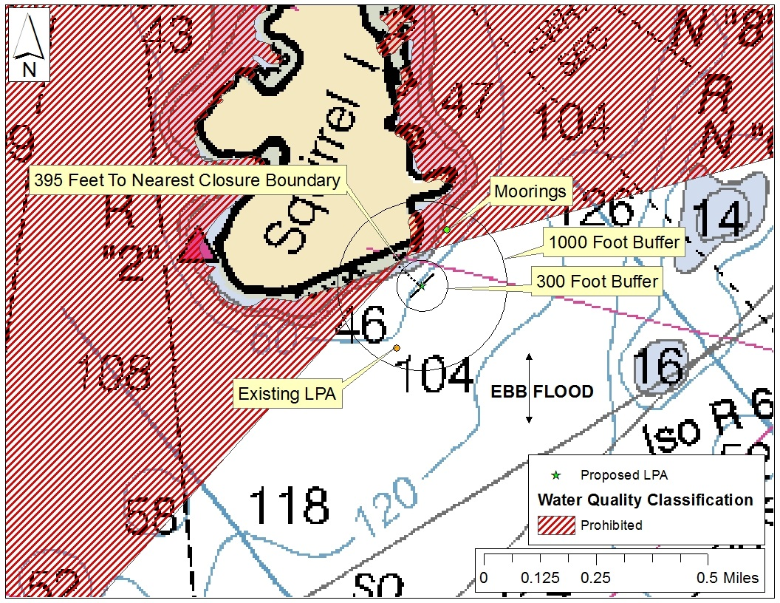
Figure 1. Example Vicinity Map.

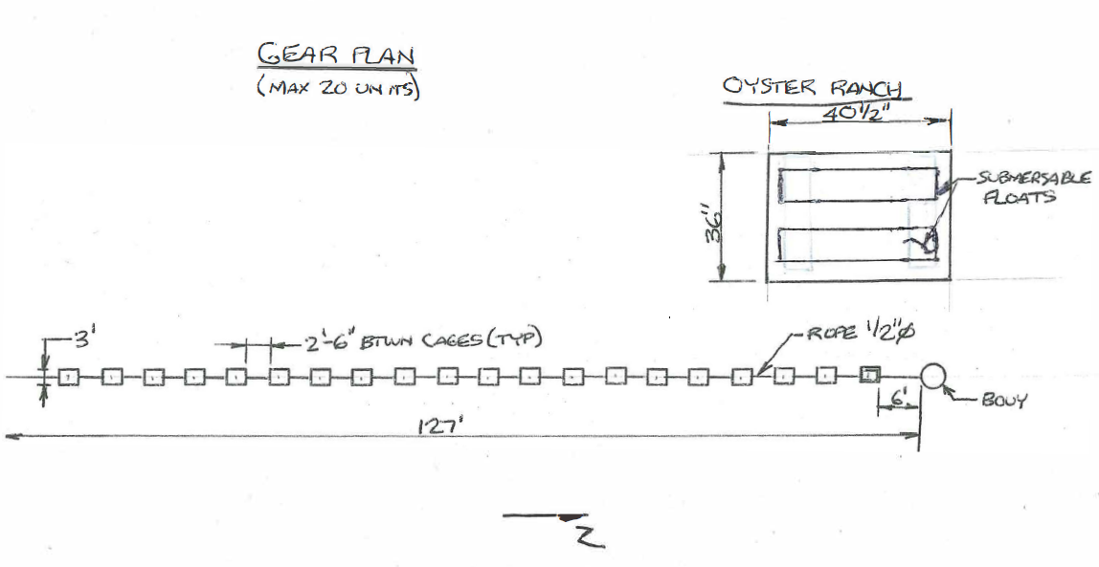
Figure 2. Example overhead view of gear.

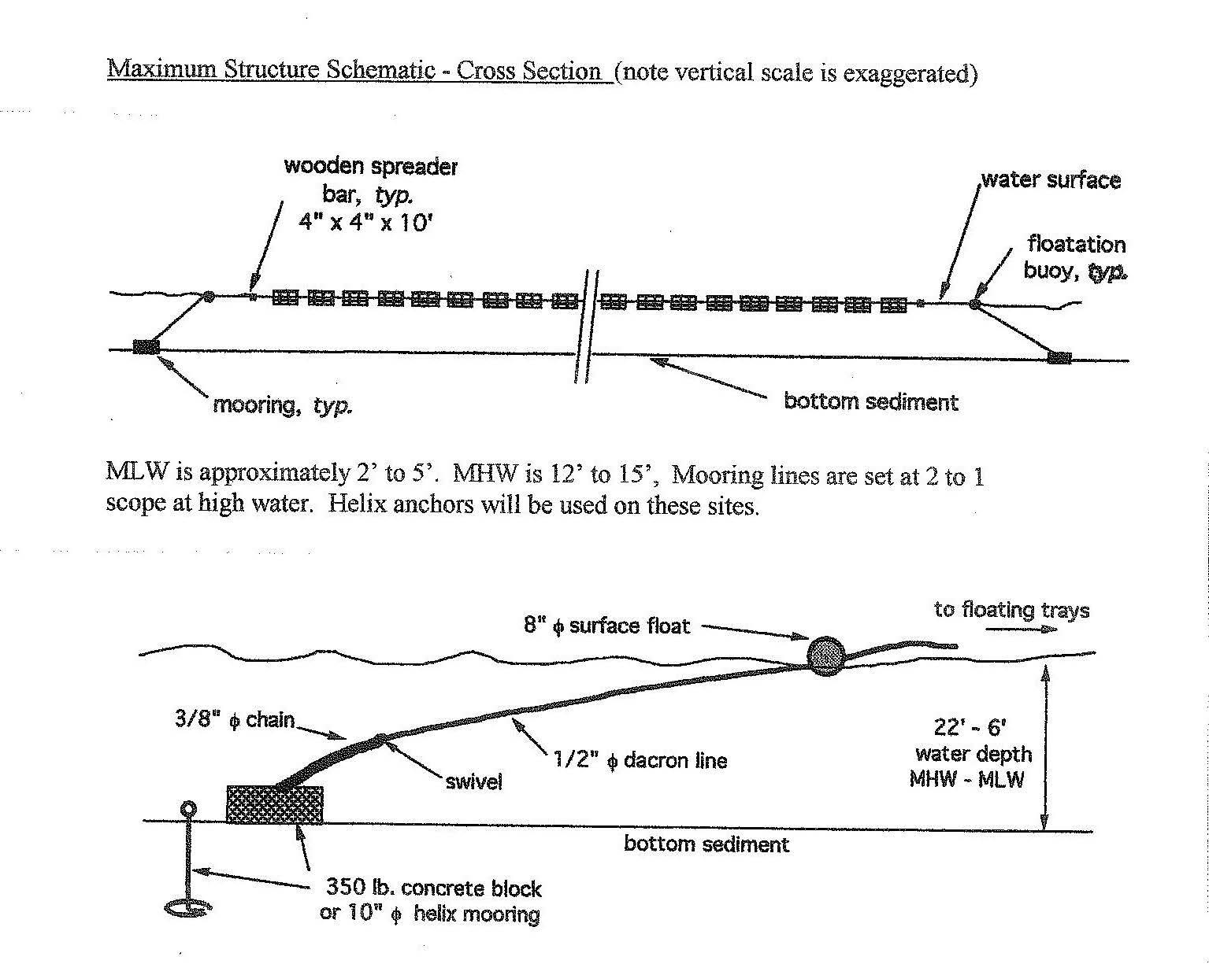
Figure 3. Example Cross Sectional View of Gear.

