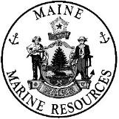
Characterization of fishing efforts for highly migratory species in the Gulf of Maine and how this relates to areas considered for offshore wind development

Davis, M.M.¹ and Kneebone, J.²

¹ Matthew M. Davis: Department of Marine Resources, State of Maine, 194 Mckown Point Rd, West Boothbay Harbor, ME 04575; 207-592-2339 (office); matthew.m.davis@maine.gov; corresponding author

² Jeff Kneebone: Anderson Cabot Center for Ocean Life, New England Aquarium, Central Wharf, Boston, ME 02110

Table of Contents
1 Executive Summary
2 Introduction
2.1 Objectives
3 Methods
3.1 Study Areas
3.2 Online Survey
3.2.1 Online Survey Design
3.2.2 Online Survey Analysis
3.3 Federal Survey Sources
3.3.1 Federal Survey Design
3.3.2 Federal Survey Analysis
4 Results
4.1 Online Survey
4.2 Large Pelagic Intercept Survey
4.3 Conventional Tagging Events
4.4 Data Convergence
5 Discussion
5.1 Technical Considerations
6 Acknowledgements
7 Literature Cited
8 Tables
9 Figures

1 | EXECUTIVE SUMMARY

The Gulf of Maine is an expansive, ecologically productive semi-enclosed body of water located in the western North Atlantic Ocean, bordered by Nova Scotia and the states of Massachusetts, New Hampshire, and Maine. The nutrient-rich waters support a complex trophic system that supports both permanent and seasonal migrants, including several highly migratory species (HMS), such as sharks and tunas. These animals rely on the Gulf of Maine for essential habitat and control the function of their respective ecosystems as apex predators. These HMS also hold an important economic role, as thousands of fishermen are attracted to the Gulf of Maine each year for seasonal fishing opportunities. The Gulf of Maine is currently under consideration for the development and installation of floating offshore wind turbines, although siting has yet to be determined within the Draft Call Area. The objective of this report was to improve our understanding of spatial fishing activities for HMS within the areas of consideration for offshore wind development in the Gulf of Maine, and to use this information in offshore siting discussions to help minimize negative impacts on HMS fisheries. Fisheries data in this report was provided by 1) recreational and commercial hand-gear fishermen via an online survey, 2) the National Oceanic and Atmospheric Administration (NOAA) Large Pelagic Intercept Survey, and 3) voluntary NOAA mark-recapture programs.
An online survey was created using ArcGIS Survey123 and left open from December 7, 2022 to February 24, 2023 (80 days). The survey asked fishermen to describe their HMS fishing activity in the Gulf of Maine between the years 1980-2021, with more details requested from the most recent years of fishing (2010-2021). A total of 187 respondents completed the survey in its entirety, with more than 70 submissions each from Maine and Massachusetts. Most respondents held either an HMS General (n = 52), HMS Charter/Headboat (n = 49), or HMS Angling (n = 38) permit at the time of surveying, although a large proportion of the relatively small HMS Harpoon fishery (n = 19; approximately 54% of HMS Harpoon permits) also participated. Of the respondents, 142 (76%) actively fished for HMS in the current Gulf of Maine Draft Call Area for floating offshore wind consideration. Fishing activity for HMS in the Draft Call Area typically decreased from west to east, with areas of greatest reported activity including the Mistaken Grounds, Platts Bank, and east of Jeffreys Ledge, followed by Three Dory Ridge, Wilkinson Divide, Murray Basin, and Wildcat Knoll.
Capture points from the NOAA Large Pelagic Intercept Survey (LPIS) and Conventional Tagging Events (CTE) provided by the NOAA Northeast Fisheries Science Center Cooperative Shark Tagging Program and the NOAA Southeast Fisheries Science Center Cooperative Tagging Program were used to directly and indirectly characterize historical fishing efforts for HMS in the Draft Call Area. There were a total of 278 trips documented by the LPIS between 2002 - 2020 in the Draft Call Area, approximately 78% of which originated in Maine. On these trips, a total of 119 HMS were captured, split nearly evenly between Atlantic Bluefin Tuna and sharks. Conventional Tagging Events spanned 1960-2020 and contained 1,063 capture points within the Draft Call Area, the majority of which involved Blue Shark (93%). Together, LPIS and CTE data demonstrated a concentration of HMS fishing activity in the northwest corner of the Draft Call Area, particularly on and surrounding Platts Bank.
Synthesis of results from the online survey and the NOAA federal fisheries-dependent data indicated that HMS fishing effort generally occurs throughout the Draft Call Area, with popular locations in the western portion (Mistaken Grounds, Platts Bank, and Jeffreys Ledge) experiencing the greatest amount of effort. Data from the Large Pelagic Intercept Survey indicated that Atlantic Bluefin Tuna were the most targeted HMS by trip number within the Draft Call Area, which was supported by results from the online survey, where 97% of respondents reported targeting Atlantic Bluefin Tuna. Nearly 43% of online survey respondents also reported targeting one or more shark species, although sharks comprised a larger proportion of CTE than did Atlantic Bluefin Tuna. Additional work is required to thoroughly assess the potential effects of floating offshore wind installation on HMS and their associated fishing industries. Stakeholder engagement will be vital in future discussions surrounding the siting and installation of floating offshore wind infrastructure to minimize the biological impacts these structures will have on the environment, as well as the economic and societal impacts on local communities.

2 | INTRODUCTION
In recent years, there has been a growing global interest in expanding offshore wind as a renewable and reliable energy resource. According to the International Energy Agency (2019), the offshore wind industry has grown an average of approximately 30% annually since 2010 (Hernandez et al., 2021). In November of 2020, the State of Maine announced its plans to host the country’s first floating offshore wind farm in the Gulf of Maine (GOM). The following October, the State of Maine submitted a research lease for 17.9 km² of offshore territory in the GOM to be used as an experimental wind research array containing up to 12 turbines. In August of 2022, the Bureau of Ocean Energy Management (BOEM) released a Request for Competitive Interest for the Maine research lease, as well as a Request for Interest (RFI) for the larger GOM outer continental shelf (known as the GOM Planning Area). In January of 2023, it was determined that no competitive interest existed for the Maine research lease application. Furthermore, the commercial RFI for the broader GOM Planning Area resulted in a reduction of 15,378 km², with the remaining territory for wind development consideration referred to as the “Draft Call Area” (Figure 1).
The GOM supports a large and complex array of marine ecological structures and oceanographic dynamics, many of which play an important role during one or more life stages of seasonal and resident temperate species (Staudinger et al., 2019). One such group of pelagic fishes, referred to as highly migratory species (HMS; e.g., tunas, billfishes, and sharks), rely on both inshore and offshore habitats in the GOM for summer foraging grounds (Campana et al., 2008; Diamond 2012; Curtis et al., 2014; Golet et al., 2015; Logan, Golet, & Lutcavage 2015; Staudinger et al., 2019). The compilation of data from collaborative research initiatives between fishing industries and fisheries scientists have led to the designation of several regions within the GOM (including parts of the Draft Call Area) as Essential Fish Habitat (EFH) by National Oceanic and Atmospheric Administration (NOAA) Fisheries, indicating these areas to be critical habitats essential for the survival of a species. Currently, NOAA Fisheries has designated seven HMS as having EFH within the current Draft Call Area: Albacore Tuna, Thunnus alalunga; Atlantic Bluefin Tuna, Thunnus thynnus; Basking Shark, Cetorhinus maximus; Blue Shark, Prionace glauca; Common Thresher Shark, Alopias vulpinus; Porbeagle Shark, Lamna nasus; and White Shark, Carcharodon carcharias (Figure 2; NMFS, 2017). The full effects of an altered environment and seascape within the GOM due to climate change and infrastructure on these HMS remain unknown. Regarding the potential impacts of offshore wind infrastructure on HMS, a study by Puig-Pons et al. (2021) observed reactions from caged Bluefin Tuna when exposed to the emissions of windmill turbine sound from a fixed distance. Reactions by the tunas came in the forms of positional change in the water column, contractions and expansions of the school, displacement of the school, possible disorientation, and increased swimming speed; however, it was noted that these semi-captive Bluefin Tuna also displayed some degree of adaptability to noise exposure over the testing period. Another area of consideration are electromagnetic fields (EMFs) generated by subsea cables, and how these may affect the orientation and navigational abilities of transient species who rely on the earth’s magnetic field, such as HMS and marine mammals (Klimley et al., 2021). Furthermore, EMFs may have secondary effects on HMS that alter aspects of their life history, such as changes in the behavior or movement of important forage species who may be affected by EMF’s or wind structures (e.g., Huchinson et al. 2018). Such changes could potentially lead to altered movement and behavior of HMS within the GOM, causing ecological shifts and impacting HMS fishers.
When considering the potential economic effects of offshore wind on the GOM HMS fishing industry, it is necessary to understand the scale of HMS fishing in the US Atlantic. According to Lovell et al. (2016), HMS angling in Northeast states (Virginia to Maine) in 2014 was estimated to have generated $73 million in economic output, contributed $56 million to the region’s GDP (gross domestic product), and provided $38 million in income. Regarding commercial landings, in 2021 the three states bordering the GOM (Maine, New Hampshire, and Massachusetts) landed a combined 765.2 mt of Atlantic Bluefin Tuna, or 77.1% of landings that year (Dianne Stephan, personal communication, 5 March 2023). These three states held 64.45% (n = 1,783) of all commercial Atlantic HMS General and Harpoon fishing permits and 87.30% (n = 55) of all domestic dealer permits specific to Atlantic Bluefin Tuna in 2021, with Maine alone holding 53.97% (n = 34) of the domestic dealer permits (NOAA 2021). Compare this with other New England states (Rhode Island and Connecticut), which held a combined one (1.59%) domestic dealer permit specific to Atlantic Bluefin Tuna and represented 6.96% (n = 190) of the commercial HMS General fishing permits (NOAA 2021). Furthermore, NOAA reported that, between 2016-2018, the Large Pelagic Survey estimated there to be more than 46,000 private and 14,500 charter trips between Maine, New Hampshire, and Massachusetts that targeted large pelagic species (which includes HMS) using rod and reel and handline gear, whereas Rhode Island and Connecticut were estimated to have only 10,218 private and 1,267 charter trips during this time frame (NOAA 2021). With this information, it becomes evident that the three states which primarily border the GOM comprise a sizable majority of the overall efforts for HMS fishing in New England and play a critical rol in the broader US Atlantic Bluefin Tuna fishery.
The GOM has been a hotspot for seasonal HMS activity and fishing since the late 1940’s, representing a rich cultural token of maritime history. Each year, thousands of recreational and commercial trips launch from New England states and charter into the GOM with the hopes of landing Atlantic Bluefin Tuna or one or more species of shark, despite the steep cost of fishing. For example, Hutt and Silva (2019) estimated that for the 2013 fishing year, charter boats in the Northeast spent an average of $966.79 on fuel per trip; nearly 260% more than in the Southeast, and 153% more than in the Gulf of Mexico (NOAA 2021). There have been discussions that if offshore wind infrastructure were to impact the distributions of HMS, or if offshore wind were to require fishermen to travel further per trip to avoid related infrastructure, that the associated costs with the extended travel would be fiscally detrimental to the fishery or cause some participants to leave the fishery altogether. The purpose of this report is to identify and characterize areas of importance to HMS fishing communities within the GOM Draft Call Area, and to inform discussions around wind farm siting to minimize adverse impacts to this important community.

2.1 | Objectives
The objective of this project was to broadly characterize the historical and contemporary fishing efforts of recreational and commercial hand-gear HMS fishermen within the GOM. Investigations into spatiotemporal fishing for HMS were performed through the collection of data via 1) an online survey, 2) the federal Large Pelagic Intercept Survey (LPIS), and 3) Conventional Tagging Events (CTE) administered by federal volunteer tagging programs. The framework for this approach was modeled after a report by Kneebone and Capizzano (2020), which involved the use of both an online fishermen survey which allowed fishermen the opportunity to characterize their recreational fishing efforts, as well as trip and catch data collected from federal survey sources.

3 | METHODS

3.1 | Study Area
The broader GOM as defined by BOEM was first subdivided into Outer Continental Shelf (OCS) cells, most of which were 4.8 km in length by 4.8 km in width (Figure 1). Some cells were smaller (1.2 km x 1.2 km) or irregularly shaped due to intersections with shipping lanes or the GOM boundary. Given that a large portion of the GOM Planning Area is no longer under consideration for wind development, data were presented for the Draft Call Area only. The Draft Call Area is approximately 40,064 km² (2,114 cells) and covers US federal waters > 20 nautical miles from the continental shore spanning from Jones Ground in the north to the Great South Channel (east of Nantucket Island) in the south. The territory excluded major traffic shipping lanes, Cashes Ledge, Fippennies Ledge, Jeffrey’s Bank, Stellwagen Bank, and Cape Cod. The Maine research Wind Lease Site is 17.9 km², with a maximum length and width of 7.2 km. The nearest major landmark, Monhegan Island, sits approximately 37 km north of the site. Immediately adjacent to the research Wind Lease Site are numerous fishing grounds used by commercial and recreational fishermen, including Harris Ground to the north, Mistaken Grounds and Sagadahoc to the west, Platts Bank and Three Dory Ridge to the south, and Toothaker Ridge to the east (Figure 1).

3.2 | Online Survey

3.2.1 | Online Survey Design
An online survey was created to allow fishermen the opportunity to self-characterize spatial fishing effort for HMS in the GOM during the period of 1980 - 2021. The survey, built using the ArcGIS Survey123 platform, consisted of nested questions relating to fishing effort across specified timeframes (i.e., number of days and years fished from 2010 - 2021), taxa-specific spatiotemporal fishing effort, fishing methods (i.e., drifting), permit type (i.e., Charter/Headboat), and port state of origin (e.g., Maine, New Hampshire, etc.). Questions were primarily aimed to characterize fishing effort between 2010 - 2021, as data from recent years were more likely to reflect current fishing trends. For a full description of the questions asked and choices available to respondents, see Table 1.
The survey description and its hyperlink were released to the fishing community through many outlets. The survey was initially released on the 7th of December 2022, and again on the 13th of January 2023 to increase viewership and fisherman participation by the Maine Department of Marine Resources (DMR) via an email to subscribers of the ‘General Recreational Fishing’ direct government notification system, which at the time of release had 4,643 members. This notification list was determined to most closely overlap with HMS fishermen in the DMR database, as the State did not have authority to send a targeted email to federal HMS permit holders. The survey was also hyperlinked on the DMR website and social media pages, advertised through email correspondence with members of the Atlantic Bluefin Tuna Association, and through the On The Water Magazine website (https://www.onthewater.com/help-minimize-offshore-wind- development-impact-on-fisheries). The survey closed at 23:59 on February 24th, after being active for 80 days. Software settings in ArcGIS Survey 123 used browser cookies to limit one submission per respondent (IP address).

3.2.2 | Online Survey Analysis
Following closure of the survey, responses were downloaded from ArcGIS Survey123. Data were then loaded into the R Statistical Environment (version 4.2.1, R Core Team 2022) for analysis. Vessel state of origin, permit type, fishing method(s), species targeted, and time spent fishing for HMS in the GOM were summarized across respondents. Following the methodology of Kneebone and Capizzano (2020), to calculate conservative estimates of the number of fishing days per year, the minimum number of days was chosen from the selected range (i.e., 1 – 10 days = 1 day, 11-20 days = 11, 21-30 days = 21, etc.). To assess differences in fishing effort by permit category and state of origin, Kruskal-Wallis and subsequent Dunn tests with a Bonferroni correction were performed. To calculate spatial fishing efforts, question 10 of the survey provided a digital nautical map which respondents could draw their fishing grounds onto. Respondents could draw multiple maps and identify the targeted specie(s) of interest as well as their fishing timeline. These maps were saved as shapefiles, which were later imported into ArcGIS Pro (version 2.8.7) for spatial analysis. Fishing grounds were overlaid on the OCS cells within the Draft Call Area to identify overlap with potential wind energy areas. In cases where a respondent submitted multiple fishing grounds, their reported minimum number of HMS fishing days per year were evenly divided amongst the fishing areas (refer to Discussion for implications). Spatial effort within the Draft Call Area was summarized by number of participants and minimum annual trip days using Jenks Natural Breaks. Fishermen who did not report fishing effort within the Draft Call Area were excluded from spatial analysis.

3.3 | Federal Survey Sources
To generate a comprehensive assessment of the historical and contemporary fishing effort for HMS in the GOM, fisheries-dependent data that represent both direct and indirect indicators of fishing effort were obtained from multiple federal sources. Permission to use the available data in the manner described herein was requested and granted from the provider.

3.3.1 | Federal Survey Design

Large Pelagic Intercept Survey Data
The LPIS is a federally administered monitoring effort established in 1992 under the NOAA Marine Recreational Information Program, with the aim to gather catch and effort information from vessels targeting HMS or large pelagic species. The survey, which operates from Virginia to Maine between the months of June through October, is a voluntary program that involves dockside sampling of a random sample of private and charter boat captains. From Virginia to New Hampshire, the LPIS is conducted by QuanTech’s Fisheries Research Group, whereas in the state of Maine the LPIS is conducted by state employees, and intermittently interviews commercial hand-gear fishermen. In the scope of this research, LPIS records were used to investigate the distribution of trips and catches within the Draft Call Area. Catch records in this report represent the combined number of animals caught and released alive, as well as kept. Catch entries where the reported catch for a single species exceeded 21 animals were removed prior to analysis (n = 13), as these were classified as outliers using the interquartile range criterion. It should be noted that LPIS data included herein covers the years 2002-2021, and includes the trip date, the state of origin, the fishermen-reported fishing location, the target species, and the reported catch by species.

Conventional Tagging Data
As a supplement to fishing effort and catch information provided by the LPIS, data from historical records of recreational CTE on HMS in the GOM were analyzed as an indirect metric of fishing effort. CTE data were provided by the NOAA National Marine Fisheries Services (NMFS) Cooperative Shark Tagging Program spanning from 1963 - 2021, and the NMFS Southeast Fisheries Science Center (SEFSC) Cooperative Tagging Center spanning 1954 - 2021. These two voluntary tagging programs allow fishermen to deploy and recover conventional dart tags on HMS to further scientific understanding of spatial distributions. In the context of this report, CTEs are used as a proxy for indirect fishing effort, given the fish would have needed to have been caught, handled, and released by an angler. CTEs were used to quantify the spatial magnitude of HMS catch but were not used to estimate the number of HMS trips occurring in the GOM or Draft Call Area over time, as yearly fishermen participation in these programs was not measured. The following data were requested from the providers: tag identification number, the month and year of tag deployment, the species, if the event was a capture or recapture event, and the coordinates in decimal degrees.

3.3.2 | Federal Survey Analysis
Prior to statistical analysis, data from fisheries-dependent sources were assessed for quality assurance and control following the methods of Kneebone and Capizzano (2020). To meet the scale of this project, fisheries-dependent LPIS and CTE spatial data were filtered to only include entries within the Draft Call Area. LPIS trips were summarized by state, permit type, target taxa, and by year. Catch data from both LPIS and CTE datasets were analyzed over time by taxa, and their spatial distributions were investigated. Given the extent of variation in the data, Jenks Natural Breaks were utilized for meaningful classification.

4 | RESULTS

4.1 | Online Survey
A total of 195 fishermen submitted responses to the ArcGIS Survey123 platform. Three respondents did not submit the number of days or years they fished, and five did not provide fishing ground information, and so were excluded from analysis. Fishermen reported from the states of Maine (n = 75), New Hampshire (n = 23), Massachusetts (n = 86), Rhode Island (n = 1), and Connecticut (n = 2). Regarding the permit type(s) of respondents, General category (n = 52) was most common, followed by Charter/Headboat (n = 49), Angling (n = 38), and Harpoon (n = 19; Table 2). Twenty-nine respondents reported having held more than one type of HMS permit throughout their career, with nearly 83% (n = 24) having held a General category permit at one time (Table 3). Respondents fished an average of 20.43 ± 11.42 (standard deviation) years throughout their careers, and an average of 9.43 ± 2.63 years between 2010-2021. During this time period, HMS were targeted a minimum of 77,873 days across respondents, with an average minimum fishing days per fisherman per year of 41.21 ± 35.07, or a minimum of 7,707 days fished each year across respondents. Effort, calculated as the minimum number of days fished per year, differed significantly between fishermen with Angling permits and the other categories (Figure 3). Fishermen utilized multiple techniques in fishing for HMS, which included anchoring (n = 145), drifting (n = 129), trolling (n = 111), harpoon (n = 62; General category permit holders can utilize harpoons at certain times of the year), and casting (n = 62). No significant differences in effort level by state were observed.
Atlantic Bluefin Tuna were targeted by 97.33% (n = 182) of respondents, and sharks by 42.78% (n = 80) of respondents. There were 26 respondents who claimed to target “other” HMS species, 22 of which were in addition to Atlantic Bluefin Tuna and sharks, but verification of the species was not requested. Only one respondent claimed to target sharks and no other species. While most respondents identified one continuous fishing area, 48 respondents identified multiple, unconnected fishing areas. However, the size and scope of any given fishing area was not enforced by the survey, and so a higher number of unique fishing areas identified by one fisherman did not necessarily equate to more coverage than that claimed by a fisherman who only drew one fishing area. Coverage was broken into bins (Table 4), with the median fishing area for any given fisherman being 2,632.99 km².
The fishing grounds of 75.94% (n = 142) of respondents were at least partially within the Draft Call Area. Of these fishermen, 45.77% originated from Massachusetts, 41.55% from Maine, 11.27% from New Hampshire, and 1.41% from Connecticut. In total, 100% (n = 2,114 OCS cells) of the Draft Call Area was reported as HMS fishing grounds, although only 17.55% of these cells were fished by 25% or more of respondents (Figure 4). The minimum number of trip days per year across respondents within the Draft Call Area ranged from 1 to 121+ (mean = 44.94 ± 35.19; median = 31). Of the respondents who fished within the Draft Call Area, Charter/Headboat permit holders reported fishing the most often (Table 5). The greatest areas of reported activity (by minimum days fished) within the Draft Call Area were west/southwest Mistaken Grounds, Platts Bank, and east Jeffreys Ledge, followed by Three Dory Ridge, Wilkinson Divide, Murray Basin, and Wildcat Knoll (Figure 5).

4.2 | Large Pelagic Intercept Survey
A total of 278 LPIS trips targeting HMS were recorded within the Draft Call Area, spanning from 2002 - 2020. No trips in the Draft Call Area were documented in 2021. Maine vessels conducted 78.06% of all trips (n = 217) and the most trips in each year, aside from 2017 when nine out of 11 reports originated from Massachusetts vessels (Figure 6). Despite the fact the LPIS is set to begin in June of each year, there were no records from that month in the Draft Call Area. Charter/Headboat permit holders had the greatest number of documented trips (n = 104), followed by Angling (n = 88) and General Category (n = 82). The remaining fishermen elected not to list their permit type. Across years, the month of August observed significantly more records than any other month in the available LPIS dataset (n = 147, 52.88% of records). Trip effort recorded over time within the Draft Call Area displayed a bimodal trend, with peaks in 2007 and 2014 (Figure 7). Statistical analysis revealed that for Maine, the number of HMS trips in the Draft Call Area during a given year had a positive linear relationship with the total number of trips recorded, with a Spearman's correlation coefficient (SCC) of 0.69. The recent observed declines in annual trips to the Draft Call Area shown in Fig. 7 are likely the result of an overall drop in trips recorded by LPIS interviewers in Maine, rather than an actual reduction in fishing effort (Figure 8). No discernible correlations were observed for Draft Call Area trips originating from other GOM states.
Fishing trips were analyzed by their primary and secondary target species, which were split between sharks and tunas. Tunas were the primary target for 108 fishing trips in the Draft Call Area, with bluefin tuna being the target on all but one of those trips (Table 6). Sharks were collectively listed as primary targets on 170 fishing trips in the Draft Call Area. Four species of shark and a fifth unspecified shark species option were targeted, with the shortfin mako the most sought-after (n = 70 trips as a primary target). There were 236 trips in which one or more HMS was declared captured and subsequently kept or released alive in the Draft Call Area, for a total of 1,165 animals recorded. Atlantic Bluefin Tuna (n = 54) comprised 45.38% of the animals kept, followed by Blue Sharks (n = 34). Sharks collectively comprised 87.73% of all animals captured in the LPIS.
Spatial analysis of trip-level data revealed a large aggregation of trips on Platts Bank, with one OCS cell containing nearly double the entries (n = 135) as the second most-fished cell (n = 77) (Figure 9). Other regions that displayed fishing preference in the LPIS dataset were the nearby Three Dory Ridge, and Wildcat Knoll to the south (refer to Figure 5 for fishing grounds in the W Draft Call Area). This preference for Platts Bank was reflected in the catch data, as the cell containing nearly half of the trip records also contained the greatest number of animals caught (53.05% of animals caught), consisting of Atlantic Bluefin Tuna (n = 49), Blue Shark (n = 539), Common Thresher (n = 7), Porbeagle (n = 4), Shortfin Mako (n = 12), and Unidentified Pelagic Species (n = 7). In total, OCS cells with at least partial overlap of Platts Bank comprised 81.20% of catch recorded (n = 946 animals caught) (Figure 9).

4.3 | Conventional Tagging Events
The NMFS Cooperative Shark Tagging Program contained 987 capture records within the Draft Call Area between 1970-2020, while the SEFSC Cooperative Tagging Center dataset contained 76 capture records between 1960-2007, 11 of which were recaptured animals (all Atlantic Bluefin Tuna), with the longest day at liberty being 2,937 days. Of those recapture records, none were originally tagged within the Draft Call Area. The Cooperative Shark Tagging Program dataset did not contain any recapture events. Atlantic Bluefin Tuna were recorded in 68 instances, whereas Blue Sharks comprised 92.66% of all CTE records (n = 985); Porbeagles, Shortfin Mako, and Common Thresher Sharks were collectively tagged 10 times (Table 7, Figure 10). Across years, August observed over 46.28% of all catch records (n = 492), followed by July and September (n = 301 and 255, respectively). When assessed by year, the ten years containing the most data occurred from 1990 – 1999, making up 69.39% of the available data (Figure 11).
Geographic overlaying of the CTE data revealed coverage throughout the general Draft Call Area, displaying several regions of interest (Figure 12). The highest catch numbers occurred in an area between Platts Bank, Mistaken Ground, and Doggetts Ridge (for reference of fishing grounds, see Figure 1). Other areas with lesser activity were Wildcat Knoll and near Mount Desert Rock and Bank Comfort (Figure 12). One cell within the Franklin Swell displayed high catch numbers, but this may be misleading. The cell contained 46 points of data across 39 years, all sharing the same coordinates (42.0, -69.0). These coordinates are most likely a broad estimation of where the animals were tagged by recreational fishers, and do not reflect their actual location. Given CTE data were largely biased by the high number of Blue Sharks tagged in the Cooperative Shark Tagging Program, it was necessary to investigate Atlantic Bluefin Tuna distribution separately. Subsequent spatial analysis of the bluefin tuna tags displayed no obvious trends, likely due to the sparse data available (Figure 12).

4.4 | Data Convergence
Union of results from the online survey and the NOAA federal fisheries-dependent data revealed extensive HMS fishing effort throughout the Draft Call Area, particularly in the western regions on and surrounding the Mistaken Grounds, Platts Bank, and Jeffreys Ledge (Figure 13). According to the LPIS, Atlantic Bluefin Tuna were the most targeted HMS by trip number within the Draft Call Area, which aligned with data from the online survey, where 97% of respondents reported targeting Atlantic Bluefin Tuna. Sharks were heavily represented in CTE data and were considered a target species by nearly 43% of survey respondents.

5 | DISCUSSION
Although HMS represent a highly valuable resource to both domestic and global markets, their transient nature has historically made long-term surveying a challenge (Bishop 2006; Lynch et al., 2012), and there remains a lack of available spatial data regarding HMS fishing activity in the GOM compared with many other regional fisheries (e.g., American Lobster, groundfish, etc.). Recreational and commercial hand-gear fishermen are not required to use vessel monitoring systems (VMS) and recreational HMS fishers are only required to report when they’ve landed swordfish or billfish, or if they land or discard dead Atlantic Bluefin Tuna. Commercial hand-gear fishermen have varying reporting obligations by species. For Atlantic Bluefin Tuna, fishermen may be asked to complete a logbook detailing fishing activity by day, and all commercial hand-gear fishermen are asked to report the number and length of Atlantic Bluefin Tuna landed or discarded dead. Commercial hand-gear fishers may only report shark landings if selected to participate in the federal logbook program. HMS Dealers are required to provide a daily landings report for each Atlantic Bluefin Tuna received from commercial hand-gear fishermen, a bi-weekly Atlantic Bluefin Tuna report, and a weekly report for other HMS (Wildlife and Fisheries, 2023). While these reporting requirements are designed to estimate the landings of HMS by state and/or region, they do not provide fine-scale spatial data on the location of effort, which is collected by many other commercial fisheries that utilize VMS.
Despite the lack of mandatory data reporting, the distribution of fishing efforts for HMS could be described here using fisher’s self-reported data. In the Draft Call Area, mark-recapture data from CTE sources highlighted several areas of heightened HMS fishing activity, most notably Platts Bank and its immediate surrounding area. Results from LPIS data provided similar results, with more than 81% of catch entries occurring on or immediately adjacent to Platts Bank. The undersea structure, which is approximately 12 miles long and 8 miles wide, has long been considered important outer fishing grounds in the GOM, particularly for cod and haddock (Walter 1929). More recent research has shown Platts Bank to provide important feeding grounds to a wide variety of marine megafauna, including highly mobile predators (Stevick et al., 2008) such as Atlantic Bluefin Tuna. The utility of Platts bank for HMS fishing territory was also supported by results from the online survey, along with the Mistaken Grounds, Jeffreys Ledge, Three Dory Ridge, Wilkinson Divide, Murray Basin, and Wildcat Knoll. Although HMS fishing activity from the online survey generally decreased moving from west-to-east in the Draft Call Area, 25% of the total OCS cells were listed as being fished by 20% or more of respondents, and all the OCS cells were used to at least some extent. These results are not necessarily surprising, as fishers who target HMS are required to adapt their strategies on a regular (sometimes daily) basis to match the highly transient nature of sharks and tunas in the GOM and beyond. It should also be noted that heightened tagging activity was observed near Mount Desert Rock and Bank Comfort in the CTE dataset, though this region did not show heightened activity in the LPIS or online survey. It could be hypothesized that this area may be a biologically productive region by HMS metrics, but experiences less overall HMS fishing effort compared to some western regions. Given the voluntary nature of the datasets used in this study, it is also possible that our results were impacted by several social factors, such as self-selection, non-response, or social desirability biases, which may lead to regional underrepresentation that does not accurately reflect true effort.
The GOM’s unique oceanographic conditions, productive waters, and diverse habitats make it a critical region for many species, including HMS and other transients. Numerous coastal communities throughout New England also rely on the GOM, including for economic activity in the forms of commercial and recreational fishing. Fishing provides income and employment opportunities, can be a source of local food security, and for many is a part of their cultural identify and heritage. Retaining prominent fishing grounds from development can help to avoid the disruption of local fishing industry and in certain cases may aid in the protection of critical habitats. While the results presented in this report attempt to close the existing data gap of spatial fishing effort for HMS in the region, additional work is required to thoroughly assess the potential effects of floating offshore wind installation on HMS and their associated fishing industries. Continued engagement with various stakeholders in government, business, and local communities will be critical for informed decision-making when discussing the siting and installation of energy infrastructure.

5.1 | Technical Considerations
While the information presented in this report provides a foundation from which to build offshore wind discussions regarding HMS fishing in the GOM, several limitations remain in the available data that should be considered. At the time of the online survey’s release, the GOM Planning Area was included in the survey map(s) to represent the areas for consideration of future wind development. The GOM Planning Area was replaced by the Draft Call Area in January of 2023 by BOEM; more than one month after the online survey had been released. As such, the Draft Call Area was not included in the map that was provided as part of the online survey. The original GOM Planning Area encompassed all of the Draft Call Area plus additional habitat (see Figure 1). Theoretically, this discrepancy should not have affected the spatial recording of effort by fishermen, as the location of possible wind development would have no effect on past fishing effort.
While there were sufficient data from the online survey to identify important HMS fishing grounds in the GOM Draft Call Area, the survey was only able to capture a component of the true HMS fishing effort. For example, only an estimated 6.4% of HMS permit holders in Maine participated in the survey (Table 2). It is plausible to hypothesize that a larger sample size from recreational and commercial hand-gear HMS fishermen would reveal more total effort and potentially greater coverage in the Draft Call Area than what was described. Furthermore, several survey respondents reported confusion regarding the mapping-portion of the survey and were thus either unable to complete the survey in its entirety or were unable to submit their survey altogether. In cases where survey respondents identified multiple unconnected fishing areas, their total effort was divided evenly amongst the areas, regardless of size (i.e., if a respondent circled two areas for fishing and claimed 10 days of fishing, then each area would be assigned five days of fishing). In reality, it is unlikely that true effort was divided perfectly amongst separate fishing areas, and the underlying assumption of equal fishing effort between areas may have resulted in under- or over-representation of actual effort.
With regards to the LPIS, while the dataset provided valuable catch coordinates that were unobtainable in the online survey, these data have several significant limitations. It is important to recognize that the reported coordinates do not always align with the true coordinates; that is to say, fishermen will often characterize their fishing trip/catch location by area name or by a sampling grid, rather than by exact location. This occurrence will often result in the approximation of spatial effort by surveyors, who have a default list of sites and affiliated coordinates they may refer to if they are not provided with a specific location (i.e., the default location for “Pollock Nubble” in the LPIS manual is at 43.30, -69.55; QuanTech, Inc. 2022). The use of these default coordinates, while helpful when information is broadly shared with surveyors, limit the precision of their subsequent spatial analysis. It is possible that some data points that were assigned to a default set of coordinates may have been placed outside the Draft Call Area when they shouldn’t have been, or vise-versa. This spatial approximation also occurred in the CTE dataset where fishermen estimated the coordinates of their tagging location(s). However, for instances where the aim is to broadly summarize the spatial efforts in and around one or more bathymetric structures over multiple decades, with less requirement for fine scale analysis, these data can provide some supplemental information even if some data points are lost or not exact.
Although fishermen from several New England states fish within the GOM, the LPIS sector in Maine faces some unique challenges that complicate the collection of data in this region. The State of Maine is the only state to conduct the LPIS using its own personnel rather than a dedicated, contracted organization (QuanTech, Inc.). Additionally, a substantial portion of HMS fishing in Maine is carried out from personal residences or docks, which can be difficult for surveyors to access. This is complicated further by Maine’s large and complex coastline, which can prolong the travel time between docks, resulting in missed interviews. Furthermore, Maine has a relatively small but very active harpoon fishery for bluefin tuna, which is not captured by the LPIS. These limitations do not discredit the Maine LPIS data entirely but highlight the substantial lack of available information relative to an otherwise large pelagic fishery, and extrapolation of these data could lead to an under-representation of the HMS fisheries’ activity. Despite these challenges, Maine vessels still comprised 78.06% of LPIS catch data in the Draft Call Area.

6 | Acknowledgements
The completion of this report was made wholly possible through the dedicated time and effort provided by several individuals. We thank Cami McCandless and Eric Orbesen of the National Marine Fisheries Service, who provided invaluable CTE data from the Apex Predator Program and Southern Fisheries Science Center (respectively) used to analyze catch of HMS in the GOM. We also thank Dianne Stephan and Jackie Wilson for their input and aid with navigating NOAA databanks. We thank David Schalit, Chris Weiner, and Steve Weiner of the American Bluefin Tuna Association, as well as Bill DeVoe of the DMR for their dedicated time towards helping to shape our fishermen’s survey into its final form to maximize relevancy and industry inclusivity. We also thank On The Water, who graciously shared our survey on their website. Finally, we thank Clarisse Brown and Chris Uraneck of the DMR, and Walt Golet of University of Maine for their general insight into HMS activity in the GOM.

Disclaimer:
The summary and resulting conclusions presented here do not represent the opinions or perspectives of the data providers or their agencies. All collaborators were informed as to how their data would be incorporated into this report. Data originating from the LPIS were publicly available, but NOAA Fisheries does not endorse or assume responsibility for their use in this report. Data originating from the Cooperative Shark Tagging Program and Cooperative Tagging Center were publicly available upon request after both parties discussed the scope of their use in this report. Submissions from the online survey were reported anonymously.

7 | LITERATURE CITED

Bishop, J. (2006). Standardizing fishery-dependent catch and effort data in complex fisheries with technology change. Reviews in Fish Biology and Fisheries, 16(1), 21–38. https://doi.org/10.1007/s11160-006-0004-9

Campana, S. E., Gibson, J., Brazner, J., Marks, L., Joyce, W., Gosselin, J.‐F., & Lawson, L. (2008). Status of basking sharks in Atlantic Canada (No. 2008/004). Fisheries and Oceans. Retrieved from http://uni.hi.is/ scampana/files/2016/01/basking-shark-Res-Doc-2008_004_e.pdf

Curtis, T. H., Zeeman, S. I., Summers, E. L., Cadrin, S. X., & Skomal, G. B. (2014). Eyes in the sky: linking satellite oceanography and biotelemetry to explore habitat selection by basking sharks. Animal Biotelemetry, 2(1), 12. https://doi.org/10.1186/2050-3385-2-12

Diamond, A. W. (2012). Managing for migrants: The Gulf of Maine as a global “hotspot” for long‐distance migrants. In R. L. Stephenson, J. H. Annala, J. A. Runge, & M. Hall‐Arber (Eds.), Advancing an ecosystem approach in the Gulf of Maine (Vol. 79, pp. 311–320). Bethesda, MD: American Fisheries Society Symposium.

Farr, H., Ruttenberg, B., Walter, R. K., Wang, Y.-H., & White, C. (2021). Potential environmental effects of deepwater floating offshore wind energy facilities. Ocean & Coastal Management, 207, 105611. https://doi.org/10.1016/j.ocecoaman.2021.105611

Golet, W. J., Record, N. R., Lehuta, S., Lutcavage, M., Galuardi, B., Cooper, A. B., & Pershing, A. J. (2015). The paradox of the pelagics: why bluefin tuna can go hungry in a sea of plenty. Marine Ecology Progress Series, 527, 181–192. https://doi.org/10.3354/meps11260

Hernandez, C.,O.,M., Shadman, M., Amiri, M. M., Silva, C., Estefen, S. F., & La Rovere, E. (2021). Environmental impacts of offshore wind installation, operation and maintenance, and decommissioning activities: A case study of Brazil. Renewable and Sustainable Energy Reviews, 144, 110994. https://doi.org/10.1016/j.rser.2021.110994

Hutt, C. P., & Silva, G. (2019). Economic Contributions of Atlantic Highly Migratory Species Anglers and Tournaments, 2016. https://doi.org/10.25923/B7KP-SB14

International Energy Agency. (2019). Offshore Wind Outlook 2019. http://119.78.100.173/C666//handle/2XK7JSWQ/270186

Klimley, A. P., Putman, N. F., Keller, B., A., & Noakes, D. (2021). A call to assess the impacts of electromagnetic fields from subsea cables on the movement ecology of marine migrants. Conservation Science and Practice, 3(7). https://doi.org/10.1111/csp2.436

Kneebone, J. and Capizzano, C. (2020). A comprehensive assessment of baseline recreational fishing effort for highly migratory species in southern New England and the associated Wind Energy Area. New England Aquarium, Anderson Cabot Center for Ocean Life, Boston, MA, Final report to Vineyard Wind. May 4, 2020, 56 p.

Logan, J. M., Golet, W. J., & Lutcavage, M. E. (2015). Diet and condition of Atlantic bluefin tuna (Thunnus thynnus) in the Gulf of Maine, 2004–2008. Environmental Biology of Fishes, 98(5), 1411–1430. https://doi.org/10.1007/s10641-014-0368-y

Lovell S, Hilger J, Steinback S, Hutt C. (2016). The economic contribution of marine angler expenditures on durable goods in the United States, 2014. U.S. Department of Commerce, NOAA Tech. Mem. NMFS-F/SPO-165, 72 p.

Lynch, P. D., Shertzer, K. W., & Latour, R. J. (2012). Performance of methods used to estimate
indices of abundance for highly migratory species. Fisheries Research, 125–126, 27–39. https://doi.org/10.1016/j.fishres.2012.02.005

Minnesota IMPLAN Group, Inc. (2010). IMPLAN professional: social accounting and impact analysis software. Minnesota IMPLAN Group, Inc., Minneapolis.

National Marine Fisheries Service (NMFS). (2017). Final Amendment 10 to the 2006 Consolidated Atlantic Highly Migratory Species Fishery Management Plan: Essential Fish Habitat. Atlantic Highly Migratory Species Management Division. https://www.habitat.noaa.gov/application/efhinventory/docs/a10_hms_efh.pdf#page=420

National Oceanic and Atmospheric Administration (NOAA). (2021). Stock Assessment and Fishery Evaluation Report: Atlantic Highly Migratory Species. Office of Sustainable Fisheries. https://media.fisheries.noaa.gov/2022-03/SAFE%20Report%202021%20Final_0.pdf

Puig-Pons, V., Soliveres, E., Pérez-Arjona, I., Espinosa, V., Poveda-Martínez, P., Ramis-Soriano, J., Ordoñez-Cebrián, P., Moszyński, M., De La Gándara, F., Bou-Cabo, M., Cort, J. L., & Santaella, E. (2021). Monitoring of Caged Bluefin Tuna Reactions to Ship and Offshore Wind Farm Operational Noises. Sensors, 21(21), 6998. https://doi.org/10.3390/s21216998

QuanTech, Inc. (2022). Large Pelagics Intercept Survey: Procedures Manual. https://www.quantech.com/Misc%20PDFs/FINAL%202022%20LPIS%20Procedures%20Manual.pdf

R Core Team (2022). R: A language and environment for statistical computing. R Foundation for Statistical Computing, Vienna, Austria. https://www.R-project.org/.

Staudinger, M. D., Mills, K. E., Stamieszkin, K., Record, N. R., Hudak, C. A., Allyn, A., Diamond, A., Friedland, K. D., Golet, W., Henderson, M. E., Hernandez, C. M., Huntington, T. G., Ji, R., Johnson, C. L., Johnson, D. S., Jordaan, A., Kocik, J., Li, Y., Liebman, M., … Yakola, K. (2019). It’s about time: A synthesis of changing phenology in the Gulf of Maine ecosystem. Fisheries Oceanography, 28(5), 532–566. https://doi.org/10.1111/fog.12429

Stevick, P., Incze, L., Kraus, S., Rosen, S., Wolff, N., & Baukus, A. (2008). Trophic relationships and oceanography on and around a small offshore bank. Marine Ecology Progress Series, 363, 15–28. https://doi.org/10.3354/meps07475

Walter, R.H. (1929). Fishing grounds of the Gulf of Maine: appendix III to the Report of the U.S. Commissioner of Fisheries for 1929. Washington, D.C. : U.S. G.P.O., 1929.
Wildlife and Fisheries, 50 C.F.R. § 635 (2023).

8 | TABLES
Table 1. List of questions asked of fishermen in the online survey. Nested questions are identified by the presence of a parent question. If the choice of “No” was given by a parent question, the following child question(s) was not presented to the respondent (i.e., if a respondent answers “No” to question 1, they are not asked questions 2 and 3). If a question has no value provided in the “Parent Question” column, then the question was presented to the respondent regardless of previous answers.
Question | Parent Question | Choices
1. Did you fish for HMS in the Gulf of Maine during the years 2010 to 2021? |  | Yes; No (select one)
2. How many years during 2010-2021 did you fish for HMS in the Gulf of Maine (1-11)? | 1  (‘Yes’ required) | 1; 2; 3; 4; 5; 6; 7; 8; 9; 10; 11 (select one)
3. During 2010-2021, what is the average number of days you fished for HMS in the Gulf of Maine each calendar year? | 1  (‘Yes’ required) | 1-10 days; 11-20 days; 21-30 days; 31-40 days; 41-50 days; 51-60 days; 61-70 days; 71-80 days; 81-90 days; 91-100 days; 101-110 days; 111-120 days; 121+ days (select one)
4. Did you fish for HMS in the Gulf of Maine during the years 2000 to 2009 |  | Yes; No (select one)
5. How many years during 2000-2009 did you fish for HMS in the Gulf of Maine (1-10)? | 4  (‘Yes’ required) | 1; 2; 3; 4; 5; 6; 7; 8; 9; 10 (select one)
6. Did you fish for HMS in the Gulf of Maine during the years 1990 to 1999? |  | Yes; No (select one)
7. How many years during 1990-1999 did you fish for HMS in the Gulf of Maine (1-10)? | 6  (‘Yes’ required) | 1; 2; 3; 4; 5; 6; 7; 8; 9; 10 (select one)
8. Did you fish for HMS in the Gulf of Maine during the years 1980 to 1989? |  | Yes; No (select one)
9. How many years during 1980-1989 did you fish for HMS in the Gulf of Maine (1-10)? | 8  (‘Yes’ required) | 1; 2; 3; 4; 5; 6; 7; 8; 9; 10 (select one)
10. Recognizing that you may target HMS in multiple locations within a year, or even in a given day/trip, using the map below please circle the areas  that you fished. |  | Respondents were able to draw their fishing area(s) on a nautical map online. There was no limit to the number of fishing areas that could be drawn by each participant. Questions 11 and 12 were assigned to each unique fishing area identified.
11. What HMS did you target when fishing this area? Please select all that apply. | 10 | Bluefin Tuna; Sharks (mako, common thresher, blue, porbeagle); Other (Billfish, Mahi mahi) (select one or multiple)
12. During what time frame(s) did you fish this habitat? Please select all that apply. | 10 | 2010-2021; 2000-2009; 1990-1999; 1980-1989 (select one or multiple)
13. What fishing methods did you typically employ when targeting HMS in the Gulf of Maine? Please select all that apply |  | Anchoring Casting (run and gun); Drifting; Harpoon; Trolling (select one or multiple)
14. What type of HMS permit do you currently (or most recently) hold? Please select all that apply. | w2 | Angling; Charter/Headboat; General; Harpoon (select one or multiple)
15. In what state is your home port located in? |  | Maine; New Hampshire; Massachusetts; Rhode Island; Connecticut (select one or multiple)

Table 2. Estimated coverage of the online HMS survey for each Atlantic HMS permit category. The number of Atlantic HMS permits by category and state are shown from 2020 (NOAA 2021). Twenty-nine survey respondents listed as having more than one permit category during their career, but it was unknown what their permit status was in 2020. As such, the first number in ‘Respondents’ and ‘% Total’ only considers respondents with one permit type identified, and the second number listed in parentheses includes respondents who identified that permit category solely or in addition to another. The bottom row displays the number of survey respondents from each state. Data from Rhode Island and Connecticut respondents were excluded from this table due to their low sample size (combined n = 3).
Permit Type | Permits by State |  |  | Total Permits | Survey Respondents | % Representation
 | ME | NH | MA
Angling | 450 | 274 | 2,566 | 3,290 | 35 (49) | 1.06 (1.49)
Charter/Headboat | 119 | 95 | 791 | 1,005 | 49 (67) | 4.88 (6.67)
General | 590 | 148 | 1,010 | 1,748 | 52 (77) | 2.97 (4.41)
Harpoon | 14 | 3 | 18 | 35 | 19 (26) | 54.29 (74.29)
Survey Respondents | 75 | 23 | 86

Table 3. HMS permit category combinations provided by twenty-nine survey respondents. Only one permit category can be held at a given time, but the category may be changed when the permit is up for renewal.
Permit Combination | Survey Respondents
Angling, Charter-Headboat | 3
Angling, Charter-Headboat, General | 5
Angling, General | 5
Angling, General, Harpoon | 1
Charter-Headboat, General | 9
Charter-Headboat, Harpoon | 1
General, Harpoon | 5

Table 4. Summary of reported fishing coverage by survey respondents. Number in parentheses represents the proportion of total respondents. That total area of the Draft Call Area is 40,064 km².
Respondents | Fishing Area (km²)
30 (16.0%) | < 1,000
21 (11.2%) | 1,001 - 2,000
29 (15.5%) | 2,001 - 5,000
39 (20.9%) | 5,001 - 10,000
16 (8.6%) | 10,001 - 15,000
18 (9.6%) | 15,001 - 30,000
18 (9.6%) | 30,001 - 50,000
7 (3.7%) | 50,001 - 100,000
9 (4.8%) | > 100,000

Table 5. Summary of information provided by survey respondents, grouped by both HMS permit type and whether or not they reportedly fished within the Gulf of Maine Draft Call Area (DCA). For simplicity, respondents who had listed as having more than one HMS permit type during their career (n = 29) were excluded from the statistics presented here.
HMS Permit Type and Spatial Fishing Status | Number of Respondents | Min Fishing Days per Year (Mean + Std Dev) | Most Common Fishing Method
Angling
Did not fish within DCA | 15 | 1 - 61 (15 ± 19) | drifting
Fished within DCA | 23 | 1 - 61 (16 ± 16) | drifting
Charter/Headboat
Did not fish within DCA | 12 | 1 - 121 (34 ± 35) | anchoring
Fished within DCA | 37 | 1 - 121 (60 ± 38) | drifting
General
Did not fish within DCA | 14 | 1 - 121 (37 ± 33) | anchoring
Fished within DCA | 38 | 1 - 121 (49 ± 39) | anchoring
Harpoon
Did not fish within DCA | 3 | 11 - 21 (18 ± 6) | -
Fished within DCA | 16 | 11 - 101 (47 ± 26) | -

Table 6. Number of trip entries within the Gulf of Maine Bureau of Ocean Energy Management Draft Call Area by target species from the Large Pelagic Intercept Survey. PrimaryT: number of trips as primary target; SecondaryT: number of trips as secondary target; %Trips: the percentage of all trips in which the species was targeted (either as primary or secondary).
Species | PrimaryT | SecondaryT | %Trips
Tuna Complex | 108 | 21 | 46.40
Atlantic Bluefin (Thunnus thynnus) | 107 | 21 | 46.04
Bigeye (Thunnus obesus) | 1 | 0 | 0.36
Shark Complex | 170 | 50 | 79.14
Blue (Prionace glauca) | 28 | 8 | 12.95
Common Thresher (Alopias vulpinus) | 4 | 28 | 11.51
Porbeagle (Lamna nasus) | 3 | 2 | 1.80
Shortfin Mako (Isurus oxyrhinchus) | 70 | 10 | 28.78
Unidentified Shark | 65 | 2 | 24.10

Table 7. Number of catch entries reported by species in the Large Pelagic Intercept Survey (LPIS) and Conventional Tagging Event (CTE) datasets reported within the Gulf of Maine Bureau of Ocean Energy Management Draft Call Area. The first LPIS number represents total catch, while the second number in parentheses represents the number of those animals kept.
Species | LPIS | CTE
Tuna Complex | 86 (54) | 68
Atlantic Bluefin (Thunnus thynnus) | 86 (54) | 68
Shark Complex | 1,071 (61) | 995
Blue (Prionace glauca) | 1,022 (34) | 985
Common Thresher (Alopias vulpinus) | 14 (9) | 2
Porbeagle (Lamna nasus) | 13 (3) | 6
Shortfin Mako (Isurus oxyrhinchus) | 22 (15) | 2
Unidentified Pelagic Species | 8 (4) | 0

9 | FIGURES
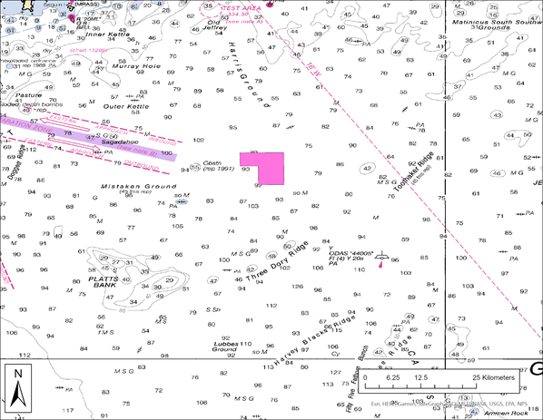
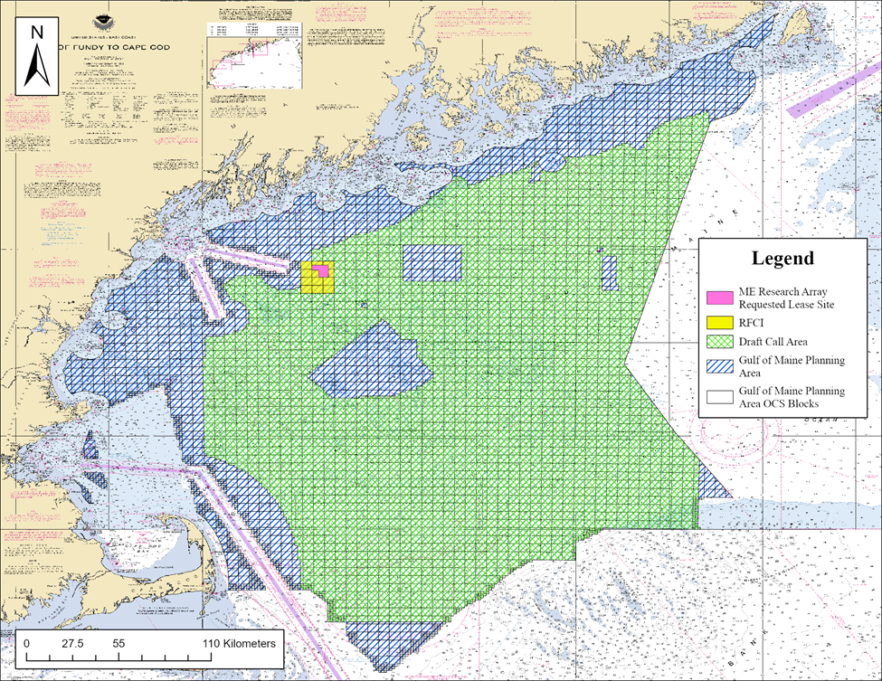
Figure 1. Area of consideration for offshore wind development in the Gulf of Maine. The Outer Continental Shelf (OCS) energy grids begin three nautical miles from land and extend outward to the continental shelf. The original Gulf of Maine Planning Area, as well as the updated Draft Call Area are displayed with the State of Maine research lease site.

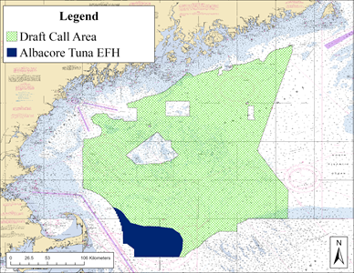
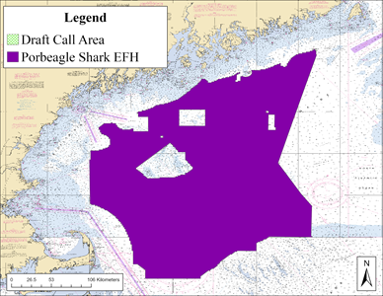
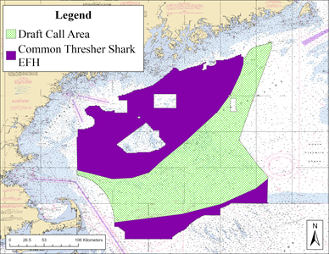
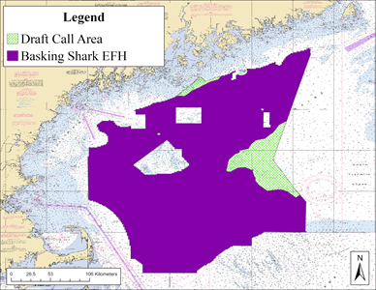
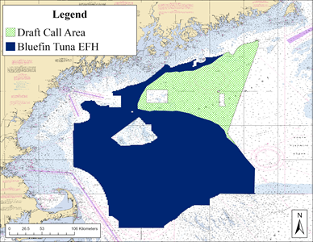
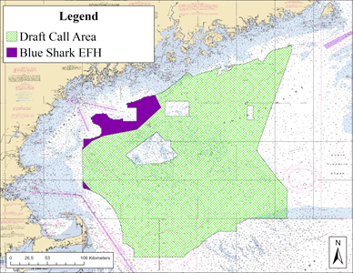
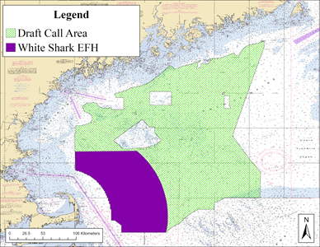
Figure 2. Essential Fish Habitat (EFH) of seven species as designated by the National Oceanic and Atmospheric Administration within the Gulf of Maine Draft Call Area. The EFH of two species of tuna (navy) and five species of shark (purple) are displayed. Three HMS species are considered to rely on the displayed habitat throughout ontogeny (basking shark, common thresher shark, and porbeagle shark); three species during their juvenile and adult life stages (bluefin tuna, blue shark, and white shark); and one species during the juvenile stage only (albacore tuna). Five species have designated EFH that overlaps with the Maine Research Array Request Lease Site (basking shark, blue shark, bluefin tuna, common thresher shark, and porbeagle shark).

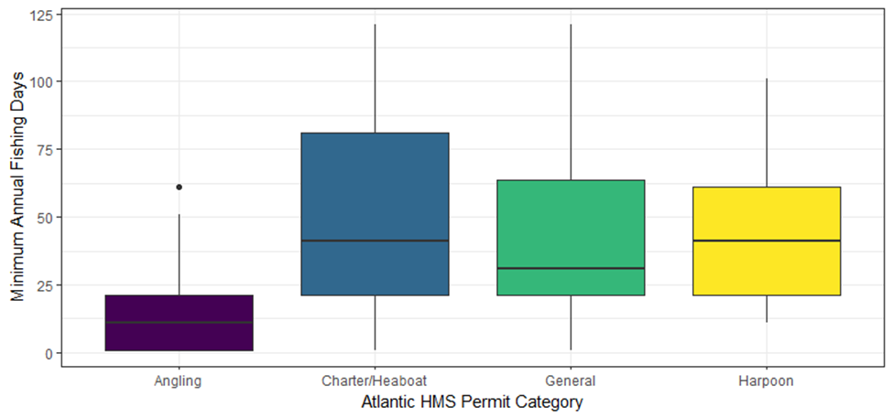
Figure 3. Estimated minimum annual fishing days exerted by online survey respondents representing each Atlantic HMS permit category. Statistically, respondents holding an HMS Angling permit fished less days per year than other permit holders (Angling x Charter/Headboat: Z = -5.40, P = 4.11e⁻⁷; Angling x General: Z = -4.47, P = 4.73e⁻⁵; Angling x Harpoon: Z = -3.63, P = 1.73e⁻³). P-values are displayed with a Bonferroni correction.

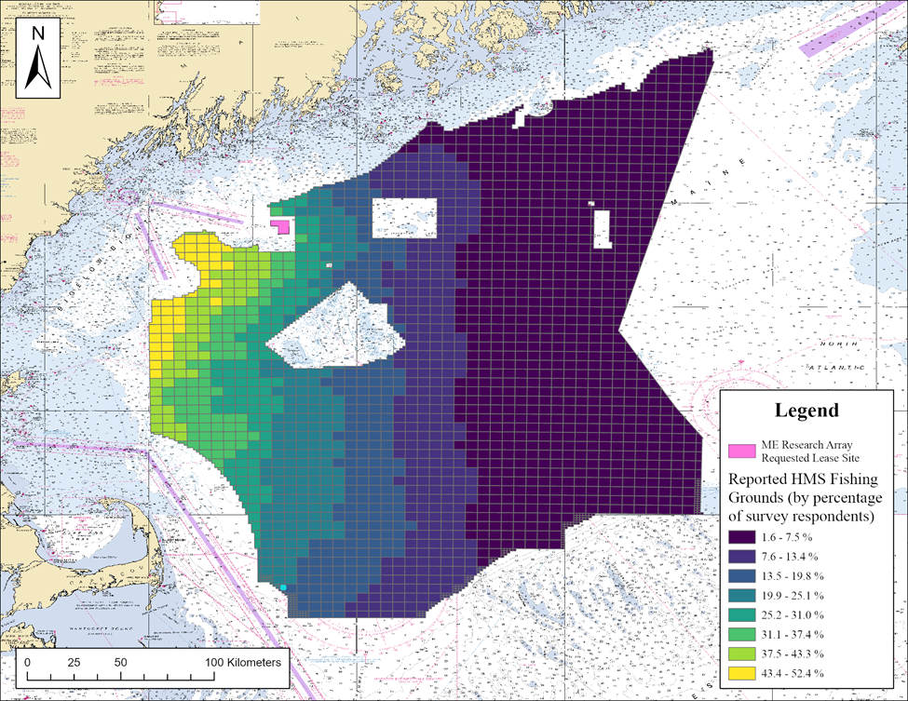
Figure 4. Spatial distribution of HMS fishing grounds within the Draft Call Area as reported by online survey respondents.

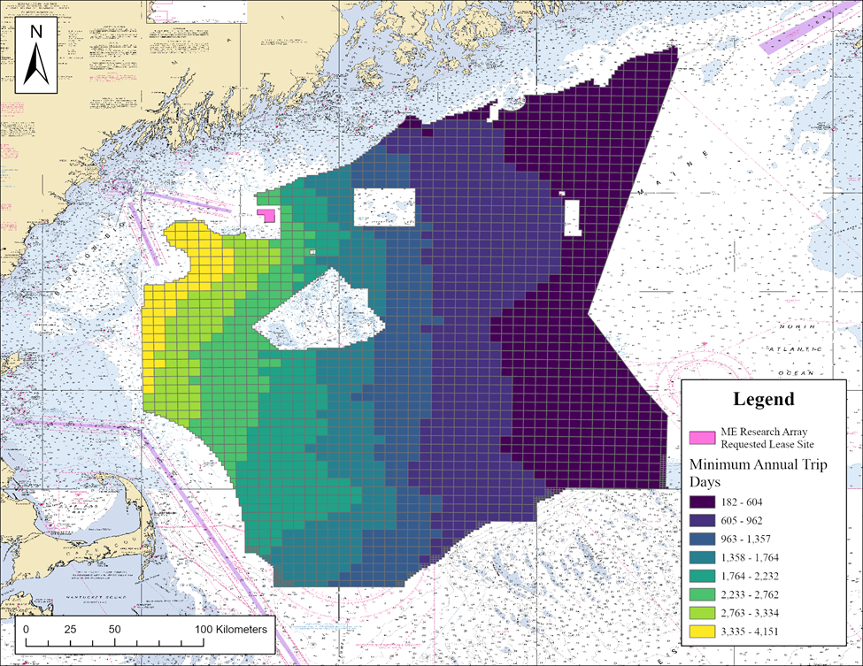
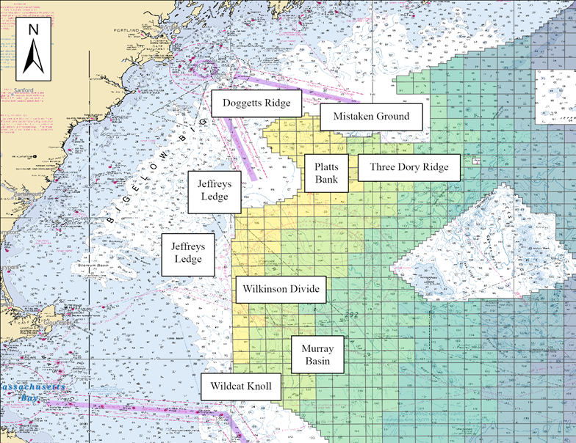
Figure 5. Spatial distribution of fishing effort displayed as the annual minimum trip days for HMS fishing in the Draft Call Area, provided by online survey respondents. The bottom window displays a concentrated view of the areas reported to be most commonly fished within the Draft Call Area. Established fishing grounds within the areas of greatest reported survey activity are labeled.
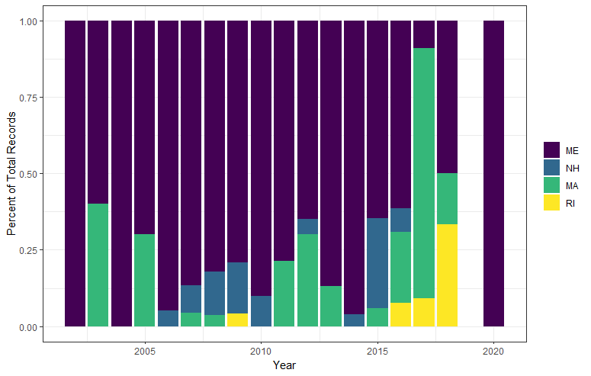Figure 6. Percent of trip records by state that were located within the Draft Call Area reported by the Large Pelagic Intercept Survey. No LPIS trips were recorded within the Draft Call Area in the years 2019 or 2021. Maine = ME; New Hampshire = NH; Massachusetts = Ma; Rhode Island = RI.

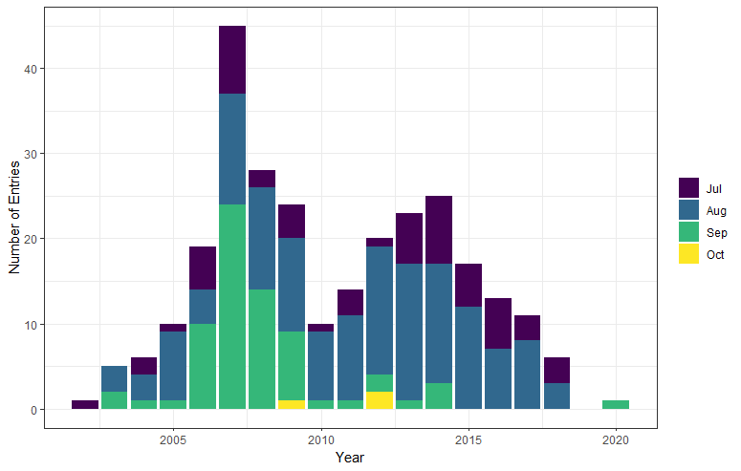
Figure 7. Temporal distribution of trips recorded in the Large Pelagic Intercept Survey (LPIS) that were located within the Gulf of Maine Draft Call Area. Records originate from the states of Maine, New Hampshire, Massachusetts, and Rhode Island. No LPIS trips were recorded in the Draft Call Area in the years 2019 or 2021. Jul = July; Aug = August; Sep = September; Oct = October.

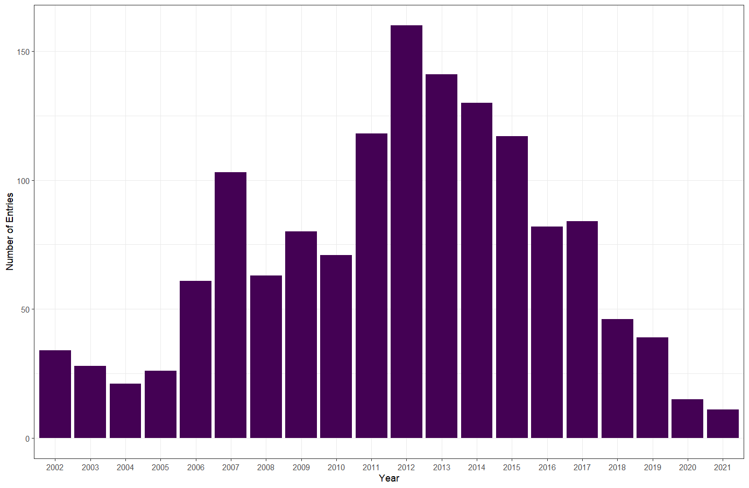
Figure 8. Annual number of trip entries recorded by interviewers of the Large Pelagic Intercept Survey (LPIS) in Maine. The annual number of interviews has steadily declined from its peak in 2012 (n = 160) to its trough in 2021 (n = 11).

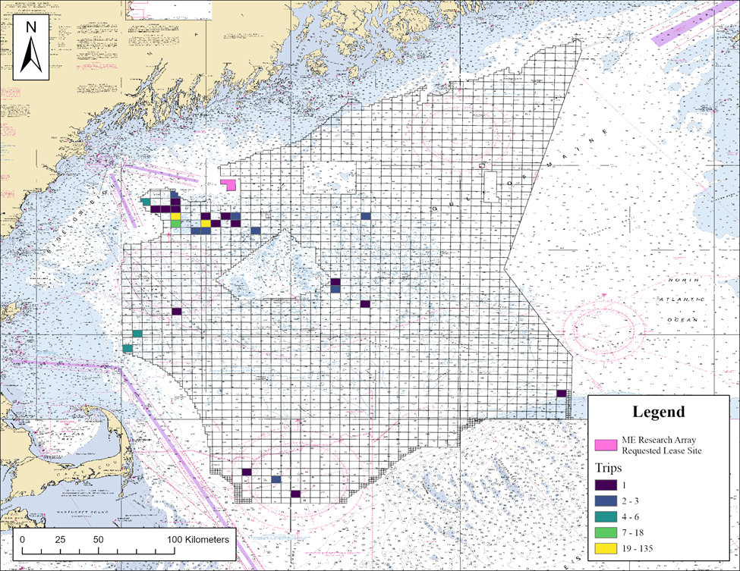
Figure 9. Spatial distribution of trip entries (top window) and animals kept or released alive (bottom window) from the Large Pelagic Intercept Survey, spanning 2002-2020 for the Draft Call Area. No data were available from 2021 within the Draft Call Area.

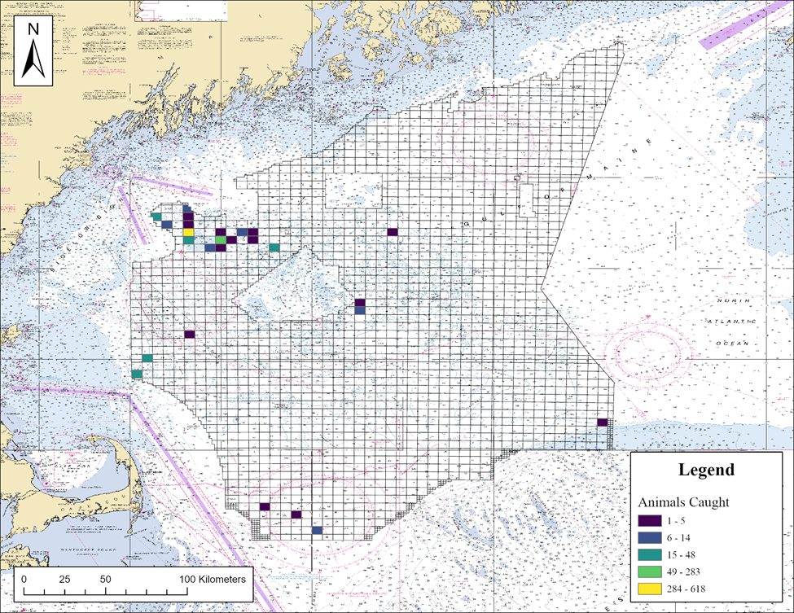

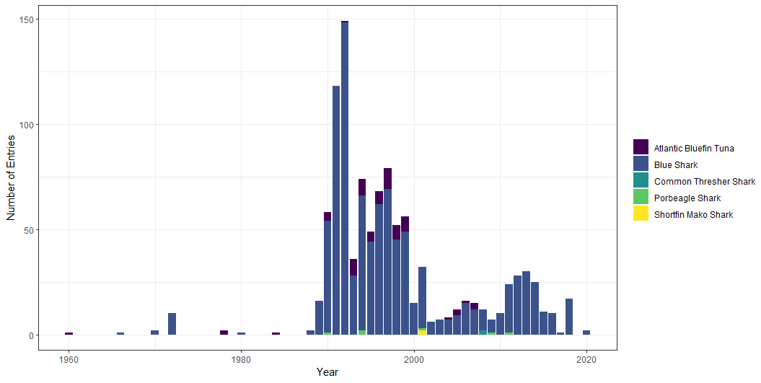
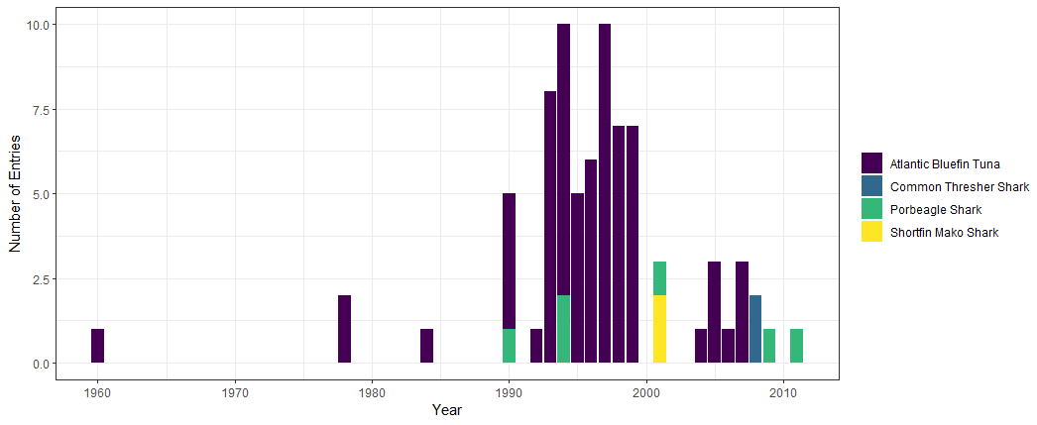
Figure 10. Annual distribution of Conventional Tagging Events by species within the Draft Call Area. The top window displays all five HMS captured in the Draft Call Area, while the bottom window omits Blue Sharks in order to view other species that were captured in lower numbers. Data from the Cooperative Shark Tagging Program were collected in the Draft Call Area between 1970-2020, and from the Cooperative Tagging Center between 1960-2012. These national voluntary tagging programs experience fluctuations in participation levels from year to year and are not reflective of effort over time.
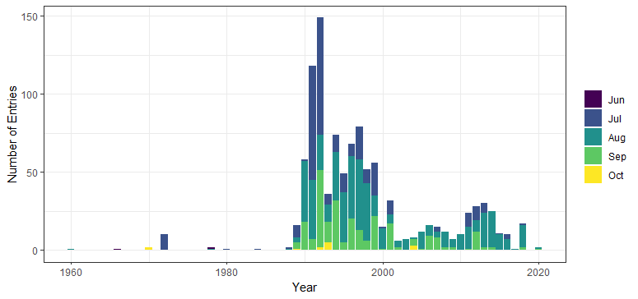
Figure 11. Monthly distribution of Conventional Tagging Events within the Draft Call Area by year. Data from the Cooperative Shark Tagging Program were collected in the Draft Call Area between 1970-2020, and from the Cooperative Tagging Center between 1960-2012. These national voluntary tagging programs experience fluctuations in participation levels from year to year and are not reflective of effort over time.

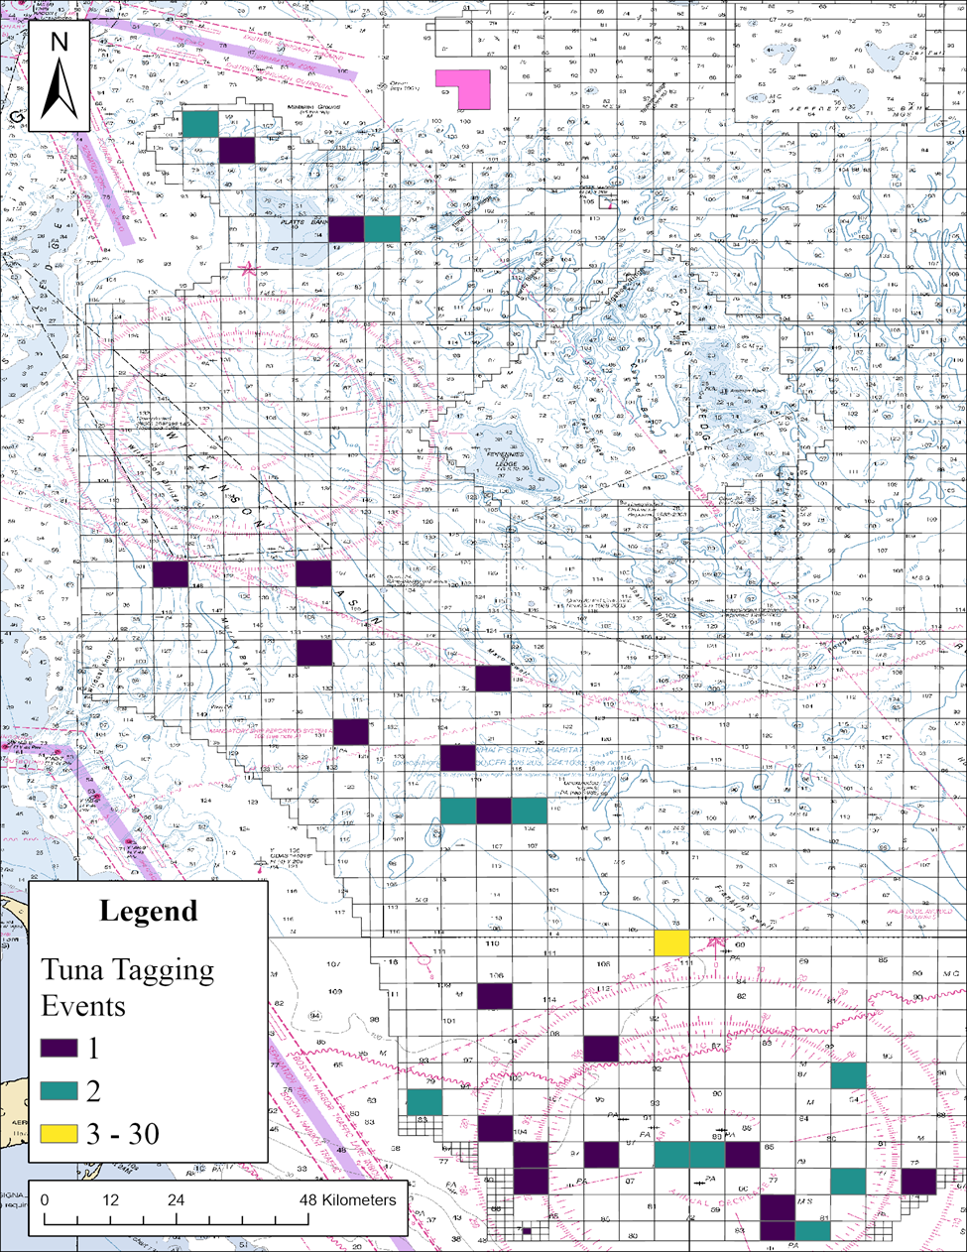
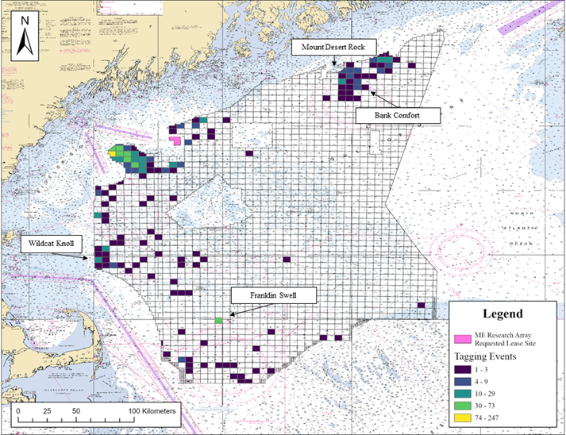
Figure 12. Spatial distribution of Conventional Tagging Events across all HMS within the Draft Call Area. The bottom window displays conventional Tagging Event data specific to bluefin tuna. Data from the Cooperative Shark Tagging Program were collected in the Draft Call Area between 1970-2020, and from the Cooperative Tagging Center between 1960-2012.

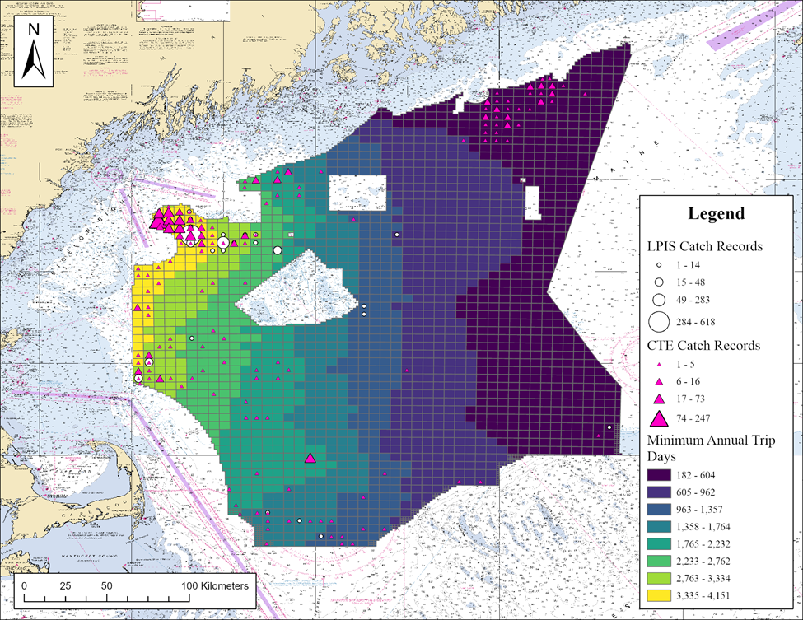
Figure 13. Spatial overlay of LPIS catch and CTE data onto the reported fishing effort across respondents from the online HMS survey.

