2026 MAINE STRIPED BASS REGULATIONS
If you are a recreational saltwater fisherman, Maine law may require you to register with the
Maine Saltwater Recreational Fishing Registry. To learn more or to register, visit: www.maine.gov/dmr/recreational-fishing/licenses/registry or call 207-624-9550.

The following Maine saltwater recreational fishing regulations are current as of March 25, 2026. However,
they are subject to change. Please contact our office or your local Marine Patrol Officer with questions.
All minimum lengths are total length, NOT fork length. The sale of fish by recreational anglers is prohibited.
Dams with fishways, the area within 150 feet of any dam in which a fishway is located, and/or 150 feet of any
part of any fishway are closed to fishing for any species.

Maine’s striped bass regulations cover all Maine coastal waters up to the head of tide in all rivers. In addition, there are special regulations in effect in the Saco River, as well as from December 1 through June 30 in the Kennebec, Sheepscot and Androscoggin Rivers and all related tributaries (see “SPECIAL REGULATIONS” sheet).
FEDERAL REGULATION
It is unlawful to fish for, take or possess striped bass in Federal waters (waters greater than 3 miles from shore).
STATEWIDE REGULATIONS
OPEN SEASON January 1 through December 31, inclusive (except the Kennebec watershed, see Special Regulations sheet).
BAG LIMITS A person may take and possess 1 striped bass per day.
SIZE LIMITS Fish can be harvested between 28 inches and 31 inches inclusive total length.
“TOTAL LENGTH” is a straight-line measurement from the lower jaw to the tip of the tail with the tail pinched together.
DISPOSITION Personal use only, sale is prohibited. Fish must remain whole and intact.
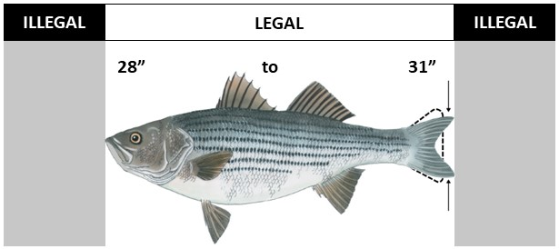

GENERAL GEAR RESTRICTIONS
- Hook and line only, no gaffing of striped bass.
- No bait allowed when using treble hooks.
- It is unlawful to use more than two barbed or barbless treble hooks on any artificial lure or fly while fishing for striped bass in territorial waters.
- It is unlawful to use any hook other than a non-offset circle hook when using bait.
Exception: Rubber or latex tube lures may be used without a circle hook if they are a minimum of 8 inches long and have a single hook protruding from the end portion of the tubing where bait may be attached.
- Bait is defined as any marine or freshwater organism live or dead, whole or parts thereof, and earthworms, including but not limited to night crawlers.
- Striped bass incidentally caught on any unapproved hook type must be returned to the water immediately and without unnecessary injury.
MAINE DEPARTMENT OF MARINE RESOURCES
P.O. Box 8, West Boothbay Harbor, ME 04575-0008
Telephone (207) 633-9500

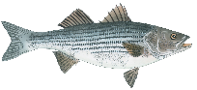
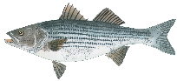
2026 MAINE STRIPED BASS SPECIAL REGULATIONS

SPECIAL SACO RIVER REGULATIONS

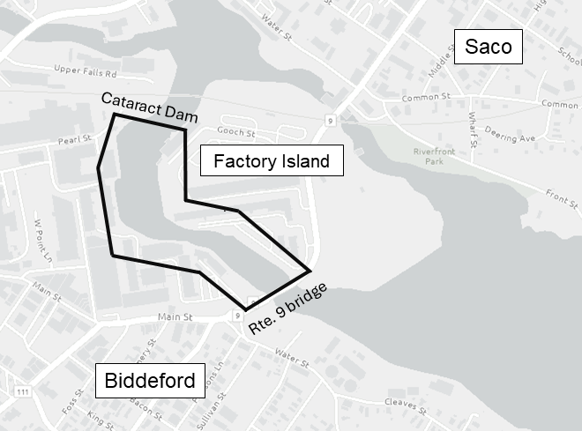
It is unlawful to fish the waters of the Saco River upstream of the Route 9/Main Street bridge between Factory Island, Saco and Mechanics Park, Biddeford, to the head of tide, commonly known as the “Cataract Dam”.

SPECIAL KENNEBEC** REGULATIONS
(including the Sheepscot River, Androscoggin River, and all related bays and tributaries)

CATCH & RELEASE SEASON WITH SPECIAL GEAR RESTRICTIONS From May 1 through June 30, inclusive. Fishing in this area is restricted to single-hooked artificial lures only (may be a single treble hook). Use of or possession of marine bait, dead or alive, is prohibited.

OPEN SEASON July 1 through November 30, inclusive.

CLOSED SEASON Striped bass fishing is prohibited from December 1 through June 30, inclusive (exception catch & release season with special gear restrictions).

** The Kennebec watershed is defined as all coastal waters inside and upstream of a line drawn from the outer extremity of Cape Small, in Phippsburg, to the outer extremity of Salter Island, and to the outer extremity of Cape Newagen, in Southport. This area includes the coastal waters of Popham Beach and the adjoining State Park, Reid State Park, and all riverine waters of the Kennebec, Sheepscot, and Androscoggin Rivers including all bays and tributaries of those rivers to the head of tide. Due to the removal of Edwards dam, the “head of tide” in the Kennebec River is now at the downstream side of the power line located approximately 4,200 feet upstream of the Calumet Bridge at Old Fort Western in Augusta (formerly the Father Curran Bridge) for enforcement purposes.

MAINE DEPARTMENT OF MARINE RESOURCES
P.O. Box 8, West Boothbay Harbor, ME 04575-0008
Telephone (207) 633-9500

