2026 MAINE SEA RUN RAINBOW SMELT REGULATIONS
If you are a recreational saltwater fisherman, a Maine law may require you to register with the Maine Saltwater Recreational Fishing Registry. To learn more or to register visit: www.maine.gov/dmr/recreational-fishing/licenses/registry or call 207-624-9550.

The following Maine saltwater recreational fishing regulations are current as of January 1, 2026. However, they are subject to change. Please contact our office or your local Marine Patrol Officer with questions. All minimum lengths are total length, NOT fork length. The sale of fish by recreational anglers is prohibited.

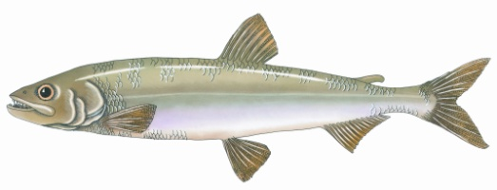
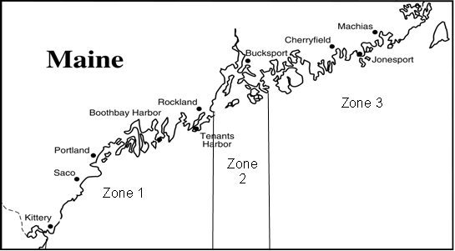
Statewide: It is unlawful to stand in the coastal waters, including the coastal waters of any river, brook, or stream, while fishing for smelts.

Zone 1: From the New Hampshire border to Owl’s Head Light in Rockland.
- From February 1 to September 30, both days inclusive, it is only legal to fish for, take or possess smelt by hook and line through the ice.
- From October 1 to January 31, both days inclusive, it is only legal to fish for or take smelt by hook and line.
- From March 15 to September 30, both days inclusive, you may not fish for, take or possess more than 2 quarts of smelts per day.
- From October 1 to March 14, both days inclusive, you may only fish for, take or possess 4 quarts of smelts per day.

Zone 2: East of Owl’s Head in Rockland to Naskeag Point in Brooklin.
- From March 15 to June 30, both days inclusive, it is only legal to fish for, take or possess smelt by dip net or by hook and line. The bag limit is 1 quart of smelts per day and no smelt fishing is allowed on Tuesdays and Wednesdays.
- From July 1 through March 14, both days inclusive, it is only legal to fish for smelt using hook and line. You may only fish for, take or possess 4 quarts of smelts per day during this period.

Zone 3: East of Naskeag Point to the head of tide on the St. Croix River.
- It is only legal to fish for, take or possess smelt by dip net or by hook and line.
- From March 15 through June 30, both days inclusive, you may only fish for, take or possess 2 quarts of smelts per day.
- From July 1 through March 14, both days inclusive, there is no daily limit.
MAINE DEPARTMENT OF MARINE RESOURCES
Marine Resources Laboratory
PO Box 8, West Boothbay Harbor, ME 04575-0008
Telephone (207) 633-9500 Fax (207) 633-9579

DEPARTMENT OF MARINE RESOURCES
Marine Resources Laboratory
PO Box 8, West Boothbay Harbor, ME 04575-0008
Telephone (207) 633-9500 Fax (207) 633-9579

