2026 MAINE MARINE RECREATIONAL FISHING REGULATIONS
SEA RUN FISH
If you are a recreational saltwater fisherman, a Maine law may require you to register with the
Maine Saltwater Recreational Fishing Registry. To learn more or to register visit: www.maine.gov/dmr/recreational-fishing/licenses/registry or call 207-624-9550.

The following Maine saltwater recreational fishing regulations are current as of March 19, 2026. However, they are subject to change. Please contact our office or your local Marine Patrol Officer with questions.
All minimum lengths are total length, NOT fork length. The sale of fish by recreational anglers is prohibited.
Dams with fishways, the area within 150 feet of any dam in which a fishway is located, and/or 150 feet of any part of any fishway are closed to fishing for any species.

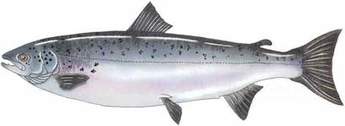

American shad
(Alosa sapidissima)

Atlantic salmon
(Salmo salar)
It is unlawful to angle, take or possess any Atlantic salmon from all Maine waters (including coastal waters). Any salmon incidentally caught, must be released immediately, alive, and uninjured. At no time should the Atlantic salmon be removed from the water.
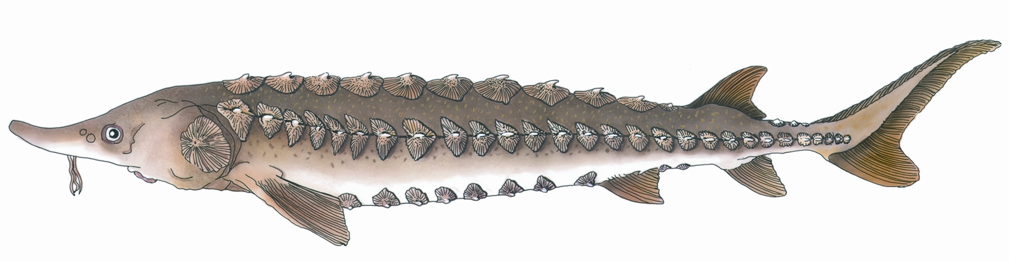
Atlantic sturgeon
(Acipenser oxyrhynchus)
It is unlawful to fish for, take or possess any sturgeon, either Atlantic or shortnose, in Maine waters. Any sturgeon incidentally caught must be released immediately, alive, and uninjured.

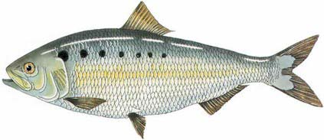
Method of take: hook and line only
Bag limit: a person may take or possess only 2 fish per day
Size: No minimum size

River herring means both species, alewife and blueback herring. Any brook, river or stream not under municipal lease is closed from 6 AM Thursday until 6 AM Sunday. If under municipal lease, contact the town for harvest plan specifics.

Method of take: hook and line, or dip net only
Bag Limit: a person may take or possess only 25 river herring per day, personal use only
Size: No minimum size
river herring
alewife
(Alosa pseudoharengus)
blueback herring
(Alosa aestivalis)
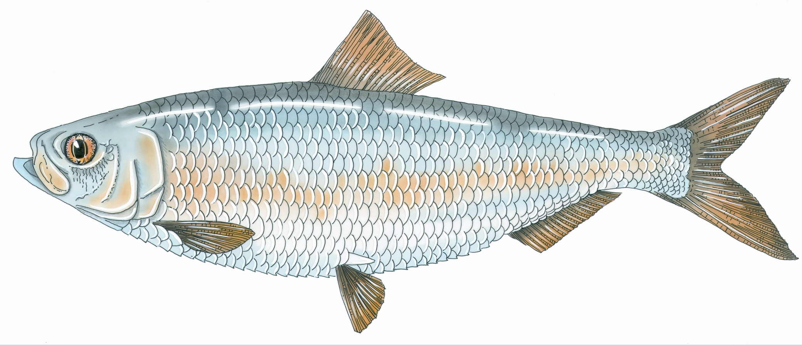
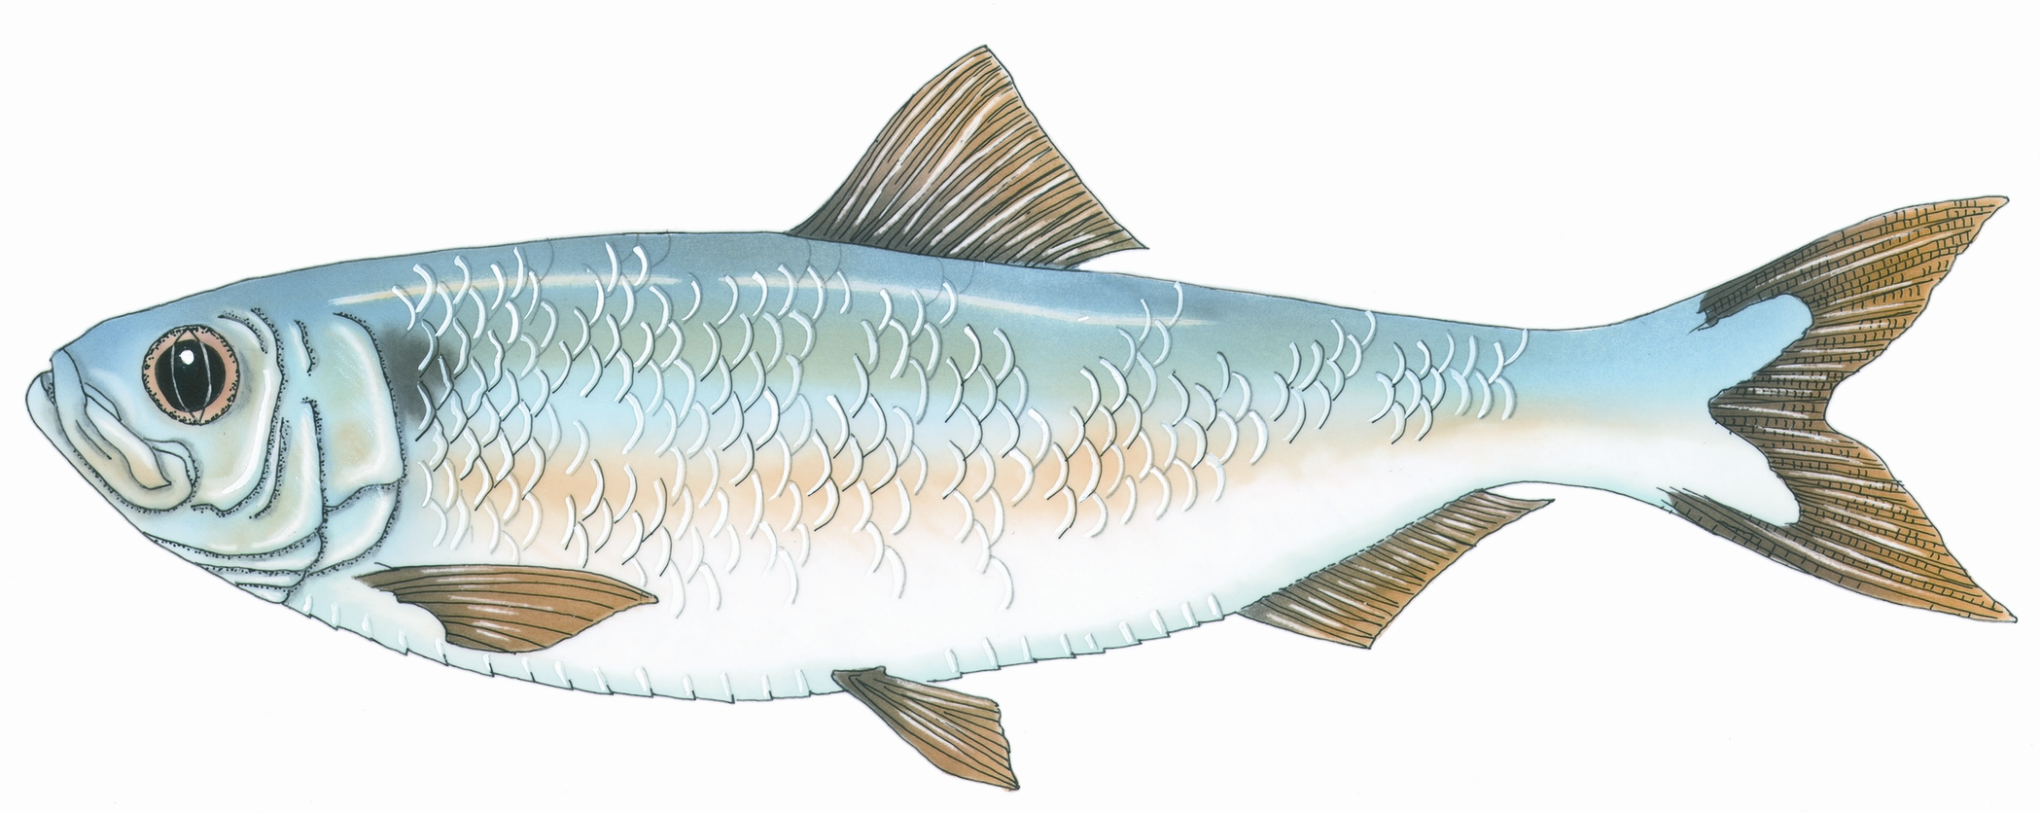

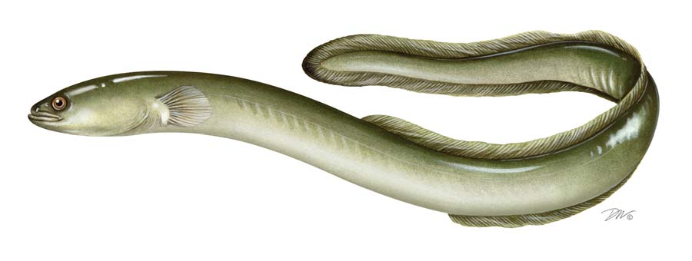
American eel
(Anguilla rostrata)
Method of take: speargun, harpoon, trap or hook and line
Bag Limit: 25 eels per angler per day, personal use only
Size: minimum size 9 inches
Size:
Rainbow Trout: minimum size 14 inches
Brook Trout: minimum size 6 inches
Landlocked Salmon and Brown Trout: minimum size 14 inches, maximum size 25 inches
Bag Limit: Unlawful to possess more than 5 fish, of which, not more than 2 may be brown trout, 2 landlocked salmon or 2 rainbow trout. All 5 may be brook trout.

Method of take: hook and line only
Penobscot River: It shall be unlawful to take or possess any landlocked salmon, brown trout, or rainbow trout from tidal waters upstream and North of the Penobscot Narrows Bridge and north of the Verona Island Bridge.

Trout
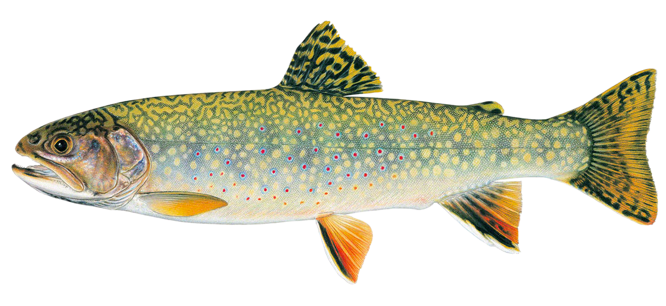

Atlantic menhaden
(Brevoortia tyrannus)
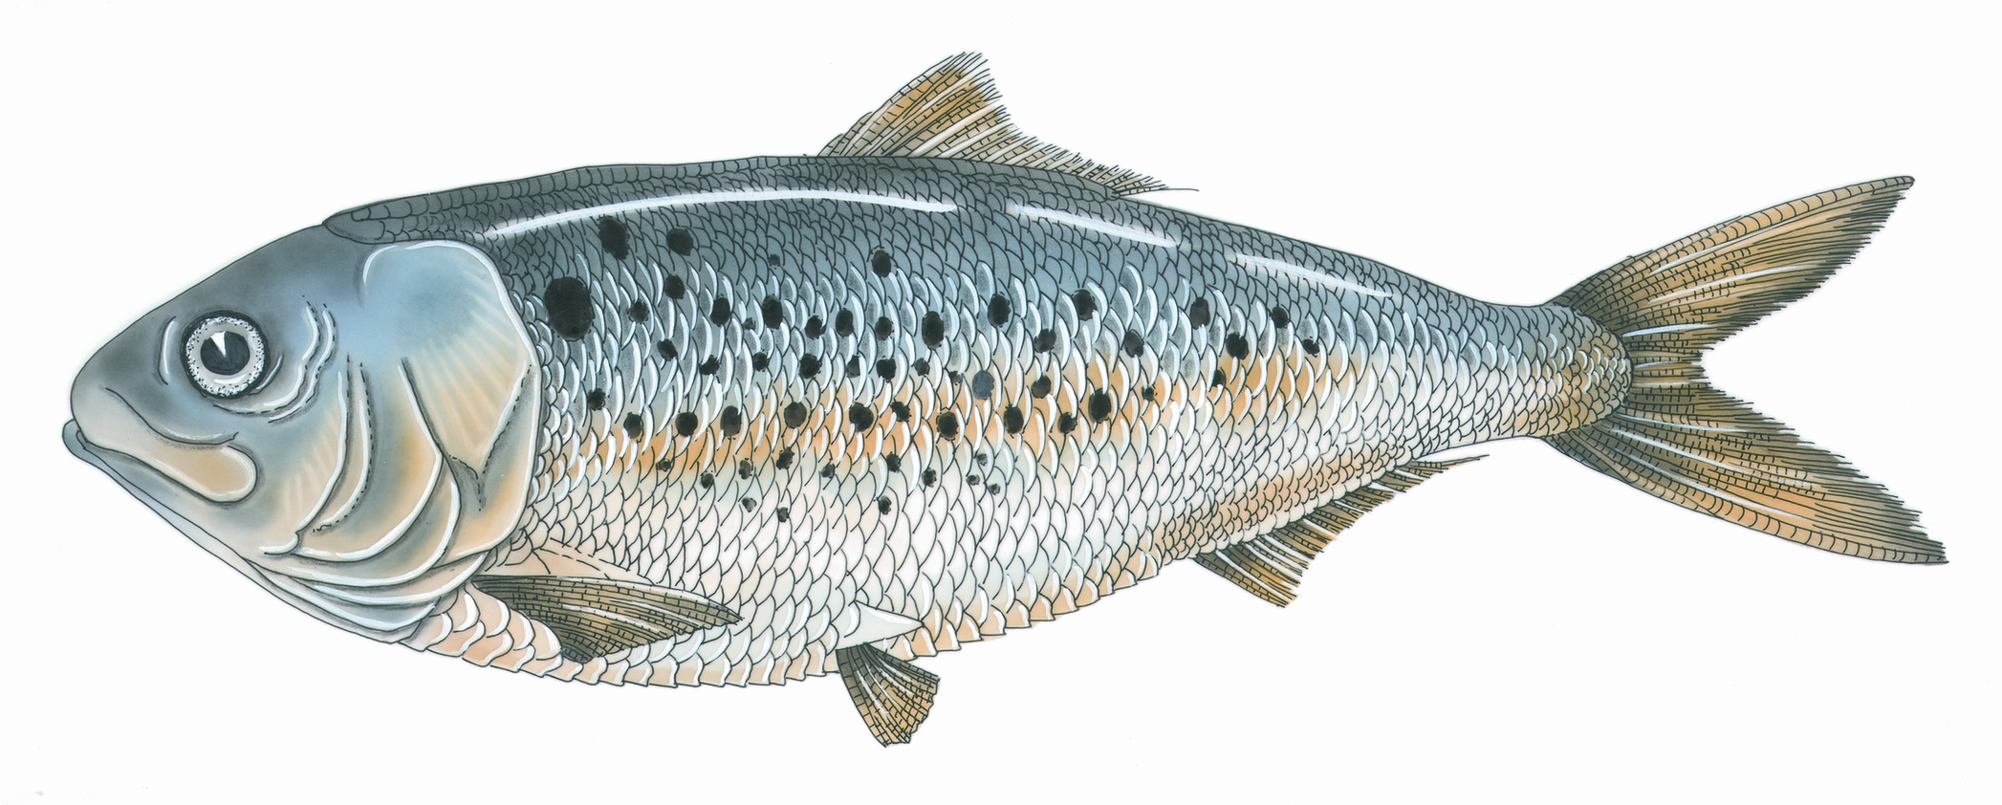
Method of take: speargun, harpoon, minnow trap, hand dip net, or hook and line
Bag Limit: 25 menhaden per angler per day, personal use only
Size: No minimum size

See separate rule sheets for striped bass and sea-run rainbow smelt.

MAINE DEPARTMENT OF MARINE RESOURCES
Marine Resources Laboratory
PO Box 8, West Boothbay Harbor, ME 04575-0008
Telephone (207) 633-9500 Fax (207) 633-9579

