

Maine Dept. of Marine Resources

2025 Annual Update

Inshore White Shark Monitoring

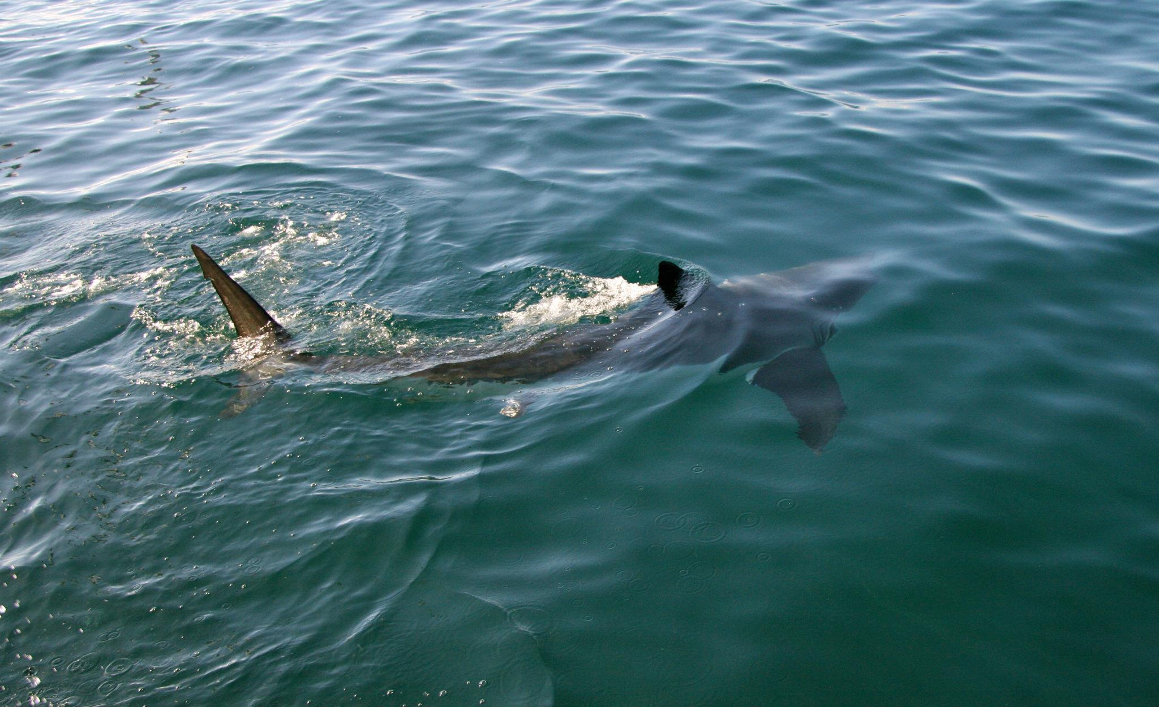

Davis, M. M., Jenner, B. P.

Maine Dept. of Marine Resources
194 McKown Point Rd
West Boothbay Harbor, ME 04575

About the Program
The Maine Department of Marine Resources (DMR) began monitoring white shark (Carcharodon carcharias) activity in the Gulf of Maine beginning late August of 2020 in response to increased public interest. The objective of this program is to investigate and improve our understanding of the distribution and habitat use patterns of white sharks in coastal Maine. This information is used to provide data in support of scientific research and to educate beach officials and the general public regarding trends in white shark activity in coastal areas.
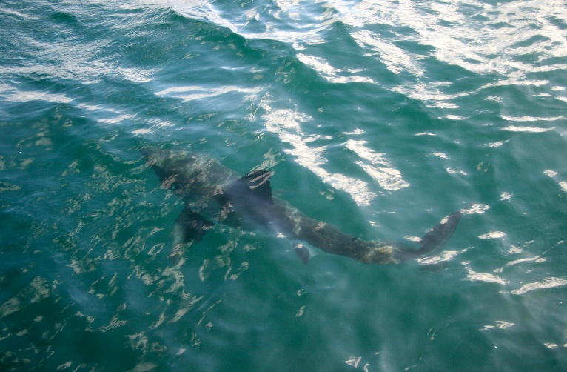Above: White shark scanning the surface of the water.

How Monitoring Works
The primary method by which shark movements are recorded is via electronic tracking technology. In the case of acoustic telemetry, sharks are outfitted with a waterproof transmitter (or tag), which is inserted into back muscle near the first dorsal fin. Along the northeast U.S., organizations such as the Atlantic White Shark Conservancy (AWSC), Massachusetts Division of Marine Fisheries (MADMF), National Oceanic and Atmospheric Administration (NOAA) and others have been tagging white sharks for more than a decade. Acoustic transmitters can be programed to meet project-specific needs, with some built to transmit for 10 years following deployment. When an acoustic transmitter comes within 1,000-3,000’ of a compatible acoustic receiver, a detection event is recorded and stored locally on the receiver. Receivers are deployed underwater by the DMR each spring at fixed locations, then recovered in the fall or early winter so scientists can download the detection event data. If a receiver is not found at the end of a season, scientists cannot access its data.
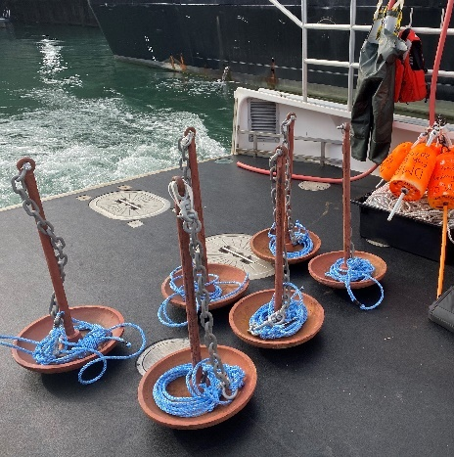
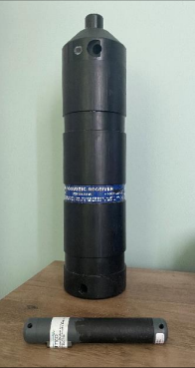
Left: A VR2Tx acoustic receiver and V16 acoustic transmitter. Right: Receivers are tethered to a marked fishing buoy and deployed from May through November with a mooring anchor.
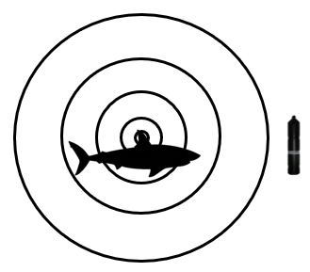
Left: A tagged shark swims near an acoustic receiver. Once close, the receiver will detect the tag and record its digital signature, along with a timestamp.

Passive Acoustic Receivers
In 2025, the DMR Inshore White Shark Monitoring (ISWM) program completed its sixth year and fifth full season of acoustic monitoring, deploying a total of 36 passive receiver sites from Ogunquit Beach to the US-Canadian border. Three receivers within western Muscongus Bay were funded in part by a 2024-2025 grant project with the Maine Outdoor Heritage Fund (maine.gov/ifw/ programs-resources/grants/outdoor-heritage-fund.html), while the 14 receivers ranging from western Penobscot Bay to the US-Canadian border were funded by a 2025-2026 grant project with the Maine Community Foundation (mainecf.org). IWSM receivers are deployed in coordination with commercial lobstermen. To view the sites on a single comprehensive map, see Appendix Fig. A1 and Table A1.1.
All receivers were successfully retrieved during the 2025 monitoring season. While every receiver was recovered during the most recent survey, previous years have seen higher rates of receiver loss. On an annual basis, receiver losses average one for every 10 receivers deployed. It can be difficult to determine the cause behind any given receiver loss, but possible causes include strong weather events, rope fraying, biofouling, and interaction with fishing gear. To view the program’s seasonal deployment history, see Appendix Fig. B1.

Real-Time Acoustic Receivers
In addition to the passive acoustic receivers, one real-time acoustic receiver was deployed by Maine DMR scientists near Scarborough Beach. As its name implies, this specialized device uses cellular towers to transmit detection alerts to beach officials and scientists in real-time. The receiver was funded by the Maine Outdoor Heritage Fund, and its location is coordinated with the help of the Department of Conservation, Agriculture and Forestry. Alerts are made publicly available on the Atlantic White Shark Conservancy’s Sharktivity phone app (atlanticwhiteshark.org/Sharktivity-app). The receiver has been previously positioned near Popham Beach State Park and Crescent Beach State Park.
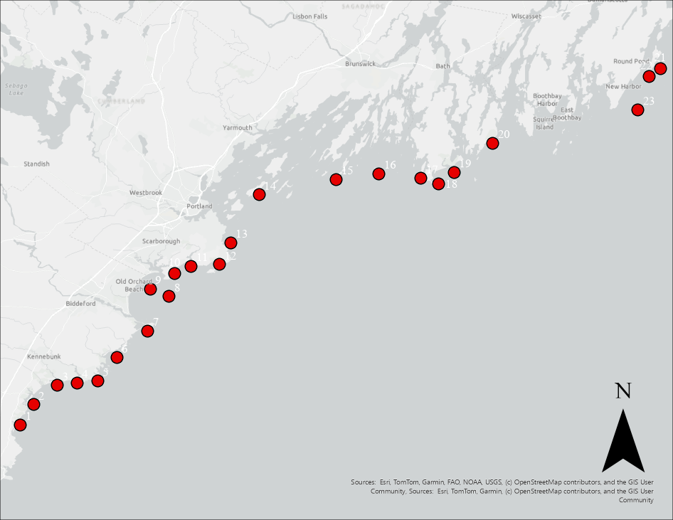
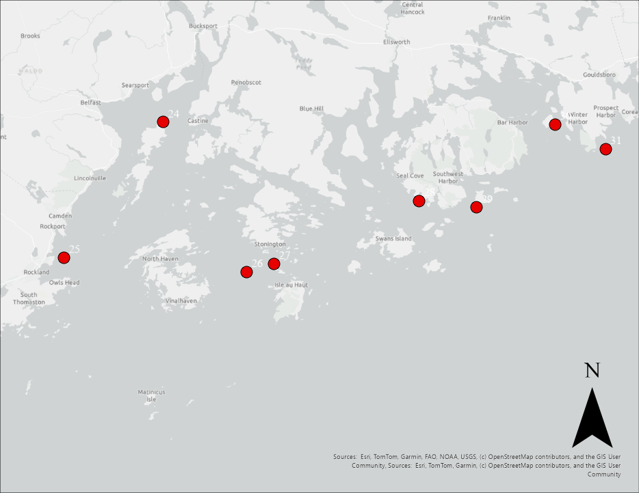

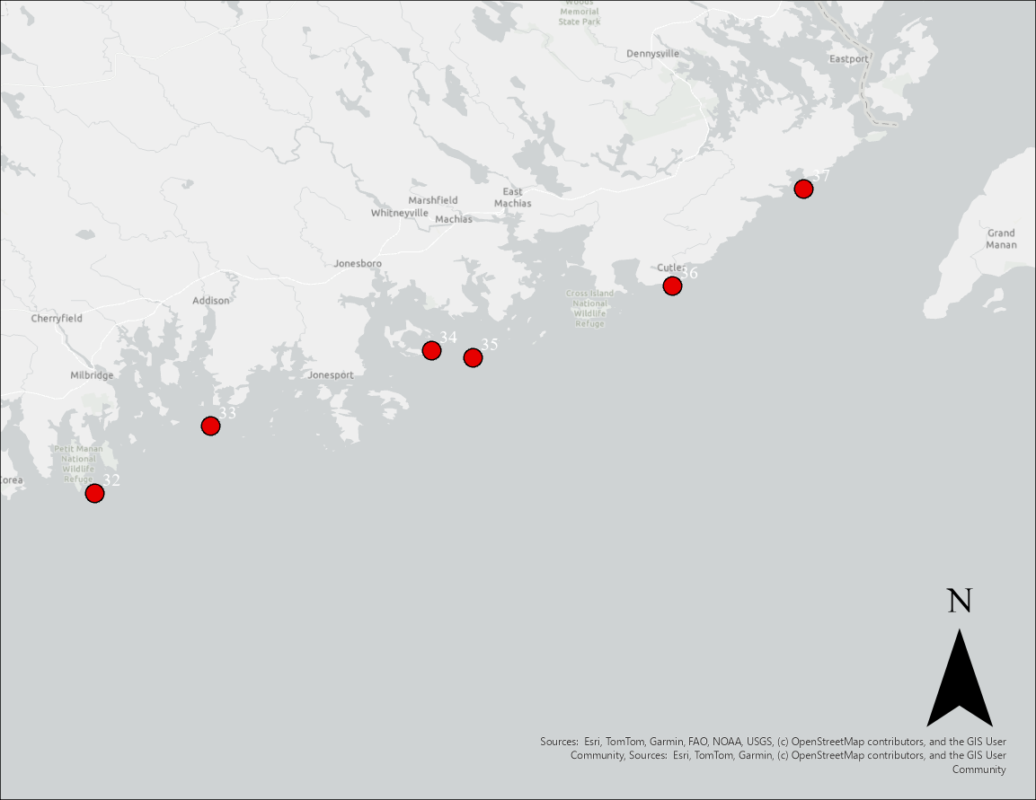
Regional maps of receiver sites divided into western (Top), central (Middle), and eastern (Bottom) Maine. Red dots represent the placement of acoustic receivers. Map scale is 1:484,653.

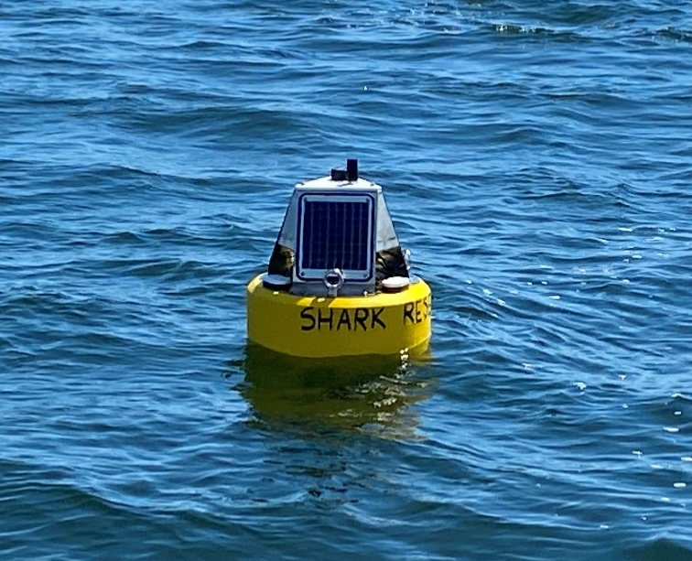Above: The real-time acoustic receiver deployed near Scarborough Beach.

2025 Data Summary
While the IWSM program is most interested in sharks, the program’s acoustic receivers detect other animals, such as sturgeon and striped bass, that have been outfitted with acoustic transmitters. Since inception, IWSM scientists have observed more than 450,000 detections from more than 650 unique transmitters, belonging to more than 30 organizations. Across the 37 DMR acoustic receivers recovered in 2025, scientists observed 81,474 detections originating from 242 transmitters. Of those detections, >9,500 can be attributed to white sharks. These detections were categorized into distinct ‘visits’, defined as the period beginning with a shark’s initial detection at a site and concluding after a 60-minute absence of further detections (Bowlby et al., 2022). The duration of each visit was estimated by measuring the time between the first and last detection. In total, 19 unique white sharks were recorded in 2025 across 95 unique dates. This brings the cumulative number of unique white sharks detected in our survey to 105 since starting in 2020. For reference, there are approximately 300-350 white sharks currently carrying detectable acoustic tags deployed by our partners as of 2025.
This season, the greatest number of sharks were detected near Ragged Island (n = 9), followed by Middle Beach, Higgins Beach, Head Beach, and Cutler (n = 8 for each site, respectively). Receivers near Scarborough Beach, Higgins Beach, and Saco Bay observed the most dates with shark activity in 2025 (n = 33, 31, 27, respectively). A similar trend of heightened activity in this area was observed during the summer of 2024. Still, the receiver site near Ragged Island retains the highest annual average number of days with shark activity (mean = 24 days).
While it is common for a few tagged individuals to account for most of any given year’s detections, the top two most detected sharks in 2025 contributed approximately 85% of all shark detections. This marks an increase from 2024 when two individuals made up 71% of all shark detections and is significantly higher than the 2020–2023 top-two-shark average of ~54%. Notably, the three most active sharks in 2024 were juveniles that had been tagged in Southern Maine waters that same summer in late August - the first white sharks tagged in Maine. The individuals that comprised most of 2025’s receiver activity were two of those same sharks. This trend may indicate a potential difference in residency patterns between white sharks tagged elsewhere and smaller juveniles tagged locally, though further research is required to confirm. To date, only four of the 300+ white sharks that have been tagged were tagged in Maine State waters.
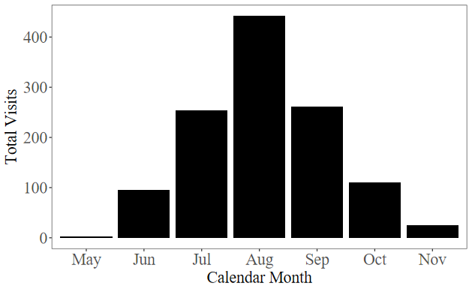
While the number of unique sharks observed per receiver deployed (SPUE) in 2025 was the lowest it’s been since the program began, the number of days in which activity was observed far surpassed the previous record (2023). Furthermore, even with the Maine-tagged sharks excluded, the number of unique dates with shark activity per receiver deployed and visits per receiver deployed were among the highest (Table 1). From this, one could hypothesize that the expanded receiver coverage in 2025 did not lead to more sharks being detected than the previous year(s) but rather, more receivers allowed for greater monitoring of the tagged sharks while they were in the region. However, it is also important to note the many variables that can impact receiver-based metrics, including but not limited to the fluctuating numbers of active transmitters, receiver deployment schedules, and both broad- and fine-scale receiver placement. For instance, a receiver mounted underwater at a sub-optimal angle will have its detection range significantly decreased, and placing a receiver adjacent to an underwater structure, such as a tall ledge or boulder, or within a holding device such as a lobster pot, could result in a “detection shadow”.
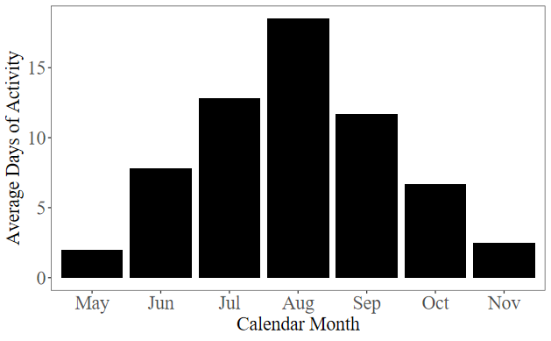
Table 1. Each receiver deployed and successfully recovered is considered a unit of effort. SPUE: unique sharks per unit effort, VPUE: visits per unit effort, and DPUE: dates of shark activity per unit effort. VPUE and DPUE are displayed with the top two most active sharks on a given year excluded.

Survey Trends
Since inception, white shark activity from acoustic telemetry has been highest along Maine’s coastline during the months of July through September, both by number of visits from sharks and by average number of days with detection activity (Figs. 1A-B). Detected sharks have ranged in size from 7’0” - 16’0” total length (from snout to tail tip), with an average estimated size of 10’1”. Of the 105 detected sharks, 41 were male, 51 were female, and the sex of the remaining 13 were unknown. Using a combination of sex and length at time of tag deployment, white sharks can be classified into one of three maturity stages (Bruce and Bradford, 2012). It is estimated that 43 sharks were juveniles, 46 were subadults, and 7 were adults. While there were 13 individuals of unknown sex, 4 were of a length where life stage could be estimated confidently.
Figure 1. Plot of (A) total visits per month and (B) average monthly days of activity. Data from 2020-2025.

The amount of time that sharks spent by any one receiver varied greatly between visits and sites. Rounding up to the nearest minute, visits from sharks ranged from 1 min to nearly 24 hr. Given that a small number of long-duration visits skewed the mean, the median was used here to describe visit length. The overall median visit duration, weighted by total visit volume per site, was 11 min. Different receiver sites exhibited different residency patterns, with Scarborough Beach recording the longest median visit duration of any beach-adjacent site (33 min), and Cutler recording the longest median visit duration of any non-beach-adjacent site (14 min). Meanwhile, sites such as Ragged Island and Head Beach, which have detected the greatest number of individuals to date and typically observe more days of shark activity per year than other sites, recorded median visit durations of 11 min each.
The receiver array has documented a relatively low frequency of inter-annual returns, with 25% (n = 27) of sharks returning to the study area in at least one subsequent year. Of the sharks which were detected for two (n = 20) or three (n = 7) years, 12 were detected at sites they had visited during a previous survey year. To date, only one individual has been detected at the same site for three consecutive years. Regarding multi-year site-specific return rates, revisitation appears to be low; for example, the receiver site with the highest percentage of multi-year visitors was located near Stratton Island, where nearly one in five sharks had been observed across multiple calendar years. Receivers near Bailey’s Island and Scarborough Beach observed a similar multi-year revisitation rate of one in six white sharks.
Of all recorded shark visits since the program’s inception, 37% involved instances where a shark returned to a site it had previously visited within 24 hr. Of those instances, 60% occurred at beach-adjacent sites, with the majority occurring at Higgins and Scarborough beaches and originating from primarily two Maine-tagged sharks. To estimate the likelihood of a shark being re-detected at a previously visited beach within a 24 hr period, the probability of reappearance following a 30 min period of acoustic silence was calculated across all years by site. To do this, sharks were grouped into behavior classifications, where sharks were defined as ‘resident’ to a given site if they were detected for greater than 3 hr in total at that site, and defined as 'transient' to a given site if they were detected for less than 3 hr.
Middle, Scarborough, Higgins, and Head were the only beaches to observe both ‘transient’ and ‘resident’ shark behavior, whereas other beaches observed only ‘transient’ shark behavior. Of those four beaches, the percentage of sharks classified as showing ‘resident’ behavior ranged from 2-15%. In general, most beaches observed minimal return probability within 24 hr from their ‘transient’ sharks, though Higgins and Head beaches observed higher probabilities (13 and 15% of ‘transient’ sharks were re-detected in 24 hr following 30 min of acoustic silence, respectively). Conversely, sharks that displayed ‘resident’ behavior at Middle, Scarborough, and Higgins were highly likely to be re-detected within 24 hr following 30 min of acoustic silence (24 hr re-detection probabilities ranged from 81-88%; Appendix Fig. C1). Head Beach was the only beach that observed an estimated 0% re-detection probability in 24 hr from ‘resident’ sharks following 30 min of silence.
Since an individual's behavioral classification cannot be determined in real-time during a detection event, weighted averages were calculated to reflect the collective return probability posed by the population of sharks that have been detected. Using this metric, the 24 hr re-detection probability for any given shark remains below 15% for the beaches analyzed (Appendix Fig. C2). However, because the range of acoustic telemetry devices can fluctuate under variable weather conditions, it is possible that periods of acoustic silence may reflect either true absence or temporary non-detection of the shark while within the receiver array; thus, estimated return probabilities represent conservative, detection-based reappearance rates rather than guaranteed physical departures and returns.

Sighting Reports
Sightings are compiled through three methods: the Maine White Shark Data Portal, the Atlantic White Shark Conservancy’s Sharktivity phone app, and personal communication. White shark sightings are categorized as confirmed or unconfirmed and are broken down into the following categories: basic sighting, predation event, and wounded mammal. A record is categorized as a basic sighting when a white shark is physically seen by the observer but is not foraging. A predation event occurs when a white shark is observed hunting an animal. A wounded mammal event is categorized as a marine mammal sighting where the animal displays wounds inflicted from a shark bite. Any instances of a marine mammal displaying wounds from a shark are reported to the Marine Mammals of Maine and/or Allied Whale. It should be noted that sighting reports are helpful, but they do not directly relate to the actual abundance or presence of white sharks.

2025 Sightings
Basic Sighting | Predation | Total Records
12 | 2 | 14
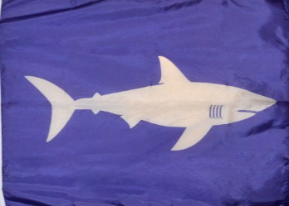
Above: 2025 shark sightings. Left: If you spot this flag at a beach, then a shark has been observed recently nearby, and you should seek beach officials for more information.

Beach Safety and Future Directions
Overall detection activity from white sharks remains relatively low compared to nearby Cape Cod, which is considered an aggregation area for the species. However, receiver coverage in Maine is relatively sparse given the large coastline, and some areas such as the waters surrounding Scarborough and Higgins beaches showed extended periods with activity from Maine-tagged sharks. It is possible that the locally tagged individuals represent a sub-population that more readily resides in coastal Maine waters compared to sharks which had been tagged in other regions, in which case our detection data may be underestimating shark presence given most of the sharks carrying transmitters were not tagged here. Though the presence of juvenile white sharks does not inherently lead to increase bite frequency (Rex et al., 2023), recreators should take caution and stay alert when in the water at these and other coastal areas.
When thinking about white shark presence in Maine, it is important to remember that an unknown portion of tagged sharks traveling through Maine waters likely went undetected because they were outside detection range of IWSM receivers. Furthermore, not all white sharks who enter the Gulf of Maine are tagged, and thus an unknown portion of the population remains undetectable. Still, while white sharks can pose potential risk to ocean users, negative interactions between white sharks and humans remain rare (Feretti et al., 2015), and at this time the general risk to water users in Maine appears to be generally low. However, to mitigate unwanted human-shark interactions, a collective of beach officials, emergency medical professionals, educators, and scientists from Maine to Massachusetts have formed the Marine Shark Working Group to improve public safety and messaging regarding shark activity at beaches. This effort was integral in forming the current shark sighting and shark encounter protocols throughout the state.
Moving into 2026, the IWSM program aims to continue deployment of the acoustic telemetry receivers along Maine’s coast. The locations in 2026 will be largely similar to those of 2025. Additionally, the DMR is continuing its partnership with Dr. Walt Golet and the Pelagic Fisheries Lab at the University of Maine to attempt vessel-based white shark tagging in Maine waters.

Further Reading
In March of 2025, the DMR published an open-access article in the journal Frontiers in Marine Science, detailing the scientific results of its white shark monitoring efforts through 2024. The article can be read here. Additionally, the DMR published a new online resource: the Maine White Shark Data Portal, where members of the public can look at site-specific shark statistics, learn more about our monitoring program, and educate themselves on shark safety.

Acknowledgements
Transmitter data used in this research are owned and maintained by the MADMF, AWSC, the NOAA Greater Atlantic Regional Fisheries Office, and Oregon State University (OSU). The acoustic receivers being used are property of the DMR and MADMF, with several receivers donated from AWSC, and historically from OSU. Western Maine receiver deployments in 2025 were made possible by captains Justin Papkee of the F/V Pull n’ Pray, Joshua Audet of the F/V Karamel, and Michael Dawson of the F/V Lisabeth Ann. Sightings reports are vetted with the support of John Chisholm of the Anderson Cabot Center for Ocean Life. We also thank the fishermen, beach officials, and citizen scientists who make our sightings data and receiver work possible.

References
Bowlby, H.D., Joyce, W.N., Winton, M.V., Coates, P.J.,
Skomal, G.B. (2022). Conservation implications of white shark (Carcharodon carcharias) behaviour at the northern extent of their range in the Northwest Atlantic. Canadian Journal of Fisheries and Aquatic Sciences, 79(11), 1843–1859. doi.org/10.1139/cjfas-2021-0313

Bruce, B.D., Bradford, R.W. (2012). Habitat Use And
Spatial Dynamics Of Juvenile White Sharks, Carcharodon Carcharias, In Eastern Australia. In Global Perspectives On The Biology And Life History Of The White Shark. CRC Press, Boca Raton, FL.

Ferretti, F., Jorgensen, S., Chapple, T.K., De Leo, G.,
Micheli, F. (2015). Reconciling predator conservation with public safety. Frontiers in Ecology and the Environment, 13(8), 412–417. https://doi.org/10.1890/150109

Rex, P. T., Iii, J. H. M., Pierce, E. K., & Lowe, C. G.
(2023). Patterns of overlapping habitat use of juvenile white shark and human recreational water users along southern California beaches. PLOS ONE, 18(6), e0286575. https://doi.org/10.1371/journal.pone.0286575

Interested in survey participation, learning more, or sponsoring a new receiver site?


Visit the Maine White Shark Data Portal at mainedmr.shinyapps.io/IWSM
or by using the QR code below!
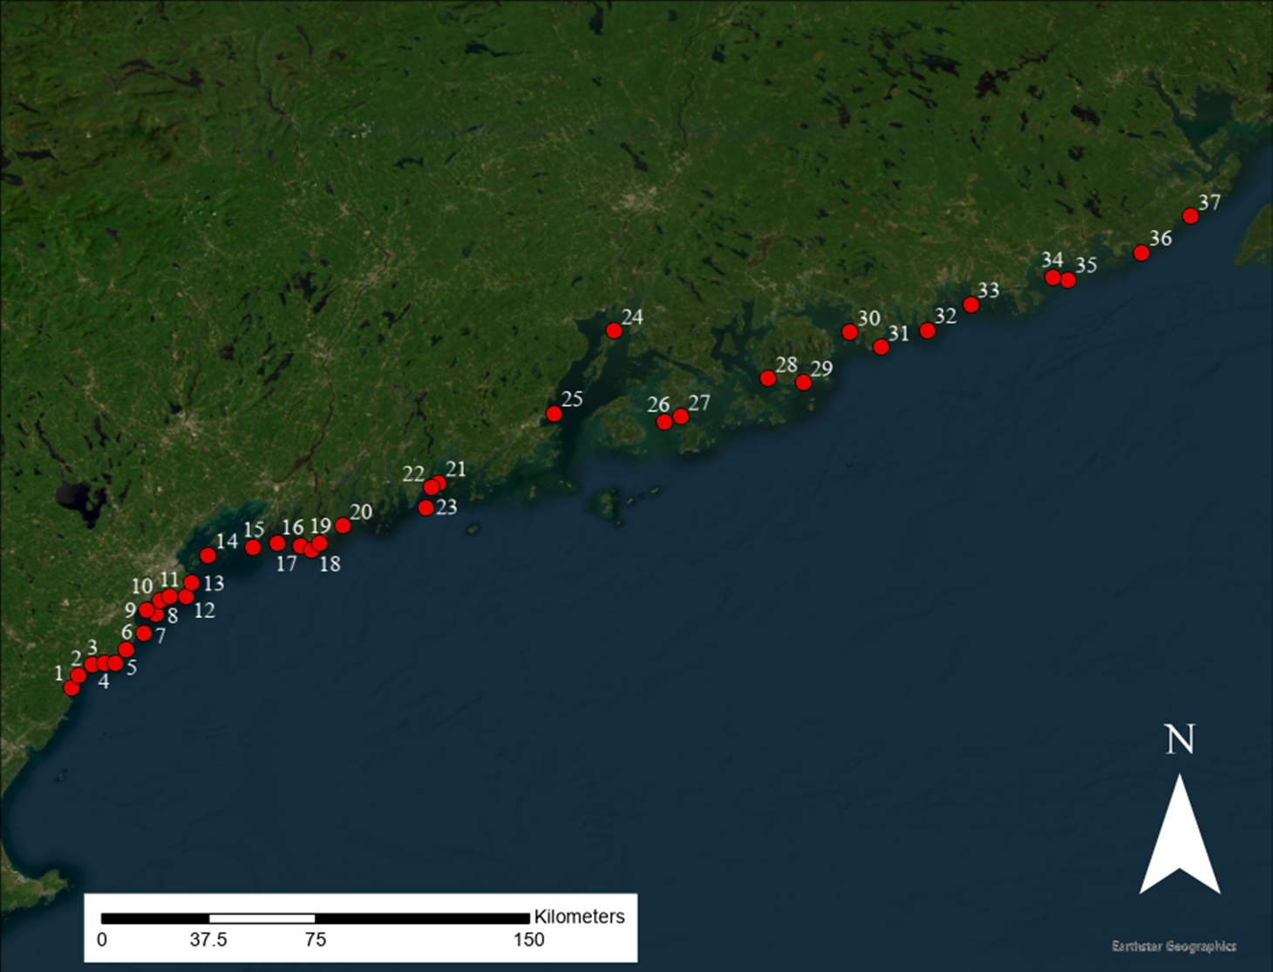
Figure A1. Comprehensive map of Inshore White Shark Monitoring Program Sites. For list of adjacent locations, refer to Table A1.1.
Table A1.1. Comprehensive list of locations adjacent to receiver sites. For map, refer to Figure A1.
No. | Location | No. | Location | No. | Location
1 | Ogunquit B. | 14 | Long I. | 27 | N Merchant I.
2 | Wells B. | 15 | Bailey’s I. | 28 | Tremont
3 | Kennebunk B. | 16 | Ragged I. | 29 | Great Cranberry I.
4 | Gooch’s B. | 17 | Head B. | 30 | Ironbound I.
5 | Goose Rocks B. | 18 | Seal Cove | 31 | Schoodic I.
6 | Fortunes Rock Cove | 19 | Popham B. | 32 | Pigeon Hill
7 | Middle Beach | 20 | Reid B. | 33 | Big Nash I.
8 | Stratton I. | 21 | Pollins Ledge | 34 | Great Spruce I.
9 | Saco Bay | 22 | Webber Dry Ledge | 35 | Brother I.
10 | Scarborough B. | 23 | E Pemaquid | 36 | Cutler
11 | Higgins B. | 24 | N Islesboro | 37 | Bailey’s Mistake
12 | Crescent B. | 25 | Rockland
13 | Cape Elizabeth | 26 | SW Sparrow I.

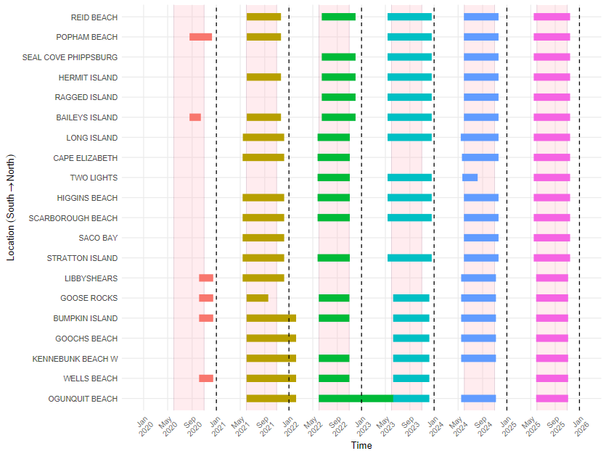
Figure B1. Receiver deployment timelines of the 20 established receiver sites used by the IWSM program, ranging from 2020-2025. Pink vertical bars represent the optimal season for a receiver to be deployed (Jun 1 - Oct 31) and dashed vertical bars separate calendar years. Receivers were not deployed until fall of calendar year 2020 in response to the fatality event at Bailey’s Island. Receiver sites from 2021-2025 which have partial or missing bars represent instances where receivers were not recovered, and thus the data is not available.
For a receiver site to be considered ‘established’, it must have had a receiver deployed for at least three full seasons with the expectation that deployment will continue in future years. Each season, extra sites may be selected for receiver deployment as equipment and funds are available. These are considered ‘experimental’ sites, and timing of deployments may vary.

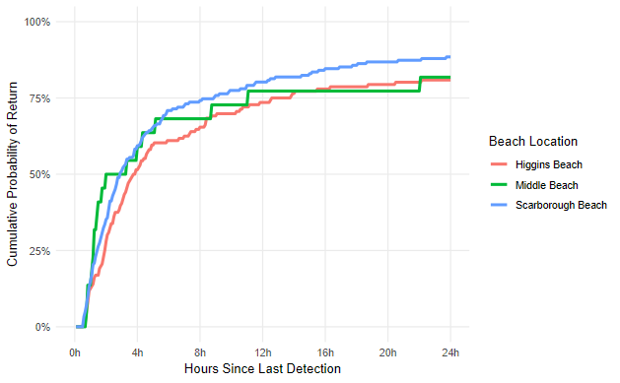
Figure C1. Comparative re-detection probability from ‘resident’ sharks within 24 hr following an initial 30 min absence from acoustic detection.
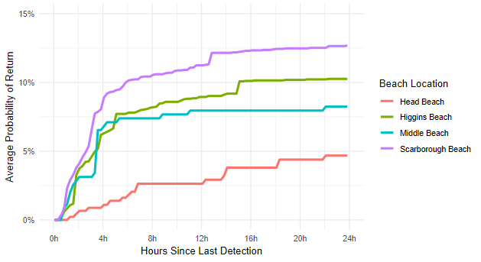
Figure C2. Weighted average re-detection probability from any given shark within 24 hr following an initial 30 min absence from acoustic detection.

