United States Coast Guard

WEB-BASED PRIVATE AID TO NAVIGATION SYSTEM
Last Revised 12-01-2012

Table of Contents
- Accessing the PATON System - 2
How to Log On – 2
  - Exhibit 1 – User Logon Screen -2
- How to Register on the PATON System - 2
- Exhibit 3 - PATON Registration Screen Example - 3
If you forget your Access Code - 4
Changing your Registration Record - 4
- Preparing a PATON Application – CG 2554 Form - 4
    - Exhibit 3 - PATON Logged On Screen Example – 4
    - Exhibit 4 - CG 2554 Screen – Header Field Group Example – 5
    - Exhibit 5 - CG 2554 Screen – Location, Depth and PATON Type Example – 5
    - Exhibit 6 - CG 2554 Screen – Floating PATON Data Field Group Example – 6
    - Exhibit 7 - CG 2554 Screen – Fixed PATON Data Field Group Example - 6
    - Exhibit 8 - CG 2554 Screen – Lighted PATON Data Field Group Example - 6
    - Exhibit 9 - CG 2554 Screen – Establishment Requested Example - 7
    - Exhibit 10 - CG 2554 Screen – Comments Section Example - 7
- Color Key Tracking System - 8
- Exhibit 11 - Color Key Tracking Codes example – 8
- Permit Cancellation Guidelines – 8

- Access to PATONS - 8

- Private Aid to Navigation Screen - 8
- Exhibit 12 - Private Aid to Navigation Screen Example -9

- Search All Options - 9
- Exhibit 13 – PATON Listing Example – 9
- The EXCEL Spreadsheet Feature - 9
- Exhibit 14 - Example of Excel Spreadsheet Option – 10.
- Off Station Criteria for Private Aids to Navigation -10
- Federal Regulations – Subpart 66.01 Aids to Navigation other than Federal or State – 11 to 15.

First District Coast Guard – Private Aid to Navigation System logon:

http://www.usharbormaster.com/

- ACCESSING THE PATON SYSTEM
All system users are required to log on to the Web-Based PATON System. This logon is just the first step. Access to this system is authorized by the Department Prevention, Waterways (DPW 1), Private Aid to Navigation Manager in Boston, MA.

HOW TO LOG ON
Using the Internet, log on to http://www.usharbormaster.com/

A User Logon Screen will appear as shown in Exhibit 2 below.

If this screen does not appear, click on the word “PATON” at the top right-hand end of the tool bar at the top of the screen.

If you are pre-registered and approved, enter your “Username” and “Password.” Then, click on “OK.” PATON Owners are able to view their own PATONs.

Exhibit 1 - User LOGON Screen

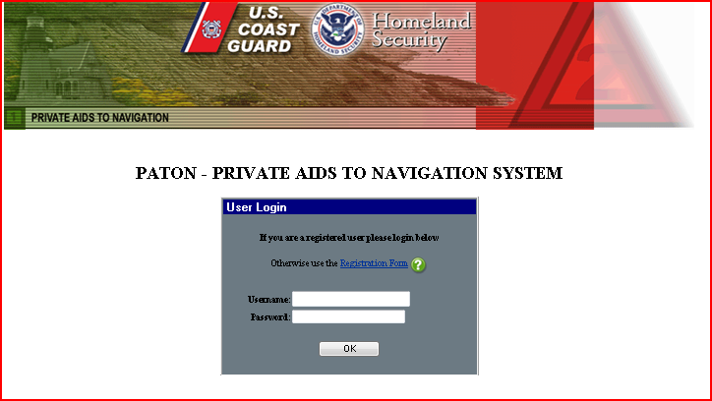

- HOW TO REGISTER ON THE PATON SYSTEM

If you are not registered on the PATON System, click on the words, “Registration Form” (Red Arrow) on the “User Logon Screen” to initiate the PATON Registration process. See Exhibit 1 above.

The PATON System Registration screen will appear. A sample PATON Registration screen is shown in Exhibit 2 on page 3.

Fields designated with a red asterisk* are required. This means that you must enter information in these fields.

The field names are self explanatory. If you are unsure of what to enter in any field, click on the field’s “Question Mark” for further instructions. The instruction lasts for about six seconds.

Note that the “State” field has a drop-down menu.

Note to new registrants: Once you register, you will not be able to use the PATON system until your access code is approved by DPW 1 [Department Prevention Waterways] in Boston. You will receive an e-mail confirming your access codes when the approval process is completed.

Exhibit 2 - PATON Registration.

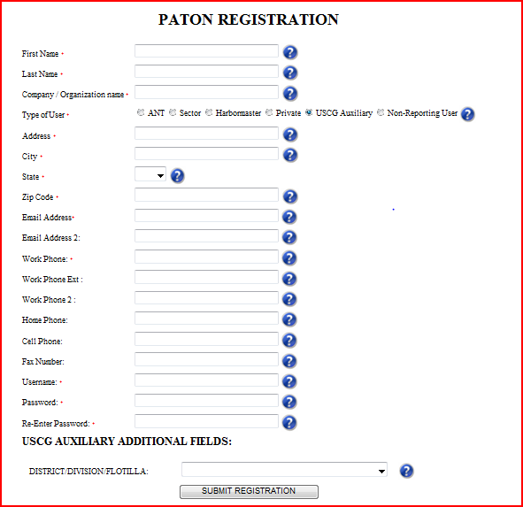

IF YOU FORGET YOUR ACCESS CODE?

E-Mail the D1 Private Aid Manager at Steven.R.Pothier.uscg.mil

CHANGING YOUR REGISTRATION RECORD

E-Mail the D1 Private Aid Manager Steven.R.Pothier.uscg.mil to correct any fields in your PATON Registration Record. Be specific as to the field(s) that you want changed and the data in the field that you want changed.

It is critical that any changes in status, telephone number and/or e-mail address be reported in a timely manner.

IMPORTANT: If you change your e-mail address without correcting your PATON System Registration record, you will lose contact with the PATON System.

- PREPARING A PATON APPLICATION – CG 2554

After you log-in to the PATON System, click on the word “Application” at the top of the LOGON screen. This button is identified with a red arrow in Exhibit 3 below.

Exhibit 3 - PATON Log On Screen Example

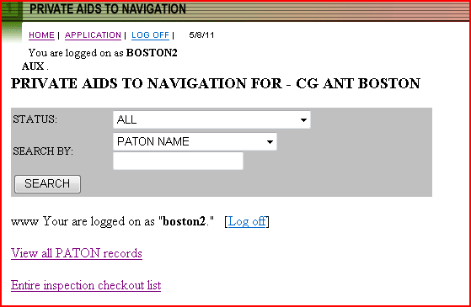

The Private Aid to Navigation CG 2554 – PATON Application Screen will appear. Sections of this on-line form are demonstrated below with explanations for their particular use.

The field names should be self explanatory. If needed, click on the field’s “Question Mark” for additional information. There is a six second time limit on viewing instructions.

Header Section for a PATON Application CG 2554 Screen:
Fields designated with a red asterisk * are required. You must enter information in these fields or your report submission will reject.

Some fields are pre-populated with data from your Registration Record. You are able to change this data. However, your Registration record will not be changed by this action. It is recommended that you change your Registration Record first.
Exhibit 4 - CG-2554 - Header Data Field Group Example.
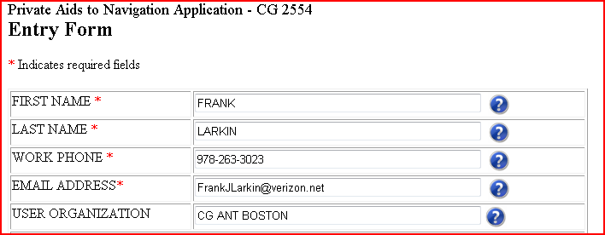

Location, Depth and PATON Identification Section:

The field names are self explanatory. Some fields have drop-down menus which control the data that can be entered in the field.

The PATON TYPE field has optional bullets that, when selected, add more appropriate data field groups to the CG2554 PATON Application. See the red arrow in Exhibit 5 below.

Floating is the alternative selection to Fixed. Lighted is the alternative selection to Unlighted.

Exhibit 5 - CG-2554 – Location, Depth and PATON Type Example

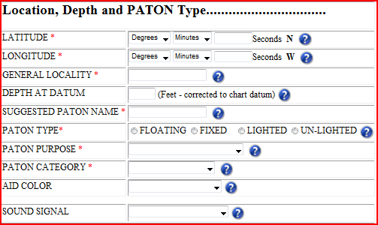

Whenever you select “Other” on a menu, always provide an explanation in the Comments Section.

Latitude and Longitude
It is very important that the Latitude and Longitude be in DD-MM-SS.SSS format or processing your application may be greatly delayed. Here is a link to assist in converting from DD-MM.MMM (Degrees and Decimal minutes) to DD-MM-SS.SSS (the required format of Degrees, Minutes and Seconds with three points after the second’s decimal):
http://transition.fcc.gov/mb/audio/bickel/DDDMMSS-decimal.html
The Floating PATON Data Field Group

When you designate a PATON TYPE as Floating, three additional fields are added as demonstrated in the Exhibit 6 below. Floating is the alternative selection to Fixed.

The three fields in the Floating Data Field Group are required. The ‘Buoy Material’ field has a drop down menu.

Exhibit 6 - CG 2554 Floating PATON Data Group Example.
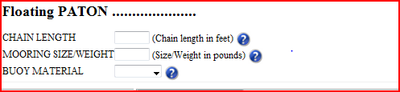

The Fixed PATON Data Field Group

When you designate a PATON TYPE as fixed, three additional fields are added as is shown in the Exhibit 7 below. Fixed is the alternative selection to Floating.

The three fields in the Fixed Data Group are required. The “Aid Structure” and “Structure Material” fields have drop-down menus.

All fixed PATONs, that are located in the seabed, must also have a Corps of Engineer’s (USACE) permit reference before the Coast Guard can approve and issue a permit.

Exhibit 7 - CG 2554 Fixed PATON Data Field Group Example

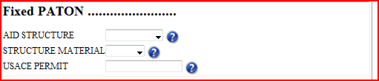

The Lighted PATON Data Field Group

When you designate a PATON TYPE as lighted, four additional fields are added as is shown in the example below. Lighted is the alternative selection to Unlighted.

The first three fields are required. The ‘Light Characteristic’ and ‘Light Color’ fields have drop down menus.

The “Height of Light” is required for fixed lighted PATONS only. Click on the “Question Mark” for instructions for measuring the height of a light correctly.

Floating lighted PATONs do not require a “Height of Light” entry.

Exhibit 8 - CG 2554 - Lighted PATON Data Field Group
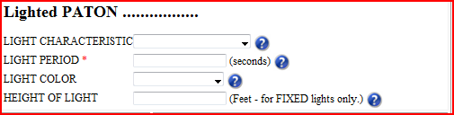

The Unlighted PATON Option
If you select “Unlighted” as the PATON TYPE field, the “Lighted PATON data field group” is removed from the PATON Application Screen. Unlighted is the alternative selection for lighted.

Establishment – Action Required and Duration
There are four options available for ‘Action Required’ – Annual, Seasonal, Temporary and Disestablish. Click on the Question Mark for an explanation of each option.

Exhibit 9 - CG 2554 - Establishment Requested Field Group Section Example
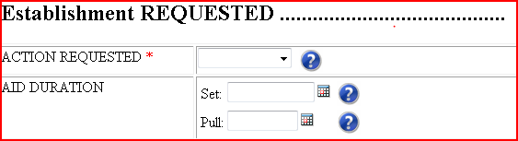
Each Establishment option has a different duration requirement. Duration is the time period when an established PATON is deployed during the year.

Annual indicates that the PATON is deployed all year round. Duration dates are not required.

Seasonal indicates that the PATON is deployed at specific times during the year. A Set and Pull date is required with this option. Enter seasonal pull dates in a month/day format or MM/DD.

Temporary indicates that the PATON is deployed for a fixed period of time. Enter the Set and Pull Date in a month/day/year format or MM/DD/YYYY.

Duration can also represent the date when the aid is planned to be Dis-established. Enter the disestablishment date in month/day/year format or MM/DD/YYYY.

Click on the Question Mark to review the details for each Duration requirement.

Comments

Enter any comments needed to explain any menu selection of “Other” or any feature that is not included in the standard permit fields. These comments may become part of the PATON’s permanent permit specification.

Exhibit 10 - CG 2554 Comments Example

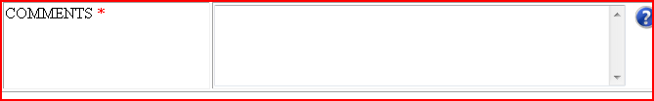

Submit Application:

Click on the “Submit Application” button to transmit your PATON Application to DPW 1 (Department Prevention, Waterways, First USCG District) for processing and approval.

4. Color Key Tracking System
The PATON Application Approval process can be tracked on line. Each step in the process is indicated by a color code. The color codes appear at the far left on each PATON listing. System Color Codes are described and explained below.

Exhibit 11 - Color Key Tracking System Codes example

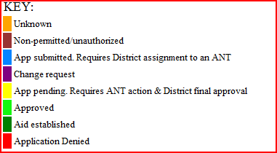

You can track the status of your application through the approval process by referencing the color code assigned to the aid’s record. Color codes appear at the extreme left on the PATON listings.

Light Blue – means the PATON application has been received and is pending action by DPW 1.

Yellow – means the PATON application is being approved by the CG ANT and/or the Harbormaster.

Light Green – means that the PATON application has been approved.

Dark Green – means that you have notified DPW 1 that you have established the aid (deployed the aid).

    - Permit Cancellation Guidelines:
The Coast Guard may cancel a PATON’s Permit when:
- The aid is not established (set out) within one-year from the date of the permit’s final approval.
- The aid is observed as not deployed for two-consecutive years.
- Check the “Permitted Comments” field for any special notes regarding this issue.

6. ACCESS TO PATONS

Once your access code has been approved and you log onto to the Web-Based PATON System, a list of the Private Aids to Navigation assigned to your linked affiliation can be accessed on the “Private Aids to Navigation Screen.”

- PRIVATE AID TO NAVIGATION SCREEN

This is the screen that appears when a user logs on to the PATON System.

The screen shows your “Username.” It appears after the phrase, “You are logged on as:” e.g. DORCH.

The title (in the example presented below) shows your affiliation. E.g. PRIVATE AIDS TO NAVIGATION FOR – DORCHESTER YACHT CLUB.

Exhibit 12 - Private Aid to Navigation Screen Example

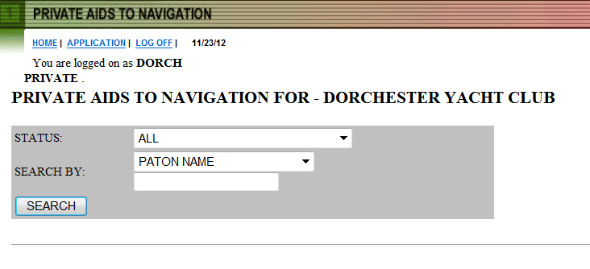

- SEARCH ALL OPTION

Using the “STATUS” command “ALL,” click in the “SEARCH” button to view all of the private aids affiliated with your organization. For the search, see the red arrows in Exhibit 14 above. Your list of private aids will be shown as listed below in Exhibit 15.

Exhibit 13 – PATON Listing Example

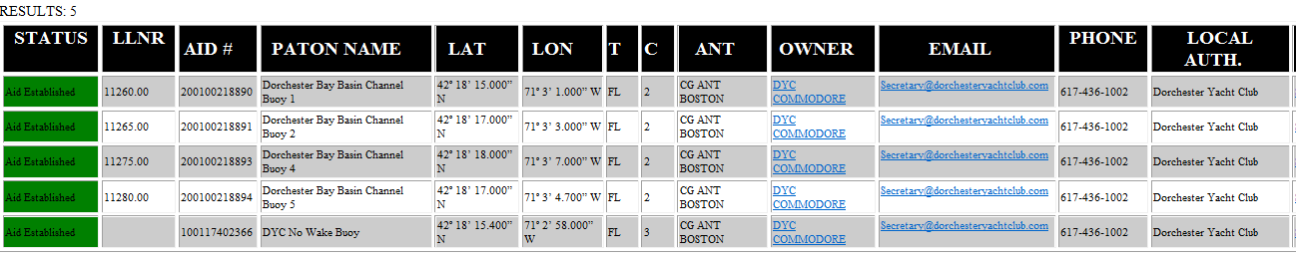

- THE EXCEL SPREADSHEET FEATURE

Follow these simple steps to create an EXCEL spreadsheet of your PATONs:

Step 1 - Open a blank EXCEL spread sheet on your computer.

Step 2 – Generate the PATON list that you want to copy.

Step 3 - Place the cursor at the top left hand side of the PATON list and drill down to the lower right hand side of the list that you are copying. Click on the copied list.

Step 4 - Paste the copied data to the blank EXCEL spreadsheet to create your spreadsheet. Exhibit 16 shows this on the next page.

Step 5 - You are now able to manipulate the data on your EXCEL spreadsheet any way that you like.

Exhibit 14 - Sample Excel Spreadsheet.

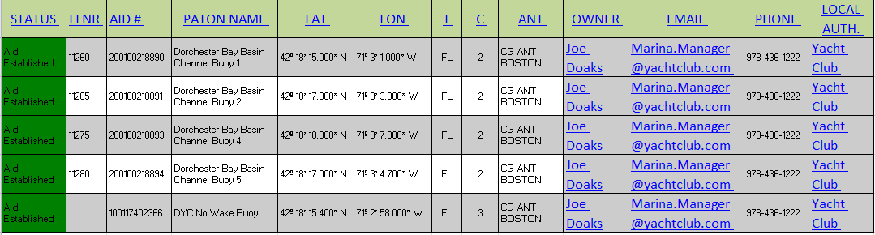

- Off Station Criteria for Private Aids to Navigation
Criteria and actions have been established for three types of PATONs – Fixed PATONs, Floating Lateral PATONS and Floating Regulatory (non-lateral) PATONS. Each has a difference course of action.

Fixed PATONs that are permanently affixed to the seabed. An observed fix for the PATON that is more than 25 feet from the fixed private aid’s permitted position is considered as off station.

Floating Lateral PATONs are the aids that mark the edges of a navigable channel or fairway. The actual position of a floating aid to navigation is the location of its anchor or mooring. A fix for the lateral PATON that is observed as more the 50 feet from the lateral private aid’s permitted position is considered as off station.

Floating Regulatory and Special Purpose PATONS are private aids that are not used for navigational purposes. These aids support local ordinances regarding boat speed, no wakes, swim areas, etc. A fix for a floating regulatory buoy that is observed as more than 300 feet from its permitted position is considered as off station. Regulatory and Special Purpose buoys are also considered as off station when they are positioned within a navigable channel.

DISTANCE STANDARDS TABLE

One degree of Latitude | [ 01-00-00-00 ] | 60.8 nm
One Nautical mile or 1 minute of Latitude | [ 00-01-00-00 ] | 6,076 ft
One Second of Latitude | [ 00-00-01.00 ] | 101.3 ft
One-tenth of a second of Latitude | [ 00-00-00.10 ] | 10.1 ft.
One-thousand of a second of Latitude | [ 00-00-00.01 ] | 1.0 ft.

- FEDERAL REGULATIONS – Private Aids to Navigation.
This section is a presentation of the Federal Regulations that have been established to manage the placement and removal of private aids to navigation. The specific procedures for handling these matters have been upgraded to speed up the permitting process and make it easier for the private aid owners to communicate with the Coast Guard. These new processes have been explained in the first part of the guide.

Subpart 66.01—Aids to Navigation Other than Federal or State
SOURCE: CGFR 68–152, 33 FR 19816, Dec. 27, 1968, unless otherwise noted.

§ 66.01–1 Basic provisions.

- No person, public body or instrumentality not under the control of the Commandant, exclusive of the Armed Forces, shall establish and maintain, discontinue, change or transfer ownership of any aid to maritime navigation, without first obtaining permission to do so from the Commandant.
(Authority is provided to the District Commander who establishes local authority to the DPW 1 (Department Prevention Waterways) under a Private Aid to Navigation Manager.

- For the purposes of this subpart, the term private aids to navigation includes all marine aids to navigation operated in the navigable waters of the § 66.01–3 33 CFR Ch. I (7–1–98 Edition) United States other than those operated by the Federal Government (part 62 of this subchapter) or those operated in State waters for private aids to navigation (subpart 66.05).
(Military normally follow the standard documentation rules as well as the States and local Municipalities.)

- Coast Guard authorization of a private aid to navigation does not authorize any invasion of private rights, nor grant any exclusive privileges, nor does it obviate the necessity of complying with any other Federal, State or local laws or regulations.
(Normal private aids include lateral aids in small channels and many regulatory aids that have no lateral significance.)

- With the exception of radar beacons (recons) and shore based radar stations, operation of electronic aids to navigation as private aids will not be authorized.
[CGFR 68–152, 33 FR 19816, Dec. 27, 1968, as amended by CGD 85–057, 51 FR 11448, Apr. 3, 1986]

§ 66.01–3 Delegation of authority to District Commanders.

- Pursuant to the authority in 49 CFR 1.45(b), the Commandant delegates to the District Commanders within the confines of their respective districts (see Part 3 of this chapter for descriptions) the authority to grant permission to establish and maintain, discontinue, change or transfer ownership of private aids to maritime navigation, and otherwise administer the requirements of this subpart.
(This is handled by the Private Aid to Navigation Manager in DPW 1 in Boston.)

- The decisions of the District Commander may be appealed within 30 days from the date of decision. The decision of the Commandant in any case is final.
[CGFR 68–152, 33 FR 19816, Dec. 27, 1968, as amended by USCG–1998–3799, 63 FR 35526, June 30, 1998]

§ 66.01–5 Application procedure.

Application to establish and maintain, discontinue, change, or transfer ownership of a private aid to navigation shall be made to the Commander of the Coast Guard District in which the private aid to navigation is or will be located. Application forms (CG–2554) will be provided upon request. The applicant shall complete all parts of the form applicable to the aid to navigation concerned, and shall forward the application in triplicate to the District Commander.
(In First Northern, aid owners are required to register and use an on-line CG-2554 PATON Application format. Required fields insure that the proper information is submitted. The procedure for preparing this application is contained in the first half of this guide.)

The following information is required:

- The proposed position of the aid to navigation by two or more horizontal angles, or bearings and distance from charted landmarks. A section of chart or sketch showing the proposed location of the aid to navigation shall be included.
(Submission of a Latitude and Longitude generated with a GPS is now sufficient and acceptable. Use of horizontal sextant angles are no long required. Always format Lat/Long as DD-MM-SS.SSS.)

- The name and address of the person at whose expense the aid will be maintained.
(Required fields are provided on the on-line CG-2554 for this purpose.)

- The name and address of the person who will maintain the aid to navigation.
(This is termed the POC-Person of contact)

- The time and dates during which it is proposed to operate the aid.
(Owner indicates whether the aid is ANNUAL (deployed all year), or SEASONAL (deployed in specific months throughout the year). If Seasonal, Set and Pull dates are required. Format as Month/Day (MM/DD)

- The necessity for the aid.

- For lights: The color, characteristic, height above water, and description of illuminating apparatus.

- For fog signals: Type (whistle, horn, bell, etc.) and characteristic.

- For buoys or day beacons: Shape, color, number, or letter, depth of water in which located or height above water.

- For racons: Manufacturer and model number of racon, height above water of desired installation, and requested coding characteristic. Equipment must have FCC authorization. [CGFR 68–152, 33 FR 19816, Dec. 27, 1968, as amended by CGD 85–057, 51 FR 11448, Apr. 3, 1986]

§ 66.01–10 Characteristics.

- The characteristics of a private aid to navigation shall conform to the United States Aids to Navigation System described in Subpart B of Part 62 of this subchapter, except that only tungsten-incandescent light sources will be approved for electric lights.
(The IALA-B System refers to lateral aids only) LED lanterns are now approved for Private Aids.)

- Owners of previously authorized, but nonconforming, private aids to navigation must bring such aids to navigation into conformance with the U.S. Aids to Navigation System not later than December 31, 1994.[CGD 86–031, 52 FR 42645, Nov. 6, 1987, as amended by CGD 93–047, 58 FR 64153, Dec. 6, 1993]
(This refers to the Black and Red colors previously prescribed for use on lateral aids.)

EFFECTIVE DATE NOTE: By CGD 97–018, 63 FR 33573, June 19, 1998, § 66.01–10 was amended by removing paragraph (b) and removing the paragraph designation (a), effective July 20, 1998.

§ 66.01–15 Action by Coast Guard.

      - The District Commander receiving the application will review it for completeness and will assign the aid one of the following classifications:
(This action is performed by the Private Aid to Navigation Manager.)

Class I: Aids to navigation on marine structures or other works which the owners are legally obligated to establish, maintain and operate as prescribed by the Coast Guard.
(Class I PATONS are verified by the Coast Guard personnel.)

Class II: Aids to navigation exclusive of Class I located in waters used by general navigation. (Class II aids are generally lateral aids and lighted aids and are generally verified by USCG Auxiliary AVs.)

Class III: Aids to navigation exclusive of Class I located in waters not ordinarily used by general navigation. (Class III aids are Regulatory Aids and are verified by the USCG Auxiliary AVs.)

(b) Upon approval by the District Commander, a copy of the application permit will be returned to the applicant by e-mail. Approval for the operation of radar beacons (racons) will be effective for an initial two year period, then subject to annual review without further submission required of the owner.
(This process is now handled by e-mail in the First District and is maintained as a permanent part of the digital record for the PATON.)

§ 66.01–20 Inspection.
All classes of private aids to navigation shall be maintained in proper operating condition. They are subject to inspection by the Coast Guard at any time and without prior notice.

§ 66.01–25 Discontinuance and removal.

- No person, public body or instrumentality shall change, move or discontinue any authorized private aid to navigation required by statute or regulation (Class I, § 66.01–15) without first obtaining permission to do so from the District Commander. (DPW-1)

- Any authorized private aid to navigation not required by statute or regulation (Classes II and III, may be discontinued and removed by the owner after 30 days’ notice to the District Commander to whom the original request for authorization for establishment of the aid was submitted.

- Private aids to navigation which have been authorized pursuant to this part shall be discontinued and removed without expense to the United States by the person, public body or instrumentality establishing or maintaining such aids when so directed by the District Commander.

§ 66.01–30 Corps of Engineers’ approval.

- Before any private aid to navigation consisting of a fixed structure is placed in the navigable waters of the United States, authorization to erect such structure shall first be obtained from the District Engineer, U.S. Army Corps of Engineers in whose district the aid will be located.

- The application to establish any private aid to navigation consisting of a fixed structure shall show evidence of the required permit having been issued by the Corps of Engineers.

§ 66.01–40 Exemptions.

- Nothing in the preceding sections of this subpart shall be construed to interfere with or nullify the requirements of existing laws and regulations pertaining to the marking of structures, vessels and other obstructions sunken in waters subject to the jurisdiction of the United States, the marking of artificial islands and structures which are erected on or over the seabed and subsoil of the Outer Continental Shelf (Part 67 of this subchapter), or the lighting of bridges over navigable waters of the United States (Subchapter J of this subchapter).

- Persons marking bridges pursuant to Subchapter J of this title are exempted from the provisions of § 66.01–5. [CGD 78–156, 48 FR 11268, Mar. 17, 1983]

§ 66.01–45 Penalties.

Any person, public body or instrumentality, excluding the armed forces, who shall establish, erect or maintain any aid to maritime navigation without first obtaining authority to do so from the Coast Guard, with the exception of those established in accordance with § 64.10 of this chapter, or who shall violate the regulations relative thereto issued in this part, is subject to the provisions of 14 U.S.C. 83. [CGD 78–156, 48 FR 11268, Mar. 17, 1983]

§ 66.01–50 Protection of private aids to navigation.

Private aids to navigation lawfully maintained under these regulations are entitled to the same protection against interference or obstruction as is afforded by law to Coast Guard aids to navigation (Part 70 of this subchapter). If interference or obstruction occurs, a prompt report containing all the evidence available should be made to the Commander of the Coast Guard District in which the aids are located.

§ 66.01–55 Transfer of ownership.

- When any private aid to navigation authorized by the District Commander, or the essential real estate or facility with which the aid is associated, is sold or transferred, both parties to the transaction shall submit application (§ 66.01–5) to the Commander of the Coast Guard District (DPW 1) in which the aid is located requesting authority to transfer responsibility for maintenance of the aid.

- The party relinquishing responsibility for maintenance of the private aid to navigation shall indicate on the application form (CG–2554) both the discontinuance and the change of ownership of the aid sold or transferred.

- The party accepting responsibility for maintenance of the private aid to navigation shall indicate on the application form (CG–2554) both the establishment and the change of ownership of the aid sold or transferred.

- In the event the new owner of the essential real estate or facility with which the aid is associated refuses to accept responsibility for maintenance of the aid, the former owner shall be required to remove the aid without expense to the United States. This requirement shall not apply in the case of any authorized private aid to navigation required by statute or regulation (Class I, § 66.01–15) which shall be maintained by the new owner until the conditions which made the aid necessary have been eliminated.
14 U.S.C. 83. [CGD 78–156, 48 FR 11268, Mar. 17, 1983]

No person, or public body, or instrumentality, excluding the armed services, shall establish, erect, or maintain any aid to maritime navigation in or adjacent to the waters subject to the jurisdiction of the United States, its territories or possessions, or the Trust Territory of the Pacific Islands, or on the high seas if that person, or public body, or instrumentality is subject to the jurisdiction of the United States, without first obtaining authority to do so from the Coast Guard in accordance with applicable regulations.
Whoever violates the provisions of this section or any of the regulations issued by the Secretary in accordance herewith shall be guilty of a misdemeanor and shall be fined not more than $100 for each offense.
Each day during which such violation continues shall be considered as a new offense.

