WORD 2003 TABLES

Table of Contents
Page
LESSON 1: TABLE BASICS 1
♦ Terminology 1
♦ Creating a Table 2
♦ Table Navigation 4
LESSON 2: FORMATTING A TABLE 6
♦ The Tables and Borders Toolbar 6
♦ The Table Menu 8
♦ Selecting 9
♦ Working with Columns and Rows 10
♦ Text Orientation 13
♦ Borders and Shading 15
♦ Merging and Splitting Cells 18
♦ Table Properties 19
♦ Converting Text/Tables 25
♦ Table AutoFormat 27
LESSON 3: CALCULATIONS 29
♦ Formulas and Functions 29
♦ AutoSum 30
LESSON 4: GIVE IT A TRY! 33
LESSON 5: Deleting 35
♦ Deleting Tables 35
♦ Deleting Files 35

This workbook may be reproduced in whole or in part by an employee of the Department of Health and Human Services. All other reproduction is prohibited unless written permission is obtained from the Training Institute.

Last Updated: February 16, 2006

TABLE BASICS

OBJECTIVE: Define tables.
Create tables.
Insert and delete table data.

Terminology

OVERVIEW
A table is a structure in which text and numbers are arranged in rows and columns.
TABLE
ROW
COLUMN

CELL

Row: A group of cells running horizontally across a table.

Column: A group of cells running vertically up and down in a table.

Cell: The intersection between a row and a column.

Gridlines: The lines appearing around each cell to show the table structure.

Creating a Table

overview
You can create a table quickly and easily using Microsoft Word. When you create a table, Word places it in the document where your insertion point is placed in the document.

STEPS
- Place the insertion point where you want the table to be located within the document.

- Click the INSERT TABLE button on the Standard Toolbar. A drop-down grid is displayed.

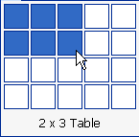

- Position your mouse pointer on the grid to select the desired number of columns and rows, and click to insert the table in the document.

- To generate a table with more than 4 rows and 5 columns, begin with your mouse in the upper left box, and click and drag your mouse to expand the grid. Let go of the mouse when you have the desired dimensions.

Lesson Example
You want to create a table to list class information.

STEPS

- Open Microsoft Word by clicking the Start button, then Programs, then Microsoft Word.
- Close the Task Pane if necessary.

- In a new blank document, type Class Information. Press ENTER twice.

- Click the INSERT TABLE button.

- Position your mouse pointer to select 3 columns and 4 rows for the table, and click.

- Save the document in the C:\MY DOCUMENTS folder using Class Information as the filename.

EXERCISE:

1) Open a new, blank document, and type Purchase Order at the top.

2) Press the Enter key twice.

3) Insert a table with six columns and seven rows into the Class Information document. (HINT: begin in the upper left box of the grid, and click and drag to expand it as needed.)

4) Save the document as Purchase Order in C:\My Documents.

5) On Your Own: Create a new document, type Phone List at the top, and insert a table with two columns and two rows.

6) Save the document in C:\My Documents using Phone List as the filename.

Table Navigation

overview
Did You Know?

Word adds a new row when you come to the last cell in the table and press TAB.

When a table is created, Word places your insertion point in the upper left cell. There are many ways to move the insertion point to other cells in order to enter information. The table below describes several:

Press | To move
TAB or the  key on your keyboard | One cell to the right, or the first cell in the next row.
SHIFT + TAB or the  on your keyboard | One cell to the left, or the last cell in the previous row.
 on your keyboard | One cell up in the current column.
 on your keyboard | One cell down in the current column.
ALT + HOME | To the first cell in the current row.
ALT + END | To the last cell in the current row.
ALT + PAGE UP | To the top cell of the current column.
ALT + PAGE DOWN | To the last cell of the current column.
Mouse Click | To any cell.

Lesson Example
You want to enter data into your Phone List table.

steps

- If your insertion point is not already there, click in the first cell of the top row, and type Name.
- Press TAB on your keyboard.
- Type Phone, and press TAB.
- Type your name, and press TAB.
- Type your phone number, and press TAB.
- What happens?

- Practice navigating through the table.
- Add two more names and phone numbers to the table.
- Save your changes.

Exercise:

1) Add the following information to the Class Information table

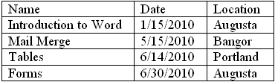

2) Save your changes.

3) On Your Own: Add the following information to the Purchase Order table:

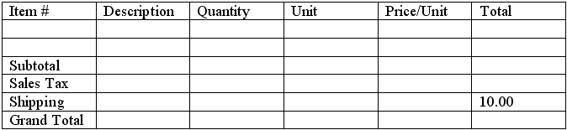

4) Save the changes to the document.

FORMATTING A TABLE
OBJECTIVES: Understand the Tables and Borders Toolbar.
Use the Table Menu.
Select sections of a table.
Resize columns and rows.
Insert columns and rows.
Apply cell borders and shading.
Arrange and format text.
Merge and split cells.
Convert text into a table format.

The Tables and Borders Toolbar

OVerview
The Tables and Borders Toolbar provides you with flexibility for making changes to your table. Click the TABLES AND BORDERS button on the Standard Toolbar to view it.
1
2
3
4
5
6
7
8
9
10
11
12
13
14
15
16
17
18

  - Draw Table – This tool allows you another way to draw a table by clicking and dragging. This is best used for more complicated tables. You should set the line style, color, and weight before drawing the table.
Helpful Hint:

You may need to click on the DRAW TABLE button to turn the pencil off.
  - Eraser – This tool allows you to erase columns, rows, cells, and tables by clicking and dragging.

  - Line Style – Use the down arrow to choose a line style.

  - Line Weight – Use the down arrow to choose the weight of the line.

  - Border Color – Click on this button to choose your border color.

  - Outside Border – Click this tool to add an outside border to your table or click the down arrow and click where you would like to place a border.

  - Shading Color – Use the down arrow to choose the shading color for the cell, table, row, or column that is highlighted.

  - Insert Table – Click this button to add a table.

  - Merge Cells – Select the cells you would like to merge together and click this tool.

  - Split Cells – Select the cell you would like to split and click this tool.

  - Align Top Left – Click this tool or the down-arrow to choose how you would like to the text aligned in the cell.

  - Distribute Rows Evenly – Select the rows and click this tool to have your rows at equal heights.

  - Distribute Columns Evenly – Select the columns and click this tool to have your columns of equal width.

  - Table AutoFormat – Select your table and click this tool to choose the format, and click APPLY.

  - Change Text Direction – Select the text to change and click this tool until you have the direction of choice. It alternates from down, to left, to up.

  - Sort Ascending – Select the column and click this icon to sort your text alphabetically.

  - Sort Descending – Select the column and click this icon to sort your text reverse order.

  - AutoSum – Click in the cell where you would like the total to be and click this tool. It will automatically add all numbers together that appear in that column.

The Table Menu

OVERVIEW
There are times when you want to format your table and the tasks are not on the Formatting or the Tables and Borders toolbars. This is when you need to use the TABLE MENU.
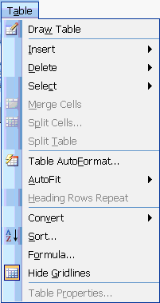
1
2
3
4
5
6
7
8
9
10
11
12
13
14
15
- Draw Table – This tool allows you another way to draw a table by clicking and dragging. This is best used for more complicated tables.

- Insert – When you pause on Insert, it displays a menu that you can choose from. The choices are Table, ColumnS to the Left, ColumnS to the Right, RowS Above, RowS Below, and Cell.

- Delete – When you pause on Delete, you can choose Table, ColumnS, RowS, or CellS from the list.

- Select - When you pause on Select, you can choose Table, Column, Row, or Cell from the list.

- Merge Cells – Takes two or more cells and combines them into one.

- Split Cells – Takes one cell and splits it into two or more.

- Split Table – Divides a table into two.

- Table AutoFormat – A quick way to choose pre-defined formats for your table.

- AutoFit – When you pause on AutoFit, you can choose to AutoFit your table to the Contents, AutoFit TO Window, FixED Column Width, Distribute Rows Evenly, and Distribute Columns Evenly from the list.

- Heading Rows Repeat – This repeats the heading rows on all of the pages of your table.

- Convert – When you pause on Convert, you can decide to Convert Text from TO Table or TABLE TO TEXT.

- Sort – Sort a column from A-z or 1-10 order.

- Formula – Enter and format a formula into your table.

- Show/Hide Gridlines – Shows or Hides the gridlines of the table. These are non-printing gridlines.

- Table Properties – Sets the properties of your table.

Selecting

Overview
At times, you need to select an entire row or column, or just a cell. That way, you can format text, gridlines, or delete information easily. The Formatting toolbar is active while working with a table, so you may use any of its features to format a table. See the Nice To Know section at the end of the courseware for details on the Formatting toolbar.

To select cells, columns, rows, or an entire table, follow the instructions below.

To Select (Highlight) | Click | Pointer Location
A cell |  | Left of cell contents
A column |  | Top border of column
A row |  | Left of a row (outside the table)
An entire table |  | Move mouse pointer inside table, when this icon appears, click once.

Working with Columns and Rows

overview
Helpful Hint:

Press and hold the ALT key while resizing and you see the measurements of the columns or rows on the rulers.

Once you have entered information into the table, you may find that the columns and/or rows are too small or large. You may also need to add or remove entire rows or columns.

steps
- Make sure that you are in Print Layout View (VIEW, PRINT LAYOUT) and that no row, column, or cell is selected (your insertion point should blink within the table.

- Position the mouse pointer over the right border of the column or bottom border of the row you want to adjust.

- When the mouse pointer appears as a double-sided arrow ( to adjust a row, to adjust a column) click and drag until the row or column is the size that you want.
Helpful Hint:

Make sure no cell or group of cells is selected (highlighted) while resizing. Only the selection would be resized.

- To resize a column to the widest entry in that column, double-click the mouse pointer .

- To resize all columns in your table to their widest entries, double-click the mouse pointer while you point at the left-most border of the table.

- To insert a new column, click in a cell adjacent to where you would like the new column. Click TABLE, Insert, then select either ColumnS To The RIGHT or COLUMNS TO THE LEFT.

- To insert a new row at the bottom of your table, click in the lower right cell of the table, and press the TAB key.

- To insert a new row elsewhere in the table, click in a cell adjacent to where you would like the new row. Click TABLE, Insert, then select either ROWS ABOVE or ROWS BELOW.

Lesson Example
You would like to begin formatting your Purchase Order table.

steps
Helpful Hint:

You can move any toolbar by clicking its Title Bar and dragging it to a different location. You can "anchor" any toolbar by double clicking its Title Bar.

- Right mouse click any toolbar and select the Table and Borders toolbar.
- Select the first row of the table by pointing to the left of the table and clicking once.

- Click the BOLD button in the Formatting toolbar.

- Resize the top row by pointing to its bottom border, then clicking and dragging down slightly.

- Click anywhere in the table to deselect the top row.

- Resize the Unit column by pointing to its right border and double-clicking.

- Select the two blank rows in the middle of the table (point outside the table to the left, and click and drag to capture both rows).

- Click TABLE, INSERT, ROWS BELOW.

- Add the following items to the table:

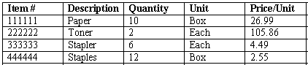

- Resize all columns to their widest entry by moving your mouse pointer to the leftmost border of the table and double-clicking.

- Save your changes.

Exercise:

1) Open the Class Information file and view the Tables and Borders toolbar.

2) Resize all columns to their widest entry.

3) Add a new column to the far right of the table.

4) Add the following information to your new column:

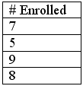

5) Resize the new column.

6) Change the text formatting of the labels in the top row.

7) Save your changes.

8) On Your Own: Make changes to the text formatting and column widths of the Phone List table.

9) Insert a new row in the middle of the table, and add another name and phone number.

10) Save your changes.

Text Orientation

overview
Did You Know?

The Tables and Borders toolbar is also available by clicking on the Standard Toolbar. However, you should to turn off the DRAW TABLE feature that automatically activates when the toolbar is opened this way.

When you are formatting your table, you may wish to change the alignment of text in your cells, both horizontally and vertically. You may also find a need to rotate text in a cell to conserve space or add style to the table. Finally, you may want to rearrange the order of the text you have entered into the table by sorting the information. All of this is possible in Word.

STEPS

1. To align text horizontally in a cell, select the cell(s) you wish to modify, and click the appropriate alignment button (Left, Center, Right, or Justified) in the Formatting toolbar.
- To open the Tables and Borders toolbar, click VIEW, then point to TOOLBARS, and click TABLES AND BORDERS.

- To align text vertically in a cell, select the cell(s) you wish to modify and click the drop-down arrow for the ALIGNMENT button in the Tables and Borders toolbar. Click the desired alignment. This feature allows for horizontal alignment as well.

4. To rotate text within a cell, select the cell(s) you wish to rotate, and click the CHANGE TEXT DIRECTION button in the Tables and Borders toolbar. Continue to click the button until the text appears in the desired direction.

5. To sort the rows of your table, click in any cell of the column by which you wish to sort, i.e. to sort by class title, click on any class Name.

6. Click the SORT ASCENDING , or SORT DESCENDING button in the Tables and Borders toolbar.

Lesson Example
You would like to arrange the text in your Class Information table.

steps
  - Select the top row of your table, and center the titles in their cells by clicking the CENTER button in the Formatting toolbar.

  - Click in any class Name cell, then click the SORT ASCENDING button in the Tables and Borders toolbar.

  - Select all of the dates (without the label) and click the ALIGN RIGHT button in the Formatting toolbar.

  - Save your changes.

Exercise:

1) Open the Purchase Order and rotate the Price/Unit label to read from bottom to top.

2) Adjust the row height and resize the column.

3) Center all of the labels in the top row both horizontally and vertically.

5) Save your changes.

6) On Your Own: Center all cells in your Phone List table horizontally.

7) Sort the list alphabetically by Name.

8) Save your changes.

Borders and Shading
Did You Know?

You can also use the LINE STYLE , LINE WEIGHT , and BORDER COLOR buttons on the Tables and Borders toolbar. They will activate the DRAW TABLE button which will allow you to draw the new line format along different borders.

The lines dividing cells in your table are called Gridlines. Word applies borders of ½ point to these gridlines. You can modify these borders for the entire table, a row or column, or for just one cell. You may also add shading to the background of a cell or group of cells.

STEPS
- Select the area you wish to change.
- To add or remove a border, click the drop-down arrow for the BORDER button on the Formatting toolbar.
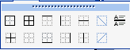
- Click on the button of the border you want to add or remove.
- To format borders further, select the area of the table to modify, and click FORMAT, BORDERS AND SHADING.
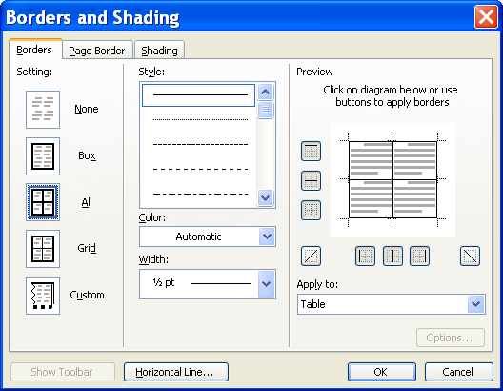
- On the BORDERS tab, click ALL to have the same gridlines for each selected cell, or click BOX to have only the outside border of your selection formatted.
- To change the line style, click on a style in the STYLE box.
- To change the line color, click on the drop-down arrow in the COLOR selection box, and click on the desired color.
- To change the line width, click on the drop-down arrow in the WIDTH selection box, and click the appropriate width.
- To apply shading to the background of your selected cells, click the SHADING tab.
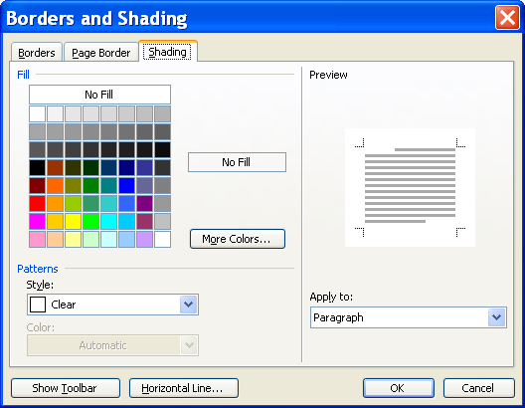
- Click the FILL color you would like.
- Once done formatting borders and shading, click OK.

Lesson Example
You decide that not all of the borders are needed in your Phone List.

steps
- Select the entire table by clicking the in the upper left corner of the table.

- Click the drop-down arrow next to the BORDERS button in the Formatting toolbar, and click the NO BORDER option.

- If your gridlines do not appear in gray, click TABLE, SHOW GRIDLINES.

- Select the top row of the table.

- Click FORMAT, BORDERS AND SHADING.

- Click the dashed line STYLE (third from the top of the Style list), and click the BOTTOM BORDER button in the PREVIEW area to apply the border. You may have to unclick the side and top borders.

- Click the SHADING tab, and select the GRAY - 10% FILL (third color in the top row).

- Click OK, and save your changes.

Exercise:

1) In the Purchase Order file, apply a double line box border around the outside of your table.

2) Select the shading color of your choice.

3) Save your changes.

4) On Your Own: Make border and shading selections for your Class Information table.

5) Save your changes.

Merging and Splitting Cells

overview
Helpful Hint:

Remember that you can remove borders between cells so they appear to be merged, if you have no real use for the larger merged cell.
Occasionally you may want your table to have an irregular configuration of cells rather than the typical straight columns and rows. Word allows you to take several cells and combine them into one cell, or break a single cell into many parts.

STEPS

1. To merge a group of cells, select the group. They must be next to one another, and only the upper left cell in the group should contain information.

2. Click the MERGE CELLS button in the Tables and Borders toolbar.

3. To divide a single cell in to multiple cells, click in the cell to be divided, and click the SPLIT CELLS button in the Tables and Borders toolbar.

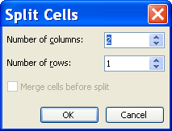

4. Use the up and down arrows to select the desired number of columns and rows. Click OK.

Table Properties

Overview
The Table Properties dialog box contains features that allow you to customize your table, including the placement of the table, specific row and column sizes, and cell alignment.

STEPS
- Click on TABLE, then TABLE PROPERTIES.
Did You Know?

If you select the entire table and click the CENTER button in the Formatting toolbar, your table, but not its contents, centers horizontally on the page.

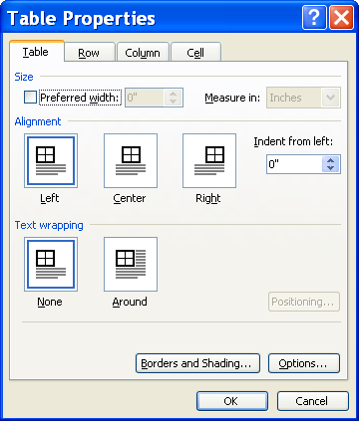

- To change where the table is located horizontally on the page, click on the LEFT, CENTER, or RIGHT buttons on the TABLE tab.
- To “wrap” external text around the table, click the AROUND button.
- To set a specific height for a row, click the ROW tab. Keep in mind that Word sets the height of the row to accommodate the font used.
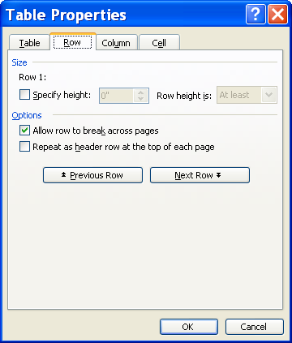
- Click the check box to SPECIFY HEIGHT, then click the arrows to increase or decrease the height of the row. You may use the PREVIOUS ROW and NEXT ROW buttons to select the appropriate rows to change.

- Click the drop-down arrow for ROW HEIGHT IS to select AT LEAST or EXACTLY.

- To prevent a single row from being divided on two pages, remove the checkmark from allow ROW TO BREAK ACROSS THE PAGE.

- When creating a table, Word divides the table into equal columns across the page. To set a specific width for a column, click the COLUMN tab.

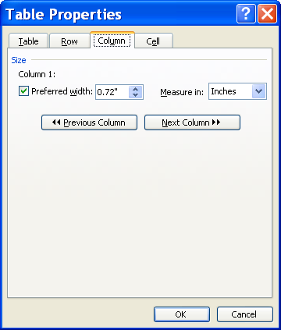

- Click the up and down arrows to increase or decrease the width of each column. You may use the PREVIOUS COLUMN and NEXT COLUMN buttons to select the appropriate columns to change.

- Click the drop-down arrow for MEASURE IN to specify INCHES or PERCENT.

- To specify the width of the active cell, click the CELL tab.

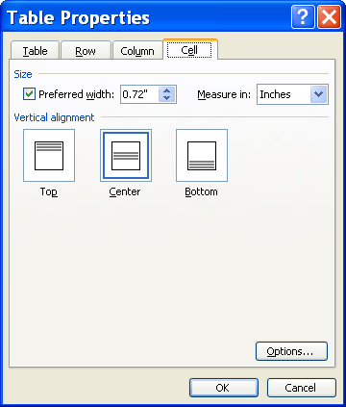

- Use the up and down arrows to increase or decrease the width of the cell. You may only change the cell that was active upon entering Table Properties.

- Click the drop-down arrow for MEASURE IN to specify INCHES or PERCENT.

- To set vertical text alignment within the active cell, click TOP, CENTER, or BOTTOM.

- When finished setting Table Properties, click OK.

Lesson Example
You continue to format your Phone List file.

steps
- Select the top row of the table, and click the MERGE CELLS button in the Tables and Borders toolbar.

- Type Phone List in the newly merged cell.

- Center the text horizontally.

- Click in the cell containing your phone number.

- Click the SPLIT CELLS button in the Tables and Borders toolbar.

- Choose to split the cell into two columns. Keep one row.

- In the new cell, type another phone number. You may need to adjust your column width to accommodate the new number.

- Select the entire table and click TABLE, TABLE PROPERTIES.

- On the TABLE tab, click CENTER in the ALIGNMENT section to center the table on the page.

- Click the ROW tab, and SPECIFY THE HEIGHT to .5" EXACTLY.

- Click OK and save your changes.

Exercise:

1) Add two new blank rows to the bottom of your Class Information table.

2) Merge the first three cells in the first new row, and type Total in the resulting cell.

3) On Your Own: Merge the first three cells in the second new row, and type Average in the resulting cell.

4) Right align these two rows.

5) Save your changes.

Converting Text/Tables

overview
In some cases, you may realize after you have typed a document that a portion of it would work better in a tabular format. Or, you may find that you have entered text into a table and would like to return it to a normal text format.

STEPS

1. To convert plain text into a table, select the text, and click TABLE, point to CONVERT, and click TEXT TO TABLE.

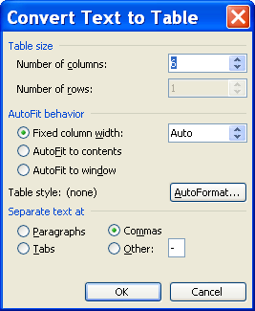

2. Use the up and down arrows to indicate the NUMBER OF COLUMNS for the new table. Depending on the text to be converted, NUMBER OF ROWS is typically unavailable.
Did You Know?

Table AutoFormat overrides several of the formatting choices you may have made before applying the AutoFormat.

3. If you want the columns to be equal in size, select FIXED COLUMN WIDTH/AUTO. If you want them sized to the contents, select AUTOFIT TO CONTENTS. If you plan to publish this table to the Web, and it should conform to the browser’s window size, select AUTOFIT TO WINDOW.
4. Choose how Word should separate the information as it goes into the table: by PARAGRAPHS, TABS, COMMAS, or OTHER.
5. Click OK.
6. To convert a table into plain text, click anywhere in the table, then click TABLE, point to CONVERT, and click TABLE TO TEXT.
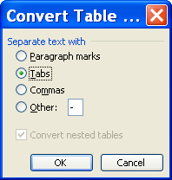
7. Indicate the method for distinguishing how the information should be separated once converted: PARAGRAPH MARKS, TABS, COMMAS, or OTHER. Click OK.

Table AutoFormat

overview
While it is possible, and maybe even preferable, to format tables manually, if you are short on time or aren't certain what you would like to do for formatting, Word has a feature that allows you to automatically set the formatting for your table.

STEPS

- Click anywhere within your table.

- Click the AUTOFORMAT button in the Tables and Borders toolbar.

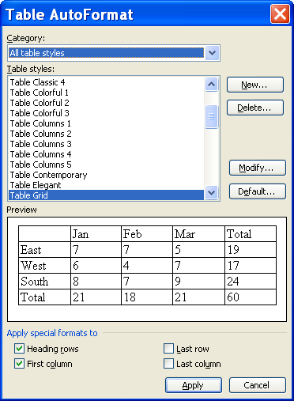

- Click the TABLE STYLES in the list to PREVIEW them below.

- Click to remove or add checkmarks from the APPLY SPECIAL FORMATS TO section.

- Click APPLY.

Lesson Example
You decide to try converting your Phone List into plain text.

steps
- Return to the Phone List file.

- Click anywhere in the table.

- Click TABLE, CONVERT, TABLE TO TEXT.

- Choose TABS for the text separator, and click OK.

- Save your changes.

Exercise:

1) Open a new, blank document, and in it, type the following list:

red, orange, yellow, green, blue, indigo, violet, 1, 2, 3,
4, 5, 6, 7

2) Select the text and click TABLE, CONVERT, TEXT TO TABLE. Change the NUMBER OF COLUMNS to 7 and click OK.

3) With the cursor in the table, click TABLE AUTOFORMAT and select TABLE COLORFUL2. Remove the checkmark from FIRST COLUMN and click APPLY.

4) On Your Own: Return the list to text.

5) Close the file without saving your changes.

CALCULATIONS
OBJECTIVES: Insert table functions.
Use the AutoSum feature.

Formulas and Functions

overview
A formula is a calculation involving cells within your table. A function is a pre-written formula in Word.

Examples of common Word functions are:

AVERAGE: | The average of a list of values
COUNT: | The number of items in a list
MIN: | The smallest number in a list
MAX: | The largest number in a list
SUM: | The sum of a list a values

In order to use a formula or function in a table, we must identify (or name) the cells to be used in the calculation. Word has a system for referencing cells by their location in the table.

A column is identified with letters, as in A, B, C…

A row is identified with numbers, as in 1, 2, 3…

They go in numerical and alphabetical order.
 | A | B | C
1 | A1 | B1 | C1
2 | A2 | B2 | C2
3 | A3 | B3 | C3

The cell is named using the column letter and row number, similar to the way maps denote sections.

STEPS

- Click in the cell in which you want the result to appear.

- Click TABLE, then FORMULA.

- To create a formula, erase the contents of the FORMULA text box.

- Type = then cell references, numbers, and/or operators (+ - * /) to perform the desired calculation. For example, to calculate 5.5% sales tax on a subtotal that is in cell D10, type =D10*.055. Click OK.

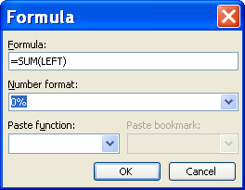

- To use a function, in the PASTE FUNCTION drop-down box, select a function.

- Type the cell range in the parentheses. Syntax for a cell range is the first cell, a colon, and the last cell in the series. For example A1:A22.

- To select number formatting, in the NUMBER FORMAT drop-down box, choose a format.

- Click OK. This insertS the results into the active cell.
- If you change a number in a table that affects the result of a calculation, Word does not automatically recalculate. You must remove and reenter the calculation or select and right-click on the result, and click UPDATE FIELD. You can also click on the calculation and press F9 to update the field.

AutoSum

overview
If you have a column or row of numbers in your table, Word has a feature that automatically adds them and inserts the total into a cell in the table.

STEPS

- If necessary, add a row or column to your table to contain totals.

- Click in the cell where you would like a total to appear. This cell should be in line with your row or column of numbers.

- Click the AUTOSUM button in the Tables and Borders toolbar. The total should appear in the active cell.

- If you change a number in a table that affects the result of a calculation, Word does not automatically recalculate. You must remove and reenter the calculation or select and right-click on the result, and click UPDATE FIELD. You can also click on the calculation and press F9 to update the field.

Lesson Example
You would like to know the average number of students enrolled per class.

steps
- In your Class Information table, click in the blank cell to the right of the Total label.
- Click the AUTOSUM button on the Tables and Border toolbar.
- Click in the blank cell to the right of the Average label.

- Click TABLE, FORMULA.

- Delete everything in the FORMULA box except the equal sign (=).

- Select the whole number from the NUMBER FORMAT drop down box.

- In the PASTE FUNCTION drop-down box, select AVERAGE.

- Type D2:D5 between the parentheses in the FORMULA box.

- Click OK.

- Change the number of students enrolled in Introduction to Word from 7 to 10.

- Click in the Total cell and press F9 to update the Total.

- Click in the Average cell and press F9 to update the Average.

- Save your changes.

Exercise:

1) In the Purchase Order table, calculate the Total Price for the first item ordered. Select TABLE, FORMULA.

2) In the FORMULA box, delete everything except the equal sign. Type in C2*E2.

3) Select the NUMBER FORMAT with 2 decimal places and click OK. Repeat Steps 2 and 3 for the other three items.

4) On Your Own: Select the cell for the Subtotal row and click the AUTOSUM button.

5) Insert a formula to calculate a 5% Sales Tax on your Subtotal.

6) Insert a formula (or function) for the Grand Total that adds your Subtotal, Sales Tax, and Shipping figures together.

7) Merge the Subtotal label with the blank cells beside it.

8) Repeat the above steps for Sales Tax, Shipping, and Grand Total labels.

9) Right align these four labels.

10) Select all of the numerical data and right align the cells.

11) Save your changes.

GIVE IT A TRY!
OBJECTIVE: Practice the skills learned in class.

EXERCISE:

Refer to Lesson 1 for assistance.

1) Open a new, blank document.

2) Insert a table with 4 columns and 5 rows.

3) Type the following information into your table:

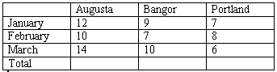

4) Save the document in the C:\My Documents folder using First Quarter as the filename. Remember to save periodically throughout the exercise.

Refer to Lesson 2 for assistance.

5) Bold and center the text in the top row, and increase the font size to 14 point.

6) Bold and italicize the text in the first column and increase the font size to 14 point.

7) Resize all columns to fit the widest entry.

8) Center the table itself horizontally on the page.

9) Apply a double line top border and Gray - 10% shading to the Total row.

10) Add another row to the bottom of the table, and type Average in the first cell of the new row.

11) View your Tables and Borders toolbar.

12) Format the text of the top row as you wish.

13) Select the Augusta, Bangor, and Portland labels, and center them vertically within their cells.

14) Apply the Table Grid 8 AutoFormat to the table.

15) Undo the AutoFormat.

Refer to Lesson 3 for assistance.

16) In the empty cell to the right of Total (in the Augusta column), use AutoSum to calculate the total number of trainings held in Augusta for the quarter.

17) Repeat for Bangor and Portland.

18) In the empty cell to the right of Average, insert a function to calculate the average number of trainings held in Augusta for the quarter.

19) Repeat for Bangor and Portland.

20) Change the February Portland figure from 8 to 5.

21) Update the Portland Total and Average calculations.

22) Save your changes and close the file.

Deleting
OBJECTIVE: Remove tables from documents.
Maintain organized file directories.

Deleting Tables

overview
Sometimes you insert a table that is no longer needed in the document. You are then able to delete it.

steps
- Select the entire table using the button.

- Click TABLE, point to DELETE, then click TABLE.

Deleting Files
STEPS

1. Close the Tables and Borders toolbar and close all open documents.

2. Select OPEN from the FILE MENU.

3. Click once on the name of the file to be deleted, or use the CTRL or SHIFT keys to select multiple files.

4. Press the DELETE key on your keyboard.

5. Click YES to confirm the deletion.

6. Click the CANCEL button to close the OPEN dialog box

Lesson Example
You want to eliminate the Class Information table as well as the Phone List file.
Did You Know?

Holding the SHIFT key while clicking the FILE MENU gives you the option to CLOSE ALL without exiting the program.

STEPS

- Open the Class Information file.
- Select the entire table using the button.
- Click TABLE, point to DELETE, then click TABLE.
- Close the file without saving it.
- If necessary, close your PHONE LIST file.
- Click OPEN in the FILE MENU.
- Click the Phone List file once, and press the DELETE key on your keyboard.
- Click YES to confirm the deletion, then click CANCEL to close the OPEN dialog box.
EXERCISE:

1) Close all remaining files, but remain in Microsoft Word.

2) In the Open Dialog box, delete all Microsoft Word files from the C:\My Documents folder.

3) Close the dialog box, exit Microsoft Word, and shut down your computer.

