WORD 2003 FORMS

Table of Contents

Page
LESSON 1: Form DESIGN 1
♦ Designing a Form 1
♦ Templates 2
♦ Inserting the Automatic Date 4
♦ Text Form Fields 7
♦ Check Box Form Fields 10
♦ Drop-Down Form Fields 13
LESSON 2: USING A TABLE IN A FORM 15
♦ Insert a Table into a Form 15
♦ Performing Calculations 17
LESSON 3: COMPLETING A FORM 21
♦ Protect and Unprotect a Form 21
♦ Completing a Form 21
LESSON 4: CHANGING A TEMPLATE 24
♦ Revise a Template 24
LESSON 5: GIVE IT A TRY! 26
LESSON 6: DELETING FILES 28
♦ Deleting Templates 28
♦ Deleting Files 28
NICE TO KNOW 30
♦ Save and Edit Templates 30
♦ Templates Created in Class 32
♦ Save/Edit/Update Templates 36

This workbook may be reproduced in whole or in part by an employee of the Department of Health and Human Services. All other reproduction is prohibited unless written permission is obtained from the Training Institute.

Last Updated: March 2, 2006

Form DESIGN

OBJECTIVES: Define forms and their components.
Investigate form design.
Insert and customize form fields.

Designing a Form

overview

A form in Microsoft Word is just like a form on paper - something that includes standard text along with spaces, called form fields, in which specific information is captured.

Typically, forms are documents that are used repeatedly. When you create forms in Word, you may design them to be completed “on-screen” or print them to be filled out on paper. If completing a form on-screen, Word allows you to save the form as a template, which provides you with a blank version of the form each time it is opened.

Before you begin to create your form in Word, you may want to consider the following:

- What type of form am I developing? Is it a letter, an order form, a travel form?

- Who will be filling out the form? Co-workers, the public, or me?

- How will my form be filled out? On-screen or on paper?

- What information does my form need to capture?

Templates

overview

If you determine that the form is to be filled out on-screen, you will want to save the document as a template, which may be used over and over again without altering the original. Microsoft Word stores document templates in a special folder that allows the user to open new blank forms easily.

steps

- Open a new, blank document, and type the form’s constant text, i.e. text that will not change from one use of the form to the next.

- Click FILE, SAVE AS.

- Type an appropriate name for the template in the FILE NAME text box.

- In the SAVE AS TYPE drop-down list, select DOCUMENT TEMPLATE.

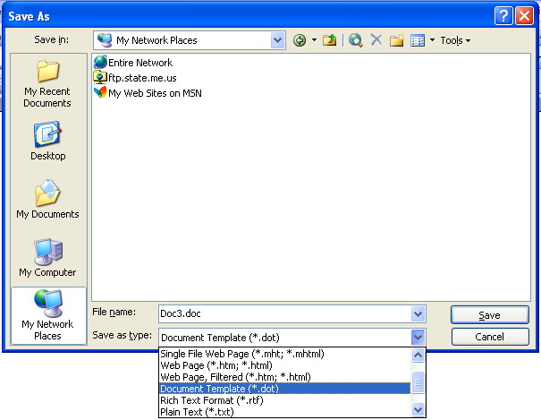
Document Templates

- Microsoft Word will automatically change the SAVE IN folder to the TEMPLATES folder. Do not change this file location.

- Click SAVE.

- To open a document based on a template, click FILE, NEW. The NEW DOCUMENT task pane will open.

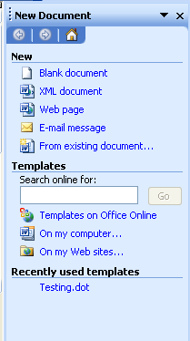
On my computer

- Select the templates ON MY COMPUTER hyperlink. The template window will open.
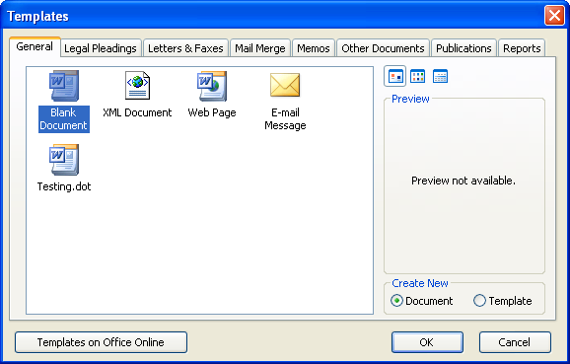
- From the GENERAL tab, select the template to use.
- Double-click the template to be used.

Inserting the Automatic Date

overview

If the form template includes a date, you will most likely want the date to be current upon opening the form. In this case, you will insert a date that automatically updates to the current day.

steps

- Click where you would like the date to appear.

- Click INSERT, then DATE AND TIME.

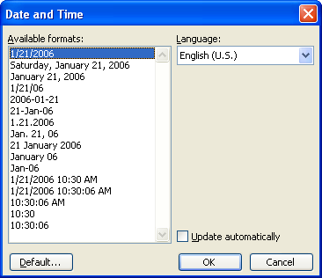

- Select the desired date format from the AVAILABLE FORMATS list.

- Ensure that the checkmark appears in the UPDATE AUTOMATICALLY check box, and click OK.

Lesson Example

You have been asked to create a form to bill clients for your computer consulting services.

steps
- Open Microsoft Word by clicking START, PROGRAMS, MICROSOFT WORD.
- Type Consulting Invoice as a title, and format it as you wish.
- Press ENTER twice.
- Type Invoice Date: and press the TAB key.
- Click INSERT, then DATE AND TIME.
- Click the Month-Day-Year format on the list.
- Put a check mark in the UPDATE AUTOMATICALLY check box. Click OK.
- Press TAB three times.
- Type Date of Service:.
- Press Enter three times.
- Type Type of Problem:, and press TAB twice.
- Type Hardware, and press TAB twice.
- Type Software, and press ENTER twice.
- Type Description of Problem:, and press ENTER twice.
- Type Solution:, and press ENTER four times.
- Type Consultant:.
- Click FILE, then SAVE AS.
- Type Consulting Invoice for the filename if necessary.
- Click the SAVE AS TYPE drop-down, and select DOCUMENT TEMPLATE from the list.
- Click SAVE.

Exercise

1) In a new document, type the following:
Class Registration Form

Student Name:

Address:

Phone:

Department:

2) Save the document as a template using Class Registration Form as the filename.

3) On Your Own: Create one more form in a new document as follows:

(automatic date)

Dear

This letter is to inform you that I have been assigned as your new Case Manager. Our records indicate that we are still in need of the following information to complete your file:

Social Security Number

Current Phone Number

Signed Notification

Copy of Picture Identification

Thank you for your cooperation.

Sincerely,

Case Manager

4) Save the document as a template using Client Letter as the filename.

Text Form Fields

overview
Helpful Hint:

If you might add more information to a form or letter, consider inserting a form field in-between paragraphs. This gives you the freedom to add extra information to the form.
A Text Form Field allows you to add text, numbers, characters and spaces to your form. You may customize this field to be a certain length, or keep it unlimited in size. To access the form field options, you will need to use the Forms toolbar.

steps

- To open the Forms Toolbar, click VIEW, TOOLBARS, then FORMS. Or, right-click on any toolbar button and select FORMS.

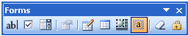

- Click in the document to move your insertion point where you would like text input.

- On the Forms Toolbar, click the TEXT FORM FIELD button. This will insert a blank text form field where the insertion point was located on the document.
Helpful Hint:

Double-click the form field to get into the Form Fields Option dialog box.

- To customize the field, click the FORM FIELD OPTIONS button.

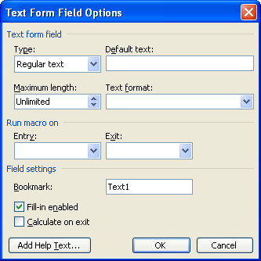
Did You Know?

Default Text will print, so do not use it if this is a printed form where the text field needs to be blank.

- If your text field has a common entry, you may type that entry in DEFAULT TEXT. The user may always type over the default entry if necessary. If there is not a typical entry, you may use this area to indicate what should be entered in the field. For example, "Type Client Name Here".

- To set a limit on the amount of text that can be entered, click on the up arrow under MAXIMUM LENGTH to set a character limit, for example, a limit of 2 for a State field.

- To change the type of information that can be entered into the field, click on the down arrow next to REGULAR TEXT and choose from the list.
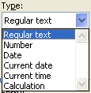

- To change the format of the field, click the drop-down arrow for TEXT FORMAT and make the appropriate choice.

- To add text that will assist another user in completing this field, click the ADD HELP TEXT button.

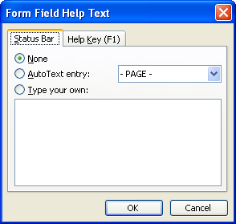

- On the STATUS BAR tab, click to place a dot in the TYPE YOUR OWN radio button. Type the appropriate text describing what to enter in the field.

- Click OK.

- When filling out the form, the text you entered will appear in the Status Bar whenever the field is active.

- Once you have finished customizing the form field, click OK.

- Repeat the necessary steps to insert additional form fields.

Lesson Example

You would like to insert text fields into your Client Letter.

steps
- Open the Forms toolbar by clicking VIEW, TOOLBARS, FORMS.
- Place your insertion point after the word Dear in the Client Letter, and press the SPACEBAR.
- On the Forms Toolbar, click the TEXT FORM FIELD button.
- Click the FORM FIELD OPTIONS button. Type Client Name in the DEFAULT TEXT area. Click OK
- Place the cursor after the form field and type a colon (:).
- Move your insertion point to the empty line between the paragraph and Social Security Number.
- Click the TEXT FORM FIELD and click the FORM FIELD OPTIONS button.
- Click the ADD HELP TEXT button.
- Click the TYPE YOUR OWN radio button on the STATUS BAR tab.
- Type Enter additional information if necessary. NOTE: You will be able to view the Help Text after you lock the template.
- Click OK twice.
- Save the file.

EXERCISE

1) Return to the Class Registration form and view the Forms toolbar.

2) Place text fields after Student Name and Address, including default text for each field. Put the proper spacing between the text field name and the text field itself.

3) Insert a text field following Phone using default text, and limit the size of the field to 15.

4) Save your changes to the file.

5) On Your Own: In the Consulting Invoice, place text fields after the Date of Service, Description of Problem, and Solution labels.

6) Save the file.

Check Box Form Fields

overview

A Check Box Form Field is used to answer Yes/No or True/False questions. For Yes or True answers, a checkmark will appear in the box, for No or False answers, the box will remain empty.

steps

- Click to place the insertion point where you want the check box to be located.

- Click on the CHECK BOX FORM FIELD button.

- To format the check box, click the FORM FIELDS OPTION button.

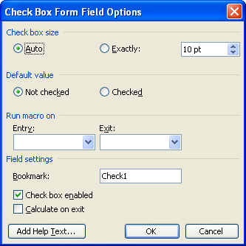

- To change the size of the check box, click the up or down arrow next to EXACTLY.

- To set the default value, click NOT CHECKED or CHECKED.

- Once you have finished formatting the check box form field, click OK.

Lesson Example

You want to include check boxes in the Consulting Invoice.

steps
  - Place your insertion point directly after the Hardware label, and press the SPACEBAR.
  - Click on the CHECK BOX FORM FIELD button.
  - Move the insertion point after the Software label, and press the SPACEBAR.
  - Click on the CHECK BOX FORM FIELD button.
  - Save the file.

Exercise:

1) In the Client Letter, add Check Box fields after the Social Security Number and Current Phone Number labels.

2) On Your Own: Add Check Box fields after Signed Notification and Copy of Picture Identification. Use the Tab key to line up the four check box fields.

3) Save the changes to the file.

Drop-Down Form Fields

overview
Helpful Hint:

You will not see the Drop-Down form field until the document has been protected.

If you have places on your form where the user is only allowed to choose from a few options, you may want to consider using a Drop-Down form field.

steps

- Click to place the insertion point where you want the drop-down form field to be located.

- Click on the DROP-DOWN FORM FIELD button.

- To format the Drop-Down field, click the FORM FIELD OPTIONs button.
Helpful Hint:

If you do not want an item to appear in the drop down box when filling out the form, place a space in the drop-down item field and click ADD. This adds a blank line.

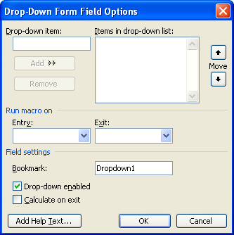

- To add items to the drop-down list, type the item in the DROP-DOWN ITEM box, then click ADD.

- To remove items from the drop-down list, click once on the item in the ITEMS IN DROP-DOWN LIST: box to select it. Then click REMOVE.

- To change the order of the items in a drop-down list, click once on the item to select it. Then click on the up or down arrow above or below MOVE.

- Once you have finished formatting the drop-down form field, click OK.

Lesson Example

You would like all Case Managers in your office to be able to use the Client Letter form, so a drop-down list in your closing would enable this.

steps

- Place your insertion point above Case Manager at the bottom of your letter. Press the ENTER key 3 times.
- Click the DROP-DOWN FORM FIELD button.
- Click the FORM FIELD OPTIONS button.
- Type your name in the DROP-DOWN ITEM box, then click ADD or press the ENTER key.
- Repeat the previous step to add three more names to your list.
- Move the names up or down on the list to alphabetize them.
- Click OK.
- Save the changes to your file.

Exercise:

1) In your Consulting Invoice, add a Drop-Down form field that lists three names following the Consultant label.

2) Save the file.

3) On Your Own: Add a Drop-Down form field to the Class Registration form that lists DHHS and Muskie after the Department label.

4) Save the changes to the file.

USING A TABLE IN A FORM

objectives: Insert a table.
Perform calculations in a table.

Insert a Table into a Form

overview

Many forms have tables in them to help with formatting and ease of use. Placing a table in a form can help with layout issues, allows the reader to fill out the form easily, and assist in defining specific sections.
Helpful Hint:

After you remove the borders, you may want to click on TABLE, SHOW GRIDLINES to see a light gray outline of the table.

steps

- Click to place the insertion point where you want the table.
- Click the INSERT TABLE button on the Standard Toolbar to show a drop-down grid.
- Drag with your mouse to select the correct number of columns and rows.
- Once you have the number of cells that you want selected, click. Word creates the table for you.
- View the Table toolbar by clicking VIEW, then TOOLBARS. Select the TABLES AND BORDERS toolbar.
- To remove the borders from your table, select the entire table and in the Tables and Borders toolbar click the drop-down arrow of the BORDER button . Select the NO BORDER option.
- To merge a group of cells, click and drag to select the cells to merge. In the Table and Borders toolbar select the MERGE CELLS button .
- To split one cell into many cells, click in the cell to split. In the Table and Borders toolbar select the SPLIT CELLS button .
- Choose the number of columns and rows into which the cell should be split and click OK.
- Enter the appropriate text and form fields into your table.

Lesson Example

The Class Registration form needs an area in which the class titles, dates, locations, and prices can be listed.

steps
  - Place your insertion point beneath all existing text and fields.
  - Click the INSERT TABLE button on the Standard Toolbar .
  - Drag with your mouse to select 4 columns and 4 rows, and click.
  - Type Title in the first cell and press TAB.
  - Type Date in the second cell, and press TAB.
  - Type Location in the third cell, and Price in the fourth.
  - Save your changes.

Exercise:

1) Insert TEXT FORM FIELDS into all remaining cells in your table. Use the F4 key to repeat.

2) Save the file.

3) On Your Own: In your Consulting Invoice, insert a 4 row, 2 column table beneath the existing information.

4) Enter the following text and text form fields into the table:

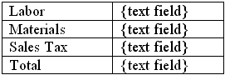

5) Save the changes to the file.

Performing Calculations

overview

One of the added benefits of using a table in your form is that you can perform calculations on text form fields. This means that you can add the charges on an invoice, or the cost of supplies, without having to use your calculator.

Before we use a formula in a table, we have to identify (or name) the cells. Microsoft Word has already done this for us. However, we do not see the cell references on the screen.

- A column is identified by a letter; for example, A, B, C…

- A row is identified by a number; i.e. 1, 2, 3…

- A cell is the intersection of a column and a row.

- The cell reference is the combination of the column letter and row number.
 | A | B | C
1 | A1 | B1 | C1
2 | A2 | B2 | C2
3 | A3 | B3 | C3

Examples:
The cell in the upper-left corner is A1
The cell next to A1 would be B1, then C1…
The cell below A1would be A2, then A3…

STEPS

- Identify cells within your table that require calculations.

- Insert a TEXT FORM FIELD into the cell to be calculated.

- Modify the field by clicking the FORM FIELD OPTIONS button.

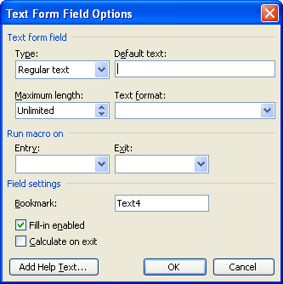
Type
Helpful Hint:

If your calculation doesn't seem to run, check that CALCULATE ON EXIT is checked for all fields used in the calculation.

- Click on the TYPE list arrow, and select CALCULATION.

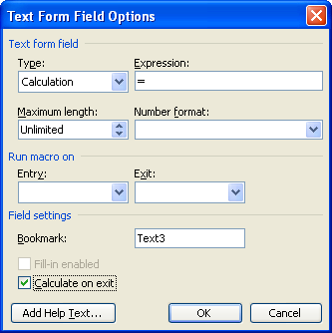
Expression
Number format
Calculate on exit

- Type the appropriate formula into the EXPRESSION field. For example, (A1 + B1) * .1 will add the values in cells A1 and B1 then multiply that sum by 10%.

- Click on the NUMBER FORMAT drop-down arrow and choose a number format.

- In the FIELD SETTINGS section, click to place a checkmark in CALCULATE ON EXIT. Repeat this step for all fields involved in the calculation.

- Click OK. Repeat the process for any other cells in which you would like a calculation.

Lesson Example

You would like to calculate the Sales Tax figure in your Consulting Invoice.

steps
  - Click the form field in the cell to the right of Sales Tax, and click the FORM FIELD OPTIONS button.
  - Click on the TYPE list arrow and click CALCULATION.
  - Type =B2*.05 into the EXPRESSION area. This will calculate a 5% sales tax on Materials.
  - Click on the NUMBER FORMAT drop-down arrow and choose the $#,##0.00 format.
  - In the FIELD SETTINGS area, click to place a checkmark in CALCULATE ON EXIT.
  - Click OK.
  - Open the FORM FIELD OPTIONS dialog boxes for the LABOR and MATERIALS fields, and place a checkmark in the CALCULATE ON EXIT box in the FIELD SETTINGS area for each of these fields.

Exercise:

1) Modify the text field in the cell next to Total to calculate the total for the invoice. (HINT: the formula would be =B1+B2+B3).

2) Format the field in the currency style.

3) Save your changes to the file.

4) On Your Own: In the Class Registration form, add a new row to the table by clicking in the bottom right cell, and pressing TAB.

5) In the last cell of your new row, enter a text form field that calculates the total Price. (HINT: =D2+D3+D4), and don't forget to calculate on exit for all numbers involved in the calculation).

6) Format the field in the currency style.

7) Save the file.

COMPLETING A FORM
Helpful Hint:

Perform a Spell Check on your form before you protect it.

objectives: Protect and unprotect a form.
Navigate in a form.
Insert and delete text in a form.

Protect and Unprotect a Form

overview

Once you are done creating the form, it needs to be protected to be used. This way, the user may ONLY type information into the form fields. The existing text is locked into place and will not change.

steps

- To protect the form, click on the PROTECT FORM button on the FORMS toolbar to lock the form.
Helpful Hint:

You must click FILE, NEW to access a template. Using the short-cut methods will not work.

- To unprotect the form, click on the PROTECT FORM button on the FORMS toolbar to unlock the form.

- Once the form is protected, it should be saved and closed.

Completing a Form

overview

In order to fill out a form, you need to open a new document based on the template you created. With the form protected, you will only be able to move among form fields.

steps

- Click FILE, NEW, and select the template, then click OK.

- To move in the form, press TAB on your keyboard to move forward to the next field, and SHIFT + TAB, to move to the previous field.

- To add information to a text form field, type text into the appropriate text-form field.

- To access a drop-down field, click on the down arrow on the right of the field, and click once on the appropriate item. Another method is to hold down your ALT key while tapping the DOWN ARROW key on your keyboard. You may then arrow down the list and press the ENTER key to enter the selection.
Did You Know?

Once protected, only the form fields are available. To make changes to anything other than entering field information, you will need to unprotect the form. You should then print or save the form before protecting it again. Once you re-protect a form, all of the fields are cleared.

- To fill in a check box, either click in the box with your mouse or press the SPACEBAR on your keyboard. This adds and removes the X from the box.
- Save the form when complete. The completed form will be saved as a new document.

Lesson Example

It's time to try out the Class Registration form.

steps
  - Spell check your form, then save it.
  - Click the PROTECT FORM button in the FORMS toolbar to lock the form.
  - Save and close the file.
  - Click FILE, then NEW. In the New Document Task Pane, select the ON MY COMPUTER HYPERLINK. Choose the CLASS REGISTRATION template. Click OK.
  - Your insertion point will be in the first form field. Type your name as the STUDENT NAME. Press TAB to move to the next field.
  - Type your address, and press TAB.
  - Type your phone number, and press TAB.
  - Select your Department, and press TAB.
  - Enter the following two classes, pressing the TAB key to move from field to field.

Time Management | 5/5/2010 | Bangor | $100.00
Team Building | 7/12/2010 | Augusta | $135.00
  - Save the form as My Registration.
  - Close the form.

Exercise:

1) Return to the Consulting Invoice document.

2) Spell check and save the file.

3) Protect the form, and close the file.

4) Open a document based on this template, and complete the form as follows:

Date of Service: Yesterday’s Date
Type of Problem: Software
Description: Could not open Microsoft Word
Solution: Reinstalled the program
Consultant: Yourself
Labor: 100
Materials: 50

5) Save the invoice, print it, and close it.

6) On Your Own: Spell check and save the Client Letter document.

7) Protect and close the file.

8) Open and complete a letter based on this template, making up all of the information.

9) Print the letter, and close the file.

CHANGING A TEMPLATE

objective: Modify a template

Revise a Template

overview

You may wish to make changes to your form after you have created the template. Any revisions have to be made to the template itself in order for new documents based on the template to be affected. If you are using Windows XP, please refer to the Nice to Know section for instructions.

STEPS

- Click FILE on the Menu Bar, then click OPEN.

- Your templates are stored in C:\WINDOWS\APPLICATION DATA\MICROSOFT\TEMPLATES. Find the appropriate template, and double-click to open it.

- Click on the PROTECT FORM button on the Forms Toolbar to unlock the form.

- Make the necessary changes to the form.

- Click on the PROTECT FORM button on the Forms Toolbar to lock the form.

- Click SAVE.

Lesson Example

Your office has hired a new consultant, so you need to add that person to the drop-down list.

steps
  - Click FILE, then OPEN.
  - Change the folder in the LOOK IN area to C:\WINDOWS\ APPLICATION DATA\MICROSOFT\TEMPLATES.
  - Double-click the CONSULTING INVOICE file to open it.
  - Click on the PROTECT FORM button on the FORMS toolbar to unlock the form.
  - Click once on the Consultant drop-down field, then click on the FORM FIELDS OPTION button.
  - Type Joseph Johnson in the DROP DOWN ITEM box, then click ADD.
  - Click OK and save the change to the form.
  - Click on the PROTECT FORM button on the FORMS toolbar to lock the form.
  - Save and close the file.

Exercise:

1) Add an automatic date to the top of your Registration template, so you will know when students register for classes.

2) Save and close the template.

3) On Your Own: Make a change to the text of the Client Letter template.

4) Save your changes, and close the file.

GIVE IT A TRY!

OBJECTIVE: Practice the lessons learned in class.

EXERCISE:
Refer to Lesson 1 for assistance.

1) Open a new, blank document.

2) Enter the following constant text:

(automatic date)

Dear

Please verify the following information:

Hire Date:

Full-time Part-time

Thank you,

3) Save the file as a template named New Employee Letter.

4) Insert a text form field with default text of Employee Name next to Dear in your salutation. Follow it with a colon (:).

5) Insert a text form field with a date format after Hire Date:

6) Place check box form fields after Full-time and Part-time.

7) Insert a drop-down form field after Thank you, including your name and another name for choices.

Refer to Lesson 2 for assistance.

8) Insert a three row, two column table after Please verify the following information.

9) Create the following table:

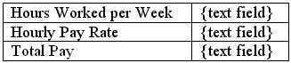

10) Format the Hours Worked per Week form field to only accept two digits. Check the Calculate on Exit option.

11) Format the Hourly Pay Rate field in the currency style. Check Calculate on Exit.

12) In the field next to Total Pay, insert an appropriate calculation, and check Calculate on Exit.

Refer to Lesson 3 for assistance.

13) Spell check and save the form.

14) Protect, save, and close the form.

15) Create a new document based on the New Employee Letter template.

16) Practice filling out the form, then close the document without saving.

DELETING FILES

OBJECTIVE: Maintain organized file directories.

Deleting Templates

steps

- Click FILE, NEW.

- Right click on the template and click DELETE. Or, press DELETE on your keyboard.

- Click YES to confirm the deletion.

- Click CANCEL to close the NEW dialog box.

Deleting Files
STEPS

1. Close all open files but remain in Microsoft Word.

2. Select OPEN from the FILE menu.

3. Click once on the name of the file to be deleted. Or, use the CTRL or SHIFT keys to select multiple files.

- Press the DELETE key on your keyboard.

- Click YES to confirm the deletion.

- Click CANCEL to close the NEW dialog box.

Lesson Example

You would like to delete the Consulting Invoice template.

STEPS
  - Click FILE, NEW.
  - Click once on the template that you need to delete.
  - Right click on the CONSULTING INVOICE template and choose DELETE.
  - Click YES to confirm the deletion.
  - Click CANCEL to close the NEW dialog box.

EXERCISE:

1) Delete all of the templates that you have created.

2) On Your Own: Delete all document files from C:\My Documents.

NICE TO KNOW

Save and Edit Templates
STEPS

- To save a document as a template, change the SAVE AS TYPE to Document Template and save it to Word’s default location.
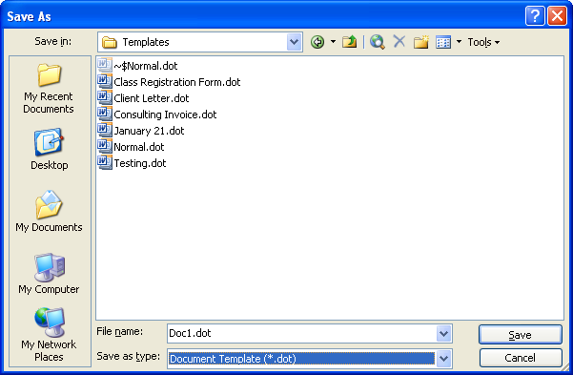
- When you need to edit the template, click on FILE, NEW.
- In the New Document Task Pane, select the ON MY COMPUTER hyperlink under TEMPLATES.
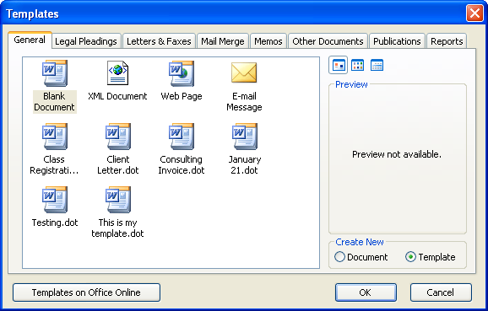
Template
- On the GENERAL Tab select the template you want to edit and click the TEMPLATE radio button.
- Click OK.
- Edit your template.
- To save your changes click FILE, SAVE AS. Name your template the exact same name as before. Click OK.
- When notified that the file already exists, click OK.
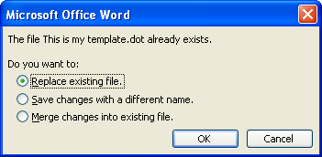

Templates Created in Class

overview

The following pages display the four templates created in this courseware.

Consulting Invoice

Invoice Date: July 28, 2026

Client Information

Date of Service: Date of Service

Type of Problem: Hardware Software

Description of Problem: Description

Solution: Solution

Labor
Materials
Sales Tax | $0.00
Total | $0.00

Consultant:
Class Registration Form

July 28, 2026

Student Name: Student Name

Address: Student Address

Phone: Student Telephone Number

Department:

Title | Date | Location | Price
 |  |  | $0.00
Client Letter

July 28, 2026

Dear Client Name:

This letter is to inform you that I have been assigned as your new Case Manager. Our records indicate that we are still in need of the following information to complete your file:

Social Security Number

Current Phone Number

Signed Notification

Copy of Picture Identification

Thank you for your cooperation.

Sincerely,

Case Manager

New Employee Letter

July 28, 2026

Dear Employee Name:

Please verify the following information:

Hire Date:

Full-time Part-time

Hours Worked per Week
Hourly Pay Rate
Total Pay | $0.00

Thank you,
Your Name

Save/Edit/Update Templates

OVERVIEW

Windows XP manages templates differently than other Windows operating systems. There are two ways to save and edit templates depending on who will be using the template. If the template will be used by many you should choose Option 1. If the template will be used exclusively by you, chose Option 2.

OPTION 1

STEPS

- Save your template to a shared drive and close out of the document.
- Locate the document using EXPLORE or MY COMPUTER.
- Right click on the document name.
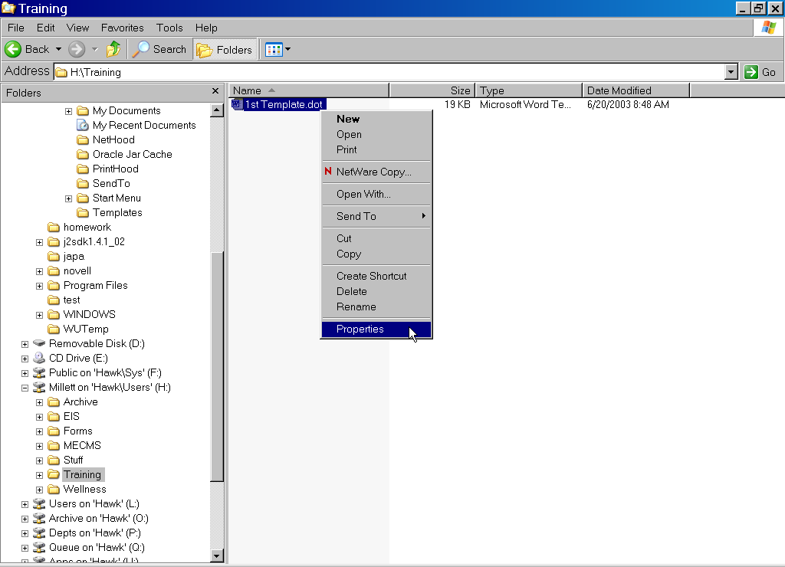
- Select PROPERTIES.
- Put a check by READ ONLY and click OK.
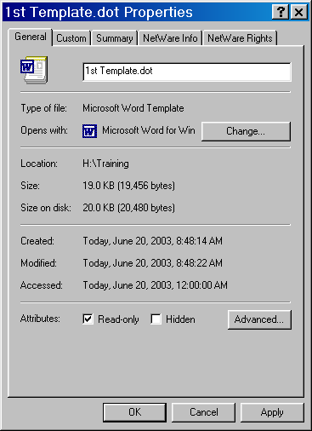
- When you need to update the template, remove READ ONLY. Repeat Steps 2 – 4 above.
- Open the template through Word.
- Make the desired changes and repeat Steps 1 – 5 to make this template READ ONLY again.

OPTION 2

STEPS

- Save your template to Word’s default location.
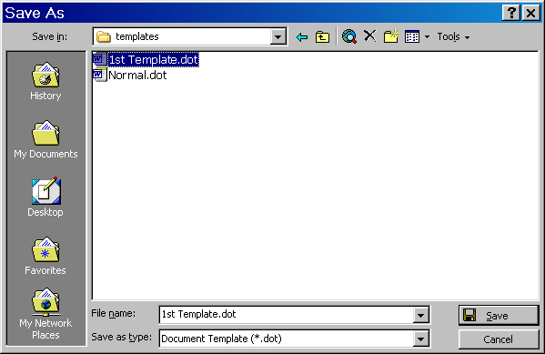
- When you need to update the template, CLICK on FILE and NEW.
- On the GENERAL Tab select the template. Click the TEMPLATE radio button.
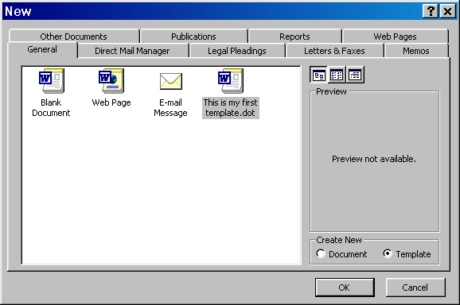
- Click OK.
- Unprotect the form.
- Edit/Update your template. Protect the form.
- To save your changes click FILE and SAVE AS. Name your template the exact same name as before. Click OK.
- When asked if you want to replace the existing file, click YES.

