INTRODUCTION TO WORD 2003

Page

LESSON 1: WORD WINDOW 1
♦ The Office Assistant 1
♦ Tip of the Day 2
♦ Parts of the Word Window 3
♦ Terms 3
♦ Menu Bar vs. Toolbar 5
♦ Toolbars 5
♦ Using The Office Assistant 6
LESSON 2: BASIC WORD TASKS 8
♦ Creating a Document 8
♦ Saving Files 9
♦ Closing Files 10
♦ Opening Files 11
♦ Copying Files 12
♦ Printing 12
LESSON 3: MOVING IN A DOCUMENT 15
♦ Quick Insertion Point Movement 15
♦ Selecting Text 16
♦ Using the Reviewing Toolbar 17
♦ The Clipboard Toolbar 20
♦ Moving and Copying Text 21
♦ Undo and Redo 22
♦ Backspace and Delete 24
♦ Insert and Overtype 24
LESSON 4: ENHANCING A DOCUMENT 26
♦ Adding the Date Automatically 26
♦ Font Style and Size 27
♦ Defaulting Font Style and Size 28
♦ Text Enhancements 29
♦ Aligning Text 29
♦ Click and Type 30
♦ Bullets and Numbering 31
♦ Switching Text Case 32
♦ Line Spacing 34
♦ Page Setup Dialog Box 35
♦ Adjusting Margins 38
♦ Headers and Footers 38
LESSON 5: EDITING A DOCUMENT 40
♦ Spelling and Grammar Check 40
♦ Thesaurus 42
♦ AutoCorrect 44
♦ AutoCorrect Options: AutoText 45
♦ AutoCorrect Options: AutoFormat As You Type 46
♦ AutoCorrect Options: AutoFormat 47
♦ AutoCorrect Options: Smart Tags 49
LESSON 6: GIVE IT A TRY 51
LESSON 7: DELETING FILES 53
NICE TO KNOW 54
♦ Word Help Features 54
♦ Keyboard Commands 56

This workbook may be reproduced in whole or in part by an employee of the Department of Health and Human Services. All other reproduction is prohibited unless written permission is obtained from the Training Institute.

WORD WINDOW

OBJECTIVES: Read the Tip of the Day feature.
Adjust the settings of the Tip of the Day feature.
Identify the parts of the Word window.
Identify Microsoft Word terms.
Identify the tools and toolbars.
Understand the relationship between toolbars and menus.

OVERVIEW

Microsoft Word is a word processing program that runs in the Windows environment. You may use Word to create letters, reports, forms, and many other documents.

STEPS

1. Click START, PROGRAMS, MICROSOFT WORD.

EXERCISE:

1) Open Microsoft Word.

The Office Assistant

OVERVIEW

Microsoft Word contains several different types of help to assist you when you have difficulty with the program. The Office Assistant is an interactive help device that comes in the form of a cartoon character. It allows you to type a question or phrase related to your problem, and it will search for help topics based on your entry.

Tip of the Day

OVERVIEW

When you start Word the first time for the day, you may receive a Tip from the Office Assistant. If you have just started to use Word, you may find this helpful to read each day. For others, you may want to remove it from automatically appearing.

STEPS

- Read the tip and click OK.
- To turn the Tip of the Day on or off, click the Office Assistant.
- Click OPTIONS.
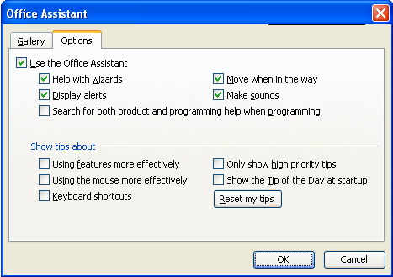
- Click the checkmark next to SHOW THE TIP OF THE DAY AT STARTUP.
- Click OK.

Parts of the Word Window

OVERVIEW

The Word window typically shows the following:
Minimize
Restore

Close
Help
Task Pane

Standard Toolbar
Title Bar
Menu Bar
Formatting Toolbar
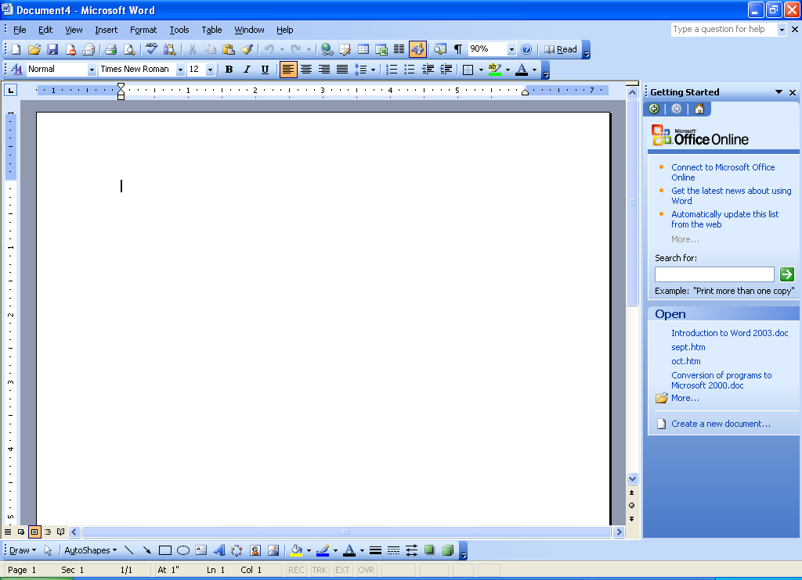
Scrollbars
Drawing Toolbar

Document View Buttons
Status Bar
Rulers
Insertion Point/Cursor

Terms

Title Bar – the blue bar at the top of the screen; it shows the program name and document name.

Minimize, Maximize/Restore, and Close Buttons – allow you to manipulate the program and document windows. Minimize collapses the window into the taskbar, Restore shrinks the window slightly, Maximize makes it as large as your screen, and Close will exit the document or program.

Menu Bar – a list of functions; click once on the menu name, then on the desired function (or use Alt and the underlined letter). When you open a menu, it will list the most common options; however, several other functions may not be visible. If you wait for a few seconds, the full menu appears, or you can click on the double-down arrow button.

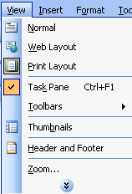

Toolbars – rows of icons representing shortcuts to common features. Click the tool you wish to use.

Standard toolbar – usually the top toolbar in which you may open, save, and print files, and other functions.

Formatting toolbar – typically the second bar in which you may change fonts, bold, underline, and center text, and apply other formatting features.

Drawing toolbar – normally appears at the bottom of the window and includes the tools to create shapes, draw lines, add WordArt, and manipulate graphic objects.

ToolTips –a box that appears with the name of the tool when the mouse pointer is on a tool in the toolbar.

Insertion Point – where the text will be typed.

Document View Buttons – allow you to manipulate the view to your preference
Normal View – shows text formatting but not page formatting.
Web Layout View – allow you to create a document for the Web.
Print Layout View – shows text and page formatting.
Outline View – views the structure of the document.
Reading Layout View - designed to make reading documents on the screen more like reading on paper.

Rulers – allow you to adjust the indents and the margins.

Selection Area – is the area to the left of the document text when the mouse pointer turns into a white block arrow.

Status Bar – is at the very bottom of the program window. It shows the number of pages and sections along with the location of the insertion point.

Scrollbars – appear on the right and bottom of the window, and allow you to see different areas of the document.

Task Pane - help you get your work done, bringing the tools you need right up close to your work

Menu Bar vs. Toolbar

OVERVIEW

Many of the selections that can be made through the Menu Bar are also available on a toolbar. This provides you with a choice for performing the task. There are also several keyboard options. For example, to print a document you could click FILE, PRINT or click the Print button or press CTRL + P. Existing keyboard shortcuts and icons appear in the menu.

Toolbars
Helpful Hint:

If a toolbar is not visible, click VIEW, TOOLBARS, and then click the toolbar.

Standard toolbar

Ctrl + N
New

Ctrl + P
Print

Ctrl + O
Open

F7
Spelling & Grammar
Ctrl + S
Save

Format Painter

Print Preview
Ctrl + X
Cut

Permission

Ctrl + Z
Undo

Ctrl + C
Copy

Insert Table

Columns

Drawing Toolbar

F1
Help

Tables & Borders

Ctrl + K
Hyperlink

Ctrl + Y
Redo

Show/Hide
Characters

Read

Zoom

Document Map

E-Mail
Ctrl + Click
Research
Ctrl + V
Paste

Ctrl + V
Paste

FORMATTING TOOLBAR
Styles &
Formatting
Ctrl + Shift + S
Style

Ctrl + Shift + P
Font Size

Ctrl + B
Bold

Ctrl + I
Italic

Ctrl + J
Justified
Ctrl + R
Right

Ctrl + E
Center

Ctrl + L
Left

Ctrl + U
Underline
Ctrl + Shift + F
Font

Decrease
Indent

Numbering
Bullets
Increase
Indent
Highlight
Line
Spacing

Font
Color
Borders &
Shading

DRAWING TOOLBAR

Format
Drawn Item
Line
Rectangle

Text Box
Insert
Clip Art
Line
Color
Arrow
Style
3-D
Style
Select
Objects
Insert
Shape

Arrows

Oval
Insert
Word Art
Fill
Color
Text
Color
Line
Style
Shadow
Style
Insert
Picture
Dash
Style

Using The Office Assistant

STEPS

- Click the OFFICE ASSISTNAT.
Helpful Hint:

To hide the Office Assistant, click HELP, HIDE THE OFFICE ASSISTANT.

- Type your question.
- Either press ENTER or click SEARCH.
- Click on one of the options available to receive additional information on that topic.
- Once finished reading the help, click the CLOSE button.

Lesson Example

It is time to get started using Microsoft Word.

STEPS

- Read the Tip of the Day and click OK.
- Turn off the tip by clicking the Office Assistant.
- Click OPTIONS.
- Click the checkmark next to SHOW THE TIP OF THE DAY AT STARTUP and then click OK.
- Click the NORMAL VIEW button and then click the PRINT LAYOUT VIEW button.

EXERCISE:

1) Click the Office Assistant. Type create a document. Click Search. Click Create a Document. Read the steps. Close Help.

2) On Your Own: Search for a topic of your choice using the Office Assistant.

3) Close the Search Results Pane.

4) Hide the Office Assistant by clicking HELP, HIDE THE OFFICE ASSISTANT.

BASIC WORD TASKS

OBJECTIVES: Create a document.
Save a document.
Close a document.
Open a document.
Print a document.
Insert the date automatically.

Creating a Document

OVERVIEW

When you first open Microsoft Word, a new document automatically appears. You can start typing at this point; however, there will be times when you need to start another document. Follow the steps below.

STEPS

- Click the NEW button on the Standard Toolbar. The keyboard method is CTRL + N.

2. Type your document. Word wrap is in effect, which means you do not have to press ENTER at the end of each line, only at the end of a paragraph.

Saving Files

OVERVIEW

Saving a document is very important. Be sure to save often, because you may lose all information if you lose electricity.

STEPS
- Click the SAVE button on the Standard toolbar. The keyboard method is CTRL + S. The SAVE AS dialog box appears.
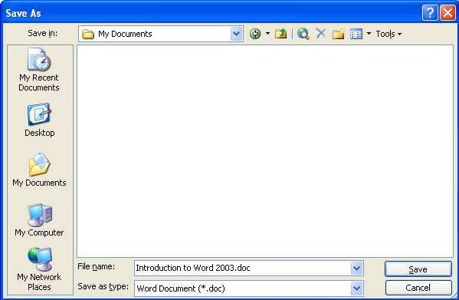
- To change the file location, click the down arrow to the right of SAVE IN . Click the appropriate drive and folder.
Did You Know?

A filename may contain 255 characters and spaces.
- Click and drag over the default filename and type a document name.

- Click SAVE. (Notice the name is on the Title Bar - next to Microsoft Word.)
- To save future changes, click the SAVE button again. The Save As dialog box will not open.

Closing Files

OVERVIEW

When a document is finished, you may want to close the file you are using.

STEPS

1. Click FILE on the Menu Bar, and then click CLOSE. A quick way is to click the CLOSE button on the menu bar.

- If you have not saved your document, the computer will ask if you want to save your changes before closing.
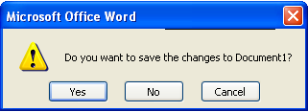
- To save the document changes, click YES.
- To close without saving, click NO.
- To return to the document, click CANCEL.

Lesson Example

You need to create a list of things to do.

STEPS

- Type To Do. Press ENTER.
- Type three things you need to do. Press ENTER after each.
- Click the SAVE button.
- Save the document in C:\My Documents as To Do. Click SAVE.
- Close the document by clicking the CLOSE button.

EXERCISE:

1) Create a new document and type your name. Press Enter. Type your title.

2) Save the document using your name as the filename in C:\My Documents.

3) Close the document.

4) On Your Own: Create a document and type a sentence about your job. Save with the filename of On Your Own and close.

Opening Files

STEPS
Helpful Hint:

To use a file recently opened, click FILE on the Menu Bar, and the last four files opened will appear at the bottom of the menu. Click once on the file to open it.

  - Click the OPEN button on the Standard toolbar. The keyboard method is CTRL+O. The OPEN dialog box appears.

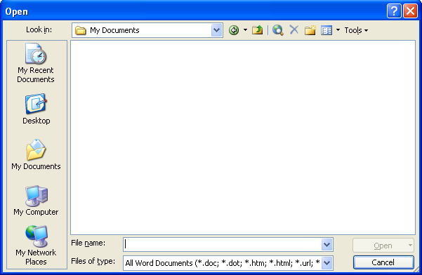

2. Find the name of the file to open. You may need to change the LOOK IN location by clicking the down arrow. Then select the drive and folder.

3. Click on the filename, then click the OPEN button. You may also double click the filename.

Copying Files

OVERVIEW

There may be times when you need to make changes to a document but you do not want to lose the original information. In this case, you will want to use Save As. This allows you to give the document a new name and/or file location. The Save As dialog box is the same as when you first save a document.

STEPS

1. Click FILE on the Menu Bar.
Helpful Hint:

The keyboard shortcut to SAVE AS is the F12 key.

- Click SAVE AS.

- To change the file location, click the down arrow to the right of SAVE IN. Click the appropriate drive and folder.
- To change the filename, click and drag over the filename and type the new filename.
- Click SAVE.

Printing

OVERVIEW

You may print all pages or choose specific pages to print.

STEPS
1. To print one copy of the whole document, click the PRINT button on the Standard toolbar.

  - To print specific pages or multiple copies, click FILE, and then click PRINT. The keyboard method is CTRL + P. This will bring you to the PRINT dialog box.

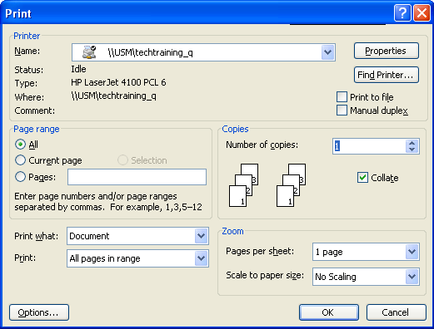

- To print the page your insertion point is on, click on CURRENT PAGE.

- To print text you have selected, click on SELECTION.

- To print individual pages, click on PAGES, then type the page numbers you want (i.e. 2-5 to print pages 2 through 5; or 2,5 to print page 2 and page 5).

- To change the number of copies, click the up or down arrow or double-click the number and type in the correct one.

- Click OK.

Lesson Example

You were unable to complete the tasks today and need to remember to do additional tasks tomorrow.

STEPS

- Open the To Do document by clicking FILE, TO DO.
- Click FILE, SAVE AS. Change the filename to To Do Tomorrow. Click SAVE.
- Position the INSERTION POINT at the end of the last item. Press ENTER.
- Add two items to the list. Press ENTER between the items. Click SAVE.
- Click the PRINT button to print the list.

EXERCISE:

1) Open “your name” document and save with the filename Letterhead.

2) Add your work address and telephone number and save the file

3) Print the document.

4) On Your Own: Open the On Your Own document and add an additional sentence. Save and print the document. Close all open documents.

MOVING IN A DOCUMENT

OBJECTIVES: Select text.
Identify the difference between Insert and Overtype.
Utilize Backspace and Delete.
Cut, copy, and paste text.
Spell check a document.
Place insertion point using the Click and Type method.

Quick Insertion Point Movement
Did You Know?

You can use the Scroll Bar and PREVIOUS PAGE and NEXT PAGE buttons to move in your document if you prefer to use the mouse.

OVERVIEW

There are several keyboard shortcuts you may use in Word to make it easier to place the insertion point at a certain location.

STEPS

1. Beginning of line - press HOME
End of line - press END

2. Move one word to the right - CTRL + RIGHT ARROW
Move one word to the left - CTRL + LEFT ARROW
Move up a paragraph - CTRL + UP ARROW
Move down a paragraph - CTRL + DOWN ARROW

3. Up one window - PAGE UP
Down one window - PAGE DOWN

4. Beginning of the document - CTRL + HOME
End of the document - CTRL + END

Selecting Text

OVERVIEW

In order to make changes to the document, you will most likely have to select or highlight text. Clicking and dragging over the text will do this. However, there are other ways that can save you time.

STEPS

- To select a word, hold the I-Beam pointer on the word and double-click.
Helpful Hint:

When text is selected, anything you type on the keyboard will replace the selection.

- To select a sentence, hold down the CTRL key and click once anywhere on a sentence.

- To select a line, move your mouse to the Selection Area (left margin of your page) so that it becomes a white arrow . Click once beside the line.

- To select a paragraph, double click in the Selection Area to the left of the paragraph or triple click in the paragraph.

- To select long sections of text, use the SHIFT + DOWN ARROW method. Place the cursor at the beginning of the selection, hold down the SHIFT key and press the DOWN ARROW to the end of the selection.

- To select a document, click EDIT on the menu bar, click SELECT ALL (or use CTRL A). To use the mouse, triple click in the selection area.

Using the Reviewing Toolbar
OVERVIEW

Microsoft Word 2003 automatically displays changes that are made to documents that you work in. It is extremely important to Accept All Changes made in a document before sending it as an e-mail attachment, publishing it to the web, or distributing it. If you do not accept all of the changes, then others have the ability to see these changes.

You created the following letter to send out to a client:
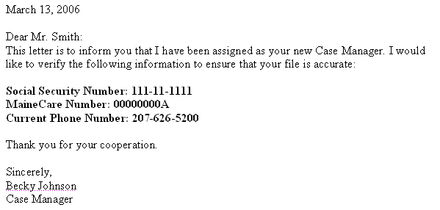

You want to send the letter to a different client, so you use Save As and change the information. The next time you open the letter, you see this:

FINAL SHOWING MARKUP view:
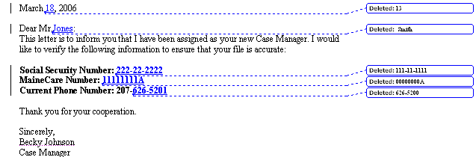

Changing the view to Final hides all of the mark-ups.
FINAL view:
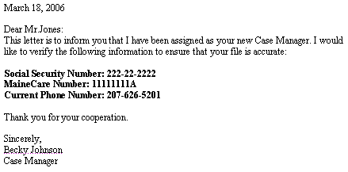

Doing that may solve the problem for printing; however, the document still contains all of the original information, as well as the changes. All the reader would need to do is switch the view to Original.

ORIGINAL view:

To solve this problem, you need to Accept All Changes in the Document. Once that is complete, other users cannot see the original data or the changes that were made.

STEPS

- To switch views, on the Reviewing Toolbar, in the DISPLAY FOR REVIEW box , click the desired view.
Accept Changes

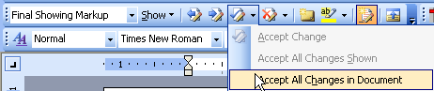
Display for Review

- To accept all of the changes made, click the down-arrow next to the ACCEPT CHANGE button and click ACCEPT ALL CHANGES IN THE DOCUMENT.

Lesson Example

You have been asked to make changes to a letter. First you want to familiarize yourself with the setup of the letter. Your instructor will give you the location of this file and any other files you will need throughout the class.

STEPS

- Click the OPEN button and locate the Open House document. Click OPEN.
- Save this file in C:\My Documents, keeping the same file name.
- Click the down-arrow next to the ACCEPT CHANGE button and click ACCEPT ALL CHANGES IN THE DOCUMENT.
- On the Reviewing Toolbar, in the DISPLAY FOR REVIEW box, click the FINAL view.
- Press CTRL + END to move to the end of the document to determine the length.
- Press CTRL + HOME to return to the beginning of the document.
- Scroll down the document until you see the first paragraph and select the word Government in the first line.
- Press HOME to move the insertion point to the beginning of the sentence.
- Hold down CTRL and click in the first sentence of the first paragraph to select it.
- Double click in the left margin to select the entire first paragraph.

EXERCISE:

1) Continue to navigate in the letter. Go to the end of the first paragraph.

2) Select the entire document by triple clicking in the left margin.

3) On Your Own: Select the entire document by clicking EDIT, SELECT ALL. Deselect the text and press CTRL + A. Deselect the text and save the document.

The Clipboard Toolbar

OVERVIEW

The Clipboard will store up to twenty-four cut or copied items from any program. To see the Clipboard, click EDIT, OFFICE CLIPBOARD… The Clipboard appears in the Task Pane on the left of the screen.

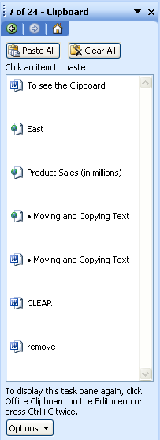
Helpful Hint:

To close the clipboard task pane, click the CLOSE button.

The two buttons contained in the Clipboard toolbar are:

The PASTE ALL button is used to paste all items on the clipboard into the current document.

The CLEAR ALL button will remove all items from the clipboard.

The OPTIONS button provides choices for how and when the Clipboard is displayed.

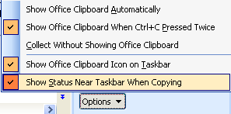

Show Office Clipboard Automatically: | Displays the Microsoft Office Clipboard when copying items.
Show Office Clipboard When CTRL+C Pressed Twice: | Displays the Office Clipboard when CTRL+C is pressed twice.
Collect Without Showing Office Clipboard: | Copies items to the Office Clipboard without displaying the Office Clipboard.
Show Office Clipboard Icon on Taskbar: | Displays the OFFICE CLIPBOARD button in the status area of the system taskbar when the Office Clipboard is active.
Show Status Near Taskbar When Copying: | Displays the collected item message 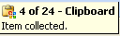 when copying items to the Office Clipboard.

Moving and Copying Text
Did you know?

You can also move text by clicking and dragging your selection.

OVERVIEW

You may copy or move information in the same document or to another document using the cut, copy, and paste techniques.

STEPS

- Select the portion of text to be moved or copied by using the methods described previously.

- Click the CUT button to move or the COPY button to make a duplicate. This will store the text on the Clipboard.
- To retrieve, click where the information is to be added, then click the PASTE button .

- To change the format of the pasted item, click on the PASTE OPTIONS button and choose the option desired option.

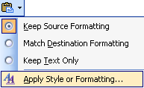

These options include:

- Keep source formatting – preserves the formatting from the original text

- Match destination formatting – removes formatting from the original text and applies the formatting of the current location

- Keep text only – removes all formatting and pastes the selection as plain text

Undo and Redo

OVERVIEW

Word allows you to go back to the last save step-by-step using the Undo button. You also have the capability to redo a step that you have just undone.

STEPS

- To restore text you have just deleted, or to remove formatting, click the UNDO button .

- To REDO what has just been undone, click the REDO button .

Lesson Example

It is now time to make some changes to the letter.

STEPS

- In the Open House document, view the CLIPBOARD Task Pane. Click EDIT, OFFICE CLIPBOARD….
- Select the first paragraph and click the CUT button.
- Click to position the insertion point below the last paragraph and click PASTE.
- Place the cursor before the word You in the moved paragraph and press the ENTER key.
- Copy the second sentence of the second paragraph and paste it using the clipboard to the end of the first sentence in the first paragraph.
- Click the UNDO button until the letter is back to the original.
- Save your changes.
EXERCISE:

1) Create a new document. View the OFFICE CLIPBOARD and paste all items. Close the document without saving.

2) On Your Own: In the On Your Own document, practice cut, copy, and paste by moving and copying the sentences to create two paragraphs. Clear the clipboard. Close without saving.

Backspace and Delete

OVERVIEW

The Backspace and Delete keys both remove text except in different directions. The BACKSPACE key will delete characters to the left of the insertion point. The DELETE key will erase characters to the right of the insertion point.

STEPS

- To erase one character, press the DELETE key or the BACKSPACE key.
- To delete a word, select the word, and then press the DELETE key or the BACKSPACE key.
- To erase words or lines, select the text with the mouse, then press the DELETE key or the BACKSPACE key.
- CTRL + DELETE will erase word by word to the right.
- CTRL + BACKSPACE will erase word by word to the left.

Insert and Overtype

OVERVIEW
Helpful Hint:

OVR will appear in the status bar when Overtype is on. Double-clicking OVR will toggle it on and off.

There are two modes that can be used when typing text. Insert mode moves text as you type. Overtype mode will type directly over text that already appears.

STEPS

- To insert text, position the insertion point at the location where you want to add text, and type.

- To type over text, press INSERT on the keyboard, then type over the text, press INSERT again to turn off Overtype.

- To set the INSERT key to Paste, click TOOLS, OPTIONS. On the EDIT tab, place a check in USE THE INS KEY FOR PASTE.

Lesson Example

You now need to edit some of the terms used in the letter.

STEPS

- In the Open House document, add the word the before Maine, first paragraph, second sentence.
- Place the insertion point after the word you, in the last paragraph, first sentence. Use CTRL + BACKSPACE key to erase the word.
- Click the UNDO button and then the REDO button.
- Place the insertion point before the word need, in the last paragraph, first sentence. Use the DELETE key to erase it.
- Turn on Overtype by pressing the INSERT key. Place the insertion point to the left of If, in the last paragraph, and type For. Notice the change. Double-click OVR in the status bar to turn Overtype off.
- Save the changes.
EXERCISE:

1) Replace the word buildings with offices, in the second sentence of the first paragraph. Delete the word there, at the end of the last paragraph. Save the changes.

2) On Your Own: Open the To Do Tomorrow document. Edit your list. Save the changes.

ENHANCING A DOCUMENT

OBJECTIVES: Adjust and default font styles and sizes.
Align text.
Add bold, italic, and underline.
Bullet and number items.
Double-space paragraphs.
Identify the options in the page setup window.
Adjust margins.
Add a header or footer.
Switch text case.

Adding the Date Automatically

STEPS

- Position the insertion point where you want the date, and click INSERT on the menu bar.
- Click on DATE AND TIME.
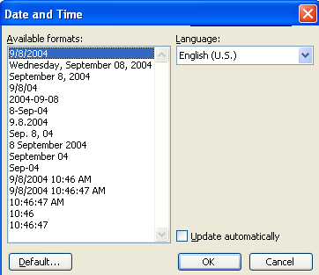
- Click UPDATE AUTOMATICALLY to have the current date on the document each time it is opened.
- Choose the format for the date, and then click OK (or double-click the date format).

Font Style and Size

OVERVIEW
Did You Know?

The font size 72 equals one inch.

A font is a character style. Times New Roman is the standard Word font. You may want to change the font to make it easier to read. The standard font size is 10. It is a good idea not to use a font smaller than 12.

STEPS

- Select the text.
Helpful Hint:

You can type a specific size in the font size box.

- Click the down arrow beside Times New Roman (Font Style).
- Select a font.
- Click the down arrow beside 12 (Font Size).
- Select a number.

Defaulting Font Style and Size

OVERVIEW

When you want your new documents to always open with a particular font in a particular size (like Arial,14), you will want to default the font style and size. Once it is defaulted, each time you create a new document that font and size will appear.

STEPS

- Click FORMAT on the menu bar, then FONT.

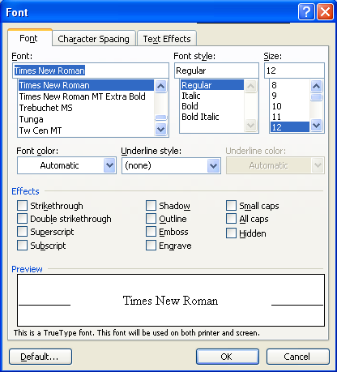

- Change the FONT and/or FONT SIZE.
- Click the DEFAULT… button. A prompt will appear.
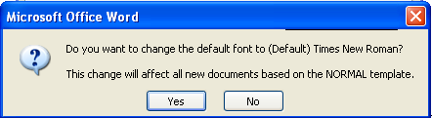
- Click YES to change the default for all new documents.

Text Enhancements

OVERVIEW

You may want to bring extra attention to certain words or headings. You may choose to do this with bold, italic, and/or underline.
Bold
CTRL + B
Italic
CTRL + I
Underline
CTRL + U

STEPS

- Click the text enhancement button on the Formatting toolbar and type. Click the button again to turn it off.
- If text is already typed, select the text to be modified, and click the text enhancement button.

Aligning Text

OVERVIEW

There are four options to align text. The default is left aligned, meaning everything lines up on the left margin. You may also choose to center text. Some lines might work well if they are right aligned. If you want the text to be even on the left and right margins, choose justify.
Left
CTRL + L
Right CTRL + R

Close
Justify
CTRL + J

STEPS

- Click the alignment button on the Formatting Toolbar and type.
- If text already exits, click within the text to be aligned, and click the alignment button.

Click and Type

OVERVIEW

Click and Type allows you to just double-click in a blank area and start typing in that location. Click and Type automatically applies the formatting necessary to position text where you double-clicked. For example, to create a title page, double-click in the middle of a blank page and type a centered title. Then, double-click the lower-right margin of the page and type a right-aligned author name.

IconS
Left Align Text

Center Text

Right Align Text

Indent the First Line

STEPS

- To turn on Click and Type, click TOOLS on the menu bar, click OPTIONS, click the EDIT tab, select the ENABLE CLICK AND TYPE check box, and then click OK.

- Make sure you are in Print Layout view or Web Layout view.

- In the document, move the mouse to a blank area where you want to insert text, graphics, or a table. Then click and you will note the different icon.

- Double-click for the desired alignment, and then start typing text or insert an item.

Bullets and Numbering

OVERVIEW
Helpful Hint:

If you would like to add bullets or numbering to an already existing list, select the text and select FORMAT, BULLETS AND NUMBERING.
If you have a list of information, you may choose to add a symbol before each item, called a bullet, or you may want to number the items.

STEPS

- To use bullets, click the BULLETS button and type the text for the first line.

- Press ENTER to automatically create a new bullet. (You may apply bullets or numbering to pretyped text if selected.)

- To turn off bullets, press ENTER to get to a new line, and then click off the BULLETS button. Numbering lines works exactly the same way using the NUMBERING button .

- To change from bullets to numbers, select the text, click the NUMBERING button. To change back, select then click the BULLETS button.

- To change the type of bullet, select the bullets (bullets will not appear to be selected) and text, then click FORMAT, BULLETS AND NUMBERING, choose the new style, and click OK.

- To choose a bullet style beyond those listed, select the bullets and text, then click FORMAT, BULLETS AND NUMBERING, select a bullet, click on CUSTOMIZE, click on a BULLET. Search the various fonts (use the drop down arrow to see choices) to choose a new bullet. Click on OK and OK again.

Switching Text Case

OVERVIEW

Word enables you to switch the case of the text without retyping it.

STEPS
Helpful Hint:

The keyboard method is SHIFT + F3. This will toggle through the options.

- Select the text to be changed, click FORMAT, CHANGE CASE.
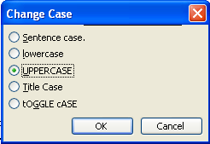
- Click the case you would like to change to in the CHANGE CASE dialog box.
Sentence Case – Capitalizes the first letter of the first word in selected sentences.
Lowercase – Changes all selected text to lowercase letters.
Uppercase – Changes all selected text to uppercase letters.
Title Case – Capitalizes the first letter of each word in the selection.
Toggle Case – Changes all uppercase letters to lowercase in the selection and vice versa.
- Click OK.

Lesson Example

The letter you have been working on does not look visually appealing.

STEPS

- In the Open House document, add the date to the top of the letter in between the addresses. Click INSERT, DATE AND TIME. Select a format and make sure the checkmark is beside UPDATE AUTOMATICALLY. Click OK.
- Select all text by pressing CTRL + A.
- Click FORMAT, FONT and change the font to Arial, size14.
- Select the words open and house in the first sentence. Click the BOLD and ITALIC buttons.
- Select Maine State Government, in the first paragraph, second sentence, and click the UNDERLINE button.
- Select the return address and click the CENTER button, then select the ALIGN RIGHT button.
- Undo the previous change, returning the text to the center alignment.
- Select the three branches of government, and click the BULLETS button.
- Select State of Maine Government in the closing and change to all uppercase by clicking FORMAT, CHANGE CASE.
- Save the changes.
EXERCISE:

1) Select all text in the Open House document, and change the font to Book Antiqua and size 12. Change the bullets to numbers. Change the Return Address to bold and all uppercase letters. Save the changes.

2) On Your Own: In the Letterhead document, insert the date and set it to update automatically. Make formatting changes to make your letterhead professional. Save the changes.

Line Spacing

OVERVIEW

If you are writing a document, you may want to double-space a paragraph or the whole document. You can choose many different spacing options by clicking on the LINE SPACING button.
Helpful Hint:

Line Spacing is also available in FORMAT, PARAGRAPH, SPACING.

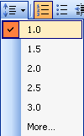

STEPS

- To double space a paragraph, click in the paragraph, click on the LINE SPACING button , and choose 2.0.
- To single space, click in the paragraph, click on the LINE SPACING button , and choose 1.0.
- To one and half space, click in the paragraph, click on the LINE SPACING button , and choose 1.5.
- To space an entire document – select the document by clicking CTRL + A and follow the steps above.

Page Setup Dialog Box

OVERVIEW
Helpful Hint:

A shortcut to page setup is to double-click in the dark grey section of the ruler.

The Page Setup Dialog Box appears by selecting FILE and then PAGE SETUP. It offers many options, which affects the overall page of the document.

The first tab in the Page Setup Dialog box, MARGINS, contains information about the Margins and page layout.

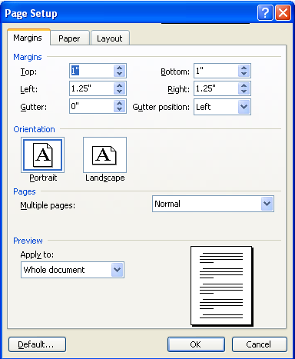
- Margins are the white space on the outside of the page.
- A gutter margin is used when you will have the document bound, like a book, so one side or the top of the page needs a little more space
- Gutter position is determined by how the document will be bound. Will it be a left bound document or top-bound?
- Orientation allows you may also choose to change the layout of the document. Portrait is 8 ½ x 11 where Landscape is 11 x 8½.
- Multiple Pages allows you to set the options for printing multiple pages. Options include Mirror margins, 2 pages per sheet, and book fold.
- Apply to gives you the option to apply the page setup to certain sections of your document. If you choose the default of whole document, the changes you make will affect the entire document. You may want it to only affect from This Point Forward. The other option is Section, which is used when you add Section Breaks.

The PAPER tab includes information about changing paper size and printer options.

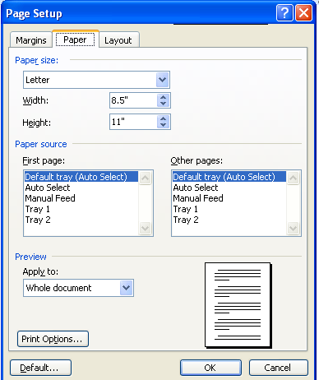

- Paper Size allows you to change the paper size and customize a size if necessary using Width and Height.
- Paper Source determines the location of paper in the printer. You can set this for the first page in the document, like for letter head, and for other pages, like page 2 of a letter.
- Apply to gives you the option to apply the page setup to certain sections of your document. If you choose the default of whole document, the changes you make will affect the entire document. You may want it to only affect from This Point Forward. The other option is Section, which is used when you add Section Breaks.

The LAYOUT tab provides you with several options concerning Headers and Footers along with page alignment.

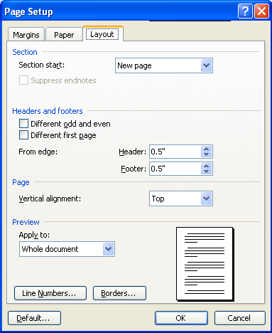
- Section Start option is used to insert a new section.
- Headers and Footers options include Different odd and even. This is used when you have double-sided pages and want the header and footer to alternate. Different first page removes the header and footer from the first page. For example, a Title Page would not need page numbering.
- Vertical alignment will position your document text vertically on the page. The choices are Top, Center, Bottom, and Justified.
- Line numbers allow you to number each line or several lines in the document.
- Borders will apply an outer border to the pages of the document.

You will notice on all tabs there is the option to Default the settings you have chosen. Remember if you default settings these will be set for all new documents.

Adjusting Margins

STEPS

- Click FILE, PAGE SETUP.
- Click the MARGINS tab.
- Click the up and down arrow for the margin to change, or select the margin setting and type.
- Repeat Step 3 for setting the other margins.
- Click OK when finished.

Headers and Footers

OVERVIEW
Helpful Hint:

To edit an existing header or footer, double click the header or footer sections at the top or bottom of the page.

A header is text such as the title of the document, a page number, etc. that appears at the top of each page of the document. A footer is similar to a header except it appears at the bottom of the page.

STEPS

- Click VIEW, HEADER AND FOOTER. This will take you into your header. Type the text to be added to the header (change the font and alignment if necessary).

- To create a footer, click the SWITCH BETWEEN HEADER AND FOOTER button on the Header/Footer toolbar. Type your footer.

- To add a page number to the header or footer, click the INSERT PAGE NUMBERS button on the Header/Footer Toolbar.

- Click CLOSE on the Header and Footer Toolbar to close the header and/or footer.

Lesson Example

Now that the fonts have been changed, it is necessary to change the overall page setup of the letter.

STEPS

- In Open House, select the first paragraph, click the LINE SPACING button and change to 1.5.
- Repeat the step above for the other two paragraphs.
- Click FILE, PAGE SETUP. In the Page Setup dialog box, change the top and bottom margins to .5” and left and right margins to 1”.
- Click VIEW, HEADER AND FOOTER to add a footer to the letter.
- Click the SWITCH BETWEEN HEADER AND FOOTER button to go to the footer.
- Click the CENTER button and type the URL address www.maine.gov.
- Close the HEADER/FOOTER toolbar.
- Save the changes.

EXERCISE:

1) Change the letter back to single spacing. Adjust the top and bottom margins to 1". Add a header with the slogan “We make clients happy.” on the right margin. Italicize the footer. Save the changes.

2) On Your Own: In the Letterhead document, change all of the margins to 1". Add a slogan to the footer of the letterhead. Save the changes.

EDITING A DOCUMENT

OBJECTIVES: Utilize AutoCorrect.
Insert text using AutoText.
Format a document using AutoFormat.

Spelling and Grammar Check

OVERVIEW

The spelling and grammar tool will check the spelling of each word in a document and give suggestions for proper grammatical usage. Spell check will recognize a word if it is misspelled and is not another word. However, be careful when you use words that sound alike such as there, their, and they’re.
Did You Know?

You can right-click on a misspelled word and get a list of options for the correct spelling. This also works for grammar errors.

STEPS
- Click the SPELLING AND GRAMMAR button on the Standard Toolbar or press F7 on the keyboard. Spelling and grammar will be checked from the present insertion point location down to the end of the document, and continue back at the beginning of the document.
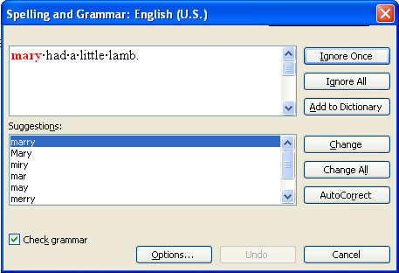
- To change a spelling, click the correct spelling or type it in, and click CHANGE or CHANGE ALL.
- To add words to the dictionary, click Add.
- To skip words, click IGNORE ONCE or ignore All to ignore all instances.
- To correct grammar usage, click the correct suggested option, click CHANGE.
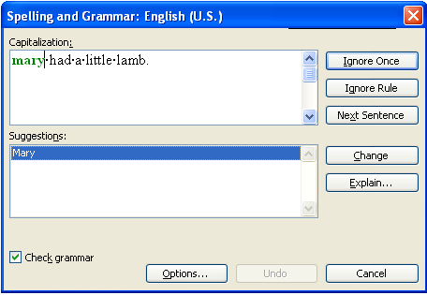
Helpful Hint:

To have only spell check run, remove the checkmark beside CHECK GRAMMAR.

- To ignore the suggested grammatical error, click IGNORE or IGNORE RULE. Ignore rule will skip over the same grammatical error throughout the document.
- When the Spelling and Grammar check is finished, a message will appear that it is complete. Click OK.
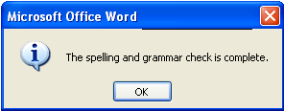

Thesaurus

OVERVIEW

The Thesaurus allows you to have the program list words of similar meaning (synonyms).
Helpful Hint:

The keyboard shortcut for the Thesaurus is SHIFT + F7.

STEPS

- Position the insertion point on the word to be reviewed, click TOOLS, LANGUAGE, THESAURUS.
- To use the new word, click on the drop-down arrow next to the word, and click INSERT.
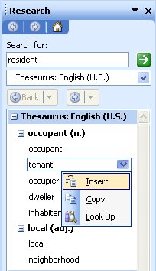
Did You Know?

You can right-click on a word and get a list of synonyms.

- To look up words, click on the drop-down arrow next to the word, and click Look Up.
- To look at previous words, click BACK.

Lesson Example

It is always important to proofread your work. Spelling and grammar check is a good place to start.

STEPS

- In the Open House document’s first sentence, delete the second “i” in invited. Put your cursor by the word open. Notice the red squiggly.
- Delete “n” from an before open in the second sentence. Click by open. Notice the green squiggly.
- Click the SPELLING AND GRAMMAR button. Select the appropriate options. Click OK when finished.
- Select the word opportunity in the second paragraph.
- Use the Thesaurus, by clicking TOOLS, LANGUAGE, THESAURUS. Select the word chance.
- Save the changes.

EXERCISE:

1) In the Letterhead document, run the Spell check. Select your title and use the Thesaurus to see options available. Choose one. Save the changes.

2) On Your Own: Spell check the On Your Own document. Use the Thesaurus to replace a word. Save the changes.

AutoCorrect

OVERVIEW

AutoCorrect includes features that may run while you are typing. Word will automatically correct certain words after you type the word and press the spacebar. It will automatically correct teh, recieve, THen, and change a small i to a capital I. Below is the dialog box to see all the options that are being corrected as you type. If you do not want an option on, you simply click to remove the checkmark.

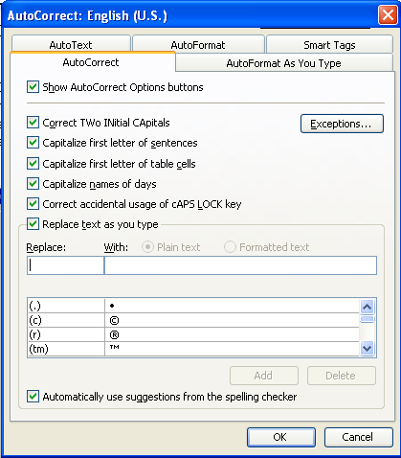

STEPS

- Click TOOLS, AUTOCORRECT OPTIONS.
- To show the AutoCorrect Options button , place a check in the checkbox. This button first appears as a small, blue box when you rest the mouse pointer near text that was automatically corrected, and it changes to a button icon when you point to it. If you find on occasion that you don't want text to be corrected, you can undo a correction or turn AutoCorrect options on or off by clicking the button and making a selection.
- To remove an AutoCorrect option, click the checkbox beside the option.
Did You Know?

You can right-click on a misspelled word, then go to AUTOCORRECT then click on the correct spelling.

- To add a word to AutoCorrect, click in the REPLACE box and type the incorrect spelling. TAB to the WITH box and type the correct spelling. Click ADD.
- To remove a word from AutoCorrect, scroll to the word. Click the word, and then click DELETE.
- When finished with AutoCorrect, click OK.

AutoCorrect Options: AutoText

OVERVIEW

The AutoText feature allows you to store standard phrases and text to be used anywhere within a file by typing in a short name and clicking on the Insert AutoText Tool to expand the name. You may want to use AutoText for the closing of a business letter or standard paragraphs that are frequently used.

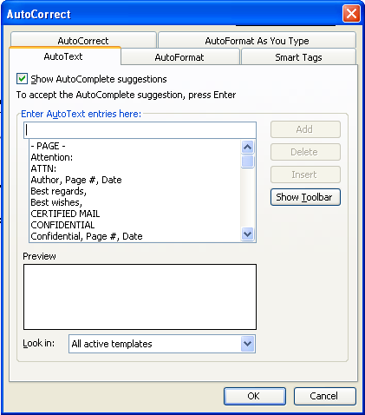
Helpful Hint:

You may select text for an AutoText entry and click INSERT, AUTOTEXT, NEW to add it as well.

STEPS
Did You Know?

If you type the first four letters of an AutoText entry, the entry appears and you may press ENTER to insert it. If another entry starts with the same four letters, you will need to type another letter.

1. Type the text (or open a document with the text already in it), and select the text using the mouse.

2. Click TOOLS on the Menu Bar, click AUTOCORRECT OPTIONS and the AUTOTEXT tab.

3. Click on ADD.

4. To use AutoText, choose TOOLS, AUTOCORRECT OPTIONS, and the AUTOTEXT tab. Click on the AutoText to use and choose INSERT, or double-click on it.

AutoCorrect Options: AutoFormat As You Type

OVERVIEW

The AutoFormat As You Type feature of AutoCorrect Options will make changes to your text as you type. Word will adjust text that it feels should be a bulleted list and change the format. This at times can be frustrating; it is important to know how to turn it off.

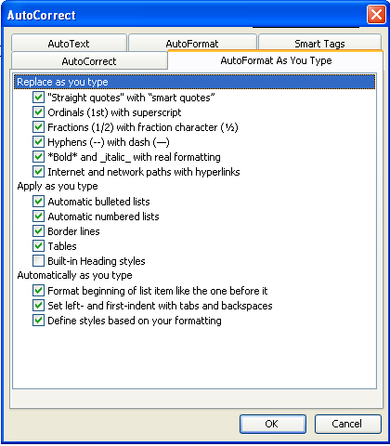

STEPS

- Click TOOLS, AUTOCORRECT OPTIONS.

- Click the AUTOFORMAT AS YOU TYPE tab.

- Click beside the options you would like to turn off to remove the checkmark.

- Click OK.

AutoCorrect Options: AutoFormat
The AutoFormat tab applies the format when you choose FORMAT, AUTOFORMAT. Word changes the entire document using all of the selected options.

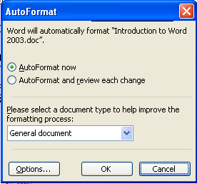
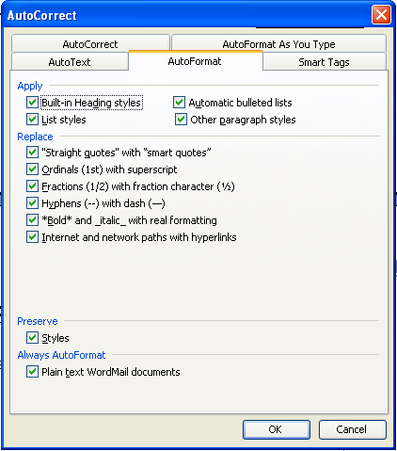

STEPS

  - Click TOOLS, AUTOCORRECT OPTIONS.

  - Click the AUTOFORMAT tab.

  - Click beside the options you would like to turn off to remove the checkmark.

  - Click OK.

  - To run AutoFormat, click FORMAT, AUTOFORMAT, and then OK.

AutoCorrect Options: Smart Tags
You can save time by using smart tags to perform actions that you would usually use a different Microsoft program to do. Smart Tags are pieces of data recognized and labeled as a particular type, like a person's name or the name of a recent Microsoft Outlook e-mail message recipient. Tasks that can be performed by using smart tags include adding a name, phone number, or calendar item to a Microsoft Outlook folder. The purple dotted lines beneath text in your document indicate the smart tags.

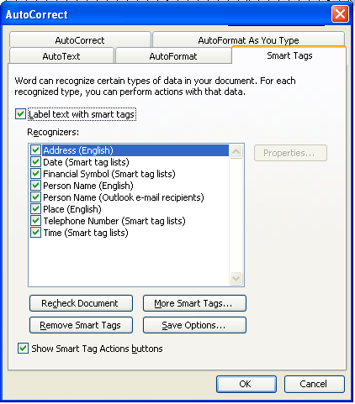

STEPS

- Place the cursor over the purple, underlined word until the SMART TAG button appears, then click on it.

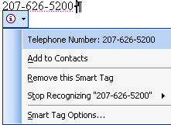

- Click on the required action.

Lesson Example

A paragraph needs to be added to the letter.

STEPS

- Enter the following paragraph as the last paragraph in the Open House document: teh governor personalyl invites teh poeple of Maine to the open house.
- Click TOOLS, AUTOCORRECT OPTIONS and type DHHS in the REPLACE box and Department of Health and Human Services WITH boxes. Click ADD and OK.
- Delete State Of Maine Government. Type dhhs and press the SPACEBAR.
- Add your name and your title above Department of Health and Human Services.
- Select your name, your title, and the Department. Create an AutoText entry by clicking TOOLS, AUTOCORRECT OPTIONS and the AUTOTEXT tab. Click ADD.
EXERCISE:

1) Use your name AutoCorrect in your Letterhead document. Start typing your name below the date and when the AutoText entry appears, press ENTER. Save the changes.

2) On Your Own: Delete the AutoCorrect and AutoText entries. Apply the AutoFormat options. Close all open documents.

GIVE IT A TRY

OBJECTIVE: Practice the lessons learned in class.

EXERCISE:

Refer to Lesson 1 for assistance

1) Turn the Tip of the Day feature on.
Refer to Lesson 2 for assistance
- Create a new document. Type a short letter (two paragraphs) to a friend.
- Save the document as Friend.
- Close the document.
- Open the Friend document.
- Save the document as Friendly Letter.
- Add the following sentence to be the last paragraph: “Have a great day.”
- Save and print the document.
Refer to Lesson 3 for assistance
9) Use the following keys. Where did the insertion point move?
CTRL + HOME ______________________________
END ___________________________________
CTRL + DOWN ARROW _____________________
CTRL + LEFT ARROW ______________________
CTRL + END ____________________________
HOME ____________________________________
10) Select the first paragraph and copy it.
11) Create a new document and paste the paragraph.
12) Close the document without saving.
Refer to Lesson 4 for assistance
13) Add the automatic date to your Friendly letter.
14) Select the entire letter and change to a font and size of your choice.
15) Make other enhancements to your letter using any of the following:
Text Enhancements
Bullets or Numbers
Text Case
Line Spacing
Margins
Headers/Footers

Refer to Lesson 5 for assistance
16) Spell check the document.
17) Save and print the document.

DELETING FILES

OBJECTIVE: Maintain organized file directories.

STEPS

1. Close all open documents.

2. Select OPEN from the FILE MENU.

3. Click once on the name of the file to be deleted. Or, use the CTRL or SHIFT keys to select multiple files.

4. Press the DELETE key on your keyboard. Click YES.

5. Click the CANCEL button to close the window.

Lesson Example

You have finished all the tasks on your To Do list.

STEPS

- Close all open documents.
- Click the OPEN button. In the OPEN dialog box, click TO DO and press the DELETE key.
- Click YES.

EXERCISE:

1) Delete all the documents you created in C:\My Documents.

2) Close the Open dialog box.

3) Shut down your computer.

NICE TO KNOW

Word Help Features

OVERVIEW

Microsoft Word contains several different types of help to assist you when you have difficulty with the program. The Office Assistant is an interactive help device that comes in the form of a cartoon character. It allows you to type a question or phrase related to your problem, and it will search for help topics based on your entry. In addition to the Office Assistant, Word provides help in a more standard form, where you search through lists of topics for one related to your issue. However, this requires that you are very familiar with Word terminology.

STEPS

- Click the HELP button or click on the TYPE QUESTION FOR HELP entry box in the upper right corner.
- Type your question.
- Either press ENTER or click SEARCH.
- Click on one of the options available to receive additional information on that topic.
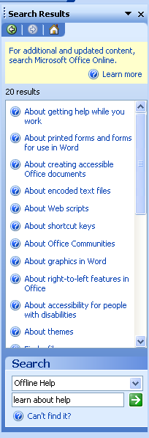

- To close the Help Box, click the CLOSE button in the upper right corner of the Task Pane.

Keyboard Commands
Align Left Ctrl + L
Align Right Ctrl + R
Bold Ctrl + B
Centering Ctrl + E
Copy Ctrl + C
Cut Ctrl + X
Find Ctrl + F
Go to Ctrl + G
(to go to a specific page)
Italics Ctrl + I
Justify Ctrl + J
New File Ctrl + N
Open File Ctrl + O
Page Break Ctrl + Enter
Paste Ctrl + V
Print Ctrl + P
Replace Ctrl + H
Save Ctrl + S

Select All Ctrl + A
(to highlight all text)
Underline Ctrl + U
Undo Ctrl + Z
To go to the beginning of document Ctrl + Home
To go to the end of document Ctrl + End

