ADVANCED WORD 2003

Table of Contents
Page
LESSON 1: DOCUMENT FORMATTING 1
♦ Selecting Text 1
♦ Creating a Style 2
♦ Format Painter 2
♦ Modifying a Style 3
♦ Using the Reviewing Toolbar 7
♦ Organizational Charts 12
LESSON 2: DOCUMENT ORGANIZATION 16
♦ Document Map 16
♦ Breaks 17
♦ Headers & Footers 18
♦ Advanced Page Setup 22
♦ Footnotes & Endnotes 26
♦ Creating a Table of Contents 28
♦ Navigating with a Table of Contents 30
♦ Updating a Table of Contents 30
LESSON 3: DOCUMENT MANAGEMENT 32
♦ Tracking Changes 32
♦ Comments 33
♦ Linking & Embedding Files 36
LESSON 4: GIVE IT A TRY! 39
LESSON 5: DELETING FILES 40
NICE TO KNOW 42
♦ Save and Edit Templates 42
♦ Keyboard Shortcuts 44
♦ Function Keys 45
♦ SHIFT + Function Keys 46

This workbook may be reproduced in whole or in part by an employee of the Department of Health and Human Services. All other reproduction is prohibited unless written permission is obtained from the Training Institute.

DOCUMENT FORMATTING

OBJECTIVES: Select text.
Use and modify styles.
Create and customize Styles.

Selecting Text

OVERVIEW

In order to make changes to the document, you will usually have to select or highlight text. Clicking and dragging over the text does this. However, there are other ways that can save you time.

STEPS

- To select a word, hold the I-Beam pointer on the word and double-click.
Helpful Hint:

When text is selected, anything you type on the keyboard will replace the selection.

- To select a sentence, hold down the CTRL key and click once anywhere on a sentence.

- To select a line, move your mouse to the Selection Area (left margin of your page) so that it becomes a white arrow . Click once beside the line.

- To select a paragraph, double click in the Selection Area to the left of the paragraph or triple click in the paragraph.

- To select long sections of text, use the SHIFT + DOWN ARROW method. Place the cursor at the beginning of the selection, hold down the SHIFT key and press the DOWN ARROW to the end of the selection.

- To select a document, click EDIT on the menu bar, click SELECT ALL (or use CTRL A). To use the mouse, triple click in the selection area.

Creating a Style
OVERVIEW
Did You Know?

Microsoft Word has a feature similar to Reveal Codes in WordPerfect. Press SHIFT + F1 to open the Reveal Formatting Task Pane.

Styles are combinations of formatting options that you may apply to pieces of text rather than selecting text and clicking on several features to achieve the look you desire. The default style is Normal, which is defined by default as 10 point, Times New Roman, left alignment, with single-line spacing. You may utilize pre-set styles, create new styles, modify, and delete styles. Once a style is modified, all text in that style changes to reflect the modifications.

STEPS

- To create a new style, format a section of text the way you wish the style to be formatted.

- Select the formatted text.

- Click in the STYLE BOX on the formatting toolbar , and type a style name. Press ENTER.

- To apply a style, position the insertion point within the text to be formatted.

- Click in the STYLE BOX on the formatting toolbar , and select the desired style.

Format Painter
OVERVIEW
Helpful Hint:

To "paint" formatting onto only one piece of text, click the FORMAT PAINTER button only once.

Rather than continually selecting text, clicking the Style Box and choosing the appropriate style, the Format Painter allows you to "paint" the formatting of one piece of text onto several other sections of text.

STEPS

- Find a section of text that is formatted the way you would like other areas formatted. This can mean a section with a style applied or simply normal text with some formatting features applied.
- Click anywhere within that formatted section of text.
- Double-click the FORMAT PAINTER button .
- Your mouse pointer becomes a paintbrush. Click and drag the brush over all areas of text to which you wish to apply the formatting.
- Click the FORMAT PAINTER button to turn off the feature.
Helpful Hint:

If you intend to generate a Table of Contents for your document, use the existing Heading styles. Headings 1, 2, and 3 automatically appear in your TOC, and may be modified to look the way you like.

Modifying a Style

STEPS

- To modify a style, position the insertion point within any text of that style.

- On the Menu bar, click FORMAT, STYLES AND FORMATTING. The STYLES AND FORMATTING task pane appears.

- Click the SHOW drop down menu and select CUSTOM.

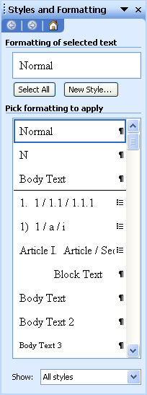
Show

- In the FORMAT SETTINGS window, select STYLES.
Helpful Hint:

Another way to modify a Style is to locate the style name in the PICK FORMATTING TO APPLY section and click the drop down list beside it. Select modify and make your changes.

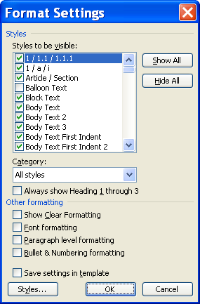
Styles

- Select the STYLE you wish to change and click the MODIFY button.

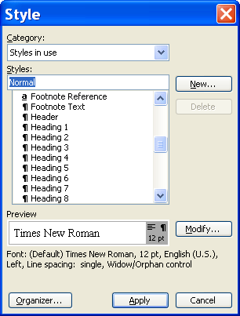
Modify

- The MODIFY STYLE window appears. You can make several formatting changes such as: FONT STYLE, FONT SIZE, FONT ATTRIBUTES, FONT COLOR, ALIGNMENT, LINE SPACING, PARAGRAPH SPACING, and PARAGRAPH INDENTS.

- To make further changes to a STYLE, click FORMAT.

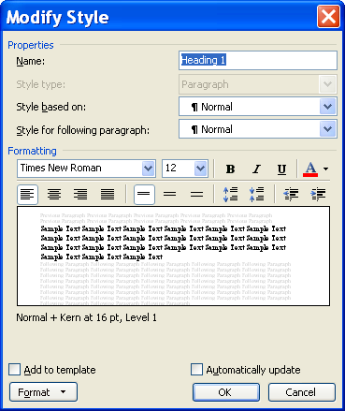
Format

- You can make changes to FONT, PARAGRAPH, TABS, BORDER, LANGUAGE, FRAME, NUMBERING, and SHORTCUT KEY.

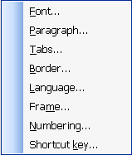

- Make the necessary selections, and click OK. Click APPLY.

- To create a new style, click the NEW STYLE button .

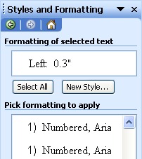
New Style

- Type a NAME for the STYLE and make the necessary formatting choices. Click OK when finished.

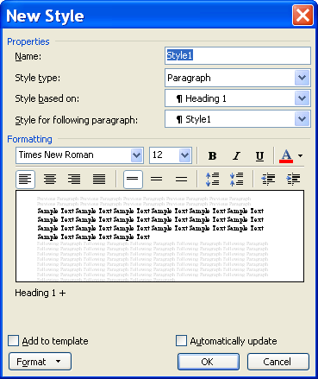
Name

- To delete a style, locate the style on the list, click the drop down list beside it, and select DELETE and click YES.

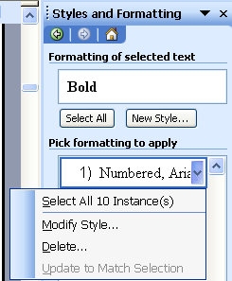
Delete

Using the Reviewing Toolbar
OVERVIEW

Microsoft Word 2003 automatically displays changes that are made to documents that you work in. It is extremely important to Accept All Changes made in a document before sending it as an e-mail attachment, publishing it to the web, or distributing it. If you do not accept all of the changes, then others have the ability to see these changes.

You created the following letter to send out to a client:
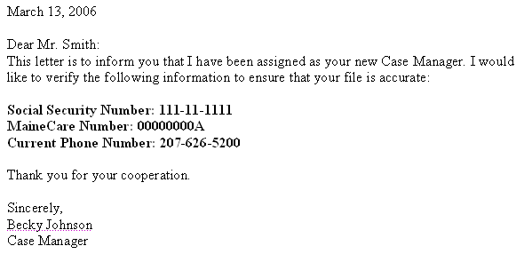

You want to send the letter to a different client, so you use Save As and change the information. The next time you open the letter, you see this:

FINAL SHOWING MARKUP view:

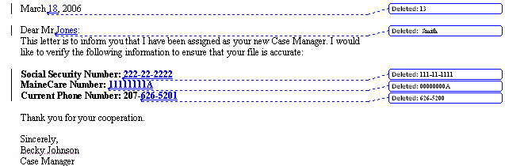

Changing the view to Final hides all of the mark-ups.

FINAL view:

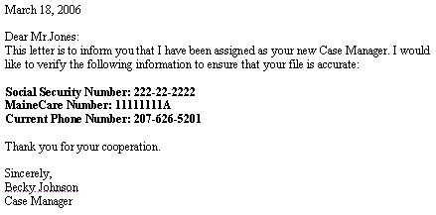

Doing that may solve the problem for printing; however, the document still contains all of the original information, as well as the changes. All the reader would need to do is switch the view to Original.

ORIGINAL view:

To solve this problem, you need to Accept All Changes in the Document. Once that is complete, other users cannot see the original data or the changes that were made.

STEPS

- To switch views, on the Reviewing Toolbar, in the DISPLAY FOR REVIEW box , click the desired view.
Accept Changes
Display for Review
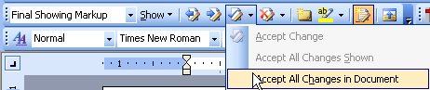

- To accept all of the changes made, click the down-arrow next to the ACCEPT CHANGE button and click ACCEPT ALL CHANGES IN THE DOCUMENT.

Lesson Example

You want to apply and modify styles in the Sample Grant document.

STEPS

- Open the Sample Letter for Reviewing document. Your instructor will indicate its location.
- Click FILE, SAVE AS and save it to C:/My Documents.
- Click the down-arrow next to the ACCEPT CHANGE button and click ACCEPT ALL CHANGES IN THE DOCUMENT.
- On the Reviewing Toolbar, in the DISPLAY FOR REVIEW box, click the FINAL view.
- Scroll through the document to get a feel for its contents. Press CTRL + HOME to return to the top of the document.
- Save and close the document.
- Open the Sample Grant document. Your instructor will indicate its location.
- Click FILE, SAVE AS and save it to C:/My Documents.
- Open the STYLES AND FORMATTING task pane by clicking FORMAT, STYLES AND FORMATTING.

- Click the drop down list in SHOW and choose CUSTOM.

- Click the STYLES button in the FORMAT SETTINGS window.

- Select HEADING 1 from the list and click the MODIFY button.

- Change the font to Arial, 16 point, and Bold.

- Click the FORMAT button and select PARAGRAPH from the pop up menu.

- Change the LEFT indentation to .25.

- Apply SPACING AFTER of 12 pt. Click OK.

- Click the FORMAT button and select NUMBERING from the pop up menu.

- Click the NUMBERED tab, and click the option for Roman Numerals. (If a Roman Numeral option does not exist, click on any available style, then click CUSTOMIZE, then choose Roman Numerals under NUMBER STYLE. Click OK)

- Click OK twice and then click CLOSE.

- Click anywhere within the word that reads Abstract on page 1 of the document.

- Select Heading 1 from the STYLES AND FORMATTING task pane and click.

- With your mouse pointer still within the Abstract text, double-click the FORMAT PAINTER button in the Standard toolbar.

- Click in the following words to apply the Heading 1 style:

Project Design and Implementation
Goals and Objectives
Key Personnel
Experience of Proposed Partners
Management and Budget Plan
Appendices

- Click the FORMAT PAINTER button to turn it off.

- Save your changes.

EXERCISE:

- From the Styles and Formatting Task Pane, click the drop down beside Heading 2 Style and click Modify.
- Make the following changes: 14 point, bold, italic text, 6 point spacing after, and change the line spacing to single.

- Apply the Heading 2 Style to the following text in the grant:

Need for Research Project
Project Goal
Project Objectives
Site Characteristics
Project Design and Implementation Task Descriptions
Waiver Requests: N/A
Implementation Schedule: See Table 1
Transferability
Chain of Command and Responsibilities
Contingency Plans
Outside Personnel

- On Your Own: modify the Heading 3 Style to be Times New Roman, 12 point, Bold, Centered text with 6 points of spacing after. Remove the paragraph spacing before.

- Apply the style to each Appendix and its Title, for example, Appendix A Relevant Experience of Key Personnel.

- Save your changes.

Organizational Charts
OVERVIEW

Organizational Charts are a great way to visually display the structure of an office.

STEPS
- Place your cursor where you want the Chart to appear. Click the INSERT DIAGRAM OR ORGANIZATIONAL CHART button on the Drawing Toolbar.
- Make sure that ORGANIZATION CHART is selected and click OK.
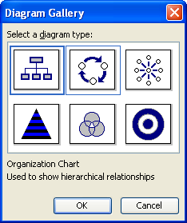
Organization Chart

- Put the cursor in the CLICK TO ADD TEXT boxes to enter the staff members' names.

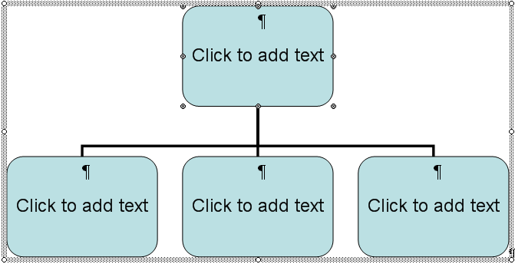
- To add another staff member, click on the box that you want to attach the shape to.

- Click the drop down arrow next to the INSERT SHAPE button on the Organization Chart Toolbar.

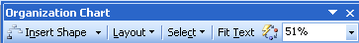

- Select the box type, SUBORDINATE, COWORKER, or ASSISTANT, of the new staff member.

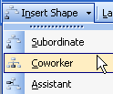

- To remove a staff member, click on the box, and then press DELETE on the keyboard.

- To select multiple items, click SELECT on the Organization Chart Toolbar and click level, branch, all assistants, or all connecting lines.

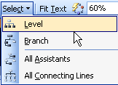

- To automatically format the organization chart, click the AUTOFORMAT button .

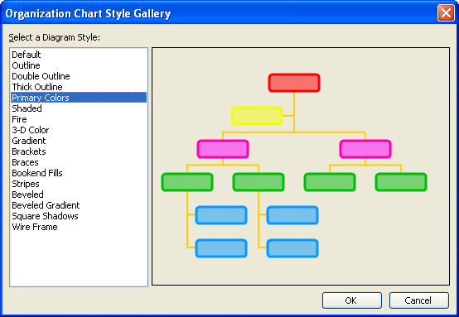

- Choose the format style and click OK.

- To format text, use the FORMATTING TOOLBAR to make your formatting choices.

- To change the color of text, highlight the text and use the FONT COLOR button on the FORMATTING TOOLBAR.

- To apply color to the boxes, use the FILL COLOR button on the DRAWING TOOLBAR.

- To format the lines, click SELECT, ALL CONNECTING LINES and make your formatting choices using the line color button , the line style button , and the dash style button .

- To change the chart layout, click LAYOUT and make your layout choices.

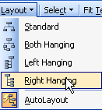

- When finished, click the CLOSE button.

Lesson Example

You want to create an organizational chart for your grant.

STEPS

    - Scroll to the end of Appendix A and put your cursor in a blank line.
    - Click the INSERT DIAGRAM OR ORGANIZATION CHART button on the Drawing Toolbar.
    - Select the ORGANIZATION CHART and click OK.
    - Click in the top box and type J. Jones. Press the ENTER key and type Program Manager.
    - Click in the box below and to the left, and type S. Smith. Press ENTER and type Manager, Community Programs.
    - Click in the box to the right and type D. Day. Press ENTER and type Director, Transportation.
    - Click in the box to the right and type W. Williams. Press ENTER and type Manager, Public Welfare Training.
    - Click in S. Smith's box. From the Organization Toolbar, click the INSERT SHAPE drop down list and choose SUBORDINATE.
    - Click in the new box and type D. Anderson. Press ENTER and type Supervisor, Food Stamp Program.
    - With A. M. Anderson's box still selected, click the INSERT SHAPE pick list and choose CO-WORKER.
    - Click in the new box and type J. Johnson. Press ENTER and type Specialist, Elder and Adult Services.
EXERCISE:

1) Select J. Jone's box. From the Organization Toolbar, click the SELECT drop down list and choose SELECT BRANCH.
2) From the Drawing Toolbar, click the FILL COLOR pick list and choose a color for the boxes.
3) From the Organization Toolbar, click the SELECT pick list and select ALL CONNECTING LINES.
4) From the Drawing Toolbar, click the LINE COLOR pick list and choose a color for the lines.
5) Form the Organization Toolbar, click the AUTOFORMAT button and make a selection from the list.
6) On Your Own: Add M. Moore as a subordinate to D. DAY with the job title of Project Specialist.
7) Change the format of the chart to an AUTOFORMAT style.
8) Save the document.

DOCUMENT ORGANIZATION

OBJECTIVES: Use the document map.
Utilize page and section breaks.
Insert headers and footers.
Customize page setup.
Generate a Table of Contents.

Document Map
OVERVIEW

The Document Map is a separate panel that displays a list of the headings in your document, similar to an outline. You must use the preexisting Heading styles in order for the outline to appear. The Document Map can be used to quickly navigate through a document and keep track of your location.

STEPS
- To turn the document map on, click the DOCUMENT MAP button on the Standard toolbar.
- To go to a certain part of a document, click on the heading of the section in the Document Map.

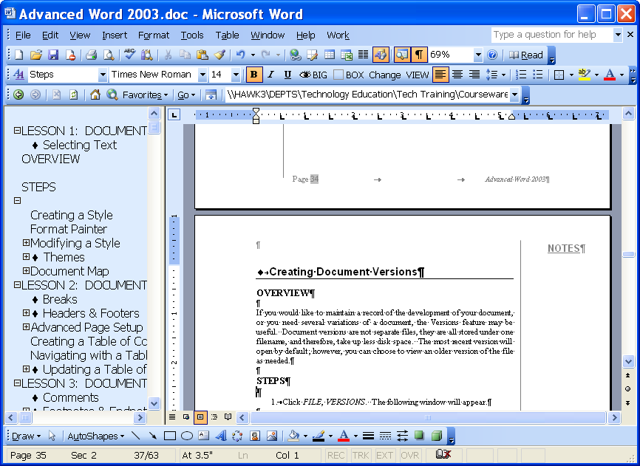
Document Map
- To display all headings at a specific level, right-click a heading in the Document Map, and then click a number on the menu. For example, click Show Heading 3 to display heading levels 1 through 3.
- To collapse the subordinate headings, under an individual heading, click the minus sign (-) next to the heading.
- To display the subordinate headings, under an individual heading, click the plus sign (+) next to the heading.

Breaks
OVERVIEW

A page break forces information after the break onto a new page. Word does this automatically as you type; however, you may want to insert manual breaks in certain places. Section breaks, which must be inserted manually, allow you to distinguish between different areas of the document. For example, if one area should be in landscape orientation, while the rest of the document is in portrait, section breaks allow you to select a different orientation for each section.
Helpful Hint:

The keyboard shortcut for inserting a page break is CTRL + ENTER.

STEPS

- Position your cursor where you want to insert a break.

- Click INSERT, BREAK.

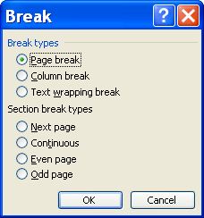

- Select the appropriate radio button, and click OK.

Types of Breaks

Page Break – ends one page and begins another. This type of break is called a hard page break.

Column Break – forces one column into another one.

Text Wrapping Break – evens out the text of columns.

Next Page – creates a new section on the next page.

Continuous – creates a new section at the insertion point.

Even page – creates a new section on the next even-numbered page (usually a left-hand page).

Odd page – creates a new section on the next right-hand page.

Headers & Footers
Did You Know?

Once a header or footer has been added, double-clicking in the top or bottom margin, opens the header and footer area.

OVERVIEW

A header or footer is printed within the top and bottom margin of each page of your document. You can use the same header and footer on every page or you can change it for specific sections of the document.

STEPS

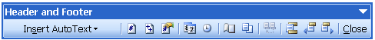
- On the Menu bar, click VIEW, HEADER AND FOOTER. This takes you into the header for the active section.
Insert Page Number
Format Page Number

Insert Time
Show/Hide Document Text

Switch Between Header and Footer
Show
Next
Insert Number of Pages
Insert Date
Page Setup
Show Previous
Close Header and Footer
Link to Previous

Did You Know?

Formatting headers and footers is the same as formatting a document.

- Type the text to be added to the header (you may change the font to match the document font if necessary).
- To move from the header area into the footer area, click the SWITCH BETWEEN HEADER AND FOOTER button on the toolbar.

- To add page numbering to the header or footer, click the INSERT PAGE NUMBER button . Or, click the INSERT AUTOTEXT button , and select PAGE X OF Y.

- To omit headers and footers from the first page, click the PAGE SETUP button on the toolbar. Select the LAYOUT tab and click DIFFERENT FIRST PAGE. Click OK.
- To see the header and footer for the next page, click SHOW NEXT button . Click the LINK TO PREVIOUS button to move backward through pages.
- Click the CLOSE button on the Header and Footer Toolbar to return to the document.
- To have different Headers and Footers in your document, insert a section break where you want the different header/footer.
- Click VIEW, HEADER AND FOOTER.
- Click the LINK TO PREVIOUS button so that it looks like it is no longer selected.
- To have the page numbers start at 1 for the new section, insert a page number by clicking the button .
- Click the FORMAT PAGE NUMBER button .
- Choose the option to START AT: and choose the #1.
- Click OK.

Lesson Example

You would like to start certain pieces of your grant on new pages. You would also like the Cover Sheet and Table of Content pages to have Roman numeral page numbering.

STEPS

- On the first page of the grant, move your insertion point in front of the words Table of Contents.

- Press CTRL + ENTER.

- Move your insertion point in front of the word Abstract.

- Click INSERT, BREAK.

- Select a NEXT PAGE Section Break. Click OK.

- Return to the Table of Contents page, and click VIEW, HEADER AND FOOTER.

- Click the SWITCH BETWEEN HEADER AND FOOTER button on the Header and Footer toolbar.

- Click the ALIGN RIGHT button in the Formatting toolbar.

- Click the INSERT PAGE NUMBER button then the FORMAT PAGE NUMBER button on the Header and Footer toolbar.

- Click the NUMBER FORMAT drop-down, and select small Roman numerals. Click OK.

- Click the SHOW NEXT button. You should now be in the Footer for Section 2.
- Click the LINK TO PREVIOUS button to disable it.

- Click the FORMAT PAGE NUMBER button.

- If necessary, click the NUMBER FORMAT drop-down, and select regular numbering.

- Click the START AT radio button in the PAGE NUMBERING section, and be sure that the number in the box is 1. Click OK.

- Close the Header and Footer toolbar and save your changes.

EXERCISE:

- Click DOCUMENT MAP on the standard toolbar.
- Click Transferability on the Document Map.
- Insert a NEXT PAGE section break before Table 1.

- Click Key Personnel on the Document Map and insert a NEXT PAGE section break.

- Insert next page section breaks before and after the word Appendices.

- Insert a page break before Appendix B.

- The numbering on the document is now incorrect. Go to Table 1 and double click the Footer section.

- Click the FORMAT PAGE NUMBER button.

- Click the CONTINUE FROM PREVIOUS SECTION radio button and click OK.

- On Your Own: Continue to check the page numbers in the document and make the necessary changes.

- Close the Header and Footer toolbar.

- Save your changes.

Advanced Page Setup
OVERVIEW

The Page Setup Dialog Box allows you to truly customize the layout of each page of your document.

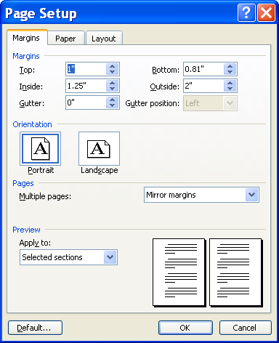
Margins
- A gutter margin is used when you want to have the document bound, like a book, so one side or the top of the page needs a little more space. Left or top placement is selected in Gutter position.
- Mirror margins are necessary when you want the facing pages of a document to be even. Margins of the left page are a mirror image of those on the right page.
- Orientation allows you to change Portrait (8 ½ x ll) to Landscape (ll x
8 ½ ).
- Apply to gives you the option to apply the page setup to certain sections of your document. If you choose the default of whole document, the changes you make affect the entire document. You may want it to only affect from This Point Forward. The other option is Section, which is used when you add section breaks.

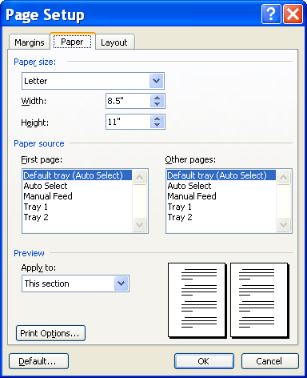
Paper
Helpful Hint:

If you choose to APPLY TO: Whole Document, the selections on ALL tabs of the Page Setup dialog box will apply everywhere and override any This Section choices made previously.

- The Paper tab allows you to change the paper size and customize a size, if necessary, using Width and Height.
- Paper Source manages which trays you use in your printer. You may make selections from both the first page and other pages.
- Apply to gives you the option to apply the page setup to certain sections of your document. If you choose the default of whole document, the changes you make will affect the entire document. You may want it to only affect from This Point Forward. The other option is Section, which is used when you add Section Breaks.
- Print options opens the same window that you can access from the Print menu.
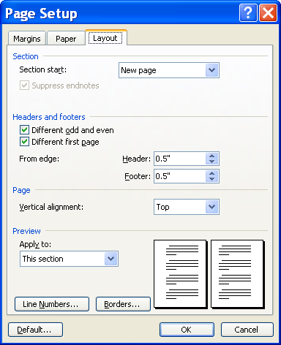
Layout

- On the Layout tab, the Section Start option is used to indicate how Word determines where to add Headers and Footers.
- Headers and Footers options include Different odd and even. This is used when you have double-sided pages and want the header and footer to alternate. Different first page removes the header and footer from the first page. For example, a Title Page would not need page numbering. You may set the distance from the edge of the page that your Header and Footer are located.
- Vertical alignment positions your document text vertically on the page. The choices are Top, Center, Justified, and Bottom.
- Apply to gives you the option to apply the page setup to certain sections of your document. If you choose the default of whole document, the changes you make affect the entire document. You may want it to only affect from This Point Forward. The other option is Section, which is used when you add Section Breaks.
- Line numbers allows you to number each line or several lines in the document.
- Borders applies an outer border to the pages of the document.

Lesson Example

Table 1 would look better in Landscape orientation.

STEPS

- Click anywhere in the Table 1 text.

- Click FILE, PAGE SETUP.

- On the MARGINS tab, select LANDSCAPE as the orientation.

- Be sure that APPLY TO indicates THIS SECTION.

- Click OK.

- The table needs to be resized to fit more appropriately. Click a cell in the table and select TABLE from the menu. Then choose AUTOFIT, AUTOFIT TO CONTENTS.

- Save your changes.

EXERCISE:

- On the Appendices page, go to PAGE SETUP.
- Click the LAYOUT tab and select CENTER for the vertical alignment.
- Click OK and preview the page.

- On Your Own: Add a left Gutter margin of .4" to the whole document.

- Save your changes.

Footnotes & Endnotes
OVERVIEW
Helpful Hint:

You may need to change the font to match the text in your document.

When working with a long document, such as a report, you may need to reference material that is somebody else’s work (who wrote it, who published it, when, etc). If you prefer this information to appear at the bottom of each page, you should use footnotes. If you would like this information at the end of the document, add endnotes. Word will position and number these notes for you automatically.

STEPS

- Position the cursor at the point where the footnote is to be added. On the Menu bar, click INSERT, REFERENCE, FOOTNOTE.

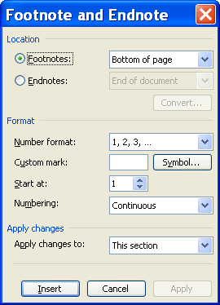

- Make the appropriate selection regarding FOOTNOTE or ENDNOTE.

- Make the necessary changes to the FORMAT of the numbers. You may also select a SYMBOL instead of a number.

- Click INSERT when finished.

- Type the text for the footnote or endnote. The number or symbol on the note will also be placed where your insertion point was when you inserted the note.

- To go to a particular footnote or endnote, on the Menu bar, click EDIT, GO TO, and then FOOTNOTE OR ENDNOTE. Click in the number box, type the footnote or endnote number, and click GO TO.

- To edit the footnote or endnote, double-click on the footnote or endnote number in the main portion of the document. Make the desired changes.
Helpful Hint:

The shortcut key for GO TO is F5.

- To delete a footnote or endnote, highlight the number in the main portion of the document, and press DELETE (this deletes the number and the text associated with it). It automatically renumbers any other footnotes or endnotes.

Lesson Example

You need to cite your references within the document.

STEPS

- Move your insertion point to the end of the Title of Table 1.

- Click INSERT, REFERENCE, FOOTNOTE.

- Keep the default settings and click INSERT.

- Type Schedule subject to change.

- Click anywhere in the document and save your changes.

EXERCISE:

- In the Need for Research Project section, go to page the 4th page, 2nd paragraph, 3rd sentence and click at the end of the sentence.

- Insert the following footnote: Rudd, RE. Factors influencing nutrition education. Journal of the American Dietetic Association. 1998: 559-564.

- On Your Own: Insert a footnote after the sentence prior to the table in the Site Characteristics section stating: US Census 1999; NALS, 1992; USDA, 2001

Creating a Table of Contents
OVERVIEW

A Table of Contents (TOC) is a list of the headings in a document that you can insert in a specific location. You can use a table of contents to get an overview of the topics discussed in a document or to quickly navigate to a topic.

Styles determine what appears in your Table of Contents. If you utilize Headings 1, 2, and 3, your TOC almost creates itself. If you want other headings or styles represented in the TOC, you must customize it to read these additional styles.

STEPS
- In your document, apply styles (preferably Heading 1 through Heading 9) to the items you want to include in your table of contents.
- Click where you want to insert the table of contents.
- On the Menu bar, click INSERT, REFERENCE, INDEX AND TABLES.
- Click the TABLE OF CONTENTS tab.
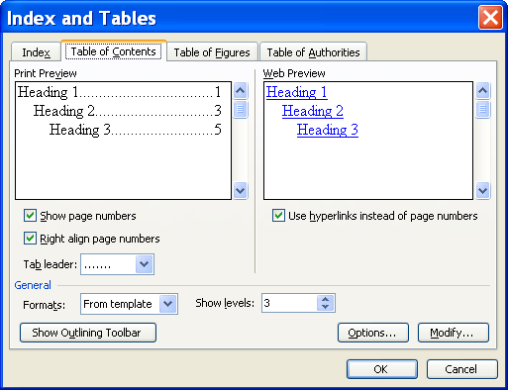

- Click to choose whether or not to SHOW PAGE NUMBERS and/or to RIGHT ALIGN PAGE NUMBERS.
- Select a TAB LEADER to fill the space between the heading and page number.
- Choose a number of heading levels to show in the Table of Contents by increasing or decreasing the number in SHOW LEVELS.
- To select styles other than headings to appear in the Table of Contents, click the OPTIONS button.
- Under AVAILABLE STYLES, find a style you have applied to items in your document that you wish to appear in the TOC.
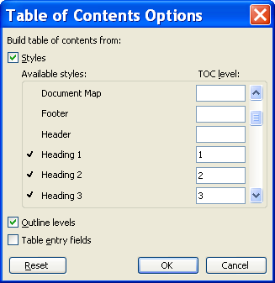
- Under TOC LEVEL to the right of the style name, enter a number from 1 to 9 to indicate the level you want that heading style to represent.
- Repeat steps 9 and 10 for each heading style you want to include in the table of contents. Click OK two times.
- To modify the Table of Contents text, refer to Modifying a Style in Lesson 1.

Navigating with a Table of Contents
OVERVIEW

When you create a TOC, Word links the headings listed in the TOC to the corresponding information within the document. This allows you to click a heading to locate that portion of the document.

STEPS

- Scroll through your TOC to find the area you want.
- Point the mouse pointer on the heading. It will become a pointing hand . Click once.
- To return to the TOC, click the BACK button 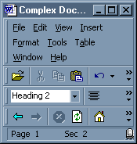 in the Web toolbar.

Updating a Table of Contents
OVERVIEW

If you add or delete headings, or your headings move to new pages in the course of editing your document, your TOC needs to be updated to reflect the changes.

STEPS
Did You Know?

Right-clicking your TOC and clicking UPDATE FIELD will also allow you to update the TOC.

- Click somewhere near the Table of Contents, and use your arrow keys to move your insertion point within the TOC. Remember that clicking in the TOC activates a hyperlink to another area of the document.
- Press F9.
- Choose to either UPDATE PAGE NUMBERS ONLY or UPDATE ENTIRE TABLE by clicking the appropriate radio button.
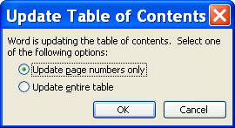
- Click OK.
- To delete a Table of Contents, move your mouse pointer into the Selection Bar (left margin) to the left of the TOC and click once.
- Press DELETE on your keyboard.

Lesson Example

Create a Table of Contents for the grant.

STEPS

- Click in the blank line below the Table of Contents heading on the second page of the document. Press ENTER.
- On the Menu bar, click INSERT, REFERENCE, INDEX AND TABLES.
- Click the TABLE OF CONTENTS tab. Click OK.
- Click FORMAT, STYLES AND FORMATTING.
- Modify the TOC 1 Style to have a 14 point font size, bold, and 12 points before and after.
EXERCISE:

- Modify the TOC 2 Style to have the left indentation at .5".

- On Your Own: At the end of the document insert a page break and add a new Appendix (D) entitled Additional Information and apply the HEADING 3 style..

- Update the Table of Contents and choose to UPDATE THE ENTIRE TABLE.

- Format the text "Table of Contents".

- Make any other changes to the Table and save your changes.

DOCUMENT MANAGEMENT

OBJECTIVES: Compare and Track Changes to a document.
Communicate with co-writers and readers.
Link and Embed objects from other files.
Protect a document.

Tracking Changes
OVERVIEW
Helpful Hint:

You can also turn Track Changes on or off by double-clicking the TRK on the Taskbar.

A revision mark is a mark that shows where a deletion, insertion, or other editing change has been made in a document. Word can track changes in two ways: by marking the revisions as they are made, or by marking the revisions later when it compares two versions of the document.

STEPS

- To turn on tracking, click TOOLS, TRACK CHANGES. The Track Changes Toolbar appears.

Display for review
Show
Previous
Next
Accept
Change
Reject change/
Delete comment
Insert
Comment
Highlight
Track
Changes
Reviewing
Pane

- Click the TRACK CHANGES button .

- Make edits in the document as you normally would. However, no "official" changes will be made until accepted.
- Click the NEXT button to take you to the first change.
- To accept a change, click the arrow beside the ACCEPT CHANGE button.

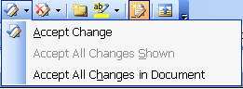

- You may make the following changes: ACCEPT CHANGE, ACCEPT ALL CHANGES SHOWN, or ACCEPT ALL CHANGES IN DOCUMENT.
- To reject changes, click the arrow beside the reject change/delete comment button .

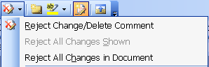

- You may make the following changes: REJECT CHANGE, REJECT ALL CHANGES SHOWN, or REJECT ALL CHANGES IN DOCUMENT.
- To turn off tracking, click the track changes button .

Comments
OVERVIEW

A comment can be inserted onto the screen without changing your document text.

STEPS

- Select the text about which you would like to comment.

- On the Menu bar, click INSERT, COMMENT. Or click the INSERT COMMENT button on the Reviewing toolbar.

- Type in the comment field.

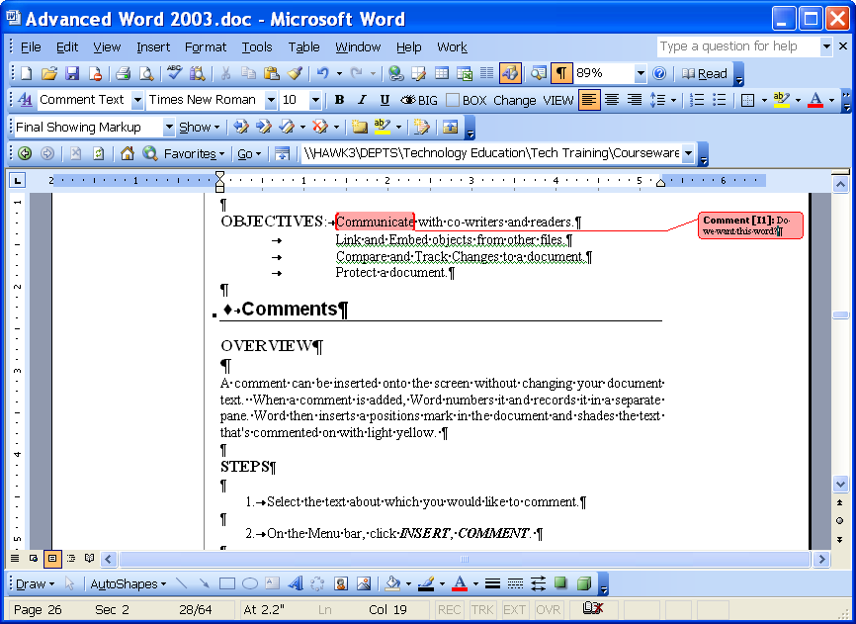
Comment field
Final Showing Markup

- To delete a comment, right-click the comment field and select delete COMMENT.
- To remove the comments, click the drop down list beside FINAL SHOWING MARKUP and change it to FINAL.
- To hide the comments section at the bottom of the bottom of the screen, click the REVIEWING PANE button on the reviewing toolbar.

Lesson Example

You have asked for several other people to assist you in writing the grant, but you want the final say in any changes made.

STEPS

- Select the text Table 1 at the top of the table in the Transferability section.
- On the Menu bar, click INSERT, COMMENT.
- Type Should we include this section as an appendix instead?
- Click the REVIEWING PANE button on the reviewing toolbar.
- Click the TRACK CHANGES button.
- On the cover page, change the project dates to January 2006 through December 2010.
- Delete Jason Johnson as the Project Manager and put in your name.
- Add the word Project before the heading Abstract.
- Click in the top of the document and click the NEXT button on the reviewing toolbar
- Click the ACCEPT CHANGE button to remove Jason Johnson's name. Click the NEXT button.
- Click the ACCEPT CHANGE button to accept your name. Click the NEXT button.
- Click the ACCEPT CHANGE button to remove the original date. Click the NEXT button.
- Click the ACCEPT CHANGE button to accept the new date. Click the NEXT button.
- Click the REJECT CHANGE/DELETE COMMENT button to delete the word Project. Click the NEXT button.
- Click the REJECT CHANGE/DELETE COMMENT button to delete the comment. Click the NEXT button.
- Click OK to return to the beginning of the document.
- Return the display for review to FINAL.
EXERCISE:

- Change the Level of Grant Support Requested to $500,000.

- On Your Own: Insert a comment on Project Goals in the Goals and Objectives section asking for input on the other potential goals.

- Accept the change.

- Turn off Track Changes.

- Save your changes.

Linking & Embedding Files

OVERVIEW
Helpful Hint:

To open an embedded object, double-click it.

When you link a file, you take information (an object) created in one file (the source file) and insert it into another file (the destination file) while maintaining a connection between the two files. The object in the destination file is updated when the source file object is modified.
With an embedded object, information in the destination file does not change if you modify the source file.

STEPS
- Select the object to be linked or embedded in the source file.
Did You Know?

The main difference between linked objects and embedded objects is where the data is stored and how it is updated after you place it in the destination file.

- On the Menu bar, click EDIT, COPY. Or, click the COPY button in the Standard toolbar.
- Open the destination file, and place your insertion point where you would like the object to appear.
- To create a linked object, click EDIT, PASTE SPECIAL.
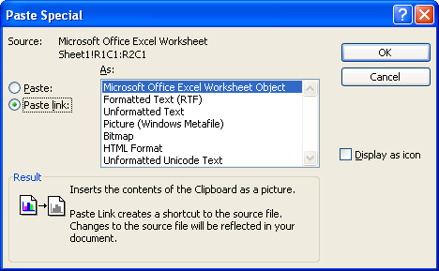
Paste Link
Helpful Hint:

Do not close the source object during the copy and paste process.

- Click PASTE LINK and select the appropriate format for the information. Click OK.
- To embed the object, simply click EDIT, PASTE. Or, click the PASTE button on the Standard toolbar.
- Once the object is embedded or linked, it may be necessary to adjust its size and location.

Lesson Example

You would like to add an Excel worksheet to the grant.

STEPS

- Start Microsoft Excel and open the Grant Budget.xls file. Click FILE, SAVE AS (or press F12) and save it to C:/My Documents.
- Select the data and copy it.
- In the Sample Grant, locate the Chain of Command and Responsibilities section. Place your cursor at the end of the section and press ENTER.
- Click EDIT, PASTE SPECIAL.
- Select the PASTE LINK radio button and choose AS A MICROSOFT EXCEL WOKSHEET OBJECT.
- Double click the 10000 in the Federal Resources cell and change the amount to 25000. Save the worksheet and return to the Sample Grant.
- Right click the 10000 and select UPDATE LINK.
- Open the Excel workbook named Grant Chart. Click FILE, SAVE AS (or press F12) and save it to C:/My Documents.
- Select the chart and click COPY.
- In the Sample Grant, move your insertion point to the end of last paragraph on page 4 and press the ENTER key.
- Click PASTE.
- Save your changes.

EXERCISE:

- Open the Excel workbook named Grant Chart. Click FILE, SAVE AS (or press F12) and save it to C:\My Documents.
- Select the chart and click COPY.
- In the Sample Grant document, move your insertion point to the end of the last paragraph on page 4 and press the ENTER key.
- Click PASTE.
- On Your Own: Center the chart.

- Save your changes.

GIVE IT A TRY!

OBJECTIVE: Practice the functions learned in class.

EXERCISE:

Refer to Lesson 1 for assistance

1) Modify your Heading 1 Style to be a different font, size, and color.

2) View the change to your headings.

Refer to Lesson 2 for assistance

3) Turn on the Document Map, and navigate through your document.

4) At the very end of the document insert a new page section break and type THE END.

5) Apply the Heading 1 Style to this text.

6) Vertically center this line on the final page.

7) Return to the top of the document and update your table of contents.

8) Use the Table of Contents to go to the Site Characteristics section.

Refer to Lesson 3 for assistance

9) Insert a comment about the Site Characteristics section.

10) At the end of the second sentence in this section, insert a footnote indicating that the information was provided by WCCSA.

11) Save and close the Sample Grant document.

DELETING FILES

OBJECTIVE: Maintain organized file directories.

OVERVIEW

If you have several different files from several different programs that you would like to delete, the most efficient place to go is Windows Explorer.

STEPS

1. Close all open documents.

2. Right-click the START MENU, and click EXPLORE. Or, press the WINDOW key plus the letter E.

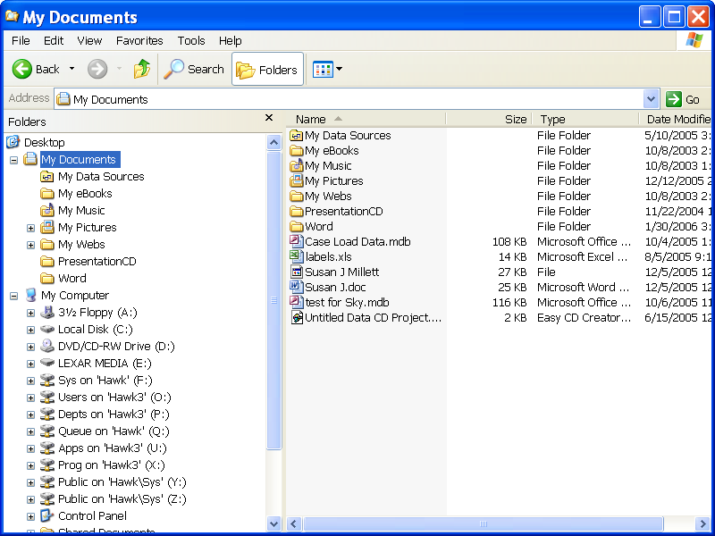

3. In the left panel, click the drive on which you have stored the file(s) to be deleted.

4. In the right panel, double-click a folder to open it. Continue double-clicking folders until you see the desired file(s) in the right panel.

5. Click the name of a file you wish to delete. You may also hold down CTRL and click to select several files.

6. Press the DELETE key on your keyboard.

7. Repeat the process until all unnecessary files are deleted.

8. Click the CLOSE button.

Lesson Example

You are going to delete your Sample Grant.

STEPS

- Close all open documents.

2. Right-click the START MENU, and click EXPLORE. Or, press the WINDOW key plus the letter E.

3. In the left panel, click the C: drive.

4. In the right panel, double-click the MY DOCUMENTS folder.

5. Click SAMPLE GRANT.

6. Press the DELETE key on your keyboard.

7. To empty your Recycle Bin, right click the RECEYCLE BIN button on your Desktop and click EMPTY RECYCLE BIN.

8. Confirm the deletion by clicking YES.

EXERCISE:

1) Delete the Grant Chart file.

2) On Your Own: Delete the Grant Budget file.

3) Close Windows Explorer.

4) Empty your Recycle Bin.

5) Shut down your computer.

NICE TO KNOW

Save and Edit Templates
STEPS

- To save a document as a template, change the SAVE AS TYPE to Document Template and save it to Word’s default location.
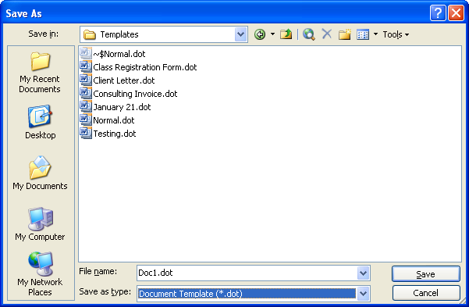
- When you need to edit the template, click on FILE, NEW.
- In the New Document Task Pane, select the ON MY COMPUTER hyperlink under TEMPLATES.
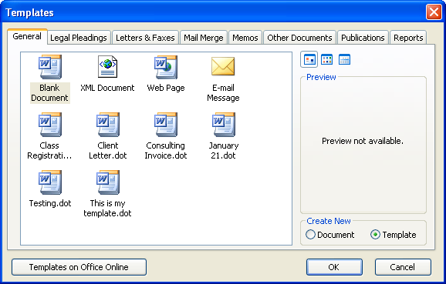
Template
- On the GENERAL Tab select the template you want to edit and click the TEMPLATE radio button.
- Click OK.
- Edit your template.
- To save your changes click FILE, SAVE AS. Name your template the exact same name as before. Click OK.
- When notified that the file already exists, click OK.
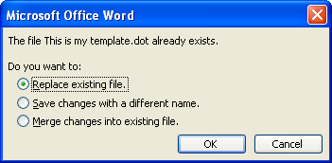

Keyboard Shortcuts

Press | To
CTRL+SHIFT+F | Change the font
CTRL+SHIFT+P | Change the font size
CTRL+SHIFT+> | Increase the font size
CTRL+SHIFT+< | Decrease the font size
CTRL+] | Increase the font size by 1 point
CTRL+[ | Decrease the font size by 1 point
CTRL+D | Font Dialog Box
SHIFT+F3 | Change the case of letters
CTRL+SHIFT+A | Format letters as all capitals
CTRL+B | Apply bold formatting
CTRL+U | Apply an underline
CTRL+SHIFT+W | Underline words but not spaces
CTRL+SHIFT+D | Double-underline text
CTRL+I | Apply italic formatting
CTRL+SHIFT+K | Format letters as small capitals
CTRL+1 | Single-space lines
CTRL+2 | Double-space lines
CTRL+5 | Set 1.5-line spacing
CTRL+E | Center a paragraph
CTRL+J | Justify a paragraph
CTRL+L | Left align a paragraph
CTRL+R | Right align a paragraph

Function Keys
Press | To
F1 | Get online Help or the Office Assistant
F2 | Move text or graphics
F3 | Insert an AutoText entry (after Word displays the entry)
F4 | Repeat the last action
F5 | Choose the GO TO command (EDIT menu)
F7 | Choose the SPELLING command (TOOLS menu)
F8 | Extend a selection
F9 | Update selected fields
F10 | Activate the menu bar
F12 | Choose the SAVE AS command (FILE menu)

SHIFT + Function Keys
Press | To
SHIFT+F1 | Start context-sensitive Help or reveal formatting
SHIFT+F2 | Copy text
SHIFT+F3 | Change the case of letters
SHIFT+F4 | Repeat a FIND or GO TO action
SHIFT+F5 | Move to a previous revision
SHIFT+F7 | Choose the THESAURUS command (TOOLS menu, LANGUAGE submenu)
SHIFT+F8 | Shrink a selection
SHIFT+F9 | Switch between a field code and its result
SHIFT+F10 | Display a shortcut menu
SHIFT+F12 | Choose the SAVE command (FILE menu)

