ADVANCED OUTLOOK 2003

Table of Contents

Page
LESSON 1: MANAGING YOUR MAILBOX LIMITS 1
♦ Understanding Mailbox Limits 1
♦ Setting AutoArchive 3
♦ AutoArchiving Your Folders 5
♦ Deleting Items Automatically 7
LESSON 2: E-MAIL 10
♦ Creating Distribution Lists 10
♦ Creating a Message to a Contact 13
♦ Creating Rules 16
♦ Changing and Deleting Rules 22
♦ Message Options 25
LESSON 3: CONTACTS 29
♦ Creating a Contact from an E-Mail you Receive 29
♦ Sharing a Distribution List 31
LESSON 4: CALENDAR 35
♦ Scheduling a Meeting 35
♦ Responding to a Meeting Request 40
♦ Checking the Status of Attendees 43
♦ Updating a Meeting 44
♦ Sharing Your Outlook Calendar 48
♦ Creating a Private Appointment 52
♦ Accessing Another User's Folder 53
♦ Calendar Options 55
LESSON 5: TASKS 58
♦ Creating and Viewing Categories for Tasks 58
LESSON 6: NOTES 64
♦ Saving a Note to Your Desktop 64
♦ Sending a Note in a Message 65
LESSON 7: GIVE IT A TRY! 67
LESSON 8: ADDITIONAL FEATURES 68
♦ Accessing Outlook Via The Internet 68
♦ Add Fields to Your Inbox 70
♦ Changing Your Outlook Password 71
♦ BIS AutoArchiving Policy and Procedure 74

This workbook may be reproduced in whole or in part by an employee of the Department of Health and Human Services. All other reproduction is prohibited unless written permission is obtained from the Training Institute.

MANAGING YOUR MAILBOX LIMITS

OBJECTIVES: Understand mailbox limits.
Set AutoArchive and AutoArchive folders.
Delete your Deleted Items folder automatically.

Understanding Mailbox Limits

OVERVIEW

Our mailbox sizes are limited to 50 MB, which requires us to keep our mail folders at a manageable size.

When your mailbox reaches:

- 35 MB – You will get a warning that your mailbox is getting full.
- 40 MB – You will not be able to send e-mail.
- 50 MB – You will not be able to receive e-mail.
Helpful Hint:

For additional information from the Bureau of Information Services, please refer to our Additional Features section in the back of this courseware.

The Bureau of Information Services runs a cleanup on the first Saturday of every month. This cleanup will:

- Delete all items older than 60 days from your Inbox and Sent Items folders.
- Send those items to your Deleted Items folder.
- Delete any items older than 30 days in your Deleted Items folder.

There are a number of techniques to keep your mailbox size at a reasonable level. When used together, you should have no problem keeping your e-mail account working well and below size limits.

STEPS

Every Day…

- After you read an e-mail and decide you no longer need it, delete it by using the delete button . It will now be in the Deleted Items folder.
- If you receive an e-mail with a file attached, open the file and save the file to your network drive or your local (C:\) drive, then delete the message.

- To return an item to its original folder from the DELETED ITEMS folder, click and drag the item to its corresponding folder in the Folder List. For example, if the item has a calendar icon in front, you would return it to the Calendar folder .
Weekly…

- Delete the items in your Sent Items folder by clicking on the SENT Items folder, selecting the Edit menu, then Select All, and then pressing the Delete key.
- After you have deleted your Sent Items, permanently delete your items in your Deleted Items folder by going to Tools, Empty “Deleted Items” Folder. You may also right click the DELETED ITEMS folder and select Empty “Deleted Items” Folder. You may choose to have these items deleted automatically when you exit Outlook (see Page 7 for instructions).
- To check your mailbox size, right click on Outlook Today in your Folder List. Select PROPERTIES and click the FOLDER SIZE button . Scroll through to see the individual folder sizes. Click CLOSE and OK when finished.

Setting AutoArchive

OVERVIEW

Outlook has a built-in feature called AutoArchive that helps manage Outlook folders. AutoArchive is on by default and can be scheduled to run automatically. When AutoArchive is run for the first time, Outlook automatically creates an archive file. Outlook also creates an Archive Folders folder in the Folder List. The Archive Folder maintain the existing structure in the Folder List. AutoArchive does not delete any folders from a Folder List even if they are empty.

STEPS
Options

- Click TOOLS, OPTIONS.
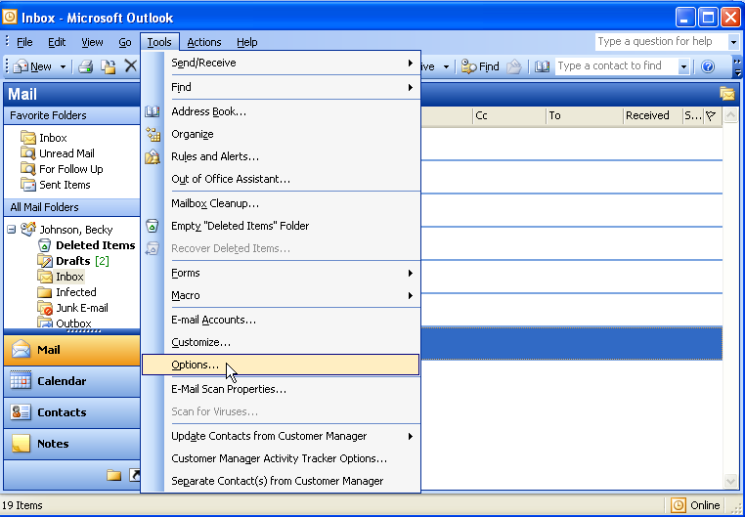
- Select OTHER.
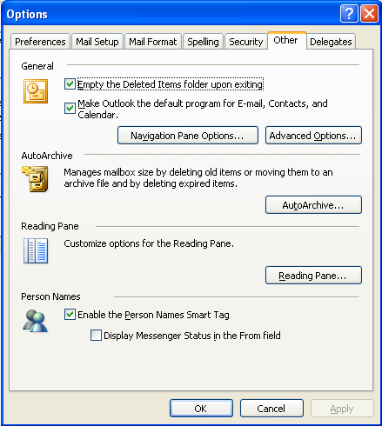
Other
- Click AUTOARCHIVE.
AutoArchive
- Place a check mark at Run AUTOARCHIVE EVERY and select the number of days you want AutoArchive to run.
Helpful Hint:

If you do not see a default archive file, please refer to our Additional Features section in the back of this courseware.
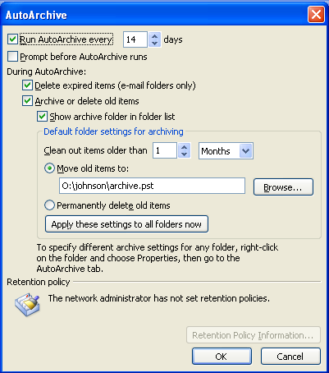
- Place a check mark at PROMPT BEFORE AUTOARCHIVE if you would like a notification before AutoArchive runs.
- Place a checkmark at DELETE EXPIRED ITEMS WHEN AUTOARCHIVING (E-MAIL FOLDERS ONLY).
- To apply these settings to all existing folders, click the APPLY THESE SETTINGS TO ALL FOLDERS NOW button.
- Click OK.

AutoArchiving Your Folders

OVERVIEW

You will want to AutoArchive your Inbox and any subfolder that you create there.

STEPS

- Right mouse click on the folder or subfolder.
- Select PROPERTIES.
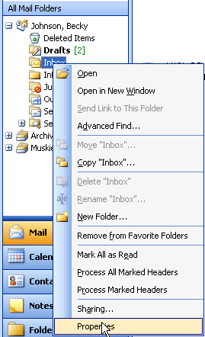
Properties

- Choose the AUTOARCHIVE tab.
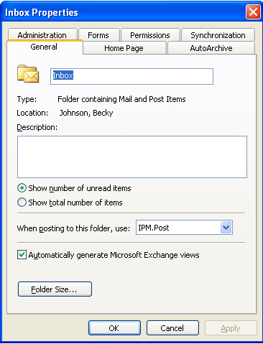
AutoArchive
Helpful Hint:

See the Additional Features section in the back of this courseware for information on setting up subfolders directly in your Archive folders.

- To archive based on default settings, click the radio button next to ARCHIVE ITEMS IN THIS FOLDER USING DEFAULT SETTINGS.
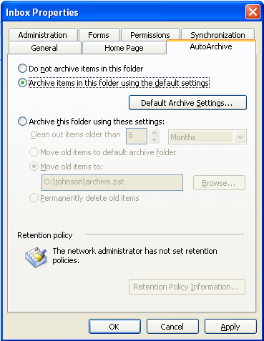
Archive using default settings
- To customize archive settings, click the radio button next to CLEAN OUT ITEMS OLDER THAN. Choose the number of DAYS, WEEKS, or MONTHS you want your items archived.
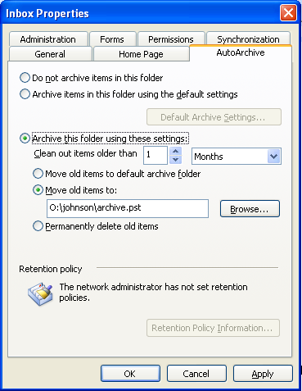
Customize Archive
- Click OK.
- You will be able to view your Archive Folders or your PERSONAL FOLDERS in your Folder List.
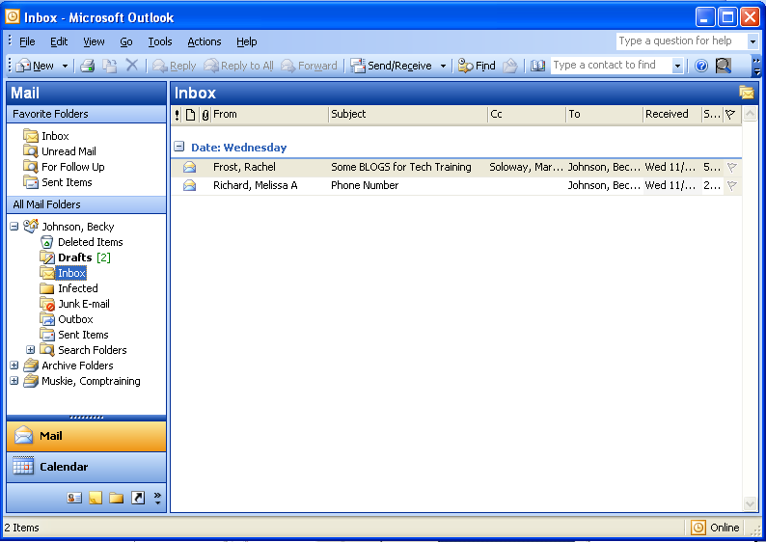
Archive Folder
Or
Personal Folder

Deleting Items Automatically

OVERVIEW

When you delete an item from a folder, it goes into your Deleted Items folder. The Deleted Items folder may be emptied automatically when you exit Outlook.

Steps
Options
- Click TOOLS, OPTIONS.
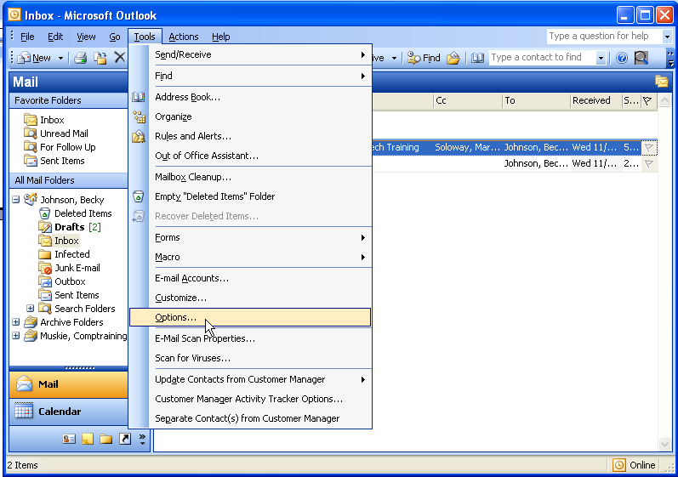

- Select OTHER.
Other

- Place a check mark at EMPTY THE DELETED ITEMS FOLDER UPON EXITING.
- Click OK.
- Lesson Example

You would like to clean out your entire mailbox account and ensure that you never lose any items older than one month.

STEPS

- Open Microsoft Outlook 2003. Your instructor will provide the password.
- Click Tools, Options, Other, AutoArchive.
- Set this to ARCHIVE EVERY 14 DAYS. Make sure that all of the boxes are checked and click OK.
- Click OK.
- Right-click your INBOX folder. Select Properties.
- Click AutoArchive.
- Click at ARCHIVE THIS FOLDER USING THESE SETTINGS.
- Change the CLEAN OUT ITEMS OLDER THAN to 30 days and select MOVE OLD ITEMS TO the default folder listed.
- Click OK.
- Right click your INBOX and click NEW FOLDER.
- Type Class in the NAME field and click OK.
- Right click the CLASS subfolder and select properties.
- Click AUTOARCHIVE.
- Click the radio button next to ARCHIVE ITEMS IN THIS FOLDER USING DEFAULT SETTINGS.

- Click OK.

EXERCISE:

1) Send two e-mails to your class participants.

2) Click your SENT ITEMS folder and delete all of the items.

3) Read and delete 2 e-mails in your INBOX.

4) Right click your DELETED ITEMS and select Empty “Deleted Items” Folder.

5) On Your Own: Create a new subfolder named Projects and set it up to AutoArchive every 30 days.

E-MAIL

objectives: Create distribution lists.

Create rules.
Apply message options.

Creating Distribution Lists

OVERVIEW

Do you often send out e-mail to the same group of individuals? Are you tired of having to find each name one by one every time? If so, creating a distribution list can save you time and reduce mistakes. A distribution list is a specific group of individual e-mail addresses stored together with one name and it is saved in your Contacts folder by default, where you have sole access.

STEPS

- Click FILE, NEW, DISTRIBUTION LIST.
Distribution List
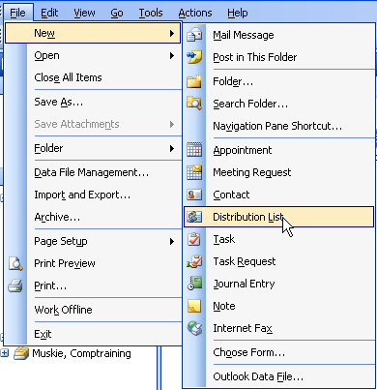
- Type a name for the group in the NAME box.
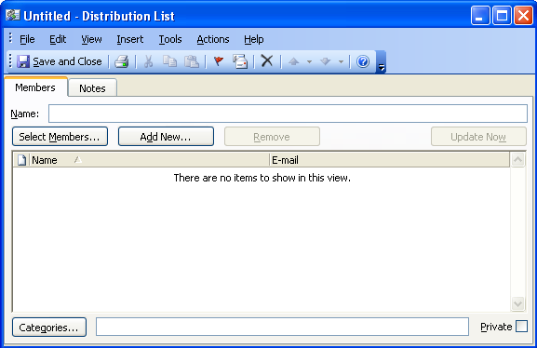
Select Members
Add New
Notes
Name
- Click the SELECT MEMBERS button.
- In the SHOW NAMES FROM THE list, click the address book that contains the e-mail addresses you want in your distribution list.
Global Address List
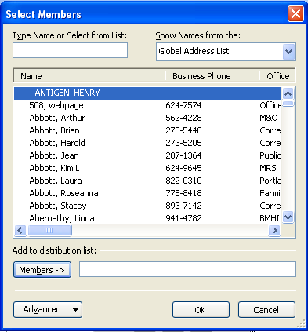
Type Name or Select from List
- In the TYPE NAME OR SELECT FROM LIST box, type a name you want to include. In the list below, select the name, and then click ADD.
- Click OK when finished.
- To add people who are not in the global address book or your contacts, click the ADD NEW button .
- Enter the DISPLAY NAME and E-MAIL ADDRESS. If you would like this person to be in your contacts, put a check mark at ADD TO CONTACTS.
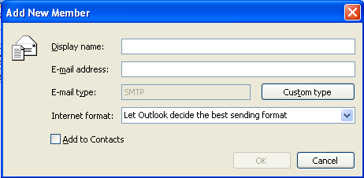
- Click OK.
- If you want to add a longer description of the distribution list, click the NOTES tab on the Distribution List window and then type the text.
- Click the SAVE AND CLOSE button .

Creating a Message to a Contact

STEPS
From the Inbox:
- Click the new mail message button .
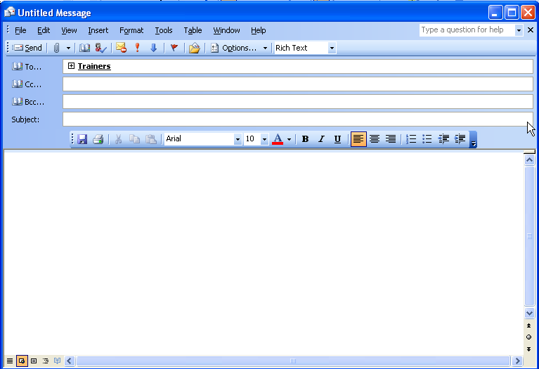
- Type the name of the contact into the to: field.
- In the SUBJECT box, type the subject of the message.
- In the text box, type the message.
- Click SEND .
From the Contacts folder:
- Right mouse click on the contact.
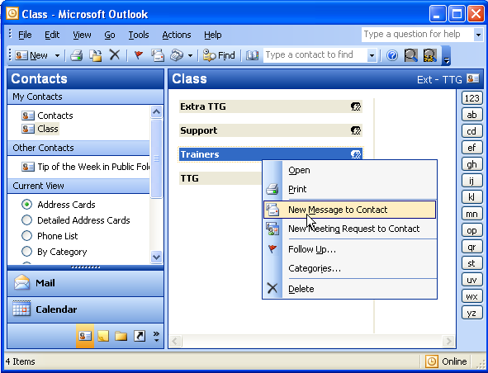
New Message to Contact
- Select NEW MESSAGE TO CONTACT.
- In the SUBJECT box, type the subject of the message.
- In the text box, type the message.
- Click SEND .
- Lesson Example

You would like to create a distribution list for your classmates to help in sending out e-mails to them.

STEPS

- Click on the FILE menu, select NEW, DISTRIBUTION LIST.
- Type the name (Your Name)’s Class in the NAME box.
- Click SELECT MEMBERS.
- In the SHOW NAMES FROM THE list, make sure it reads Global Address List. In the TYPE NAME OR SELECT FROM LIST box, type in Muskie. In the list below, select the class participants, and then click ADD.
- Click OK.
- Click the SAVE AND CLOSE button.
- Compose a new e-mail and address it to this group by typing (Your Name)’s Class in the To: field.
- Type (Your Name)’s Distribution List in the SUBJECT line. Notice how Outlook recognizes the group.
- Click Send.
- Go to the Contacts folder and right click on the (Your Name)’s Class contact.
- Select NEW MESSAGE TO CONTACT.
- Type Another Distribution List from (Your Name) in the Subject line.
- Click Send.

EXERCISE:

  - Create a new distribution list named (Your Name)’s Lunch Partners.
  - Add three of the class participants to this list.
  - On Your Own: Send an e-mail to this new distribution list.

Creating Rules

OVERVIEW

A rule is a set of conditions, actions, and exceptions that controls how Outlook processes and organizes messages. Examples of rules are:
- perform an action when a message arrives or before a message is sent,
- move incoming messages that satisfy certain conditions into a specific folder;
- be notified when certain messages arrive;
- automatically delete messages that satisfy certain conditions, and
- automatically reply to certain messages.

STEPS

- From the INBOX, select TOOLS, RULES AND ALERTS.
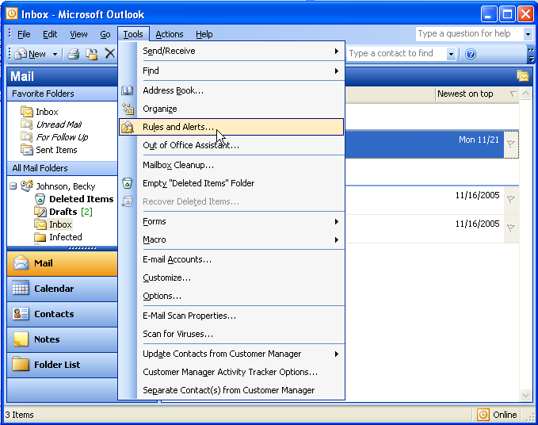
Rules and Alerts

- Click the NEW RULE… button.
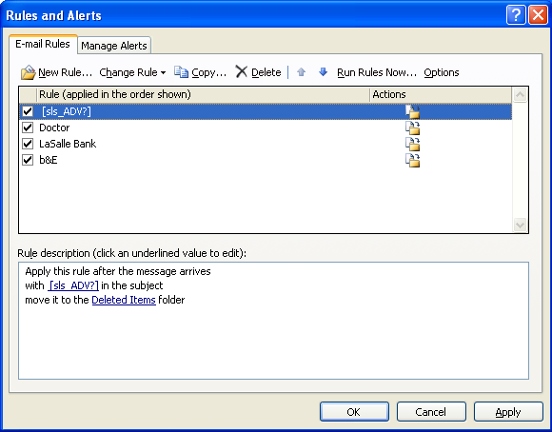
New Rule
- To create a rule from a template, click START CREATING RULE FROM A TEMPLATE.
- To create a blank rule, click START FROM A BLANK RULE.
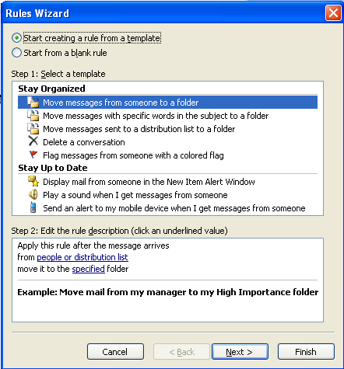
- Choose the desired option from either STAY ORGANIZED or STAY UP TO DATE.
- Click NEXT.
- Select one or more conditions from WHICH CONDITION (S) DO YOU WANT TO CHECK?
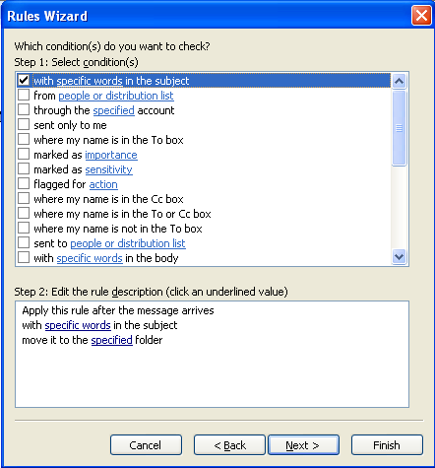
- Click on the underlined SPECIFIC WORDS under STEP 2: EDIT THE RULE DESCRIPTION.
- Click NEXT.
- Select an option from WHAT DO YOU WANT TO DO WITH THE MESSAGE?
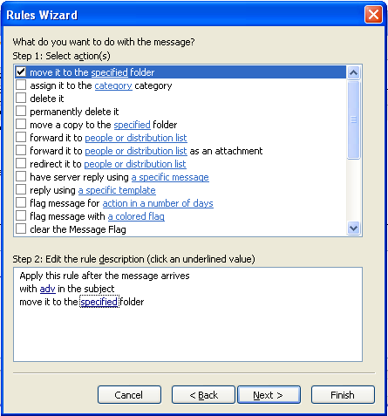

- Click on the underlined SPECIFIED under STEP 2: EDIT THE RULE DESCRIPTION to choose a specific folder.
- Click NEXT.
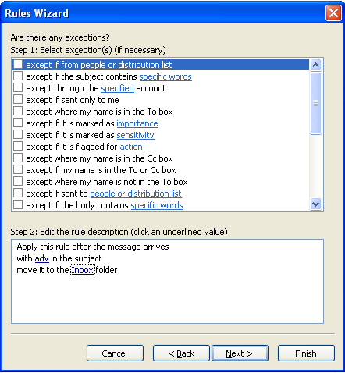
- Select exceptions (if needed) from SELECT EXCEPTION(S) (IF NECESSARY).
- Click NEXT.
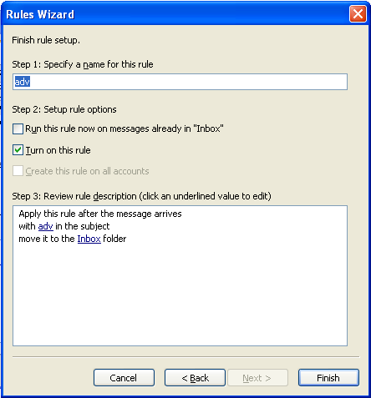
- Type a name for the rule in STEP 1: SPECIFY A NAME FOR THIS RULE.
- Click FINISH and OK.

Changing and Deleting Rules

OVERVIEW

You may change or delete any rules that you have previously created.

STEPS

- Select TOOLS, RULES AND ALERTS.
Rules and Alerts
- Select the rule you want to change or delete.
Change Rule
Delete

- To modify a rule, select the rule and click the CHANGE RULE button .
- Follow the directions outlined in the Creating Rules section.
- To delete a rule, select the rule and click the DELETE button .
- Click YES.
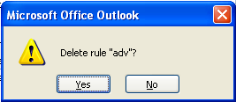
- Click OK.
- Lesson Example

You decide to set a rule to eliminate all the e-mail messages telling workers that the main printer is not working. You have your own printer, therefore, you don’t print to the main printer.

STEPS

- Click the INBOX in your Folder List. Click TOOLS, RULES AND ALERTS.
- Click the NEW RULE… button.
- Click START CREATING RULE FROM A TEMPLATE.
- Select Move messages WITH SPECIFIC WORDS IN THE SUBJECT.
- Click the NEXT button.
- Click specific words in the RULE DESCRIPTION.
- Type printer in ADD NEW.
- Click the ADD button and click OK.
- Click the NEXT button.
- Click specified in the RULE DESCRIPTION.
- Choose the Deleted Items folder and click OK.
- Click the NEXT button two times.
- Click FINISH and click OK.
- Create a new e-mail and address it to your Class distribution list. Put the word printer in the SUBJECT line. Send the message.
- Go to your Deleted Items folder to see if your rule worked correctly.
- Click TOOLS, RULES WIZARD.
- Make sure your printer rule is selected.
- Click the DELETE button.
- Click YES and click OK.
EXERCISE:
  - Click TOOLS, RULES WIZARD, and DELETE this rule.
  - Click YES and click OK.
  - On Your Own: Click TOOLS, RULES AND ALERTS, then NEW RULE.
  - Select Move messageS WITH SPECIFIC WORDS IN THE SUBJECT.
  - Click specific words and type in food in the kitchen.
  - Click ADD and click OK.
  - Click specified and select the Deleted Items folder.
  - Click OK and click NEXT.
  - Click NEXT three more times.
  - Click FINISH and click OK.
  - Send an e-mail to the class members using food in the kitchen in the SUBJECT line.
  - Check your INBOX and DELETED ITEMS to see if the rule worked.
  - Delete the rule.

Message Options

OVERVIEW

You may utilize one or many of Outlook’s message options: return receipts, voting buttons, expiration dates, etc.

STEPS

- Create a new e-mail by clicking on the New button .
- Click the OPTIONS button .
Options
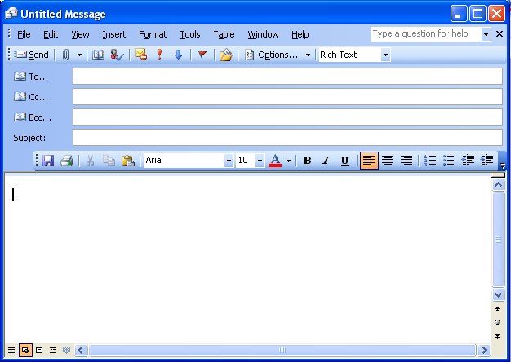

- To set importance for the message, click on Importance and select Low, Normal or high. High and Low importance are depicted with these symbols , respectively.
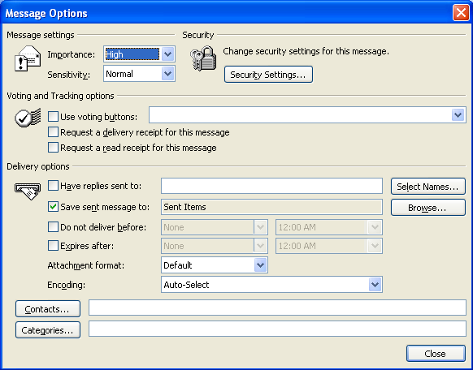
Importance
Voting and Tracking Options
Delivery Options
- To use voting buttons to get a quick response from recipients, put a check mark at Use Voting Buttons and select your choice from the drop-down list. When the message is received, it will appear as below and all a recipient has to do is click on one of the buttons to respond.
Did You Know?

You can customize what a voting button reads by typing in the text next to Voting Buttons and separating the button text with semicolons (;).
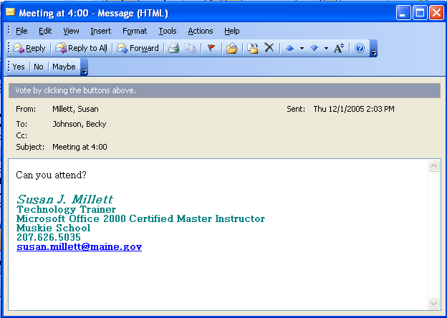
Yes, No, Maybe

- To receive a delivery receipt for this e-mail, select the option request a delivery receipt for this message.
- To receive a read receipt for this e-mail, select the option Request a read receipt for this message.
Did You Know?

To see a list of responses from your voting e-mail, go to your Sent Items, open the message, and click the Tracking tab.

- To send replies of this message to another person, select have replies sent to. Click the select names button , and pick the name from the Global Address List.
- To specify a delivery time for the e-mail, select DO NOT DELIVER BEFORE, choose the appropriate date and time from the drop down box.
- To set an expiration date for your e-mail (if you are dealing with time sensitive material), select Expires After and choose the appropriate date and time.
- Lesson Example

You would like to send an e-mail asking class participants to vote on a location for an upcoming meeting.

STEPS

- Create a new e-mail to all class participants and make the subject line read This is (Your Name)’s test for group meeting place options.
- Type the following in the body of the message: We need to decide on a location for our meetings. Please use the voting buttons above to cast your vote.
- Click the Options button.
- Put a check by Use Voting Buttons.
- Edit the voting buttons by typing The Augusta Civic Center; The Bangor Auditorium; The Lewiston Ramada.
- Click the Close button.
- Click Send.
- When you receive the message in your Inbox, respond to one of the class participants by using a voting button of your choice.
- Choose to SEND THE RESPONSE NOW and click OK.

EXERCISE:

- Create a new message to every class participant.
- Type This is a Delivery Receipt Message as your SUBJECT.
- Go to options and apply Request a delivery Receipt for This Message.
- Close the window and send the message.
- Watch your Inbox to receive a Delivery Receipt.
- On Your Own: Create a new e-mail and send it to all participants.
- Give it the subject of There is cake in the kitchen.
- Go to options and apply Expires after.
- Select (Today’s Date) from the drop-down box and edit the time so that it is 10 minutes from now.
- Close the window and send the message.

CONTACTS

objectives: Create a contact from an e-mail you receive.
Share a distribution list.

Creating a Contact from an E-Mail you Receive
Did You Know?

You can also create a contact from an e-mail as long as the person was also a recipient of the e-mail and is listed in the To: or CC: field.

STEPS

- Open the e-mail message that contains the name you want to add to your contact list.
- Right mouse click on the name in FROM field. Click ADD TO OUTLOOK CONTACTS on the shortcut menu.
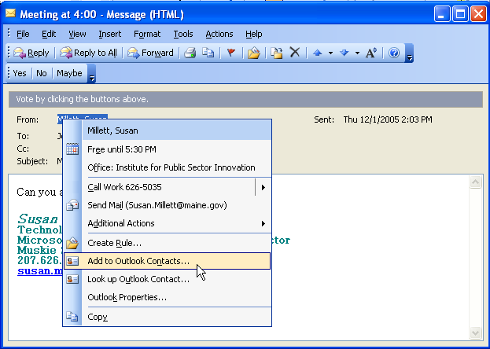
Add to Contacts
- Fill out the New Contact window.
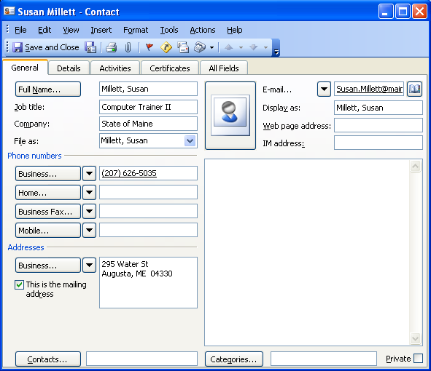
Save and Close
- Click save and close when finished.

Sharing a Distribution List

OVERVIEW

You may want to share your distribution list or other contacts with co-workers, or you may want them to share with you.

STEPS

To share a contact or a distribution list:
- Create an e-mail.
- Click Insert, ITEM or if you use Word as your e-mail editor, click the drop-down arrow next to the Insert File button and click insert item.
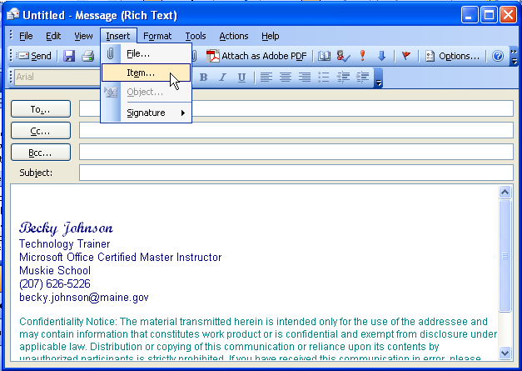
Item
- Select Contacts from look in and choose the contact in items.
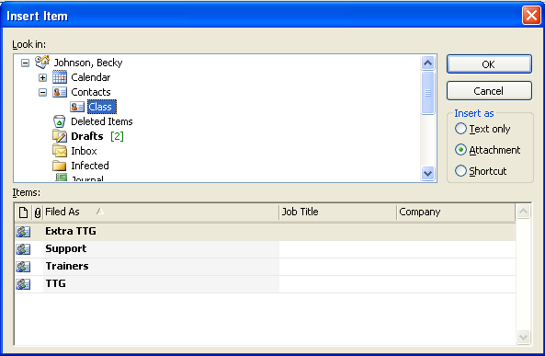
Contacts
- Click ok.
- Click SEND to send the e-mail.
To receive a contact:
- Open the e-mail message that contains the contact information.
Restore Down
- Click the restore down button .
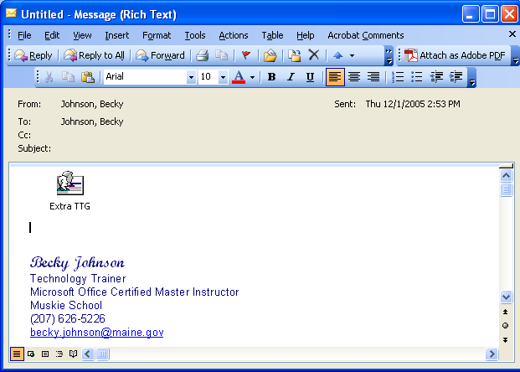
- Drag the object from the e-mail message and drop it into your Contacts folder.
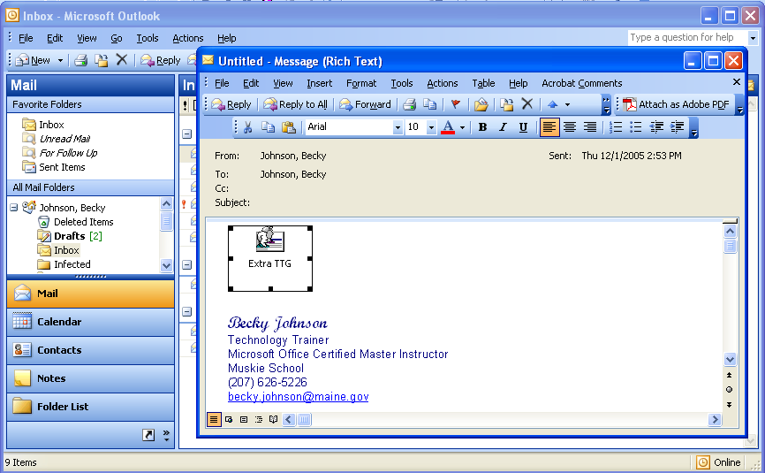

- Lesson Example

You are going to create a contact from an e-mail. You are also going to share a distribution list.

STEPS

  - Click INBOX from your Folder List.
  - Right mouse click the e-mail from External Contact.
  - Click ADD TO CONTACTS.
  - Click CONTACTS from your Folder List, and make sure External Contact is now in your contact list.
  - Prepare an e-mail to your instructor.
  - Type (Your Name)’s Lunch Partners Distribution List in the subject line.
  - Click insert, item.
  - Select Contacts in Look in, and select the (Your Name)’s Lunch Partners distribution list.
  - Click OK and click send.
  - Open an e-mail with Lunch Partners Distribution List in the subject line.
  - Click the restore down button.
  - Drag the Lunch Partners distribution list into your Contacts folder.
EXERCISE:

- Prepare a new e-mail to your class participants with (Your Name)’s Class Distribution List as the subject.
- Insert your distribution list named (Your Name)’s Class.
- Send the message.
- On Your Own: Open an e-mail with Class Distribution List in the subject line. Save this in your Contacts folder.

CALENDAR

objectives: Schedule a meeting.
Respond to a meeting request.
Check the status of meeting attendees.
Update and cancel meetings.
Share your calendar.
Create a private appointment.
Access another user’s calendar.
Utilize calendar options.

Scheduling a Meeting

OVERVIEW

One of the most helpful features of Outlook is the ability to schedule a meeting and invite participants to attend via e-mail. In addition, if the participants are members of your organization who use Outlook, you can identify a time for the meeting when your desired attendees are free.

STEPS
Did You Know?

You can also select attendees by clicking TO: and then check their schedules by clicking ATTENDEE AVAILABILITY.
- Add your meeting just as you would an appointment.
- Click on the Invite Attendees button .
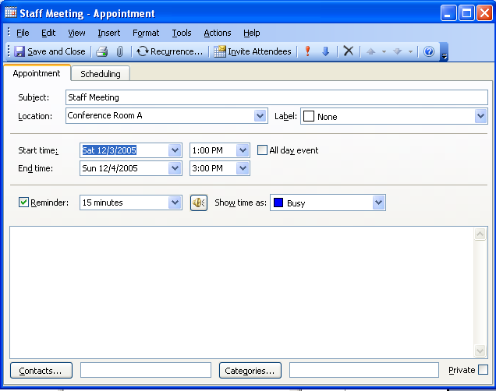
Invite Attendees
- Your screen will now look like a combination of an appointment window and an e-mail window.
- Click the TO. . . button to get the select names window where you can choose from either the Global Address List or your list of contacts (use the drop down arrow for your list choices in Show Names From The: box).
Did You Know?

You can color code your appointments by clicking the dropdown arrow next to LABEL.
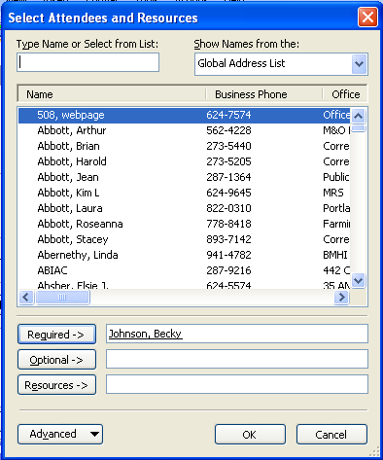
Show Names From The drop-down list
Type Name
Did You Know?

The Global Address List lists everyone that works for the State. Your department may have distribution lists set up in the Show Names From The drop-down menu.

- Select names to send into the appropriate fields:
  - Required is used for people that are required to attend the meeting.
  - optional is used for people that may or may not choose to attend the meeting.
  - Resources is used for scheduling meeting items, like conference rooms.
- Click OK.
- Click the SCHEDULING tab .
- Outlook will return you to the SCHEDULING screen where it will display a color-coded version of each attendee's schedule. This allows you to determine if the meeting is scheduled for an appropriate time. If not, use the AUTOPICK ARROWS to find a time that is good for everyone, either before or after the currently scheduled time.
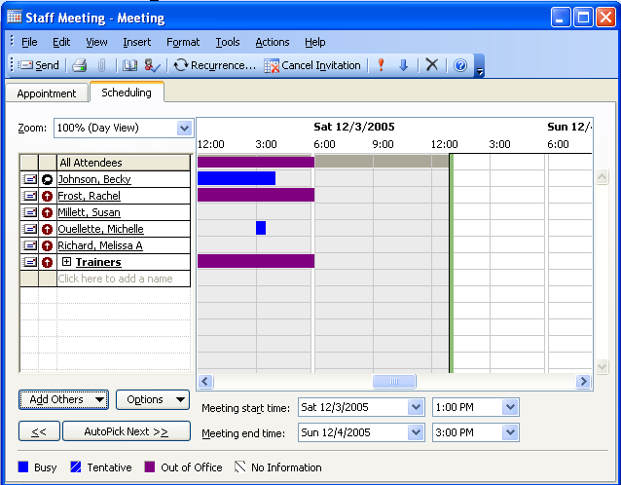
- When satisfied with the time, click the SEND button . This will send an e-mail message to all invitee, and the meeting will be scheduled in your Calendar.
- If you are using a Distribution List for attendees, you will need to click the sign to expand the list to check on their availability on an individual basis.
Expand the List

- Lesson Example

You have decided to invite some people to meet with you.

STEPS

  - Click CALENDAR in the Folder List.
  - Create an appointment for next Monday. This will be a (Your Name)’s Staff Meeting that begins at the time your instructor assigns you.
- Click INVITE ATTENDEES.
- Type in (Your Name)’s Class in the TO… line.
- Click the SCHEDULING tab.
- Expand the distribution list by clicking on the sign to see a color-coded version of each attendee's schedule, and click OK. This allows you to determine if the meeting is scheduled for an appropriate time. If it is not, use the AUTOPICK ARROWS NEXT to find a time that is good for everyone.
- When satisfied with the time, click the SEND button. This will send an e-mail message to all invitee, and the meeting will be scheduled in your Calendar.
EXERCISE:

1) Create a (Your Name)’s Lunch Meeting for next Friday.
2) Invite your instructor and two class attendees to the meeting by clicking on Invite Attendees.
3) Choose a time that is free for everyone by using AutoPick and then click Send.
  - On Your Own: Create an all day Staff Retreat and invite all of the class participants.
  - Use AutoPick to choose a time that is convenient for everyone.
  - SEND the meeting request.

Responding to a Meeting Request

overview

When you receive a meeting request from an individual, Outlook makes it very easy to respond to them.
Did You Know?

If you select DON’T SEND A RESPONSE, the host will not have the ability to see your status and will not know if they should expect your attendance.

STEPS

- Open the meeting request (depicted with the symbol in front of it) by double-clicking it. It will look like this:

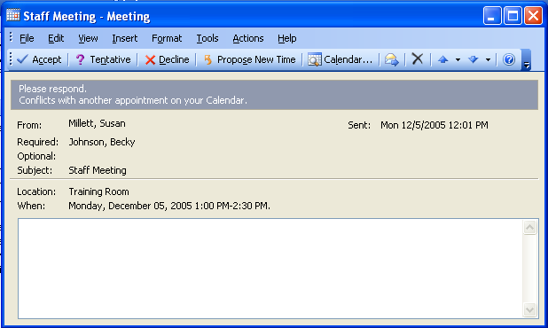
Accept, Tentative, Decline

- When you receive an e-mail inviting you to a meeting, you can choose an ACCEPT, DECLINE, or TENTATIVE response by clicking on the appropriate button. You may edit the response to inform the meeting host of any extra information.

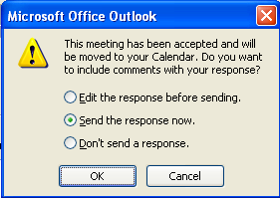

- To suggest a different meeting time, click the PROPOSE NEW TIME button.
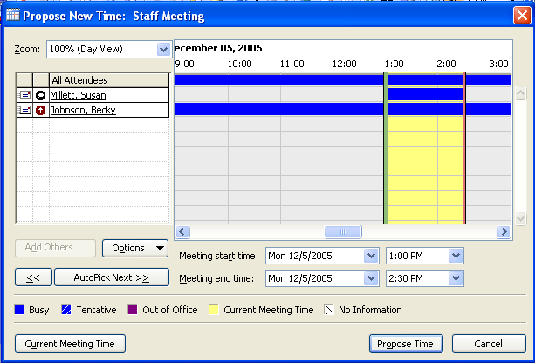
- Click the AUTOPICK NEXT button to choose the next time where all attendees appear to be available.
- Click the PROPOSE TIME button .
- If you accept the meeting, it will automatically be entered in your calendar.

- Lesson Example

You have received some meeting requests from people, and you would like to respond to them.

STEPS

1. Click INBOX in the Folder List.
2. Open the earliest meeting request by double-clicking it.
- Choose to accept the meeting request by clicking the accept button.
- Click SEND THE RESPONSE NOW and click OK.
- Click CALENDAR in your Folder List and notice that Outlook has automatically updated your calendar with the meeting.
EXERCISE:

1) Open another meeting request in your INBOX.
2) Decline the meeting request and choose to Edit the Response Before Sending.
3) Type I apologize for not being able to attend your meeting, I have another meeting taking place at this time in the message window and click Send.
4) On Your Own: Open up another meeting request and this time, give a tentative response. Let the person know the reason why your response is tentative.

Checking the Status of Attendees

overview

When a meeting invitee sends you a response, you will know immediately whether they have accepted your invitation; but Outlook makes it easy to keep track of attendee responses so that you do not have to save their response e-mails. Attendee responses will be one of three things:

Attendee has accepted meeting request.
Attendee has tentatively accepted meeting request.
Attendee has declined meeting request.

To check attendee status after deleting the individual responses, follow the instructions below.

STEPS

- Double-click the meeting in your Calendar.
- Click on the TRACKING tab .
- All invitees will be listed as well as their response to the meeting.
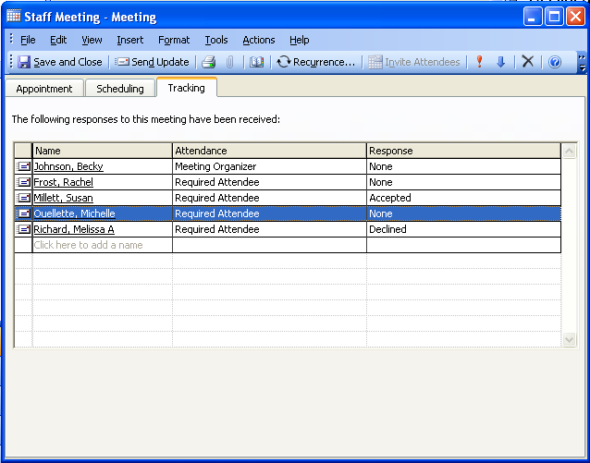

Updating a Meeting

overview

You may need to update your meeting after you have scheduled it. You may want to change the date and time. You might even need to cancel the meeting all together.

STEPS

To Update a Meeting:

- Double-click the meeting in your Calendar.
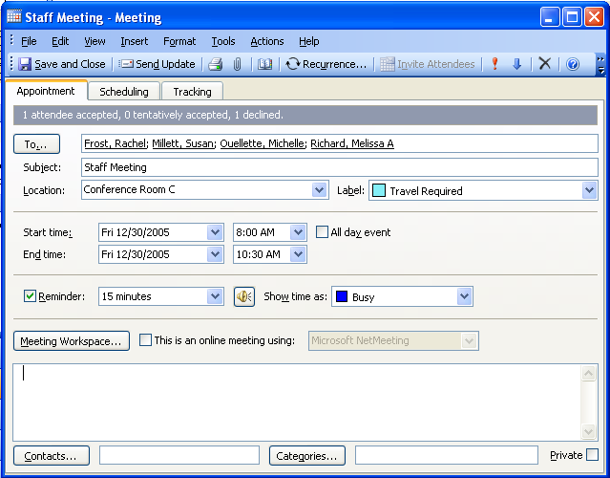

- Make any changes necessary for the meeting.
- Click the SEND UPDATE button . If you do not see the SEND UPDATE button, maximize the window.
- The attendees will receive an e-mail notifying them of a meeting update.
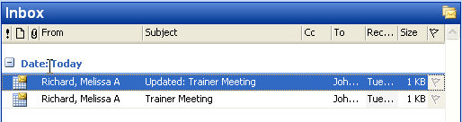

- When they open the e-mail, they will need to respond by clicking one of the ACCEPT, TENTATIVE, or DECLINE buttons.
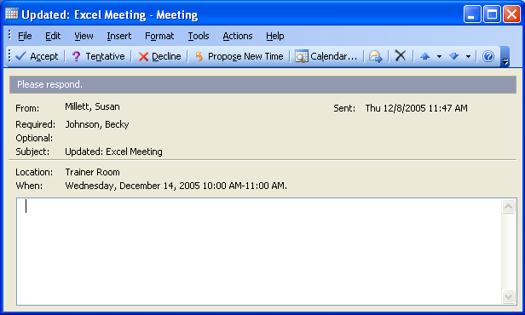

- They will have the opportunity to EDIT THE RESPONSE BEFORE SENDING, SEND THE RESPONSE NOW, or DON’T SEND A RESPONSE.
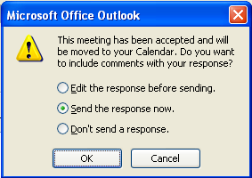

- The appointment appears as Updated in their Calendar.
To Cancel a Meeting:
- Select the meeting you created in your Calendar and press the delete button .
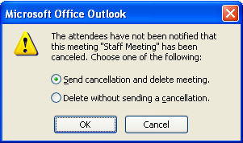
- You may choose to either SEND CANCELLATION AND DELETE MEETING or DELETE WITHOUT SENDING A CANCELLATION.
- Click OK.
- If you choose to send a cancellation, the attendees will receive an e-mail notifying them of a Meeting Cancellation and the meeting will be removed from their Calendar. If you do not send a cancellation, the meeting will not be deleted form the attendees’ calendars.

- Lesson Example

You would like to review the attendee status for your meeting then change the time of the meeting.

STEPS

    - Open and review all meeting responses in your Inbox. Delete them when you are done.
    - Go to the CALENDAR.
- Open the (Your Name) Staff Meeting and check the status of your attendees by clicking the TRACKING tab.
- Go back to the APPOINTMENT tab and make the meeting last a half hour longer than originally planned (Hint: Change the end time).
- Click the send update button to redistribute invitations with the updated information. If you do not see the SEND UPDATE button, maximize the window.
EXERCISE:

  - Open your Lunch Meeting appointment and view the attendee status.
  - Go back to the APPOINTMENT tab and click the delete button.
  - Choose SEND CANCELLATION AND DELETE MEETING.
  - Click the SEND button.
  - On Your Own: Open the Staff Retreat appointment and delete it. Send a cancellation to the attendees.

Sharing Your Outlook Calendar

OVERVIEW

You may allow other people to view, add to, or edit one or more of your Outlook folders by adding them as a delegate.

STEPS

- To add a delegate to a single folder, click on CALENDAR in the folder list.
- Click SHARE MY CALENDAR.
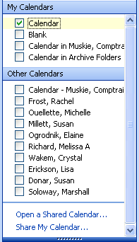
Share my Calendar
- Click the ADD button .
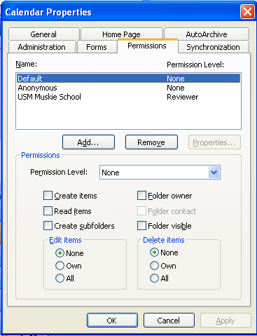
Add
- Type the beginning of the user's last name until she/he appears on the list. Select the delegate and click the ADD button Repeat these steps for any additional delegates, if necessary, and click OK.
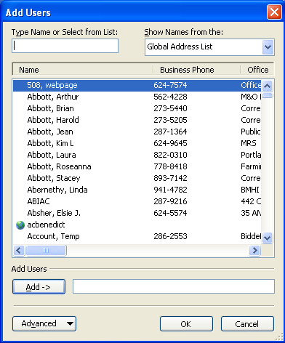
- Select a delegate in the Name box. Choose the desired Role from the drop-down list.
- To customize this role, click on the check boxes and radio buttons you wish to activate or turn off.
- Repeat Steps 4-6 for any other delegates. Click OK.
- To add a delegate to multiple folders, from the TOOLS menu, choose OPTIONS. Click the DELEGATES tab.
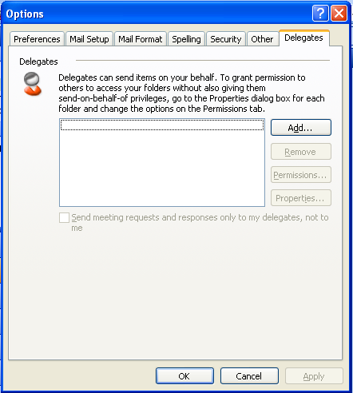
Delegates
- Click the ADD button and select the delegate(s) you wish to add. Click OK.
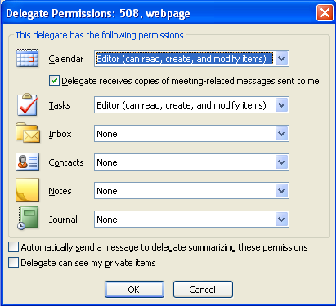
- Select the appropriate level of access for each folder from the drop-down list. Click OK.
- Indicate whether you wish the delegate to receive an e-mail outlining the permissions you have assigned to him/her, and if you want to allow him/her to read those items marked private. Click OK.

Creating a Private Appointment

OVERVIEW

Now that you have given access to your calendar, you may want to make some of your appointments “private.” This will allow others to see that your time is busy, but they will not know the details of your appointment.

STEPS

- Create your appointment.
- Click the PRIVATE check box in the appointment window.
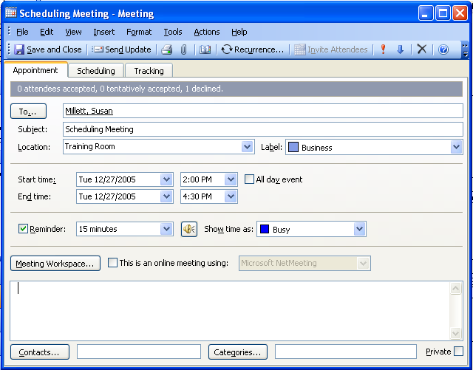
Private
- Click SAVE AND CLOSE .
- When another person views this appointment, they will see the following window.
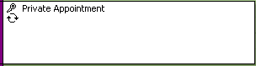

Accessing Another User's Folder

OVERVIEW

Once you have been given permission to open another user's calendar, you may open it at any time.

STEPS

- Click Calendar on the folder list.
- Click OPEN A SHARED CALENDAR.
Open a Shared Calendar…

- Click the Name button to open the Global Address List, select the name, and click OK, or simply type the name in the text box next to the Name button. Click OK.
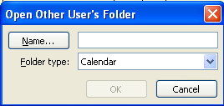
- Once you have opened the folder, the person's name now appears under OTHER CALENDARS.
- Lesson Example

You would like the instructor to have access to your calendar, and you would like to view the instructor’s calendar.

STEPS

      - Right click Calendar from the Folder List and choose PROPERTIES.
      - Click the PERMISSIONS tab and click the ADD button.
      - Select your instructor’s ID in the TYPE NAME OR SELECT FROM LIST, and click the ADD button.
      - Click OK.
      - Choose the ROLE of Reviewer from the drop-down list and click OK.
      - Create a new appointment for next Thursday at 11:30 a.m. This will be a private doctor appointment.
      - Click the SAVE AND CLOSE button.

EXERCISE:

1) Click File, Open, and Other User's Folder.
2) Click the NAME button and select your instructor.
3) Click ok two times.
4) View the instructor’s calendar and close it.
5) On Your Own: Remove the permissions you previously assigned to the instructor.

Calendar Options

OVERVIEW

You may wish to customize the appearance of your Outlook Calendar. You can set a default reminder for all of your appointments, you can change the color or your calendar, and you can set your Free/Busy options.

Steps

- Click TOOLS, OPTIONS.
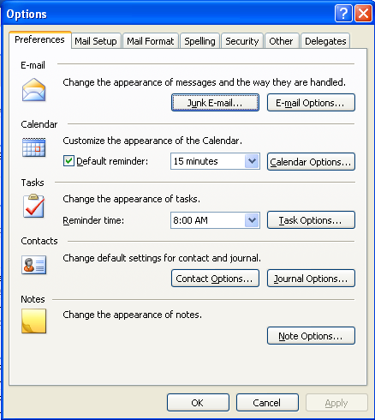
Calendar Options
Default Reminder

- If want a default reminder on all of your calendar events, place a check mark at default reminder and adjust the amount of minutes if necessary.
- Click CALENDAR OPTIONS to view more choices.
- You may adjust your CALENDAR WORK WEEK by checking the appropriate boxes.
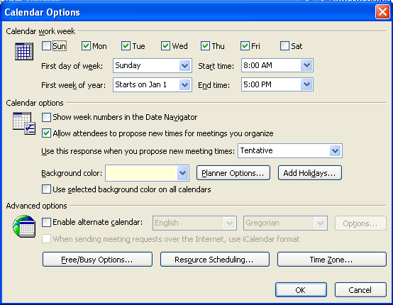
Calendar Work Week
Background Color
Free/Busy Options
Time Zone

- You may change your BACKGROUND COLOR, TIME ZONE, and ADD HOLIDAYS.
- Click the FREE/BUSY OPTIONS button to allow others to look at your calendar to schedule a meeting.
- Lesson Example

You would like to put a reminder on all of your appointments.

STEPS

- Click TOOLS, OPTIONS.
- On the PREFERENCE tab, put a check mark at default reminder and change the time to 10 minutes.
EXERCISE:

- Click the CALENDAR OPTIONS button.
- Change the BACKGROUND COLOR to blue.
- On Your Own: Change your FREE/BUSY OPTIONS to 3 months.

TASKS

OBJECTIVE: Create and view categories for tasks.

Creating and Viewing Categories for Tasks

OVERVIEW

Outlook allows you to assign categories for tasks as well as for other folder items. After you have assigned a task a category, you are able to view the tasks by that category.

STEPS
- Click Tasks 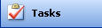 in your Folder List.
- Click the NEW TASK button .
- Create the task by filling in the subject, due date, start date, and priority. You may type instructions in the text box.
- Click the CATEGORIES button .
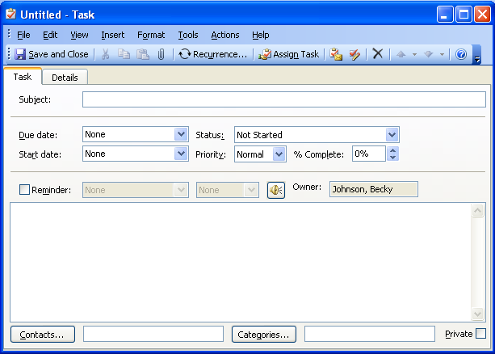
Categories
- Scroll through the AVAILABLE CATEGORIES and put a check by the category to which you wish to assign the task.
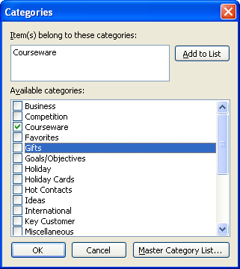
Available Categories
Master Category List
Add To List

- Click OK. Click the SAVE AND CLOSE button .
- You may create your own category by typing in the ITEM(S) BELONG TO THESE CATEGORIES: section.
- Type in the NEW CATEGORY name and click the ADD TO LIST button .
- Put a check mark beside the new category you created and click OK.
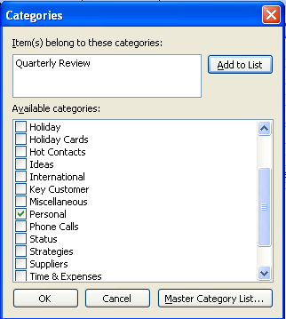
- Click the SAVE AND CLOSE button .
- To delete the category, click the MASTER CATEGORY LIST… button .
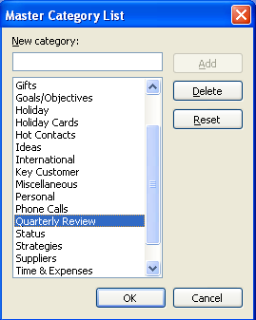
- Click on the category that you want to delete.
- Click the DELETE button and then OK.
- To view your task by categories, click BY CATEGORY on the Folder List.
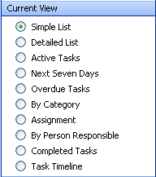
By Category

- Click the plus sign beside a category to view the tasks assigned to it.
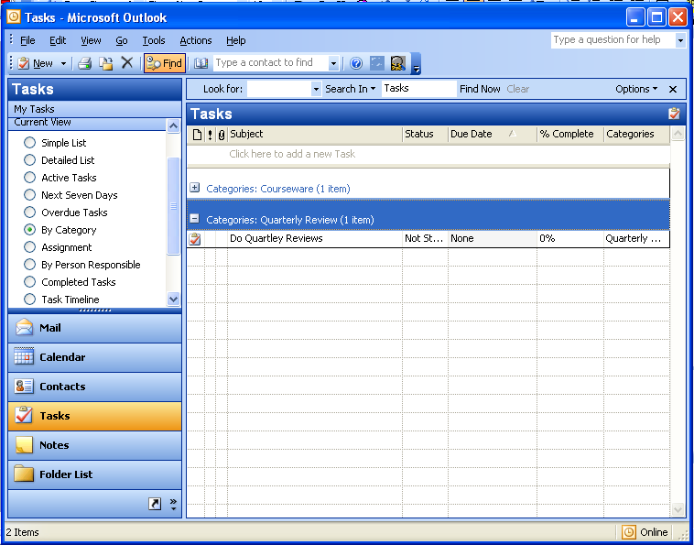
Categories

- Lesson Example

You would like to organize your task list.

STEPS

- Click the NEW TASK button.
- Type Baker Report in the SUBJECT line.
- Assign this task a DUE DATE three weeks from today.
- Click the categories button.
- Type Reports in the ITEM(S) BELONG TO THESE CATEGORIES: section.
- Click the add TO LIST button.
- Scroll through the available categories and make sure that there is a check mark by Reports.

- Click OK.
- Click the SAVE AND CLOSE button.
- Create another new task with Smith Report as the SUBJECT. This report will be due next Friday.
- Click CATEGORIES and put a check mark by Reports.
- Click OK, and SAVE AND CLOSE.
- Click view, current view, and put a check mark BY category.
- Click the plus sign by Reports to view your two tasks.

EXERCISE:

- Create a new task titled Call Turner for new prices. This task will be due two weeks from today.
- Assign this task the CATEGORY of Suppliers.

- Click the MASTER CATEGORY LIST… button and delete your Reports category.

- Click OK two times and click SAVE AND CLOSE.

- On Your Own: Change your current view to SIMPLE LIST.

NOTES

OBJECTIVES: Save a note on your desktop.
Attach a note to an e-mail message.

OVERVIEW

Although notes are saved in their own folder, you may want to put them on your desktop. You can also attach them to an e-mail message.

Saving a Note to Your Desktop

STEPS

- Click Notes in your Folder List.
- Double click in the white section of the window or click the NEW button .
- Type your note and click the CLOSE button .
- Click the restore down button so you can see your desktop.
- Select the note and drag it to your desktop.
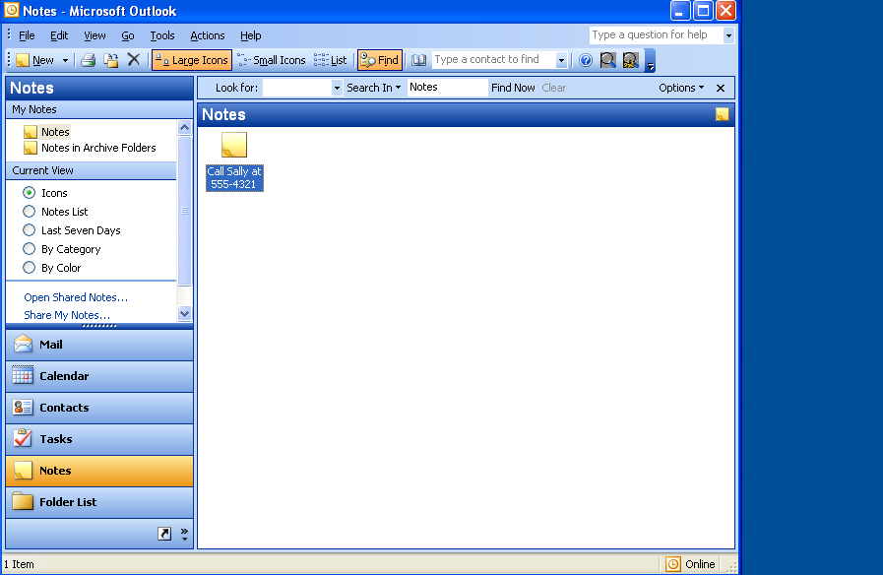
Desktop

Sending a Note in a Message

STEPS

- Prepare an e-mail message.
- Click INSERT, ITEM.
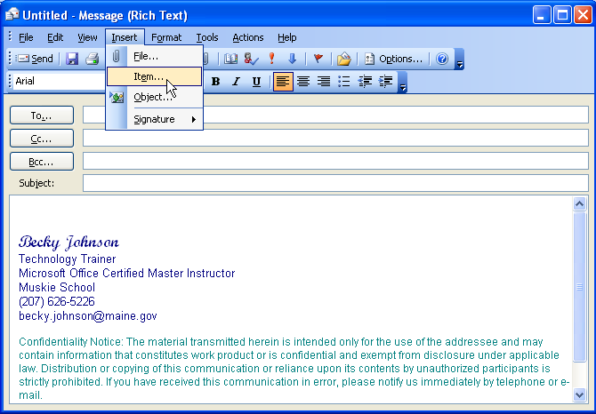
Item
- Select Notes in the LOOK IN section and select the note you want to attach.
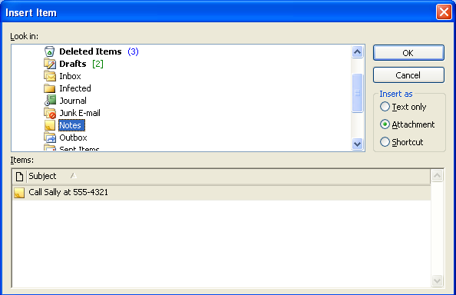
Notes
- Click OK .
- When receiving a note, if you choose to put it in your NOTES folder, restore the window and click and drag the note to your NOTES folder.

- Lesson Example

In an effort to reduce the sticky note mayhem at your workstation, you decide to use Outlook notes. You also want to send a note to another student.

STEPS

- Click NOTES in the Folder List.
- Double-click on the white space. Type Call Sally at 555-4321.
- Click the CLOSE button.
- Click the RESTORE DOWN button on the Outlook window.
- Drag the note to your Desktop.
- Click the maximize button to restore your window to its original size.
- Prepare an e-mail to your instructor with (Your Name)’s Note in the SUBJECT line.
- Click INSERT, ITEM. Choose Notes in the LOOK IN section and select the note you previously created.
- Click OK.
- Click SEND.
EXERCISE:

  - Minimize the Outlook window and select the note.
  - Press DELETE on the keyboard. Click YES to send the note to the Recycle Bin.
  - On Your Own: Maximize Outlook and create a new note titled Kickboxing on Tuesdays and Thursdays at 5:30

- Send this note to your instructor.

GIVE IT A TRY!

OBJECTIVE: Practice Outlook features learned in class.

EXERCISE:
Refer to Lesson 1 for assistance
- Create a new folder in your Inbox named Training.
- Set up this folder to AutoArchive. Set it to: clean out items after 1 month and move them to the default location.
Refer to Lesson 2 for assistance
- Create a new rule to move all messages from your instructor into the folder named Training.
- Delete this new rule.
Refer to Lesson 3 for assistance
- Open any e-mail and create a Contact from the message.
- Send an e-mail to this contact.
Refer to Lesson 4 for assistance
- Schedule a Staff Meeting with the class participants for next Monday at 9:00 a.m. Make sure everyone is available. If not, use the AUTOPICK button. Send the message.
- Update this meeting to begin at 10:00 a.m.
- Change the color of the calendar to yellow and turn off the reminders.
Refer to Lesson 5 for assistance
- Create a task to Update Training Calendar and assign a category.
Refer to Lesson 6 for assistance
- Create a note to Water the office plants and send this note to your instructor.

ADDITIONAL FEATURES

Objectives: Access Outlook via the internet.
Change your Outlook password.
View the Bureau of Information Services AutoArchiving policy.

Accessing Outlook Via The Internet

OVERVIEW

If your job requires you to be out of the office, you may be missing important information sent to you via e-mail. If you are connected to the State of Maine’s Wide Area Network (i.e. you are at another office and working at a different State PC than your own) you can simply follow the steps below. If you are not connected to the State’s Wide Area Network, you will need to have a Secure ID.
Helpful Hint:

If you intend to access Outlook from the same machine frequently, you may want to bookmark the site so you will not need to type it in each time.

STEPS

- Connect to the internet.
- Type in the address https://sommail.state.me.us/exchange.
- Next, you may see a Security Alert dialog box. Click OK.
- On the Outlook Web Access screen, type your domain and your name in the format som/First.Last in the DOMAIN/USER NAME area. Press TAB on your keyboard and type in your Outlook password.
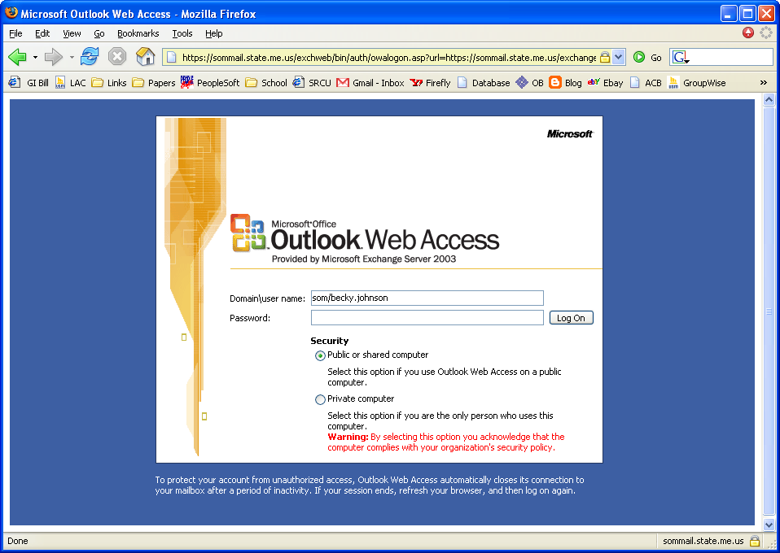
- Click the LOG ON button .

- Web Access Outlook looks somewhat different than at your desk. It will not have all the same functionality. For instance, you will not be able to access your archive folders using the web.
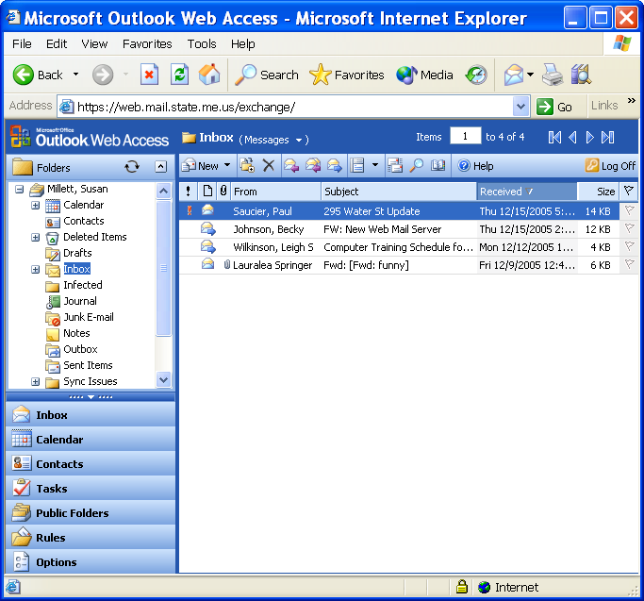

Add Fields to Your Inbox

OVERVIEW

You may want to see different properties for your mailbox.

STEPS
Field Chooser
- Right click your Inbox column heading.

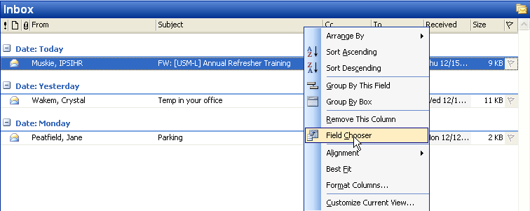
Column Headings

- Select FIELD CHOOSER.

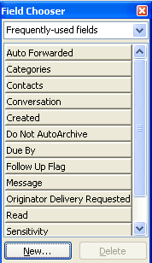

- Click on your selection and drag it up to Inbox column heading.

Changing Your Outlook Password

OVERVIEW

It is a good idea to change your password to access Outlook on a regular basis

STEPS

- Click TOOLS, OPTIONS.
- Click the OTHER tab and select advanced options.
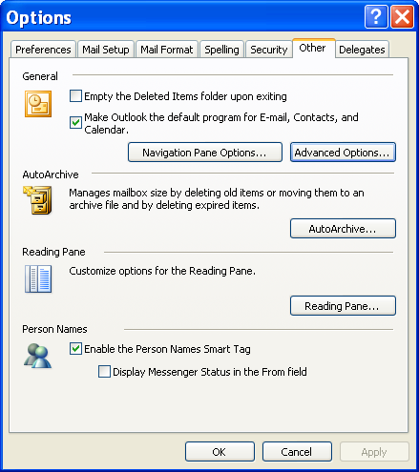
Other
Advanced Options

- Click CUSTOM FORMS.

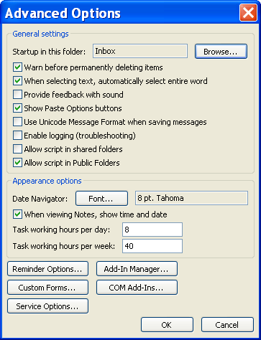
Custom Forms

- Click PASSWORD.
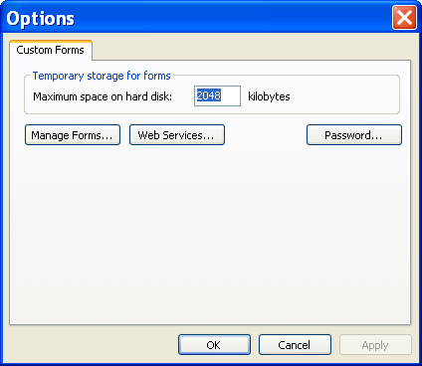
Password

- Enter your USERNAME, DOMAIN, OLD PASSWORD, NEW PASSWORD, and CONFIRM NEW PASSWORD.

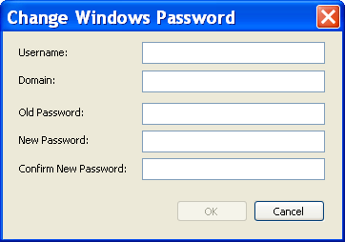

- If you do not know your domain name, check with your LAN administrator.

- Click OK.

BIS AutoArchiving Policy and Procedure

Bureau of Information Services
Outlook Auto-Archiving and the Mailbox Cleanup Procedure
April 2, 2002

            - Create a new folder called Archive (see network administrator to find out which drive you should be storing your archives on)
- Double click My Computer
- Double click appropriate drive letter
- Right click once in window on blank space
- Left click once on New
- Left click once on Folder
- Type in Archive beside newly created folder
- Left click once in window on blank space
- Close all windows

            - Double click on Outlook icon
- left click once on Tools, then Services
- left click once on the Add button
- in the Add Service to Profile window, scroll to find Personal Folder and left click once to highlight
- left click once on OK
- under the Create/Open Personal Folders File window left click once on down arrow beside the Look In window and find drive (c: or network drive) where you created your Archive folder and double click on the Archive folder
- in the File Name window type in archive.pst
- left click once on Open
- Under the Personal Folders window change Name: from Personal Folder to Archive Folders
- Make sure Path: reads APPROPRIATE DRIVE LETTER:\Archive\archive.pst
- left click once on OK under the Personal Folder window
DO NOT SET A PASSWORD ON THIS FOLDER, IF YOU FORGET IT, THERE IS NO WAY TO RESET IT!
- -left click once on OK again under the Services window

            - To set how often Outlook will archive your mail:
- left click once Tools, left click once on Options, left click once on Other tab, left click once on AutoArchive
- left click once in each of the three check boxes to turn them on if they aren’t already checked
- under the AutoArchive every___ days, type in 14
- Make sure Default Archive File is APPROPRIATE DRIVE LETTER:\Archive\Archive.pst
- left click once on OK in AutoArchive window
- left click once on OK in Options window

            - To set up individual folders to archive mail older than a certain number of days
- right click once on Inbox folder, left click once on properties, left click once on AutoArchive tab
- left click on in check box to clean out items older than
enter in 45 in the first window
- left click once on down arrow after the second window
- left click once on Days
- left click once to turn on radio button beside Move old items to:
- if not already there type in path of archive.pst file APPROPRIATE DRIVE LETTER:\Archive\Archive.pst
- left click once on OK on the AutoArchive window

            - Step number 4 must be repeated for all folders that you want archived, this includes Notes, Outbox, Sent Items, Journal, Drafts, Deleted Items, and any new folders you may set up in the future.

Outlook 2003 may be set up the same way for archiving, or you can make a single default setting and apply it to each folder. To do this, go to Tools, Options, Other, Auto-Archive and enter the settings. You will still have to go to each folder you want archived and select Archive Items in this Folder Using the Default Settings.

Every 14 days Outlook will prompt you that it is ready to archive your mail. Click yes to accept this message.

Since the Exchange servers have mailbox limits, it is advised that you use the Auto-Archiving function to keep your mailbox size down. The limits on the mailboxes are as follows: 1. when your mailbox reaches 35MB, you will receive a warning 2. when your mailbox reaches 40MB you will no longer be able to send mail 3. when your mailbox reaches 50MB you will no longer be able to send or receive mail.

AutoArchiving your messages that are older than 45 every 14 days, will also protect against the mailbox cleanup that is run the first Saturday of every month. This cleanup deletes all items older than 60 days that are in your Inbox and Sent Item folders. Those items will be moved to your Deleted Items folder. It will also delete items older than 30 days that is in your Deleted Items folder. Those items may be retrieved through your deleted item retention by doing the following:

Highlight Deleted Item folder
Go to Tools
Recover Deleted Items

Highlight messages you want brought back to your mailbox and click the envelope at the upper left hand corner to recover selected items. Those items will be returned to your Deleted Items folder under your mailbox. All messages deleted from your Deleted Items folder remain in deleted item retention for 14 days and then will be removed permanently from the Exchange server.

If you need assistance in setting up your Outlook for AutoArchiving, please call BIS Customer Support at 624-7700 or e-mail them at Customer-Support.BIS@maine.gov.

