FILE MANAGEMENT 2003

Table of Contents

Page
LESSON 1: CONCEPTS 1
♦ Terminology 1
♦ Where to Store Files 2
♦ Naming Conventions 3
LESSON 2: MANAGING FILES 6
♦ Getting Started 6
♦ Saving Files 7
♦ Using My Computer 10
♦ Finding Files 13
♦ Creating Folders 16
♦ Managing Files and Folders 17
LESSON 3: DELETING 20
♦ The Recycle Bin 22
LESSON 4: the desktop 24
♦ Creating Desktop Icons 24
LESSON 4: GIVE IT A TRY! 26
NICE TO KNOW 28
♦ File Management in Applications 28
♦ File Management Using Windows Explorer 29

This workbook may be reproduced in whole or in part by an employee of the Department of Health and Human Services. All other reproduction is prohibited unless written permission is obtained from the Training Institute.

Last Updated: May 15, 2006

LESSON 1: CONCEPTS

OBJECTIVES: Become familiar with file management terminology.
Learn to store files in the appropriate locations.
Discuss proper naming conventions.

♦ Terminology

OVERVIEW

In an office setting, drives available for storage may not only exist at your computer. A Local Area Network (LAN) is a group of computers that are connected together within a confined area. A personal computer (PC) on a LAN can work either alone or in concert with the other computers on the same LAN.

A Wide Area Network (WAN) is a group of geographically dispersed computers that are able to work together in a similar fashion to a LAN.

The Internet is perhaps best described as a network of networks. The Internet consists of computers that provide access to information and work together to form a seamless web of users and servers.

An Intranet is a secured network of computers within an organization that acts similar to the Internet. The main purpose of an Intranet is to share organizational information and computing resources among employees.

All networks rely on one or more Servers to satisfy the user’s requests for data and/or functionality, such as storing and processing data and performing back-end functions not visible to users, like managing peripheral devices (such as printers and scanners) and backing up data.

In an office filing system you store files within folders in a file cabinet. If you organize the system well, it will be easy to find files when you need them. Computer disk drives are like filing cabinet drawers. Like drawers in a real filing cabinet, they may contain several labeled folders to keep other folders (subfolders) and your files organized. If you create an organized system of folders, it is easy to find your computer files when you need them.

Folder or Subfolder
 
File
Drives

♦ Where to Store Files

OVERVIEW

Drives are like file drawers, they store files and folders. On an office file drawer you may see a label identifying its contents. Similarly, computers also use labels to identify the drives using a single letter for each. Some letters are commonly used for specific kinds of drives, others may be chosen by the network administrator.

The three most commonly used drive names are:

A: which is the drive that uses floppy disks;
C: which is the drive that exists inside your system unit;
D: which may be the drive used for CDs.
E: which may be the drive used for Jump or Thumb drives.

The following are suggestions on where to store files. Files stored on network drives are backed up every night. If you have trouble with any network file, check with your network administrator to restore a file from backup. You are responsible for backing up files stored on your A: drive, C: drive, or any other local drive.

If the file is used by | Store it in
everyone | Network folder to which everyone has access
your program | Network folder only your program may access
you | Network folder designated only to you
you, but you need to travel with it | A:\ (floppy disk)

♦ Naming Conventions

In order to keep track of all of the files, folders, computers, servers, and other devices involved in a network, everything is given a name to identify its location. When you understand how items are named, you will be able to locate them and store them more efficiently.

A path is the name given to identify where you can locate a folder or subfolder. The first part of the path is the drive name (a letter followed by a colon). You use a backslash (\) to separate folders. An example of a path is

C:\PROGRAM FILES\MICROSOFT OFFICE

which represents the subfolder MICROSOFT OFFICE in the folder PROGRAM FILES on the C: drive.

A file specification is the name given to identify a file. The path is the first part of the file specification. The file name and extension make up the remainder of the file specification. For example, the file specification

C:\WINDOWS\HOME.BMP

identifies the file HOME.BMP in the WINDOWS folder on the C drive.

The file extension identifies the application in which the file was created. Some common Microsoft Office extentions include:

File Extension | Application
.DOC | Word
.XLS | Excel
.MDB | Access
.PPT | PowerPoint
.PUB | Publisher

A combined file name and extension can contain up to 255 characters including spaces, but not /, \, :, *, ?, “, <, >, or |. When naming a file, use a very descriptive name, so when you are faced with many files, they each may be easily identified.

✓ Lesson Example

You are trying to become more familiar with the appropriate maintenance of your files.

STEPS

Define the following terms in your own words:

- Drive

- Folder

- File

- Network

EXERCISE:

1) What files would you store in a network folder everyone could access?

2) What files would you store in a network folder only your program can access?

3) What files would you store in a network folder only you have access to?

4) What files would you store in your A: drive?

5) What files would you store in your C: drive?

LESSON 2: MANAGING FILES

OBJECTIVES: Become familiar with My Computer.
Create and utilize folders and subfolders.
Use the Find feature to locate files.

♦ Getting Started

The easiest way to manage files is when you create them. Once a filing system has been created, it is simple to create new file folders to store work in.

STEPS

- Open the appropriate application by clicking START, PROGRAMS, then the name of the application desired.

- To create a new folder, click FILE, OPEN. In the LOOK IN drop-down, select the drive folder where the new folder will reside, and click the CREATE NEW FOLDER button . Type in the name of the folder and click OK.

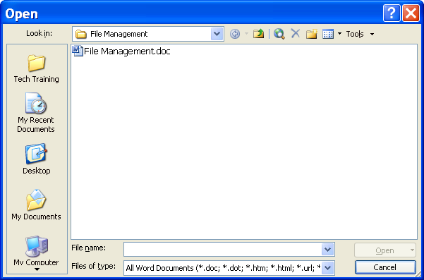
Create New Folder

- To open a file, click FILE, OPEN. Click the drop-down list next to the LOOK IN box to select the necessary drive or folder.

- Double-click each subfolder until you locate the desired file, and double-click the file to open it. Or, click once on the file, then click OPEN.

- To rename a file or folder, click FILE, OPEN. Right click on the file to rename, and click RENAME.

- Type the new file or folder name and press ENTER.

  - Saving Files

OVERVIEW

When you find and open a file, you may make changes to the file that you would like to keep. You may choose to save the modifications directly in the original file, or you may decide to save the changed file while retaining the original.

STEPS

- Open the desired file, and make the necessary changes.

- To save the file with your changes, click FILE, SAVE. If this is the first time the file has been saved, continue with step 4.

- To save a new version of the file and retain the original, click FILE, SAVE AS.

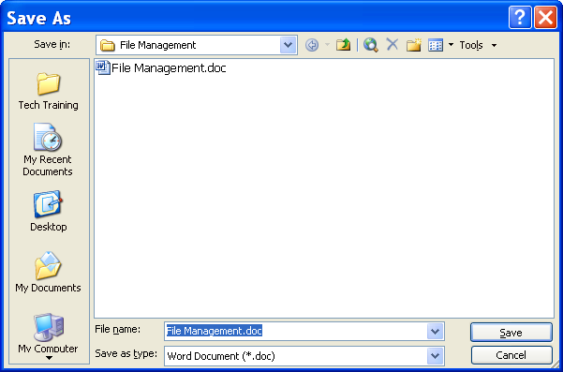

- Type a new name for the file (the original will keep its old name), and if desired, choose a new file storage location by clicking the SAVE IN drop-down arrow, and selecting a new folder.

- Click SAVE.

✓ Lesson Example
You decide to create a To Do list in a Microsoft Word document.

STEPS

- Click START, PROGRAMS, MICROSOFT WORD.

- Type the following in Word, pressing the ENTER key at the end of each line:

To Do List
Learn about file management
Practice file management
Tell others about file management

- Click FILE, SAVE.

- In the SAVE IN drop-down, select the location provided by your instructor.

- Click the CREATE NEW FOLDER button.

- Type (Your Name) as the new folder and press the ENTER key.

- Type (Your Name) To Do List for a filename.

- Check to be sure that your folder name appears in the SAVE IN box and click SAVE.

EXERCISE:

1) Add Become a file management expert to your To Do List.

- Save this new version as (Your Name) Modified To Do List by pressing F12 on your keyboard.

- On Your Own: Create a Word Document by clicking on the NEW button.

- Type two sentences about your job and save it as (Your Name) Job Description.

- Close Microsoft Word.

  - Using My Computer

OVERVIEW

One way that Windows enables you to view and manage your computer filing system is by using My Computer. My Computer displays the contents of the computer and network in a window. However, My Computer divides the window into two sections for easier viewing. The left section shows all of your drives, folders and subfolders. The right section, or contents list, displays the contents of the drive or folder selected on the left, including files, which are not displayed on the left.

In the left panel, My Computer uses lines and indentations to show you the relationship between drives and folders. Because this area looks like branches, it is called a tree. Folders and subfolders may be displayed or hidden using the + and - signs before the drive or folder in which they reside.

Windows uses icons to identify different objects. Drives are indicated by a gray box . Shared drives are a similar gray box with a cable running underneath 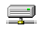. Folders and subfolders have an icon that looks like a folder 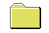. Programs have the 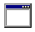 icon or one directly associated with the application. The most common Microsoft Office icons are as follows:

Icon | Application
 | Microsoft Word
 | Microsoft Excel
 | Microsoft Access
 | Microsoft PowerPoint
 | Microsoft Publisher
 | Microsoft Outlook

Based on the extension of the file, different icons will appear beside each file name. For example,  is the icon for a Microsoft Word 2003 file. If a combination of folders and files appear on the right side, folders will be listed first in alphabetical order followed by files (also in alphabetical order).

1. To open My Computer, double-click the MY COMPUTER icon 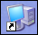 on your DESKTOP or on your QUICK LAUNCH toolbar..

- Click on the FOLDERS button 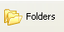.

- To view the contents of a drive, click the desired drive name.

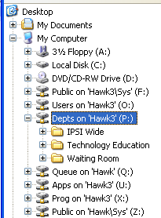

- To continue down a path, keep selecting folders and subfolders to click. The contents of the chosen folder will appear.

- To open a file, in the right pane, double-click the file name.

- To delete a file or folder, click once on the item and press the DELETE key , or right click the item and choose DELETE.

✓ Lesson Example

You want to work in My Computer.

STEPS

- Open My Computer by double clicking the MY COMPUTER icon on your Desktop or on your Quick Launch toolbar.

- Click the FOLDERS button.

- What drives appear in My Computer?

- Which drive or folder is actively displayed?

EXERCISE:

1) Display the contents of the Desktop.

2) Collapse and expand My Computer.

3) Display the contents of the C:\My Documents folder.

4) On Your Own: Display the contents of the Recycle Bin.

5) Expand the C:\Program Files folder.

6) Display the contents of the Microsoft Office folder.

♦ Finding Files

OVERVIEW

If you are unsure of the path of the file you wish to find, the Find feature lets you search for files by name, location, date, file type, size, or text in files.

For information you do not know precisely, you can use a wild card, which is represented by the asterisk (*). For example, to identify any file with an extension of .XLS on the drive being searched, you can type *.XLS. However, if you know the beginning of the file name, you do not need to use a wildcard at the end.

STEPS

- Click START, SEARCH.

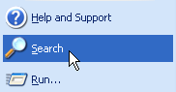

- Select FOR FILES OR FOLDERS.

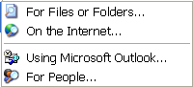

- Select the option that you wish to search for under WHAT DO YOU WANT TO SEARCH FOR.
- To seach for a document, click DOCUMENTS.

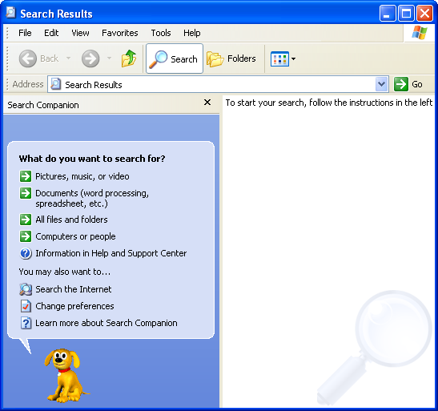
Documents
All Files or Folders
Search Results

- To search by document name, type the name or part of the name.

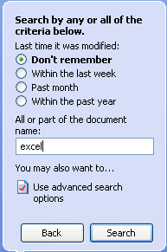

- In the SEARCH RESULTS drop-down list, specify the drive you wish to search and click SEARCH .

- If you cannot remember the document name, click USE ADVANCED SEARCH OPTIONS .

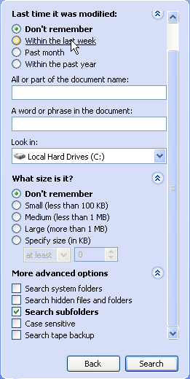
Search
All or Part of the Document Name
Word or Phrase in a Document
Size
Where to Search

- Choose last time modified, file type, size, or text within the file in the appropriate box.

- Click SEARCH.

- To open a file that is found, double-click the name of the file in the right pane.

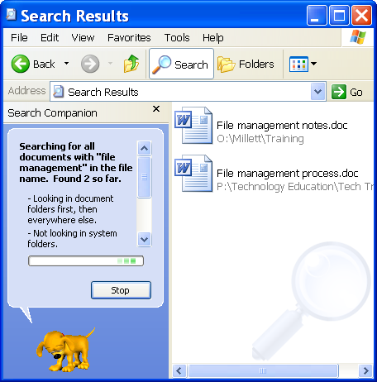

- To copy a file that is found, right-click the file and click COPY.
- Right-click the folder, and choose PASTE.
- To select a group of files or folders to open or copy, click on the first file, hold down the SHIFT key and click on the last file. To select more than one file, click on the first file, hold down the CONTROL key and click on any other file. CONTROL + CLICK a file to unselect it (all other selected files will still be selected).

♦ Creating Folders

OVERVIEW

Windows has many folders and subfolders already established. They contain items that allow your programs to work correctly, your printers to print, and other functions to happen behind the scenes. As you create files, you will likely want to store them in an organized fashion; however, what Windows has set up might not fit your needs. Therefore, you have the ability to create your own system of folders and subfolders.

By default, many programs place your new files in a folder on the C: drive named My Documents. As discussed earlier, for important files, the C: drive is not the appropriate storage location. You always have the option to choose another folder when saving.

STEPS

1. In My Computer, click the drive, folder, or subfolder in which you would like to create a new folder.
Helpful Hint:

If you are renaming an item that has a file extension, be sure to include it in your new filename.

2. Click FILE, NEW, FOLDER.

3. A folder named NEW FOLDER will appear in the right panel under all existing folders and files. Type the name you would like the folder to have and press ENTER.

4. When the screen is refreshed, the folder will appear in alphabetical order among the other folders.

✓ Lesson Example
You have decided to create a special folder for all of the lists you make.

STEPS

- If necessary, expand the C: drive. Click the MY DOCUMENTS folder.

- Click FILE, NEW, FOLDER.

- Type Lists, and press ENTER.

- Press F5 to refresh your screen.

EXERCISE:

1) Create another new subfolder within C:\My Documents for Job Information.

2) On Your Own: Create a subfolder for Graphics, also within the C:\My Documents folder.

♦ Managing Files and Folders

OVERVIEW

Once folders are established, maintaining an organized file system is simple in My Computer.

STEPS

1. To rename a file or folder, right click on the current name and select RENAME.

2. Type the new name for the file or folder, and press ENTER. Once the screen is refreshed, the file will be alphabetized by its new name.

3. To move a file or folder, make sure the destination folder is displayed on the left side, and the item(s) to move are displayed on the right. Click and drag the item(s) from the right side to the new folder on the left. If the destination is a different drive, the item(s) will be copied. To avoid making a copy, hold down the SHIFT key while dragging.

4. To copy a file or folder, ensure that the destination folder is displayed on the left side, and the item(s) to move are displayed on the right. If the destination is a different drive, click and drag them to the new folder. If not, hold down the CONTROL key while dragging.

5. To select a group of files or folders, click on the first file, hold down the SHIFT key and click on the last file. To select more than one file, click on the first file, hold down the CONTROL key and click on any other file. CONTROL + CLICK a file to unselect it (all other selected files will still be selected).

✓ Lesson Example

You would like to move your two List documents into the Lists folder.

STEPS

- If necessary, expand the C:\MY DOCUMENTS (or location provided by your instructor) folder so its subfolders are in view.

- Click the folder with your name on the left.

- Click the TO DO LIST file.

- Hold down your CTRL key and click the MODIFIED TO DO LIST file. Both files should be selected (shaded). Let go of CTRL.

- Starting with your mouse pointer in any shaded area, click and drag from the right side to the left, letting go of your mouse when you are pointing at the LISTS folder.

- Click the LISTS folder on the left to verify that the files moved.

EXERCISE:

1) Using the Search feature, locate the Purple flower.jpg file on the C: drive and copy it to your C:\My Documents\Graphics folder.

2) Rename the file Flower.jpg.

- On Your Own: Move the Job Description file into your Financial Information folder.

LESSON 3: DELETING

OBJECTIVES: Remove files and folders you no longer need.
Utilize the Recycle Bin.

OVERVIEW
Did You Know?

To permanently delete an item, press SHIFT + DELETE.

Another important aspect of File Management is the removal of items you no longer need. Every file or folder stored takes up space on your computer or the network.

STEPS

1. To delete a file or folder in Explorer or My Computer, select the item(s) to delete.
Did You Know?

When you delete from a network drive, it does NOT go to the Recycle Bin.

2. Click the DELETE button . Or, press the DELETE key.

3. Click YES to confirm the deletion, NO to cancel.

4. Items deleted from your C:\ drive will be moved to the RECYCLE BIN. See the following lesson topic for more information on the Recycle Bin.

✓ Lesson Example

You determine that you no longer need the Flower.jpg file.

STEPS
Helpful Hint:

If the Recycle Bin is full, items WILL NOT be sent there. They will be deleted immediately.

- Display the contents of the C:\My Documents\Graphics folder.

- Click once on Flower.jpg.

- Click the DELETE button.

- Click YES in the CONFIRM FILE DELETE window.

EXERCISE:

1) Delete your Job Information folder.

2) On Your Own: Delete one of your lists from the Lists folder.

♦ The Recycle Bin

OVERVIEW
Did You Know?

You can delete all items in the Recycle Bin right from your Desktop by right-clicking on the RECYCLE BIN icon, and choosing EMPTY RECYCLE BIN.

Deleting from the C: drive or Desktop, or by clicking and dragging will move the item(s) deleted to the Recycle Bin. Files will be held there indefinitely until you delete them. You may retrieve a item deleted by mistake from the Recycle Bin. Items that are NOT sent to the Recycle Bin can only be restored if you have backups.

STEPS
1. Double-click the RECYCLE BIN icon 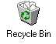 on the Desktop.

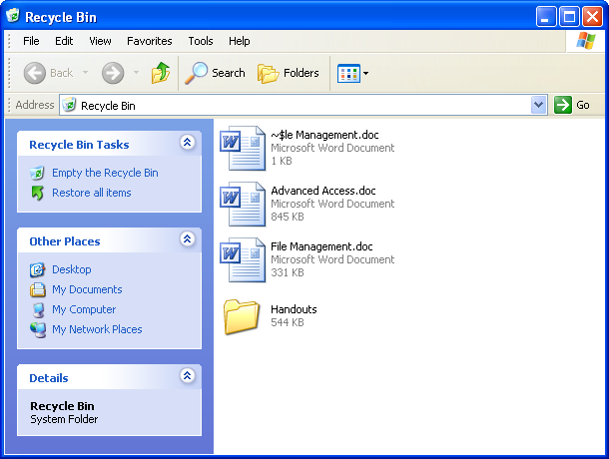

2. To bring a file back to its previous folder, click once on the file to restore, then click FILE, RESTORE. The file will return to its original location.

3. To permanently delete, click FILE, DELETE, then YES to confirm the deletion.

4. To delete all items in the Recycle Bin, click EMPTY THE RECYCLE BIN in the left pane, then YES to confirm the deletion.

✓ Lesson Example

You changed your mind about Flower.jpg.

STEPS

- Minimize any open windows by clicking the MINIMIZE button in the upper right corner of each window.

- Double-click the RECYCLE BIN icon.

- Click the Flower.jpg file.

- Click FILE, RESTORE.

- Click the MY COMPUTER… button in the Taskbar to reopen My Computer.

- Click to display the contents of C:\My Documents\Graphics and check that Flower.jpg is there.

- Minimize the My Computer window.

EXERCISE:

1) Delete the list file permanently.

2) On Your Own: Restore the Job Information folder.

3) Check for it in C:\My Documents in My Computer.

4) Close My Computer.

5) Empty the Recycle Bin, and close the window.

LESSON 4: the desktop

OBJECTIVES: Manipulate shortcuts on the Desktop.

♦ Creating Desktop Icons

OVERVIEW

The Desktop in Windows is just like your actual desktop. On it are many of the tools you need to do your job. And like your desk, you will want to have the most important tools close at hand. Several icons for applications already exist; however, you have the ability to add program icons, folders, and individual files if you wish. These are often referred to as shortcuts.
Helpful Hint:

You may skip a step by right clicking and dragging the item directly onto the Desktop and choosing CREATE SHORTCUT HERE.

STEPS

1. Open MY COMPUTER, or click START, FIND, FILES OR FOLDERS and locate the file, folder, or program for which you want a shortcut.

- Right-click the item, and choose SEND TO, DESKTOP (CREATE SHORTCUT).

- To use the Shortcut, double-click the icon on your desktop.
Did You Know?

Deleting a shortcut does NOT delete a file, folder, or program.

- To rename the Shortcut, right click the icon, and click RENAME. Type the new name and press ENTER.

- To organize Desktop icons, right click and blank area of the Desktop, point to ARRANGE ICONS, and click the appropriate arrangement.

- To delete a Shortcut, click the icon, and press the DELETE key. Click YES to confirm the deletion. Or, click and drag the icon into the RECYCLE BIN.

✓ Lesson Example

You know that your computer has a calculator feature, and you would like to have it readily available.

STEPS

- Click START, SEARCH, FOR FILES OR FOLDERS.

2. In the ALL OR PART OF THE FILE NAME: box, type Calculator.

3. In the LOOK IN drop-down list, choose the C: drive.

4. Click SEARCH.

5. When you find it, right click on it, and choose SEND TO, DESKTOP (CREATE SHORTCUT).

6. Close the SEARCH RESULTS dialog box.

EXERCISE:

1) Make a shortcut to your Lists folder on your Desktop.

2) Rename the shortcut To Do Lists.

3) Arrange your Desktop icons by Name.

4) Send the Calculator icon to the Recycle Bin.

5) On Your Own: Create a shortcut for the Flower.jpg on your desktop.

6) Send the To Do Lists shortcut to the Recycle Bin.

LESSON 4: GIVE IT A TRY!

OBJECTIVES: Practice features learned in class.

EXERCISE:

Refer to Lesson 2 for assistance

1) Create a new folder on the C: drive named Confidential.

2) Will the items stored in this folder be backed up?

3) Look for a file on the C:drive named Coffee Bean using the Search feature.

4) Copy the file and put it into your Confidential folder.

Refer to Lesson 3 for assistance

5) Delete the files/folders you created in C:\My Documents.

6) Close My Computer.

7) Open the Recycle Bin and delete three of the items.

8) Close the Recycle Bin.

Refer to Lesson 4 for assistance

9) Create a shortcut to Microsoft Word on your Desktop.

10) Rename it Word.

11) Arrange your Desktop icons any way you would like.

12) Drag the Flower.jpg shortcut into the Recycle Bin.

13) Empty the Recycle Bin from the Desktop.

14) Shut down your computer.

NICE TO KNOW

♦ File Management in Applications

OVERVIEW

Windows-based applications allow you to open more than one file at a time. You can also find, rename, delete, preview, and print files. In addition, you may create folders in applications.

You may open or delete more than one file at the same time. Use your SHIFT or CTRL keys as you click files to select a group or several individual files to open. Then click the OPEN button.

If you would like to know what a file contains before opening or deleting it, click FILE, OPEN and choose PREVIEW from the VIEWS dropdown . A portion of the selected file will be displayed.

STEPS

1. Open the appropriate application by clicking START, PROGRAMS, then the name of the application desired.

2. To open a file, click FILE, OPEN.

3. Click the drop-down list next to the LOOK IN box to select the necessary drive or folder.

4. Double-click each subfolder until you locate the desired file, and double-click the file to open it. Or, click once on the file, then click OPEN.

5. To rename a file, click FILE, OPEN. Right click on the file to rename, and click RENAME.

6. Type the new file name, and press ENTER.

7. To copy a file, click FILE, SAVE AS. Type a new name for the file and/or select a new file location in LOOK IN. Press ENTER.
8. To create a new folder, click FILE, OPEN. In the LOOK IN drop-down, select the drive folder where the new folder will reside, and click the CREATE NEW FOLDER icon .

9. Type the name of the new folder, and press the ENTER key.

10. To print a file, click FILE, OPEN. Right click on the file to print, and click PRINT.

11. To delete a file, click FILE, OPEN. Right click on the file to delete, and click DELETE. Or, you may select multiple files using CTRL or SHIFT, and press the DELETE key on your keyboard.

12. You will be asked to confirm the deletion. Click YES to confirm, NO to cancel.

13. If the file is sent to the Recycle Bin, you must delete it from the Recycle Bin in order to permanently delete it. See Lesson 3 for details on the Recycle Bin.

♦ File Management Using Windows Explorer

OVERVIEW

My Computer enables you to travel any path available on your computer to locate a file or folder. The opening screen will display all of the drives available to you. Double-clicking a drive will display the folders and files stored on that drive. While you are able to perform many file management functions within My Computer, it is not the most efficient method for doing so.

STEPS

1. Right-click the START menu and click EXPLORE or press the flying windows key + E.

2. To display, or expand, the subfolders of a drive or folder in the left panel, click the + in front of the drive or folder name.

3. To hide, or collapse, subfolders, click the - in front of the drive or folder name.

4. To display the contents of a drive or folder in the right panel, click once on the drive or folder name in the left panel. Or, double-click the folder name in the right panel. The name of the drive or folder will appear above the right-hand side.

5. To print a file from Windows Explorer, click the filename in the right panel, and click FILE, PRINT.

- To open a file from Windows Explorer, double-click the file in the right panel. The corresponding application will open followed by the file itself.

