Computer Basics

Table of Contents

Page
LESSON 1: GETTING STARTED 1
LESSON 2: THE MOUSE 5
LESSON 3: BASIC WINDOWS CONCEPTS 7
LESSON 4: INTRODUCING MICROSOFT WORD 11
LESSON 5: EDITING FILES 15
LESSON 6: CUT, COPY, AND PASTE 19
LESSON 7: PRINTING FILES 22
LESSON 8: INTRODUCING OUTLOOK 2003 24
LESSON 9: OUTLOOK INBOX 27
LESSON 10: OUTLOOK CONTACTS 41
LESSON 11: OUTLOOK CALENDAR 45
LESSON 12: OUTLOOK TASKS 50
LESSON 13: OUTLOOK NOTES 52
LESSON 14: OUTLOOK PRINTING 54
LESSON 15: DELETING FILES 57
LESSON 16: SHUTTING DOWN THE COMPUTER 59
NICE TO KNOW 60

This workbook may be reproduced in whole or in part by an employee of the Department of Health and Human Services. All other reproduction is prohibited unless written permission is obtained from the Training Institute.

LESSON 1: GETTING STARTED

OBJECTIVES: Discuss the components of the computer.
Properly turn on the computer.
Explore the Desktop.

Parts of the Computer

OVERVIEW

The physical components of a computer are called hardware. Each piece of hardware allows you to perform certain tasks. Hardware can include:

- Monitor: Looks like a television screen and acts as the visual connection to any computer process. The information you type, the mouse pointer movement, and program interfaces appear on the screen.

- System Unit: The container for drives, processors, memory, and all of the components that do the actual work in a computer.

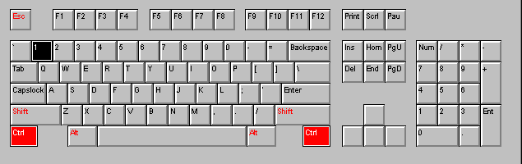
Helpful Hint:

In order to use the Number Pad, you must be sure the NUM LOCK light above the pad is on.
- Keyboard: The keyboard is similar to a typewriter’s (with additional keys). Additional keys include function keys at the top of the keyboard (F1 – F12), command keys to the right of the keyboard, and a keypad for numbers.

- Mouse: For Windows-based programs, the mouse is essential for gaining access to and efficiently utilizing the program.

- Printer: There are many different kinds of printers. The most common type is the laser printer. Laser printers are typically able to print several copies per minute, including graphics. There are also ink jet and color printers.

Starting the Computer

OVERVIEW

Turning on your computer is as simple as pressing a button. However, every computer's power button is in a slightly different place. Somewhere near the button, you should see a circle with a vertical line down its center.

STEPS

- Press the Power Button located on the system unit. Lights will come on.

- If the monitor does not turn on, press its Power Button.

- Wait until you are asked to enter your Login information.

- If necessary, enter your Login (or User) name and press the TAB key. If you were the last person to log in, your Login or User name will appear automatically. If not, you will have to click in the Login name area and clear the previous entry using the BACKSPACE or DELETE keys on your keyboard.

- Type your password. It will appear as a series of asterisks, preventing others from viewing it.

- Click OK, or press ENTER.

- You may need to close a LOGIN results window by clicking on CLOSE.

Terminology

OVERVIEW

- The Desktop is the primary Windows display. It consists of a background, several icons, the Taskbar which includes the Start button and System Tray. The Desktop may also display the Office Toolbar.

- An Icon (picture) can represent programs, files, a printer, and other computer information. Beneath each icon is the name of the item it represents. To activate the item represented by an icon, you double-click it with the mouse.

- The Taskbar (gray bar - usually across the bottom) shows what programs are running, if printing is in progress, and displays the time.

- The Start button (located on the Taskbar) gives you the ability to access Help, change settings, start programs, etc.

- The System Tray appears on the far right side of the Taskbar, and contains several utilities. These utilities may include a virus scan, speaker controls, the time, and more.

- The Office Toolbar may appear on your Desktop. This toolbar provides you with shortcuts to various applications. A simple click of the mouse will activate them.

Desktop Icons

OVERVIEW

Windows is an operating system that utilizes icons to make it easy for the operator. Some of the standard Windows icons are:

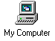 | This icon gives you access to your computer’s contents and allows you to manage files.
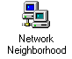 | This icon allows you to look at network items if your computer is connected to a network.

EXERCISE:

1) Turn on the computer.

2) Log on to the computer using the user name and password provided by the instructor.

LESSON 2: THE MOUSE

OBJECTIVES: Learn to hold and use the mouse.

Using the Mouse

OVERVIEW

Holding the mouse appropriately can mean the difference between using your computer efficiently and becoming frustrated with the entire Windows experience. The proper method is to gently rest the palm of your hand on the lower portion of the mouse, grasp either side of the mouse with your thumb and ring finger, and keep your fore finger over the left mouse button and your middle finger over the right mouse button.
Helpful Hint:

If you are unsure whether to click or double-click, try clicking once. If what you wanted to happen does not, then double-click.

By moving the mouse on a flat surface, you move the pointer (arrow tip) within the window. The following operations are available:
- Pointing: Positioning the tip of the mouse pointer on an item without pressing a mouse button. Sometimes this action will cause a "Tooltip" to be displayed. You must always point before performing any of the following mouse functions.
- Clicking: Pressing and releasing the left mouse button once. This allows you to select an item, and activate toolbar buttons.
- Double-clicking: Pressing and releasing the left mouse button twice quickly. Typically this action is used on large icons to open the related object.
Helpful Hint:

If you ever accidentally right-click, click once with your left mouse button outside the gray menu to close it without activating an option.
- Clicking and Dragging: Holding down the left mouse button while moving the mouse. This will move an object or select a series of items.
- Right-clicking: Pressing and releasing the right mouse button once. A shortcut menu of options related to the clicked item will appear. Click with the left button to select an option.

✓ Lesson Example

It is time to try out the mouse.

STEPS

- Click once the MY COMPUTER icon. What happens?

2. Double-click the MY COMPUTER icon. What happens?

3. Close MY COMPUTER by clicking the X in the upper right hand corner.

EXERCISE:

- Click and drag the MY COMPUTER icon to another area of the desktop.

- Right-click the MY COMPUTER icon. What happens?

3) Move your mouse to a blank area of the desktop and right-click again. What is different this time?

4) Point at ARRANGE ICONS; slide your mouse pointer over to by NAME and click to select it.

5) On Your Own: Click once on the RECYCLE BIN icon.

6) Double-click the RECYCLE BIN icon.

7) Close the RECYCLE BIN window by clicking the X.

8) Right-click the RECYCLE BIN icon and click outside the gray menu to close it.
LESSON 3: BASIC WINDOWS CONCEPTS

OBJECTIVES: Explore the Start Menu.
Define the parts of a window.
Manipulate windows.

Using the Start Menu

Did You Know?

Some applications and files require a login name and password to open them.

OVERVIEW
If you do not see an icon on your desktop for the activity you wish to perform, you may use the Start Menu to access the item.

The Start Menu has seven default commands available. They are:
- All Programs: Shows a list of the applications you may open for use that may not have an icon or button on the Desktop.
- My Recent Documents: Displays the last fifteen (15) files opened on the computer.
- Printers and Faxes Settings: Allows you to change various printer settings.
- Search: Provides a tool for locating files by name, content, or revision date.
- Help and Support Center: Allows you to look through documentation of Windows functions.
- Run: Another option for opening files. This is typically used when loading new software.
- Shut Down: Shuts down or restarts your computer or logs you off the network.

- To select one of the commands, click the START button, then slowly move the mouse pointer up and down the list. (Notice how the items with a right arrow display secondary menus when your pointer rests on them).

- To select an item from a secondary menu, slide your mouse pointer straight across then up or down within the secondary menu to get to the item.

- Click the item to open.

Did You Know?

You may have several applications open at the same time.

- To close the Start Menu without making a selection, click START, or click anywhere outside the menu.

✓ Lesson Example

You wish to open an application from the Start Menu.

STEPS

- Click the START button in the Taskbar.

- Slide your mouse pointer up to ALL PROGRAMS.

- Slide across to the secondary menu and point at ACCESSORIES.

- Slide into the ACCESSORIES menu and click NOTEPAD.

- Close the NOTEPAD window by clicking the CLOSE button.

EXERCISE:

1) Open the CALCULATOR application, which can be found in ALL PROGRAMS, ACCESSORIES.

2) On Your Own: Without closing the CALCULATOR, open MICROSOFT WORD.

Sizing and Moving Windows

Knowing how to size and move windows is important, particularly when using multiple applications in Windows. You may have to resize and move windows or icons in order to view the contents of open Windows or in order to find an icon hidden behind an application.

STEPS
1. To resize a window (your window must not be maximized), move the pointer across the edge of the Windows border until it turns into a double-headed arrow . Click and drag toward the window to make smaller, and away from the window to make larger. Release the mouse button when completed.
2. To move a window (your window must not be maximized), point to any blank area of the Title bar (at the top of the window), click and drag the window around and release the mouse when it has been relocated.

Switching between Windows

OVERVIEW

Did You Know?

Whatever size and location are set upon closing the window will be applied the next time that application is opened.
Since Windows allows you to open several applications and files at one time, knowing how to bring the one you wish to work on to the forefront is important. All open applications will have a representative button in the Taskbar. All files open in a single application will be listed in the applications Window menu (with the exception of Microsoft Word 2000).

STEPS

1. To change the active application using the Taskbar, click once on the button in the Taskbar that represents the application you wish to open.

2. To change the active application using the program windows, click the RESTORE button on the active application.

3. If you can now see any part of the window you wish to make active, click on it.
4. If this is the one you want, let go of the ALT key. If not, tap TAB until the dialog box displays the correct application.

5. To change the active file within a single application, click the WINDOW menu and select the appropriate file.

Did You Know?

On many computers pressing ALT while tapping TAB allows you to switch between open applications and open files. A small dialog box will indicate each application in succession as you continue to tap TAB. Simply release the ALT key when the desired application/file is displayed.

ü Lesson Example

You would like to view both applications at once.

STEPS

- Minimize the Word document by clicking the MINIMIZE button in the upper right corner.

- Move the CALCULATOR window to the upper right corner of the screen by pointing at any blank area of the Title Bar and clicking and dragging to the desired location.

- Click the Word document on the taskbar. Restore down the window by clicking the RESTORE DOWN button in the upper right hand corner.

- Move the Microsoft Word window to the upper left corner of the screen by clicking and dragging the Title Bar.

EXERCISE:

1) Move the Calculator window to the center of the screen.

2) Click any visible area of the Microsoft Word window.

3) Activate the Calculator window by clicking its button in the Taskbar.

4) Use Alt+Tab to switch to Microsoft Word.

5) On Your Own: Alter the size of the Microsoft Word window.

6) Reactivate the Calculator window.

7) Close the Calculator.

LESSON 4: INTRODUCING MICROSOFT WORD

OVERVIEW

Microsoft Word is an advanced word processing program that allows you to automate a wide variety of job tasks that use the written word. Some common tasks that you can accomplish using Microsoft Word include creating memos, letters, faxes, newsletters, and brochures.

STEPS

1. Click START, ALL PROGRAMS, MICROSOFT OFFICE, MICROSOFT WORD 2003.

Creating a New Document

OVERVIEW

When you open Microsoft Word, a new blank document automatically appears. You also can create as many new documents as you like.

STEPS

- Click the NEW BLANK DOCUMENT button .

Saving a Document

OVERVIEW

Saving a document is very important. After completing a document, or typing several pages, you should save the file. If the computer is turned off, or the electricity fails, you will lose the file if it is not saved. Note: Microsoft Word is preset (defaulted) to save your document every 10 minutes. However, it is still a good idea to save frequently.

STEPS

- Click FILE on the Menu bar and then SAVE and type a document name with a maximum of 255 characters (for example, my first document.) Microsoft Word automatically assigns .doc to the end of the filename. Click SAVE. (Notice the name is on the Title Bar - next to Microsoft Word.)

2. To save changes, click the SAVE button .

Closing a Document

OVERVIEW

When a document is finished, to type another new document, or to open another file, you may want to close the file you are using.

STEPS

1. Click FILE on the Menu Bar, then click CLOSE. A quick way is to click on the CLOSE button in the upper right hand corner.

2. If you have not saved your document, the computer will ask if you want to save your changes before closing.

Opening a Document

STEPS

1. Click FILE on the Menu bar, and then click OPEN, or click the OPEN button .

2. Click the drop down arrow beside LOOK IN to locate the appropriate drive. Click on the drive. Find the name of the file to open in the dialog box. If your filename is not visible, click the arrows of the Scroll Bar or click and drag the Scroll Box.

3. Click on the filename, then click OPEN.

Saving a Document with a Different Name or Location

Follow the steps below to give the file a new name and/or new location after it has been saved. Note: The original file will still remain.

STEPS

1. Click FILE on the Menu Bar.

2. Click SAVE AS.

3. To change just the filename, type a new name. Click SAVE.

- To change the file location, click the down arrow beside SAVE IN and select the appropriate location. Click SAVE.

ü Lesson Example

A supplies order is being sent to the vendor tomorrow. You were asked to type a list of the requested supplies. For future reference, you will want to save the list.

STEPS

- Open Microsoft Word.

2. In the new Word document that appears, type the following list:

Paper Clips
Highlighters

3. Save the document in the C:\My Documents folder as Supplies.

4. Close the document, leaving Microsoft Word open.

5. Re-open the Supplies document and add Pens to your list.

6. Click FILE, SAVE AS and save the revised document as Revised Supplies.

7. Close the document.

EXERCISE:

1) Open the Open House document. Your instructor will tell you the location.

2) Save the document to the C:\My Documents folder.

3) On Your Own: Create a To Do List and save it in the C:\My Documents folder using To Do as the filename.

LESSON 5: EDITING FILES

OVERVIEW

Editing files requires knowledge of the many editing features available in Microsoft Word. Below are several of the most commonly used features.

Using the Keyboard

 | Key | Function
1 | INSERT | Allows you to place text without deleting text
2 | DELETE | Erases text to the right of the cursor
3 | BACKSPACE | Erases text to the left of the cursor
4 | HOME | Moves cursor to beginning of line
5 | END | Moves cursor to end of line
6 | PAGE UP | Moves cursor up one window
7 | PAGE DOWN | Moves cursor down one window
8 | ENTER | Starts a new line or paragraph
9 | TAB | Indents
10 | SHIFT | Capitalizes letters and symbols above the number and symbol keys
11 | ARROW KEYS | Move left, right, up, and down
12 | CTRL + ESC | Opens the Start Menu
13 | F1 | Help
1
3
4
6
13
2
5
7
8
9
10
11
12
12

Selecting Text Using the Mouse and Keyboard

OVERVIEW

You can select text by using the mouse or keyboard. When text is selected, everything you type on the keyboard will replace the selection. To deselect the text, move the keyboard cursor by using the arrow keys or click with the mouse.

STEPS

- To select a word: Hold the I-Beam pointer over the word and double-click.

2. To select a sentence: Hold down the CTRL key and click once anywhere on a sentence.

3. To select a line: In the selection area (which is the left margin area of the document), click once beside the line.

4. To select a paragraph: Double click outside of the paragraph or triple click in the paragraph.

- To select a document: Click EDIT on the menu bar, click SELECT ALL (or use CTRL A). To use the mouse, triple click to the left of the document in the selection bar.

Undo and Redo

OVERVIEW

If you make a mistake, you do not need to worry in Microsoft Word. There is an Undo button available. You can undo all actions up to the point of where you last performed a save. You also have the option to Redo an action if you decide you actually wanted it to happen.

STEPS
- To undo your last action, click the UNDO button .
- To redo what has just been undone, click the REDO button

ü Lesson Example

You have been notified that your Supplies list needs to be more specific.

STEPS

1. Open the Revised Supplies document.

2. Change your list to appear as follows:

Acco Paper Clips
Accent Highlighters
Blue Bic Stix

3. Add Scotch Tape to the bottom of the list.

4. Undo your addition.

5. Redo the addition.

6. Save your changes.

EXERCISE:

- Select the word Tape and press the DELETE key on the keyboard.
- Undo the deletion.
- Save your changes.
- On Your Own: Add a new item to your To Do list.

- Undo this change.

- Save the changes.

LESSON 6: CUT, COPY, AND PASTE

OVERVIEW

Cutting removes the text from the document and places it in a temporary storage area called the Clipboard. It will remain there until you paste the text or exit the program.

Cut

STEPS

- Select the portion of text to be moved by using the techniques described in the previous lesson.

2. Click the CUT button .

3. To retrieve the text, position the cursor at the location where the text is to be added, then click the PASTE button . This will retrieve the text from the Clipboard storage area and insert it at the cursor location.

ü Lesson Example

You need to prioritize the needs on your Revised Supplies list.

STEPS

1. Rearrange the list placing them in order from most expensive to least (your best guess is fine).

2. Save the list.

EXERCISE:

- Select the first sentence of the Open House document and click the CUT button.

- Paste the sentence as a new paragraph below the current paragraph.

- Move to the beginning of the document by pressing CTRL + HOME on your keyboard. Type your name. Press ENTER twice.

- Select your name and CUT it.

- Paste your name at the end of the document.

- Save the changes.

7) On Your Own: Rearrange your To Do document into alphabetical order using Cut and Paste.

8) Save the changes.

Copy

OVERVIEW

Copying retains the text in the current location and duplicates it in another location.

STEPS

- Select the portion of text to be moved by using the techniques described in the previous lesson.

2. Click the COPY button . This will store the text on the clipboard.

3. To retrieve the text, position the cursor at the location where the text is to be added, then click the PASTE button . This will retrieve the text from the clipboard storage area and insert it at the cursor location.

ü Lesson Example

You want to order Black Bic Stix in addition to Blue.

STEPS

1. In the Revised Supplies document, copy Blue Bic Stix to the bottom of your list.

2. Change Blue to Black on the duplicate item.

3. Save your changes.

EXERCISE:

- In the Open House document, select your name and click the Copy button.

- Create a new document.
- Paste your name at the beginning of the new document.
- Save the document as Name in C:/My Documents.
- Close the document.
- On Your Own: Copy the first sentence of the Open House document.

- Open the Name document, and paste the sentence below your name.

- Save the changes, and close the document.

LESSON 7: PRINTING FILES

Print

OVERVIEW

You may print all pages or choose specific pages to print.

STEPS
1. To print all pages (one copy only), click the PRINT button on the toolbar.

2. To print specific pages or multiple copies, click FILE, then click PRINT.

- Change the number of copies by clicking on the up or down arrow.

- To print the page your cursor is on, click on CURRENT PAGE.

- To print text you have highlighted, click on SELECTION.

- To print individual pages, click on PAGES, then type the page numbers you want (i.e. 2-5 to print pages 2 through 5; or 2,5 to print page 2 and page 5).

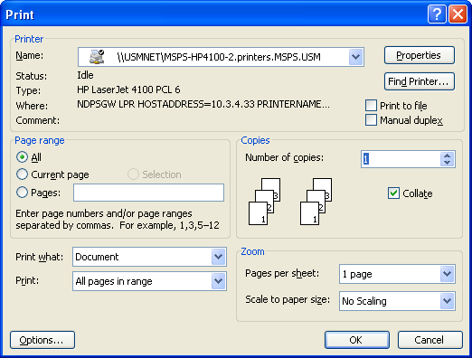

Selecting Different Printers

STEPS

1. Choose File, Print from the menu line or CTRL + P.

2. Click on the drop-down arrow to the right of the current printer NAME and a list of other available printers will appear.

3. Click on the name of the printer you want.

4. Select your print options, then click on the OK button.

ü Lesson Example

It is time to print your supplies order.

STEPS

1. Open the Revised Supplies document..

2. Click FILE and choose PRINT.

3. Select 2 for the NUMBER OF COPIES and click OK.

EXERCISE:

- Print the first page only of your Open House document.

- On Your Own: Print one copy of your To Do document.

LESSON 8: INTRODUCING OUTLOOK 2003

OBJECTIVES: Define Parts Of The Outlook Window.
Describe The Folder List And Outlook Bar.

OVERVIEW

Microsoft Outlook is a personal organization system that allows you to send and receive e-mail, schedule appointments and meetings, add and maintain contacts, create task lists, and eliminate sticky notes from your work area.

STEPS

- Click START, PROGRAMS, MICROSOFT OUTLOOK, or double-click the Outlook icon on your desktop if one exists.

- Your User Name should be completed. If it is not, your User Name is typically your FirstName.LastName.

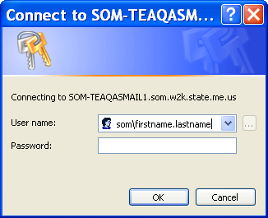

- In the PASSWORD field, type your password. Please note that the password will be displayed as asterisks (*****).

EXERCISE:

- Open Microsoft Outlook.

Outlook Window

OVERVIEW

When you first log into Outlook, you will see the following screen. Depending on your needs, this opening screen may be changed.
Title Bar

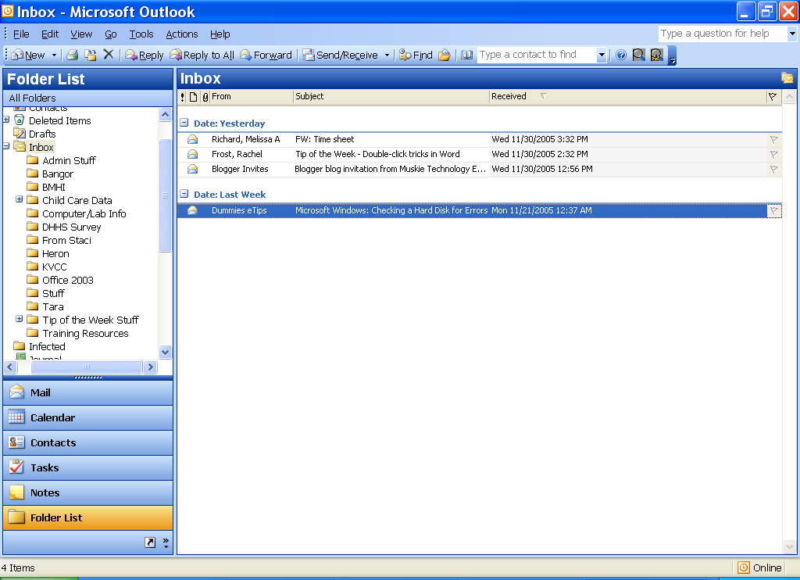
Menu Bar
Tool Bar
Folder List
Inbox
Message Counter
Shortcuts
Status Bar

Folder List and Outlook Bar

OVERVIEW
Helpful Hint:

The number(s) that appear next to a folder in the Folder List represent the number of unread messages in that folder.
The Folder List contains all the components of Outlook.

Calendar – allows you to plan your future activities and to refer back to previous activities. The Calendar deals with three types of activities: appointments, meetings, and events. Appointments are activities that occur at specific times on specific dates. Meetings are times when you meet with other people, usually in a group. You can use Outlook to schedule meetings at times when other people are available. Events are occasions, such as birthdays and holidays, which occur on specific days, but not at particular times on those days. All of the activities can be one-time or recurring. Recurring activities can be daily, weekly, monthly, or yearly.

Contacts – saves information such as a contact’s name, address, phone and fax numbers, and e-mail address. Outlook uses Contacts for several reasons: addressing e-mail messages, arranging meetings, assigning tasks, addressing conventional mail, placing phone calls and sending faxes (if your system allows for it).

Deleted Items – holds messages that you have deleted. As a safety precaution, you can retrieve deleted messages from the Deleted Items Folder if you later decide to keep them. Deleting messages from the Deleted Items Folder removes the messages permanently.

Drafts – retains copies of messages that you are not ready to send.

Inbox – allows you to receive and store incoming e-mail messages, compose messages, and send messages.

Journal – records your daily activities. The Journal can automatically record such activities as: e-mail messages you send to, and receive from specific contacts, including messages that request appointments or attendance at meetings, and those about accepting task assignments. You can also record phone calls that you make, or track each time you work with an Office document (Note: the Journal is a good tool for salespeople to help them track communications; however, it will not be covered in this book as not many State employees require its features).

Notes – provides you with a medium to write down thoughts, ideas or questions that you might write down on a sticky note or note pad. Notes can remain open while you perform other work on you computer.

Outbox – temporarily holds messages you send until Outlook delivers the messages.

Sent Items – retains copies of messages that you have sent.

Tasks – organizes the many duties and projects for each day. Tasks allow creation of a task list of items that need to be tracked through completion. Tasks can be simple to do items, daily reminders, assignments with due dates, or business responsibilities.

LESSON 9: OUTLOOK INBOX
Did You Know?

You can sort the e-mail in your Inbox or another folder, in ascending or descending order, by clicking on a column heading.
OBJECTIVES: Use the Inbox.
Compose a new message.
Check spelling.
Read, reply and forward messages.
Delete messages.
Attach and save files.
Use the Out of Office Assistant.

Inbox

OVERVIEW

Your INBOX is the place where you receive your incoming messages, as well as where you can compose and send messages.
Helpful Hint:

You may also address an e-mail by simply typing the e-mail address or the person’s name (if they are listed in the global address list or your contacts list) in the text box next to the To… button or CC… button in your message window.
Composing a New Message

OVERVIEW

You may compose new messages from any of the Outlook e-mail folders. Typically, you will do this from your INBOX.

STEPS

- Click the INBOX folder in your Folder List.
- Click the NEW MAIL MESSAGE button . The following window appears.
Save
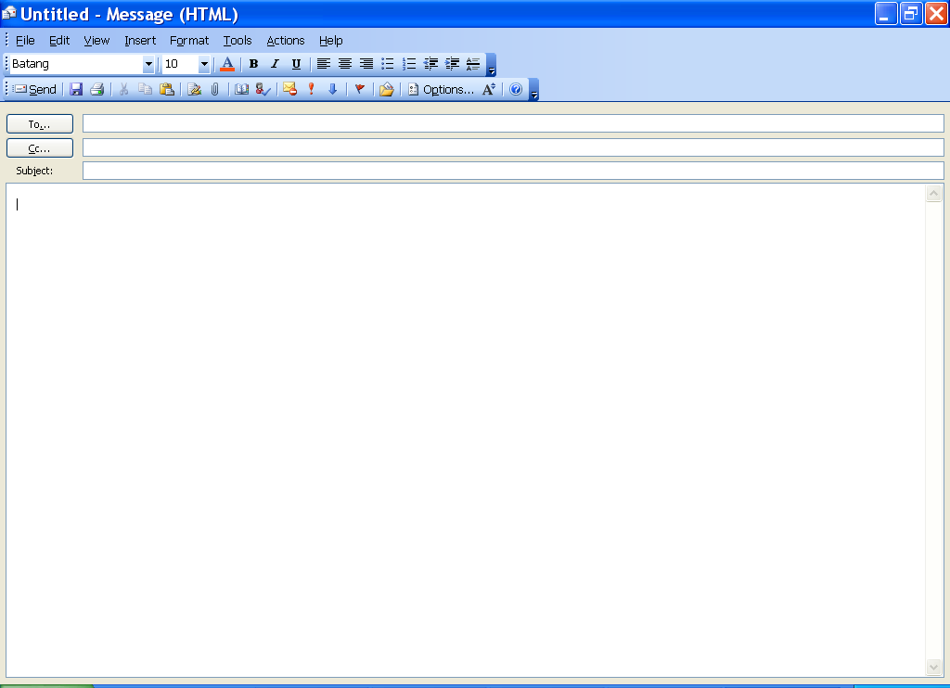
Message Window
Subject Line
Select Names
Fields
Close

- Click the TO. . . button to get the select names window where you can choose from either the global address list or your list of contacts (use the drop down arrow for your list choices from Show Names From The: box).
Did You Know?

The Global Address List lists everyone that works for the State. Your department may have distribution lists set up in the Show Names From The drop-down menu.
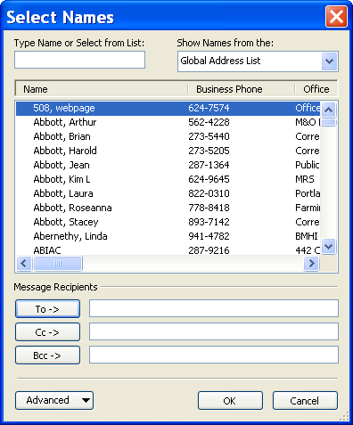
Show Names From the
Drop-Down List
OK
Type Name
To, Cc, Bcc
Did You Know?

Some people will not read a message if it has a blank subject line.
- You may place the recipients into one of three categories by clicking To, CC (Courtesy Copy), or BCC (Blind Courtesy Copy – other recipients do not see BCC entries.).
- Click OK.
- Click in the Subject line and type an appropriate description for your message.
- Press the TAB key to move to the message window and type your message.
- Click the SEND button to send the message, or click the SAVE button to send it to the Drafts folder for later use.

Spell Check

OVERVIEW

In order to ensure your correspondence is as professional as possible, one crucial step is to check your spelling before sending an e-mail. You have two options for spell checking: manually running the spell check before sending each message or setting a spell check option to run automatically before executing a send.

STEPS

- To manually check the spelling of a message, compose the message as described above.

- Before sending the message, click TOOLS, SPELLING.
- Make the necessary corrections, and click the SEND button.
- To set the automatic spell check, from the Inbox folder (with no messages open) click TOOLS, OPTIONS, then choose the SPELLING tab.
- Click the box to Always check spelling before sending.
- Click OK.
When correcting spelling errors that may occur:
- To change a spelling, click the correct spelling, and click CHANGE or CHANGE ALL.
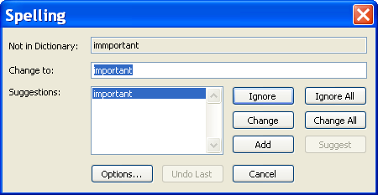
- To add words to the dictionary (so that they no longer get caught as misspellings), click Add.
- To skip words, click IGNORE or ignore All to ignore all instances.
- Lesson Example

You would like to send an e-mail to someone that works for the State of Maine.

STEPS

- If necessary, click the INBOX folder in your Folder List.
- Click TOOLS, OPTIONS, and then click the SPELLING tab.
- Click the box to Always check spelling before sending.
- Click OK.
- Click the NEW MAIL MESSAGE button.
- Click the TO button to get the select names window.
- Choose a student name (ex. student1.muskie) from the global address list in the Show Names From The: box.
- Place the recipients into the To: category by clicking on TO.
- Click OK.
- Press the Tab key on your keyboard twice to place the insertion point in the subject line.
- Type this is my test e-mail as the subject.
- Press the TAB key.
- Type the message I’m so glad I’m learning how to do thiss!* (*include the spelling error) in the message pane.
- Click the SAVE button to send it to the Drafts folder for later use.
- Click the close button.

EXERCISE:

1) Compose a new message to the class participants. Put your name in the Subject line. Send the message.

2) On Your Own: Send a new message to the group of students in class. Text is as follows:

Subject: Here is a practice e-mail from (your name)

Body: Practice makes perrfect!* (*include spelling error)

3) Exit the e-mail and when it prompts you to save it, click Yes.

Reading Messages

OVERVIEW

You have two choices for viewing new messages when they arrive in your Inbox. One way is to open them in a new window and the other is to view them with the Preview pane.

STEPS

- To open a message in its own window, double-click the message in the inbox or right-click the message and select open.
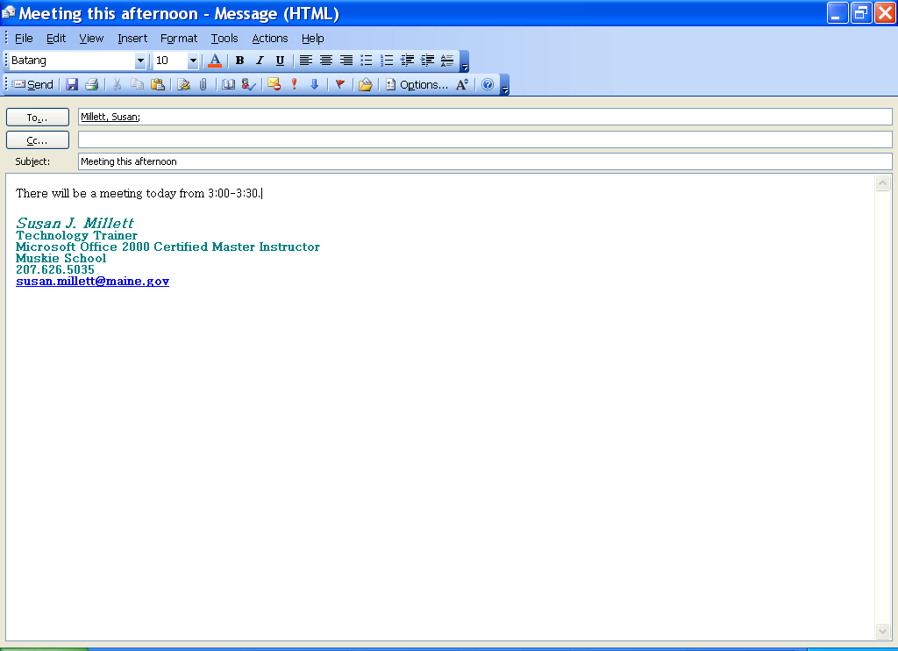
- To read the next message, click on the NEXT ITEM button or to go back to the previous message, click on the PREVIOUS ITEM button .
- Click the CLOSE button to go back to the Inbox.
- To view a message using the Reading Pane, click on View, READING PANE. You may choose to view the reading pane to the right of the inbox or at the bottom of your inbox.
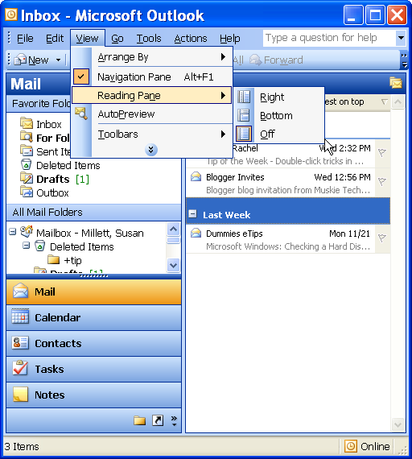
Right, Bottom, Off
- If you would like to remove the Reading Pane from view, go to the View, READING PANE, and select OFF.

Replying To and Forwarding Messages

OVERVIEW
Helpful Hint:

If your original message does not close once you send a reply, refer to the Nice to Know section for information on changing this setting.
Often it is necessary to give a response back to the person who sent you an e-mail or to send the message to another person so that he or she may have the information. Outlook calls this replying and forwarding. Both of these functions can be achieved very easily with the following steps.

STEPS

- To reply to the sender of an open or selected message, click the REPLY button on the toolbar and type your response. When finished, click the SEND button .

- To reply to the sender, as well as everyone else who received the message, click the REPLY TO ALL button on the toolbar and type your response. When finished, click the SEND button .

- To forward a message, click the FORWARD button on the toolbar and follow the steps for selecting recipients as described in Composing a New Message. If you choose to, you may add information to the message. When finished, click SEND .

Deleting Messages

OVERVIEW

Once you read a message and you no longer need it, you can delete it from your Inbox.

STEPS
Did You Know?

You can delete an entire section of e-mails by clicking on the first one, holding down the shift button and clicking on the last one and then pressing the Delete
key.

- Select the message(s) you wish to delete, and click on the DELETE button , or press delete on your keyboard.

- Lesson Example

You would like to send your message from the Drafts folder and make sure that you have no spelling errors and read and respond to some e-mail that you have received.

STEPS

  - Click on the Drafts folder in the Folder list.
  - Double-click the e-mail with This is my test e-mail as the subject.
- Review the e-mail and then click Send. Fix any spelling errors.
- Go back to the Inbox folder and open the top message in the message window by double-clicking it.
- View the next e-mail.
- Close out of the e-mail and go back to the inbox.
- Open any message (read or unread).
- Press the Reply button and send an appropriate response to the other participant.
- Click (to select) the e-mail that you just replied to from the Inbox.
- Delete it by clicking the Delete button.

EXERCISE:

- Go to the Drafts folder and open the draft e-mail that is there.

- Send the e-mail and fix any spelling errors.

- Choose another message in your Inbox and open it.

- Forward the message to another class participant by pressing the Forward button.

- Add appropriate text and send the message.

- Delete the original message.

- On Your Own: Open another message in your Inbox.

- Use Reply to All and send a message back to everyone else that received the message.

- Delete the original message.

Attaching Files

OVERVIEW

Sometimes a simple e-mail message is just not enough, and you may want to attach a file to your message. You can send a Word document, an Excel worksheet, a picture, or another type of file.

STEPS

- Prepare the new e-mail as you normally would.
- Click the INSERT FILE button in the toolbar.
Look in:
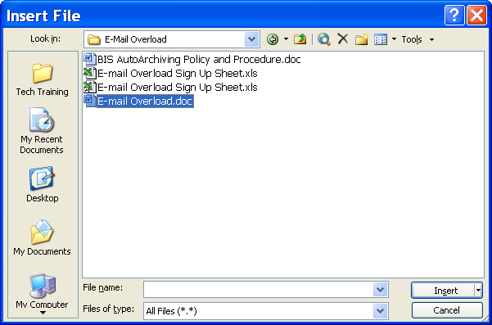
Insert
- Locate the file you wish to attach by using the Look In drop-down menu.
- Click on the file to select it and click the INSERT button.
- Click the SEND button to send the e-mail.

Saving Attached Files

OVERVIEW

After you open an attachment that you have received, you may need to save it on a network drive for future reference.

steps

- Open the e-mail that has an attachment and double click on the file.
Did You Know?

You can also right-click on the attachment inside the email and click Save As…

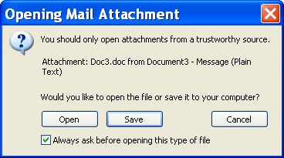
Save
- Click the SAVE button.
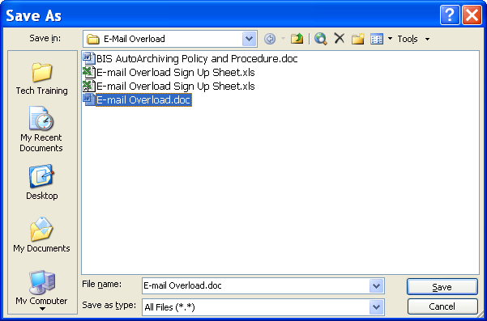
Save in:
Save
- Locate the drive where you want to save the document by using the Save In drop-down menu.
- Change the file name if necessary and click SAVE.
- Lesson Example

You would like to send an attachment to the students in the class.

Steps

- Open Microsoft Word by clicking on the Start button, then Programs, then Microsoft Word.
- Type your name and work address in the document window.
- Click the Save button.
- Click My Documents in the Save dialog box (on the left).
- Keep the name that defaults for the file and click the Save button.
- Close Word by clicking the Close button.
- Go back to your Outlook Inbox, create a new e-mail message, and address it to the students in the classroom. Type a subject and enter some text in the message.
- Click the INSERT FILE button in the toolbar.
- Select the document you just created (from the My Documents folder) and click the INSERT button.
- Click on the Send button to send the e-mail.
EXERCISE:

1) Open an e-mail message that contains an attachment.

2) Double click the attached file.

3) Click the SAVE button.

  - Save the file in the MY DOCUMENTS folder.

  - Close Microsoft Word.

  - On Your Own: Attach the file you just saved to your My Documents folder to a new e-mail to class participants.

  - Delete the original e-mail.

The Out of Office Assistant

OVERVIEW

If you plan to be out of the office for a vacation or a business trip, you may have Outlook forward an automatic message to each person who sends you a message while you are away. Each sender will only receive this message the first time they e-mail you.

STEPS

- From your Inbox folder (with no messages open), select Tools, OUT OF OFFICE ASSISTANT.

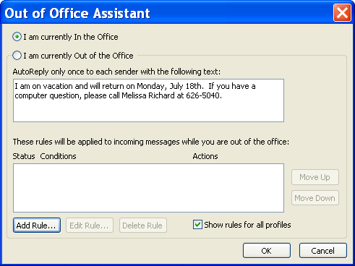

- Click the I AM CURRENTLY OUT OF THE OFFICE radio button. Press the Tab key.

- Type the message you wish to send upon receipt of an e-mail. Click OK.

- Every time you log into Outlook after the Out of Office Assistant is activated, you will be asked if you want to turn it off until you click YES to do so.

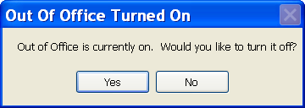

- Lesson Example

You would like to create an Out of Office Assistant.

STEPS

- Click TOOLS, OUT OF OFFICE ASSISTANT.

- Click the I AM CURRENTLY OUT OF THE OFFICE radio button and press the TAB key.

- Type in your message and click OK.

EXERCISE:

  - Send an e-mail to the class.

  - Read several new e-mails to view the new signatures and out of office assistant responses.

  - On Your Own: Turn off your Out of Office Assistant and delete the message.

LESSON 10: OUTLOOK CONTACTS

OBJECTIVES: Create A New Contact.
Send A Message From The Contacts Window.

OVERVIEW

Outlook’s Contacts folder is like an electronic card file. Not only can you store regular names, nicknames, home and work addresses, multiple phone numbers, and e-mail addresses, you may store other information relating to the contact, such as an anniversary date or birthday. To access your contacts, simply click on the Contacts folder in the Folder List.
Helpful Hint:

You can find a contact by clicking on the first letter of either the first name or the last name (depending on how it is sorted) on the right side of the Contacts window.

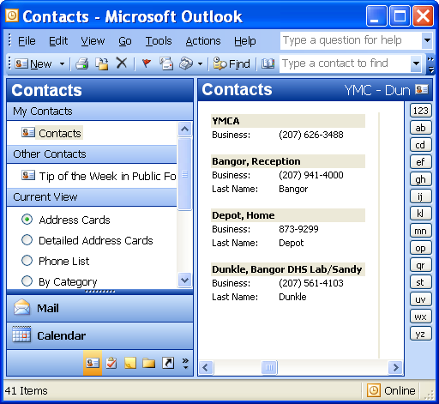

Creating a New Contact

STEPS
- Click on the CONTACTS folder in your Folder List.
- Click the NEW CONTACT button , or double-click any blank area in the contact window.
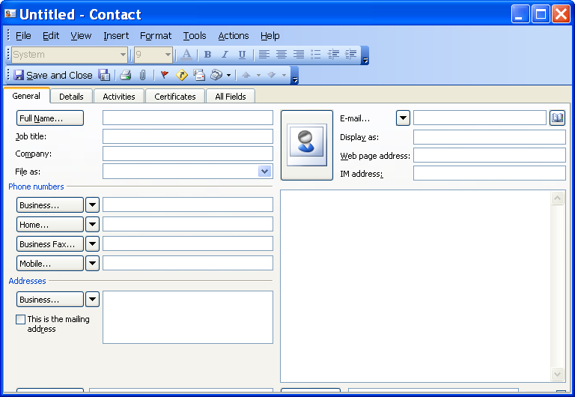
- In the FULL NAME textbox, type a name for the contact.
- Enter the information you want to include for the contact. Wherever there is a drop-down arrow, you are able to click for additional information. For example, if you wish to enter a second e-mail address, you may choose E-mail 2 from the drop-down and enter another e-mail address. Clicking on the arrow again will allow you to select any address.
- Click the SAVE AND CLOSE button .

Sending a Message from the Contacts Window

STEPS

- Select a contact
- Click the new message to contact button or right mouse click the Contact and select NEW MESSAGE TO CONTACT.

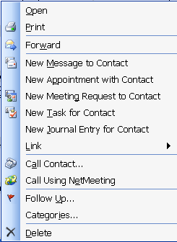
New Message to Contact

- In the SUBJECT box, type the subject of the message.

- Type your message in the message window.

- Click the SEND button .

Deleting Contacts

STEPS

- Select the contact(s) you want to delete.
- Click the DELETE button .

- Lesson Example

You would like to make some Outlook contacts for people you e-mail outside the State of Maine system.

STEPS

- Go to the Contacts folder in the folder list.

2. Click the NEW CONTACT button and type in the following information for this new contact:

Pamela Small
Financial Advisor
Thompson's Financial Planning
Business - 800-425-9821
Business Fax- 328-956-4825
131 West River Road
Thompson, AZ 41569
psmall@thompsons.com

- Click the SAVE AND CLOSE button.

- Select your contact information and right mouse click. Select NEW MESSAGE TO CONTACT.

- In the SUBJECT line, type Outlook Class.

- Type your message in the message window.

- Click Save to save this message to the Drafts folder.

EXERCISE:

1) Create another new contact using the following information:
Joseph James Jackson
Technology Consultant
Florida Consulting Firm
Phone – 847-215-6528
45643 Palm Springs Drive
Daytona Beach, FL 84215
joejames@fcf.com
Nickname: Joe

2) On Your Own: Delete one of your contacts.

LESSON 11: OUTLOOK CALENDAR

OBJECTIVES: Describe Calendar views.
Create appointments or events.
Create recurring appointments.
Edit and delete appointments.

OVERVIEW
Did You Know?

Bolded dates on the Month-at-a-Glance calendar indicate scheduled time on that day.

Your Outlook Calendar can replace your desk calendar. Microsoft Outlook allows you to electronically keep track of your time without the chaos of adding and erasing appointments. You may add three types of items to your calendar: appointments, events, and meetings. Scheduling meetings is discussed in Advanced Outlook.

Calendar Views

OVERVIEW

You may look at your Outlook Calendar using one of four views: Day, Work Week, Week, or Month.

STEPS

- Click the CALENDAR folder in your Folder List.

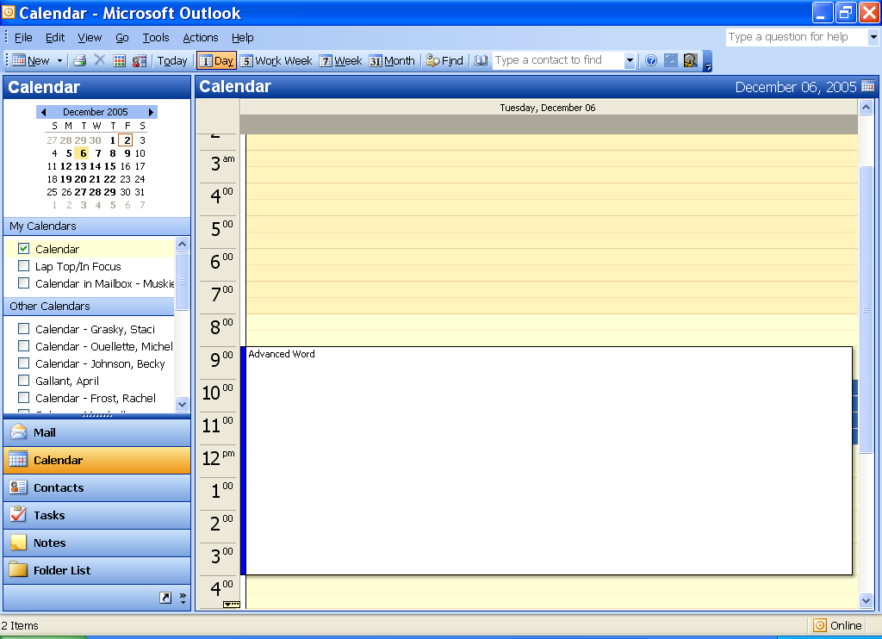

- To choose a view, click on one of the VIEW buttons in the toolbar. Outlook will update your view to look like one below.
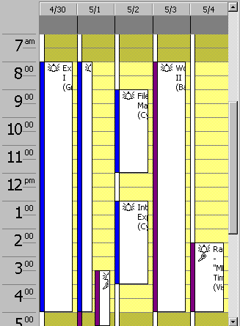
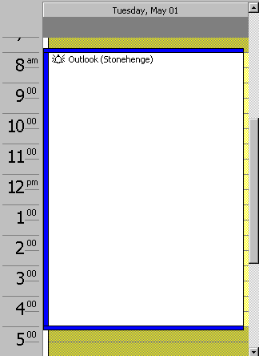
Work Week View
Day View

Month View
Week View
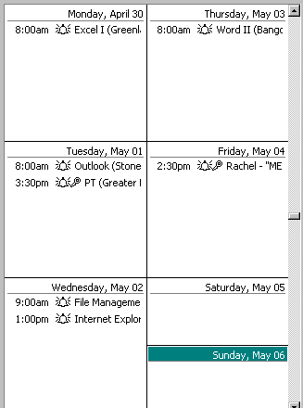
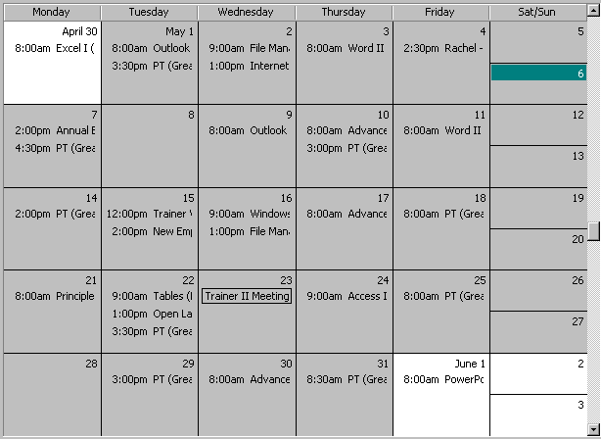

- Lesson Example

You would like to view your calendar in each of the different choices to see what you like best.

STEPS

  - Click the Calendar in the Folder List.

  - Click the day view button. View the screen.

  - Click the Work Week button. View the changes.

EXERCISE:

1) Click the week button. View the screen.

- Select the month button. View the changes.

- On Your Own: Click the single day icon to come back to the daily calendar view.

Creating an Appointment or Event

OVERVIEW

Appointments are activities that occur for a specific period of time and no one else needs to be invited to them. There are two types of appointments: one time or recurring. An event is an activity that lasts for 24 hours or longer; for example, a vacation or a holiday.
Did You Know?

You can drag an e-mail from your Inbox to your Calendar folder to create an appointment with relevant text already entered. You simply need to update the date, time, and location.

STEPS

- Click on the day of the appointment or event in the Month-at-a-Glance calendar.

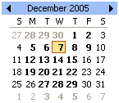

- Click on the Newappointment button or double-click on the day and time of your appointment if you are in Day or Work Week view.
Save and Close
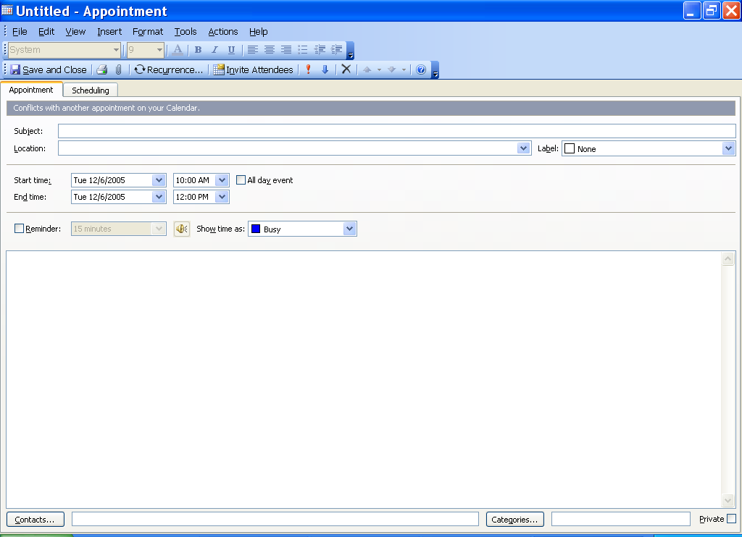
Subject, Location
All day event
Reminder
Show time as:
Private
Helpful Hint:

In order for Outlook to remind you of your appointments, Reminder must be selected, and the program must be active.
- In the SUBJECT line, type a description of the appointment

- Enter a location for your appointment in Location.

- You can edit your start and end times if necessary by using the drop-down arrows.

- To set an activity as an event, check the ALL DAY EVENT check box .

- To create a private appointment, click the PRIVATE check box in the lower right hand corner.

- When finished, click the SAVE AND CLOSE button .

- Lesson Example

You need to create an appointment for this afternoon.

STEPS

- Double-click in the 4:00 p.m. to 4:30 p.m. section of today’s calendar.

- In the SUBJECT line, type (Your Name)’s Appointment.

- Enter My Desk as your location for your appointment in Location.

- Use the drop-down arrow to change the End Time to 5:00 p.m.

- Set your reminder for a two-hour reminder time.

- Verify that your time will be considered Busy in the Show Time As field.

- When finished, click the SAVE AND CLOSE button.

EXERCISE:

1) Create an appointment for tomorrow morning from 8:00 a.m. to 9:00 a.m. titled Update Meeting with Staff to take place in the Conference Room. Fill in the following agenda in the body of the appointment window.

Agenda

8:00-8:15 Breakfast and introductions
8:15-8:45 Discussion of work plan
8:45-9:00 Questions and wrap-up

2) On Your Own: Create another appointment titled Haircut from 5:30 p.m. to 6:30 p.m. today.

LESSON 12: OUTLOOK TASKS

OBJECTIVES: Enter and edit tasks.
Create recurring tasks.
Mark a task complete.
Delete a task.

OVERVIEW

Think of your task list as a “to do” list. Tasks may occur once or repeatedly. To access your tasks, simply click on the tasks folder in the Folder List.

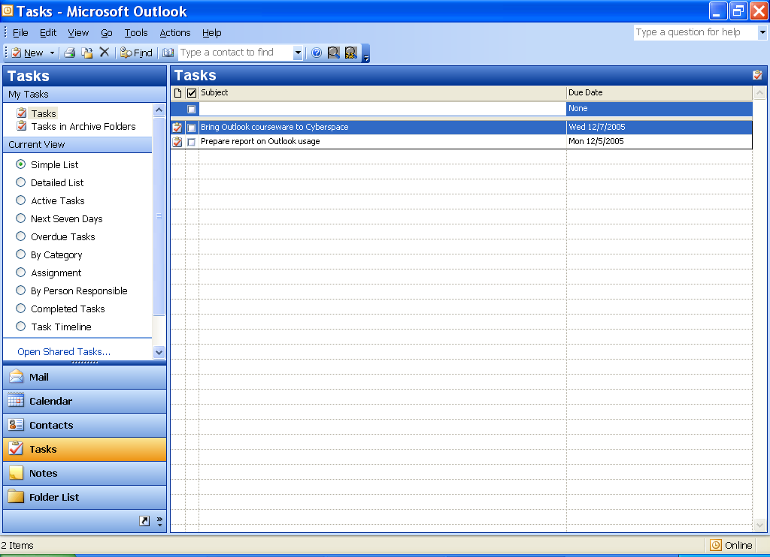
Helpful Hint:

When entering dates, you can type in text like Today, Tomorrow, Next Friday, Next Month, etc. and Outlook will assign the correct day.

Entering a Task

STEPS

- Click the TASKS folder in your Folder List.

- Click on CLICK HERE TO ADD A NEW TASK .

- Enter a subject under Subject. Press the TAB key.

- Enter a due date under Due Date, when one exists.

- To add another task, press the ENTER key.

- When finished entering tasks, click on any blank area of the task list.

Deleting a Task

STEPS

- Select the task you wish to delete.
- Click the Delete button on the toolbar.

- Lesson Example

Some important tasks are on your “to do” list and you would like to use Outlook to track them.

STEPS

- Select the TASKS folder in your Folder List.

- Click on CLICK HERE TO ADD A NEW TASK.

- Enter Pick up stamps under Subject.

- Type Today under Due Date.

- Add another task by pressing the ENTER key.

- Enter Finish monthly reports under Subject.

- Type Next Friday under Due Date.

- Click Save and Close to exit the task.

EXERCISE:

1) Add a new task titled Contact Bates client with a due date of tomorrow.

2) On Your Own: Delete the task.

LESSON 13: OUTLOOK NOTES

OBJECTIVE: Create and manage notes.

OVERVIEW

Outlook notes are the electronic equivalent of sticky notes. Rather than plastering notes all over your desk, you can keep them contained on one Outlook screen.

Adding a Note

STEPS

- Click the NOTES folder in your Folder List.

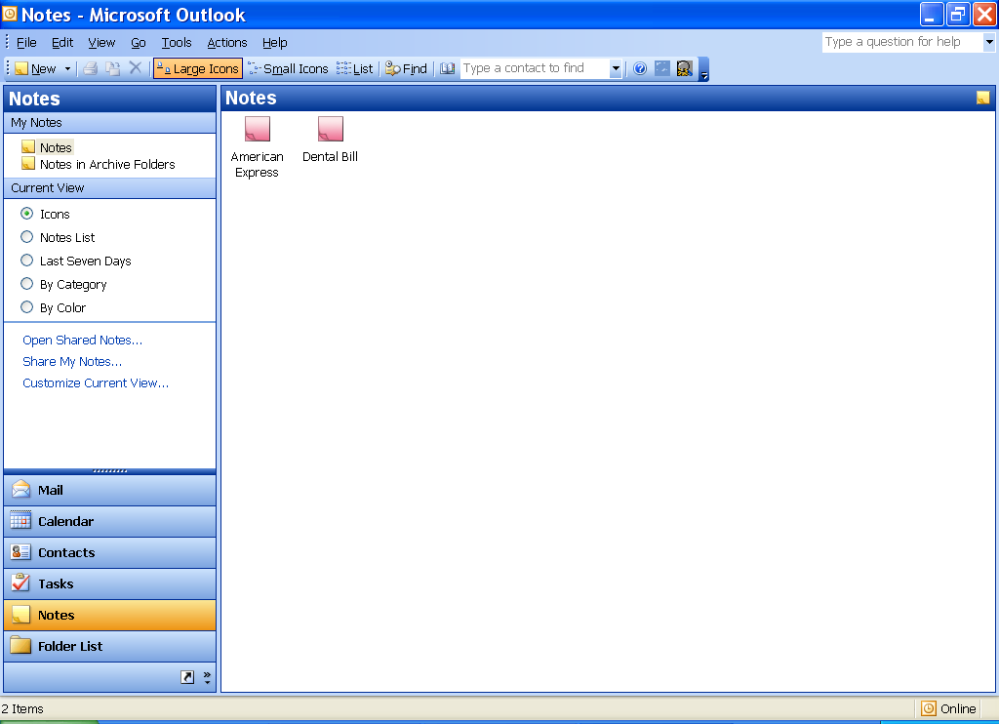

- Double-click on the white space or click the New button. A note will appear as follows:

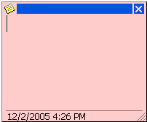

- Type your note.

- Click the CLOSE BUTTON in the upper right hand corner of the note.

- To delete a note, select the note and press Delete .

- Lesson Example

In an effort to reduce the sticky note mayhem at your workstation, you decide to use Outlook notes.

STEPS

- Click on the NOTES folder in your Folder List.

- Double-click on the white space. Type My fax number is 626-5246.

- Click the CLOSE button in the upper right hand corner of the note.

- Delete the note by clicking the Delete button or pressing Delete on your keyboard.

EXERCISE:

1) Add the note Go to kickboxing.

2) View the note. Delete the note.

3) On Your Own: Add the note Eugene’s phone number next week is 555-9876.

LESSON 14: OUTLOOK PRINTING

OBJECTIVE: Print various items in multiple ways.

OVERVIEW

You are able to print many Outlook items, sometimes in a variety of styles. The following are the steps for printing several different Outlook objects:

STEPS

- To print an e-mail message from any mailbox, select the message and click the PRINT button .

- To print an individual contact's information, open that contact and click the PRINT button .

- To print the general information for all contacts, from the Contacts window, click File, print, and select the style you would like.

- Make any appropriate changes in page setup and click ok. If necessary, click the Preview button to look at the setup. When satisfied, click the PRINT button .

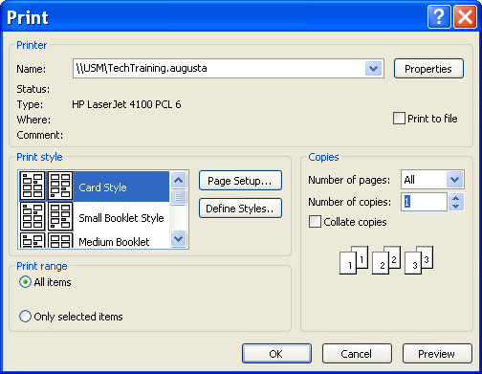

- To print your calendar, from the Calendar window, click File, Print, and select the style you would like.

- Make the appropriate choices in Page Setup, then click ok. If necessary, click the Preview button to look at the setup. When satisfied, click OK.

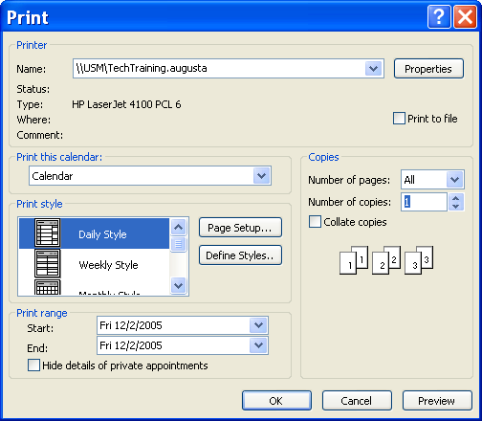

- To print your task list, open the Tasks window and click the PRINT button .

- To print your notes, open the NOTES window. Select the notes you want printed and click the PRINT button .

- Lesson Example

You would like to print out your contacts list to use as a phone directory at your desk.

STEPS

    - Click on the Contacts folder.

    - Click File, then print.

    - Choose the Phone Directory Style from the Print Style box.

    - Click the Preview button to look at the setup. When satisfied, click the PRINT button.

EXERCISE:

1) Print your task list.

2) Preview the printing of an e-mail.

3) On Your Own: Print the current month’s calendar.

LESSON 15: DELETING FILES

OVERVIEW

It is important to regularly remove files from your computer that you no longer need. Unnecessary documents take up space on your computer's drives. You may delete files through Microsoft Word 2000. You may also copy, rename, or print files in the Word 2000 Open dialog box.

STEPS

- Close any open files. Click FILE on the Menu Bar, click OPEN or CTRL + O.

- Locate the file(s) you want to delete.

- Click on the file to delete, press the DELETE KEY on the keyboard, then click YES.

- To choose several files, hold down the CTRL KEY (on the keyboard) and click on each file to delete, press DELETE, then YES.

- To choose a block of files, click on the first file you want to choose, hold down the SHIFT key and click on the last file you want choose, press DELETE, then YES.

- Lesson Example

Several months have passed, and you have a hard copy of your supplies order in a file. You no longer need a copy of this file on your computer.

STEPS

1. Delete your Revised Supplies and Supplies documents from the C:\My Documents folder.

2. Cancel the Open dialog box.

EXERCISE:

- Delete the Open House document.

- On Your Own: Delete all remaining files stored in C:\My Documents.

- Cancel the Open Dialog Box.

- Close Microsoft Word.

LESSON 16: SHUTTING DOWN THE COMPUTER

OVERVIEW

When you’re ready to turn off your computer, it is important in Windows XP to “shut down” the computer by closing out of Windows. This will ensure that Windows has saved all the files and removed any temporary files that may have been created by programs. Always use the Shut Down command to safely shut down Windows.

STEPS

1. Click the START button.

2. Select SHUT DOWN and click OK.

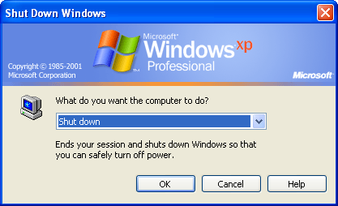

EXERCISE:

1) Initiate the Shut Down procedure.

2) If necessary, select SHUT DOWN from the drop down menu.

3) Shut down your computer and turn it off.
NICE TO KNOW

Changing Mouse Settings

OVERVIEW

Windows was created and designed to maximize use of the mouse. However, in order for you to get the most out of the mouse, you should tailor it for your physical and visual needs.

STEPS

1. Click on START. Choose CONTROL PANEL. (You may also open MY COMPUTER and choose CONTROL PANEL.)

2. Double-click on the MOUSE icon.

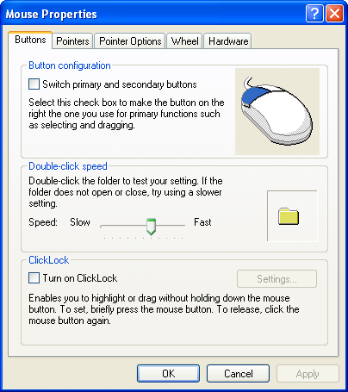

3. To change Button configuration, click the BUTTONS tab and put a check mark in SWITCH PRIMARY AND SECONDARY BUTTONS.

4. To change the double-click speed, click and drag the pointer on the double-click speed control. To test the speed, double-click the folder.

5. To change pointer styles, click the POINTERS tab, click the down arrow next to the scheme box. The available sets of pointers are displayed. Click the desired pointer.

6. To change Pointer speed or add Pointer Trails, click on the POINTER OPTIONS tab. Click and drag the pointer on the SELECT POINTER SPEED. To add pointer trails, put a check mark in DISPLAY POINTER TRAILS.

7. Click APPLY to make the changes and leave this window open, or click OK to set your changes and return to Windows.

♦ Glossary of Terms

OVERVIEW

A large part of learning to use computers effectively is learning the terminology surrounding the technology. It can be very much like learning a foreign language. If you are familiar with certain terms, using the computer and even asking for help can be easier.

CD-ROM | Compact Disc-Read Only Memory drives (usually drive D:) allow the computer to run large programs from a CD-ROM without having to load the program onto the hard drive. CD-ROMs come pre-loaded and cannot store additional information.
Click | Press and release the left mouse button once.
Click and Drag | Hold down the left mouse button and move the mouse.
Close Button | This icon appears as the last button on the right of the title bar. Click on this button to close the program quickly.
Control Menu Icon | This icon is in the upper left-hand corner of the title bar. You can close the program by double-clicking on the icon or by clicking once and clicking CLOSE in the control menu.
Database | An application that produces and maintains lists of information (such as DBase, Foxpro, Approach and Access).
Dialog Box | Small boxes containing options for continuing with a process. For example, when you choose to shut down your computer, a dialog box opens to offer several options.
Double-click | Press and release the left mouse button twice quickly.
Electronic Transfer of Information | Applications that send information from one computer to another (such as E-Mail) over a LAN (Local Area Network) or WAN (Wide Area Network).
Floppy disk drives | Allow you to put in a storage disk that is portable. Floppy drives are usually the A: drive or B: drive.
Folder | Divides storage devices (drives) into categories for organization.
Formatting Toolbar | Usually the second toolbar in which you may change fonts, bold, underline, center text, etc.
Gigabyte (Gb) | A gigabyte is a billion characters of information.
Graphics Packages | Programs for creating and manipulating illustrations (such as Harvard Graphics, Freelance and PowerPoint).
Hard disk drives | Drives inside your computer that are generally not removable. They store the programs and data you type into your computer. The drive inside your computer is usually drive C.
Hardware | The physical equipment that you use to perform tasks, i.e. the different parts that perform computer functions. Hardware includes the monitor, keyboard, mouse, system unit, speakers, and other devices.
Icon | A picture that can represent programs, files, a printer, and computer information. Underneath many icons is a brief description of its function.
Internet | The Internet is an immense network that connects computers at schools, commercial institutions, governments and research labs around the world. Most of the information on these systems can be accessed through an Internet provider using a desktop computer loaded with Internet software and a modem.
Keyboard | The keyboard is similar to a typewriter keyboard (with additional keys). Additional keys include function keys at the top of the keyboard, command keys to the right of the keyboard, and a keypad for numbers.
Maximize & Restore Buttons | Clicking on this button will expand the window to fill all available space or restore it back to its previous size.
Megabyte (Mb) | A megabyte is a million characters of information.

Menu Bar | A list of functions at the top of a program window. Click once on the menu name (or use Alt and the underlined letter). When you click on a menu option, the menu will list the common options. If you wait for a few seconds, the full menu appears, or you can click on the double down arrow button.
Minimize Button | Click once on this icon to reduce the program to a button on the taskbar. Click on the taskbar button to return the program to its previous size. Minimizing the program does not close the program.
Modem | Equipment by which your computer may communicate with other electronic devices such as a fax or Internet servers.
Monitor | Looks like a television screen and acts as the visual connection to any computer process. The information you type, the mouse pointer movement, and program interfaces appear on the screen.
Mouse | For Windows-based programs, the mouse is essential for gaining access to and efficiently utilizing the program.
My Briefcase | When using a desktop computer and a laptop, My Briefcase assists in keeping documents updated on both computers.
My Computer | Provides access to your computer’s contents and allows you to manage files.
Network Neighborhood | Allows you to look at network resources.
Pointing | Positioning the tip of the mouse pointer on an item.
Printer | Produce paper or "hard" copy of computer files.
Publishing Programs | Software used to produce newsletters and brochures (such as PageMaker and Microsoft Publisher).

RAM | Random Access Memory is the internal memory of your computer that holds the programs and documents that you type. When you lose power, you lose whatever is stored in RAM - that is why it is important to frequently save any important information.
Recycle Bin | The Recycle Bin is a temporary storage space for deleted files. Double-clicking on this icon will allow you to retrieve files deleted by mistake.
Shut Down | Shuts down or restarts your computer or logs you off the network.
Software | A list of instructions that tells the computer how to perform certain functions. These programs are often called Applications.
Speakers | Allow you to hear audio playback via your computer.
Spreadsheet Programs | For producing budgets and other accounting tasks (such as Lotus 1-2-3, Quattro Pro and Excel).
Standard Toolbar | The top toolbar where you open, save, print files, etc.
Start Button | Gives you access to Help, changing system settings, and starting programs, among other things.
System Unit | The container for drives, processors, memory, and all of the components that do the actual work in a computer.
Taskbar | Shows what programs are running, if printing is in progress, and displays the time.
Title Bar | The band across the top of the window that contains the name of the program and the program control buttons.
Windows | An operating system that utilizes icons to make it easy for the operator. Windows allows you to run many programs at the same time (called multi-tasking).
Word Processing Software | Produces documents such as letters and memos (software would include WordPerfect, Microsoft Word and Lotus WordPro).

