ADVANCED ACCESS 2003

Table of Contents
Page
LESSON 1: INTRODUCTION 1
♦ Potential Access Outputs 1
♦ The Impact of Data Entry 2
LESSON 2: ADVANCED QUERIES 4
♦ Parameter Queries 4
♦ Crosstab Queries 7
♦ Statistical Queries 12
♦ Calculated Fields 14
♦ Action Queries (Make Table, Update, Append, Delete) 17
LESSON 3: ADVANCED REPORTS 22
♦ Editing Reports in Design View 22
♦ Summary Options 25
♦ Writing Expressions 26
♦ Concatenation 30
LESSON 4: SWITCHBOARDS 33
♦ Creating a Switchboard 33
♦ Edit the Switchboard Form 37
LESSON 5: USING MACROS AND BUTTONS 41
♦ Creating a Macro 41
♦ Create a Command Button 44
♦ Display Options 48
LESSON 6: GIVE IT A TRY! 50
LESSON 7: DELETING OBJECTS 52
NICE TO KNOW 53
♦ Mouse Pointers 53
♦ Toolbar Buttons 54
♦ Keyboard Shortcuts 56

This workbook may be reproduced in whole or in part by an employee of the Department of Health and Human Services. All other reproduction is prohibited unless written permission is obtained from the Training Institute.

INTRODUCTION

OBJECTIVES: Discuss Access output capabilities.
Recognize the impact of data entry on output.

Potential Access Outputs
OVERVIEW

Tables are the basis for all objects in an Access database. Data can be entered either directly into a table, or into a form, which passes data on to the table. Data can be described as the raw facts and figures that are input, but information is more likely what you want to get out of your database. Information takes data and makes it meaningful. For example, data could be the cities where classes are held. Information based on those cities could include how many classes are held in a given city, or how many different cities offer classes.

When you are looking for information from your tables, a variety of tools are available to help you find the specific information you need. You may simply need to scroll through the records in the table or form, use the Find tool, or filter the data as necessary. However, Access provides you with more streamlined methods for extracting information from your database.

Queries allow you to ask a question of your data. The answer to that question appears as a group of records matching certain criteria, and displaying only specific fields. These results are called a dynaset in Access.

Reports display the results of a query or show selected fields from a table, whose records may be grouped and sorted as desired. While all objects created in an Access database may be printed, reports are specifically designed for printing.

The Impact of Data Entry
OVERVIEW

There is a commonly used phrase related to databases that is, “Garbage in, garbage out.” If the data being entered is inaccurate or inconsistent, the information extracted will also be inaccurate or inconsistent. It is very important to realize this fact as you make decisions based on data output.

Another important aspect of the relationship between data entry and output is that you cannot take out what has not been put in. If the data has not been collected and entered, there is no way to pull information based on that data out of your database. Therefore, it is essential that you are very familiar with the content of your database. You should know the fields that exist in each table, how tables are related, how data is collected and entered, and who is responsible for data entry. It is impossible to generate meaningful and accurate queries and reports without this knowledge.

Following are the tables we will be using in this course.

Classes

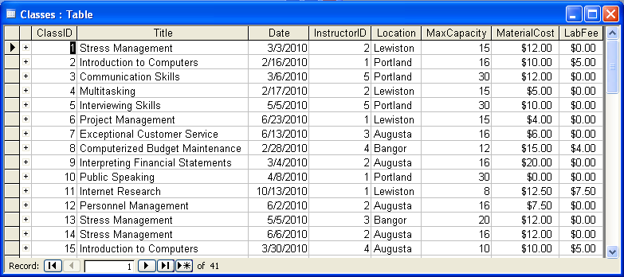

Instructors

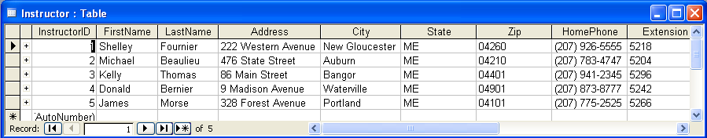

Students

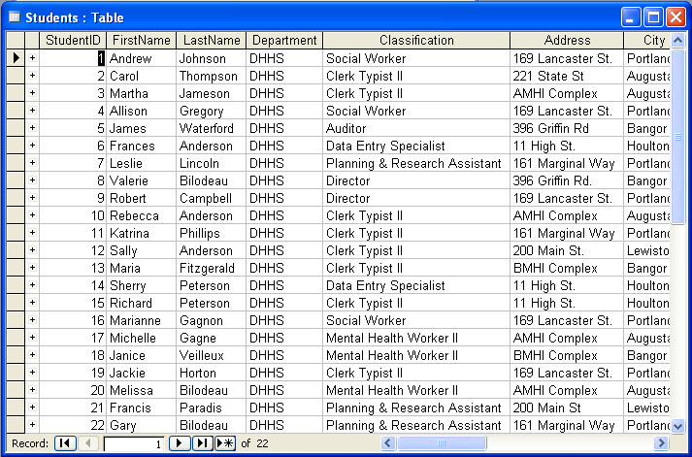

Students, continued…

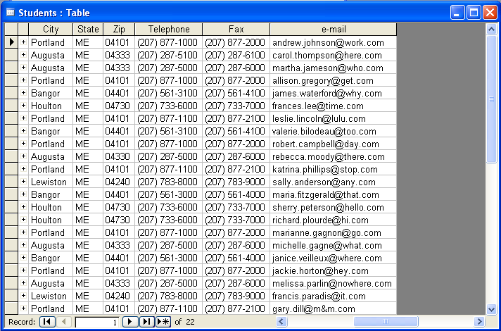

ADVANCED QUERIES

objective: Utilize advanced queries to retrieve information from the tables in a database.
Did You Know?

If you change data in a dynaset (query results), the source table is also updated.

Parameter Queries
OVERVIEW

A Parameter Query allows you to ask a question with criteria that can be set differently each time you run the query. For example, you may create a query with the criteria to find only Region III records, while someone from Region II needs the same information, but for their own region. If the query is initially set up as a parameter query, when it is run, Access will display a dialog box and ask you to type in the Region you wish to see.

STEPS
Helpful Hint:

You must always use square brackets around the text you want in your parameter query. However, you cannot use text that exactly matches a field name in your database. Also, you can use a colon (:) at the end of your message, but not a period (.), as it causes an error to occur.

- Create a SELECT QUERY and include the fields you wish to have appear in your query results.

- Set any standard criteria for the query, if applicable.

- In the criteria line of the field(s) for which you wish to set parameters, type the question you want Access to ask in its dialog box. For example, in the criteria line for the City field, type:

[Enter City]

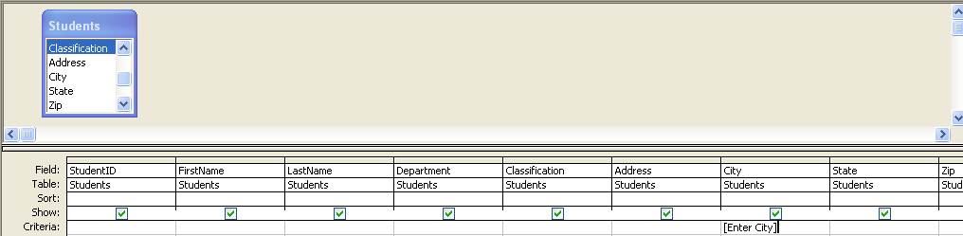

- To create a parameter query that allows you to type just the first letter or two of the entry, type the following:

Like[Enter and your field name:]&*

For example, Like[Enter Classification:]&*

- RUN the query by clicking on the VIEW button , and at the dialog box, type the appropriate response.
Did You Know?

If you want to be able to type any portion of the field entry, type Like *&[dialog box prompt]&* in the Criteria line.

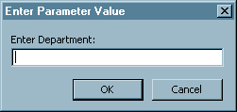

- Look through your results, and return to Design View, if necessary, to make any further adjustments.

- SAVE your query.

Lesson Example

Your supervisor would like to know how many students are taking classes from different locations. She would also like to see how many Social Workers are taking classes in Portland, as well as other locations and classifications. Instead of creating 35 queries to look up each location and each classification, you decide that a parameter query would answer the questions.

STEPS

- Open Access by clicking on Start, Programs, Microsoft Access.

- Open the Advanced Access file (your instructor will give you the location).

- Click the OPEN button on the Security Window.

- Click the Queries object on the objects bar.

- Open the Student Info query in Design View.

- Type [Enter City] in the CRITERIA line of the City field.

- Run the query.

- In the dialog box, type Augusta.

- Return to Design View.

- Run the query again, this time typing Portland in the dialog box.

- Return to Design View.

EXERCISE:

1) In Design View of the Student Info query, add another parameter that prompts for a Classification that allows you to type a few characters by typing the following into the Classification criteria row.

Like [Enter Classification]&*

2) Run the query and find the Classification Social Worker in Portland. Try typing only Soc at the Classification prompt.

3) Save and close the Student Info query.

4) On Your Own: Add a parameter to prompt for Location in your Class List query. Test it for Augusta, then try it again for Lewiston.

5) Close the query without saving your changes.

Crosstab Queries

OVERVIEW

A crosstab query displays summarized values (sums, counts, and averages) from one field in a table and groups them by one set of facts listed down the left side of the datasheet (row headings) and another set of facts listed across the top of the datasheet (column headings). For instance, if you were trying to find out how many cases each case manager had in each city, you could use a crosstab query.

STEPS

- Click the NEW button .

- Select the CROSSTAB QUERY WIZARD. Click OK.

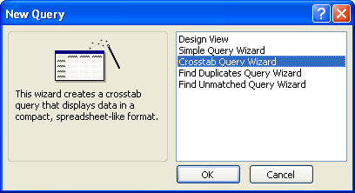

Did You Know?

You can only use one table in a crosstab query. If you need to use more than one table, create a query with the pertinent fields and base the Crosstab query on the new query.

- Identify the table you want to use for the query. Click NEXT.

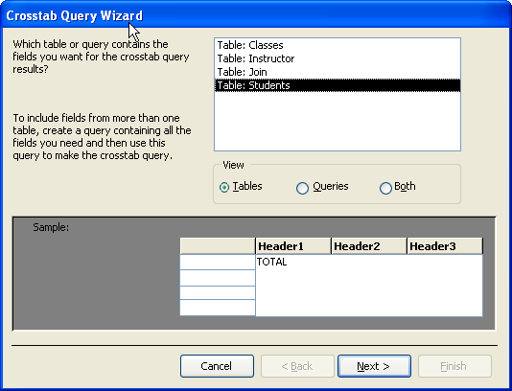

- Select the field(s) that you want to use for row headings. You can identify up to three fields. Click NEXT.

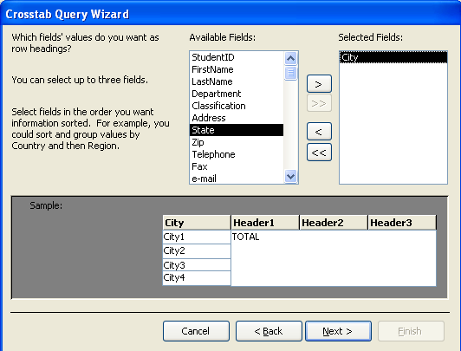

- Identify the field that you want to use for the column heading. You may only choose one. Click NEXT.

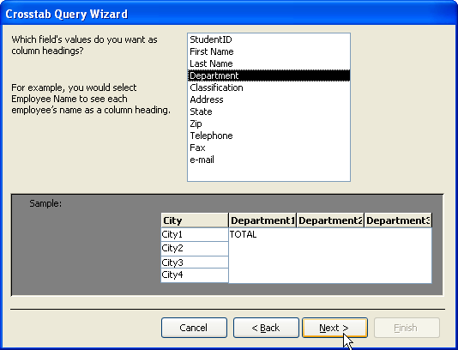

Did You Know?

Text fields in a crosstab query will not have as many calculation options as numeric fields.

- Identify the field that you want to be calculated, and how you want it calculated. Click NEXT.

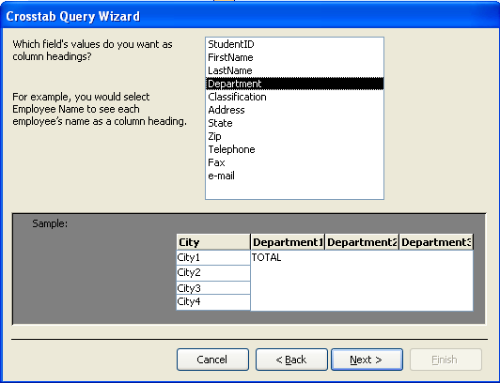

- Name the query. Click FINISH.

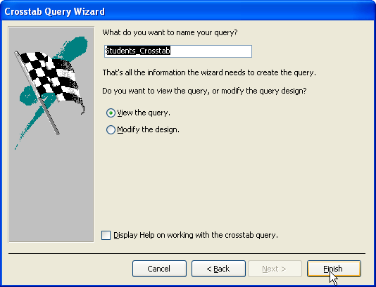

Did You Know?

Crosstab queries are depicted with an icon in the Queries object window.

- View the Query.

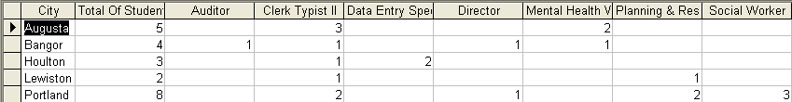

Lesson Example

You are curious about how many students take classes in each city by classifications.

STEPS

- Create a new query by clicking the NEW button.

- Select the CROSSTAB QUERY WIZARD. Click OK.

- Click on the Students table. Click NEXT.

- Double-click on the City field to use as the row heading. Click NEXT.

- Click on the Classification field to use as the column heading. Click NEXT.

- Click on the StudentID field and COUNT under FUNCTION. Click NEXT.

- Save the query as Students_Crosstab. Click FINISH.

- View and close the query.
Did You Know?

You can go into Design View for a Crosstab query and change row and column headings.
EXERCISE:

  - Create a query in design view that has the Students, Join and Classes table with the following fields:
Classes: Title
ClassID
Students: Classification

  - Run the query.

  - Name the query Classification Class Breakdown and close it.

  - Use the Classification Class Breakdown query to create a crosstab query to count the number of students from each classification to take each class.

  - The row heading will be Title, the column heading will be Classification, and count the ClassID field.

  - Save the query as Classification Class Breakdown_Crosstab and close it.

  - On Your Own: Create a crosstab query to look at how many classes are being offered in each city. Use the Classes table and use the Title field as the row heading, and Location as the column heading. Count the ClassID field. Save the query as Classes_Crosstab and close it.

Statistical Queries

Overview

To display the results of a calculation in a field, you can use a predefined calculation that Microsoft Access provides or custom calculations you define. Use the predefined calculations, called "totals", if you want to compute the following amounts for groups of records or for all the records combined: sum, average, count, minimum, maximum, standard deviation, or variance. You choose one “totals” calculation for each field you want to calculate.

STEPS

- Create a new query and add the appropriate fields, or use an existing query.

- In DESIGN VIEW, click the TOTALS button . This will give you a new line (called Total) in the QBE grid at the bottom of the query window.

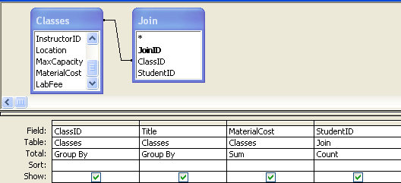

- In the field that you want to perform the calculation, click in the TOTAL line, and select from several calculations that are listed. Total will default to Group By, which defines the groups where you want to perform the calculations. For example, to show material costs by class title, select Group By for the Title field.

- Run the query.

Lesson Example

You want to create a query to calculate how many students are enrolled in each class, and how much money students are paying in material fees per class.

STEPS

- Create a new query in Design View using:

Classes table – ClassID, Title, and MaterialCost
Join table – StudentID

- Click the TOTALS button. This will give you a new line called Total in the QBE grid at the bottom of the query window.

- Assign these calculations by clicking in the TOTAL line, and select the calculation listed:

ClassID – Group By
Title – Group By
MaterialCost – Sum
StudentID - Count

- Run the query. Save as Total Material Costs and close it.

EXERCISE:

1) Create a query in Design View using the Title and LabFee fields from the Classes table. Sum the lab fees for any classes that have them. Save as Classes With Lab Fees. (Hint: Use the Sum statistical function and type >0 in the Criteria field for LabFee).

2) On Your Own: You want to determine the average amount being paid in material fees. Reopen Total Material Costs, and add another field to average the material costs. To do this, in the next column after StudentID, insert another MaterialCost field. In the Total row, select Average. Save as Average Material Costs.

Calculated Fields

Overview

In addition to the statistical queries that calculate groups of records, there are other types of calculations you can perform in a query that modify individual fields. For example, you can multiply the values in two fields, or calculate the date three months from the current date. When you display the results of a calculation in a field, the results aren't actually stored in the underlying table.

STEPS

- Create a new query and add the appropriate fields, or use an existing query.

- In DESIGN VIEW, type an expression (formula) in an empty cell in the Field row. If the expression includes a field name, you must place square brackets around the name. (Example: [Date]+15)

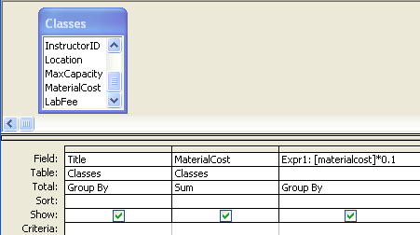

- Press the ENTER key.

- RUN the query.

- To rename the new field (from EXPR1), in DESIGN VIEW, type over the Expr# with the field name you prefer. You may name the new calculated field when creating the expression simply by typing in the name you want for the field, followed by a colon (:), then type the expression.

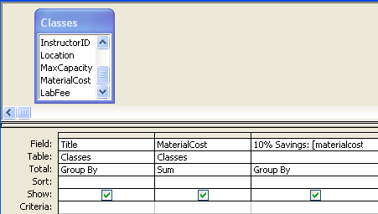
Did You Know?

When working with percentages in calculations, type 0.10 instead of 10%.

- To format the field as currency, in DESIGN VIEW, click the PROPERTIES button or right mouse click over the field you want to format and select PROPERTIES. On the General tab, change the FORMAT to CURRENCY.

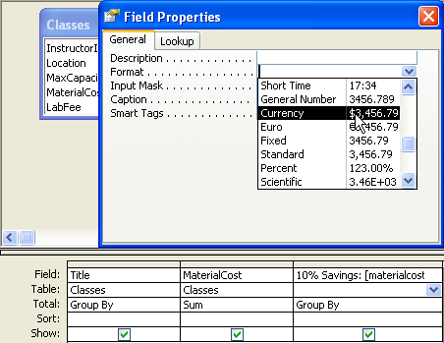
Helpful Hint:

If you type an expression and get a parameter box when you run the query, it means that one of the field names is misspelled and correct it in the formula.

Lesson Example

Your supervisor is considering reducing material fees. You decide to create a query that will calculate how much students will save in each class if material costs are cut by 10%.

STEPS

- Create a new query in Design View with the Title and MaterialCost fields from the Classes table.

- Type [MaterialCost]*0.10 in the next empty cell in the Field row.
Did You Know?

You can use an expression name as a field if you want to use it in another calculation. Be sure to use the brackets [ ] when referring to it.

- Press ENTER.

- RUN the query.

- Go back into DESIGN VIEW, and rename the new field 10% Savings by typing over the Expr1.

- Click the PROPERTIES button.

- On the General tab, change the format to CURRENCY.

- Save the new query as 10% Savings.

EXERCISE:

1) Determine how much we receive in student fees for each class if the class is fully enrolled. From the Classes table, use the Title, Date, MaxCapacity, MaterialCost, and LabFee fields.

2) In the next available field type Total: [MaxCapacity]*([MaterialCost]+[LabFee]).

3) Save the query as Total Student Fees.

4) On Your Own: Determine how much students would save if lab fees were cut 5%. Reformat the calculated field to be in currency format. Save as 5% Savings (Hint: Use the 10% Savings query as a guide).

Action Queries (Make Table, Update, Append, Delete)

Overview
Helpful Hint:

It is a good idea to save all queries as select queries, not as action queries. This prevents other users from accidentally running an action query by opening it.

Normally, the majority of the queries you will create are Select queries. You specify criteria and run the query, it tallies the data and displays the results in datasheet view. Occasionally, you may need the query to do more, such as make a new table, or add data from one table into another; those tasks require an action query to be built. An action query is a query that makes changes to many records in just one operation. There are four types of action queries: make-table, update, append, and delete.

- Make-Table Query: Creates a new table from all or part of the data in one or more tables. Make-table queries are helpful for:

- Creating a table to export to other Microsoft Access databases. For example, you might want to create a table that contains several fields from your Employees table, and then export that table to a database used by your personnel department.

- Making a backup copy of a table. If you update records in the original table, the table created in the Make-Table process will not be updated. Also, relationships and other properties (such as input masks) do not carry over either.
- Creating a history table that contains old records. For example, you could create a table that stores all your old orders before deleting them from your current Orders table.
Helpful Hint:

When using an Append query make sure that the destination table has all the fields that are in the table to be appended, of not, add the fields to the destination table and then process the append query.

  - Update Query: Makes global changes to a group of records in one or more tables. For example, you can raise prices by 10 percent for all training products, or you can raise salaries by 5 percent for the people within a certain job category. With an update query, you can change data in existing tables.

  - Append Query: Adds a group of records from one or more tables to the end of one or more tables. For example, suppose that you acquire some new customers and a database containing a table of information on those customers. To avoid typing all this information in, you'd like to append it to your “Customers” table. Append queries are also helpful for:

- Appending fields based on criteria. For example, you might want to append only the names and addresses of customers with outstanding orders.

- Appending records when some of the fields in one table don't exist in the other table. For example, you have a Customers table that has 11 fields. Suppose that you want to append records from another table that has fields that match 9 of the 11 fields in the Customers table. An append query will append the data in the matching fields and ignore the others.

  - Delete Query: Deletes a group of records from one or more tables. For example, you could use a delete query to remove products that are discontinued or for which there are no orders. With delete queries, you always delete entire records, not just selected fields within records.

STEPS

- Create a query using the necessary fields from the appropriate table.

- Run the query and note how many records there are. Save the query.

- Return to design view of the query.

- Click on the QUERY TYPE button . Select the appropriate action query from the listing. Notice that the query type (in the query title bar) changes from a Select query to the action query you selected.

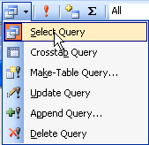

- The steps differ based on which type of action query you are creating.

- To create a Make-Table query, Name the new table and determine where you want the new table located. Click OK.

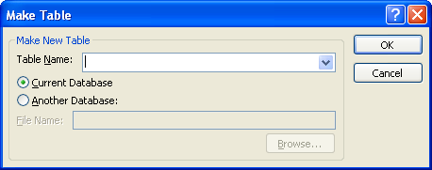

- To create an update query, type an expression in the Update To row for the field that you want updated.

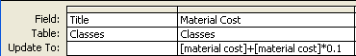
Did You Know?

The datasheet view button will allow you to see what data will be affected by the action query without actually carrying out the action. To run the query, you must click the Run button.
- To create an append query, identify which table you want to append into, and click OK.

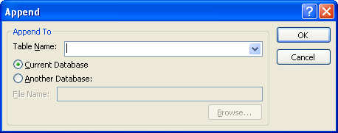

- To create a delete query, indicate any criteria that will identify the records to be deleted in the Criteria row. Where appears under all fields, From will appear if an entire table is sent to the QBE grid.
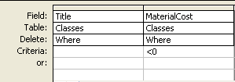

- Click the RUN button . Access will perform the action query that you requested. You may have to click YES if a message box appears (depends on the action query selected).

- Close the query.

Lesson Example

You want to split the Students table, so that you can use the data for other purposes, without recreating it. Create a table for Clerk Typist II’s using the Make-Table feature.

STEPS

- Create a query in DESIGN VIEW. Use all of the fields from the Students table. Save the query as Make Clerk Typist II Students.

- In the Criteria row for the Classification field, type Clerk Typist II as the criterion.

- Run the query and note the number of records.

- Return to design view of the query.

- Click on the arrow next to the QUERY TYPE button. Select Make-Table QUERY.

- Name the new table Clerk Typist II Students and place it in this database. Click OK.

- Click the RUN button, then click YES. Access will create a new table called Clerk Typist II Students and will tell you how many records got pasted into it.

- Save the query, close the query and notice the icon for a Make- Table QUERY.

- Click on the Tables object in the objects bar and see that the new table has been placed there.

EXERCISE:

1) The instructors are going to be attending some classes, so you need to add them to the Students table. Create a new query in Design View based on the Instructor table. Add all fields. Save as Append Instructor.

2) Change Select Query to an Append Query. Append to the Students table by selecting it from the drop-down list. Click OK. Run the query. Click YES at the message box. Close the query but don’t save changes.

3) View the Students table to see that 5 new records were added. Notice that information is inserted only where the field names were an exact match.

4) Material Costs will be 10% less than they are now. Create a new query in Design View based on the Classes table to it. Use the ClassID, Title, and MaterialCost fields. Save as Update Material Costs.

5) Change Select Query to Update Query. Click in the MaterialCost column. In the Update To row type [MaterialCost]- [MaterialCost]*0.1. Run the query. Click YES at the message box. Close the query but don’t save changes.

6) View the Classes table to see that the material costs have decreased 10%.

7) On Your Own: Identify the correct action query to use.

To create a new table Delete

To make a global change Append

To add records from another table Update

To remove certain records from a table Make-Table

ADVANCED REPORTS

Objective: Customize and edit reports.
Did You Know?

All editing features you can do in design view of forms, you can do in design view of reports.

Editing Reports in Design View

Overview

You can improve the layout and readability of your report if the wizard doesn’t give you what you were expecting by viewing the report in Design View and customizing it.

STEPS

- To move a text box and its label, click on the box once. Move your mouse pointer so that it is between any of the handles (small black boxes on the perimeter). When you see a little hand , click and drag the field to the new location.

- To move a text box or label, click on the box once. Move your cursor to the upper left corner. When you see a pointing hand , click and drag the field to the new location.

- To resize a control (a.k.a. box), click on the box once. Move your cursor so that it is over one of the handles. When you get the double headed arrow mouse pointer , , or , click and drag to resize.

- To add color to the background of a selected control, click the FILL button on the toolbar to color the background, or use the drop-down arrow to choose another color.

- To add color to the text of a selected control, click the TEXT button on the toolbar to color the text, or use the drop-down arrow to choose another color.

- To add color to a line, select the line and click the LINE button on the toolbar to change the effect of the line, or use the drop-down arrow to choose another color.

- To insert a page break, click the Page Break button on the toolbar and click in the report section where you would like the report to start on a new page (for example, at the bottom of the detail section).

- To expand the report area, get the double-headed arrow by placing the mouse pointer just above the section bar, click and drag down or up.

- To change the autoformat select the report by clicking on the gray box that connects the top and side ruler, so that it has a black square in the center.
- Click the AUTOFORMAT button on the Standard toolbar.

- Select the new background that you want. Click OK.

- Click the PRINT PREVIEW button on the toolbar to see the report

Lesson Example

Customize the Students report so that it is pleasing to you.

STEPS

- Open the Students report in Design View.

- Click the AutoFormat button and select Formal.

- Move the Students box in the Report Header so that it is centered.

- Click in the Detail section to select it, then click the arrow next to the Fill/Back Color button and select navy blue.

- Select all the text boxes in the Detail section by holding down Shift and clicking on each box.

- Change each text box font color to white by clicking on the arrow next to the Font/Fore Color button and selecting white.

- Save your changes.

- Click the PRINT PREVIEW button to view the report and then close.

EXERCISE:

1) In the Student Transcript report, apply a new AutoFormat.

2) On Your Own: Make any other manual changes you like to the report. Save your changes.

Summary Options

overview

Did You Know?

In order to see the Summary Options button during the wizard, you must have fields with data types of number, currency, or yes/no and choose grouping levels or have multiple tables.

Summary options are calculations that are available to you while you are using the Report Wizard. They provide standard calculations (sum, average, minimum and maximum) for fields in your report.

steps

- Use the Report Wizard to make a report by double clicking Create Report by Using the Wizard.

- On the Sort Order and Summary Information screen of the wizard, click the Summary Options button.

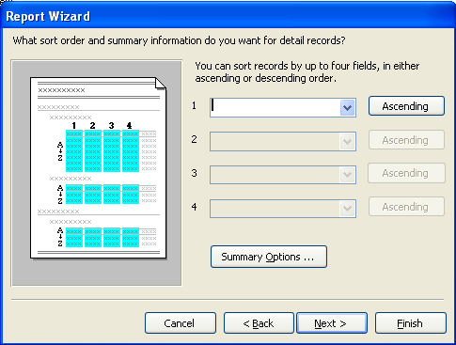

- Click the check box below the calculation (Sum, Avg, Min, Max) you would like to use for the field(s) you would like to compute in the report.

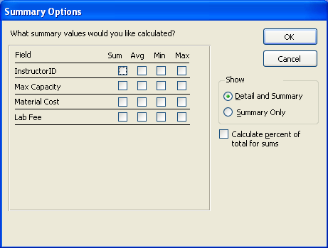

- Click whether you would like to display Detail and Summary or Summary Only.

- Click Ok and continue with the Report Wizard.

Writing Expressions

Overview

Just like you can perform calculations in queries, you can perform them in a report. The results of the calculations are not stored in any table.

STEPS

- Select a report and click the DESIGN VIEW button on the toolbar.

- Click the TOOLBOX button on the Standard Toolbar.

- Click the TEXT BOX button on the Toolbox Toolbar, and then click on the new location.

- To change the label name, click and drag over the Text # (the label) and add a new label name, or you may want to get rid of it entirely by deleting it.

- To add an expression in the text box, click the text box, and type the new expression (Example: =[Hours]*[Hourly Wage]).



- To use the expression builder to help create the formula, click the PROPERTIES button on the toolbar.

- Click in the CONTROL SOURCE BOX and type the expression.

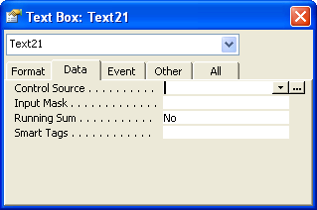
Type expression here
Build button

- To get help with the expression, click the BUILD button to the right.

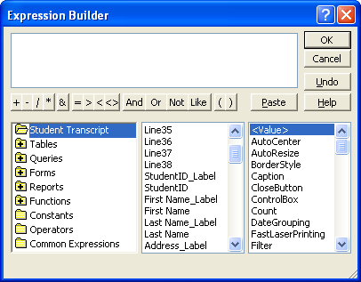

- To format a result box, select it and then click on the PROPERTIES button , and click on the FORMAT tab. Select a choice from the drop down list in the FORMAT row.

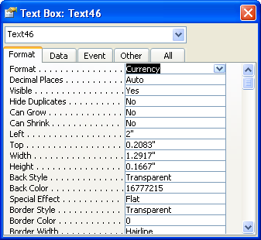

Lesson Example

Create a report that will calculate each student’s material costs and lab fees.

STEPS

- Create a new report using the Report Wizard:

Students table: StudentID, FirstName, and LastName

Classes table: Title, Date, Location, MaterialCost, and LabFee

- Make the following selections in the Report Wizard:
View data by Students.
No groupings.
Sort ascending by Date.
Sum MaterialCost and LabFee from Summary Options.
Choose Outline1 layout with portrait orientation.
Select Corporate style.
Name the report Student Costs.

3. Click the VIEW button on the toolbar.
- Click the TOOLBOX button on the Standard Toolbar.

- Place your mouse at the top of the PAGE FOOTER bar, with the two-headed arrow, click and drag down to make the STUDENTID FOOTER approximately ¼ inch larger.

- Click the TEXT BOX tool, and then click in the StudentID footer section and below the Sum of Material Cost text box.

- Click and drag over the label and rename it Total Costs.

- Click the unbound text box, and type the expression =sum([MaterialCost]+[LabFee]).

- Go to Print Preview to see how the new field looks.

- Go back to Design View and move controls if needed.

- Click on the text box and click the Bold button. You may need to resize your text box to accommodate the data.

- Change the color of the label to match the others.

- Click on the Total Costs result box

- Click on the PROPERTIES tool, and click on the FORMAT tab.

- Select CURRENCY from the drop down list in the FORMAT row.

- Save, view, and then close the Student Costs report.

EXERCISE:

1) Add a text box to the Detail section of the Student Transcript report before Date.

2) Change the label to Last Date of Refund:.

3) Cut the label and paste it into the STUDENTID HEADER.

4) Move it to the left of Date and resize it by making the width smaller and the height larger.

3) In the unbound textbox, create an expression that will calculate the last date of refund as 15 days after the date that the class started (Hint: =[Date]+15).

4) Resize, move, and reformat the label and text box as necessary.

5) On Your Own: Calculate the Grand Total of Total Costs in the Report Footer and format it to currency.

6) Save the report.

Concatenation

Overview

You can use the concatenation feature to combine two fields into one, seamlessly, so that gaping spaces are eliminated. One common area where concatenation is used is to combine the First Name field with the Last Name field to eliminate problems with huge spaces between those fields. (Example: MARIA MATTISON)

STEPS

- Select a report and then click the DESIGN VIEW button on the toolbar.

- Click the TEXT BOX button , and then click on the new location.
Helpful Hint:

You may type the expression directly into the text box if you prefer.

- Click and drag over the label and add a new label name, or you may want to get rid of it entirely by deleting it.

- Click on the text box. Click the PROPERTIES button on the toolbar.

- Click on the DATA tab, and click in the CONTROL SOURCE field.

Type expression here
Build button

- Click the BUILD button to the right of the field.

- Scroll down in the listing of controls that are on your report (middle panel). Double click FirstName (not FirstName_ Label), type a &“ ”& (ampersand quote space quote ampersand), and double click LastName, as shown below.

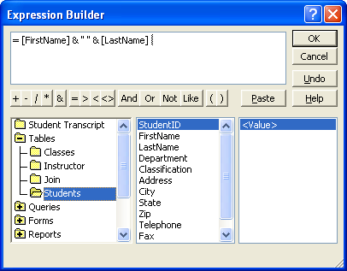

- Click OK, then close the Properties box.

Lesson Example

You want the students’ first and last names to appear at the top of each page in the Student Transcript report. But, when you add the text boxes there is a huge gap between the two fields.

STEPS

- Open the Student Transcript report in Design View.

- Click on the PAGE BREAK button and then click in the lower right-hand corner of the STUDENTID FOOTER.

- Click the TEXT BOX button, and then click below the Zip label in the STUDENTID HEADER section.

- Click and drag over the label and add the new label name Student:.

- Click in the unbound text box. Click the PROPERTIES button on the toolbar.

- Click on the DATA tab, click the CONTROL SOURCE field, and then click the BUILD button to the right.

- Scroll down the list of controls that are in your report (middle panel). Double-click FirstName (not FirstName_ Label).

- Type a &“ ”& (ampersand quote space quote ampersand).

- Double click LastName.

- Click OK, and close the Properties box.

- View the report in Print Preview.

EXERCISE:

1) Delete the FirstName and LastName textboxes and labels. Move the Student: label and textbox to the upper right-hand corner of the section.

2) Move the Address label and textbox directly below the Student: label.

3) Add another text box below the address that concatenates the City, State, and ZIP fields.

2) Delete the remaining extra fields in the StudentID header.

3) On Your Own: What other fields might you want to concatenate?

SWITCHBOARDS

Objective: Create a user interface for your database.

OVERVIEW

A switchboard is a form that may contain buttons that you can click to open other forms and reports, exit Access, or even customize the switchboard to meet specific needs. A switchboard gives the user direct access to the major tasks performed in the database and can be used to deny access to certain areas in the database.

Creating a Switchboard

Overview

Access will automatically create a Switchboard that you can modify.

STEPS

- Click TOOLS, DATABASE UTILITIES, SWITCHBOARD MANAGER.

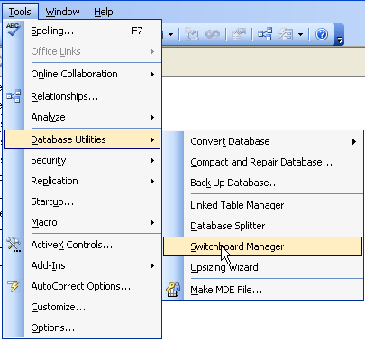

- Click YES at the following window

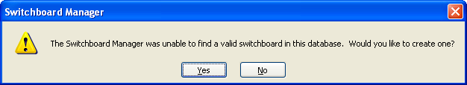

- Highlight the main Switchboard. Click on the EDIT button.

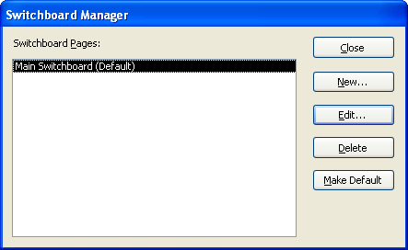

- On the Edit Switchboard window, click the NEW button.

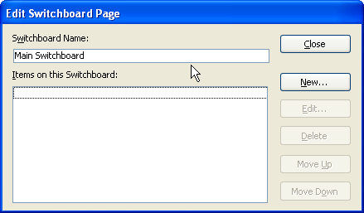

- Type the name of your switchboard item where it says Text on the Edit Switchboard Item window. In the Command drop down list, select the command that you want to perform. The last piece of information that is required is the name of the database object that you want affected by the command. Click OK.

Did You Know?

If you type an ampersand (&) in front of any letter in the TEXT line, when the Switchboard is open, you may press the key for that letter to activate the item. The letter will be identified with an underscore.
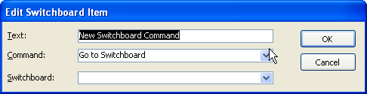

- To add more items to your switchboard, repeat Steps 4 and 5.

- To edit or delete items on your switchboard, on the Edit Switchboard page, identify the item and click the EDIT or DELETE buttons (as seen in Step 4).

- To move items on your switchboard, on the Edit Switchboard page, identify the item and click the MOVE UP or MOVE DOWN buttons.

- To complete your switchboard, close all windows back to your database screen.

- To keep users from getting to the database window, go to Tools, Startup, and remove the checkmark to Display Database Window. Click Ok.

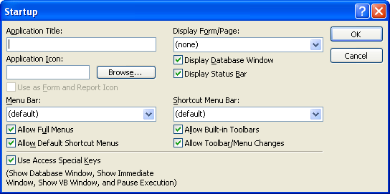

Lesson Example

You want to create a switchboard for your database. We’ll add the Students form, as well as the Students report.

STEPS

- Click TOOLS, DATABASE UTILITIES, SWITCHBOARD MANAGER.

- Click YES to create a Switchboard.

- Click the NEW button.

- Type Edit Student Information on the Text line. In the Command drop down list, select OPEN FORM IN EDIT MODE. Select the Student form under Form. Click OK.

- Click NEW.

- Type Register New Students on the Text line. In the Command drop down list, select OPEN FORM IN ADD MODE. Select the Student form under Form. Click OK.

- Click NEW.

- Type View Students Costs on the Text line. In the Command drop down list, select OPEN REPORT. Select the Student Costs report. Click OK.

- Close all windows back to your database screen.

- View your switchboard by clicking the FORMS object and double clicking the SWITCHBOARD form. Close the form.

EXERCISE:

1) Go back to the Switchboard Manager and add the following item:

Open the Student Transcript report. Name the item View Student Transcripts.

2) On Your Own: Go back to the Switchboard Manager and add the following item:

Open the Classes form in add mode. Name the item Enter New Classes.

3) Exit the Switchboard Manager and then view and close the form.

Edit the Switchboard Form

Overview

Once you have created your switchboard, you can customize it so that it looks like your other forms and gives the database a professional look.

STEPS

- Click on the FORMS button on the objects bar.

- Open the SWITCHBOARD form in Design View. Edit this form as you would any other form. Do not delete the eight controls where switchboard items will be displayed, or you will have trouble using your switchboard. Even though you may not need all of those controls, Access will look for them, and display error messages when it can’t find one.

- Activate the Toolbox toolbar if it does not appear by clicking on the Toolbox button .
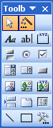

- To insert a picture on the form, click the Unbound Object Frame button and then click on the switchboard where the picture should appear. Select a picture from the Microsoft Clip Gallery (or another location of your choice). Click Ok. Select your picture and click the Insert Clip button to insert it.

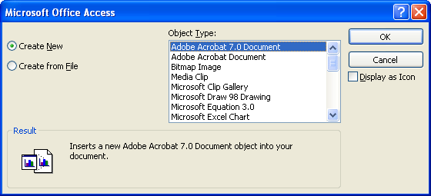
Helpful Hint:

Do not delete the controls where switchboard items will be displayed, or the switchboard will not work properly.

- To resize the picture, activate the PROPERTIES window for the picture once it is inserted. On the FORMAT tab, change the Size Mode to ZOOM.

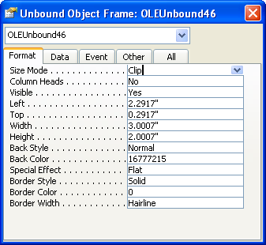

- Save your changes.

Lesson Example

STEPS

- Open the SWITCHBOARD form in Design View.

- Select the background by holding down Shift and clicking on the left side of the switchboard and the top of the switchboard.

- Click the arrow next to the Fill/Back Color button and selecting light blue.

- Activate the Toolbox toolbar if it does not appear by clicking on the Toolbox button.

- Click the Unbound Object Frame button, and click in the area on the left side of the form.

- Select MICROSOFT CLIP GALLERY, and click OK.

- Choose a picture of your liking.

- Go back to properties and on the FORMAT tab, change the Size Mode to ZOOM.

- Resize and move as necessary.

- Save your changes.

- View your form to see the results.

EXERCISE:

  - Open the Switchboard in Design View.

  - Change the font for Advanced Access by selecting the text box and clicking on the drop-down arrow next to the current font and changing it to Arial, size 20..

  - On Your Own: Change the background color to a color of your choice.

  - Save your changes and close the switchboard.

USING MACROS AND BUTTONS

Objective: Utilize macros and buttons to enhance database functionality.

Creating a Macro
OVERVIEW

A macro is a set of one or more actions that perform a particular operation, such as opening a form or printing a report. Macros can help you to automate common tasks. For example, you can run a macro that prints a report when a user clicks a command button.

When you create a macro, you record the actions that you want to carry out. Unlike Word or Excel, Access doesn’t allow you to perform the steps to record them, you need to type the action arguments in, for this reason you may find that it is helpful to do the steps and write them down. That way, when you create the macro, it will be easier to remember all of the steps.

STEPS

- Click the MACROS button in the object window, and then click NEW.

- In the first row, click the drop-down arrow to choose the action you want.

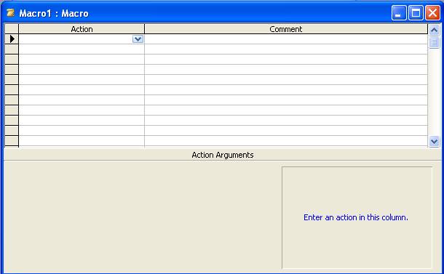

- Click in the ACTION ARGUMENTS box at the bottom (or press F6 to move to this pane).

- Change the Action Arguments (such as the name of the table to open), and then press F6 to move back or click in the upper pane.
Helpful Hint:

You can only have one AutoExec macro.

- Add other actions you want to include, then close and save the macro.

- To use the macro, select it and then click the RUN button in the Database Window.

- To create a macro that will automatically run when the Access file is opened, name the macro Autoexec.

Lesson Example

You want to create a macro that will open the RegisterStudents form maximized, in a new record, so that it will make entering new students and registering them for classes easier.

STEPS

- Click on the MACRO button on the objects bar, and then click NEW.

- Click the drop-down arrow under Action to choose OPENFORM. Click in the ACTION ARGUMENTS box at the bottom (or press F6 to move to this pane).

- The Form Name will be RegisterStudents, and the Data Mode will be ADD.

- In the next ACTION row, click the drop down arrow and select MAXIMIZE.

- Close and save the macro as Register New Students.

- Click the RUN button in the Database window.

- Close the form and return to the objects window.

EXERCISE:

  - Create a macro that will open the switchboard, maximized. To make the switchboard open automatically every time the database is opened, name the macro Autoexec.

2) On Your Own: Create a macro named BacktoSwitchboard that will close the RegisterStudents form and open the switchboard maximized.

3) Use the Close action. In the properties pane, choose the object type of form, and the object name RegisterStudents.

4) Add the second action OpenForm the Switchboard. Remember to set the properties to open the correct form.

5) Add the third action to Maximize. No properties need to be changed.

6) Try out the BacktoSwitchboard macro.

7) Close the database and reopen it.

8) Go back to the objects window.

Create a Command Button
You can create 30 different types of command buttons by using the Command Button Wizard. For example, you can create a command button that finds a record, prints a record, opens another form, or applies a form filter. You use a command button on a form to start an action or a set of actions. If you want a button to perform multiple tasks, simply create a macro then build the button from that.

Command Button Options:
Category | Action | Description of Action
Record Navigation | Find next | Use this once a FIND has already been performed.
Record Navigation | Find record | This displays the Find and Replace dialog box.
These four controls match the record navigation buttons. | Goto first record | Go to the first record.
These four controls match the record navigation buttons. | Goto last record | Go to the last record.
These four controls match the record navigation buttons. | Goto next record | Go to the next record.
These four controls match the record navigation buttons. | Goto previous record | Go to the previous record
Record Operations | Add new record | Adds a new, blank record.
Record Operations | Delete record | Deletes the current record.
Record Operations | Duplicate record | Duplicates the current record.
Record Operations | Print record | Prints the current record.
Record Operations | Save record | Saves the current record-this is not a necessary button since all data entry is saved as soon as you move off of the field.
Record Operations | Undo record | Un-does the last thing.
Form operations | Apply form filter | Applies an already existing filter to the current form.
Form operations | Close form | Closes the current form
Form operations | Edit form filter | Brings you to Edit filter view which is very similar to query view.
Form operations | Open form | Opens a specified form
Form operations | Print a form | Prints all of the records in the form.
Form operations | Print current form | Prints all of the records in the form.
Form operations | Refresh form data | It updates only data that already exists in your datasheet or form. It doesn't reorder records, display new records, or remove deleted records and records that no longer meet specified criteria.
Report Operation | Mail report | Creates a file that it then attaches to a new, blank email message.
Report Operation | Preview report | Opens the report in Print Preview.
Report Operation | Print report | Prints the report without displaying in Print Preview.
Report Operation | Send report to File | Outputs the report to a file.
Application | Quit application | Exits Microsoft Access.
Application | Run application | Opens a Microsoft Application.
Application | Run MS Excel | Opens Microsoft Excel.
Application | Run MS Word | Opens Microsoft Word.
Miscellaneous | Auto dialer | Opens Microsoft Phone Dialer, which allows you to make voice calls, video calls, and conference video calls from your personal computer.
Miscellaneous | Print table | Prints the selected table.
Miscellaneous | Run macro | Runs the selected macro.
Miscellaneous | Run query | Runs the selected query.

STEPS

- Turn on the Toolbox toolbar by clicking the TOOLBOX button on the STANDARD toolbar.

- In Design View of the form, click on the COMMAND BUTTON button on the TOOLBOX toolbar and then click where you want the button to be placed.

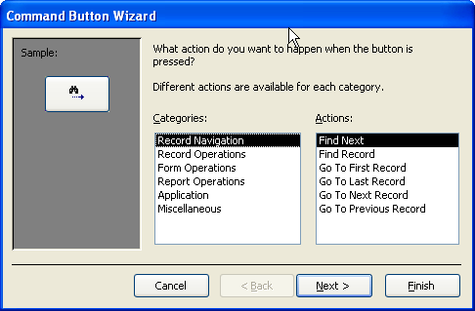

- Click on your choice from the CATEGORIES.

- Select the appropriate ACTIONS.

- Click NEXT.

- The following screens vary depending on the categories and actions chosen.

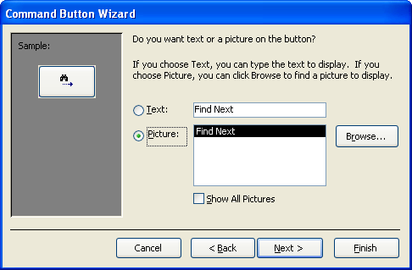

- To have the button display text, type the text in the TEXT line.

- To have an image, choose a default image or click BROWSE to locate your own.

- Click NEXT.

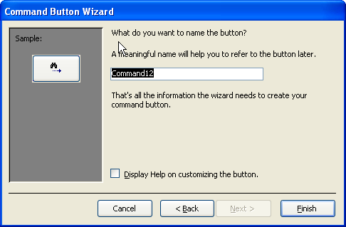

10. Type a name for the command button and click FINISH.

Display Options
You may want to have a command button on your form that will print the current record. If you do not want the button to print along with the form, then you need to change the display properties.

STEPS

- Click the command button.

- Click PROPERTIES on the toolbar to open its property sheet.

- On the FORMAT tab, set the DISPLAY WHEN property to your choice.

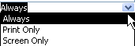

- ALWAYS: displays the button on the screen and prints it out.
- PRINT ONLY: only displays the button on a printed form.
- SCREEN ONLY: only displays the button on the screen.

Lesson Example

You want to create a button that will print out the current form.

STEPS

  - Open the RegisterStudents form in design view.

  - Turn on the Toolbox toolbar by clicking the TOOLBOX button on the STANDARD toolbar.

  - Click on the COMMAND BUTTON button on the TOOLBOX toolbar and then click in the detail section.

  - Click RECORD OPERATIONS from the CATEGORIES.

  - Select the PRINT RECORD.

  - Click NEXT.

  - Type Print Student Information in the TEXT line.

  - Click NEXT.

  - Type PrintRecord for the command button and click FINISH.

  - Click PROPERTIES button on the toolbar to open its property sheet.

  - On the FORMAT tab, set the DISPLAY WHEN property to SCREEN ONLY.

EXERCISE:

1) Create a button that will use the BacktoSwitchboard macro (Hint: Choose RUN MACRO from the MISCELLANEOUS category and choose the BacktoSwitchboard macro).

2) Set the button properties to only display on the screen.

3) Save the form and return to Form View.

4) Test the buttons.

5) On Your Own: Create a button to preview the Student Transcript report on the RegisterStudents form (Hint: Choose PREVIEW REPORT from the REPORT OPERATIONS category).

6) Set the button properties to only display on the screen, save the form and return to Form View.

7) Test the button.

GIVE IT A TRY!

OBJECTIVE: Practice new skills learned in class.

EXERCISE:

Refer to Lesson 2 for assistance

- Using the Advanced Access database, create a query in design view that shows the Location, MaterialCost, and Title from the Classes table. Name it Material Cost per Location.

- Create a crosstab query to find out how much each location will generate in Material Costs. Use Location as the Row Heading; Title as the column heading, and Sum MaterialCost.

- Use the Material Cost per Location query. Save as Material Cost per Location_Crosstab.

- Create a query based on the Classes table that will show Title, Material Cost and Lab Fee. Create a calculated field that will add together material costs and lab fees. Save as Total Fees.

- Create a Make-Table query that will create a new table based on the Students table to show students from Augusta. Name the new table Augusta Students and save it as an action query.

Refer to Lesson 3 for assistance

- Create a report using the wizard based on all the fields in the Total Student Fees query. Group it by Title, make it Landscape orientation, and add an expression that will give totals for fees for each class. In Design View, arrange fields so they fit better on the page. Save it as Total Student Fees.

- Update the Students report so that the students’ names are concatenated. Delete the fields that are currently used to list the student names.

Refer to Lesson 4 for assistance

- Update the colors on the switchboard and add different clipart and graphics to the buttons.

Refer to Lesson 5 for assistance

- Create a new macro that will open up the Total Fees query and view it in Design View. Name it Total Fee Update.

DELETING OBJECTS

objectiveS: Delete database objects.

Maintain organized file directories.

STEPS

- To delete an Access database object, select the object and press Delete on the keyboard. Click Yes to confirm the deletion.

- To delete an entire database, close the database (if it is open), select OPEN from the file menu, click on the database to be deleted, press DELETE key on your keyboard, and click YES to confirm the deletion.

Lesson Example

Delete the Autoexec macro, the Student Costs report and the copy of the Advanced Access database that we worked on today.

STEPS

- Go to the macros window in the Objects bar and select the Autoexec macro and press Delete on the keyboard. Click Yes to confirm.

- Go to the Reports window in the Objects bar and select the Student Costs report and press Delete on the keyboard. Click Yes to confirm.

- Close the database by going to File, Close.

- Select OPEN from the file menu.

- Click once on Advanced Access and press DELETE key on your keyboard. Click YES to confirm the deletion.

- Close all open windows and shut down the computer.

NICE TO KNOW

Mouse Pointers
 | Text Selector - appears while among text; click to place insertion point or click and drag to select a section of text
 | Field Selector - appears on the left side of a field in Datasheet View; click to select the contents of the field
 | Column Selector - appears when pointing at field names in Datasheet View; click to select an entire row
 | Row Selector - appears in the gray box to left of a record in Datasheet View; click to select the entire record
 | Column Resize - appears between field names in Datasheet view or on a vertical border in Design View of a Form or Report; click and drag to increase or decrease width
 | Row Resize - appears on a horizontal border in Design View of a Form or Report; click and drag to increase or decrease height
 | Normal Select - allows you to click to choose an object; also allows you to click and drag a rectangle to select a group of objects
 | Move - in Design View of a Form or Report, this pointer appears when you point at the middle a selected control; click and drag to move the control
 | Move Separately - appears when pointing at the upper left corner of a selected control; allows you to click and drag a label separately from a text box and vice versa
 | Horizontal Resize - appears when you point at a resizing handle (small black square) on the edge of a control; click and drag away from the object to enlarge, toward the object to make smaller
 | Diagonal Resize - see above
 | Vertical Resize - see above
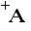 | Add Label - appears when the Label tool is selected in the Toolbox; click to insert a standard label, or click and drag to draw a specific size
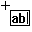 | Add Text Box - when the Text tool is selected in the Toolbox, this mouse pointer will appear; click to insert a standard text box and label, or click and drag to draw the size you desire

Toolbar Buttons

The View buttons change the perspective of the active object. This button allows you to go to Design View of any object.
This View button sends you to Datasheet View of a Table or Report.
This View button sends you to Form View.
This View button sends you to Print Preview of a Report.
Save will save your most recent changes.
Print prints the active object. Be careful if your object contains many records!
Print Preview shows you what your active object will look like on paper.
Spellcheck will check for spelling errors.
Cut removes text or an object and places it on the Clipboard, so it may be placed elsewhere.
Copy places a copy of the selected text or object on the Clipboard, so it may be copied to another location.
Paste takes the item from the Clipboard and places it at the location of your insertion point or selection.
Format Painter allows you to copy the formatting of selected text to other text in your database.
Undo will undo the last action taken.
Properties allows you to look at the specific attributes of an object in your database.
Relationships opens the Relationships Window, in which you are able to view the formal relationships that have been drawn between tables.
AutoForm allows you to create an instant form from a selected table. The drop down arrow to the right lets you choose a different “AutoObject” to create.
The Office Assistant provides you with interactive help regarding Access.
Delete will remove the selected object from your database.
Sort Ascending puts your records in alphabetical, chronological, or numeric order based on the active field.
Sort Descending sorts records backwards.
AutoFilter removes any record not including the selected entry.
Filter by Form allows you to filter records by more than one entry.
The Filter button becomes activated when AutoFilter is used. Pushing this button will remove the current filter. When Filter by Form is used, this button will turn on the filter once criteria are established, then turn it off when you wish to see all records.
Find lets you search for an entry.
New Record sends you to a blank record for data entry. Some databases require a different button to be used.
Delete Record will remove the active record.
Database Window will place the Database Window in front of any other open windows. You may also use the F11 key.
The Primary Key button will establish the active field as the unique identifier of the records in a table.

Keyboard Shortcuts

Keystroke Combination | Effect
F1 | Opens Access Help
F6 | Moves from Design Grid of Table to Properties section
F9 | Updates the active object
F11 | Brings the Database Window to the front
Tab | Moves you ahead one field
Shift + Tab | Moves you backward one field
Enter | Moves you ahead one field
Spacebar | Toggles a checkmark on and off in a Yes/No field
Ctrl + Alt + down arrow | Opens a drop-down list
Ctrl + Tab | Moves you out of a subform to the next form field
Ctrl + Home | Sends you to the beginning of the first record
Ctrl + End | Sends you to the end of the last record
Ctrl + ‘ | Copies the previous record's entry into the current field
Home | Sends you to the beginning of the active record
End | Sends you to the end of the active record
Arrow (Cursor) Keys | Send you one field in the arrow's direction

