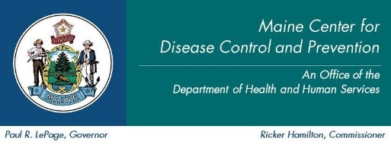

Maine Weekly Arboviral Surveillance Report
August 6, 2018

January 1, 2018 – August 4, 2018:

Humans – Domestic arboviral illnesses
 | Number Tested | WNV positive | EEE positive | JCV positive
Current Week | 4 | 0 | 0 | 0
2018 Year to Date | 29 | 0 | 0 | 0
Human arboviral testing performed at Maine’s Health and Environmental Testing Laboratory (HETL); testing may be performed year round. Confirmation testing performed at CDC Fort Collins

Humans – Imported arboviral illnesses
 | Chikungunya positive | Dengue positive | Zika positive*
2018 Year to Date | 2 | 1 | 0
Imported arboviral testing may be performed at HETL, CDC Fort Collins, or other national reference laboratories

Animals
 | Number Tested | WNV positive | EEE Positive
Current Week | 0 | 0 | 0
2018 Year to Date | 1 | 0 | 0
Animal arboviral testing may be performed at HETL or through the National Veterinary Services Laboratory (NVSL); testing may be performed year round

Mosquitoes – Domestic arboviruses
 | Pools Tested | WNV positive | EEE positive
Current Week | 27 | 0 | 0
2018 Year to Date | 114 | 0 | 0
Mosquito arboviral testing performed at HETL; mosquito collection begins July 1 and continues through September 30

Only completed testing is included in this report.

EEE = Eastern Equine Encephalitis
CHIK = Chikungunya
JCV = Jamestown Canyon Virus
SLE = Saint Louis Encephalitis
WNV = West Nile Virus

2018 Maine Positive Results
Surveillance | Species | Collection Date | Town | County | Agent

*There are no confirmed locally acquired mosquito-borne Zika virus disease cases in the United States to date in 2018.

For more information about Zika include updated counts on travel associated cases and the US Zika pregnancy registry see: www.cdc.gov/zika.

