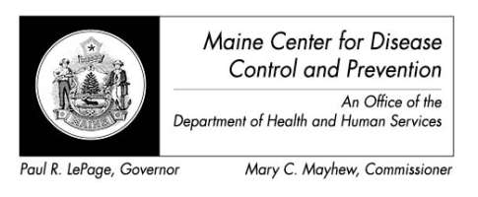

Maine Weekly Arboviral Surveillance Report
July 18, 2016

January 1, 2016 – July 16, 2016:

Humans
 | Number Tested | WNV positive | EEE Positive
Current Week | 1 | 0 | 0
2016 Year to Date | 22 | 0 | 0
Human arboviral testing performed at Maine’s Health and Environmental Testing Laboratory (HETL); testing may be performed year round

Animals
 | Number Tested | WNV positive | EEE Positive
Current Week | 0 | 0 | 0
2016 Year to Date | 0 | 0 | 0
Animal arboviral testing may be performed at HETL or through the National Veterinary Services Laboratory (NVSL); testing may be performed year round

Mosquitoes
 | Pools Tested | WNV positive | EEE Positive
Current Week | 29 | 0 | 0
2016 Year to Date | 29 | 0 | 0
Mosquito arboviral testing performed at HETL; mosquito collection begins July 1 and continues through September 30

Only completed testing is included in this report.

WNV = West Nile Virus
EEE = Eastern Equine Encephalitis

2016 Positive Results
Surveillance | Species | Collection Date | Town | County | Agent

