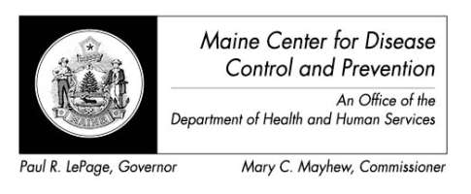

Maine Weekly Arboviral Surveillance Report
November 23, 2015

January 1, 2015 – November 21, 2015:

Humans
 | Number Tested | WNV positive | EEE Positive
Current Week | 1 | 0 | 0
2015 Year to Date | 65 | 2* | 1**
Human arboviral testing performed at Maine’s Health and Environmental Testing Laboratory (HETL); testing may be performed year round

* One human that tested positive for West Nile was a Massachusetts resident and is therefore being counted in Massachusetts
**The EEE positive was tested at the New Hampshire Public Health Laboratory and confirmed by CDC Fort Collins

Animals
 | Number Tested | WNV positive | EEE Positive
Current Week | 0 | 0 | 0
2015 Year to Date | 7 | 0 | 0
Animal arboviral testing may be performed at HETL or through the National Veterinary Services Laboratory (NVSL); testing may be performed year round

Mosquitoes
 | Pools Tested | WNV positive | EEE Positive
Current Week | 0 | 0 | 0
2015 Year to Date | 631 | 1 | 1
Mosquito arboviral testing performed at HETL; mosquito collection begins July 1 and continues through September 30

Only completed testing is included in this report.

WNV = West Nile Virus
EEE = Eastern Equine Encephalitis

2015 Maine Positive Results
Surveillance | Species | Collection Date | Town | County | Agent
Human |  | 9/11/2015 |  | Cumberland | WNV
Mosquito | Culiseta melanura | 9/11/2015 | Alfred | York | EEE
Mosquito | Culiseta melanura | 9/20/2015 | Waterboro | York | WNV
Human |  | 10/8/2015 |  | York | EEE

