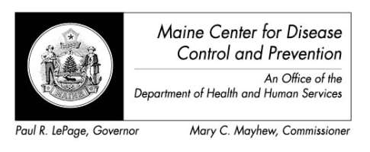

Maine Weekly Arboviral Surveillance Report
October 5, 2015

January 1, 2015 – October 3, 2015:

Humans
 | Number Tested | WNV positive | EEE Positive
Current Week | 0 | 0 | 0
2015 Year to Date | 45 | 1 | 0
Human arboviral testing performed at Maine’s Health and Environmental Testing Laboratory (HETL); testing may be performed year round

Animals
 | Number Tested | WNV positive | EEE Positive
Current Week | 2 | 0 | 0
2015 Year to Date | 5 | 0 | 0
Animal arboviral testing may be performed at HETL or through the National Veterinary Services Laboratory (NVSL); testing may be performed year round

Mosquitoes
 | Pools Tested | WNV positive | EEE Positive
Current Week | 28 | 0 | 0
2015 Year to Date | 625 | 1 | 1
Mosquito arboviral testing performed at HETL; mosquito collection begins July 1 and continues through September 30

Only completed testing is included in this report.

WNV = West Nile Virus
EEE = Eastern Equine Encephalitis

2015 Positive Results
Surveillance | Species | Collection Date | Town | County | Agent
Human |  | 9/11/2015 |  | Cumberland | WNV
Mosquito | Culiseta melanura | 9/11/2015 | Alfred | York | EEE
Mosquito | Culiseta melanura | 9/20/2015 | Waterboro | York | WNV

