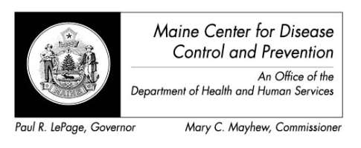

Maine Weekly Arboviral Surveillance Report
September 8, 2015

January 1, 2015 – September 5, 2015:

Humans
 | Number Tested | WNV positive | EEE Positive
Current Week | 0 | 0 | 0
2015 Year to Date | 37 | 0 | 0
Human arboviral testing performed at Maine’s Health and Environmental Testing Laboratory (HETL); testing may be performed year round

Animals
 | Number Tested | WNV positive | EEE Positive
Current Week | 0 | 0 | 0
2015 Year to Date | 3 | 0 | 0
Animal arboviral testing may be performed at HETL or through the National Veterinary Services Laboratory (NVSL); testing may be performed year round

Mosquitoes
 | Pools Tested | WNV positive | EEE Positive
Current Week | 167 | 0 | 0
2015 Year to Date | 488 | 0 | 0
Mosquito arboviral testing performed at HETL; mosquito collection begins July 1 and continues through September 30

Only completed testing is included in this report.

WNV = West Nile Virus
EEE = Eastern Equine Encephalitis

2015 Positive Results
Surveillance | Species | Collection Date | Town | County | Agent

