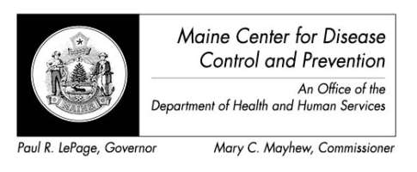

Maine Weekly Arboviral Surveillance Report
September 3, 2013

January 1, 2013 – August 31, 2013:

Humans
 | Number Tested | WNV positive | EEE Positive
Current Week | 2 | 0 | 0
2013 Year to Date | 35 | 0 | 0
Human arboviral testing performed at Maine’s Health and Environmental Testing Laboratory (HETL); testing may be performed year round

Animals
 | Number Tested | WNV positive | EEE Positive
Current Week | 0 | 0 | 0
2013 Year to Date | 8 | 0 | 0
Animal arboviral testing may be performed at HETL or through the National Veterinary Services Laboratory (NVSL); testing may be performed year round

Mosquitoes
 | Pools Tested | WNV positive | EEE Positive
Current Week | 63 | 0 | 5
2013 Year to Date | 197 | 0 | 7
Mosquito arboviral testing performed at HETL; mosquito collection begins July 1 and continues through September 30

Only completed testing is included in this report.

WNV = West Nile Virus
EEE = Eastern Equine Encephalitis

2013 Positive Results
Species | Date Collected | County | Agent
Culiseta melanura | 07/16/2013 | York | EEE
Culiseta melanura | 08/14/2013 | York | EEE
Culiseta melanura | 08/24/2013 | York | EEE
Culiseta moristans | 08/24/2013 | York | EEE
Culiseta melanura | 08/24/2013 | York | EEE
Culiseta moristans | 08/24/2013 | York | EEE
Culiseta melanura | 08/27/2013 | York | EEE

