developing AN alcohol sales policy For Your Business

On Premise Sales

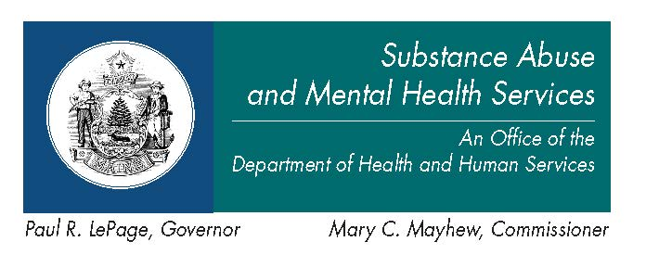

Printed March 2009
Updated January 2013
Table of Contents

Purpose ……………………….……………………………. 3

How to Use This Guide ……….…………………………..... 3

Mission Statement …………….……………………………. 3

Guidelines for Your Policy ………………………………… 4
General ………………….……………………………. 4
Customer Assessment …...…………………………… 4
Carding Practices …………………………………….. 5
Visibly Intoxicated Individuals ……………..……….. 6
Miscellaneous ……………………………………...… 7

Other Considerations …………..……………………..…… 8

Disclaimer………………………………………………..… 8

Resources ……………………………………………….… 9
Purpose of Document:
The content of this document is designed to help on-premise retail licensees develop a guide for their business to stay compliant with the Maine Liquor Laws and to assist their employees with the responsible sale of alcohol through the use of uniform policy and best practices.

This guide is not designed to be used for an operational policy, but rather to assist the licensee in developing a premise policy that will apply to their specific business needs by addressing key points and providing suggestions for consideration.

There are many types of on-premise establishments. Each are unique and have different issues that need to be addressed within their policy. Before starting you should consider what best practices you’ll need to adopt as policy to best protect your business and its bottom line, prevent violations of the law, and control your service of liquor to ensure a safe and compliant experience for your patrons.

How to use this guide:
This guide should be used to develop a policy around the sale of alcohol to be used internally with your employees. Research shows that “consistent and effective outlet policies are the key to providing a work environment in which sales personnel are able and willing to implement the knowledge and skills they acquire through responsible sales training. Policies standardize staff behavior and licensee expectation regarding alcohol sales. They provide a written reference, so that new and long-term employees are clear about what is expected of them. They can be used in current training or coaching of employees. Polices help the manager to identify those effective practices that are already in place within the organization. A well-written policy manual, signed by employees who have read it, provides an excellent, responsible business practice defense. If reasonable care is found, liability might be eliminated or mitigated.”

Most of the components found in this guide are suggestions, not state requirements. Anything that is requirement of the state or state law will be noted with a star (*). The language for each component is written so you can copy and paste it into your own policy.

The guide is broken down into six sections:
- General components;
- Assessment;
- Carding practices;
- Visibly intoxicated individuals;
- Miscellaneous; and
- Resources

Each section contains a number of components to choose from. You should read through the components and decide which ones best fit your business’ needs. You may use the check box ( ◻ ) by each component to check off the components you would like to use. Copy each component you check into a separate document to create the framework for your policy. There is no right combination of components, but the more you choose the more comprehensive and effective your policy will be.

Disclaimer: All operational policies must be reviewed by your insurance underwriter and your legal counsel to ensure content accuracy, effectiveness and compliance with the law. The Office of Substance Abuse and Mental Health Services is not liable for any legal action taken against the licensee.

Liquor Policy Mission Statement
Each licensee’s policy should have a mission statement. The purpose of the mission statement is to state the philosophy, scope, and responsibility of the licensee so security/wait staff will be clear on your expectations. Below is an example of a mission statement:

“Blue’s Restaurant & Lounge” recognizes that it is a privilege to buy and sell alcoholic beverages in the State of Maine and with that privilege, realizes that it is our legal and social responsibility to comply with all Maine laws, rules and regulations and follow best practices as they pertain to the service of alcoholic beverages. We are committed to the safe and responsible sale of all alcoholic beverages to only those patrons who are 21 years of age or older and to refuse service of alcoholic beverages to those individuals that are visibly intoxicated or, in those cases where we deem it necessary, to prevent a person from becoming visibly intoxicated. In order to achieve these goals, we have adopted the following policies.”

Guidelines for Policy Components:
1. General:

- A. All new employees will review, with a member of management, the laws, rules and regulations and best practices as described in the mission statement prior to making any sale of liquor or imitation liquor. Once trained, all employees will regularly review those laws, regulations and best practices with a member of management, asking for clarification on topics they don’t understand and upon completion of the review, sign off that they understand and will comply with all of the premise policies governing the sale of liquor or imitation liquor.

- B. Employees shall comply with all the Maine Liquor Laws and Rules and Regulations governing the sale of alcoholic beverages.

2. Assessment:

- A. When initially greeting patrons, all staff will make visual and verbal contact with them to convey greetings and to assess sobriety.

- B. All wait staff will make verbal and visual contact with each customer purchasing liquor or imitation liquor and will repeat the process every time subsequent service of liquor is made.

  - When making visual contact, employees will make eye contact with the patron, paying special attention to the facial characteristics, as well as noting trendy clothing, behavior and young acquaintances that might indicate the purchaser is underage. The employee should make note of bloodshot or drooping eyes, disheveled clothing and any other signs that might indicate the patron is visibly intoxicated or there is a likelihood they will become intoxicated with the purchase of alcohol and should not be served.
  - When making verbal contact, ask the patron a question that would invoke a response such as, “How are you?”, “May I answer any questions you might have about the menu?”, “How is the weather?” “May I interest you in an appetizer?” or any small talk about sporting events, local entertainment, etc. Note any odor of liquor on the patron’s breath and any signs of slurring.

- C. When an employee is carding an individual they will always observe the patron retrieving their ID from the wallet noting fine motor skills.

- D. A manager or their designee will make regular rounds, interacting with patrons assessing sobriety and when appropriate, re-check identification of youthful patrons possessing or consuming alcohol.

3. Carding Practices:

- A. Maine law requires a licensee or licensee’s employee or agent may not sell, furnish, give or deliver liquor or imitation liquor to a person under 27 years of age unless the licensee or licensee’s employee or agent verifies the person is not a minor by means of reliable photographic identification containing that person’s date of birth* (Title 28A-sec 706-2).

- B. Security/wait staff must ask for a reliable identification from anyone under 27 (30, 40, 45 or all patrons, etc.) years of age every time they enter the establishment to purchase liquor or imitation liquor.

- C. Our policy is to card anyone that orders liquor or imitation liquor and appears to be under the age of _______in order to comply with Maine law. (Age appropriate policy should be set by the licensee based on median age of patrons, employees and type of business. Remember it is state law that you must card anyone under the age of 27.)

- D. The security/wait staff will ask for a current, reliable and verifiable pictured identification containing the patron’s date of birth (acceptable forms of ID are state driver’s license, state non-driver identification card or a Passport issued by a state or federal government agency).
  - All out of state driver’s licenses or identification cards will be verified with the Driver’s License Guide.
  - If the patron appears to be under 21 years of age, the employee will ask for a secondary form of identification, such as a military ID, passport, credit/debit card, etc.

- E. The security/wait staff will request that the patron remove their ID from their wallet and take physical control of the identification, checking the back, then the front for signs of forgery such as:
        - Poor photo copy quality, blurred imagery or digitized lettering.
        - Disclaimers like “non-government ID” or “non transferable ID card”.
        - Statements of authenticity such as “Genuine”, “Authentic”, “Secure”, etc. (if it has to tell you it’s “Genuine”, it’s not).
        - Unusual thickness or unevenly cut edges or corners and bumpy surfaces indicate the card has been hand cut or the picture has been replaced.

- F. The security/wait staff will verify that the information and picture on the identification match the person presenting it, paying special attention to the date of birth in order to confirm that the individual is old enough to purchase and that the DOB has not been altered (are the numbers the same size, color, evenly spaced and level with one another?).

- G. No employee will accept an expired identification card.

- H. The safe and responsible service of alcohol is the responsibility of all wait staff; when receiving an order for liquor or imitation liquor all staff should re-card any patron that appears to be underage and not assume that security or another wait staff has carded the individual.

- I. In the event any patron fails to show proper identification or if there is doubt by the security/wait staff of the validity of an ID, the sale will be refused. All refusals for failure to meet the requirements of the identification policy are final. Please note that restaurants will refuse alcohol service and any on-premise licensees that do not serve food will require the patrol to leave.

Retaining Identification (Only choose one):
- J. Option #1. When a patron displays an identification card that is obviously false, the security/wait staff will refuse entrance/sale of liquor or imitation liquor and report it to a manager who will explain to the patron that they are going to retain the identification for the purpose of verifying their age. A premise representative will IMMEDIATELY call the police and surrender the identification to the authorities for that purpose. (Authority to retain Title 28-A Section 2516-2). Please note, licensee must advise individual why the ID is being retained.

- K. Option #2. When a patron displays an identification card that is obviously false, the security/wait staff will refuse sale of liquor or imitation liquor and report it to a manager and/or the police.

4. Visibly Intoxicated Individuals:

- A. When a patron attempting to enter the premise appears to be visibly intoxicated, the security/wait staff shall explain to the patron that Maine law, Title 28-A Rule 1.8 and policy prevents them from entering the establishment. If the patron is operating a motor vehicle, the security/wait staff will express concern about them driving and offer to call alternative transportation. If they insist on operating, the police will be notified immediately and given a description of the visibly intoxicated person, their vehicle and direction of travel.

- B. All staff will continuously appraise the sobriety of patrons within the premise, repeating the process of verbal and visual contact when a patron orders another drink or when serving subsequent drinks.

- C. No licensee shall permit or allow visibly intoxicated persons to remain on the licensed premises* (Title 28-A -Rule 1.8).

  - When wait staff discovers a visibly intoxicated individual in the premise, they will notify the manager/security staff/person in charge immediately. The manager will attempt to invite the patron to the side and explain that because of Maine law and policy, they can no longer allow the individual to possess or consume alcohol. In any event the liquor will be removed from the person immediately.

- D. Once a visibly intoxicated person has been identified and alcohol removed, the manager/wait staff will express concern to the patron about driving and offer alternative transportation. If the patron insists on driving, the manger/wait staff will notify the police immediately, giving them a description of the visibly intoxicated individual, their vehicle and direction of travel.

- E. In the event alternative transportation for a visibly intoxicated person cannot be arraigned, wait staff will accompany them to a secure area of the bar/restaurant where the visibly intoxicated person cannot take possession or control of any alcoholic beverages. They will be offered food, non alcoholic beverages and afforded time to sober up. The visibly intoxicated individual will be monitored at all times.

- F. If a visibly intoxicated person becomes argumentative, assaultive, disorderly or in anyway threatens the safety or well being of the patrons, staff or the community, the manager will immediately call the police.

- G. All incidents involving intoxicated patrons will be written down in a premise log, noting the date, the time, names of employees involved and brief statement of facts regarding the incident. It will be the responsibility of the manager or supervising security/wait staff to log these incidents.

- H. All sale refusals due to a patron’s visible intoxication are final with the exception of a patron advising the security/wait staff that their appearance is due to a disability as defined under the Americans with Disability Act (ADA) (for compliance, refer to your attorney or human resource officer).

5. Miscellaneous:

- A. Employees will always be professional, friendly and polite with all patrons when complying with Maine law or policy, explaining that when service is declined, it is because of Maine law and premise policy.

- B. No licensee shall permit or allow visibly intoxicated persons to remain on the licensed premises. No licensee shall show effects of, nor allow any of his employees, agents, or entertainers to consume or to show any effect of liquor while on duty or performing on the licensed premises* (Title 28-A, Rule 1.8).

- C. All employees will report for work sober and will not have consumed any alcoholic beverage prior to arriving, or consume any alcohol while on duty.

- D. All questionable incidents involving patrons will be written down in a premise log, noting the date, time, names of employees involved and brief statement of facts regarding the incident. It will be the responsibility of the manager or supervising security/wait staff to log these incidents.

- E. Any staff whose responsibilities include the sale, handling or marketing of alcoholic beverages will attend a seller/server training approved by the Commissioner of the Department of Public Safety and Liquor Licensing as soon as possible upon employment. See the following website for a list of approved trainings: http://www.maine.gov/dps/liqr/contact.html#training

- F. A licensee for the sale of liquor to be consumed on licensed premises may not employ a person under 17 years of age in the serving or selling of liquor on the premises where the liquor is sold* (Title 28-A, Section 704)

- G. An employee who is at least 17 years of age but less than 21 years of age may serve or sell liquor only in the presence of an employee who is at least 21 years of age and is in a supervisory capacity* (Title 28-A, Section 704)

- H. No on-premise licensee shall permit the direct handling of liquor on the licensed premises by any person under the age of 15 years. Persons who are at least 15 years old may stock coolers or bus tables, but may not sell, serve, or mix liquor* (Title 28-A rule 2.3).

- I. The service and consumption of liquor must be limited to areas that are clearly defined and approved in the application process by the bureau as appropriate for the consumption of liquor. Outside areas must be controlled by barriers and by signs prohibiting consumption beyond the barriers* (Title 28-A, section 1051).

- J. All staff should use due diligence in watching for patrons or activities that are not consistent with this policy or Maine Law and should report a breach of either to management immediately.

6. Other Considerations:

A. You should decide what disciplinary action will be taken for non-compliance by staff, i.e., dismissal, retraining, progressive discipline, etc.

B. All policies should be regularly reviewed. Some details to consider include:
- How often should the policies be reviewed?
- Who should review the policies?
- Who will oversee the review process and enforce compliance?
- Will you use an acknowledgment form?
- Should you use a testing procedure to ensure staff understands the policy and laws?

Disclaimer: All operational policies must be reviewed by your insurance underwriter and your legal counsel to ensure content accuracy, effectiveness and compliance with the law. The Office of Substance Abuse and Mental Health Services is not liable for any legal action taken against the licensee.
Resource Materials:

For an electronic copy of this guide, please go to: http://www.maine.gov/dhhs/samhs/osa/prevention/community/licensee/policy.htm

For a full list of liquor laws, please refer to the Maine Liquor Licensing and Compliance Division: http://www.maine.gov/dps/liqr/index.html

Americans with Disabilities Act – U.S. Department of Justice ADA home page
http://www.ada.gov/

United States Court of Appeals First District - David Dudley v. Hannaford Bros. Co.
http://caselaw.lp.findlaw.com/cgi-bin/getcase.pl?court=1st&navby=docket&no=021382

Pacific Institute for Research and Evaluation’s Guide to Responsible Alcohol Sales: Off Premise Clerk, Licensee and Manager Training
http://www.pire.org/documents/responsible_sales.pdf

Maine Office of Substance Abuse and Mental Health Services
Information and Resource Center
41 Anthony Avenue
#11 State House Station
Augusta, ME 04333-0011
Ph: 1-800-499-0027 or 207-287-8900
TTY: 711 (Maine Relay)
Email: osa.ircosa@maine.gov
Web: www.maineosa.org

This project was supported by Grant No. 2005-AH-FX-0007 awarded by the
Office of Juvenile Justice and Delinquency Prevention, U.S. Department of Justice with support from the Fund or Healthy Maine and administered through The Maine Office of Substance Abuse.

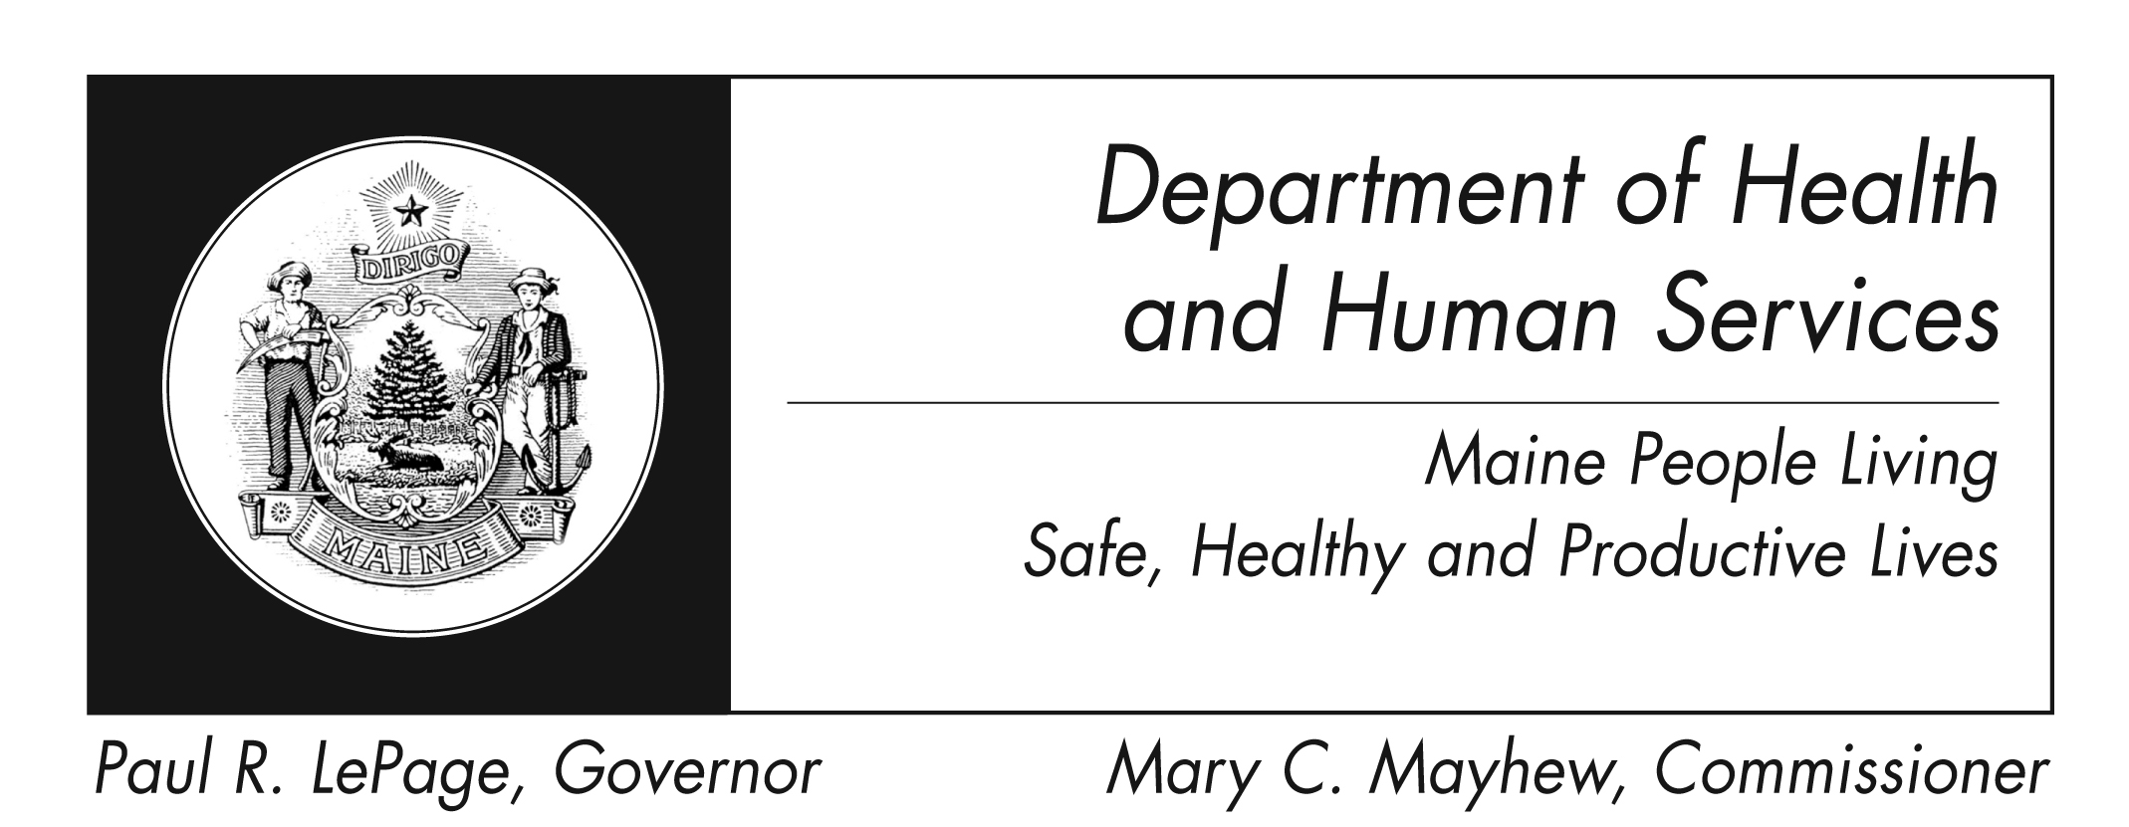

The Department of Health and Human Services does not discriminate on the basis of disability, race, color, creed, gender, sexual orientation, age or national origin in admission or access to or operations of its programs, services, or activities, or its hiring or employment practices. This notice is provided as required by Title II of the Americans with Disabilities Act of 1990 and in accordance with the Civil Rights Act of 1964 as amended, Section 504 of the Rehabilitation Act of 1973 as amended, the Age Discrimination Act of 1975, Title IX of the Education Amendments of 1972 and the Maine Human Rights Act. Questions, concerns, complaints or requests for additional information regarding the ADA may be forwarded to DHHS ADA Compliance/EEO Coordinator, SHS #11, Augusta, ME 04333; (207) 287-4289 (V) or (207) 287-3488 (V), TTY: 800-606-0215. Individuals who need auxiliary aids or services for effective communication in programs and services of DHHS are invited to make their needs and preferences known to the ADA Compliance/EEO Coordinator. This information is available in alternate formats upon request.

Guide to Responsible Alcohol Sales: Off Premise Clerk, Licensee, and Manager Training

