Equality for All

Civil Rights

Self-Paced Training Workbook Maine CDC WIC Nutrition Program

Adapted from California WIC Program, with permission Revised for FFY2026



## Welcome!

The Maine CDC WIC Nutrition Program is pleased to present this self-paced version of the required Civil Rights annual training. It is our commitment to provide a variety of training modalities to make this training available to all staff. To keep this training current, this training will be reviewed annually for required updates.

Please complete the evaluation form at the completion of this training to provide us with feedback on your training experience. Your feedback is invaluable, assuring that we address your staff training needs.

## Before You Begin

1. **Save and rename this document:** save a copy of this training by selecting “File ➔ Save As” **before** you begin. Rename it with your name in the document title and save it on your desktop or in a network folder of your choice. This is the copy you will use as you do the training.
2. **Open the document you just saved which includes your name in the title:** type in your name and the current date in the box provided below.
3. **Complete the training:** answer the questions by checking the appropriate responses or by typing in your text responses. When you have finished the training and answered all questions, choose “File➔ Save**”** to retain your answers before closing the document. Submit your completed training to your immediate supervisor.
4. **Complete the training evaluation and certificate of completion.** Print and submit your certificate of completion to your immediate supervisor.
5. **Add the Civil Rights training and date to your Continuing Education log.** Include the number of hours spent in the training.

|  |  |
| --- | --- |
| **Staff Member Name** | Click here to enter text. |
| **Date** | Click here to enter a date. |



WIC receives federal funding from the Food and Nutrition Service (FNS) through the United States Department of Agriculture (USDA). All programs receiving this funding are required to ensure that program staff members attend civil rights training annually. The State Agency is required to also cover components of civil rights policy and procedure compliance within local WIC management reviews.

This training is being offered to satisfy the annual training requirement and contributes to WIC’s commitment to providing quality services.

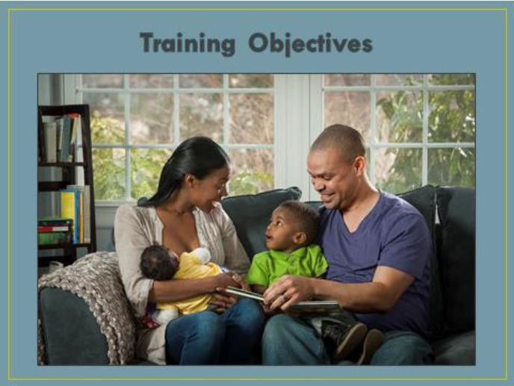

### Objectives

At the end of this training, trainees will be able to:

* + Understand Maine CDC WIC policies regarding civil rights and discrimination
  + Identify examples of the protected categories listed in the Rights and Responsibilities section of the Maine CDC WIC Participant Booklet
  + Distinguish between stereotype, prejudice, and discrimination and explore their roles in protecting civil rights
  + Describe methods for making reasonable accommodations for participants with disabilities and limited English proficiency
  + Differentiate between ethnicity and race and review USDA’s reporting requirements regarding these terms
  + Learn the steps WIC staff must take in the discrimination complaint process
  + Explore ways to prevent complaints using customer service and conflict resolution techniques

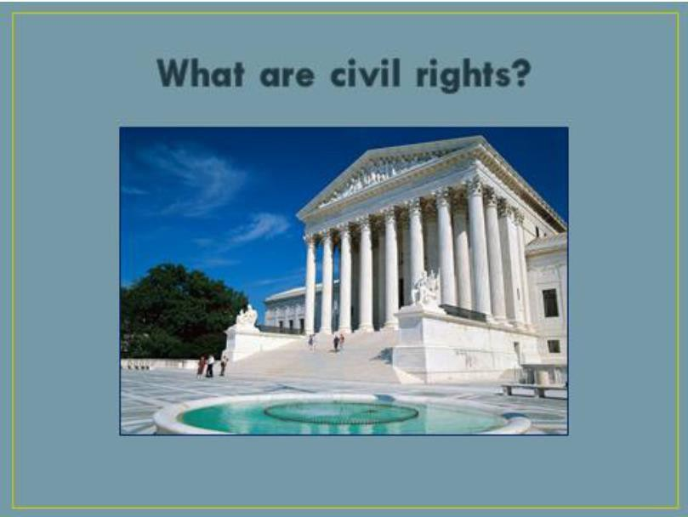

Civil Rights are the rights of individuals to receive equal treatment based on certain legally protected classes.

* + These classes include disability, race, color, creed, gender, sexual orientation, age, national origin, sex, reprisal.
  + USDA prohibits discrimination in employment or in any program or activity conducted or funded by the Department.



**State**

**What are the WIC Protected Categories?**

**Federal**

Disability Race Color Sex Gender

Sexual Orientation

Age

National Origin

Religious or Political Belief Ancestry

Familial or Marital Status Genetic Information Association

Previous Assertion of a Claim or Right

Whistleblower Activity

Race Color

National Origin Sex

Disability Age

Reprisal

These WIC protected Civil Rights categories are listed in the Rights and Responsibilities section on pages 2-3 of the WIC Participant Booklet. Both state and federal WIC protected Civil Rights categories are listed.

**Participant Rights and Responsibilities must be reviewed with all authorized representatives at all certifications.** This includes ensuring authorized representatives are made aware of:

* + their right to complain if they feel they have been discriminated against (under “Your Rights”, page 2 of Participant Booklet)
  + how to file a complaint of discrimination (under “Non-Discrimination Notice”, page 3 of Participant Booklet)

### Activity 1

**WIC Protected Categories**

**Instructions:** For each **Category** listed below, match the Civil Rights **definition** in the right-hand column. Type the letter of the definition in the **Answer** column. If you need assistance, refer to the next page (page 8).

|  |  |  |
| --- | --- | --- |
| **Answer** | **Category** | **Definition** |
| Choose an item. | Marital Status | A. A followed spiritual belief. It does not have to be an organized group or traditional denomination |
| Choose an item. | Disability | B. An individual belonging to one of the accepted anthropological groups; or the perception, based usually on physical characteristics. |
| Choose an item. | Ancestry | C. The act of being threatened or retaliated against for participating in any aspect of the discrimination complaint process. |
| Choose an  item. | Color | D. Gender (including breastfeeding) |
| Choose an item. | Sex | E. The country or part of the world that an individual or his or her ancestors are from. |
| Choose an item. | Religious Belief | F. The people who were in a person’s family in past times. |
| Choose an  item. | Sexual Orientation | G. Applies to persons 40 years old and over. |
| Choose an item. | Political Belief | H. Individual who discloses mismanagement, corruption, illegal activity, or some other wrongdoing. |
| Choose an item. | Age | I. Married or not married |
| Choose an item. | Race | J. Physical or mental impairment, permanent or temporary. |
| Choose an  item. | National Origin | K. Gathering of people for a common cause or purpose. |
| Choose an item. | Genetic Information | L. Known to be a member of a political group or to have certain political views. |
| Choose an item. | Association | M. The direction of one’s affection, sexual or emotional attractions involving others. |
| Choose an item. | Whistleblower | N. Applies to information about an individual or family member’s genetic test, disease or disorders. |
| Choose an  item. | Reprisal | O. Includes shade of skin within a racial group. |

### WIC Protected Categories / Classes

**Blue shaded items: Federally protected groups for WIC Gray shaded items: Maine State protected groups Pink shaded items: Both Federal and State**

|  |  |  |
| --- | --- | --- |
| **Protected Category** | **Definition** | **Examples** |
| **Creed or Religion** | A followed spiritual belief. It does not have to be an organized group, traditional denomination, or world religion. | Catholic, Jewish, Latter-Day Saints, Muslim, etc. |
| **Race** | An individual belonging to one of the accepted anthropological groups; or the perception, based usually on  physical characteristics, that a person is a member of a racial group. | African American—Black Caucasian—White Mongolian—Asian |
| **Color** | Color of skin; including shade of skin within a racial group. | Black, light brown, brown, dark brown, white, etc. |
| **National Origin** | The country or part of the world that an individual or his or her ancestors are from. (Most complaints associated with language or accents are covered here.) | Chinese, Cuban, Japanese, Mexican, Vietnamese, etc. |
| **Age** | Age discrimination Act of 1967 applies to persons 40 years old and over. | An individual 40 and over. |
| **Disability** | Physical or mental impairment, permanent or temporary | Alcoholic, amputee, arthritic, blind, epileptic, paraplegic, etc. |
| **Sexual Orientation** | The direction of one’s affection, sexual or emotional attractions involving others. | Bisexual, Heterosexual, homosexual |
| **Sex** | Gender, sexual harassment, pregnancy, childbirth, breastfeeding | Female, male, hermaphrodite; pregnancy-related conditions include mastitis, gestational diabetes, postpartum depression, loss or end of pregnancy or recovery from loss or end of pregnancy.  Lactation accommodation: requires employer to provide reasonable time to allow employee to express breastmilk, and place to pump milk  in private that is near workplace; toilet stall is not acceptable. |
| **Gender** | See description above for sex |  |
| **Reprisal or retaliation** | No one employed or representing USDA shall intimidate, threaten, harass, coerce, or discriminate against anyone who  participates in any aspect of the discrimination complaint process. | A person files a complaint and is treated unfairly or retaliated against. |
| **Ancestry** | People who were in a person’s family in past times. | Grandparents, great-grandparents |
| **Familial or marital status** | Having a child under age of 18 in the household, or woman  who is pregnant or people in process of adopting or gaining custody of child/children; married or not married. | Pregnant woman, parents, foster parents, custodial parents |
| **Genetic Information** | Information about an individual or family member’s genetic test, disease or disorder(s). | Down’s syndrome, familial hypercholesterolemia, cystic fibrosis |
| **Association** | Gathering of people for a common cause or purpose. | Lion’s Club, Rotary Club |
| **Previous**  **assertion of claim or right** |  |  |

**Nondiscrimination Statement**

**FNS food assistance programs other than SNAP and FDPIR (available in Spanish from USDA)**

In accordance with Federal civil rights law and U.S. Department of Agriculture (USDA) civil rights regulations and policies, the USDA, its Agencies, offices, and employees, and institutions participating in or administering USDA programs are prohibited from discriminating based on race, color, national origin, sex, disability, age, or reprisal or retaliation for prior civil rights activity in any program or activity conducted or funded by USDA.

Persons with disabilities who require alternative means of communication for program information (e.g. Braille, large print, audiotape, American Sign Language, etc.), should contact the Agency (State or local) where they applied for benefits. Individuals who are deaf, hard of hearing or have speech disabilities may contact USDA through the Federal Relay Service at (800) 877-8339. Additionally, program information may be made available in languages other than English.

To file a program complaint of discrimination, complete the [USDA Program Discrimination Complaint](http://www.ocio.usda.gov/sites/default/files/docs/2012/Complain_combined_6_8_12.pdf) [Form,](http://www.ocio.usda.gov/sites/default/files/docs/2012/Complain_combined_6_8_12.pdf) (AD-3027) found online at: <http://www.ascr.usda.gov/complaint_filing_cust.html>, and at any USDA office, or write a letter addressed to USDA and provide in the letter all of the information requested in the form. To request a copy of the complaint form, call (866) 632-9992. Submit your completed form or letter to USDA by:

1. mail: U.S. Department of Agriculture

Office of the Assistant Secretary for Civil Rights 1400 Independence Avenue, SW

Washington, D.C. 20250-9410;

1. fax: (202) 690-7442; or
2. email: [program.intake@usda.gov.](mailto:program.intake@usda.gov)

This institution is an equal opportunity provider.

#### Short version to be used if material is too small to permit full statement—Policy CR-1:

This institution is an equal opportunity provider.

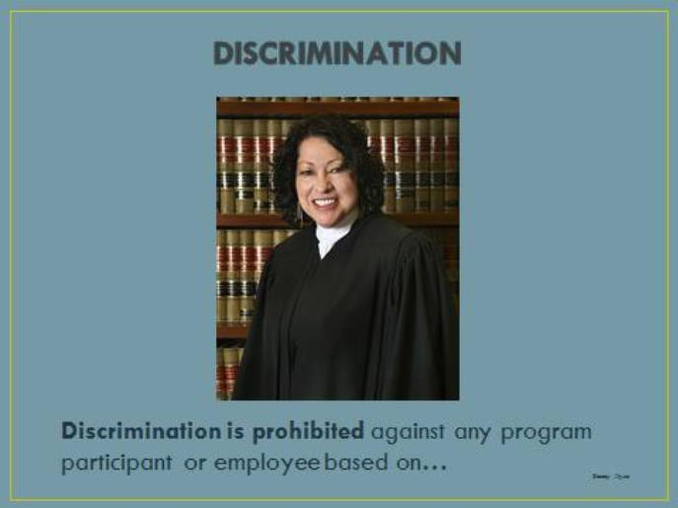

## What is Discrimination?

* + Different or unequal treatment (intentional)
  + Different or unequal adverse impact (unintentional)
  + Retaliation

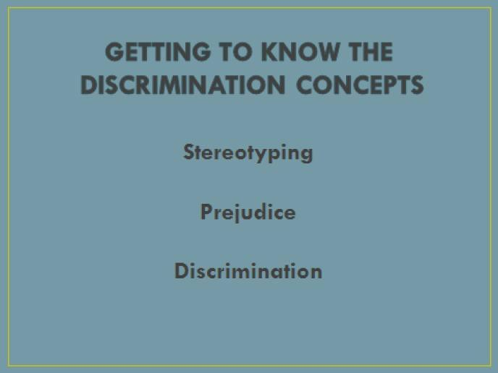

Imagine you are in a bank applying for a loan and you notice the loan officer is staring at you. After collecting your loan information, she excuses herself to discuss your application with her supervisor. You overhear the loan officer mentioning to her supervisor that you don’t look like the type of person who would repay a loan. The loan officer returns and informs you that you do not qualify for the loan and your application has been denied.

* + - **How would you feel as the one who has applied for the loan?**
    - **What do you think of the loan officer’s decision?**
    - **What type of discrimination has the loan officer demonstrated in this situation?**

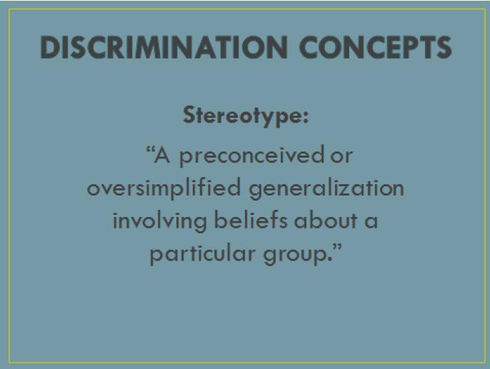

## Stereotyping:

* + - Can be negative
      * Example of a negative stereotype: “None of the younger moms know how to make tasty food choices for their children.”
    - Can be positive
      * Example of a positive stereotype: “All breastfeeding mothers are caring and nurturing.”
    - Based on what we hear, read or believe
    - Does not consider individual characteristics

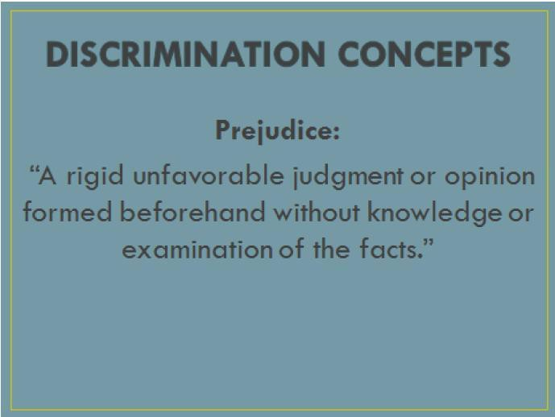

## Prejudice:

* Is negative
* Can be thought of as a pre-judgment
* Is not factual (ignorance based)
* Can be based on race, gender, nationality, social class, and/or disability

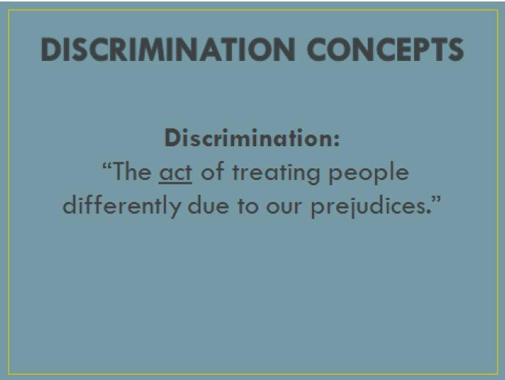

## Discrimination can include:

* + Not providing the same opportunities to everyone, i.e. training and career opportunities, access to activities or places
  + Treating people with less respect
  + Denying people certain things

**NOTE:** Verification of citizenship or immigration status is NOT required for WIC participation; it is illegal for this issue to result in discrimination from program enrollment.

# Discrimination is illegal

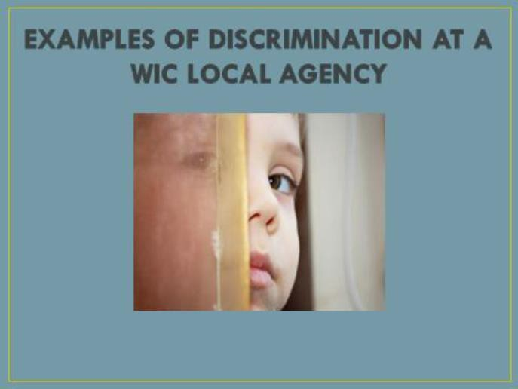

## Here are some examples of how WIC might discriminate against a WIC participant:

* Treating people disrespectfully based on a protected class
* Providing a different level of benefits based on a protected class
* Requesting extra verification or documentation from people based on a protected class
* Differences in waiting times based on a protected class
* Not providing nutrition education to ESL clients

### Activity 2 Discrimination Concepts

* **Stereotype:** an oversimplified generalization or belief about a particular group
* **Prejudice:** a rigid unfavorable judgment or opinion formed beforehand, without knowledge or examination of the facts
* **Discrimination:** the act of treating people differently due to prejudices

**Instructions:** Read each statement and determine which concept(s) apply.

1. “I can’t stand her. She always wears those nose rings.”
   * Stereotype ☐ Discrimination
   * Prejudice ☐ All of these
2. “She’s going to have to wait for her food benefits. As big as she is, she obviously doesn’t need more food.”
   * Stereotype ☐ Discrimination
   * Prejudice ☐ All of these
3. “Most participants come from poor families.”
   * Stereotype ☐ Discrimination
   * Prejudice ☐ All of these
4. “I think if she wants to be a part of WIC, she should speak English.”
   * Stereotype ☐ Discrimination
   * Prejudice ☐ All of these
5. “I am not going to approve her for WIC. She is obviously not eligible since she is wearing a diamond ring.”
   * Stereotype ☐ Discrimination
   * Prejudice ☐ All of these

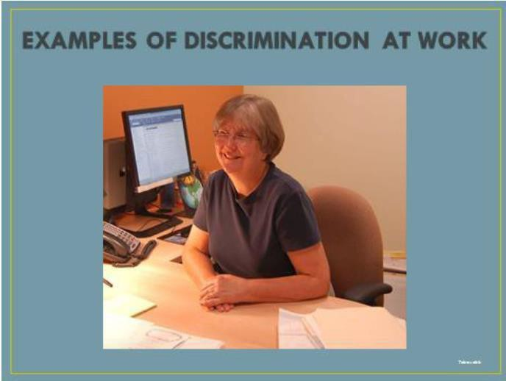

## Workplace discrimination is also illegal.

**Here are some examples of illegal treatment:**

* Failure to promote a viable candidate solely based on age
* A female manager does not hire the best candidate (male) for a job because she wants her unit to consist of all women
* Leaving a man out of meetings solely because a coworker does not like people of his religion

## Activity 3 Case Studies

The following are two civil rights discrimination case studies. Each scenario provides a real-life situation that may exist in a WIC site. Answer the question below each case study.

1. **Case Study — Ms. Diaz**

Ms. Diaz has an appointment at 9:15 at the Funtown City Hall site. She arrives at the site 15 minutes prior to her appointment. The site serves a high number of refugees from Africa. Ms. Diaz, who is not an African refugee, attends this site because it is close to her workplace. She notices that she is the only non-African descent participant in the site when she arrives.

It is now 9:45, and Ms. Diaz is still waiting for the nutritionist. She sees participants who came into the office after her, who have had their appointments and are leaving. She lets the receptionist know that she is still waiting and was told that it would probably be only an additional 5 minutes. However, 10 minutes pass and Ms. Diaz is still waiting to be seen. She tells the receptionist that she needs to be at work in 45 minutes. Ms. Diaz asks to speak with the supervisor. Ms. Diaz lets the supervisor know that she’s seen other participants come and go within 15 minutes of coming into the site. She tells the supervisor that she feels that the staff sees other participants first because they are of African descent, and she is not. The supervisor tells her that if she wants to file a complaint, she can call the State WIC Program. The supervisor gives Ms. Diaz the State WIC Program’s telephone number and explains to her about her right to file a complaint.

Ms. Diaz eventually sees the nutritionist who provides her with an excellent nutrition education session and issues her food benefits to her. Ms. Diaz leaves the Funtown City Hall site frustrated and unhappy due to the delay in waiting time and she calls the State WIC Program to complain.

**Which protected class would this discrimination complaint fall under?**

* + Race
  + Reprisal
  + National origin

**What could staff have done differently?**

Click here to enter text.

1. **Case Study – Ms. Johnson**

Ms. Johnson has just learned that she is four months pregnant and wants to sign up to receive WIC services. She was previously on the WIC program with her other children who are now teenagers. She calls the Southend WIC office and schedules an appointment.

On the day of her appointment, Ms. Johnson arrives at the clinic site 15 minutes late for her appointment but has all the required eligibility information with her. When she walks up to the receptionist’s desk, the receptionist notices that Ms. Johnson is legally blind and unable to read the signs and other information at the desk. The receptionist becomes nervous and does not know how to help Ms. Johnson, so she speaks loudly to inform her that they will need to reschedule her appointment. When Ms. Johnson asks why the appointment needs to be rescheduled, the receptionist loudly states that “It is because we are not equipped to assist people with your condition.” The receptionist informs her that there may be someone to assist her “kind of people” at an appointment time next week.

**Which protected class would this discrimination complaint fall under?**

* + Race
  + Disability
  + Religion

**What could staff have done differently?**

Click here to enter text.

1. **Case Study – Ms. Hassan**

Ms. Hassan’s family has just arrived in this country and her family has found housing in your area. Her caseworker told her about WIC and where your clinic is located. Since she has no vehicle or phone yet, she walks into your clinic with a baby and two children, desiring to enroll in the program. Her primary language is Somali, but she also speaks and reads Arabic, some French and knows a few English words.

When she walks up to the reception desk, she points to the language sign, indicating which language she can read and speak. The administrative assistant has never worked with someone who does not speak English. Not sure how to handle this situation, she asks Ms. Hassan very loudly, “Can I help you with something today?

Are you here for an appointment?” Ms. Hassan shakes her head yes and hands the staff member a letter from the case worker which includes the names of all Ms. Hassan’s family, their dates of birth, and current residence address. The staff member, still unsure of herself, tells Ms. Hassan in a very loud voice to have a seat and someone will be with her as soon as possible. Ms. Hassan looks very confused and again points to the language sign.

The administrative assistant makes a few phone calls to try to find someone who can tell her what she should do. After not being successful in reaching anyone, she again speaks in a very loud voice to Ms. Hassan, saying “You will have to come back tomorrow. I need verification that you can be in this country before I can make an appointment for you.”

**Which protected class would this discrimination complaint fall under?**

* + Race
  + Creed
  + National Origin

**What could staff have done differently?**

Click here to enter text.

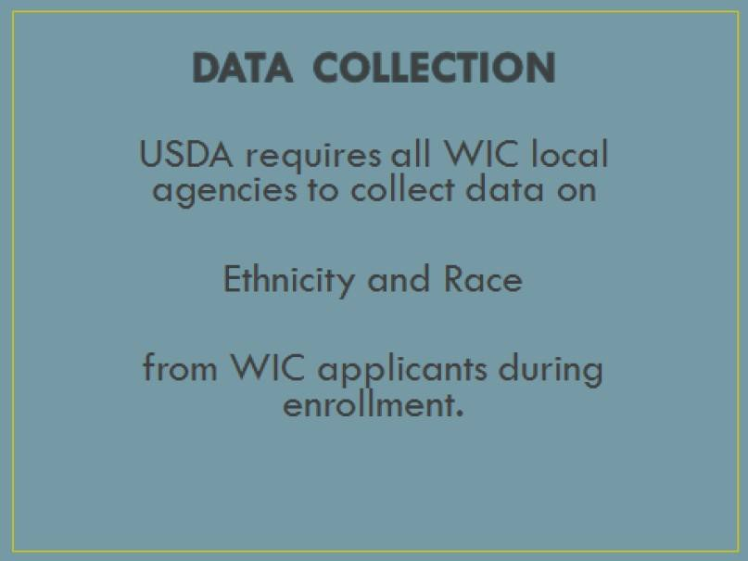

## What is the difference between ethnicity and race?

* **Ethnicity** is characteristic of a group of people sharing a common and distinctive culture, religion, language, or background. It can also include race and national origin.
* **Race** is based more on one’s biological origins and refers to a person’s physical appearance including skin color, eye color, hair color, bone structure and facial type.

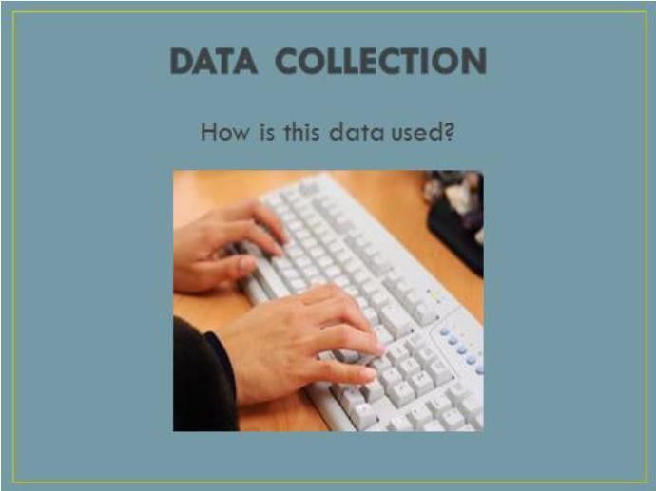

## Race and Ethnicity data is used to:

* determine how well WIC is reaching potential eligible people
* help identify areas where additional outreach is needed

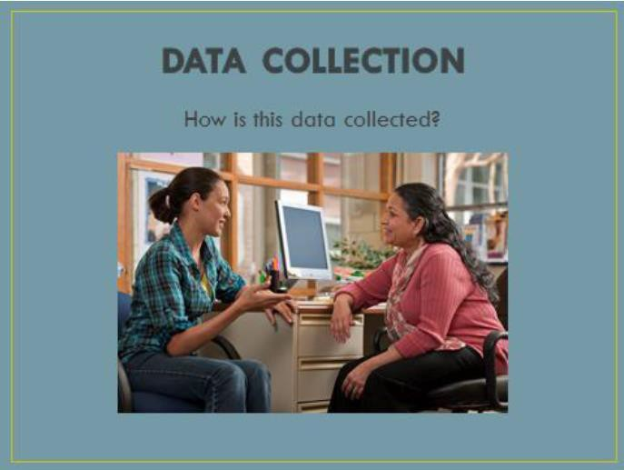

Local agency staff shall ask every applicant to identify their ethnicity and race **upon enrolling in the WIC Program.** The information is used by USDA to determine how effectively WIC is reaching minority groups and identify where additional outreach is needed. Local agency staff members are required to:

* Explain to every WIC applicant that the collection of the information is:
  + strictly for statistical reporting requirements, and
  + has no effect on the determination of their eligibility for WIC benefits
* Verbally assess the applicants’ understanding.
  + Example: What questions do you have before we proceed?
* Collect ethnicity and race category data:
  + **Ethnicity: Select either** Hispanic or Latino or Not Hispanic or Latino
  + **Race(s): Select one or more of the five racial categories:** American Indian or Alaskan Native, Asian, Black or African American, Native Hawaiian or Other Pacific Islander, and/or White
* Use visual identification to determine and document the applicant’s ethnic or racial categories **only if an applicant is unwilling or unable to respond.** At a minimum, local agency staff is required to select an ethnic category and at least one racial category when completing a WIC certification. **Refer to page 23-24, Ethnicity and Race Categories Definitions** and **Ethnicity and Race Data Collection Flowchart** for steps in the data collection process.

## Ethnicity and Race Categories Definitions

**Instructions:** Review the USDA ethnicity and race categories below.

#### Ethnic / Racial Categories as Identified in SPIRIT

|  |  |
| --- | --- |
| **Ethnic Category (Choose one)** | **Definition** |
| **Hispanic or Latino** | A person of Cuban, Mexican, Puerto Rican, South or Central America, or other Spanish culture or origin regardless of race.  The term “Spanish origin” can be used in addition to “Hispanic” or Latino”. |
| **Not Hispanic or Latino** | A person not having Cuban, Mexican, Puerto Rican, South or  Central American, or other Spanish culture or origin, regardless of race. |
| **Race Category (Choose as many as apply)** | **Definition** |
| **American Indian or Alaska Native** | A person having origins in any of the original peoples of North or  South American (including Central America), and who maintains tribal affiliation or community attachment. |
| **Asian** | A person having origins in any of the original peoples of the Far East, Southeast Asia, the Indian subcontinent including, for examples, Cambodia, China, India, Japan, Korea, Malaysia, Pakistan, the Philippine Islands, Thailand, or Vietnam. |
| **Black or African American** | A person having origins in any of the black racial groups of  Africa. Terms such as “Haitian” can be used in addition to “Black or African American”. |
| **Native Hawaiian or Other Pacific Islander** | A person having origins in any of the original peoples of Hawaii, Guam, Samoa, or other Pacific Islands. |
| **White** | A person having origins in any of the original peoples of Europe,  Middle East, or North Africa. |

**When asking the ethnicity and race questions, WIC staff must explain:**

* The collection of the information is strictly for statistical reporting requirements.
* It has no effect on the determination of their eligibility for WIC benefits.

#### If a participant asks how the data is used, you may explain:

* The information is used by USDA to determine how effectively WIC is reaching minority groups and to identify where additional outreach is needed.

## Ethnicity and Race Data Collection Flowchart

Verbally explain that:

* + This information is strictly for statistical purposes
  + The answers will have no effect on eligibility for WIC benefits
  + The applicant will be asked a series of questions with a *Yes* or *No* response

Verbally assess the applicant’s understanding

*Example: What questions do you have before we proceed?*

Ask and record response to the ethnicity question

Applicant answers *Yes* or *No*

Applicant unable **or** unwilling to respond

Ask all race questions

Applicant answers *Yes* to at least **one race** question

Applicant answers *No* to

**all** five race questions

Staff member is required to use visual identification to determine applicant’s ethnicity and/or race. Staff member is required to select **ethnicity** and at least **one racial category.**



Proceed with certification

### Activity 4

**Ethnicity and Race Data Collection**

#### Instructions: Answer each question below independently.

1. What are the two civil rights questions that WIC staff must ask all participants?
   * Height and Weight
   * Ethnicity and Race
2. When is WIC staff required to collect ethnicity and race data?
   * Whenever time is available
   * At initial certification or enrollment
3. What are the two items that WIC staff must explain to participants when collecting ethnicity and race data?
   * The collection of the information is necessary to receive their food benefits, and could have an effect on receiving WIC benefits.
   * The collection of the information is strictly for statistical reporting and has no effect on the determination of their eligibility for WIC benefits.
4. What information must WIC staff review with a participant / authorized representative at all certifications?
   * Rights and Responsibilities
   * Race and Ethnicity
5. What should WIC staff do if a participant refuses to state her ethnicity or race?
   * Ask them why they won’t answer
   * Select and enter an ethnicity and race for them and enter it into SPIRIT

What are some ways that you have effectively asked the ethnicity and race questions?

Click here to enter text.

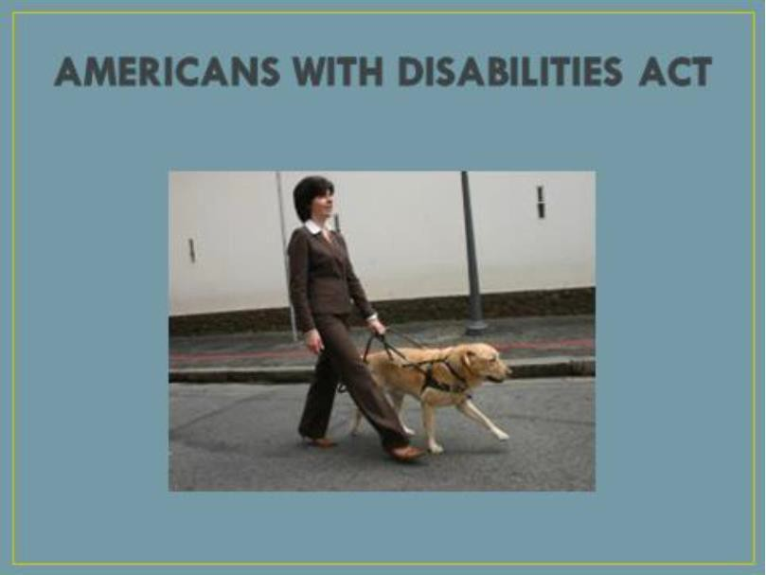

#### What is the Americans with Disabilities Act (ADA)?

* The most comprehensive federal legislation that prohibits discrimination against people with disabilities

#### Who is protected by ADA?

* ADA protects individuals with disabilities. A disability is a physical or mental impairment that substantially limits an individual’s major life activities (such as: caring for one’s self, performing manual tasks, walking, seeing, hearing, speaking, breathing, learning and working).
  + This includes function of the immune system, normal cell growth, digestive, bowel, bladder, neurological, brain, respiratory, circulatory, cardiovascular, endocrine, and reproductive functions (ADA Amendments Act 2008).

#### ADA mandates reasonable accommodation

* Reasonable accommodation is a modification or adjustment to enable individuals with disabilities to have equal access to benefits and privileges or a service or program, such as:
  + Changing existing facilities to make them accessible or usable
  + Acquiring or modifying equipment
  + Modifying tests, training materials, or policies to accommodate program participants with disabilities
  + Parking accommodations
  + NOTE: women, infants and children must be accommodated if medically or nutritionally warranted **(nutrition tailoring)**

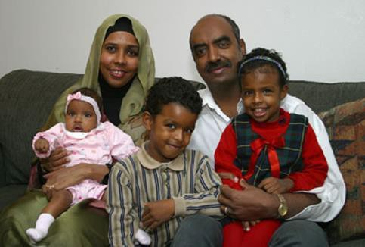

## What is Limited English Proficiency (LEP)?

* State and local agencies must take reasonable steps to ensure “meaningful” access to program information and services by people with Limited English Proficiency (LEP). These services may include:
  + providing interpreters
  + providing printed materials in different language

#### Who is protected by LEP requirements?

* Individuals for whom English is not their primary language and who have a limited ability to read, speak, write or understand English.

#### Local Agencies must have a LEP plan

* Your agency’s LEP plan should include:
  + ways to identify individuals needing language assistance
  + staff training on ways to assist individuals needing language assistance
  + ways to notify LEP individuals about available support services
* The WIC SPIRIT application has Language fields for staff to identify language needs of our participants.



**Language Assistance**

## How service is provided depends on:

* Number and proportion of Limited English Proficient (LEP) persons served
* Frequency of LEP persons’ contact with program
* Nature and importance of program, activity, or service
* Resources available and costs

#### A shortage of resources does not eliminate the LEP requirement except in the case of extreme hardship.

See page 33 for a helpful summary of ADA and LEP requirements for WIC agencies.

Refer to **Maine CDC WIC Policy CR-6 Language Access** for detailed information regarding working with LEP as well as deaf / hard of hearing participants.

**Americans with Disabilities Act and Limited English Proficiency**

|  |  |
| --- | --- |
| **Americans with Disabilities Act (ADA)** | |
| **What is it?** | The Americans with Disabilities Act (ADA) is the most comprehensive federal legislation that prohibits discrimination against people with disabilities |
| **Who is protected by ADA?** | ADA protects individuals with disabilities. A disability is a physical or mental impairment that substantially limits an individual’s major life activities |
| **ADA mandates reasonable accommodation** | Reasonable accommodation is a modification or adjustment to enable individuals with disabilities to have equal access to benefits and privileges of a service or program, such as:   * Changing existing facilities to make them accessible or usable * Acquiring or modifying equipment * Modifying tests, training materials, or policies to accommodate program participants with disabilities |
| **Limited English Proficiency (LEP)** | |
| **What is it?** | State and local agencies must take reasonable steps to ensure “meaningful” access to program information and services by people with Limited English Proficiency (LEP). These services may include:   * Providing interpreters * Providing printed materials in different languages |
| **Who is**  **protected?** | Individuals for whom English is not their primary language and who have a limited ability  to read, speak, write or understand English. |
| **Local agencies must adhere to LEP policies** | Procedures taken by LA staff must include:   * Proper identification of individuals needing language assistance * Consistent provision of interpreter services to LEP participants * Documentation in participant record when interpreter service is refused |

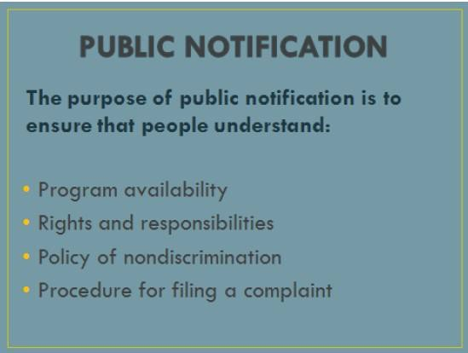

## Public Notification

* Federal law requires WIC programs to inform potential WIC applicants and program participants about:
  + Program availability—inform applicants and eligible persons of the availability of the program and the steps necessary for participation
  + Rights and responsibilities—inform applicants, participants and potentially eligible persons of their program rights and responsibilities
  + Complaint procedures—advise applicants and participants at the service delivery point of their right to file a complaint, and the complaint procedures
  + Nondiscrimination policy—all information and sources, including websites, used to inform the public about FNS programs must contain a nondiscrimination statement. The statement is not required to be included on every page of the program website; at a minimum, the nondiscrimination statement or a link to it must be included on the home page of the program information.



#### What are some of the components of public notification at WIC Agencies?

* Displaying the *And Justice for All* poster
* Including the nondiscrimination statement on all materials that mention WIC or any other program funded by USDA
* Making program information available to the public upon request
* Informing potentially eligible persons, applicants, participants and community partners of program or changes in program
* Providing information in other languages and by means accessible to people with disabilities
* Ensuring that photos and graphics reflect diversity

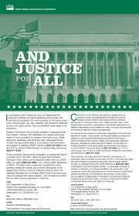

* + *And Justice for All* posters must be placed anywhere that services are provided and where they are easily visible.
  + In the local agency offices and clinics, they should be posted in a place where participants are able to read the poster, usually in the waiting room or waiting area.

**The current version of the *And Justice for All* posters must be on display. Version AD-475, updated September 2019 and currently authorized for use.**

Copies of this poster may be downloaded for local agency printing or ordered from the State Agency.

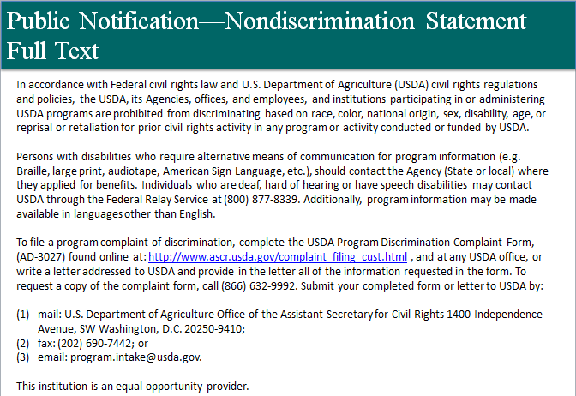

#### There are two authorized Nondiscrimination Statements (NDS):

* “Full” version (above)
* “Short” version

Maine CDC WIC Policy CR-1 provides details on the use of each statement.

#### Requirements regarding use of NDS:

* Local agencies are required to include the NDS on all materials used for certification, eligibility, program outreach and/or promotion, and participant rights that are distributed, posted, or aired for public viewing. Examples of materials requiring the NDS include flyers, information, referral and outreach materials, posters, handouts, videos, leaflets, brochures, and publications.
* The NDS is not required for nutrition education and breastfeeding promotion and support materials that strictly provide a nutrition message and simply carry the WIC logo.
* **NOTE:** The State WIC Program uses the short version of the NDS on its nutrition education and breastfeeding promotion and support materials because many of the materials are may be distributed by local WIC agencies to conduct program outreach. When materials describe the WIC Program eligibility requirements and benefits offered, the long version is used.

#### Use of statements:

* The short version may be used on smaller materials or on short public service announcements.
* The statements may be excluded when the size or configuration of the material makes it impractical.

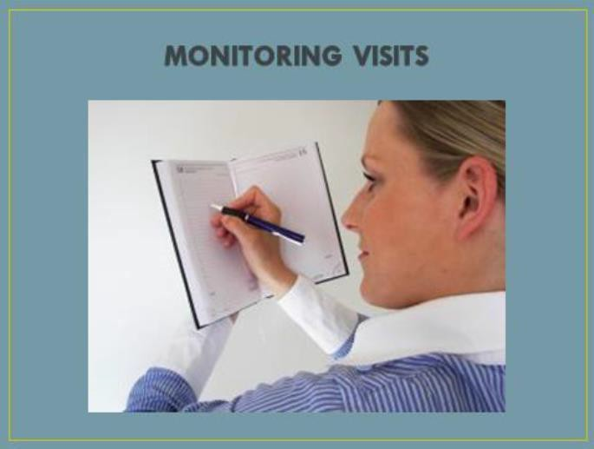

## Civil Rights Compliance Monitoring

#### Federal Review of State Agency

* + The Maine CDC WIC Nutrition Program is evaluated by USDA FNS through the WIC Management Evaluation (ME) process.
  + USDA may choose two or more local agencies to be evaluated on areas under review which may include compliance with civil rights policies, laws and regulations.
  + USDA also reviews Maine CDC WIC Nutrition Program staff to ensure all staff members receive Civil Rights training on an annual basis.
  + Any identified noncompliance is reported as a finding on USDA’s ME report.

#### State Agency Review of Local Agency

* + Each Local Agency is evaluated by State Agency staff at least every two years through the Management Evaluation Review (MER) process.
  + The State Agency evaluates each agency’s civil rights compliance during the MER to assess for adherence to civil rights laws and regulations as well as mandatory annual training.
  + Any identified noncompliance is reported as a finding on the State Agency MER report, with corrective action plan requirements established for the Local Agency.



## Civil Rights Compliance Monitoring

* + - If a local agency receives a finding from a federal or a state management evaluation, the local agency must develop and submit a corrective action plan (CAP) to the State Agency, outlining the action(s) taken to resolve the issue(s). The State Agency is responsible for following up with the local agency to ensure the CAP is implemented and issue(s) have been corrected.
    - The State Agency must also develop and submit a CAP to USDA on its federal ME finding(s). USDA follows up with the State Agency to ensure the issue(s) have been corrected.
    - Failure to correct a finding may result in reduction in program funding.

### Activity 5

**Instructions:** Review the following questions and select the answer that you think is most appropriate.

1. Which of the following help notify the public about their civil rights?
   * *Rights and Responsibilities* notice in the WIC Participant Booklet
   * Nondiscrimination statement
   * *And Justice for All* poster
   * All the above
2. Where should the *And Justice for All* posters be placed?
   * In the manager’s office
   * In your cubicle
   * Where everyone can easily read it
3. State WIC staff are required to receive Civil Rights training on an annual basis.
   * No
   * Yes
4. In reference to Civil Rights, what does **ADA** mean?
   * American Diabetes Association
   * Americans with Disabilities Act
   * American Dental Association



## Civil Rights Compliance Includes Our Customer Service

* Be patient and polite
* Listen with presence and compassion
* Avoid sarcasm
* Be empathetic
* Ask for help to resolve a difficult situation
* Smile whenever possible, especially when you answer the phone—it will come across in your voice
* Apologize when appropriate
* To avoid offending anyone, be open to valuing the other person’s opinion
* Do not feel you need to have the last word
* Treat everyone the same no matter who they are, how they look, or how they act
* Impose policies that impact all people the same
* Treat everyone with dignity and respect



## Civil Rights Compliance Includes Conflict Resolution

* + Try to remain calm and not mirror the behavior at hand
  + If you are unable to resolve the situation, obtain assistance from a manger
  + If you feel threatened in any way, obtain assistance from others, protect yourself, and if necessary, call 911. Threats or acts of violence are never to be tolerated in the workplace
  + Use alternative dispute resolution techniques when appropriate

### Activity 7 Customer Service

**Scenario:** It is 11:50 A.M.; you have had computer network issues all morning, and the waiting room is packed. The front door opens and a woman comes in with her two toddlers. Her voice is raised as she is waving her hands in the air. There is a room full of participants patiently waiting to be assisted when the woman walks to the front desk, points her finger in your face, and states very loudly, “Get me your supervisor now! I have a complaint!”

**Instructions:** Answer the following questions in your groups.

1. How do you handle this situation?

Click here to enter text.

1. What can you say to her that might make her feel valued?

Click here to enter text.

1. What actions might you use to calm the situation (tone of voice, body language, eye contact)?

Click here to enter text.

1. Describe how she might be feeling or what may have upset her.

Click here to enter text.

1. What words can you use to convey you understand, have compassion for, empathize with, and respect the participant?

Click here to enter text.

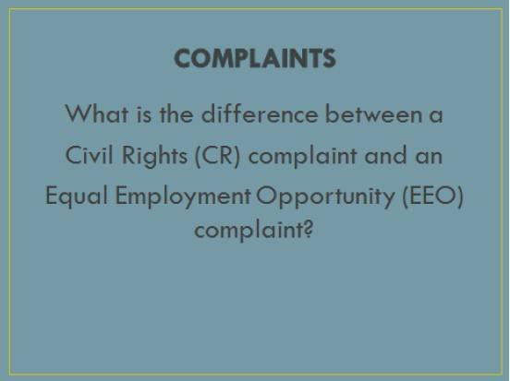

## Complaints

* + A **Civil Rights (CR)** complaint is a verbal or written allegation of discrimination that a FNS program administers or operates in a manner that results in disparate treatment or services being provided to persons or groups of persons because of their protected class.
  + An **Equal Employment Opportunity (EEO)** complaint involves any employee or applicant for employment who believes that he or she has been discriminated against based on one of the protected classes when applying for a job or currently working for a FNS funded program.

### Everyone has the right to file a complaint!

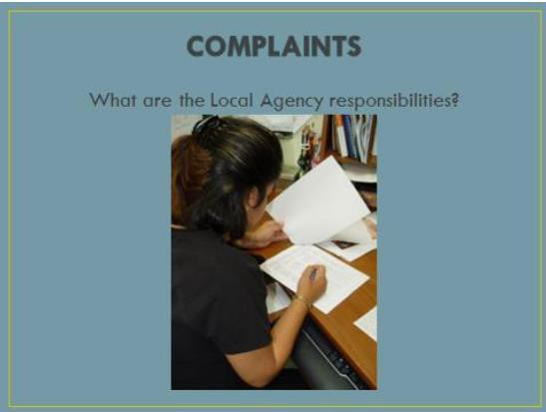

**Complaints**

* If an applicant or participant wants to file a complaint, the local agency shall:
  + Advise the applicant or participant of their rights and responsibilities
  + Advise the participant that their identity is kept confidential
  + Details of the complaint are only to be shared with: WIC supervisors, the person filing the complaint, State WIC staff (Director or designee), and staff involved in the incident.
* If the applicant or participant needs assistance with filing a complaint, the local agency staff member shall:
  + Draft the complaint on behalf of the applicant or participant
  + Complaint details to include:
    - Name, address, and telephone number of the complainant
    - Specific location, date(s) and Local Agency name where incident took place, and if applicable, the name of the person delivering WIC services
    - Description of incident or action, including reason complainant believes that it was discriminatory
    - Name(s), title(s) and address(es) of persons who may have knowledge of the discriminatory action
  + Submit the complaint to the appropriate address
  + Retain a copy in the local agency complaint file
* The local agency is required to maintain a paper or electronic file that contains discrimination complaints and procedures. **See Appendix CR-4-A for State Agency log format.**

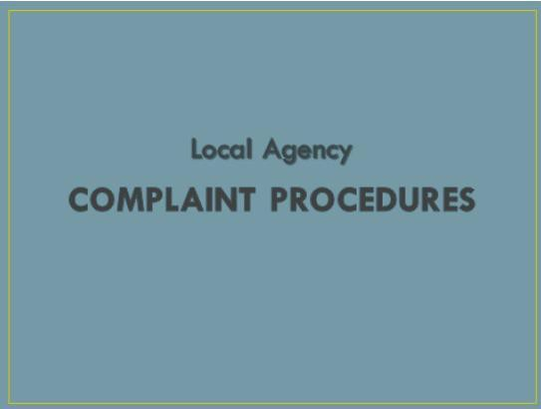

## Civil Rights Complaints

* + Must be based on one or more of the protected classes
  + Must be filed within 180 days of the occurrence or notice
  + Anonymous complaints shall be handled like any other complaint

#### Refer to Discrimination Complaint Process and Procedures, pages 47-48

as a helpful guide regarding handling participant complaints.

### Discrimination Complaint Process

If a participant claims to have been discriminated against, these steps must be followed:

**Step 1**

* Apologize to the participant and inform a supervisor immediately.
* *Note: the participant has up to 180 days after the incident to report the complaint. Complaints may be written, verbal or anonymous.*

**Step 2**

If the supervisor cannot resolve the situation:

* Share the rights and responsibilities information in the WIC Participant Booklet with the participant.
* Assist the participant with filing a complaint, if necessary.
* *Note: Maine CDC WIC Policy CR-4 provides detail on filing a complaint.*

**Step 3**

Send the complaint to the addresses listed below. If the participant files the complaint her/himself, provide the addresses for where to send the complaint.

* *Note: the agency must respond to the complaint within 5 days.*

**Send the complaint form to:**

United States Department of Agriculture

Office of the Assistant Secretary for Civil Rights 1400 Independence Avenue, SW

Washington, DC 20250-9410

Fax: (202) 690-7442

Email: [program.intake@usda.gov](mailto:program.intake@usda.gov)

**AND**

**Send a copy to:**

Maine CDC WIC Nutrition Program ADA Compliance/EEO Coordinator

ATTN: Ginger Roberts-Scott 11 SHS

11 SHS Augusta, ME 04333

286 Water Street, 4th Floor Augusta, ME 04333

***Note:*** *Details of the complaint are confidential and should only be shared among WIC supervisors, staff involved in the incident, the person filing the complaint, and the State WIC Director or designee.*

### Complaint Procedures Overview

Local Agency staff must advise the participant that their identity is kept confidential, except for the purpose of investigating the complaint, or conducting hearings or judicial proceedings.

The Local Agency shall ensure the following information is provided in the written complaint:

#### Participant Information

* 1. Name
  2. Address
  3. Telephone number
  4. Or other means of contacting the individual

#### Local Agency Information

* 1. LA name
  2. Location where the participant receives WIC services

#### Complaint Description

* 1. The nature of the incident/action that led to the participant feeling discriminated against

|  |  |  |
| --- | --- | --- |
| 4. | **Perso** | **ns involved or who may have knowledge of the incident/action** |
|  | a.  b.  c. | Names Titles  Business addresses |

#### Date(s)

1. Date the incident/action occurred
2. If continuing, the duration of incidents/actions

The Local Agency **shall not** interfere with any rights or privileges of a participant because she/he made a complaint or allegation, testified, assisted, or participated in the investigation, proceeding, or hearing relating to the incident/action.

As a result of a complaint, the LA must ensure that no person is:

* Intimidated
* Threatened
* Coerced
* Discriminated against

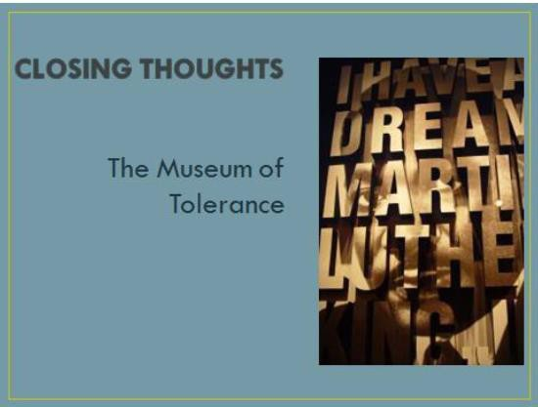

The **Museum of Tolerance** in Los Angeles welcomes its visitors in a unique and compelling way. Visitors must wait in the lobby until invited into the museum by a tour guide. The guide points out there are only two doors to enter the museum. One door is marked “prejudiced” and the other door is marked “unprejudiced”.

Visitors are instructed to enter the door that most represents them. Almost always, the door marked

“unprejudiced” is selected. The brave visitor who is first to try the door is unable to turn the knob. Much to everyone’s surprise, the “unprejudiced” door is locked. The only way to enter the museum is through the door marked “prejudiced”.

This is a powerful lesson. We are all prejudiced in some way for some reason. We must acknowledge this to ourselves.

The real question is not… “Are we prejudiced”?

The real question is… “Are we **acting** on our prejudices”?

It is in the **action** that discrimination exists.



**Congratulations!**

You have completed the annual required Civil Rights training. Please do the following:

discuss activity responses with your supervisor if you need clarification regarding any of the questions

update your continuing education log

notify your immediate supervisor you have completed the training complete the training evaluation and send to the State Agency

* email: [wic.maine@maine.gov](mailto:wic.maine@maine.gov)

fill in the Certificate of Completion; you may print it **or** scan and save for your training records

**We hope you have found this training to be helpful in your work.**



**Maine CDC WIC Nutrition Program Policy Manual Resources**

For additional information or technical assistance, please refer to the following policies:

**CR-1** Public Notification

**CR-2** Compliance

**CR-3** Data Collection **CR-4** Complaint Process **CR-5** Training

**CR-6** Language Access

**CR-7** Special Populations

**Maine CDC WIC Nutrition Program Civil Rights Training Evaluation**

**Date:** Click here to enter a date.

Your responses to the following statements and questions will help us evaluate this training program to best meet the needs of WIC staff. Please take a few moments to give us your feedback by completing this evaluation.

Please rate each statement by choosing an option in the drop-down menus provided.

|  |  |
| --- | --- |
| All mandated objectives were covered in the training. | Choose an item. |
| The information was relevant and current. | Choose an item. |
| The activities were effective. | Choose an item. |
| The training was a positive learning experience. | Choose an item. |

What did you like best about this training?

Click here to enter text.

Please list one idea that you will use in your job as a result of this training.

Click here to enter text.

What suggestions do you have to improve this training?

Click here to enter text.

**Thank you for your feedback!**



# Maine CDC WIC Nutrition Program Certificate of Completion

**Civil Rights Training**

“Equality for All”

Presented to

Click here to enter text. Click here to enter a date.

This certifies that the above named has completed the Maine CDC WIC Civil Rights Training and has agreed to comply with the information given on discrimination, federal and state civil rights requirements and complaint procedures.

50