Public Health Work Group (PHWG)

Infrastructure Sub-committee
Draft Working Document

A Report to the PHWG
October 30, 2006

Public Health Work Group
Infrastructure Subcommittee Report

TABLE OF CONTENTS

Section Topic Page Number

Executive Summary 3-4

Section I 10 EPHS Structural Reality and Gap Analysis 5-7

Section II Sub-State Public Health Assets (by the 10 EPHS) 8

Section III Map Elements 9

Section IV Maps 10

Section VI Acknowledgements 11

Appendices A – Acronyms 12-13

B – Assessment of delivery of the 10 EPHS
State and Local Levels 14-15

C - Observations of Factors and Variables in
Maine that Influence The Delivery of the 10 EPHS 16-17

D – Local Health Officer Basics 18-19

E – 10 Essential Public Health Services in Plain English 20

F – Sample GIS Maps 21-27

G – Existing Community Health Coalitions 28-30

Executive Summary

A public health system focused on delivering the ten essential public health services is distinct in two key respects: its primary emphasis is on health protection and health promotion, especially upstream prevention of disease and disability, and it is centered on the health of entire populations, rather than individuals. Maine’s current public health infrastructure is truly a complex network of people, systems, coalitions and organizations, working independently and/or together at state, regional and local levels. Two of our state’s largest municipalities (Portland and Bangor) have their own public health system, but the majority of Maine people receive public health services through locally organized and governed entities, including community health officers (see Appendix D), health care institutions/networks, school systems, and voluntary coalitions scattered across the state. Funding for these entities comes from a variety of public and/or private sources and their work may or may not be coordinated by the Maine Center for Disease Control and Prevention .

This subcommittee, as have all other states, found it difficult to capture a complete picture of the delivery of the ten essential public health services (EPHS) in Maine. Due to time and resource constraints, this committee concluded it could not provide a complete and accurate analysis of all of the public, private and in-kind funding and EPHS service providers in our state. Therefore, while we recognize that public health funding is very limited at present, this report does not contain any information regarding the current funding of Maine’s public health infrastructure beyond state dollars. This report also does not include a detailed listing of all public health service providers. Rather, what we have done is to provide dual perspectives from state funders and a variety of service providers by category. In short, our report provides a general understanding of:

- Which of the EPHS currently has State funding support;
- Who delivers EPHS now at the local level;
- Why EPHS delivery varies across the state; and
- Where are the major deliveries of the EPHS occurring.

Highlights of what we have learned about Maine’s current public health infrastructure include:
- Maine’s current delivery of EPHS lacks the systemic structure of the three components of public health infrastructure: workforce capacity and competency; information and data systems; and organizational capacity/system coordination.
- Maine’s current public health infrastructure has many strengths in local and statewide entities which deliver EPHS.

- Maine’s current public health infrastructure has evolved through a patchwork of strategies and funding streams, resulting in many un-integrated and under-resourced programs to deliver the EPHS.
- Maine’s geographic/demographic characteristics challenge the equitable and efficient delivery of EPHS. Mapping of services, although not necessarily by geopolitical boundaries, can help us identify strengths and gaps in our current delivery of EPHS.
- Effective delivery of EPHS requires a community strategy to accomplish broad and far-reaching goals that must utilize the strengths and unique capacity within that geographic region and respect the local culture.

Our committee’s recommendations for further research and analysis include:
- A complete and thorough analysis of the current public health resources should be completed, including all sources of public and private funding capacity.
- There should be statutorily assigned responsibility for delivery of each of the EPHS statewide.
- Any proposal around public health infrastructure should focus on creating and maintaining the three components of public health infrastructure: adequate workforce capacity and competency; information and data systems; and organizational capacity/system coordination.

The end we seek, through these public health system enhancements, is the improved health of Maine citizens. Taken as a whole, we hope that this report will assist the other committees and the full Public Health Workgroup in their work to develop the legislative proposals necessary to create and fund the best possible public health system for the citizens of Maine.

Section I

The 10 Essential Public Health Services (EPHS) Structural Reality and Gap Analysis

NPHSPS: National Public Health System Performance Standards
NACCHO: National Association of City and County Officers
Substate: large region [multiple or single county] or micro region
[multiple or single town]; also includes townships & Tribal homelands

One View of Current Public Health Infrastructure In Maine 2006

  - State Public Health System: “includes state public health agencies and other partners that contribute to public health services at the state level.” [NPHSPS].

    - Maine’s state public health agency is not required by statute to be responsible for the effective delivery of public health services.
    - Effective delivery of each EPHS varies among services and between local and state levels (see Appendix for Committee Assessment of Delivery of 10 EPHS at local and state levels).
    - Maine’s state public health agency [Maine CDC] works with many public and private partners at the state level. Partnerships can be formal (statute, contract, memorandum of understanding) or informal (handshake or memo).

  - Local Public Health System is “all entities that contribute to the delivery of public health services within a community. This system includes all public, private and voluntary entities, as well as individuals and formal associations.” [NPHSPS]

    - Maine municipalities and counties are not by law responsible for the overall health status of their residents.

      - For over 100 years in State statute, towns and cities have had authority to address some components of public health, such as Local Health Officer response to “public health nuisances”, and to address aspects of communicable disease outbreaks. Municipalities also deliver public safety, general welfare, solid waste management, public works, public education, and comprehensive municipal planning services, which are factors influencing resident health.
      - Counties do deliver public safety, corrections, and emergency management services, and may offer other services as well. Such services are factors in population health, but do not constitute performance of the core functions of assessment, assurance or policy development.

    - No statewide system of sub-state comprehensive health jurisdictions exist in State statute. Health care service areas (e.g. hospital, health center) exist; but primary missions are often delivery of personal health services, not comprehensive population health services for the public good.

    - There are inconsistent assessments of effective public health system performance and community health status across Maine.

      - There is a nationally accepted standardized tool to assess the effectiveness of public health system performance. This tool has had sparse application in Maine.
      - Local community health status assessments are not standardized across the state. There is significant inconsistency of critical elements such as public health workforce capacity to carry out community health assessment processes, data analysis, and interpretation of finding.

  - Local Public Health Governing Body: ultimately accountable for public health at the local level. Such governing bodies may include boards of health, local commissions, or councils.

1. This service includes:
      - Effective local public health governance.
      - Development of policy, codes, regulations, and legislation to protect the health of the public and to guide the practice of public health.
      - Systematic LPHS and state-level planning for health improvement in all jurisdictions.
      - Alignment of LPHS resources and strategies with community health improvement plans.
      - Assurance that each member of the governing body understands, exercises, and advocates for appropriate legal authority to accomplish these assurance functions. [NPHSPS].

    - A variety of local public health entities exist in Maine, with varying degrees of governing responsibilities and effectiveness. Some examples include:

      - Distinct statutory authority and commitment of resources to deliver public health services:
        - City of Portland Division of Public Health (city regulations)
        - City of Bangor Department of Health and Welfare (city regulations)
        - Tribal Health Departments (separate Nations recognized by federal
government)

      - Distinct creation of Boards of Health and commitment of volunteer resources to deliver public health services:
        - Sagadahoc County
        - Cumberland County (in progress)
      - Written public health plan and commitment of resources to deliver public health services:
        - Town of Ellsworth
        - Town of Bucksport
        - Other Maine towns (complete list not available)

 | Section II
 | Sub State Public Health Assets
 | Types of Local or Regional Organizations whose Core Mission & Services could be aligned as part of a local Public Health System | EPHS | EPHS | EPHS | EPHS | EPHS | EPHS | EPHS | EPHS | EPHS | EPHS
Category Number |  | #1 monitor status | #2 health hazards | #3 educate people | #4  partner  ships | #5  policy plan | #6 enforce law regs | #7 access to care | #8 work  force | #9 evaluation | #10 research
1 | Area Agencies on Aging |  |  | X |  | X |  | X | X
2 | Community Action Programs [CAP] (+service agencies like CAP) |  |  |  |  | X |  | X
3 | Community Coalitions (HMPs, HCs, OneMaine, C4C) | X | X | X | X | X |  | X | X | X | X
4 | County Government (EmergencyManagement [EMA]; jails; sheriff etc) |  | X | X | X | X | X
5 | DHHS Regional Offices (TANF.WIC.Foodstamps.PHNursing.etc) | X | X | X |  |  |  | X | X
6 | Early Childhood Agencies (Head Start, Child Care Centers, etc) |  |  | X |  |  | X | X | X
7 | Environmental Organizations (water/air quality.pollutionprevention,etc) | X | X | X |  | X | X | X | X
8 | Health Care Systems (integrated, linked network of providers&affiliates) | X | X | X | X | X |  | X | X | X | X
9 | Hospitals (stand alone or affiliate of a health care system) | X | X | X | X | X |  | X | X | X | X
10 | Judicial (District Attorneys, District Courts, etc) |  |  |  |  |  | X
11 | Law Enforcement (State Police, ME Warden Service,Marine Patrol etc) |  | X | X |  |  | X |  | X
12 | Municipal government (healthdepts.planning.healthofficers.codeofficers.publicsafety.police.fire.ambulance roads.sanitation.school budgets.parks.recreation programs. etc) | X | X | X | X | X | X | X | X
13 | OutpatientCare Primary.Dental.MentalHealth.FamPlan (communityhealthctr.communitymentalhealth.schoolbasedhealthservices.dentalclinic.substanceabusetreatmentfacility) | X |  | X | X |  |  | X | X
14 | Public Housing Authorities |  |  |  |  | X
15 | Recreation Organizations (YMCA/YWCA, Boys+GirlsClub etc) |  |  | X
16 | Regional Resource Centers (Hospital-based Preparedness Programs) |  | X |  |  | X |  | X | X |  | X
17 | Regional InfectiousDiseaseEpidemiology Offices (MCDC) | X | X |  |  | X |  | X | X |  | X
18 | Regional Planning Commissions | X |  |  | X | X
19 | School Districts (K-12 public & private) |  |  | X |  | X |  |  | X |  | X
20 | Tribal Health Centers | X |  | X |  | X | X |  | X |  | X
21 | Universities, Colleges (public; private; incl. Cooperative Extension offices) |  |  | X | X | X |  | X | X | X | X
22 | United Ways | X |  | X | X | X |  | X
23 | Voluntaries (Am.CancerSoc.Am.HeartAsso.AmLung.etc.) |  |  | X |  | X |  | X | X
This list represents categories of public health providers as generated by PHWG members and interested parties using available written materials and committee member expertise. Local providers and communities were not surveyed. Criteria for selection was intentionally broad, with a relatively low threshold for inclusion. It is not intended to indicate RESPONSIBILITY for delivery of any particular EPHS. Despite best intentions, the list is likely incomplete, and does not include many sectors, such as business, civic associations, the arts, agriculture, that contribute to public health. Within any type of organizational asset listed or mapped, there is variability in both quantity and quality of public health services delivered across the state.

Section III

Map Elements

Map Elements (GIS layers)
Reflecting Sub-State Public Health Assets
Types of sub-state organized entities reasonably active in delivery of any of the
Ten Essential Public Health Services.

The following are selected map elements the Current Infrastructure committee intends to visually represent on electronic asset map(s) using GIS technology. Electronic mapping and presentation software will enable the Public Health Workgroup to selectively view single or multiple layers of information on demand. Maps presented will present a partial view of sub-state organized assets in order to provide a perspective of Public Health service delivery from the ground up. The accompanying lists of sub-state assets and assets organized by the ten essential public health services will serve as companion documents to maps presented.

9. Recreation Organizations (YM/WCA’s Boys & Girls Clubs etc)
- Map location of YMCA’s.

10. Regional Resource Centers (Emergency Preparedness)
- Map locations

11. Regional Epidemiology Offices
- Map region & office location

12. Regional Planning Commissions
- Map office location & region

13. School Districts (K-12)
  - Map districts

14. Tribal Health Centers
- Map clinic location and reservation
15. UME Cooperative Extension Agencies
- Map location

16. Universities & Colleges
  - Map location

17. United Ways
  - Map office locations

Other Demographic layers: Need to confer with consultant

- Population density & distribution
- Poverty
- Education

Area Agencies on Aging
- Map central office locations

- CAP - Community Action Programs
(and agencies that function like CAPs)
- Map central office locations

- Community Coalitions (healthy community coalitions, healthy maine partnerships, communities for children and substance prevention coalitions)
- Map a symbol on service center town where either an HMP, HCC or C4CY exists (do not place more than one mark if more than one coalition exists)

- Counties (EMA’s, law enforcement etc)
- Map county boundaries, use symbol for county government

- DHHS Regional Offices (Public Health Nursing, Food Stamps etc)
- Map office locations, using symbol

- Early Childhood Agencies (Head Start, Child Care Centers, etc)
  - Map Head Start Centers, and RDC’s (resource development centers)

- Hospitals
- Map hospital location and service area

- Municipalities (health depts., planning, LHO’s, CEO’s, public safety etc)
- Map town boundaries

- Primary, Dental and Mental Care (CHC’s, CMHC’s, SBHC’s, Dental, Substance Tx etc)
- Map FQHC’s, & CMHC’s office locations

Section IV

Maps

Based on the section V sub-elements, our subcommittee has utilized the technology of GIS mapping to provide a sampling of existing state agencies/organizations fulfilling some of the 10 EPHS across the state. We believe that this technology can greatly assist us in identifying our strengths and gaps in the 10 EPHS across Maine. Maps are not easily available to insert into this report, below is a sample for preview. A power point presentation with other sample maps is available on line at http://www.healthyhancock.org/regioninfo/studies.htm (see appendix F for sample maps).

Sample Map

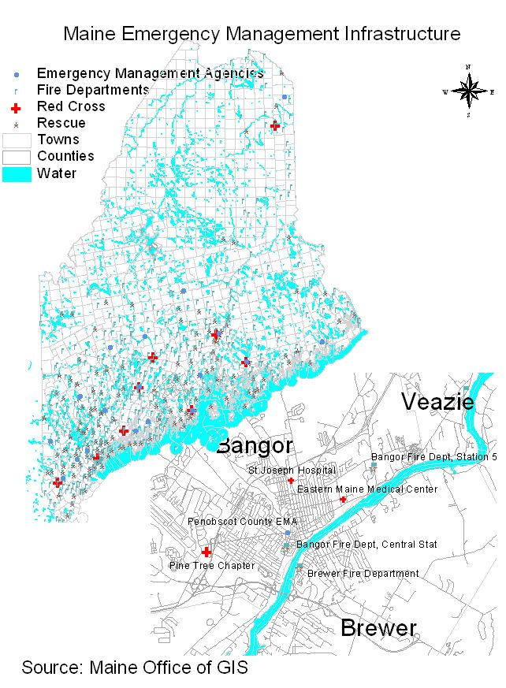

Section V

Acknowledgements

The Public Health Work Group assigned the task of describing Maine’s current Public Health Infrastructure to a subcommittee of its members in the spring of 2006. Over a 5 month period the committee reviewed documents and literature, engaged stakeholders at both the state and local level for their input and expertise and boiled the many ingredients of Public Health in Maine down to the report you have just read. We wish to thank everyone who contributed to this document and extend a special thanks to the following CINF members and committee contributors:

Reinhold Bansmer, Director, Division of Chronic Disease, Maine CDC

Joanne Joy, Project Director, Healthy Communities of the Capitol Area

Carol Kelly, Maine Coalition on Smoking and Health

Christine Lyman, Maine CDC, Department of Health and Human Services

Doug Michael, Partnership Director, Healthy Acadia

Laura Morgan, Director of Training and Collaborative Initiatives, Institute for Civic Leadership

Sandra L. Parker, Esq., Vice President & General Counsel, Maine Hospital Association

Barbara J. Peppey, Director, Healthy Peninsula

William Primmerman, Project Director, Somerset Heart Health

Meredith Tipton, University of NewEngland

Shawn Yardley, Director, City of Bangor Health and Welfare

Appendix A

Acronyms

ACS American Cancer Society

AHA American Heart Association
AHEC Area Health Education Center [health professional continuing education]
ALA American Lung Association
ARC Association of Retarded Children, National
CAP Community Action Program

CD chronic disease

CEO Code Enforcement Officer, municipal

CHC Community Health Centers [see also FQHC]

CMHC Community Mental Health Center
COGs Councils of Governments (municipal)
DA District Attorney
DHHS Department of Health and Human Services, Maine

EMA Emergency Management Agency

EPHS Essential Public Health Services
FQHC Federally Qualified Health Center
HC Healthy Communities coalition
HHS Health and Human Services, Maine Dept. of
HMP Healthy Maine Partnerships
LHO Local Health Officer

LBOH Local Board of Health
LPHS Local Public Health System
MCDC Maine Center for Disease Control and Prevention/HHS
ME CDC Maine Center for Disease Control and Prevention
MCPH Maine Center for Public Health
Muskie Muskie Institute/USM
NACCHO National Association of City and County Officers
NPHSPS National Public Health System Performance Standards
OSA Office of Substance Abuse/HHS
RDC Resource Development Centers (child care)
PHI Public Health Infrastructure
Pre-K Pre-Kindergarten

SA substance abuse
SBHC School Based Health Centers
TANF Temporary Assistance for Needy Families
Tx treatment
UM University of Maine
UME University of Maine Extension Service
UNE University of New England
USM University of Southern Maine
WIC Women and Infants, Children [Nutrition Program]

Appendix B

Assessment of Delivery of 10 EPHS at State and Local Levels

This Essential Public Health Service (EPHS) Assessment reflects only the opinions of the Current Infrastructure Subcommittee. The Assessment results are based on consideration of the following question:
Is each EPHS being resourced adequately and delivered effectively to all citizens of Maine?

The scores reflect if effective EPH service is occurring across Maine either (a) because public or private sector entities have been funded or mandated by state regulation to deliver the service or (b) because Maine state government or all local governments provide the service directly.

Assessment Rankings:
+ occurring effectively and is assured for 0 to less than 25% of Maine
++ occurring effectively and is assured for between 25% to 50% of Maine
+++ occurring effectively and is assured for greater than 50% of Maine

EPHS LOCAL LEVEL STATE LEVEL/State Gov’t.

1. Monitor  but not assured    but not all assured
ie hospitals, local health depts. decade reviews, i.e. Healthy Maine 2010, not
[LHD], some community coalitions assured; infectious diseases are

2. Diagnose  
& Investigate Local Health Officers [LHOs] local PH emergency funds to date have
health depts., & hospitals do some, increased this capacity
but limited capacity, incl workforce

3. Inform  
& Educate esp. re chronic disease (CD) but not assured in most non-CD &
substance abuse (SA) issues; non-SA issues, ie. environmental health, infectious disease
 on other health issues  on other health issues
(LHDs & hospitals in some cases
do this) but no assurance

4. Mobilize  
Partnerships esp. re chronic disease (CD) & with other state agencies & statewide
substance abuse (SA) issues; & private partners

5. Policies   esp on CD & SA issues
 on other health issues

6. Enforce  
Laws done by LHOs, regional State regional State staff few;
staff, & law enforcement;. weak state support for LHOs
LHO has workforce capacity
challenges

7. Assuring  
Health Care done by hospitals, LHDs, by MaineCare, state regulations on
rural health centers & federally insurance companies and providers
qualified health centers, family
planning services

8. Competent  personal health svs  personal health svs
Workforce hospitals assure workforce competency [medical, oral, mental health]
+ population health svs  population health svs

9. Evaluate  
some federal grants/contracts assure some federal grants/contracts assure,
but not a long-standing function

10. Research  
State and Local Levels, Maine CDC, OSA,
UNE, Muskie/USM, UM, biomedical research
carry out some research, mostly from state level

Key to Acronyms:
CD = Chronic Disease
SA = Substance Abuse
LHDs = Local Health Departments
LHOs = Local Health Officers

Appendix C

- Observations of Factors and
- Variables in Maine that Influence
The Delivery of the 10 EPHS*

1. Monitor health status to identify community health problems

- Gathering and reporting data can be fragmented because of a variety of measures at several different levels
- Not all regional planning entities Council of Governments are engaged in public health planning
- The capacity to gather and report data may not exist at local levels
- Duplication of effort often exists because individual systems simultaneously conduct surveillance for chronic disease, infectious disease, risk and protective factors, and environmental health
- Monitoring is often tied to agency interests or categorical funding requirements instead of what the state or individual communities may need in order to maximize the health of our citizens
- Epidemiological capacity is limited at all levels

2. Diagnose and investigate health problems and health hazards in the community

- It is not clearly defined who has authority to investigate various types of hazards
- Polices and (perceived) authorization vary from community to community
- Availability of professional staff (e.g., code enforcement, public health nurses) is sometimes limited

3. Inform, educate, and empower people about health issues

- There are many entities that are performing this service across the state
- It is not clearly defined which entity should take the lead for dissemination of information and education
- Funding requirements of categorical programs often drives priorities rather than actual needs/wants
- The language and methods used to inform and educate may prevent empowerment rather than encourage it

4. Mobilize community partnerships to identify and solve health problems

- Availability of resources is not always equitable statewide
- Effectiveness may depend on the ability of community leaders to share a common perspective on the importance of public health and how the community defines itself

* See the nationally accepted definitions of the 10 EPHS

5. Develop policies and plans that support individual and community health efforts

- Policy development can be accomplished through many different processes involving a single person, a small group of people, a community or at the state level
- Existence of a cohesive, inclusive community whose residents share common interests is conducive to effective policy development and planning

6. Enforce laws and regulations that protect health and ensure safety

- Consistent enforcement of laws and regulations is dependent on universal interpretation, application and the availability of adequate resources (e.g, law enforcement, health officers, code inspectors, etc.)

7. Link people to needed personal health services and assure the provision of health care when otherwise available.

- Inadequate access to reliable transportation services and a the lack of health care coverage can inhibit effective linkages
- Effective linkages depend on the availability of health care providers and the types of providers available (i.e., physicians, dentists, orthodontists, etc.) at the local level

8. Assure a competent public health and personal healthcare workforce

- The number of persons qualified (educated or trained to perform all of the necessary tasks at all levels must be available.
- The number of qualified (educated or trained) persons is often contingent on the availability of funding and accessible education and training opportunities.

9. Evaluate effectiveness, accessibility, and quality of personal and population-based health services

- Requires capacity for evaluation expertise at all levels
- Developing and maintaining capacity requires adequate allocation of funding and other necessary resources
- Ability to think broadly about who actually delivers these services is conducive to ensuring delivery of this service

10. Research for new insights and innovative solutions to health problems

- This service is hampered by Maine’s lack of linkage between the public health practice and the public health research community, nationally recognized researchers to provide assistance in drawing down available grant funds for research
- In order to increase the likelihood of receiving grant funds for research, the amount of research conducted at all levels that is ultimately published should be increased
- Having the capacity to bring to Maine proven researched initiatives for dissemination is conducive to accomplishment of this service.

- Need to raise awareness about the capacity of community-based participating research to the Maine public health community.

Appendix D

Report on Local Health Officer Realities and Gaps

Key Points re Current Infrastructure: Sept. 2006

Over 100 years ago, state statutes established a State Board of Health and a system of Local Health Officers [LHOs]. The LHO system is a legacy system whose duties have evolved over time, and is currently under review.

Municipalities:
Every town and city in Maine is required by law to appoint a Local Health Officer
Compensation for LHOs varies widely according to locality if it exists at all.
No established criteria for appointment; terms of office are 3 years.
No systematic trainings or certification program exist for LHOs.
A 2003 online manual based on existing State statutes offers some orientation to new LHOs.

Note: by statute, State government provides backup support for LHO service delivery, not counties.

Unorganized Territories
LHO in towns or plantations contiguous to unorganized territory are required to serve those areas.

Local Board of Health
Municipalities may also appoint a Board of Health to serve in an advisory capacity to the LHO.

Records and Reports and Scope of duties
Statutes require the LHO to keep records and make reports.
Duties fall into four major areas: (1) administrative duties; (2) notifiable disease control;
(3) environmental health protection and nuisance control; and (4) other duties.

Selected examples of such duties include investigating and addressing:

- Persons and things liable to cause the spreading of contagious diseases
- Local contagious disease outbreak management assistance
- Unhealthy or otherwise dangerous buildings
- Dead domestic animals
- Faulty septic systems
- Offensive smells, abandoned wells or mining shafts, abandoned motor vehicles.
- Unsafe drinking water
- Unsafe bathing beaches

At present Local Health Officers contribute to the delivery of some components of Essential Public Health Services #1 (monitoring) #2 (health hazards) and #6 (enforcement of laws and regulations.)
Many LHOs combine their duties with those of school physician, school nurse, public health nurse, local plumbing inspector, code enforcement officer or other health and/or local-government related role.

Note: Tribal Homelands:
No State statute requires each Maine-based Tribe to appoint a Local Health Officer. Tribal health is addressed through Tribal Health Centers funded by the federal Indian Health Service.
Excerpted from Local Health Officers Manual 2003 06/MCDC/CHPP/Lyman

Appendix E

Definition of 10 EPHS In Plain English

- Understand health issues at the state and community levels
(Or “what’s going on in our state/community? Do we know how healthy we are?”)

- Identify and respond to health problems or threats
(Or “Are we ready to respond to health problems or threats? How quickly do we find out about problems? How effective is our response?”)

- Keep people informed about health issues and healthy choices.
(Or “How well do we keep all people and segments of our State informed about health issues?”)

- Engage people and organizations in health issues.
(Or “How well do we really Get people and organizations engaged in health issues?”)

- Plan and implement sound health policies.
(Or “What policies promote health in our State? How effective are we in planning and in setting health policies?”)

- Enforce public health laws and regulations.
(Or “When we enforce health regulations are we up-to-date, technically competent, fair and effective?”)

- Make sure people receive the medical care they need.
(Or “Are people receiving the medical care they need?”)

- Maintain a competent public health and medical workforce.
(Or “Do we have a competent public health staff? How can we be sure that our staff stays current?”)

- Evaluate and improve programs.
(Or “Are we doing any good? Are we doing things right? Are we doing the right
things?”)

- Support innovation and identify and use best practices.
(Or “Are we discovering and using new ways to get the job done?”)

- Appendix F

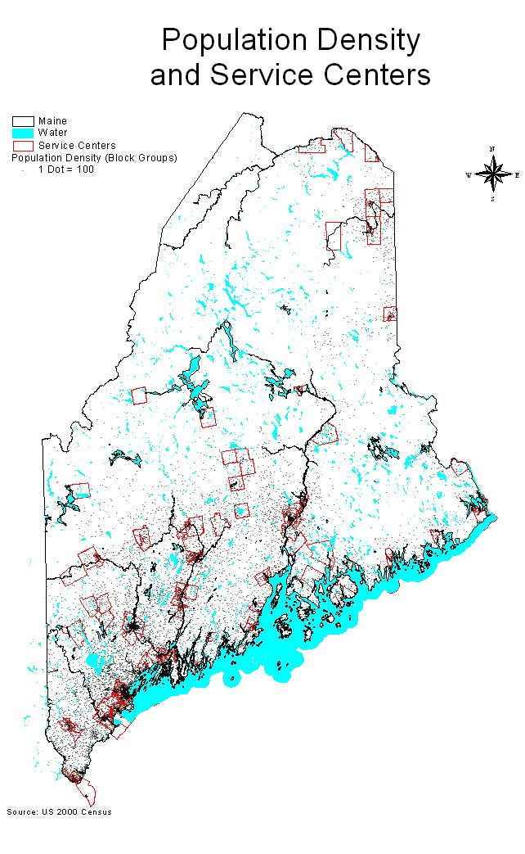
- Dot Density = 100 people

- Service Centers are Maine’s Population and Economic Clusters

- Service Centers have higher population densities

- Maine’s 76 Service Centers are defined by the State Planning Office
  - Employment (Jobs/Workers)
  - Volume of Retail Sales
  - Federally Assisted Housing
  - Service Sector Employment

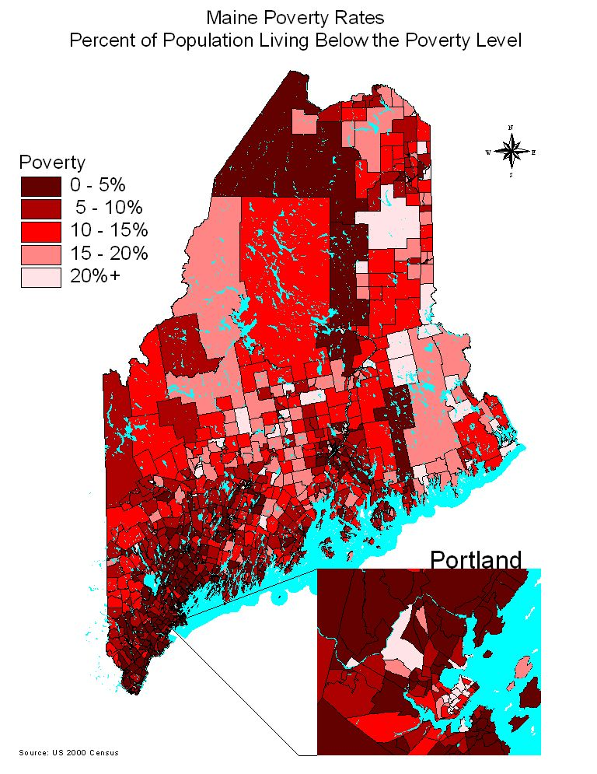
- White coded census block areas exceed 20% of population in Poverty

- Poverty in Maine is more concentrated in:

  - North and North-east
  - Inner City Blocks

- Inset view (Portland) shows more detailed information, linked to data sets

- Maine’s Emergency Management Network includes:
  - Fire
  - Police (not shown)
  - Ambulance/Rescue
  - Red Cross
  - County Emergency Agencies
  - Regional Resource Centers (not shown)
  - Hospitals (not shown)
  - And others

- Inset view (Bangor) details location of first stations, hospitals etc

- Emergency Response
  - Well developed at the local level
  - Strong commitment from community volunteers

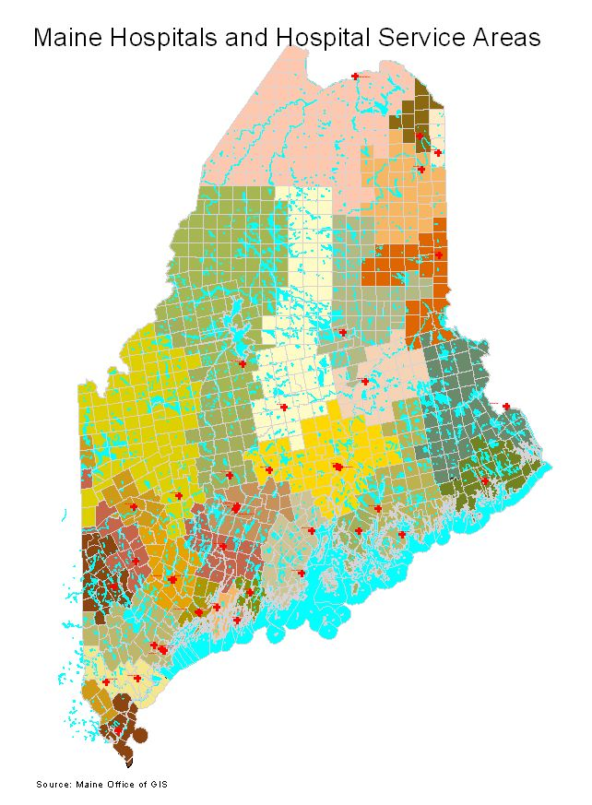
- Hospitals (red cross)

- Hospital Service Areas (in color)

- Town layer (white boundaries

- Hospitals typically located in Services Centers
  - Hospitals built near population centers
  - Now help to define the service center as major employers

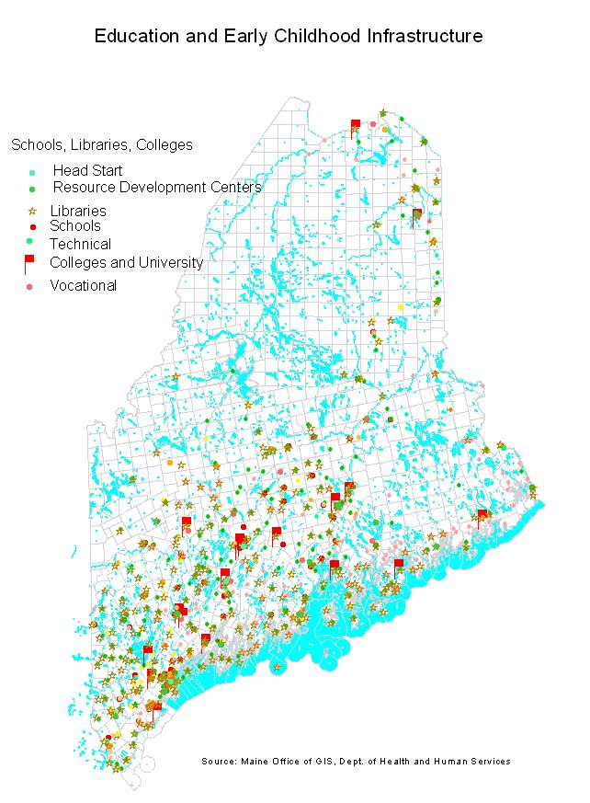
- Maine’s Educational Infrastructure
  - Population based
  - Extensive coverage
  - Strong local commitment

- Early Childhood Agencies
  - 14 Agencies Operating Head Start Programs
  - 8 Resource Development Centers
  - Head Start Programs (not shown)

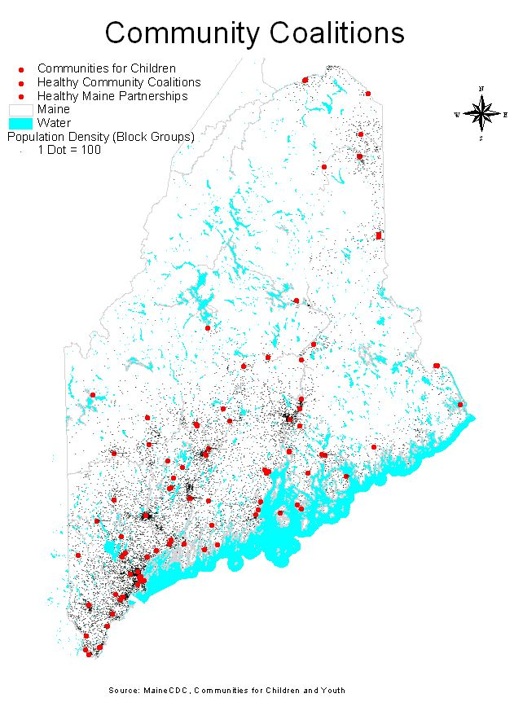

- Three coalition types mapped:
  - Communities for Children and Youth
  - Healthy Community Coalitions
  - Healthy Maine Partnerships

- Population density (dot density) layer

- Some share office space or staff

- Coalitions are based primarily in or near to service centers/population centers

- Strong commitment from community volunteers

Appendix G

Modified Version of
Existing Community Health Coalitions
by State Planning Office Service Center

In fall of 2006, the CINF committee adapted the original version of the grid (attached separately) below for its working document. The original version of this grid was prepared by coalition staff, public health stakeholders and interested parties in the fall of 2005, as convened by the Maine Network of Healthy Communities (MNHC) in preparation for PHWG planning activity. Grid data was generated by survey of coalition staff and expertise of participating committee members. Note: funding for One Maine coalitions has since ended, the current status of these entities is not known. This list is intended as general reference and may contain some inaccuracies. A PDF file of the original document was also included to the PHWG.

State Planning Office Service Centers are another term for “service center community.” A service center is a municipality or group of municipalities identified by the State Planning Office according to a methodology established by rule that includes 4 basic criteria (level of retail sales, jobs-to-workers ratio, the amount of federally assisted housing, and the volume of service sector jobs). By rule, regional service centers include communities that meet basic criteria, as well as portions of adjacent municipalities that meet certain criteria (1990 US “census designated places” and 1990 DOT “compact urban areas”).

63 Service Centers, 14 contiguous CDPs/CUAs = 77 communities

X = Coalition exists C = Coverage by an existing coalition ? = don’t know

SPO Service Center (includes contiguous areas – census designated places and compact urban areas) |  | One Maine | Healthy Community Coalition/PATCH | Communities for Children and Youth |  | Healthy Maine Partnership
Ashland |  |  |  | X |  | C
Auburn |  |  |  | C |  | C
Augusta (includes Hallowell) |  |  | C | X |  | C
Bangor (includes Hampden) |  | ? | X | X |  | X
Bar Harbor |  | X | X | X |  | X
Bath |  | C |  | X |  | C
Belfast |  | X | X | X |  | X
Bethel |  |  | ? | C |  | C
Biddeford |  |  |  | X |  | X
Blue Hill |  | X | X | X |  | X
Boothbay Harbor |  |  |  | C |  | C
Brewer |  |  |  |  |  | C
Bridgton |  | X | X | X |  | X
Brunswick (includes Topsham) |  | X  C |  | X  X |  | X
Bucksport |  | X | X | X |  | C
Calais |  |  |  | X |  | X
Camden |  |  |  | X |  | C
Caribou |  |  |  | X |  | X
Damariscotta (includes Newcastle) |  | X |  | X |  | X
Dexter |  |  |  |  |  | X
Dover-Foxcroft |  |  |  |  |  | X
Eastport |  |  |  |  |  | X
Ellsworth |  | X | X | X |  | X
Fairfield |  | X | X | X |  | C
Farmingdale (includes Gardiner and Randolph) |  |  | X | X |  | X
Farmington |  |  | X | X |  | X
Fort Kent |  | X | X | X |  | X
Freeport |  |  |  | X |  | C
Greenville |  |  | X | X |  | X
Guilford |  |  |  |  |  | X
Houlton |  |  | X | X |  | X
Jackman |  |  |  |  |  | C
Kittery (includes Eliot) |  | X | X | X |  | X
Lewiston |  | X |  | X |  | X
Limestone |  |  | C |  |  | C
Lincoln |  |  |  |  |  | X
Lubec |  |  |  | X |  | C
Machias |  |  |  | X |  | C
Madawaska |  |  | C | C |  | C
Milbridge |  |  |  | X |  | C
Millinocket |  | X |  |  |  | X
Newport |  |  | C |  |  | C
Norway |  |  |  |  |  | X
Orono (includes Old Town and Milford) |  | X |  | X |  | X
Oxford |  |  |  |  |  | C
Paris |  | X |  | X | C
Pittsfield |  | X | X | X | X
Portland |  | X |  | X | X
Presque Isle |  | X | X | X | X
Rangeley |  |  |  | X | C
Rockland |  |  |  | X | C
Rockport |  |  |  |  | X
Rumford (includes Mexico) |  | X | X | X | X
Saco (includes Old Orchard Beach) |  |  |  | X  X | C
Sanford |  |  |  |  | X
Scarborough |  |  |  |  | C
Skowhegan (includes Norridgewock) |  |  |  | X | X
South Portland |  | X |  | X | C
Southwest Harbor |  |  |  | C | C
Thomaston |  |  |  |  | C
Van Buren |  |  |  |  | X
Waterville (includes Oakland and Winslow) |  | X | X | X | X
Westbrook |  |  |  | X | C
Other coalitions:  Stonington |  |  | X
Kennebunk/Kennebunkport |  |  |  | X

See appendix B Assessment of delivery of the 10 EPHS State and Local Levels

