
Vision:
Healthy People in Healthy Communities
Mission:
Promote Physical and Mental Health and Prevent Disease, Injury, and Disability
Public Health
- Prevents epidemics and the spread of disease
- Protects against environmental hazards
- Prevents injuries
- Promotes and encourages healthy behaviors
- Responds to disasters and assists communities in recovery
- Assures the quality and accessibility of health services
Essential Public Health Services
- Monitor health status to identify community health problems
- Diagnose and investigate health problems and health hazards in the community
- Inform, educate, and empower people about health issues
- Mobilize community partnerships to identify and solve health problems
- Develop policies and plans that support individual and community health efforts
- Enforce laws and regulations that protect health and ensure safety
- Link people to needed personal health services and assure the provision of health care when otherwise unavailable
- Assure a competent public health and personal health care workforce
- Evaluate effectiveness, accessibility, and quality of personal and population-based health services
- Research for new insights and innovative solutions to health problems
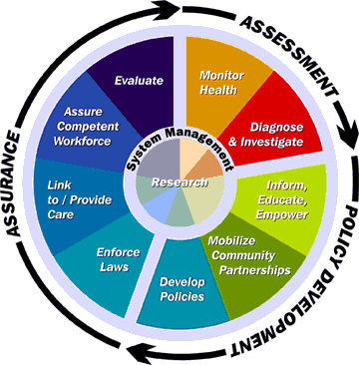
Adopted: Fall 1994, Source: Public Health Functions Steering Committee, Members (July 1995):
American Public Health Association·Association of Schools of Public Health·Association of State and Territorial Health Officials·Environmental Council of the States·National Association of County and City Health Officials·National Association of State Alcohol and Drug Abuse Directors·National Association of State Mental Health Program Directors·Public Health Foundation·U.S. Public Health Service --Agency for Health Care Policy and Research·Centers for Disease Control and Prevention·Food and Drug Administration·Health Resources and Services Administration·Indian Health Service·National Institutes of Health·Office of the Assistant Secretary for Health·Substance Abuse and Mental Health Services Administration

Description | Partners | Structure | Activities | ODPHP

Return to home page

Send mail to rhan@osophs.dhhs.gov with questions or comments about this web site.
Last modified:

