DHHS
Non-Discrimination Notice

The Department of Health and Human Services (DHHS) does not discriminate on the basis of disability, race, color, creed, gender, sexual orientation, age, or national origin, in admission to, access to, or operations of its programs, services, or activities, or its hiring or employment practices. This notice is provided as required by Title II of the Americans with Disabilities Act of 1990 and in accordance with the Civil Rights Act of 1964 as amended, Section 504 of the Rehabilitation Act of 1973, as amended, the Age Discrimination Act of 1975, Title IX of the Education Amendments of 1972, the Maine Human Rights Act and Executive Order Regarding State of Maine Contracts for Services. Questions, concerns, complaints or requests for additional information regarding the ADA may be forwarded to the DHHS ADA Compliance/EEO Coordinators, 11 State House Station – 221 State Street, Augusta, Maine 04333, 207-287-4289 (V), or 287-3488 (V), TTY Users: Dial 711 (Maine Relay). Individuals who need auxiliary aids for effective communication in program and services of DHHS are invited to make their needs and preferences known to the ADA Compliance/EEO Coordinators. This notice is available in alternate formats, upon request.

To order additional copies of this publication or if you have questions about the content, please call: Maine CDC, Data, Research, and Vital Statistics at 207-287-5500. “TTY users call Maine relay 711”.

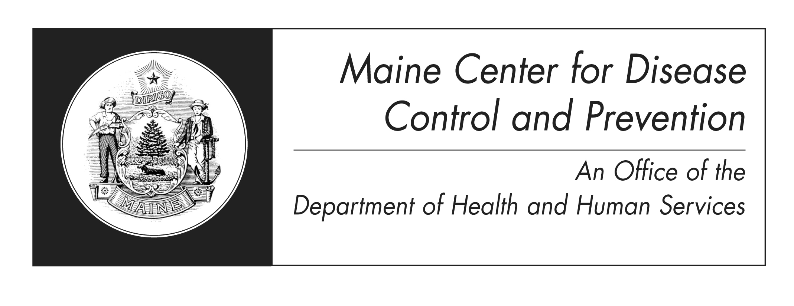
R 08/2013

A Legal Change
of Name on
Maine Birth Record

What you must do

What you should know

Maine Center for Disease Control and Prevention
(Maine CDC)
Vital Records Office
244 Water Street
11 State House Station
Augusta, Maine 04333-0011
(207) 287-3771 Fax: (207) 287-1093
TTY Users: Dial 711 (Maine Relay)

Legal Name Change

If you were born, or reside, in Maine and want to have your name changed, you may petition the Judge of Probate in the county where you reside; if you are minor, your legal guardian may petition on your behalf. The judge, after due consideration and notice, may issue a decree changing your name. This process changes only your name on your birth certificate. There is a simple procedure to follow.

Where to Petition

You must apply for a legal change of name at the Probate Court in the county where you reside, either in person or through a lawyer. If you are under the age of 18, your parent or legal guardian may apply on your behalf.

Registration of New Name

The Probate Court where the legal change of name is granted will notify the State Registrar of Vital Statistics at the Maine CDC vital records office, Department of Health and Human Services, using Form VS-14, “Notification of Legal Change of Name.” The Registrar of Probate will attach your check for the registration fee to the form. The Maine CDC vital records office will notify each municipal clerk having a copy of your birth certificate of the legal name change.

If your legal change of name was granted prior to July 1, 1983, you will have to register the change yourself. You may do this by sending the court decree or a notarized copy and the registration fee to:

Maine Center for Disease Control and Prevention
(Maine CDC)
Vital Records Office
244 Water Street
11 State House Station
Augusta, Maine 04333-0011

Each municipal clerk having a copy of your birth certificate will be notified by the Maine CDC vital records office to change the birth record that is on file. The court decree will be returned to you after registration is completed.

Certified Copy of Birth Record

Certified copies of the amended birth certificates will have a line drawn through the name(s) to be changed and the new name(s) entered above or to the side of the original entry (e.g. Smith *Jones). Every copy will also include a marginal notation that the name was changed and will show the name and location of the court and the date of the decree. You will receive a copy of the amended certificate when the registration of your new name has been completed.

Fee

A fee of $60.00 is required for a court-ordered legal change of name to be registered by the Maine CDC vital records office. This fee includes one certified copy of the birth certificate with the new name.

A check in the amount of $60.00, payable to TREASURER, STATE OF MAINE, must accompany the “Notification of Legal Change of Name” form when it is forwarded by the Register of Probate or submitted by you directly.

