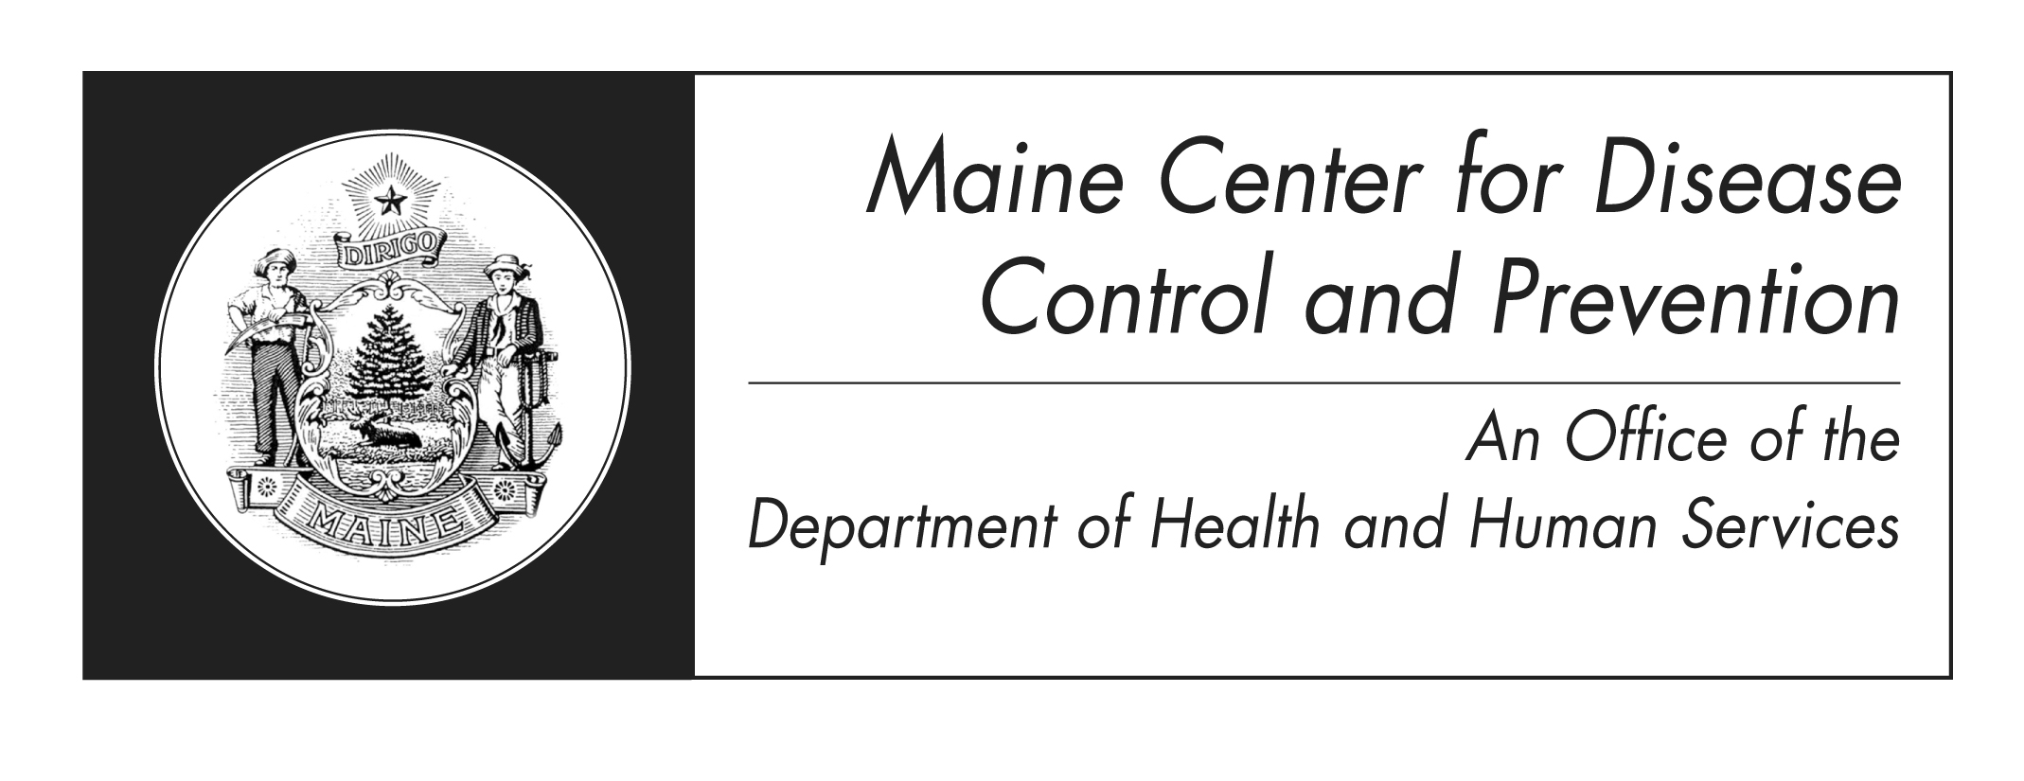

2011 Maine PRAMS Data Brief
July 25, 2013

This is a report on the Pregnancy Risk Assessment Monitoring System (PRAMS), a survey conducted on a sample of Maine women with live births since 1987. This report includes data from 2011, the third year of PRAMS Phase 6 data collection. Presented here are some highlights, organized by topic area. More detailed tables of the responses to questions in each topic area are available.

Preconception Health and Family Planning
- 33% of mothers reported dieting to lose weight in the year prior to pregnancy, and over 55% reported exercising 3 or more times per week.
- 6% of women reported visiting a health care worker in the year prior to pregnancy, to be checked or treated for diabetes and over 7% for high blood pressure, while 21% of women reported visiting a health care worker to be checked or treated for depression or anxiety.
- 49% of women reported not taking a multivitamin during the month prior to pregnancy, while 38% reported taking a vitamin every day.
  - Of those not taking a vitamin, 67% reported their pregnancy was unplanned.
- 36% of mothers reported their pregnancy was unintended.
  - 9% didn’t want to be pregnant then or at any time in the future.
- 52% of mothers who were not trying to become pregnant reported doing something to keep from getting pregnant.
- 87% reported using birth control at the time of the survey (mothers are mailed surveys 3 months after the birth of their babies)

Prenatal Care
- Most women (89%) reported they received prenatal care as early as they wanted to. Of those who did not, the most common reasons reported were:
  - Did not know they were pregnant (37%).
  - Could not get an appointment (43%).
  - They were too busy (23%).
  - No money or insurance (14%).
- 23% of women reported they did not get advice from a healthcare worker how smoking during pregnancy could affect their baby.
- 69% reported being tested for HIV during their most recent pregnancy.
- 83% reported talking with a healthcare worker about the health affects of mercury on babies and 81% were given a mercury brochure.
- 72% reported talking with a healthcare worker about how much weight they should gain during their pregnancy.
2011 Maine PRAMS Data Brief
July 25, 2013

Alcohol and Tobacco Use
- 33% of women reported smoking in the 3 months prior to pregnancy. 38% reported having smoked some cigarettes in the past 2 years.
- 19% reported smoking during the last trimester.
- 23% reported smoking at the time of the survey.
- 77% reported drinking at least some alcohol in the 2 years prior to pregnancy, and 35% reported at least one binge (4+ drinks/sitting) during the 3 months before pregnancy.

Stress and Abuse
- 59% of women reported at least two stressors during the year before giving birth, while 33% reported 3-5, and 8% reported 6 or more.
- 9% reported not having enough money to buy food during the 12 months before their new baby was born.
- 11% reported getting emergency food from a church, a food pantry, or a food bank, or ate at a food kitchen during the 12 months before their new baby was born.
- After childbirth, 33% reported never feeling down, depressed or sad while 10% reported those feelings often.
- 98% of mothers reported no domestic abuse during their pregnancy.

Breastfeeding
- 86% of mothers reported having ever breastfed their new baby.
  - Of those that breastfed, 59% are currently breastfeeding their baby.

Sleep Environment
- 80% of mothers reported most often putting their infant to sleep on his or her back.

Dental Health
- 43% of women reported they had their teeth cleaned during their most recent pregnancy.
- 48% reported visiting a dentist or dental clinic while pregnant.
- 66% reported having dental insurance that pays for some or all dental care.

Postpartum Care
- 11% of newborns were reportedly placed in the intensive care unit.
- Birth certificate data indicated 6% of births were low birth weight babies (<2500 grams or 5lbs, 8oz). 94% of mothers reported having previously delivered a normal birth weight baby (>2500 grams or 5lbs, 8oz).
- 9% of babies were reportedly born premature (<37 weeks). 10% reported having previously delivered a premature baby.

2011 Maine PRAMS Data Brief
July 25, 2013

Delivery
- 17% reported planning a cesarean section at least 1 week before birth.
  - 32% of all births were cesarean delivery.
- 35% reported their labor was induced.

Questions or comments about this report may be addressed to Tom Patenaude, MPH, Maine PRAMS Coordinator thomas.patenaude@maine.gov (207) 287-5469.

