WIC Nutrition Program
FFY 2020 Local Agency Annual Report

Program Overview
Program Overview 1

Who We Serve 2
Clinic Initiatives 3
WIC Foods 4
Breastfeeding 5
Outreach 6
Budget/Expenditures 7

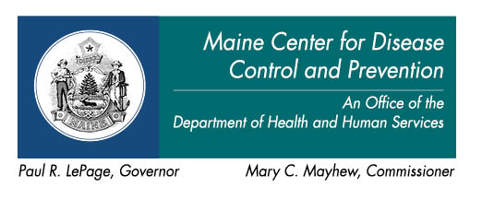

This section will include the purpose of the LA WIC Program, how it fits within the Local Agency, etc.

Program Goals

This section will include the LA’s WIC program goals for the upcoming year and what data indicators will be assessed next year

Who We Serve
Information about participant demographics, information that makes this region unique, etc

Clinic Initiatives This section will include information about special projects, clinic initiatives, WOW customer services. Please include a needs assessment including key health indicators (ex: hemoglobin, smoking, BMI, benefit redemption, etc) that drive your nutrition education plan.

WIC Food Benefits
This section will include information about activities promoting WIC Food Benefit items, including Farmers Market promotion.

Breastfeeding
This section using key health indicators (ex: duration, initiation, levels, etc.) should have information related to the agency’s promotion and support efforts for Breastfeeding.

Outreach

Steps to Developing Your Outreach Plan
Develop a long-term outreach plan before you begin to conduct outreach activities. Here are some suggested steps.
1. Identify and Prioritize Needs and Assess Resources Available
What do you need? …to increase caseload? …to increase WIC referrals? to maintain
caseload? What are the particular underserved areas or unmet needs in your community (for example: pregnant teens, specific ethnic groups, geographical areas)? What staff and
program resources do you have to implement outreach activities? What are some different approaches you can use, such a multimedia or other low-cost options?
2. Identify Your Target Audience(s)
Whom do you want to reach? …potentially eligible people? …the general public? …the
African American community? …health or social service providers who refer clients to WIC?
3. Define Goals and Objectives
What is it you would like your audience to do once they have heard your message? Who will
do what, how, where, and by when?
4. Identify Outreach Strategies
What outreach methods and tools will you use? Will outreach be one-time, short-term, or
ongoing or a combination? At a minimum, your outreach plan should include ongoing
outreach activities.
5. Implement Plan
Put your plan into action. Monitor to make sure that implementation is going as planned.
Make adjustments if needed.
6. Evaluate Plan
Before you implement your plan, identify how you will evaluate it. How will you know if your
plan is working? What baseline information will you obtain before you implement the plan?
What outcomes will you be measuring? What feedback will you gather from participants,
potential participants, providers, etc.? What can you learn that may help you be more
successful in the future?
Template for Outreach Plan
Needs and Resources Available
Target Audience(s)
Goals & Objectives
Outreach Strategies
Staff
Evaluation
Goal:
Who | What & How | Where |  | When | Evaluation

Budget/Expenditures

This section has information regarding budget, agency expenditures, etc.

